Bellevue University

Assignment:

M1.4

Jason Jensen

Professor Henry Le

CYBR410-308H

January 4, 2023

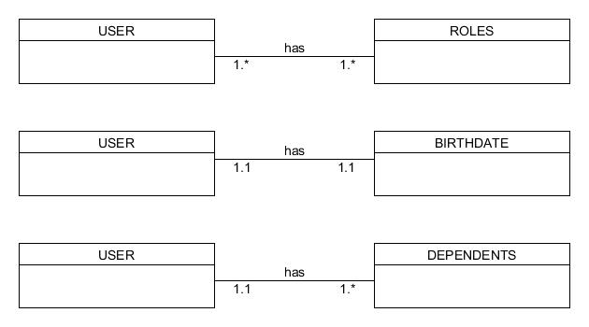

NoSQL Data Structure:

{

"first_name": "Bruce",

"last_name": "Wayne",

"Roles": [

{

"type": "Household",

"Chore": "Clean Dishes"

},

{

"type": "Work",

"color": "Do Assignment."

}

]

"Birthdate": [

{

"day": "30",

"month": "January"

"year": "2001"

}

]

"Dependents": [

{

"first_name": "Jack",

"last_name": "Sparrow"

},

{

"first_name": "Harry",

"last_name": "Potter"

}

]

}