# Our Database

**Overview**

WeWork.com has an online MySQL database based on AWS Relational Database Service to store all the information include jobs, users, payments, messages, reviews, citys, categories and so on. Due to the database will work for each module, it’s designed as a whole thing, with all the references between each tables, to make sure there is no information leakage when people are using this database and all the workflow is rigorous and reasonable, all the data are stored in right way and can still work in future development. All the information can be found in “weworkDatabase2.3.zip” .

**Database Design**

There are 9 tables in this database: job, user, user_detail, review, job_applicant, payment_history, message, city, category.

* **Job:** This is a core table, store all the information about jobs, such as poster, time, wage type, and so on. It works for job_applicant table and it helps users to find the job they posted and which job they can do easily.
* **User:** This is another core table, store all the key information for users, like email, password, balance, rating. We put all other specific information into user’s detail table, through a foreign key.
* **User_detail:** The “user_detail” table is for some specific information of users, which the user may want to see them in the profile page, and some of them may be used into fruture functions, like if we want to know which city has most wework users.
* **Review:** This table stores the reviews between users, to help the posters to know the workers and help the workers to know the posters. It can change the users’ rating and it’s important.
* **Job_applicant:** This table stores all the information that between jobs and workers, like who applied which work, and did he finished it, to keep all the workflow working well.
* **Payment_history:** This table stores all the payments, so users can find his payments and see all the information about his payments, like the payment’s status, time, payer, job.
* **Message:** The table is used to store all the messages sent by users, we make records for sender, receiver, time and content.
* **City:** The “city” table is for all the cities this website may support. Only managers can add new data into this table.
* **Category:** The “category” table is for all the categories the job can be. Only managers can add new data to this table.

**E-R Diagram**

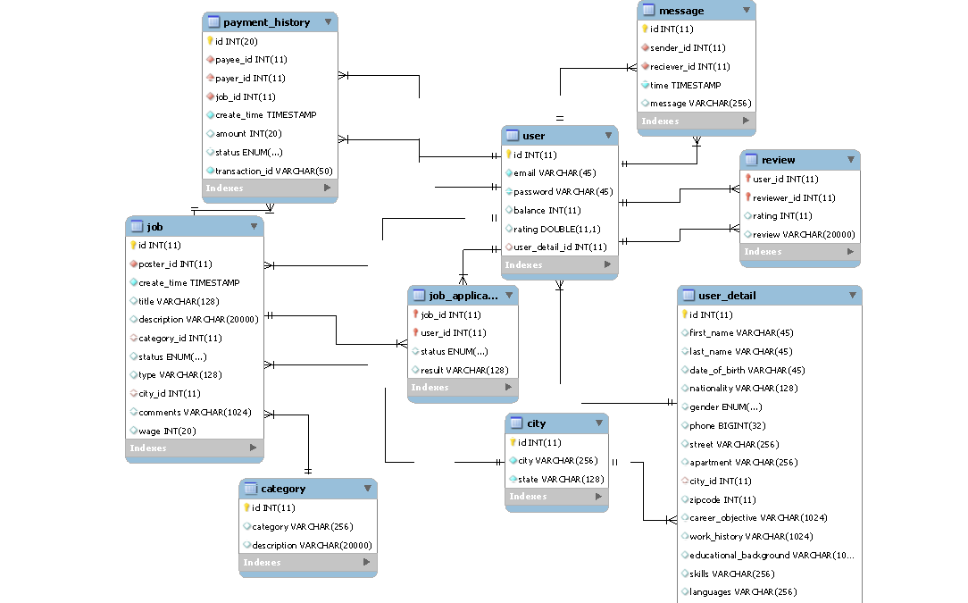

It’s a little small, you can see it(E-R diagram.pdf) in the weworkDatabase2.2.zip file.

**Versions**

There are many versions we created in the development process.

* **version 1.1:** Create a basic database with all the tables and run. All the things are fine.
* **version 1.2:** Add 'status' into job table, as an enum column. Changed 'status' in job_applicant table, as an enum column. Changed 'status' in payment_history table, as an enum column. Add 'transaction_id ','payer_id, 'job_id' into payment_history table. Changed 'user_id' into payment_history table, now it's called 'payee_id'. Changed 'amount' type, now it's Integer.
* **version 1.3:** Category and city table are already filled now. Add 'wage' column into job table. User_detail table are well done.
* **version 2.0:** uploaded the database into the AWS RDS. Users can use "ConnectToAWS.php" to connect with AWS RDS in PHP. Users can connect AWS by using the Workbench, just follow "how to connect with AWS and basic workbench operations.pdf" . And if users are using Linux, you can follow "how to connect with AWS in Linux.pdf". New SQL queries are updated.
* **version 2.1:** New SQL queryies are updated. Users can use the files in the query_filling, to fill all basic data into the database. Each user got 100 coins when his account is created.
* **version 2.2:** To make the development easier, the job table and job_detail table are merged now. Almost all the query files are updated.
* **version 2.3:** Add message table for storing all the messages. Almost all the query files are updated.