Jaskarn Jagpal

06/18/2016

Csc 138 T, TH 1240-410

Socket Programming- Assignment 1

* **UDP implementation:** 
  + **Client**:
    - **From socket import\***
    - **serverName = ‘localhost’**
    - **serverPort = 12000**
    - **clientSocket = socket(AF_INET, SOCK_DGRAM)**
    - **message = raw_input(‘Input lowercase sentence: ‘)**
    - **clientSocket.sendto(message, (serverName, serverPort))**
    - **modifiedMessage, serverAddress = clientSocket.recvfrom(2048)**
    - **print modifiedMessage**
    - **clientSocket.close()**
  + 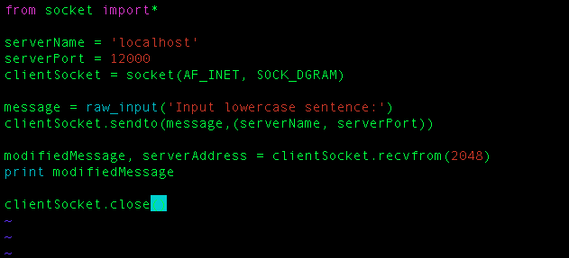
  + 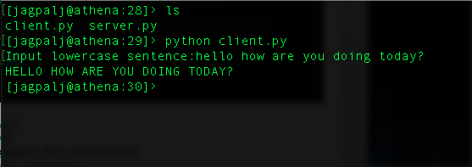
  + **Server**:
    - **From socket import\***
    - **serverPort = 12000**
    - **serverSocket = socket(AF_INET, SOCK_DGRAM)**
    - **serverSocket.bind((‘ ‘, serverPort))**
    - **print ‘The server is ready to receive’**
    - **while 1:**
      * **message, clientAddress = serverSocket.recvfrom(2048)**
      * **modifedMessage = message.upper()**
      * **serverSocket.sendto(modifedMessage, clientAddress)**
  + 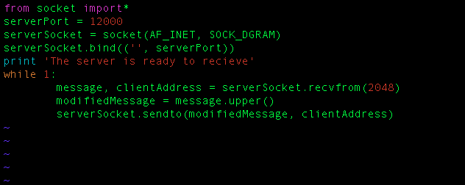
  + 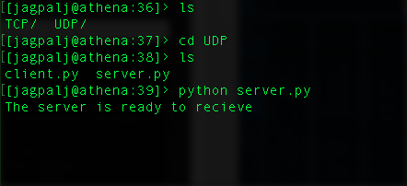
* **TCP Implementation:**
  + **Client**
    - **From socket import\***
    - **serverName = ‘localhost’**
    - **serverPort = 12000**
    - **clientSocket = socket(AF_INET, SOCK_STREAM)**
    - **clientSocket.connect((serverName, serverPort))**
    - **sentence = raw_input(‘input lowercase sentence: ‘)**
    - **clientSocket.send(sentence)**
    - **modifiedSentence = clientSocket.recv(1024)**
    - **print ‘From Server: ‘, modifiedSentence**
    - **clientSocket.close()**
  + 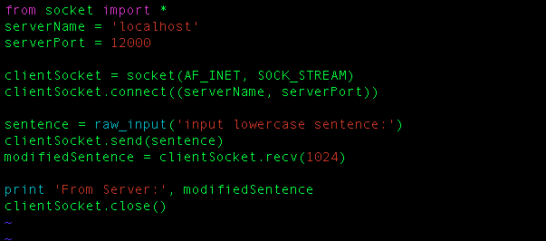
  + 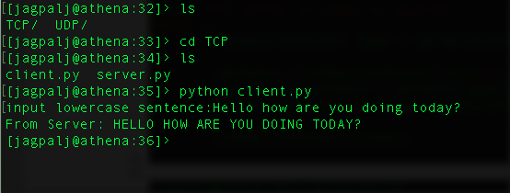
  + **Server**
    - **From socket import\***
    - **serverPort = 12000**
    - **serverSocket = socket(AF_INET, SOCK_STREAM)**
    - **serverSocket.bind((‘ ‘, serverPort))**
    - **serverSocket.listen(1)**
    - **print ‘The server is ready to receive’**
    - **while 1:**
      * **connectionSocket, addr = serverSocket.accept()**
      * **sentence = connectionSocket.recv(1024)**
      * **capitalizedSentence = sentence.upper()**
      * **connectionSocket.send(capitalizedSentence)**
      * **conectionScoket.close()**
  + 