

CMPE 283 –VIRTUALISATION TECHNOLOGIES
PROJECT- 1

Advisor: Dr. Simon Shim

Submitted by
Jasleen Kaur
SJSU ID: 009430304

Contents

Contents 2
Introduction 3
Background 3
Requirements 4
Design 5
Implementation 7
ANSWERS TO QUESTION: 13
DISCUSSION: 14
References 14

Introduction
Goals
The goal of this project is to create an availability manager to monitor the status of Virtual Machines on a datacenter in a Vsphere server using Java and Vmware web services SDK. The project monitors both virtual machines and hosts for failure. When a failure is detected first the host is checked for failure. If the host has failed, an attempt to reconnect is done. If the reconnection fails, another host is searched for migrating virtual machines. If no other host is present, a new host is added and vm is restarted on that host. If virtual machine fails, it is reverted to an old cached image. The caching of images is done every 10 minutes. All the task mentioned are automated.
Objectives

- Gain experience with several hypervisors and the corresponding management servers
- Explore the capabilities offered by these components and their APIs,
- Apply the concepts discussed in the course to a real-world problem, and
- Learn about the issues arising from interoperability

Needs
- Manual monitoring of virtual machines is a difficult, time consuming and resource consuming.
- Manual fault detection is hard especially in environments with large number of virtual machines.
- In a scenario with large number of virtual machines and hosts manually caching images of each virtual machine on a regular interval becomes hard, inefficient and unreliable.
- Availability manager is not only needed to automate monitoring, fault detection, caching tasks but also required for lower downtime of machines.

Background
Availability Monitoring is a service that periodically checks to see if a specific resource is available to end users, i.e. checks to see if a visitor can connect to and consume the resource. It is aimed at high availability of resources and low downtime. Traditionally all resources are monitored manually by a server administrator or a team of server administrator. But when the number of resources increases, the management cost becomes more than revenue earned. So it becomes critical to automate the management of resources and track the performance statistics of each resource. The virtual machine and host availability is checked by pinging them and analyzing results. If ping fails after a fixed number of times, the virtual machine is declared dead. A powered off VM is not considered a failed Virtual Machine. Only a machine which is powered on but is unreachable is considered as a failed machine.

Requirements
Functional Requirements
- Monitoring- Virtual Machines and hosts are monitored by a periodic ping mechanism to each to ensure if it is alive or dead.
- Add new hosts- When there is no alive host, a new host is added programmatically without and intervention from user.
- Remove failed host- When a possible host failure is detected, an attempt to reconnect to the host is tried. If the reconnection fails, the host is removed from the inventory along with its virtual machines.
- Periodic caching of virtual machines- A periodic caching of virtual machines is done by taking snapshots and exporting OVF file locally is done to cope up future failures.
- Failure detection- Failure detection is done by a fixed number of timely pings after a fixed interval of time on each component is done to detect failure.
- Failure recovery- If a virtual machine fails, it is recovered by reverting to a previous snapshot or OVF file. If a host fails, an attempt to reconnect to it is done. Failing to do so, it is removed from inventory and its child components are migrated to another host.
- Tracking resource statistics- A periodic tracking of CPU, memory, etc. resources is done programmatically.
- Virtual Machine Migration- A cold migration(Migration with virtual machine in powered of state ) is done to cope with a host failure.
- Alarms- Alarms on every host and virtual machine are configured to monitor the state of machine

Non functional requirements
- Usability- The availability manager is easy to use and requires no special training to operate.
- Logging- Every event, process, and task is outputted to console for easy readability by user.

Design
Keywords
- Host- VMware ESX and VMware ESXi are Type 1 hypervisors that are VMware's enterprise software hypervisors for guest virtual servers that run directly on host server hardware without requiring an additional underlying operating system.
- Virtual Machine- A virtual machine (VM) is a software implementation of a computing environment in which an operating system (OS) or program can be installed and run.
- Folder- The Folder managed object is a container for storing and organizing inventory objects. Folders can contain folders and other objects. The childType property identifies a folder's type and determines the types of folders and objects the folder can contain.
  - A folder can contain a child folder of the same type as the parent folder.
    - All Datacenter objects contain dedicated folders for:
    - VirtualMachine, templates, and VirtualApp objects.
    - ComputeResource hierarchies.
    - Network, DistributedVirtualSwitch, and DistributedVirtualPortgroup objects.
    - Datastore objects.
  - A folder can contain child objects of type childType. Virtual machine and network entity folders can also contain additional object types.
  - The root folder is a data center folder.
- Datacenter- The Datacenter managed object provides the interface to the common container object for hosts, virtual machines, networks, and datastores. These entities must be under a distinct datacenter in the inventory, and datacenters may not be nested under other datacenters. Every Datacenter has the following set of dedicated folders. These folders are empty until you create entities for the Datacenter.
  - A folder for VirtualMachine, template, and VirtualApp objects.
  - A folder for a ComputeResource hierarchy.
  - A folder for Network, DistributedVirtualSwitch, and DistributedVirtualPortgroup objects.
  - A folder for Datastore objects.

- Datastore- Represents a storage location for virtual machine files. A storage location can be a VMFS volume, a directory on Network Attached Storage, or a local file system path. A datastore is platform-independent and host-independent. Therefore, datastores do not change when the virtual machines they contain are moved between hosts. The scope of a datastore is a datacenter; the datastore is uniquely named within the datacenter.

Architecture

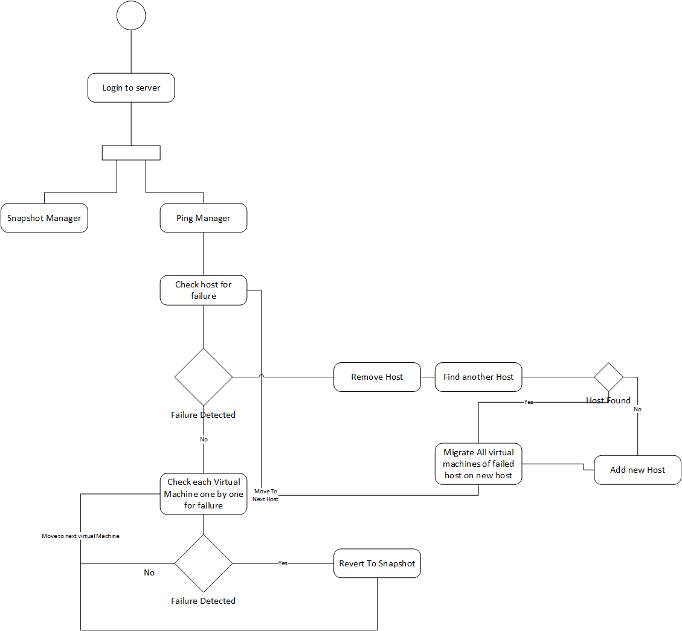
Figure 1 Architecture of Availabiilty Manager
The availability manager starts by logging into vshpere server. Then simultaneously pingmanager and snapshot manager start. These processes run infinitely at an interval of 2 minutes and 10 minutes respectively.
- The ping manager first checks each host for failure. If a host fails, its VM’s are transferred to another healthy host and it is removed from inventory. If no other host is available, a new host is added. Then virtual machines are then pinged. If ping fails after successive 5 attempts, the vm is reverted to an old snapshots.
- The snapshot manager captures snapshot of each virtual machine every 10 minutes and also saves an OVF file and disk file of vm locally. This Ovf and disk file is used when host fails and there is a need to migrate the vm to a new host.

Implementation
Environment& tools
- Eclipse IDE In computer programming, Eclipse is an integrated development environment (IDE). It contains a base workspace and an extensible plug-in system for customizing the environment. Written mostly in Java, Eclipse can be used to develop applications. By means of various plug-ins, Eclipse may also be used to develop applications in other programming languages: Ada, ABAP, C, C++, COBOL, Fortran, Haskell, JavaScript, Lasso, Perl, PHP, Python, R, Ruby (including Ruby on Rails framework), Scala, Clojure, Groovy, Scheme, and Erlang. It can also be used to develop packages for the software Mathematica. Development environments include the Eclipse Java development tools (JDT) for Java and Scala, Eclipse CDT for C/C++ and Eclipse PDT for PHP, among others
- Vmware workstation- VMware Workstation is a hypervisor that runs on x64 computers; it enables users to set up multiple virtual machines (VMs) and use them simultaneously along with the actual machine. Each virtual machine can execute its own operating system, such as Microsoft Windows, Linux or BSD variants. As such, VMware Workstation allows one physical machine to run multiple operating systems simultaneously. Workstation is developed and sold by VMware, Inc., a division of EMC Corporation
- Ubuntu Ubuntu is a Debian-based Linux operating system, with Unity as its default desktop environment (GNOME was the previous desktop environment). It is based on free software and named after the Southern African philosophy of ubuntu (literally, "human-ness"), which often is translated as "humanity towards others" or "the belief in a universal bond of sharing that connects all humanity".
- Microsft Server 2012
- Java 1.7
- The vSphere Web Services SDK supports the development of vSphere client applications that use the vSphere API to manage virtual machines and other virtual infrastructure components (datacenters, datastores, networks, and so on).
Screenshots

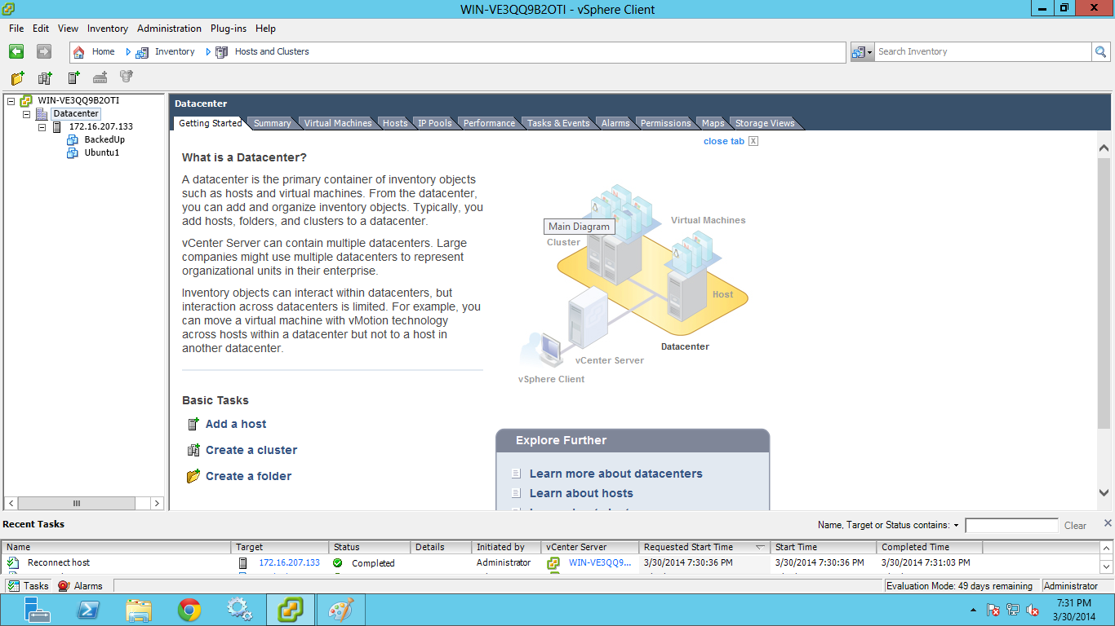
Figure 2 Before Shot
Step 1: Host is disconnected.
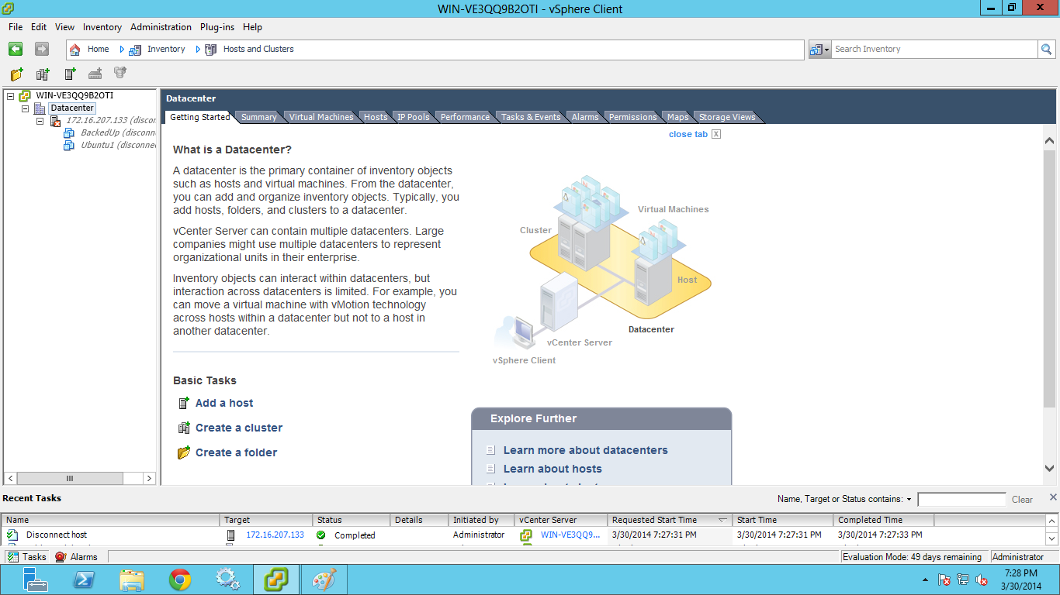
Step 2: Host is reconnected programmatically
Step 3: Host is failed
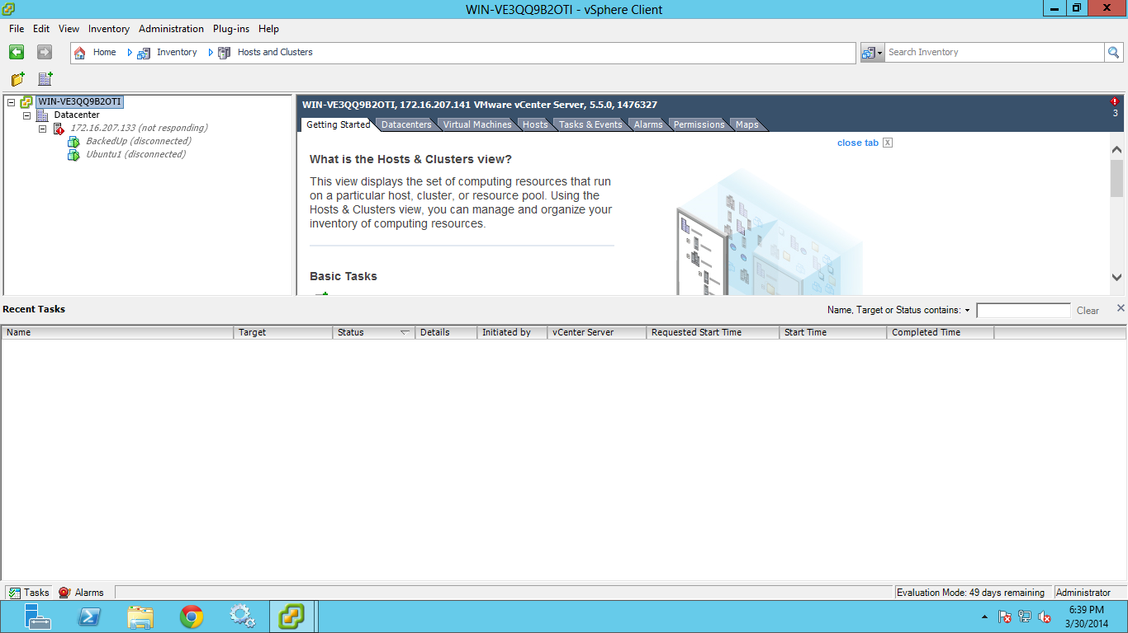
Step 4: Host is removed, a new host is added and vm's are exported
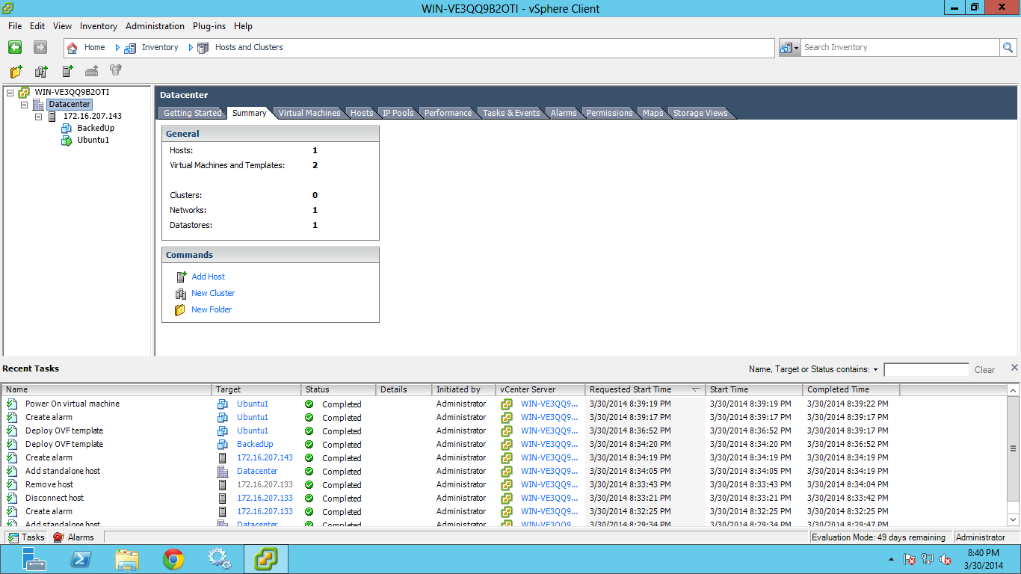
Step 5: Nic is disabled
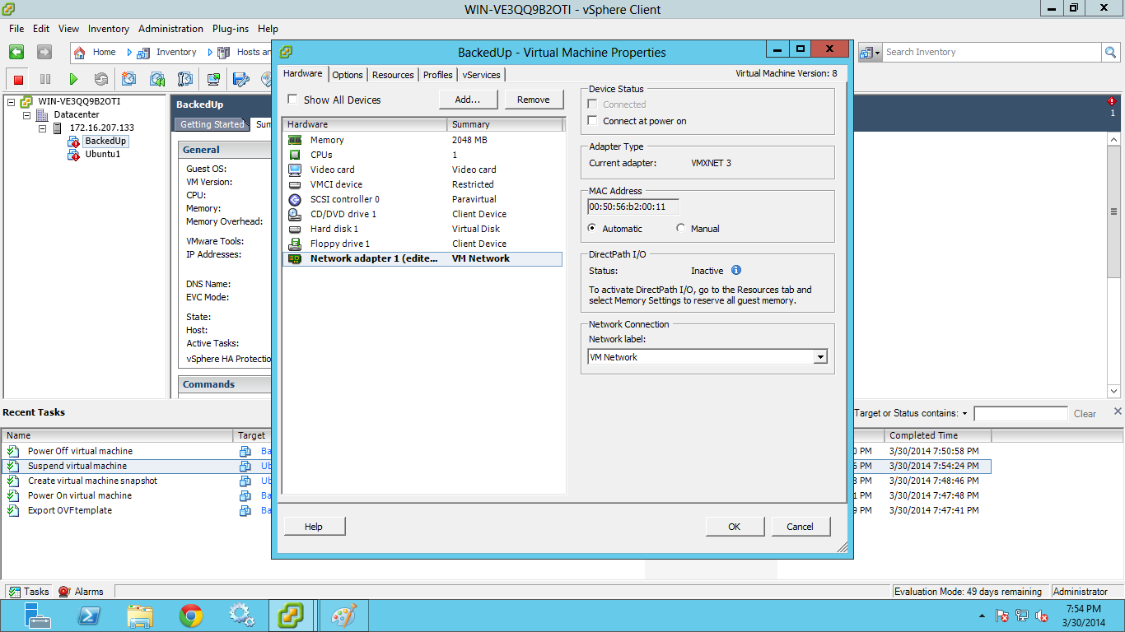
Step 6: Snapshot is reverted
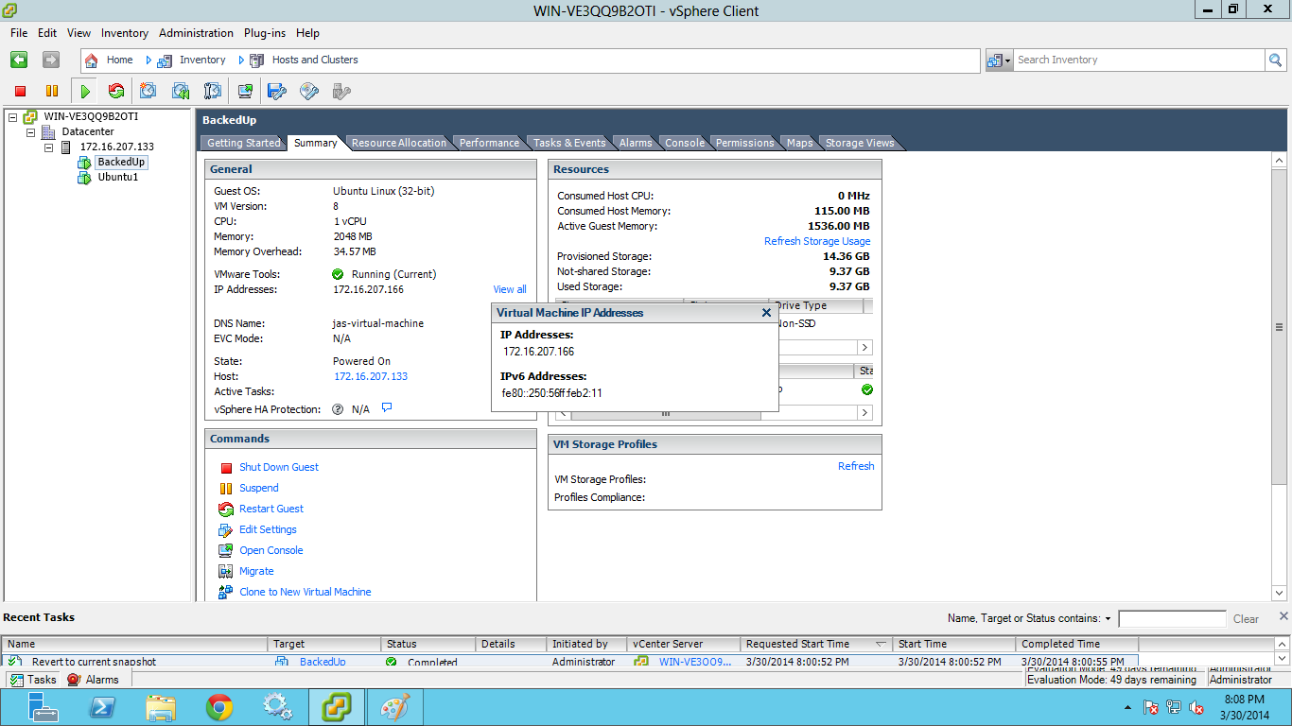

ANSWERS TO QUESTION:
1. In case of failure, what is the good approach during Disaster Management of Virtual Machines,
- Check the Host first and then the virtual machine
- Check the virtual machine and then the host
Justify the answer with sufficient reasons.

It is best to check host first because if a host fails, the virtual machine will automatically become unavailable. However it is not mandatory that if virtual machine has failed that means host has failed.

2.How many threads do you think are required for the optimal functioning of your Availability managers? Support your answer with reasons.
A minimum of two threads are required- one to ping hosts and one to take snapshosts. It is required because both these tasks need to be done simultaneously and both have different intervals and sleep for different intervals. Further failure of one process will not affect failure of other

3. How did you set and use the alarms to aid your availability manager? Where else can you use the alarms? Explain.
I used StateAlarm on HostSystem and virtual machines.
- A state alarm on host system helped distinguish between a disconnected host and a not responding host. In case of disconnected host an attempt to reconnect to it was done.In case of not responding host, it was declared dead and its virtual machines were transferred to another host.
- A state alarm on virtual machine helped in recognizing when a vm was powered off or suspended. In this case the VM was powered up and was not declared dead. If this alarm was not used, it would have been difficult to distinguish between actual failure and power off.

DISCUSSION:

- The host add/remove mechanism- The host was added when there was no other host available. It was done by AddHost_Task() task method of HostSystem. The host was removed on failure by host.getParent().Destroy_Task() method where host is an instance of HostSystem.

- The approach used to configure the failure detection for each VM – First the host was pinged, if the host failed, the vm was restarted on another host by using the previously cached OVF and vmdk disk file of the vm. If the host was alive, the Vm was pinged. If ping failed five times consecutively, it was reverted to a previous snapshot

- How host failures were detected – The host alarm state was checked by triggered alarm. if the host was disconnected,it was reconnected. Else the host was in non responsive state, it was pinged. If ping failed five times consecutively the host was declared dead.
- The mechanism used to convert between the image formats used by the hypervisors – The ovf and vmdk files were saved locally every 10 minutes and those were uploaded to new host when required

8. CONCLUSION:

The following conclusions were made from the project experience:
- The availability manager is an efficient method to manage hosts
- A familiarity with various components of vspehere was achieved.
- A hands on experience with vmware webserver sdk was gained.

References

1. vSphere API and VI SDK functionality differences.(A)
http://vijava.sourceforge.net/faq.php

