**Mobile E-Commerce**

Submitted for the partial fullfillment of the Degree

of

Bachelor of Technology

(Computer Science Engineering)



**Submitted By: Submitted to:**

Jasleen kaur Sukhjit Singh Sehra 90370305174 Poonamdeep Kaur, Dipti Kunra

Department of Computer Science & Engineering

Guru Nanak Dev Engineering College

Ludhiana 141006

**ABSTRACT**

Mobile e-commerce (m-commerce) is a term that describes online sales transactions that use wireless electronic devices such as hand-held computers, mobile phones or laptops. These wireless devices interact with computer networks that have the ability to conduct online merchandise purchases. Any type of cash exchange is referred to as an e-commerce transaction. Mobile e-commerce is just one of the many subsets of electronic commerce.  
Mobile e-commerce may also be known as mobile commerce.

This project deals with developing a Mobile e-commerce website application in Android Application Development. It enables various businesses to come together and trade with each other on a global platform. It has four basic users- Administrator, Supplier, Retailer, Customer. It provides each user with a catalog of different items available for purchase in the application. The role of each user is explained in the document.

In order to facilitate online purchase a shopping cart is provided to the user. The system is

Tomcat Server and JSP technology, and an android device as the front end client.

In order to develop an e-commerce application, a number of Technologies must be

studied implemented using a 3-tier approach, with a backend database, a middle tier of Apache

and understood. These include multi-tiered architecture, server and client side

scripting techniques, implementation technologies such as JSP, programming

language (such as Java, XML, Android Application Develpment), relational databases (such as MySQL).

This document will discuss each of the underlying technologies to create and

implement an e-commerce application.

##### **ACKNOWLEDGEMENT**

At the very onset, I am highly indebted to **One Infonet Technology, Ludhiana** for giving me an opportunity to carry out my project on **“Mobile Ecommerce”** at their esteemed organization.

I would specially thank **Miss GaganpreetKaur**, Project Guide of One Infonet Technology, Ludhianafor giving time and guidance throughout my training without whom it would have been impossible to attain success. My heartiest thanks to Trainees and employees at One Infonet Technology, Ludhiana for helping me throughout the project tenure.

I owe my regards to the entire faculty of the department of computer science engineering at **Guru Nanak Dev Engineering College,Ludhiana**from where I have learnt the basics of Computer Science and whose informal discussions and able guidance became light for me in the entire duration of this work.

**Table Of Contents**

Introduction to company 1

Introduction to Project 3

Overview: 3

Existing System:- 3

Need of New System:- 4

User Requirement Analysis 8

Feasibility Study 9

Objective 17

Product Design 18

Project perspective 18

Product functions 19

Constraints 22

Use Case Model/FlowChart/DFDS 23

Database design 28

Table Structure 29

Assumptions and Dependencies 37

Specific Requirements 39

Other Nonfunctional Requirements 39

Development and Implementation 42

Introduction to Languages 42

1. ANDROID 42

2.JAVA:- 42

Implementation 45

Testing 53

CONCLUSIONS & FUTURE SCOPE 56

CONCLUSIONS 56

Future Scope 57

**Definitions, Acronyms and Abbreviations**

* XML

Extensible Markup Language (XML) is a set of rules for encoding documents in machine-readable form. It is defined in the XML 1.0 Specification produced by the W3C, and several other related specifications, all gratis open standards.

* JSP

JavaServer Pages (JSP) is a technology that helps software developers create dynamically generated web pages based on HTML, XML, or other document types. Released in 1999 by Sun Microsystems,[1] JSP is similar to PHP, but it uses the Java programming language.

* MYSQL

MySQL (/maɪ ˌɛskjuːˈɛl/ "My S-Q-L",[3] officially, but also called /maɪ ˈsiːkwəl/ "My Sequel") is (as of 2008) the world's most widely used[4][5] open source relational database management system (RDBMS) that runs as a server providing multi-user access to a number of databases. It is named after co-founder Michael Widenius' daughter, My. The SQL phrase stands for Structured Query Language.

* Android Application Development

Android software development is the process by which new applications are created for the Android operating system. Applications are usually developed in the Java programming language using the Android Software Development Kit, but other development tools are available.

**List of Figures**

1Project Overview 3

2Project perspective 18

3 Administrator 23

4 User Authentication 24

5 Customer 25

6 Customer Detailed 25

7 Retailer 26

8 Supplier 27

Table 1 Warehouse 29

Table 2 Advertisement 29

Table 3 MasterUserInfo 30

Table 4 Order Details 30

Table 5 Shop Complaint 30

Table 6 Fine 31

Table 7 Item Availabilty 31

Table 8 Item Sold 31

Table 9 General Complaint 31

Table 10 Batch Discount 32

Table 11 Item Complaint 32

Table 12 Complaint 32

Table 13 Category User 32

Table 14 Notification 33

Table 15 Order 33

Table 16 Shop Pricing 33

Table 17 Advertisment Pricing 34

Table 18 Login 34

Table 19 Country 34

Table 20 Category 34

Table 21 Item Review 35

Table 22 Wish List 35

Table 23 Item 35

Table 24 Item Shop 36

Table 25 Invoice 36

Table 26 Contact 36

Table 27 Shop 37

Table 28 City 37

9: Add Avertisement 45

10: Add Batch Order 45

11: Pick Item- Add New Item 45

12: Select Category-Add New item 45

13: Add Item- Specify Availability 45

14: Add New Item 45

15: Place Order-No warehouse found 46

16: Add Sub Category 46

17: Add Super Category 46

18: Add Warehouse-Select Country 46

19: Add Warehouse 46

20: General Complaint 46

21: Advertisement Pricing 47

22: Customer Control Panel 47

23: Delete Customer 47

24: Registration Options 47

25: Edit My Categories 47

26: General Notifcation 47

27: My Items 48

28: My Supplier 48

29: Paypal payment 48

30: Add Advertisement- Pick Background 48

31: Add Advertisement- Pick Color 48

32: Confirm Payment 48

33: Place Order Retailer 49

34: Place order Supplier 49

35: Place Order Supplier 49

36: Place Order Retailer 49

37: Add Advertisement- Preview 49

38: Restore Customer 49

39: Shop Pricing 50

40: Shopping Cart 50

41: Sign Up 50

42: Subscribe Item 50

43: Supplier Home 50

44: Update Info 50

45: View Advertisement Pricing 51

46: View Batch Discount 51

47: View Order 51

48: View Order List 51

49: Shop Pricing 51

50: View Warehouse 51

51: Wishlist 52

Introduction to company

**Foundation**

OIT has been founded by group of senior IT Professional under the Leadership of Mr.Prabhjot Singh since 1st Sept, 2006. Right from the inception of this start up, OIT has prospered by Leaps and bounds in technology products and critical solutions. Our technologies are acknowledged by leading names of the industry such as Sun Microsystems, Oracle, Computer Associates etc. Within the span of three years, OIT is the strong team of more than 40 members having its operations based in New York, Noida, Mumbai and Ludhiana.  
**Achievements**

OIT believes in innovation and it is evident from various technology breaks through like from fastest database management systems to Desktop Retail Applications integrated with highly innovative data centre services which OIT has achieved in a short span. Our achievements represent our capabilities and expertise in catering directly to the problematic area of a business enterprise.  
OIT works along with the client to improve its business outcomes by exploring new business opportunities, deriving cost takeouts, increasing process efficiency without any major change. From innovative ideas to their implementation and thereafter, OIT offers all business transformation outsourcing services to clients under one flagship in four different phases of consulting, developing, outsourcing and training.

**Business Domains**

* **Training-:** From corporate training to end user training and technical Trainings like System Administration, Enterprise Architecture, Enterprise Network etc, OIT has client based dedicated training programs to ensure client can take maximum advantage of our system, services and solutions.

**Professional Learning:-**

* + Web Application Development
  + Software Development
  + Database Administration
  + Advance Networking Solutions
  + Graphics and Animations
  + Project Engineering & Management

**Student Coaching**

* + Sun Certifications
  + Cisco Certifications
  + Microsoft Certifications
  + Oracle Certifications
  + Redhat Certifications

Introduction to Project

Overview:

|  |  |  |
| --- | --- | --- |
| **Project Name** | **:** | Mobile Ecommerce |
| **Company** | **:** | **ONE INFONET TECHNOLOGIES** |
| **Project Type** | **:** | Mobile Application |
| **Front End** | **:** | Android |
| **Middle tier** | **:** | JSP |
| **Back End** | **:** | MySQL |

1Project Overview

Existing System:-

The existing system is based on a Manual System. It does not provide the user a faster and easy way to access different types of items. Selection is not made easily. Manual selection process and stock maintenance is not easy, as stock is managed manually on paper itself. It is not easy to update the stock and variety every now and then.

Since records are maintained on paper, it can create confusion if papers are misplaced due to some reasons. An individual does not have direct access to item of his/her choice. Shopkeeper keeps on displaying the clothing item to an individual whether he/she likes it or not. This leads to time wastage of both shopkeeper and the individual.

Further trading is limited to the local market. This leads to hoardings, shortages and unfair competition.

Need of New System:-

There has been felt the new to switch from Manual System to computer based system because the existing system has the following drawbacks:-

* Lack of Proper Interface:

The existing system is not computerized hence it does not provide graphical interface to the users.

* Cumbersome:

Handling and maintenance of stock is cumbersome.

* Time Wastage:

The biggest problem of existing system is that all the operations are time consuming like entering of all the records manually.

* High Cost:

Lot of paper work and storage is needed to keep back up of records. Also a lot of money is wasted in hiring of personnel and buying stationery.

* Mishandling:

Mishandling of registers, stock records can cause a great deal of confusion.

* High Maintenance:

Manual Record handling requires high maintenance in terms of regular updation so as to facilitate easy handling and maintenance.

* Limited to Local Market:  
  Most of the trading is limited to the local market. This leads to hoardings, shortages and unfair competition.

1. **Objectives of Proposed System:-**

The objectives of the proposed system are as follows:-

* To facilitate easy retrieval of data and information.
* To update various files after input processing and validations.
* To simplify the present manual task.
* To reduce the precious time, manpower and paper work.
* To maintain different databases on the system, thus storage space and lot of paper is saved.
* To provide timely and valuable information to the customer , suppliers, retailers.
* To provide menu driven, user friendly system.
* To provide faster and easy access to data.
* To provide easier and wider selection procedure to the user.

**Proposed System:-** Mobile Ecommerce  is an app which aims to digitize the modern business world. Here the user will get the opportunity to meet sellers, customers, suppliers on in one place. The owner can showcase all range of products along with various discounts and promotional schemes through his virtual shop. Anyone can buy or sell any products through his virtual shop. Anyone can buy or sell any product through this application while making/ receiving payments online.

This app provides various convenience tools to the owner for price management, advertisement management, discounts and schemes management, virtual inventory management, order processing, cost management like shipping, taxation, etc.

Incredible convenience: In comparison to a brick and mortar store with fixed hours, online shoppers can choose any time of the day or night to get on the Web and shop. This is especially useful for moms with small children, people that are home-bound, or simply in times of inclement weather.

Price comparisons: When you visit a store, you most likely have to settle for whatever price the vendor has placed on a particular item. Not so with Mobile Ecommerce - you have the ability to compare prices from hundreds of different vendors Infinite choice: Shelf space in a brick and mortar store is limited, which means that your variety of goods is limited. Not so with an online store. Plus, if you don't see what you want in one store online, you can simply move on to the next one - you've got the power to do that.

No pressure sales: We've all been awkwardly propositioned by eager salespeople. You don't have to put up with that online.

1. **Software/Hardware Requirements:-**

* Hardware:-

Processor : 1.70 GHz and Above

Main Memory : 512 MB.

Hard Disk : 20 GB.

Disk Space : 100 MB.

Floppy Disk Drive : 1.44 MB.

CD ROM Drive : 52x Samsung CD ROM

* Software:-

Operating System : Windows 7/Windows Vista

Software : NetBeans IDE

Data Base : MySQLServer 5.0

User Requirement Analysis

This section provides requirement overview of the system.Various functional modules that can be implemented by the system will be **-**

**3.1 Description**

**3.1.1 Registration**

If customer wants to buy the product then he/she must be registered, unregistered user can’t use the application. If a user wants to be a supplier, he should register as a supplier. If a user wants to be a retailer, he should register as a retailer. If a user wants to be a customer, he should register as a customer.

**3.1.2 Login**

User logins to the system by entering valid user id and password for the shopping. If the user is a supplier or retailer or administrator, he/she is taken to his respective control panel.

3.1.3 Changes to Cart

Changes to cart means the customer after login or registration can make order or cancel order of the product from the shopping cart.

3.1.4 Payment

For customer, retailers the payment method is paypal.

3.1.5 Advertisements

Suppliers and retailers can advertise their virtual shops.

3.1.6 Order Management

Order Management is done from within the application.

3.1.7 Category Management

Categories are distributed in an n-level hierarchy.

3.1.8 Warehouse management

Various warehouses can be managed.

3.1.9 Item Management

Suppliers and retailers can add or delete item according to their will.

3.2 Technical Issues

This system will work on client-server architecture. It will require an internet access on his phone.

Feasibility Study

Feasibility study is carried out to test is the proposed system is worth being implemented. Given unlimited resources and infinite time, all project are feasible. Unfortunately, such situations are not possible in real time. Hence it becomes necessary and prudent to evaluate the feasibility of the project at earliest possible time in order to avoid unnecessary wastage of time. Feasibility study is the test of the system proposed regarding its work ability, impact or organization’s ability to meet user’s needs and effective use of resources. It is usually carried out by a small group of people who are familiar with the information system technique, understand the part of business that will be involved and affective by the people that are skilled in analysis and design.A feasibility study is conducted to select the best system that meets the performance requirements. This entails an identification description, and emulation of candidate systems and selection of best system for the job.

The factors that should be included in the feasibility assessment can be as follows.

**Cost** : operating, maintenance, unit

**Accuracy**: frequency, significance and correction of errors

**Reliability**: stability, durability

**Capacity**: average, low and peak loads

**ECONOMIC FEASIBILITY:**

Economic analysis is the most frequently used method for evaluating the effectiveness of a candidate system. More commonly known as cost/benefits and saving that are expected from a candidate system and compare them with cost If benefits outweigh costs, then the decision is made to design and implement the system.

Usually cost benefits analysis is made to find the savings or extra overheads that would arise new development. The technique of cost benefit analysis is often used as a basis for assessing economic feasibility. The factors for evaluation are:

* Cost of operation of existing system and proposed system
* Cost of development of proposed system
* Value of benefits of proposed system.

**TECHNICAL FEASIBILITY:**

Technical feasibility centers on existing computer system and to what extent it can support the proposed addition. This involves financial consideration to accumulate technical enhancement. E.g. if the current operating system is at 80% capacity and arbitrary ceiling then running another application could overload the system or require additional hardware. If the budget is serious constraint then the project is not feasible.

**OPERATIONAL FEASIBILITY:**

The operational feasibility refers to the assessment of proposed system in the manner that how much this system is feasible for passenger the end users. The system should have capabilities in it. That person with a simple knowledge can also use the system. Our proposed system is user-friendly interface. The user just have to press the choice with the help of menu. Therefore the system is feasible on operational front too.

Our system will improve the performance and save the time. Also, it will help to remove the errors that may occur by the human operator. Human may undergo many mistakes in the busy enquiry schedule and crowdy and irritating environment.

**SYSTEM ANALYSIS**

Analysis is a detailed study of the various operations performed by a system and their relationship within and outside of the system. In journal view system is collection of people, procedures and equipments. People are not an important component of any information system. Information is produced and used by people in an organization in their everyday activities to make decisions. Information system establishes procedures ensuring that right people receive right data at right time. These procedures determine what is to be done at it enter and passed through the system. System analysis is the method that is used to analyze the system, design them and build them. Analysis is used to gain an understanding of existing and what is required in system. The analysis phase ends with the system description and a set of requirement of the new system. Analysis is a process of diagnosis the situation with the boundaries of system kept in mind to produce a report based own findings. Planning for information system development is done within in the framework of organizations overall MIS plan.

**Identification of need**

Detailed information requirement analysis of organization is collected from present system. As a person has to be changed with the prevailing conditions of society, in the same a system has to be changed accordingly. Computerized organization is the today’s demand. In comparison to the old system, the computerized system is more reliable and cost effective. In the present organization, the data is scattered whereas the data should be integrated at one place so that the modifications can be made easily and it becomes easy for any authorized person to get information from these files.

**Preliminary investigation**

To meet the above-mentioned requirement, we need a system that has the tools of Android SDK. It should be a simple system because the user going to use it are not much familiar with these kind of systems so it should be a simple, easy to use an understandable to all persons.

**Objectives**

1. Efficiency: when all the work is done by computer then it will increase the efficiency, so all the activities will be done fastly.
2. This system also save time for making test results..

At present time, every person is in hurry, nobody has spare time. Every user wants quick service. With this software, every user will avail every type of services.

The existing system is based on a Manual System. It does not provide the user a faster and easy way to access different types of items. Selection is not made easily. Manual selection process and stock maintenance is not easy, as stock is managed manually on paper itself. It is not easy to update the stock and variety every now and then.

Since records are maintained on paper, it can create confusion if papers are misplaced due to some reasons. An individual does not have direct access to item of his/her choice. Shopkeeper keeps on displaying the clothing item to an individual whether he/she likes it or not. This leads to time wastage of both shopkeeper and the individual.

Further trading is limited to the local market. This leads to hoardings, shortages and unfair competition.

**SYSTEM DESIGN**

The design phase focuses on the detailed implementation for the system recommendation in the feasibility study. The design phase is a translation from a program-oriented-document to user-oriented-document. The design activity begins when the required document for the software to be developed is available. This may be SRS for the complete system, in case of waterfall model is being followed or the requirement for the next iteration, if the iterative enhancement is being followed or the requirement for the prototype if the prototyping is being followed. Design is essentially the bridge between requirement specification and the final solution for satisfying the requirements. The term “design” is used in two ways, when used as a verb it represents the process the designing while it represents the result of design process. The goal of design process is to produce some order, which can be later used to build that system. The produced model is called the design of the system.

The design of the system is essentially a blueprint or a plan for solution for the system. Here we consider a system to be asset of components which clearly defines the behavior that interacts with each other in a fixed define manner. A component of a system can be3 considered as a system with its own components. In a software system a component is a software module.

The design process for software system has two levels, Top level and logical design. In top level, it is indicated that how the modules should be integrated. Logical design expands the system design to contain more detailed description of processing logic and data structures.

Design is essentially the bridge between requirement specification and the final solution for satisfying the requirements. The term “design” is used in two ways, when used as a verb it represents the process the designing while it represents the result of design process.

The goal of design process is to produce some order, which can be later used to build that system. The produced model is called the design of the system. The design of the system is essentially a blueprint or a plan for solution for the system. Here we consider a system to be asset of components which clearly defines the behavior that interacts with each other in a fixed define manner. A component of a system can be considered as a system with its own components. In a software system a component is a software module

**IMPLEMENTATION**

It is one of the main modules of the project development stage. All the work done as earlier comes near to end when I am going to implementing the project. I tried my best to fulfill all the requirements of Mobile Ecommerce . However, implementation can be taken finalize the testing procedure. But if we implement the project there is not any standardized procedure to check the testing while implementation give us chance to test if there is any problem, it can be taken remedies so we can finalize the project, using implementation and reviewing techniques. So far, this project is concerned; it is free from errors and can be implemented very effectively.

**TESTING**

Testing is the major control measure used during software development. Its basic function is to detect errors in the software. During requirement analysis and design, the output is a document that is usually textual and no executable. After the coding phase, computer programs are available that can be executed for testing purpose. This implies that testing not only has to uncover errors introduced during coding, but also errors introduced during previous phase. Thus the goal of testing is to uncover the requirements, design and coding errors in the programs.

**FUNCTIONAL TESTING**

This testing phase includes checking the functionality of the system we have developed. This may include checking the overall functionality and to check the each module one by one. In functional testing the structure of the program is not considered. The basis for deciding the test cases in this is the requirement or the specification of the program or the module. For the entire system the test cases are designed from the requirement specification document for the system. Test cases are given for testing against requirements of the unit being tested. The unit modifies a test databases for the integrity of the databases after the operation. Test cases based on experience such as testing for boundary conditions minimum, maximum and off by one boundary**.**

**PERFORMANCE TESTING**

When a program is tested, the actual output is compared with the expected output. When there is a discrepancy, the sequence of instructions must be traced to determine the problem. The process is facilitated by breaking the program down into self-contained portions, each of which can be checked at certain key points. The idea is to compare program values against desk-calculated values to isolate the problem.

**STRESS TESTING**

The purpose of stress testing is to improve that the candidate system does not malfunction under peak loads. Unlike volume testing, where time is not a factor, we subject the system to a high volume of data over a short time of period. This simulates and online environment where a high volume of activities occurs in spurts.

**CONVERSION**

Conversion means changing from one system to another. The objective is to put the tested system into operation while holding costs, risks and personnel irritation to a minimum. It involves

1. Creating computer-compatible files
2. Training the operating staff
3. Installing terminals and hardware

A critical aspect of conversion is not disrupting the functioning of the organization.

**MAINTAINANCE**

Maintenance is a provision, which includes both the improvement of system functions and the correction of faults which arise during the operating of system. Maintenance activity may require the continuing involvement of a large proportion of computer resources. When we install the software, chances arise in two ways

1. As a part of normal running system where errors are found, user may ask for improvement or external requirements change.
2. As a result of specific investigation and review of system performance.

Objective

To create an application that will implement B2B and B2C parts of E Commerce. Business-to-business (B2B) describes commerce transactions between businesses, such as between a manufacturer and a wholesaler, or between a wholesaler and a retailer. Business-to-Customer or Retail is the sale of goods and services from individuals or businesses to the end-user. Retailers are part of an integrated system called the supply chain. A retailer purchases goods or products in large quantities from manufacturers directly or through a wholesale, and then sells smaller quantities to the consumer for a profit.

To create a user friendly shopping and trading experience.

To create a fair trading environment.

To enable business trading globally.

To incorporate stock management, order management and item management all in one place.

To enable purchase and sale in one place.

To bring to hands the entire modern business world with the use of PDA's gadgets, mobiles, laptops, etc.

Product Design

Project perspective

Mobile E commerce is a three tier application with a simple android device as a front end, a JSP server as a backend, MySQL as data storage. It sends http request to the server and gets response in JSON format. It includes all the sub systems required to meet the software requirements. The interfaces have been developed keeping in mind both the trend and user friendliness and are independent of any external system. This application can run on multiple screen sizes with ease. The following figure demonstrates the application structure of this application**.**

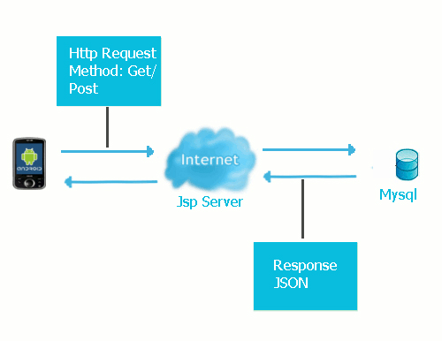

2Project perspective

**Operating Environment**

Software system will operate on Android based mobile devices.

**Hardware Interfaces**

The only hardware required is some Data Cables for the interaction of our programming environment (Java) with the physical device (Android based mobile phone) and data sending or retrieving. This would be a wired interaction where one end of the cable would be connected to the mobile device and the other end with the machine where our programming platform resides**.**

**Software Interfaces**

As the application will be built on Android operating system, so it will definitely use the routines and procedures of the underlying OS. As the implementation of the system will be supported from certain libraries, for certain tasks to be done, the application will certainly interact with those libraries.

**Communication Interfaces**

While implementing the core functionalities the application will requires a working internet connection.

Product functions

Registration -If customer wants to buy the product then he/she must be registered, unregistered user can’t use the application. If a user wants to be a supplier, he should register as a supplier. If a user wants to be a retailer, he should register as a retailer. If a user wants to be a customer, he should register as a customer.

Login- User logins to the system by entering valid user id and password for the shopping. If the user is a supplier or retailer or administrator, he/she is taken to his respective control panel.

Changes to Cart-Changes to cart means the customer after login or registration can make order or cancel order of the product from the shopping cart.

Payment- For customer, retailers the payment method is paypal.

Advertisements- Suppliers and retailers can advertise their virtual shops.

Order Management- Order Management is done from within the application.

Category Management -Categories are distributed in an n-level hierarchy.

Warehouse management- Various warehouses can be managed.

Item Management- Suppliers and retailers can add or delete item according to their will.

User characteristics

**There four types of users**

**Administrator**

**Retailer**

**Supplier**

**Customer**

Administrator has following privileges

ManagingComplaint  
  
a. Shop Complaints- Complaints regarding the various virtual shops are managed by Admin  
b. Item Complaints- Complaints regarding the items sold are managed by admin.  
c. General Complaints- General Complaints regarding any aspect of the application are managed by the admin

Notifications  
a)General Notifications- Admin can send a general notification to any registered user via inbuilt email functionality.  
b)Urgent Notifications- Admin can send an urgent notification to any registered user via inbuilt email functionality. this is usually sent in extreme scenarios.

Customer  
a)Delete Customer- Admin has the privilege to delete any existing customer in case of misconduct.  
b)Restore Customer- The deleted customers can also be restored by the admin.

Retailer   
a)Delete Retailer- Admin has the privilege to delete any existing retailer in case of misconduct.  
  
b)Restore Retailer- The deleted retailers can also be restored by the admin.

Supplier   
a)Delete Supplier- Admin has the privilege to delete any existing supplier in case of misconduct.  
b)Restore Supplier- The deleted suppliers can also be restored by the admin.

Advertisement Pricing Management- Advertisement pricing is set by the administrator. Prices are different for retailers and suppliers and for various categories.

Shop Pricing Management- - Shop pricing is set by the administrator. Prices are different for retailers and suppliers and for various categories.

Category Management- An n-level hierarchy of categories can be set by admin.

Supplier has following privileges:

Advertisement- supplier can add advertisements to promote his products. the advertisement is generated dynamically on the basis of information given by the supplier. The advertisements are available on the retailers homepage.

Category- each supplier can subscribe only to a specific number of advertisements based upon his shop plan. But the supplier can choose which category he wants to subscribe. the supplier can also add sub categories of his subscribed categories.

Item Management-

The privilege to add new items is only with the supplier. While adding the items following things are must:  
a. Item name   
b. Description  
c. Selling price  
d. Discount (can be zero)  
e. Minimum Order  
f. Availabilty in different countries  
g. Batch Discounts (optional)

Order Management- Both sale and purchase orders can be managed from a single place in this application

Retailer has following privileges:

Advertisement-Retailer can add advertisements to promote his products. The advertisement is generated dynamically on the basis of information given by the Retailer. The advertisements are available on the customers homepage.

Category- Each retailer can subscribe only to a specific number of advertisements based upon his shop plan. But the retailer can choose which category he wants to subscribe. The retailer can also add sub categories of his subscribed categories.

Item Management- retailer can only sell items added by the supplier to sell an item he has to subscribe to it first. While subscribing he has to specify the following things:

a. Selling Price

b. Quantity

Order Management- Both sale and purchase orders can be managed from a single place in this application

Constraints

The application will be developed for mobile devices with limited memory and processing power. For an effective working, extensive training on large data sets is required naturally requiring large memory and high processing power. However, since the training phase is offline, it can be carried out on a desktop machine and the learned parameters can be used on the mobile device for recognition of the input textual content.

A working internet connection and business knowledge is required.

Use Case Model/FlowChart/DFDS

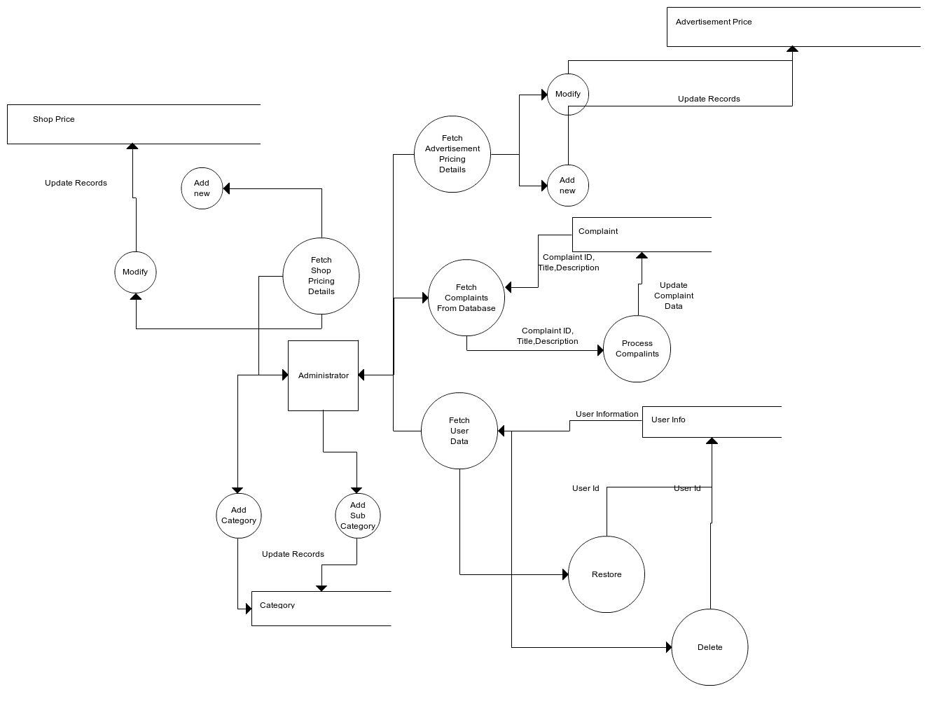

****3**** Administrator

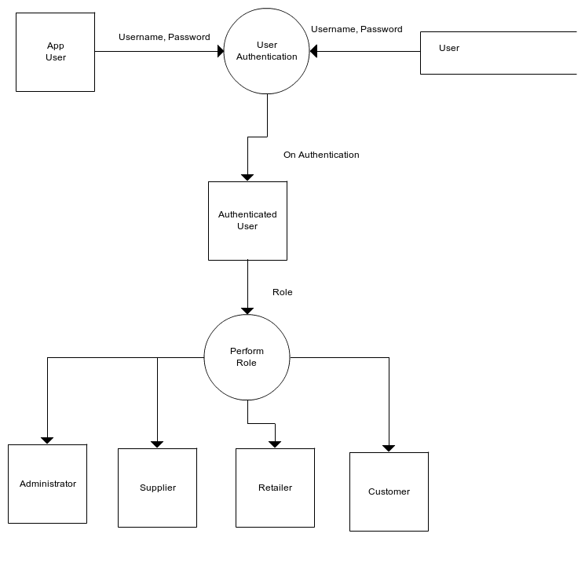

****4**** User Authentication

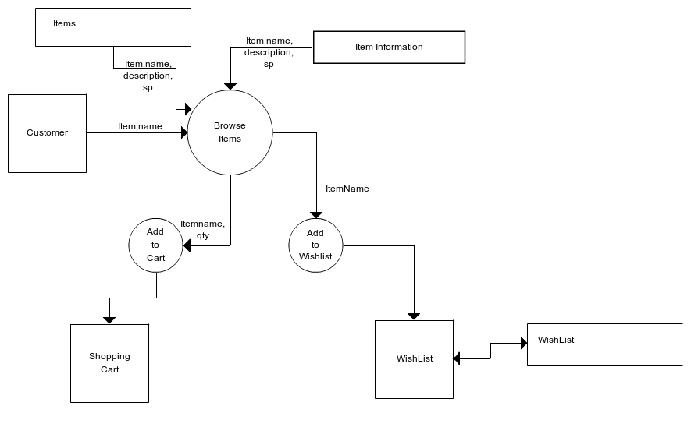

****5**** Customer

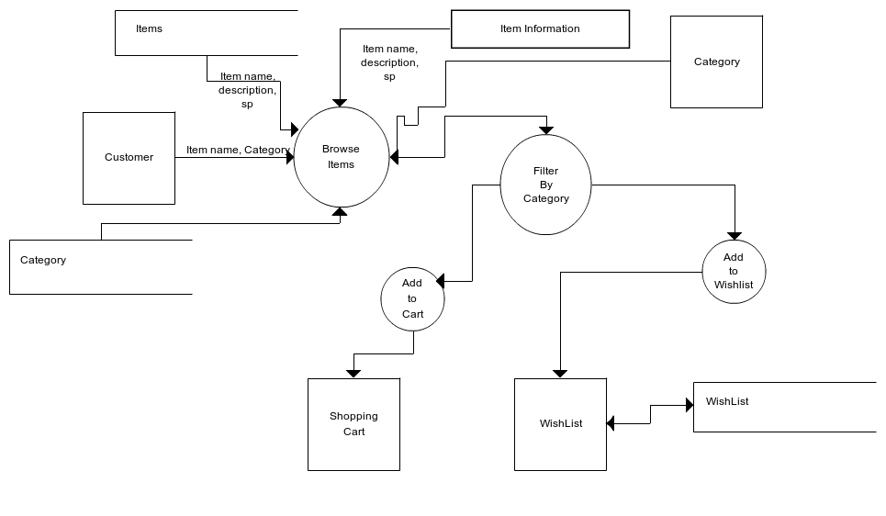

****6**** Customer Detailed

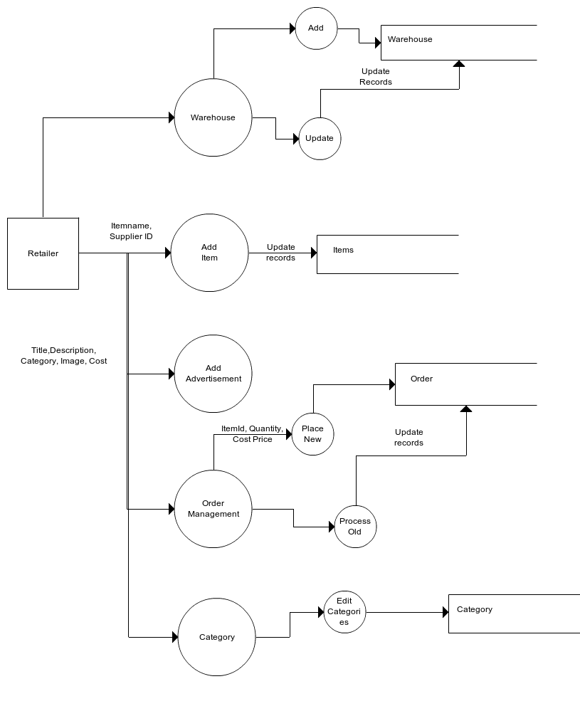

Retailer

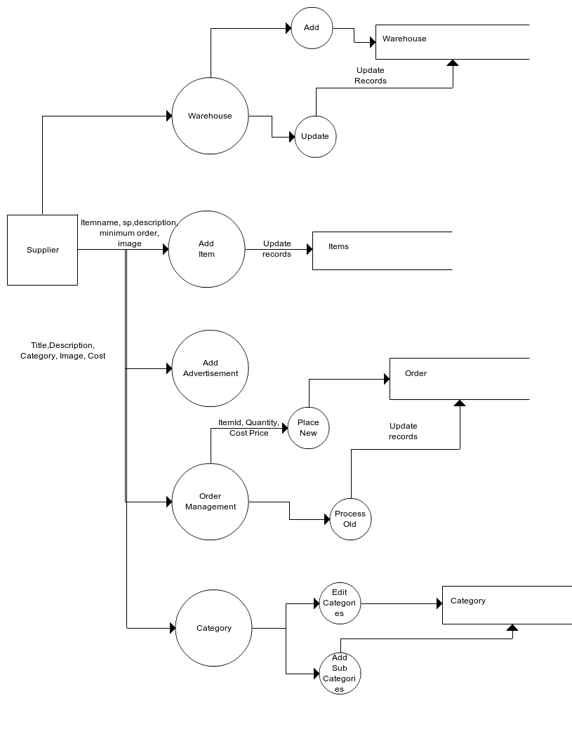

****8**** Supplier

Database design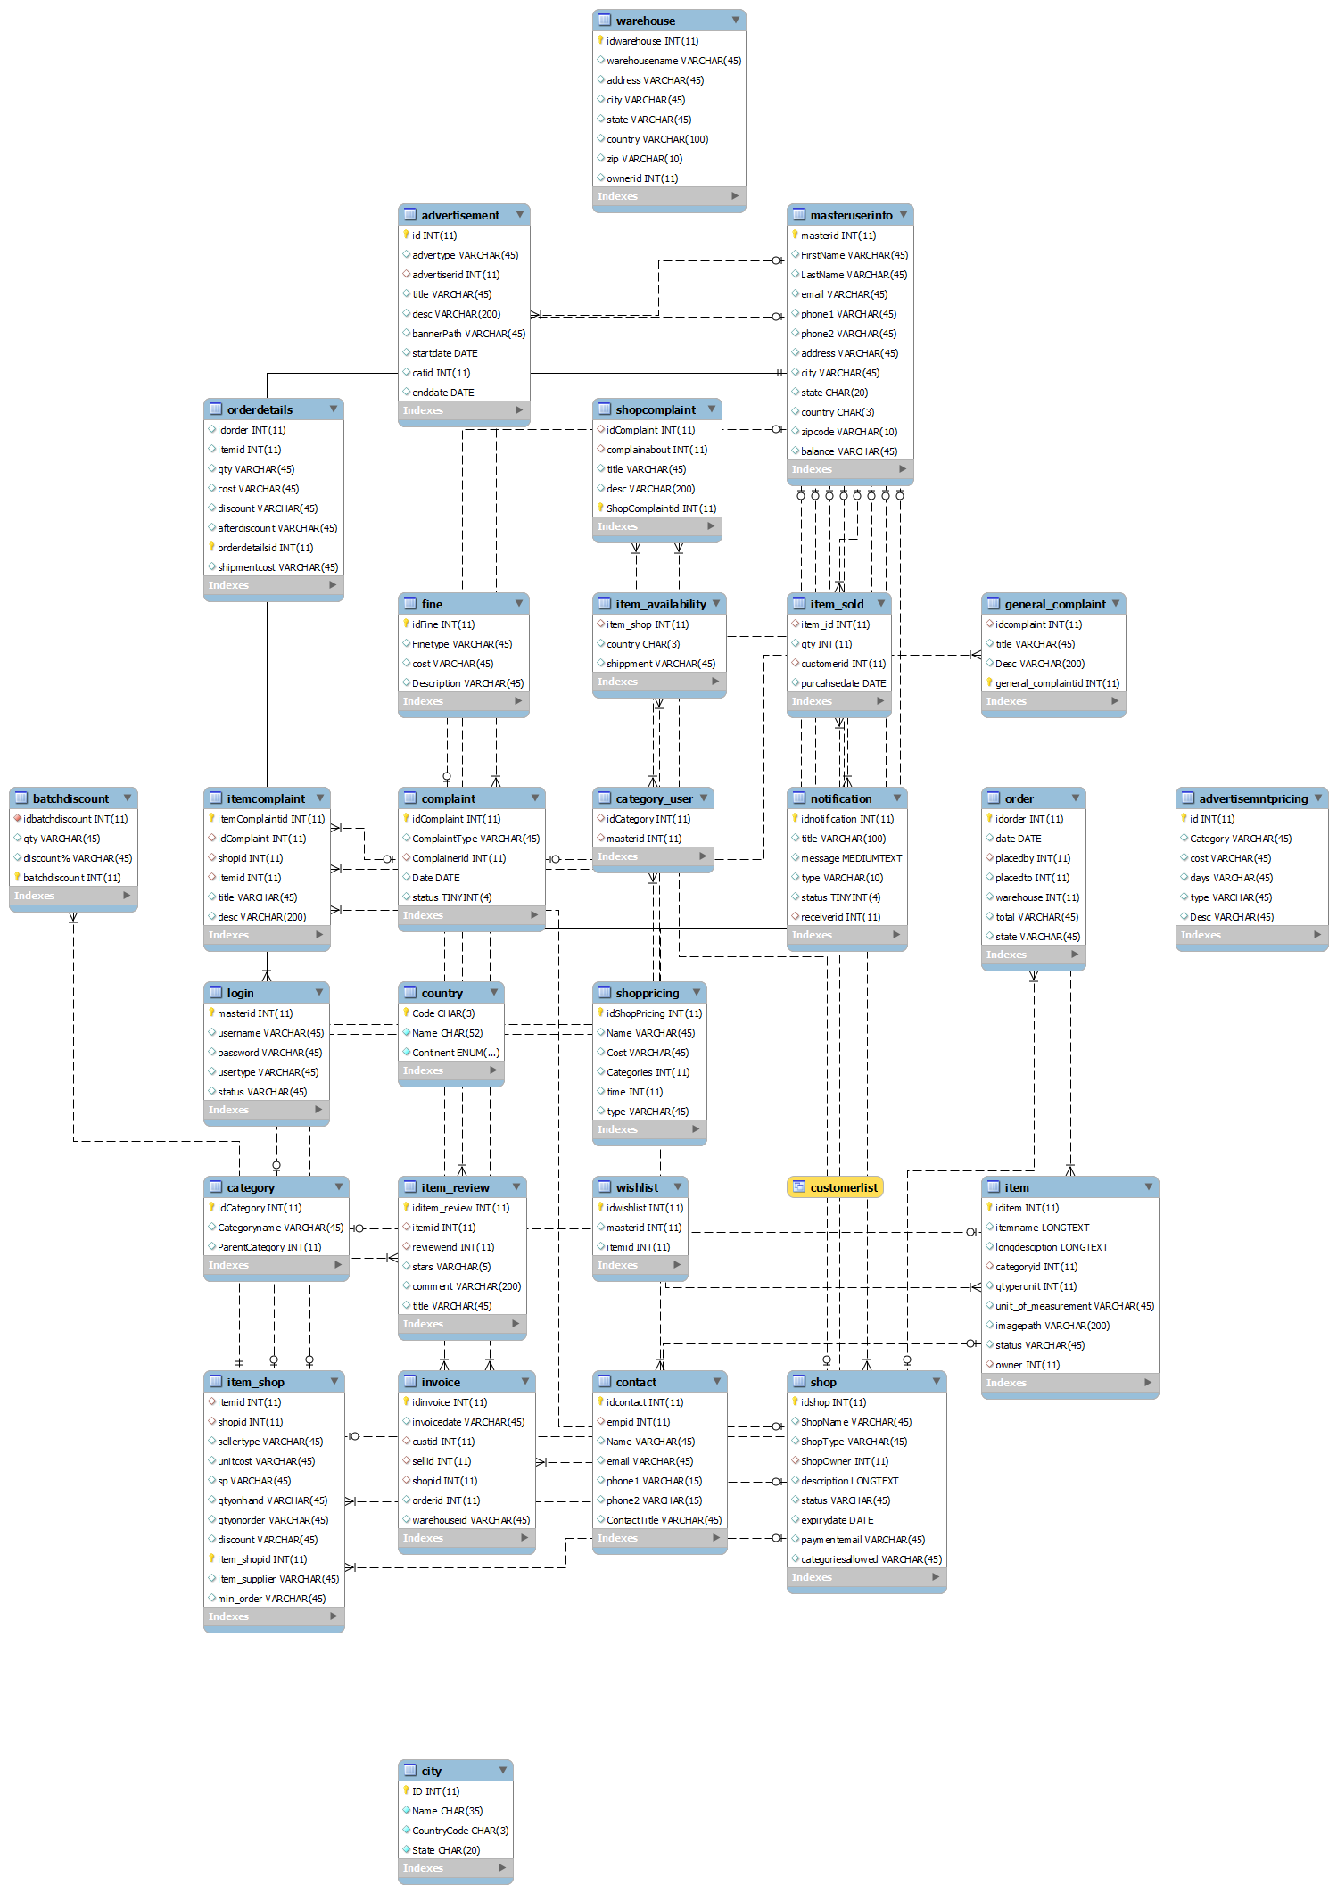

Table Structure

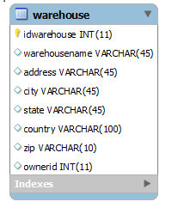

Table Warehouse

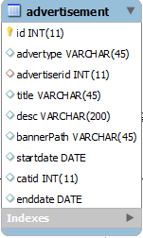

Table Advertisement

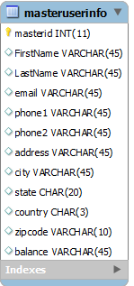

Table MasterUserInfo

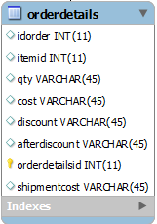

Table Order Details

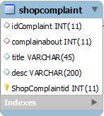

Table Shop Complaint

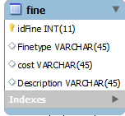

Table Fine

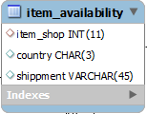

Table Item Availabilty

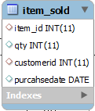

Table Item Sold

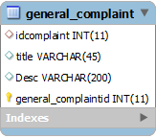

Table General Complaint

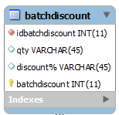

Table Batch Discount

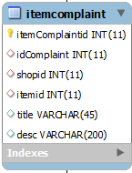

Table Item Complaint

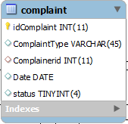

Table Complaint

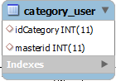

Table Category User

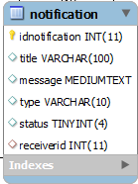

Table Notification

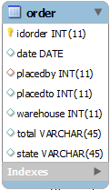

Table Order

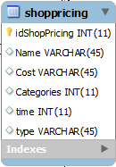

Table Shop Pricing

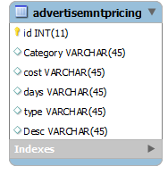

Table Advertisment Pricing

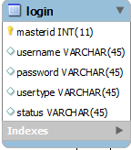

Table Login

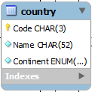

Table Country

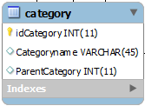

Table Category

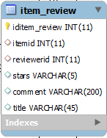

Table Item Review

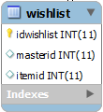

Table Wish List

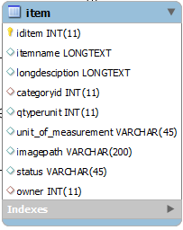

Table Item

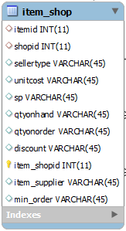

Table Item Shop

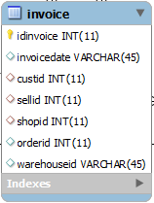

Table Invoice

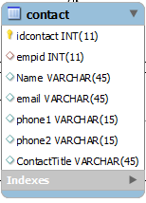

Table Contact

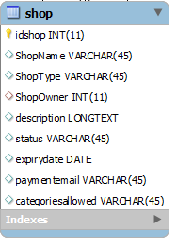

Table Shop

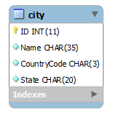

Table City

Assumptions and Dependencies

The project is based on the following assumptions:

* An Android based mobile will be available for deployment of application.
* The application would be developed using Android’s OS architectural model.
* Application would run on required mobile device without integration of any extra hardware.
* We may use some third party components, COTS, to specifically achieve functional or non-functional requirements, as is required.
* Optional components of the project would only be implemented only if the time and required resources are available.
* As now the project scope/core functionalities to achieve have been finalized and approved by the concerned authority, scope may not be further enhanced at any stage during the project construction.

Specific Requirements

External Interface Requirements

User Interfaces

User will have to interact with an Android based mobile phone’s interface while using the software system. The user will navigate to the app utility from the home screen of the mobile.

The interface of the application includes three parts:

Registration Section

Login

Control Panel

All the three components of the application will be placed on a single container holding the three controls for the mentioned functionalities. User will have to move sequentially while using the software . While navigating through the mentioned functionalities if a user goes against the intended behavior which is required from the user, application would generate an error message informing the user about the cause of the error.

Other Nonfunctional Requirements

**Performance Requirements**

For the best performance of the software user must follow the sequence of the activities to achieve the required. While using the software, user’s action must be consistent and unique. Input to the software must be in the required format.

Safety Requirements

While the software is executing a particular task, user must wait for the undergoing task to complete and must not interrupt otherwise the application may crash or output may be affected. Incompatible input or format may also result the crash of complete application or a part of it.

Security Requirements

Mobile applications developed in Android’s platform require proper application security signature and certificate when application is deployed to the market or end user. Usually ‘.apk’ file contains the signature and certified version of the application. Our application also requires the mentioned security and certification requirements.

Software Quality Attributes

Some of the quality attributes identified include:

*\*Portability-in API, portability can be defined as “compatibility of application with platform (Android’s version) upgraded or downgraded versions. In Android’s platform when an up gradation is done, application requires some changes for compatibility with new version. As android’s OS is backward compatible so no changes are required in down gradation.

Maintainability-Whenever there is a change in requirement or bug found, the application will be easily maintainable.

Adaptability-as already mentioned that android OS is backward compatible, for forward compatibility some changes in the implementation are required.

Availability-the application will be available 24/7, provided mobile is in working state and application is configured properly.

Flexibility-the layout/architecture of the application will be flexible enough for some later requirements change or application enhancement.

Usability-the presentational features of the application will be designed user friendly with minimum training required to use the application.

Reliability-the system will be designed to provide maximum reliability.

**Software Components**

* Our project contains following software components:
* Operating Systems
* Linux(Ubuntu)
* Windows XP
* Android OS

**Software Packages**

* Android SDK(Software Development Kit)
* Eclipse IDE(Integrated Development Environment)
* Java

**Hardware Components**

* Our project contains following hardware components:
* Personal Computer(s)
* Mobile Phone Having Android as OS and a 2-4Mpx Camera
* Connecting Cables

Development and Implementation

Introduction to Languages

1. ANDROID

Android is a mobile operating system that is based on a modified version of Linux. It was originally

developed by a startup of the same name, Android, Inc. In 2005, as part of its strategy to enter the

mobile space, Google purchased Android and took over its development work (as well as its development

team).

Google wanted Android to be open and free; hence, most of the Android code was released under

the open-source Apache License, which means that anyone who wants to use Android can do so by

downloading the full Android source code. Moreover, vendors (typically hardware manufacturers)

can add their own proprietary extensions to Android and customize Android to differentiate their

products from others. This simple development model makes Android very attractive and has thus

piqued the interest of many vendors. This has been especially true for companies affected by the phenomenon

of Apple’s iPhone, a hugely successful product that revolutionized the smartphone industry.

Such companies include Motorola and Sony Ericsson, which for many years have been developing

their own mobile operating systems. When the iPhone was launched, many of these manufacturers

had to scramble to find new ways of revitalizing their products. These manufacturers see Android as

a solution — they will continue to design their own hardware and use Android as the operating system

that powers it.

The main advantage of adopting Android is that it offers a unified approach to application development.

Developers need only develop for Android, and their applications should be able to run on numerous

different devices, as long as the devices are powered using Android. In the world of smartphones, applications

are the most important part of the success chain. Device manufacturers therefore see Android

as their best hope to challenge the onslaught of the iPhone, which already commands a large base of applications.

2.JAVA:-

The entire component has been developed using Java technology. Java has been chosen as the platform because of its feature rich nature. The Java Platform provides robust end-to-end solutions for networked applications as well as a trusted standard for embedded applications. So Java was a natural choice for development process.

**Characteristics of Java:-**

* **Object Oriented**:

Java is object oriented to the truest sense of the word. Everything in Java is represented as objects. Variables and methods both are encapsulated

in objects. Java is the purest object-oriented language.

* **Robust**:

Java is a very robust language owing to the following features. Excellent exception handling facilities. Memory management relief for the user. User does not have to worry about allocation and deallocation of memory. Strict compile-time and runtime checks for data types.

* **Portable and Architecture-neutral (Platform Independent):**

Java is portable and platform independent so much that they satisfy “write once;run anywhere, anytime, forever”. This feature is implemented in the following ways:

* Compiler generates machine independent byte-code instructions which can be run on any machine supporting **Java Virtual Machine**.
* Size of primitive data type is machine independent.
* **Multithreaded:**
* Programs can do many things simultaneously using different threads.
* Provides a solution for multiprocess synchronization.
* Allows the creation of networked and interactive programs.
* **Distributed:**
* Open access to remote objects by the use of RMI(Remote Method Invocation).
* Brings a level of abstraction to client/server programming.
* **Secure:**
* Security is achieved by confining a java program to the java execution environment and not allowing access to other parts of the user computer.
* Absence of pointers provides memory related security as encroachment of memory is avoided Proper measures for prevention of viral infection and malicious intent.
* **Dynamic and Extensible:**
* Facilitates linking in of new classes, objects and methods.
* Supports native methods (methods written in other languages like C, C++).
* Programs carry with them a substantial amount of runtime type information that is used to verify and resolve accesses to objects at run-time.
* **High Performance:**

Just-In-Time (JIT) compilers are used to convert byte-code into native machine code resulting in very high performance. These JIT compilers can be used on a real time, piece by piece demand basis to perform on-the-fly compilation of byte-code into native-code.

* **Compilation and Interpretation:**
  + - Java programs are implemented as a two-stage system.
    - Compilation: Source code to byte-code and not machine instructions.
    - Interpretation: Byte-code to machine code (for any system that supports Using JVM). Thus cross-platform programs can be written

|  |  |
| --- | --- |
| Implementation  : Add Avertisement | : Add Batch Order |
| : Pick Item- Add New Item | : Select Category-Add New item |
| : Add Item- Specify Availability | : Add New Item |
| : Place Order-No warehouse found | : Add Sub Category |
| : Add Super Category | : Add Warehouse-Select Country |
| : Add Warehouse | : General Complaint |
| : Advertisement Pricing | : Customer Control Panel |
| : Delete Customer | : Registration Options |
| : Edit My Categories | : General Notifcation |
| : My Items | : My Supplier |
| : Paypal payment | : Add Advertisement- Pick Background |
| : Add Advertisement- Pick Color | : Confirm Payment |
| : Place Order Retailer | : Place order Supplier |
| : Place Order Supplier | : Place Order Retailer |
| : Add Advertisement- Preview | : Restore Customer |
| : Shop Pricing | : Shopping Cart |
| : Sign Up | : Subscribe Item |
| : Supplier Home | : Update Info |
| : View Advertisement Pricing | : View Batch Discount |
| : View Order | : View Order List |
| : Shop Pricing | : View Warehouse |
| : Wishlist |  |

Testing

Software testing is an investigation conducted to provide stakeholders with information about the quality of the product or service under test. Software testing can also provide an objective, independent view of the software to allow the business to appreciate and understand the risks of software implementation. Test techniques include, but are not limited to, the process of executing a program or application with the intent of finding software bugs (errors or other defects).

Software testing can be stated as the process of validating and verifying that a computer program/application/product:

meets the requirements that guided its design and development,

works as expected,

can be implemented with the same characteristics,

and satisfies the needs of stakeholders.

Tests are frequently grouped by where they are added in the software development process, or by the level of specificity of the test. The main levels during the development process as defined by the [SWEBOK](https://en.wikipedia.org/wiki/SWEBOK) guide are unit-, integration-, and system testing that are distinguished by the test target without implying a specific process model.[[30]](https://en.wikipedia.org/wiki/Software_testing#cite_note-Computer.org-30) Other test levels are classified by the testing objective.[[30]](https://en.wikipedia.org/wiki/Software_testing#cite_note-Computer.org-30)

Unit testing

Main article:

Unit testing, also known as component testing, refers to tests that verify the functionality of a specific section of code, usually at the function level. In an object-oriented environment, this is usually at the class level, and the minimal unit tests include the constructors and destructors.[[31]](https://en.wikipedia.org/wiki/Software_testing#cite_note-31)

These types of tests are usually written by developers as they work on code (white-box style), to ensure that the specific function is working as expected. One function might have multiple tests, to catch [corner cases](https://en.wikipedia.org/wiki/Corner_case) or other branches in the code. Unit testing alone cannot verify the functionality of a piece of software, but rather is used to assure that the building blocks the software uses work independently of each other.

Unit testing is a software development process that involves synchronized application of a broad spectrum of defect prevention and detection strategies in order to reduce software development risks, time, and costs. It is performed by the software developer or engineer during the construction phase of the software development lifecycle. Rather than replace traditional QA focuses, it augments it. Unit testing aims to eliminate construction errors before code is promoted to QA; this strategy is intended to increase the quality of the resulting software as well as the efficiency of the overall development and QA process.

Depending on the organization's expectations for software development, unit testing might include [static code analysis](https://en.wikipedia.org/wiki/Static_code_analysis), data flow analysis metrics analysis, peer code reviews, code coverage analysis and other software verification practices.

Integration testing

Integration testing is any type of software testing that seeks to verify the interfaces between components against a software design. Software components may be integrated in an iterative way or all together ("big bang"). Normally the former is considered a better practice since it allows interface issues to be localised more quickly and fixed.

Integration testing works to expose defects in the interfaces and interaction between integrated components (modules). Progressively larger groups of tested software components corresponding to elements of the architectural design are integrated and tested until the software works as a system.

System testing

System testing tests a completely integrated system to verify that it meets its requirements.

In addition, the software testing should ensure that the program, as well as working as expected, does not also destroy or partially corrupt its operating environment or cause other processes within that environment to become inoperative (this includes not corrupting shared memory, not consuming or locking up excessive resources and leaving any parallel processes unharmed by its presence).

Acceptance testing

At last the system is delivered to the user for Acceptance testing.

**Mobile E Commerce can be tested on the basis of following test cases:**

1. Installation Testing:- Mobile E commerce installs on android devices with Android version greater than 8.
2. Compatibility Testing- Mobile E commerce is backward compatible till android version 4 and also forward compatible with latest versions.(Tested upto version 17)
3. Usability testing- Mobile E commerce has been tested on all screen sizes. It works properly without compromising the user interface.
4. Functional testing- All the functional requirements have been thoroughly tested.
5. Non Functional testing-The application has found to be portable and scalable.

CONCLUSIONS & FUTURE SCOPE

CONCLUSIONS

This project that I undertook was truly a very rewarding experience for me in more than one way. It has given a big thrust to my technical knowledge as prospective Software professional. It has also helped me enhance my skills on the personal front.

And I feel extremely satisfied by the fact that I have managed to develop the project . I think I have exploited the opportunity that came my way to the fullest extent by increasing my technical know-how and also gaining the valuable work experience apart from studying the other subjects in our curriculum

Future Scope

* In built Accounting System
* Enhanced Inventory Management System
* Increased Search Filters

References

* <http://developer.android.com/index.html>
* <http://www.vogella.com/>
* <https://developer.paypal.com/>
* <http://www.lynda.com/18E>
* http://thenewboston.org/‎