AI Usage DISCLOSURE FORM

1. Team Details
Team Name: Mozimo
Project / Product Name: AGENTIC_CODE_INTELLIGENCE
Organization / Institution (if any): Thapar Institue of Engineering & Technology
Submission Date: 30 September 2026

2. AI Usage Declaration
Did your team use any Artificial Intelligence (AI) in developing this project? Yes / No
Yes
3. Purpose of AI Usage ( Brief Details)
Idea generation / brainstorming:- To explore pipeline design options
Code generation or assistance:- To implement the retrieval pipeline (query pre-processing, dense recall ensemble, rerank logic)
UI / UX design:- To build the demo web UI (search page, metrics view) for interactively exploring retrieval results
Content creation:- NA
Data analysis:- NA
Testing / debugging:- NA
Other:- NA
4. Feature Origin Classification (Please add/delete based on the number of the feature)
● Feature Name: Multi-pass retrieval pipeline (pre-process → dense recall ensemble → rerank)
Self-Generated/AI-Generated/Both: Both
Description: Designed the pipeline architecture, ensemble weighting logic, and rerank signal selection myself based on tuning-split ablations; used Claude Code to generate the implementation (pipeline.py, encoders.py, preprocess.py). Prompt used: "Implement a dense recall function that encodes queries with two models — jina-code-embeddings-0.5b and Qwen3-Embedding-0.6B — and combines their L2-normalized cosine scores with weights 1.0 and 0.4 via weighted concatenation, running on CPU in float32. Then add a rerank stage over the top-100 candidates that scores program-style agreement, shared-literal IDF overlap, a small BM25 term, and a per-query z-scored hubness penalty, using the weights I've already tuned." Output summary: working Python modules matching the design; modified to fix batch-size handling and add the content-hash embedding cache.
● Feature Name: Lineage grouping / all-versions retrieval (bonus)
Self-Generated/AI-Generated/Both: AI-Generated
Description: Used Claude Code to implement lineage.py — union-find lineage matching (stable key, identical text, cosine + shape-Jaccard threshold) and lineage collapse for all-versions search. Prompt used: "Implement lineage inference across snippet versions using union-find: group snippets that share a stable key (path::symbol#window), have identical text, or have cosine similarity ≥0.9 and shape-Jaccard ≥0.3. Add a collapse function for all-versions search that keeps each lineage's best-matching member and shows the hinted or newest version." Output summary: lineage inference and collapse logic; modified thresholds (0.9 cosine, 0.3 Jaccard) based on evaluation against the evolution benchmark.
● Feature Name: Web demo UI (search + metrics pages)
Self-Generated/AI-Generated/Both: AI-Generated
Description: Used Claude Code to build the frontend (search page, metrics dashboard). Prompt used: "Build a web UI with a search page — pick a library and version (or 'All versions'), paste or select a query, and show the query category, pre-processed text, timing per retrieval pass, and ranked snippets with scores, style match, and shared literals. Add a metrics page showing the APPS, P1, and bonus results." Output summary: functional UI at localhost:8000 showing query category, retrieval passes with timing, and ranked snippets with scores; modified styling and added the "All versions" toggle.
● Feature Name: Tuning & evaluation protocol (contamination-aware proxy-model tuning, ablation design)
Self-Generated/AI-Generated/Both: Self-Generated
Description: Designed the dev-tune/dev-holdout split strategy, identified jina's train-split contamination, and chose Qwen3-Embedding-0.6B as an uncontaminated tuning proxy; decided which ablations to run and how to interpret results.

5. Ethical & Compliance Confirmation
AI usage complies with guidelines and policies. Yes
No proprietary or copyrighted data misused. I Agree

6. Declaration & Sign-Off
Name of Team Representative: Jasleen Kaur
Role: Team Leader
Signature:
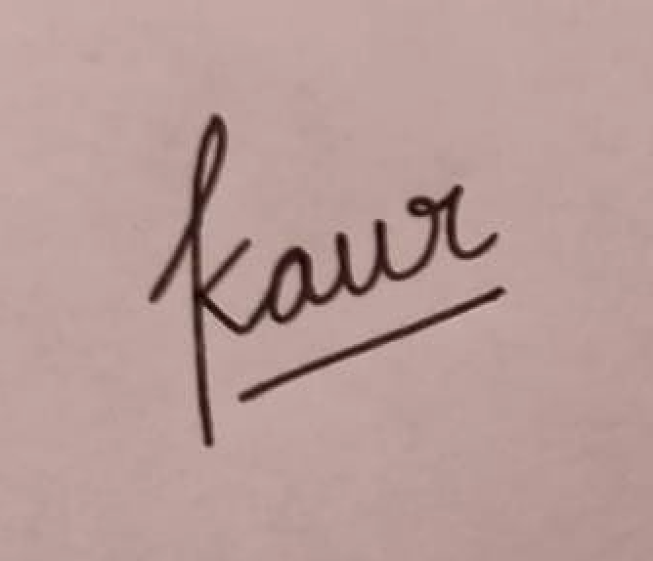
Date: 30/09/26

