**DAILY ONLINE ACTIVITIES SUMMARY**

|  |  |  |  |  |  |  |  |
| --- | --- | --- | --- | --- | --- | --- | --- |
| **Date:** | **20/05/2020** | | | **Name:** | | **JASLINE SHARON TAURO** | |
| **Sem & Sec** | **4th sem, A Section** | | | **USN:** | | **4AL18CS029** | |
| **Online Test Summary** | | | | | | | |
| **Subject** | | **OBJECT ORIENTED CONCEPTS** | | | | | |
| **Max. Marks** | | **30** | | | **Score** | **15** | |
| **Certification Course Summary** | | | | | | | |
| **Course** | **STEPathon-communication skills [ICT ACEDAMY]** | | | | | | |
| **Certificate Provider** | | | **THE HINDU** | | **Duration:3 HRS** | |  |
| **Coding Challenges** | | | | | | | |
| **Problem Statement: 1. Given an array a [] of size n which contains elements from 0 to n-1, write a program print Duplicates which prints the duplicate elements of the given array. If no duplicate element is found print -1. Input: The first line of input must contain an integer n which denotes number of elements of Array. Second line contains n space separated integers denoting elements of array a [].**  **Output: Print the duplicate elements from the given array**  **2.  Write a C Program to Reverse a Linked List (SLL) in groups of given size.** | | | | | | | |
| **Status: DONE** | | | | | | | |
| **Uploaded the report in GitHub** | | | | | **YES** | | |
| **If yes Repository name** | | | | | **1.**[**https://github.com/jaslinesharontauro/lockdown_coding/blob/master/duplicate.java**](https://github.com/jaslinesharontauro/lockdown_coding/blob/master/duplicate.java)  **2.** [**https://github.com/jaslinesharontauro/lockdown_coding/blob/master/Strings.c**](https://github.com/jaslinesharontauro/lockdown_coding/blob/master/Strings.c) | | |
| **Uploaded the report in slack** | | | | | **YES** | | |

**Online Test Details: (Attach the snapshot and briefly write the report for the same)**

**Certification Course Details: (Attach the snapshot and briefly write the report for the same)**

**Coding Challenges Details: (Attach the snapshot and briefly write the report for the same)**

**1.ONLINE TEST DETAILS:**

**Today we had assessment in the subject OBJECT-ORIENTED CONCEPTS. It was based on first module of this subject. There were total 30 number of questions of 1 mark each.**

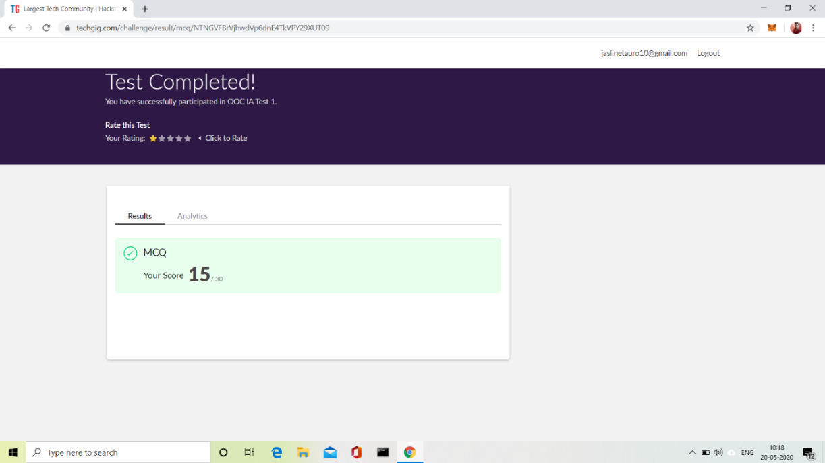

**2.CERTIFICATION COURSE DETAILS:**

**Today I have done 2 certification courses**

* **STEPathon-communication skills [ICT ACEDAMY]:**

**This course based on communication skills. Today I have completed the WEEK TWO- 8 videos. This week two session was consisting of some questions based on our listening, Reading, Writing and Grammar skills.**

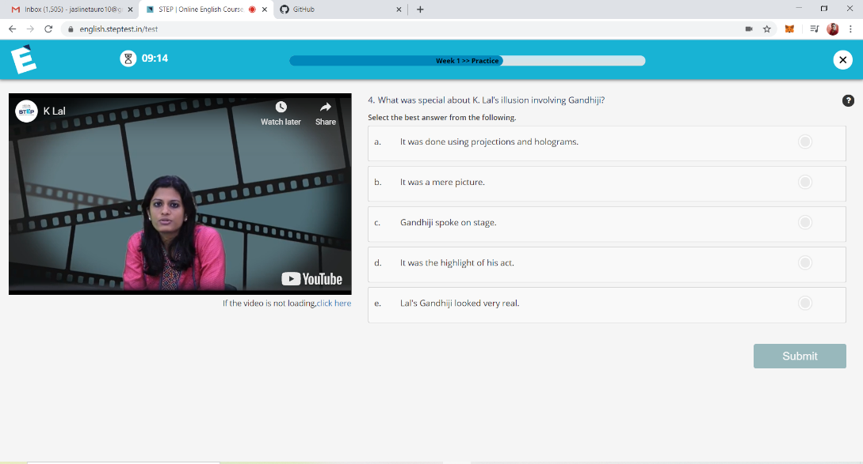

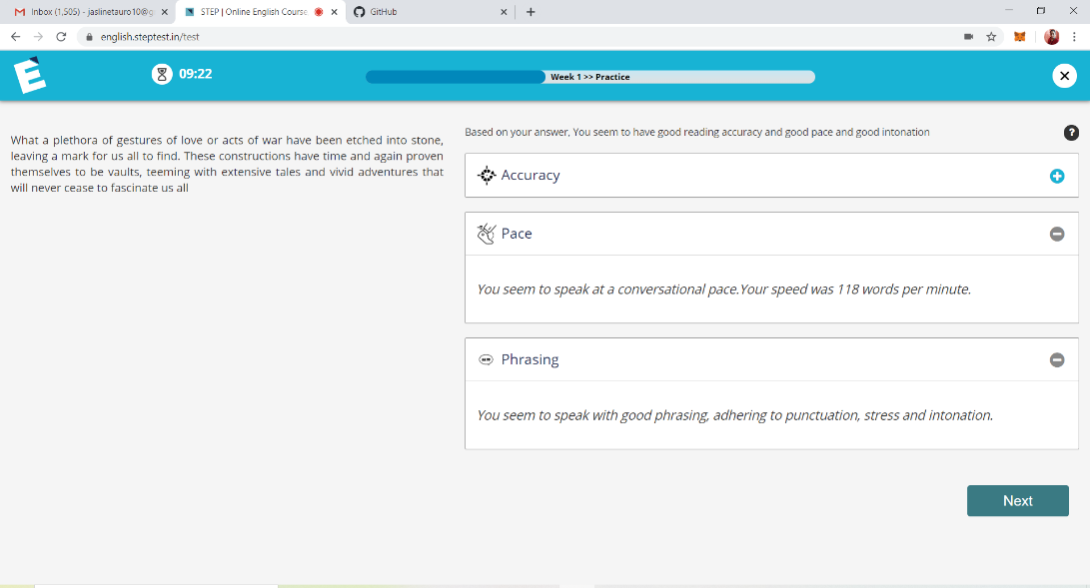

**3.CODING CHALLENGES DETAILS:**

**Problem statement 1:**

**Given an array a [] of size n which contains elements from 0 to n-1, write a program print Duplicates which prints the duplicate elements of the given array. If no duplicate element is found print -1.  
Input:  
The first line of input must contain an integer n which denotes number of elements of Array. Second line contains n space separated integers denoting elements of array a [].**

**Output:  
Print the duplicate elements from the given array**

**Solution: Uploaded it in GitHub**

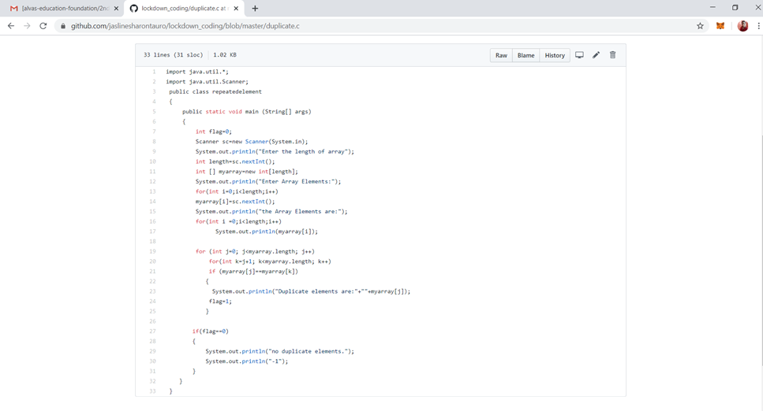

**Problem statement 2:**

**Write a C Program to Reverse a Linked List (SLL) in groups of given size.**

**Test Case 1:  
If a linked list is: 1 → 2 → 3 → 4 → 5 → 6 → 7 → 8  
The value of size k is 2  
Then the linked list looks like: 2 → 1 → 4 → 3 → 6 → 5 → 8 → 7**

**Test Case 2:  
If a linked list is: 1 → 2 → 3 → 4 → 5 → 6 → 7 → 8  
The value of size k is 3  
Then the linked list looks like: 3 → 2 → 1 → 6 → 5 → 4 → 8 → 7**

**Solution: Uploaded it in GitHub**

