REPORT

DATE:18/05/2020

* Today I have started a new certification course that is AWS ALEXA. Which is of AWS organization. It is a part of ICT ACEDEMY Certification course.
* I have completed the module one of this course. Which consist of two chapter

1. Module 1.1: Prerequisite Knowledge - S3
2. [Module 1.2: Prerequisite Knowledge - Lambda](https://awseducate.instructure.com/courses/175/modules/items/3947)

* Module 1.1 consists of some fundamental prerequisite knowledge that is needed before learning Alexa skills.
* 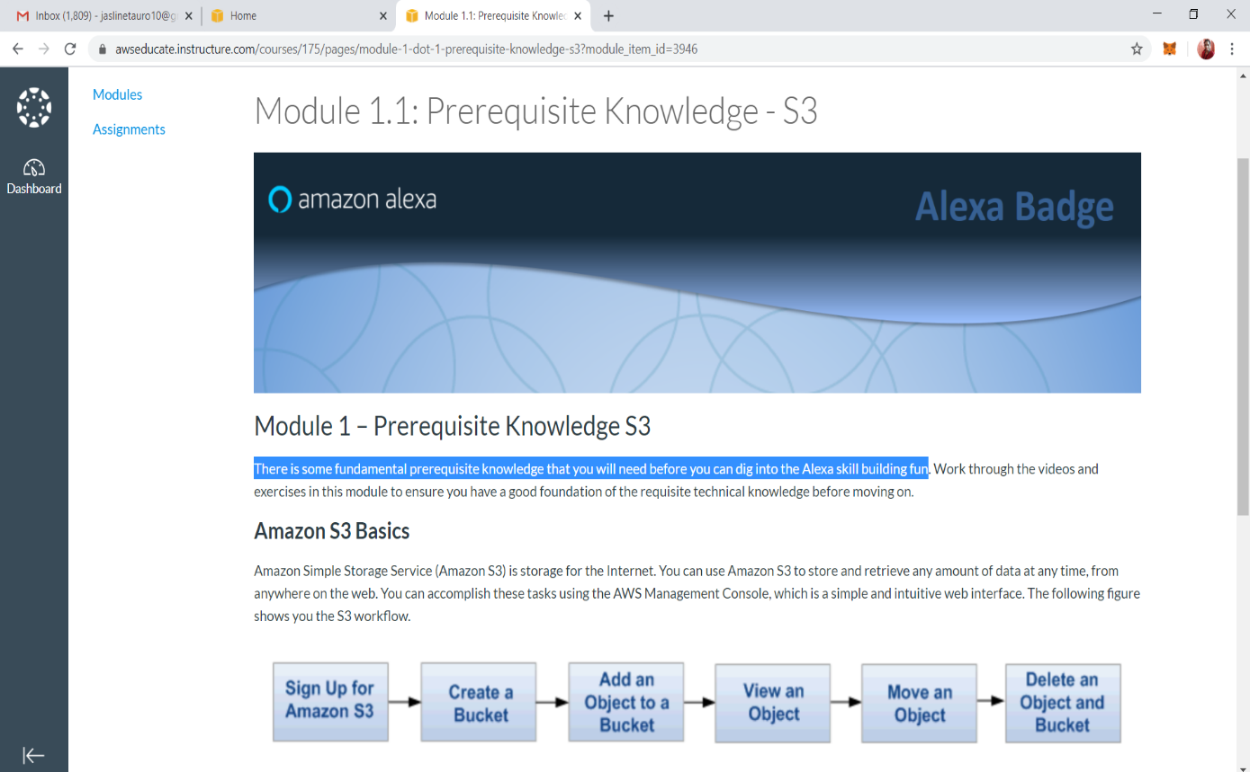

## Module 1.2 consists of some fundamental prerequisite knowledge about Lambda

* After viewing the video, I got to learnt:

1. Amazon Simple Storage Service (Amazon S3) is storage for the Internet.
2. AWS Lambda is a compute service that lets to run code without provisioning or managing servers. AWS Lambda executes the code only when needed and scales automatically, from a few requests per day to thousands per second.

Thank you