**RESUME**

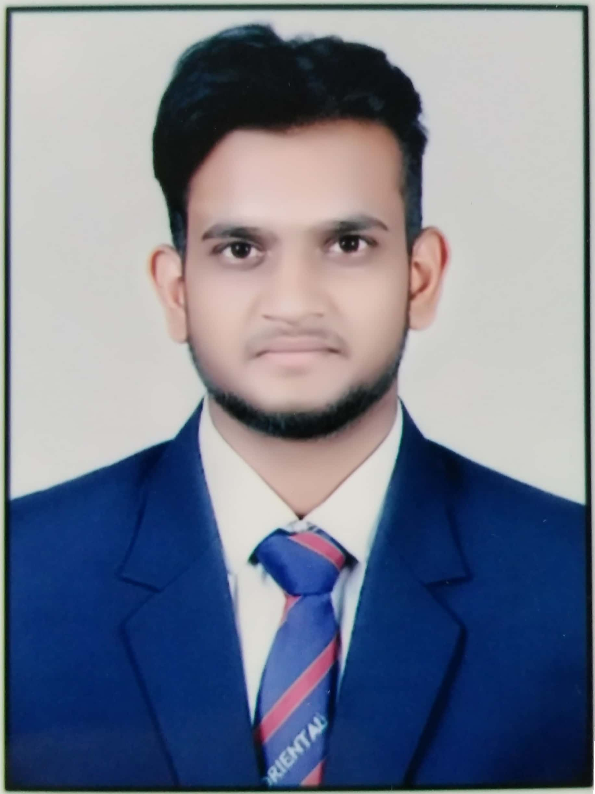

**Pavan Kumar Jain**

**Mobile No.** 8349312393

**Email** – [013pavanjain@gmail.com](mailto:013pavanjain@gmail.com)

**Address** – Kalpana Nagar 434, Bhopal, M.P.

**Career Objective**

**Cc**

Seeking a ***Full Stack* Web Developer** and **Desktop Developer** position with a progressive employer where I can contribute to the development of new technologies and work with the bright and committed people.

**Educational Qualifications**

|  |  |  |  |  |
| --- | --- | --- | --- | --- |
| **Course/Degree** | **Subject** | **Board/University** | **Year of Passing** | **Percentage** |
| B.E. | I.T. | Rajiv Gandhi Proudyogiki Vishwavidyalaya | 2020 | 8.87 cgpa (upto 5th sem) |
| 12th | P.C.M. | C.B.S.E. Board | 2015 | 78.8% |
| 10th | Science | M.P. Board | 2013 | 88.3% |

**Seminar/Conference/Workshop**

* Attended a 3 day workshop on “Ethical Hacking” at Oriental Institute of Science and Technology, Bhopal.
* Attended a 5 day workshop on “Internet of Things” organised by TEQIP at SISTec College under RGPV University.
* Attended various seminars on Cloud Computing, Data Analytics, Machine Learning, Artificial Intelligence.

**Summer Trainings**

* Training on **Web Development** through **PHP** for the duration of one month in June 2018.
* Training on **Web Development** through **PHP** and **NodeJS** for the duration of one month

**Projects**

* Snake Game, Hangman Game developed in **C** and **C++**.
* Audio Player, Text Editor developed in **JavaSE**.
* Supermarket Application, To Do Application, Bus Reservation Portal developed in **PHP**.
* Online Song Streaming Application, Blood Bank Application, Engineering Notes Application developed in **Django,** a web framework of **Python**.

**Technical Skills**

* Programming languages like **C, C++, JavaSE** and **Python**.
* **HTML, CSS, JavaScript, Bootstrap** for frontend web development.
* **PHP** and **Django** (Web framework of **Python**) for backend web development.
* **SQL** for manipulating data in database.

**Achievements**

* Won the 2nd prize in Model Presentation for making “Floor Cleaning Robot” at Oriental Institute of Science and Technology, Bhopal.
* Established IoT Lab at Oriental College of Technology, Bhopal on 12th September, 2018 and have demonstrated various IoT projects.

**Personal Details**

**DOB -** November 13th, 1996

**Languages Known -** Hindi, English

**Hobbies –** Singing, Playing Instruments, Pool Billiards, Travelling, Cooking

**Online** **Portfolio –** pavanportfolio.herokuapp.com

**YouTube Channel –** Scope Programming Pavan Jain

**Strengths**

Determined, Leadership, Consistent, Anxious, Logical, Communication Skill, Creative

**Weakness**

* I am a congenial person.
* I like taking risks.

**Place -** Bhopal