Agent Cost Summary — memory_assistant
Model: gemini-2.5-flash Platform: Vertex AI Agent Engine (GEAP Agent Runtime)
Experiments: EXP-004 (full priced breakdown), EXP-005 (4-run variability)
Cost unit: 1 interaction = 3 user messages across 2 sessions (2 facts + 1 recall) + memory generation; ~5.75 model calls. Not comparable to single-query agents.

1. Architecture
A coordinator with long-term memory delegating to two specialist sub-agents:
- personal_assistant (coordinator) — tool: preload_memory
- └─ prefs_agent → set_unit_preference, convert_temp
- └─ notes_agent → make_checklist
- Memory Bank (auto-wired on deploy) — generate / retrieve / store
- Sessions (managed, persistent) — every turn/event persisted

2. Components / SKUs used
Component | Meter | Capture source
Gemini 2.5 Flash | input/output/cached tokens | usage_metadata
Agent Runtime | vCPU-sec + GiB-sec | Cloud Monitoring allocation_time
Memory Bank — generate | Gemini tokens (server-side) | Monitoring generate_memories_token_count
Memory Bank — retrieve | per retrieval op | Monitoring memory_retrieval_count
Memory Bank — store | per memory / month | export-only
Sessions | per event appended | observed events (approx)

3. How the experiments were run
- Deploy once to Agent Engine; Memory Bank + managed Sessions auto-wire.
- Per run: Session A (2 fact turns) → add_session_to_memory → 20s wait → Session B (recall).
- Capture per-run token usage instantly from usage_metadata.
- Settle ~300s for Monitoring ingestion, then pull runtime + memory_bank metrics (60s alignment).
- Repeat N times (EXP-005: 4 runs, fresh user each) → mean / CV% / min–max per dimension.
- Price every captured quantity × live Billing Catalog rate.
Reproduce: python scripts/exp005_variability.py --runs 4 --settle 300

4. Typical usage & variance
Metric | mean | min–max | CV%
Input tokens | 3397.5 | 2552–4001 | 15.9%
Output tokens (incl. thinking) | 1604.5 | 752–3150 | 57.2%
Model calls | 5.75 | 5–6 | 7.5%
Session events | 11.5 | 10–12 | 7.5%
Model cost ($) | 0.005 | 0.0028856000000000003–0.0090753 | 47.7%
Recall success rate: 100% (function reliable; cost is what varies).
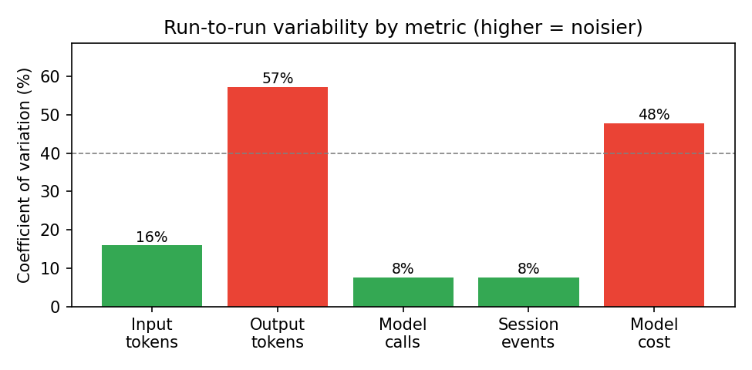
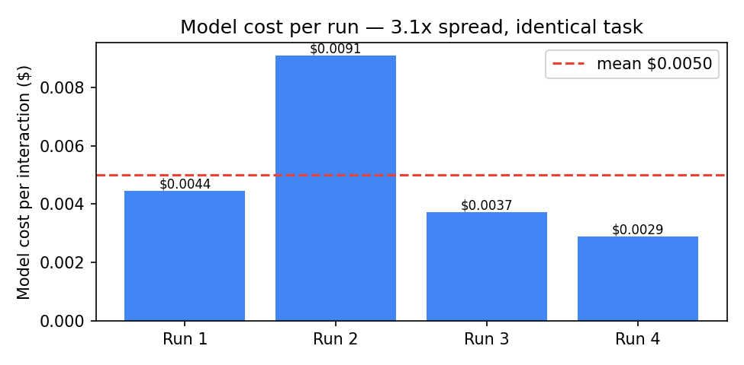
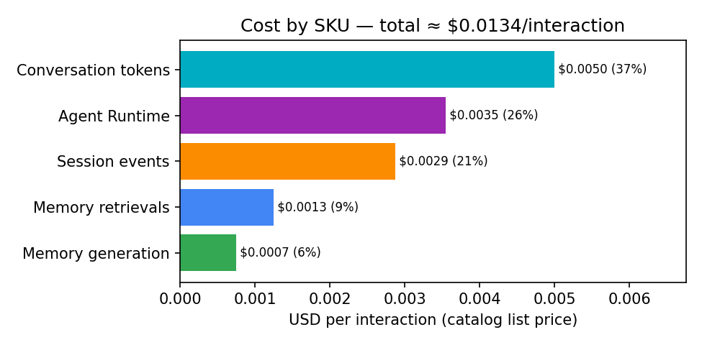

5. Summary
Budget ≈ $0.0134 per interaction at list price, but treat it as a distribution: model-token cost swings ~3.1x run-to-run (CV 48%), driven by output/thinking tokens (CV 57%). Structural usage (model calls, session events, input tokens) is stable (CV 8–16%). Runtime cost is utilization-dependent — pin a queries/hour assumption. For an SLA/quote use the p50–max range, not the mean.

6. Caveats
- Catalog list price, not the project's actual billed rate (needs BigQuery export).
- Memory storage (monthly) and authoritative session-event counts are export-only.
- Cloud Trace (enabled on deploy), Logging, GCS, egress not captured.
- Runtime amortization depends on the measurement window's utilization.

