Visoka škola strukovnih studija za informacione i komunikacione tehnologije u Beogradu

Dokumentacija za sajt
Cocco Magazine
http://jasminasevic.byethost18.com/index.php

Predmet: Web programiranje PHP2
Autor: Jasmina Šević 130/15

Beograd, februar 2019

Sadržaj:

1. Uvod
1.1. Korišćeni programski jezici
1.2. Opis funkcionalnosti
1.3. Template
1.4. Korišćeni CSS
2. Organizacija
2.1. Organizaciona šema
2.2. Mapa sajta
2.3. Stranice
3. Baza podataka
4. Kodovi
4.1. Index.php
4.2. PHP
4.4. AJAX, JS i jQuery

1. Uvod
Sajt je realizovan za potrebe predmeta Web programiranje PHP2 koji se sluša na trećoj godini u Visokoj ICT školi.

1.1. Korišćeni jezici

- PHP
- AJAX
- JavaScript
- jQuery
- HTML5
- CSS3
- BOOTSTRAP

1.2. Opis funkcionalnosti

– Dinamički dropdown meni – realizovan PHP-om. Isti meni se ispisuje i u futeru, s’ tim što je limitiran na 1 nivo.

– Slajder – sastoji se iz 3 slike i 3 kratka opisa koji se učitavaju iz baze. “Read more” button vodi na stranicu koja dinamički prikazuje sve najnovije vesti unete u bazu.

– Dinamički prikaz 6 najnovijih vesti (Home page) ispod slajdera sortiranih po datumu.

– Slajder citati (Home page) – dinamički prikaz citata iz baze.

- Magazin stranica prikazuje izlistane sve tekstove u bazi (galeriju postova). Klikom na tačno određenu kategoriju prikazuju se sve vesti koje pripadaju izabranoj kategoriji.

- Paginacija – implementirana na izlistanim postovima, limitirana na prikaz 3 posta po stranici.

- Klikom na određeni post, otvara se stranica sa tim postom koja se sastoji od slike i teksta. Sa desne strane se prikazuje slika autora teksta i njegova biografija. Klikom na sliku ili ime autora otvara se stranica sa više detalja o autoru. Klikom na “Read all posts” prikazuju se svi postovi koje je taj autor napisao. Ispod dela o autoru, takođe sa desne strane, izlistane su sve kategorije, klikom na naziv kategorije, prikazuje se listing svih postova koji pripadaju toj kategoriji. Ispod kategorija se nalaze “Recent posts” - izlistana 3 najskorije objavljena posta. Ispod sadržaja posta se nalazi “Related posts” deo koji se sastoji od prikaza 2 posta koji su najskorije objavljeni, a pripadaju istoj kategoriji kao i post iznad.

-
– Registracija i logovanje – realizovani PHP-om i AJAX-om. Registracija obuhvata proveru unetih podataka i na klijentskoj i na severskoj strani.

– Kontakt forma – realizovana PHP-om i AJAX-om, takođe obuhvata proveru unetih podataka i na klijentskoj i na severskoj strani.

– Anketa – realizovana upotrebom AJAX-a i PHP-a, moze je videti samo ulogovan korisnik.

– Admin panel – realizovan PHP-om i AJAX-om, moze mu pristupiti samo ulogovan korisnik koji ima ulogu admin-a.

1.3. Template
Za izradu sajta korišćen je free template preuzet sa easetemplate.com, konkretno se može naći na narednom linku: https://easetemplate.com/free-website-templates/nutrition/index.html. Template je dosta izmenjen tokom rada na sajtu, pa će u nastavku biti dat print screen finalne verzije.

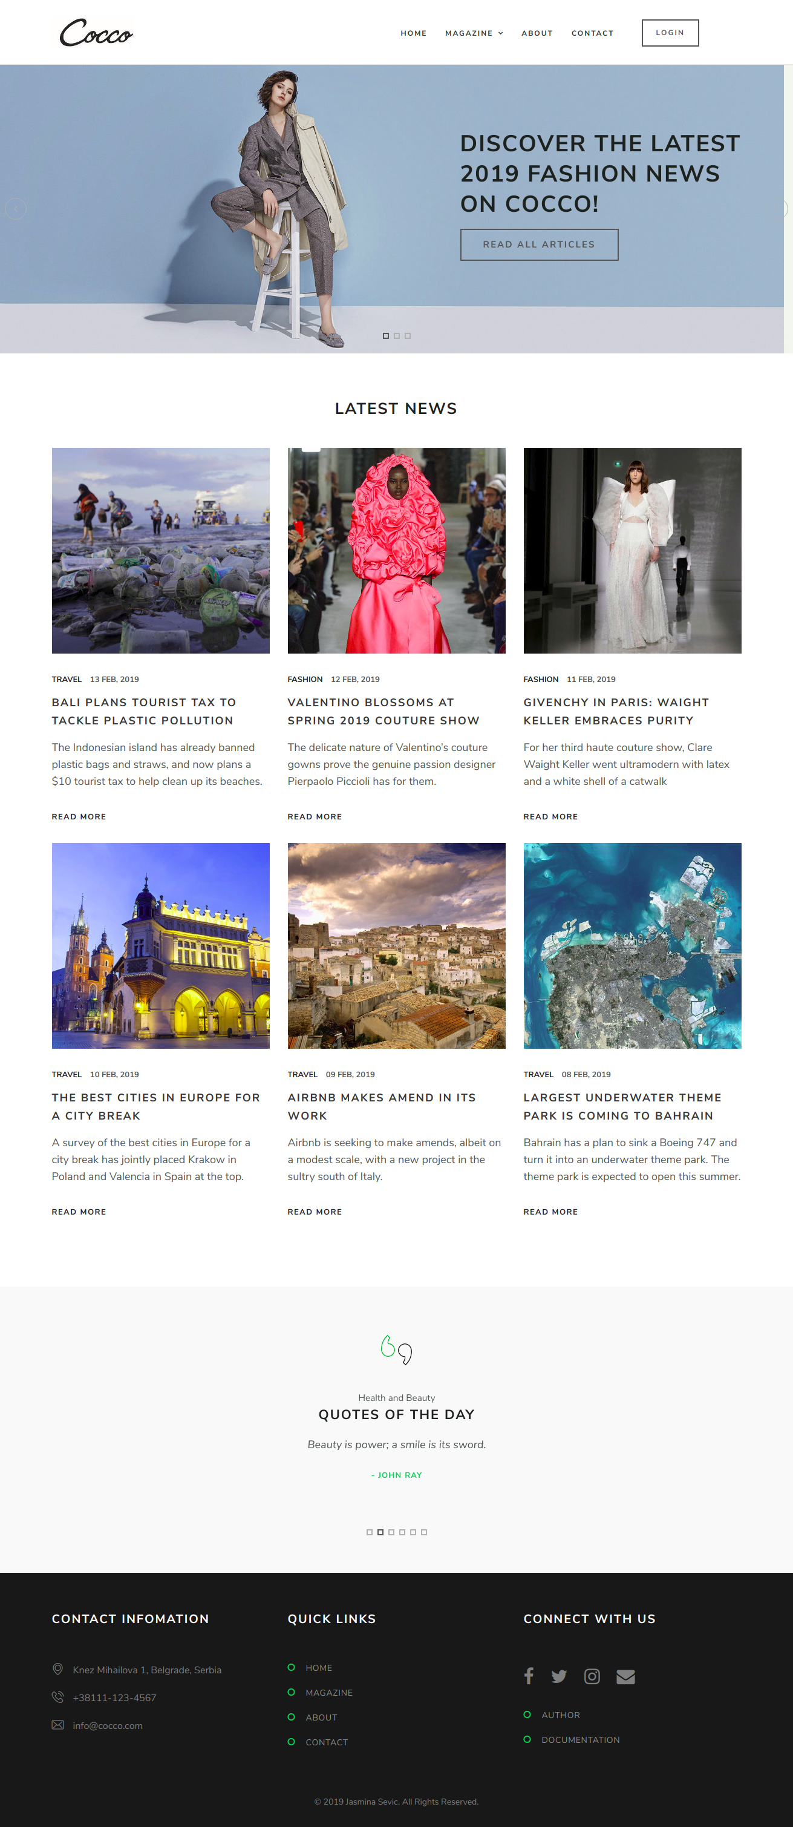

1.4. Korišćeni CSS
CSS kod je preuzet uz template. U nastavku je ovaj kod označen žutom pozadinom.

1.4.1 css/style.default.css
@charset "UTF-8";

/* CSS Document */

/*------------------------------------------------------------------

Template Name: Jessica - Nutritionist Website Template
Version: 1.0.0
Created Date: 9/08/2017
Created by : https://easetemplate.com/

------------------------------------------------------------------
[CSS Table of contents]

1. Body / Typography
2. Form Elements
3. Buttons
4. General / Elements
4.1 Section space
4.2 Margin space
4.3 Padding space
4.4 Background color
4.5 Features
4.7 Call to actions
4.8 Img hover effect
4.9 Icon
-----------------------
5. Header / Navigations
5.1 Header Regular
5.2 Header Transparent
5.3 Navigation Regular
5.4 Page Header

-----------------------
6. Slider
6.1 Slider
-----------------------
7. Content
8. Footers
9. Pages
9.1 Service
9.2 Service Single / sidebar with sidenav
9.3 Testimonial
9.4 Contact us
9.5 Styleguide
9.6 404 error
------------------------------------
10.Blog
10.1 Blog Default
10.2 Blog Single
------------------------------------
11.Sidebar
11.1 Widget
------------------------------------

13. Media Queries

------------------------------------------------------------------*/

/*-----------------------------------
1. Body / Typography
-----------------------------------*/

body { font-family: 'Nunito Sans', sans-serif; font-size: 18px; letter-spacing: 0px; color: #525652; font-weight: 400; line-height: 26px; }
h1, h2, h3, h4, h5, h6 { font-weight: 700; color: #181c18; font-family: 'Nunito Sans', sans-serif; margin: 0px 0px 15px 0px; text-transform: uppercase; letter-spacing: 2px; }
h1 { font-size: 26px; }
h2 { font-size: 22px; line-height: 30px; }
h3 { font-size: 20px; line-height: 34px; }
h4 { font-size: 18px; line-height: 30px; }
h5 { font-size: 16px; line-height: 28px; }
h6 { font-size: 14px; }
p { margin: 0 0 30px; line-height: 1.6; }
p:last-child { margin: 0px; }
ul, ol { list-style: none; margin: 0; padding: 0; }
a { text-decoration: none; color: #181c18; -webkit-transition: all 0.3s; -moz-transition: all 0.3s; transition: all 0.3s; }
a:focus, a:hover { text-decoration: none; color: #52c75a; }
.lead { font-size: 21px; font-weight: 300; line-height: 1.5; font-family: 'PT Serif', serif; color: #52c75a; margin-bottom: 30px; font-style: italic; }
.blockquote { border-bottom: 1px solid #ededed; border-top: 1px solid #ededed; color: #181c18; }
.blockquote-content p { font-family: 'Nunito Sans', sans-serif; color: #181c18; margin-bottom: 15px; margin-top: 15px; line-height: 1.6; font-weight: 400; font-size: 30px; }
.blocquote-author { }
.blockquote-icon { font-size: 30px; color: #52c75a; font-family: FontAwesome; font-style: normal; float: left; margin-right: 15px; margin-top: 8px; }
strong { color: #111; font-weight: 700; margin-right: 8px; }
hr { border-bottom: 1px solid #ededed; margin-bottom: 40px; margin-top: 40px; }

/*-----------------------
2 Form Elements:
-------------------------*/
label { }
.control-label { font-size: 12px; letter-spacing: 1.5px; text-transform: uppercase; color: #9b9a98; }
.form-control:focus { }
.textarea.form-control { }
.required { }
.input-group, .form-group { }
.form-control { font-style: normal; letter-spacing: 1px; border: 0; color: #767a7e; font-size: 12px; font-weight: 600; width: 100%; height: 50px; padding: 10px 0px; line-height: 1.42857143; background-image: none; background-color: transparent; border-radius: 0px; margin-bottom: 10px; -webkit-box-shadow: inset 0 0px 0px rgba(0, 0, 0, .075); box-shadow: inset 0 0px 0px rgba(0, 0, 0, .075); border-bottom: 2px solid #d3d3d3; }
.input-group { position: relative; display: table; border-collapse: separate; }
input[type=checkbox], input[type=radio] { margin: 8px 0 0; margin-top: 1px\9; line-height: normal; }
.input-group-addon { border-radius: 0px; }
input::-webkit-input-placeholder { color: #4d5457 !important; }
textarea::-webkit-input-placeholder { color: #4d5457 !important; }
.input-group-addon { background-color: #eaf0f2; border: 1px solid #eaf0f2; }

/*-------------- align ------------*/

/* =WordPress Core
-------------------------------------------------------------- */

.alignnone { margin: 5px 20px 20px 0; }
.aligncenter, div.aligncenter { display: block; margin: 5px auto 5px auto; }
.alignright { float: right; margin: 0px 0 30px 30px; }
.alignleft { float: left; margin: 0px 30px 0px 0; }
a img.alignright { float: right; margin: 0px 0 30px 30px; }
a img.alignnone { margin: 5px 20px 20px 0; }
a img.alignleft { float: left; margin: 5px 20px 20px 0; }
a img.aligncenter { display: block; margin-left: auto; margin-right: auto; }
.wp-caption { background: #fff; border: 1px solid #f0f0f0; max-width: 96%; /* Image does not overflow the content area */ padding: 5px 3px 10px; text-align: center; }
.wp-caption.alignnone { margin: 5px 20px 20px 0; }
.wp-caption.alignleft { margin: 5px 20px 20px 0; }
.wp-caption.alignright { margin: 5px 0 20px 20px; }
.wp-caption img { border: 0 none; height: auto; margin: 0; max-width: 98.5%; padding: 0; width: auto; }
.wp-caption p.wp-caption-text { font-size: 11px; line-height: 17px; margin: 0; padding: 0 4px 5px; }

/*-----------------------------------
3. Buttons
-----------------------------------*/
.btn { font-family: 'Nunito Sans', sans-serif; font-size: 12px; text-transform: uppercase; font-weight: 700; padding: 12px 22px; margin-bottom: 4px; letter-spacing: 2.2px; border-radius: 0px; border: 2px solid #555555; -webkit-transition: all 0.3s; -moz-transition: all 0.3s; transition: all 0.3s; word-wrap: break-word; white-space: normal !important; }
.btn-primary { background-color: transparent; border: 2px solid #52c75a; color: #52c75a; }
.btn-primary:hover { background-color: #52c75a; border: 2px solid #52c75a; color: #fff; }
.btn-primary.focus, .btn-primary:focus { background-color: #52c75a; border: 2px solid #52c75a; color: #fff; }
.btn-default { background-color: transparent; border: 2px solid #555555; color: #555555; }
.btn-default:hover { background-color: #555555; border: 2px solid #555555; color: #fff; }
.btn-default.focus, .btn-default:focus { background-color: #555555; border: 2px solid #555555; color: #fff; }
.btn-lg { padding: 15px 36px; font-size: 15px; }
.btn-sm { padding: 8px 18px; font-size: 12px; }
.btn-xs { padding: 6px 16px; font-size: 10px; }
.btn-link { color: #181c18; font-size: 13px; font-weight: 700; letter-spacing: 1.5px; text-transform: uppercase; -webkit-transition: all 0.3s; -moz-transition: all 0.3s; transition: all 0.3s; }
.btn-link:hover { color: #52c75a; text-decoration: none; }
button.btn { margin-right: -1px; }

/*-----------------------------------
4. General / Elements
-----------------------------------*/

/*-----------------------
4.1 Section space :
-------------------------*/

/*Note: Section space help to create top bottom space;*/

.space-small { padding-top: 40px; padding-bottom: 40px; }
.space-medium { padding-top: 80px; padding-bottom: 80px; }
.space-large { padding-top: 120px; padding-bottom: 120px; }
.space-ex-large { padding-top: 140px; padding-bottom: 140px; }

/*----------------------
4.2 Margin Space
-----------------------*/
.mr10 { margin-right: 10px; }
.ml5 { margin-left: 5px; }
.mb0 { margin-bottom: 0px; }
.mb10 { margin-bottom: 10px; }
.mb20 { margin-bottom: 20px; }
.mb30 { margin-bottom: 30px; }
.mb35 { margin-bottom: 35px; }
.mb40 { margin-bottom: 40px; }
.mb60 { margin-bottom: 60px; }
.mb80 { margin-bottom: 80px; }
.mb100 { margin-bottom: 100px; }
.mb130 { margin-bottom: 130px; }
.mt0 { margin-top: 0px; }
.mt10 { margin-top: 10px; }
.mt20 { margin-top: 20px; }
.mt30 { margin-top: 30px; }
.mt40 { margin-top: 40px; }
.mt60 { margin-top: 60px; }
.mt70 { margin-top: 70px; }
.mt80 { margin-top: 80px; }
.mt100 { margin-top: 100px; }

/*----- less margin space from top --*/
.mt-20 { margin-top: -20px; }
.mt-40 { margin-top: -40px; }
.mt-60 { margin-top: -60px; }
.mt-80 { margin-top: -80px; }

/*-----------------------
4.3 Padding space
-------------------------*/
.nopadding { padding: 0px; }
.nopr { padding-right: 0px; }
.nopl { padding-left: 0px; }
.pinside10 { padding: 10px; }
.pinside20 { padding: 20px; }
.pinside30 { padding: 30px; }
.pinside40 { padding: 40px; }
.pinside50 { padding: 50px; }
.pinside60 { padding: 60px; }
.pinside80 { padding: 80px; }
.pinside130 { padding: 130px; }
.pdt10 { padding-top: 10px; }
.pdt20 { padding-top: 20px; }
.pdt30 { padding-top: 30px; }
.pdt40 { padding-top: 40px; }
.pdt60 { padding-top: 60px; }
.pdt80 { padding-top: 80px; }
.pdb10 { padding-bottom: 10px; }
.pdb20 { padding-bottom: 20px; }
.pdb30 { padding-bottom: 30px; }
.pdb40 { padding-bottom: 40px; }
.pdb60 { padding-bottom: 60px; }
.pdb80 { padding-bottom: 80px; }
.pdb150 { padding-bottom: 150px; }
.pdl10 { padding-left: 10px; }
.pdl20 { padding-left: 20px; }
.pdl30 { padding-left: 30px; }
.pdl40 { padding-left: 40px; }
.pdl60 { padding-left: 60px; }
.pdl80 { padding-left: 80px; }
.pdr10 { padding-right: 10px; }
.pdr20 { padding-right: 20px; }
.pdr30 { padding-right: 30px; }
.pdr40 { padding-right: 40px; }
.pdr60 { padding-right: 60px; }
.pdr80 { padding-right: 80px; }
.pdtb40 { padding-bottom: 40px; padding-top: 40px; }

/*--------------------------------
4.4 Background & Block color
----------------------------------*/
.bg-light { background-color: #f9f9f9; }
.bg-primary { background-color: #ffe62c; color: #fff; }
.bg-default { }
.bg-white { background-color: #fff; }
.outline { }
.section-title { margin-bottom: 50px; text-align: center; }
.title { color: #333333; }
.small-title { }
.small-text { padding-top: 20px; font-size: 12px; font-weight: 500; text-align: center; }
.text-white { color: #fff; }
.text-black { color: #111; }
.primary-sidebar { }
.secondary-sidebar { }
.well-block { }
.divider-line { }

/*--------------------------------
4.5 Features Block
----------------------------------*/
.feature-block { border: 1px solid #ededed; padding: 30px; margin-bottom: 30px; background-color: #fff; }
.feature-text { }
.feature-title { }
.feature-content { margin-left: 80px; }
.feature-section { }
.feature-icon { font-size: 50px; color: #52c75a; margin-bottom: 30px; float: left; }

/*--------------------------------
4.6 Bullet/arrow
----------------------------------*/
.angle, .arrow { position: relative; font-weight: 400; }
.angle-right li:before { font-family: FontAwesome; display: block; position: absolute; left: 0; font-size: 14px; padding-top: 0px; color: #52c75a; content: "\f10c"; }
.arrow-right li:after { font-family: FontAwesome; display: block; position: absolute; right: 15px; font-size: 14px; padding-top: 0px; color: #52c75a; content: "\f105"; bottom: 20px; }
.chekbox { position: relative; color: #777777; font-weight: 400; line-height: 34px; }
.chekbox li:before { font-family: FontAwesome; display: block; position: absolute; left: 0; font-size: 14px; padding-top: 0px; color: #111111; content: "\f046"; }
.chekbox li { padding-left: 25px; }

/*--------------------------------
4.7 Call to actions
----------------------------------*/
.cta-section { background-color: #25aae1; padding-top: 40px; padding-bottom: 40px; color: #fff; text-align: center; }
.cta-block { }
.cta-text { font-size: 28px; font-style: italic; font-weight: 400; font-family: 'Nunito Sans', sans-serif; margin-bottom: 20px; }
.cta-title { }
.cta-btn { }
.widget-cta-primary { background-color: #25aae1; padding: 30px; border-radius: 5px; color: #fff; margin-bottom: 30px; }
.widget-cta-primary-title { color: #fff; }
.widget-cta-default { background-color: #143575; padding: 30px; border-radius: 5px; color: #fff; margin-bottom: 30px; }
.widget-cta-default-title { color: #fff; }
.widget-cta { background-color: #fff; padding: 30px; border-radius: 5px; border: 1px solid #dfe6ea; margin-bottom: 30px; }
.widget-cta-block { }
.widget-cta-icon { }
.widget-cta-content { }
.widget-cta-title { }
.widget-cta-text { }

/*--------------------------------
4.8 Image Hover Effect
----------------------------------*/
img { width: auto; max-width: 100%; height: auto; margin: 0; padding: 0; border-radius: 0px; line-height: normal; vertical-align: middle; }
.imghover { display: block; position: relative; max-width: 100%; }
.imghover::before, .imghover::after { display: block; position: absolute; content: ""; text-align: center; opacity: 0; }
.imghover::before { top: 0; right: 0; bottom: 0; left: 0; }
.imghover::after { top: 55%; left: 50%; padding: 10px; line-height: 10px; margin: -25px 0 0 -25px; content: "\f061"; font-family: "FontAwesome"; font-size: 30px; }
.imghover:hover::before, .imghover:hover::after { opacity: 1; }
.imghover:hover::before { background-color: rgba(17, 22, 17, 0.60); }
.imghover:hover::after { color: #fff; }

/*--------------------------------
4.9 Icon
----------------------------------*/
.icon { }
.icon-1x { font-size: 18px; }

/* default icon size of font*/
.icon-2x { font-size: 38px; }
.icon-4x { font-size: 65px; }
.icon-6x { font-size: 88px; }
.icon-8x { font-size: 108px; }
.icon-default { color: #aa9144; }
.icon-primary { color: #474954; }
.icon-secondary { color: #fff; }
.icon-white { color: #fff; }

/*--------------------------------
5 Header / Navigations
----------------------------------*/

/*--------------------
5.1 Header Regular
----------------------*/

.header-wrapper { z-index: 9; position: relative; padding-top: 25px; padding-bottom: 25px; background-color: #fff; border-bottom: 1px solid #eaeaea; }
.is-sticky .header-wrapper { }
.header-btn { margin-top: 7px; }

/*--------------------------
5.2 Navigations Regular
----------------------------*/
.hero-section { background: url(../images/hero-img.jpg) no-repeat center; background-size: cover; }
.hero-section-caption { margin-top: 110px; margin-bottom: 110px; background-color: #4d8638; border-radius: 6px; }
.hero-title { color: #fff; font-size: 35px; font-weight: 100; line-height: 45px; margin-bottom: 25px; }
#navigation { float: right; }
#navigation, #navigation ul, #navigation ul li, #navigation ul li a, #navigation #menu-button { margin: 0; padding: 0; border: 0; list-style: none; line-height: 1; display: block; position: relative; -webkit-box-sizing: border-box; -moz-box-sizing: border-box; box-sizing: border-box; }
#navigation:after, #navigation>ul:after { content: "."; display: block; clear: both; visibility: hidden; line-height: 0; height: 0; }
#navigation #menu-button { display: none; }
#navigation { padding-top: 9px; font-family: 'Nunito Sans', sans-serif; -webkit-font-smoothing: antialiased; text-rendering: optimizeLegibility; }
#navigation>ul>li { float: left; }
#navigation.align-center>ul { font-size: 0; text-align: center; }
#navigation.align-center>ul>li { display: inline-block; float: none; }
#navigation.align-center ul ul { text-align: left; }
#navigation.align-right>ul>li { float: right; }
#navigation>ul>li>a { padding: 15px; font-size: 12px; color: #292f29; letter-spacing: 2px; text-decoration: none; font-weight: 700; text-transform: uppercase; }
#navigation>ul>li:hover>a { color: #52c75a; background-color: transparent; }
#navigation>ul>li.has-sub>a { padding-right: 32px; }

/*#navigation>ul>li>a:after {
position: absolute;
top: 16px;
right: -3px;
height: 2px;
display: block;
content: '/';
}
*/
#navigation>ul>li.has-sub>a:before { position: absolute; right: 14px; font-family: FontAwesome; content: "\f107"; -webkit-transition: all .25s ease; -moz-transition: all .25s ease; -ms-transition: all .25s ease; -o-transition: all .25s ease; transition: all .25s ease; }

/*#navigation > ul > li.has-sub:hover > a:before {
top: 23px;
height: 0;
}*/
#navigation ul ul { position: absolute; left: -9999px; }
#navigation.align-right ul ul { text-align: right; }
#navigation ul ul li { top: 30px; height: 0; -webkit-transition: all .25s ease; -moz-transition: all .25s ease; -ms-transition: all .25s ease; -o-transition: all .25s ease; transition: all .25s ease; }
#navigation li:hover>ul { left: auto; }
#navigation.align-right li:hover>ul { left: auto; right: 0; }
#navigation li:hover>ul>li { height: 41px; }
#navigation ul ul ul { margin-left: 100%; top: 0; }
#navigation.align-right ul ul ul { margin-left: 0; margin-right: 100%; }
#navigation ul ul li a { background-color: #292f29; padding: 14px 22px; width: 218px; font-size: 12px; text-decoration: none; color: #fff; font-weight: 700; text-transform: uppercase; border-bottom: #383e38 1px solid; letter-spacing: 1.2px; }
#navigation ul ul li:first-child>a { border-top-right-radius: 0px; }
#navigation ul ul li:last-child>a { border-bottom-right-radius: 0px; border-bottom-left-radius: 0px; }
#navigation ul ul li:last-child>a, #navigation ul ul li.last-item>a { border-bottom: 0; }
#navigation ul ul li:hover>a, #navigation ul ul li a:hover { color: #fff; background-color: #383e38; }
#navigation ul ul li.has-sub>a:after { position: absolute; top: 16px; right: 11px; width: 8px; height: 2px; display: block; background: #dddddd; content: ''; }
#navigation.align-right ul ul li.has-sub>a:after { right: auto; left: 11px; }
#navigation ul ul li.has-sub>a:before { position: absolute; top: 13px; right: 14px; display: block; width: 2px; height: 8px; background: #dddddd; content: ''; -webkit-transition: all .25s ease; -moz-transition: all .25s ease; -ms-transition: all .25s ease; -o-transition: all .25s ease; transition: all .25s ease; }
#navigation.align-right ul ul li.has-sub>a:before { right: auto; left: 14px; }
#navigation ul ul>li.has-sub:hover>a:before { top: 17px; height: 0; }
#navigation.small-screen { width: 100%; }
#navigation.small-screen ul { width: 100%; display: none; }
#navigation.small-screen.align-center>ul { text-align: left; }
#navigation.small-screen ul li { width: 100%; border-top: 1px solid #383e38; top: auto; color: #fff; background: #383e38; }
#navigation.small-screen ul ul li, #navigation.small-screen li:hover>ul>li { height: auto; }
#navigation.small-screen ul li a, #navigation.small-screen ul ul li a { width: 100%; border-bottom: 0; padding: 20px 15px; color: #cccfcc; background-color: #292f29; }
#navigation.small-screen>ul>li>a:after { position: absolute; top: 16px; right: -3px; height: 2px; display: block; content: ''; }
#navigation.small-screen>ul>li { float: none; }
#navigation.small-screen ul ul li a { padding-left: 25px; }
#navigation.small-screen ul ul ul li a { padding-left: 35px; }
#navigation.small-screen ul ul li a { color: #fff; background: #292f29; }
#navigation.small-screen ul ul li:hover>a, #navigation.small-screen ul ul li.active>a { color: #fff; background-color: #383e38; }
#navigation.small-screen ul ul, #navigation.small-screen ul ul ul, #navigation.small-screen.align-right ul ul { position: relative; left: 0; width: 100%; margin: 0; text-align: left; }
#navigation.small-screen>ul>li.has-sub>a:after, #navigation.small-screen>ul>li.has-sub>a:before, #navigation.small-screen ul ul>li.has-sub>a:after, #navigation.small-screen ul ul>li.has-sub>a:before { display: none; }
#navigation.small-screen #menu-button { display: block; padding: 18px; color: #fff; cursor: pointer; font-size: 12px; text-transform: uppercase; font-weight: 600; background-color: #292f29; margin-top: 15px; }
#navigation.small-screen #menu-button:after { position: absolute; top: 16px; right: 17px; display: block; height: 12px; width: 20px; border-top: 2px solid #fff; border-bottom: 2px solid #fff; content: ''; }
#navigation.small-screen #menu-button:before { position: absolute; top: 21px; right: 17px; display: block; height: 2px; width: 20px; background: #fff; content: ''; }
#navigation.small-screen #menu-button.menu-opened:after { top: 20px; border: 0; height: 2px; width: 15px; background: #fff; -webkit-transform: rotate(45deg); -moz-transform: rotate(45deg); -ms-transform: rotate(45deg); -o-transform: rotate(45deg); transform: rotate(45deg); }
#navigation.small-screen #menu-button.menu-opened:before { top: 20px; background: #fff; width: 15px; -webkit-transform: rotate(-45deg); -moz-transform: rotate(-45deg); -ms-transform: rotate(-45deg); -o-transform: rotate(-45deg); transform: rotate(-45deg); }
#navigation.small-screen .submenu-button { position: absolute; z-index: 99; right: 0; top: 0; display: block; border-left: 1px solid #383e38; height: 54px; width: 53px; cursor: pointer; }
#navigation.small-screen .submenu-button.submenu-opened { }
#navigation.small-screen ul ul .submenu-button { height: 34px; width: 34px; }
#navigation.small-screen .submenu-button:after { position: absolute; top: 25px; right: 20px; width: 8px; height: 2px; display: block; background: #fff; content: ''; }
#navigation.small-screen ul ul .submenu-button:after { top: 15px; right: 13px; }
#navigation.small-screen .submenu-button.submenu-opened:after { background:; }
#navigation.small-screen .submenu-button:before { position: absolute; top: 22px; right: 23px; display: block; width: 2px; height: 8px; background: #fff; content: ''; }
#navigation.small-screen ul ul .submenu-button:before { top: 12px; right: 16px; }
#navigation.small-screen .submenu-button.submenu-opened:before { display: none; }
#navigation.small-screen.select-list { padding: 5px; }

/*----------------------------------------------
5.4 Page Header
----------------------------------------------*/
.page-header { background-color: #f2f2f2; background-size: cover; margin: 0px; padding: 0px; border: 0px; }
.page-section { padding-top: 120px; padding-bottom: 120px; }
.page-description { }
.page-description p { }
.page-title { font-size: 30px; font-weight: 600; margin-bottom: 10px; color: #181c18; text-transform: uppercase; letter-spacing: 1px; }
.page-header p { color: #464e47; font-family: 'PT Serif', serif; font-size: 18px; font-style: italic; }
.page-breadcrumb { padding-top: 3px; color: #b5b5b5; }
.page-breadcrumb .breadcrumb { background-color: transparent; padding: 5px 0px; margin-bottom: 0px; font-size: 13px; font-weight: 600; border: none; letter-spacing: 0.5px; text-transform: uppercase; color: #b5b5b5; }
.breadcrumb>li+li:before { padding: 0 5px; color: #b5b5b5; content: "/\00a0"; }
.breadcrumb>li>a { color: #52c75a; }

/*-----------------------------------
6. Slider
-------------------------------------*/
.slider { margin-bottom: -30px; height: auto; }

/*
.slider-img {
background: -moz-linear-gradient(top, rgba(11, 12, 13, 0.6) 0%, rgba(11, 12, 13, 0.6) 100%);
background: -webkit-linear-gradient(top, rgba(11, 12, 13, 0.6) 0%, rgba(11, 12, 13, 0.6) 100%);
background: linear-gradient(to bottom, rgba(11, 12, 13, 0.6) 0%, rgba(11, 12, 13, 0.6) 100%);
filter: progid:DXImageTransform.Microsoft.gradient(startColorstr='#cc1b2429', endColorstr='#cc1b2429', GradientType=0);
position: relative;
}
*/
.slider-img img { position: relative; z-index: -1; }
.slider-captions { position: absolute; bottom: 150px; width: 100%; color: #fff; }
.slider-title { color: #181c18; font-size: 38px; font-weight: 700; letter-spacing: 2px; line-height: 50px; }
.slider-text { color: #181c18; font-weight: 700; letter-spacing: 1px; }
.slider .owl-dots { text-align: center !important; position: relative; bottom: 40px; }
.slider .owl-nav { text-align: center; }
.slider .owl-nav .owl-prev { position: absolute; top: 42%; left: 0px; color: #b3b3b3; font-size: 18px; margin: 8px; padding-top: 4px; background: transparent; display: block; cursor: pointer; border-radius: 50px; height: 36px; width: 36px; border: 1px solid #b3b3b3; }
.slider .owl-nav .owl-next { position: absolute; top: 42%; right: 0px; color: #b3b3b3; font-size: 18px; margin: 8px; padding-top: 4px; background: transparent; display: block; cursor: pointer; border-radius: 50px; height: 36px; width: 36px; border: 1px solid #b3b3b3; }
.slider .owl-nav .owl-prev:hover { background-color: transparent; border: 2px solid #52c75a; text-decoration: none; color: #52c75a; }
.slider .owl-nav .owl-next:hover { background-color: transparent; border: 2px solid #52c75a; text-decoration: none; color: #52c75a; }
.slider .owl-dots .owl-dot { display: inline-block; zoom: 1; }
.slider .owl-dots .owl-dot span { width: 10px; height: 10px; margin: 5px 4px; background: transparent; border-radius: 0px; border: 2px solid #b3b3b3; display: block; -webkit-backface-visibility: visible; transition: opacity 200ms ease; }
.slider .owl-dots .owl-dot.active span, .owl-theme .owl-dots .owl-dot:hover span { background-color: transparent; border: 2px solid #555555; }
.slider .owl-carousel .owl-item img { width: 100%; }
.slider-profile { position: absolute; bottom: 8px; }
.profile { bottom: -20px; position: absolute; }
.profile img { border-radius: 50%; margin-bottom: 30px; position: relative; }
.back-pic { background-color: #ebebeb; height: 548px; width: 385px; border-radius: 50%; transform: rotate(-140deg); }

/*-----------------------------------
7. before after gallery
-------------------------------------*/
.ba-gallery { }
.left-btn, .right-btn { }
.ba-left-btn { }
.ba-right-btn { }

/*-----------------------------------
8. Footer
-------------------------------------*/
.footer { background-color: #111111; padding-top: 60px; padding-bottom: 30px; color: #808080; font-weight: 400; }
.footer-title { margin-bottom: 55px; color: #fff; }
.footer-widget { margin-bottom: 30px; }
.footer-widget ul { margin-bottom: 25px; }
.footer-widget ul li { line-height: 1; margin-bottom: 18px; font-size: 16px; margin-top: 25px; }
.footer-widget ul li a { font-size: 14px; color: #8e918e; text-transform: uppercase; letter-spacing: .75px; font-weight: 400; margin-left: 30px; margin-top: 1px; }
.footer-widget ul li a:hover { color: #a5d897; }
.footer-widget ul li i { margin-right: 15px; color: #808080; font-size: 20px; }
.footer-widget .form-control { color: #808080; background-color: transparent; border-bottom: 1px solid #808080; border-radius: 0px; margin-top: -10px; }
.footer-social { margin-top: 50px; }
.footer-social a span { font-size: 40px; padding-right: 12px; color: #58595a; }
.footer-social a span:hover { color: #a5d897; }

/*-------------- tiny footer ------------*/
.tiny-footer { margin-top: 50px; font-size: 14px; color: #808080; text-align: center; }

/*-----------------------------------
9. Pages
-------------------------------------*/

/*-------------------------
9.1 About us
---------------------------*/

.about-section { padding-bottom: 55px; padding-top: 55px; }
.about-title { border-bottom: 1px solid #ededed; margin-bottom: 25px; padding-bottom: 10px; }
.about-img img { border-radius: 5px; position: relative; }
.about-icon { }
.build-pic { }
.about-btn { margin-top: -130px; }
.about-list { }
.about-list ul { }
.about-list ul li { padding-left: 20px; margin-bottom: 20px; }
.about-list ul li:before { }
.gallery-slider-carousel { margin-bottom: 80px; }
.gallery-slider-carousel .owl-dots { text-align: center !important; position: relative; bottom: -20px; }
.gallery-slider-carousel .owl-nav { display: none; }
.gallery-slider-carousel .owl-nav .owl-prev { }
.gallery-slider-carousel.owl-nav .owl-next { }
.gallery-slider-carousel .owl-nav .owl-prev, .owl-nav .owl-next:hover { }
.gallery-slider-carousel.owl-dots .owl-dot { display: inline-block; zoom: 1; }
.gallery-slider-carousel .owl-dots .owl-dot span { }
.gallery-slider-carousel .owl-dots .owl-dot.active span, .owl-theme .owl-dots .owl-dot:hover span { }
.gallery-slider-carousel .owl-carousel .owl-item img { }
.play-btn { position: absolute; bottom: 40%; left: 40%; }
.play-link { position: absolute; bottom: 5%; left: 30%; color: #fff; }

/*-------------------------
9.2 Service / single / sidebar
--------------------------*/
.service-block { margin-bottom: 30px; }
.service-content { margin-top: 30px; }
.service-img img { }
.service-list { }
.service-list ul { margin-bottom: 30px; }
.service-list ul li { margin-left: 20px; line-height: 28px; }

/*----------------- Gallery Wide ---------------*/
.gallery-thumbnail img { width: 100%; }
.gallery-img img { width: 100%; }
.gallery-block { }

/*-----------------------------------------
service side-nav
------------------------------------------*/
.sidenav { margin-bottom: 30px; border-radius: 0px; }
.sidenav ul li { position: relative; font-weight: 600; }
.sidenav ul li a { display: block; color: #181c18; font-size: 13px; font-weight: 700; letter-spacing: 1.2px; padding: 20px 10px 20px 0px; text-transform: uppercase; border-bottom: 1px solid #ededed; }
.sidenav ul li a:hover { color: #52c75a; }
.sidenav ul li.active a { color: #52c75a; border-bottom: 1px solid #52c75a; }
.sidenav ul li.active a:before { color: #52c75a; border-bottom: 1px solid #52c75a; }
.sidenav a:focus, a:active { background-color: transparent; border-bottom: 1px solid #52c75a; }

/*-----------------------------------------
Diet-plan
------------------------------------------*/
.plan-block { border: 1px solid #ededed; padding: 40px; margin-bottom: 30px; }
.plan-header { border-bottom: 1px solid #ededed; margin-bottom: 40px; position: relative; }
.plan-price { padding-right: 0px; position: absolute; bottom: 8px; right: 0; font-size: 30px; color: #52c75a; }
.plan-content { }
.plan-content ul { margin-bottom: 40px; }
.plan-content ul li { margin-left: 25px; line-height: 38px; }

/*--------------------------
9.5 Testimonial
---------------------------*/
.testimonial-wrapper { }
.testimonial-block { border: 1px solid #ededed; padding: 40px; margin-bottom: 30px; }
.testimonial-block ul { margin-bottom: 50px; }
.testimonial-block ul li { float: left; font-size: 16px; color: #ffcf03; padding-right: 8px; }
.testimonial-icon { margin-bottom: 40px; }
.testimonial-content { text-align: center; }
.testimonial-content ul { margin-bottom: 20px; display: inline-block; }
.testimonial-content ul li { float: left; font-size: 16px; color: #ffcf03; padding-right: 8px; }
.testimonial-pic img { margin-bottom: 20px; }
.testimonial-text { font-size: 18px; font-style: italic; color: #525652; font-weight: 500; margin-top: 20px; }
.testimonial-meta { margin-bottom: 20px; line-height: 1.2; font-size: 13px; text-transform: uppercase; color: #4ec355; letter-spacing: 1.2px; font-weight: 700; margin-top: 0px; display: block; }
.testimonial-wrapper span { line-height: 1.2; font-size: 14px; text-transform: uppercase; color: #fff; letter-spacing: 1.2px; font-weight: 700; }
.testimonial-carousel .owl-dots { text-align: center !important; position: relative; bottom: 0px; }
.testimonial-carousel .owl-nav { display: none; }
.testimonial-carousel .owl-nav .owl-prev { }
.testimonial-carousel.owl-nav .owl-next { }
.testimonial-carousel .owl-nav .owl-prev, .owl-nav .owl-next:hover { }
.testimonial-carousel.owl-dots .owl-dot { display: inline-block; zoom: 1; }
.testimonial-carousel .owl-dots .owl-dot span { }
.testimonial-carousel .owl-dots .owl-dot.active span, .owl-theme .owl-dots .owl-dot:hover span { }
.testimonial-carousel .owl-carousel .owl-item img { }

/*--------------------------
9.6 team
----------------------------*/
.team-block { margin-bottom: 20px; text-align: center; }
.team-section { }
.team-img { margin-bottom: 20px; }
.team-content { text-align: center; }
.team-title { margin-bottom: 4px; }
.team-meta { text-transform: uppercase; font-size: 10px; color: #25aae1; font-weight: 700; }

/*-------------------------
9.8 Contact us
---------------------------*/
.contact-block { margin-bottom: 30px; padding: 30px; border-radius: 5px; background-color: #25aae1; color: #fff; }
.contact-form { margin-bottom: 30px; border-radius: 5px; }
.contact-head { padding-left: 50px; margin-top: -42px; }
.contact-info h4 { color: #fff; }
.contact-info p { color: #fff; }
.contact-icon { }
.contact-info ul { }
.contact-info ul li { color: #525652; line-height: 2; margin-bottom: 10px; font-size: 15px; }
.contact-info ul li i { margin-right: 16px; color: #52c65a; font-size: 24px; }
.contact-info ul li:last-child { border-bottom: 0px; }
.contact-title { }
.get-in-touch { }
.contact-social { margin-bottom: 22px; }
.contact-social ul { margin-top: -1px; }
.contact-social ul li { line-height: 1; margin-bottom: 8px; }
.contact-social-btn { border-radius: 0px; display: inline-block; line-height: 1.5; font-size: 22px; color: #fff; }
.contact-social span { margin-left: 8px; font-size: 14px; font-weight: 700; text-transform: uppercase; }
.btn-twitter { background: transparent; color: #00aced; }
.btn-twitter:hover, .btn-twitter:active { background: transparent; color: #00aced; }
.btn-facebook { background: transparent; color: #3B5997; }
.btn-facebook:hover, .btn-facebook:active { background: transparent; color: #3B5997; }
.btn-googleplus { background: transparent; color: #D64937; }
.btn-googleplus:hover, .btn-googleplus:active { background: transparent; color: #D64937; }
.btn-instagram { background: transparent; color: #fb3958; }
.btn-instagram:hover, .btn-instagram:active { background: transparent; color: #fb3958; }
.btn-linkedin { background: #0074A1; color: #fff; }
.btn-linkedin:hover, .btn-linkedin:active { background: #006288; color: #fff; }
.btn-social { margin: 20px 0px 25px 0px; -webkit-font-smoothing: antialiased; font-size: 12px; }
.contact-social { }
.contact-social a span { }
.contact-social a span:hover { }

/*------------------------
10. Blog pages
--------------------------*/

/*----- post-----*/

.post-holder { border-bottom: 1px solid #dfdfdf; margin-bottom: 30px; }
.post-block { margin-bottom: 30px; }
.post-img img { border-radius: 0px; }
.post-header { margin-bottom: 20px; margin-top: 20px; }
.post-content { margin-top: 30px; }
.sticky-box, .video-box { height: 50px; width: 50px; background-color: #8e1e1a; position: absolute; z-index: 8; top: 20px; right: 0px; left: 20px; border-radius: 50px; padding-top: 2px; line-height: 1; }
.post-sticky, .post-video { position: absolute; bottom: 48%; left: 48%; font-size: 60px; color: #fff; }
.video-block { position: absolute; bottom: 48%; left: 48%; font-size: 60px; color: #fff; }

/*----- meta -----*/
.meta { font-size: 13px; margin-bottom: 10px; font-weight: 700; text-transform: uppercase; }
.meta i { color: #25aae1; margin-right: 5px; }
.meta-date .meta-author, .meta-comments { color: #8e908e; }
.meta-categories { color: #4ec355; }
.meta-date, .meta-author, .meta-comments, .meta-categories { margin-right: 10px; }
.meta-tag { }

/*----- pagination -----*/
.pagination { display: inline-block; padding-left: 0; margin: 20px 0; }
.st-pagination { text-align: center; margin-top: 30px; }
.st-pagination .pagination>li>a, .pagination>li>span { position: relative; float: left; line-height: 1.6; color: #333333; letter-spacing: 2px; text-decoration: none; font-size: 11px; border-radius: 0px; border: 1px solid #333333; background-color: transparent; font-weight: 700; text-transform: uppercase; margin-right: 8px; margin-bottom: 5px; }
.st-pagination .pagination>li>a:focus, .st-pagination .pagination>li>a:hover, .st-pagination .pagination>li>span:focus, .st-pagination .pagination>li>span:hover { z-index: 2; color: #fff; background-color: #333333; border: #333 1px solid; }
.st-pagination .pagination>li:first-child>a, .st-pagination .pagination>li:first-child>span { margin-left: 0; border-radius: 0px; }
.st-pagination .pagination>li:last-child>a, .st-pagination .pagination>li:last-child>span { border-radius: 0px; }
.st-pagination .pagination>.active>a, .st-pagination .pagination>.active>a:focus, .st-pagination .pagination>.active>a:hover, .st-pagination .pagination>.active>span, .st-pagination .pagination>.active>span:focus, .st-pagination .pagination>.active>span:hover { z-index: 3; color: #fff; cursor: default; background-color: #333; border: 1px solid #333; }
.related-post-block { border-bottom: 1px solid #ededed; border-top: 1px solid #ededed; margin-bottom: 30px; }
.related-post-title { margin-top: 30px; }
.related-post { }
.related-img img { margin-bottom: 30px; }
.related-post-content { margin-bottom: 30px; }
.post-meta { margin-right: 20px; line-height: 0px; }

/*----- prev-next-----*/
.post-navigation { background-color: #ededed; padding: 30px; }
.nav-links { text-decoration: none; }
.nav-previous { }
.prev-link, .next-link { color: #4f544f; font-size: 12px; font-weight: 700; letter-spacing: 1px; text-transform: uppercase; -webkit-transition: all 0.3s; -moz-transition: all 0.3s; transition: all 0.3s; }
.prev-link, .next-link:hover { color: #52c75a; text-decoration: none; }
.prev-link i { }
.next-link i { }
.nav-next { }
.next-link { }
.previous-next-title { margin-top: 20px; }

/*----- Author-post -----*/
.author-block { margin-top: 40px; margin-bottom: 30px; text-align: center; }
.author-header { margin-bottom: -15px; }
.author-content { margin-top: 17px; }
.author-img { margin-bottom: 20px; }
.author-title { }
.author-post-content { }
.author-meta { font-size: 12px; color: #abafab; letter-spacing: 1px; text-transform: uppercase; }

/*----- Comments -----*/
.comment-area { margin-top: 40px; margin-bottom: 30px; border-top: 1px solid #ededed; border-bottom: 1px solid #ededed; }
.comment-title { font-size: 22px; line-height: 22px; margin-bottom: 30px; margin-top: 30px; }
.comment-list { margin-top: 40px; }
.comment { }
.comment-body { }
.comment-header { position: relative; }
.comment-author { }
.comment-author img { float: left; }
.comment-info { padding-left: 100px; }
.user-title { font-size: 18px; float: left; margin-bottom: 0px; margin-right: 30px; }
.comment-meta-date { padding-bottom: 10px; color: #9a9fa4; font-size: 12px; font-weight: 700; letter-spacing: .75px; text-transform: uppercase; position: absolute; right: 5px; top: 0; }
.comment-content { margin-bottom: 10px; font-size: 16px; }
.reply-link { }
.childern { padding: 45px; background-color: #ededed; padding-right: 0px; margin-left: 100px; }

/*----- leave-Comments -----*/
.leave-comments { }

/*------------------------
13. Sidebar / Widgets
--------------------------*/

/*----- widget -----*/

.widget { margin-bottom: 30px; padding: 30px; border-radius: 0px; background-color: transparent; border: 1px solid #ededed; }
.widget-title { color: #181c18; font-size: 18px; font-weight: 700; text-transform: uppercase; border-bottom: 1px solid #ededed; padding-bottom: 10px; margin-bottom: 30px; }
.widget-title:after { }
.widget ul { }
.widget ul li { }
.widget ul li a { }
.widget-categories, .widget-archives ul li a:hover { color: #111; }
.widget-categories, .widget-archives { }
.widget-categories ul li, .widget-archives ul li { position: relative; margin-bottom: 8px; }
.widget-categories ul li a, .widget-archives ul li a { padding: 0px 0px 0px 18px; font-size: 13px; font-weight: 700; color: #797f82; display: block; text-transform: uppercase; letter-spacing: 1.2; }
.widget-archives { }
.recent-post { margin-bottom: 30px; }
.recent-img img { }
.recent-pic { float: left; margin-right: 20px; }
.recent-title { line-height: 22px; font-size: 14px; }
.widget-tags { }
.widget-tags a { color: #888888; padding: 5px 12px; background-color: transparent; display: inline-block; margin-bottom: 5px; border-radius: 0px; font-size: 10px; font-weight: 700; text-transform: uppercase; letter-spacing: 1px; line-height: 20px; margin-right: 5px; border: 1px solid #888888; }
.widget-tags a:hover { background-color: #111; color: #fff; border: 1px solid #111; }
.widget-search { margin-bottom: 30px; }
.widget-search button { background-color: transparent; border: #143575; color: #181c18; font-size: 13px; position: absolute; right: 0px; padding: 13px 4px; position: absolute; bottom: 0; }
.widget-search .form-control { height: 52px; }
.search-form { position: relative; }

/*-------------styleguide-------------*/
.box-info { font-size: 16px; line-height: 1.6; }
.circle-default-color { background-color: #181c18; height: 162px; width: 162px; border-radius: 50%; border: 5px solid #5d605d; }
.circle-primary-color { background-color: #52c75a; height: 162px; width: 162px; border-radius: 50%; border: 5px solid #86d88b; }
.circle-heading-color { background-color: #181c18; height: 162px; width: 162px; border-radius: 50%; border: 5px solid #5d605d; }
.circle-secondary-color { background-color: #525652; height: 162px; width: 162px; border-radius: 50%; border: 5px solid #868886; }
.box-bg-color { }
.unordered ul { list-style: none; padding-left: 18px; }
.unordered ul li { line-height: 2; }
.ordered ol { list-style: decimal; margin-left: 20px; }
.ordered ol li { line-height: 2; }
.altenate { }
.altenate ul { list-style: none; }
.altenate ul li { border-bottom: 1px solid #e1e0dd; line-height: 2.5; }
.box-table { padding: 16px 30px; margin: 0 -15px 15px; border-color:; border: 1px solid #dbdad8; }
.unordered i { margin-right: 10px; color: #ff8119; font-size: 16px; }

/*-------------404 error-------------*/
.error { text-align: center; position: relative; }
.error-content { position: absolute; text-align: center; top: 250px; left: 34%; }
.error-icon { }
.error-heading { font-size: 200px; margin-top: 120px; font-weight: 900; }
.error-meta { font-size: 22px; font-weight: 700; letter-spacing: 70px; text-transform: uppercase; display: block; margin-top: 80px; position: absolute; left: 10px; }
.error-text { font-size: 18px; position: absolute; margin-top: 150px; font-weight: 400; }
.error-btn { position: absolute; margin-top: 240px; left: 70px; }

/*-------------map-------------*/
#map { }
#contact-map { width: 100%; height: 400px; }

/*-------------FAQ-------------*/
.faq-question { margin-bottom: 40px; }

/*--------------------------------
14. Accodrion
----------------------------------*/
.st-accordion { }
.st-accordion .panel { box-shadow: none; }
.st-accordion .sign { color: #a0729a; padding: 0 2px; position: absolute; left: -30px; top: 2px; }
.st-accordion .accordion .panel-heading.active .sign { color: #a0729a; }
.st-accordion .panel-title { margin-top: 0; margin-bottom: 0; font-size: 18px; color: #393538; position: relative; font-weight: 500; }
.sign { color: #a0729a; padding: 0 2px; top: 6px; }
.st-accordion .panel-heading.active .sign { color: #a0729a; }
.st-accordion .panel { margin-bottom: 20px; background-color: transparent; border: 1px solid #e4e9ea; border-radius: 0px; }
.st-accordion .panel-default { border-color: transparent; }
.st-accordion .panel-group .panel { margin-bottom: 10px; border-radius: 0px; border-bottom: 1px solid #ededed; }
.st-accordion .panel-default>.panel-heading { color: #323734; background-color: transparent; border-bottom: 1px solid #e4e9ea; padding: 30px 0px; }
.st-accordion .panel-group .panel-heading+.panel-collapse>.list-group, .st-accordion .panel-group .panel-heading+.panel-collapse>.panel-body { border-bottom: 1px solid #e5e5e5; }
.st-accordion .panel-body { padding: 30px 0px; }
.st-accordion .panel-body p:last-child { margin-bottom: 0px; }
.st-accordion .panel-group .panel-heading+.panel-collapse>.list-group, .panel-group .panel-heading+.panel-collapse>.panel-body { border-bottom: 1px solid #e5e5e5; }

/*========== Non-Mobile First Method ==========*/

/* Large Devices, Wide Screens */
@media only screen and (max-width:1200px) {
.slider-captions { bottom: 50px; }
.slider-title { font-size: 24px; line-height: 36px; font-weight: 700; }
.slider .owl-nav .owl-prev { display: none; }
.slider .owl-nav .owl-next { display: none; }
.page-section { padding-bottom: 50px; padding-top: 50px; }
}

/* Medium Devices, Desktops */
@media only screen and (max-width:992px) { }

/* Small Devices, Tablets */
@media only screen and (max-width:768px) {
.slider-captions { bottom: 80px; }
.slider-title { font-size: 24px; line-height: 12px; font-weight: 700; }
.slider .owl-nav .owl-prev { display: none; }
.slider .owl-nav .owl-next { display: none; }
.page-section { padding-bottom: 50px; padding-top: 50px; }
.error-content { position: absolute; text-align: center; top: 130px; left: 24%; }
}

/* Extra Small Devices, Phones */
@media only screen and (max-width:480px) {
.slider-captions { bottom: 40px; }
.slider-title { font-size: 16px; line-height: 12px; font-weight: 700; }
.slider .owl-nav .owl-prev { display: none; }
.slider .owl-nav .owl-next { display: none; }
.page-section { padding-bottom: 30px; padding-top: 30px; }
.plan-price { position: initial; }
.comment-meta-date { position: inherit; }
.error { text-align: center; position: relative; margin-bottom: 70px; }
.error-content { position: absolute; text-align: center; top: 60px; left: 14%; }
.error-content h3 { font-size: 10px; }
.error-icon { }
.error-heading { font-size: 80px; margin-top: 20px; font-weight: 900; }
.error-meta { font-size: 12px; font-weight: 700; letter-spacing: 24px; text-transform: uppercase; display: block; margin-top: 5px; position: absolute; left: 30px; }
.error-text { font-size: 10px; position: absolute; margin-top: 30px; font-weight: 400; }
.error-btn { position: absolute; margin-top: 120px; left: 10px; }
}

/* Custom, iPhone Retina */
@media only screen and (max-width:320px) {
.slider-captions { bottom: 40px; }
.slider-title { font-size: 16px; line-height: 12px; font-weight: 700; }
.slider .owl-nav .owl-prev { display: none; }
.slider .owl-nav .owl-next { display: none; }
.page-section { padding-bottom: 30px; padding-top: 30px; }
.plan-price { position: inherit; }
.comment-meta-date { position: initial; }
.error { text-align: center; position: relative; margin-bottom: 70px; }
.error-content { position: absolute; text-align: center; top: 60px; left: 14%; }
.error-content h3 { font-size: 10px; }
.error-icon { }
.error-heading { font-size: 80px; margin-top: 20px; font-weight: 900; }
.error-meta { font-size: 12px; font-weight: 700; letter-spacing: 24px; text-transform: uppercase; display: block; margin-top: 5px; position: absolute; left: 30px; }
.error-text { font-size: 10px; position: absolute; margin-top: 30px; font-weight: 400; }
.error-btn { position: absolute; margin-top: 120px; left: 10px; }
}

.external{
color: #808080;
font-size: 30px;
padding-right:20px;
}

.star {
color: red;
display: none;
}

2. Organizacija

2.1. Organizaciona šema
Sajt je urađen kao single-page, sve je dostupno na index.html stranici.

2.2. Mapa sajta
<urlset>
<url>
<loc>
http://jasminasevic.byethost18.com/index.php?page=home
</loc>
<lastmod>2019-02-17T23:46:13+00:00</lastmod>
</url>
</urlset>

2.3.Stranice
U nastavku ću dati print screen prikaz samo onih delova sajta na kojima je primenjena neka od funkcionalnosti koje su objašnjenje u uvodnom delu dokumentacije. Radi lakšeg snalaženja, biće kopiran opis uz svaku od stranica.

2.3.1. Home Page

– Dinamički dropdown meni – realizovan PHP-om. Isti meni se ispisuje i u futeru, s’ tim što je limitiran na 1 nivo.

– Slajder – sastoji se iz 3 slike i 3 kratka opisa koji se učitavaju iz baze.

– Dinamički prikaz 6 najnovijih vesti (Home page) ispod slajdera sortiranih po datumu.

– Slajder citati – dinamički prikaz citata iz baze. Read more button vodi na stranicu koja dinamički prikazuje sve najnovije vesti unete u bazu.

2.3.2. Galerija

– Galerija – implementirana u vidu Magazin stranice koja prikazuje izlistane sve tekstove u bazi (galeriju postova). Klikom na tačno određenu kategoriju prikazuju se sve vesti koje pripadaju izabranoj kategoriji. Klikom na sliku posta ili naslov otvara se stranica konkretnog posta na koji je kliknuto.

- Paginacija – implementirana na izlistanim postovima, limitirana na prikaz 3 posta po stranici. Paginacija je implementirana na listingu svih magazina, na listingu svih magazina koji pripadaju određenoj kategoriji (učitava se kada se klikne na naziv kategorije), kao i na listingu svih postova koje je napisao jedan autor (kada se klikne na “Read more” button ispod biografije autora).

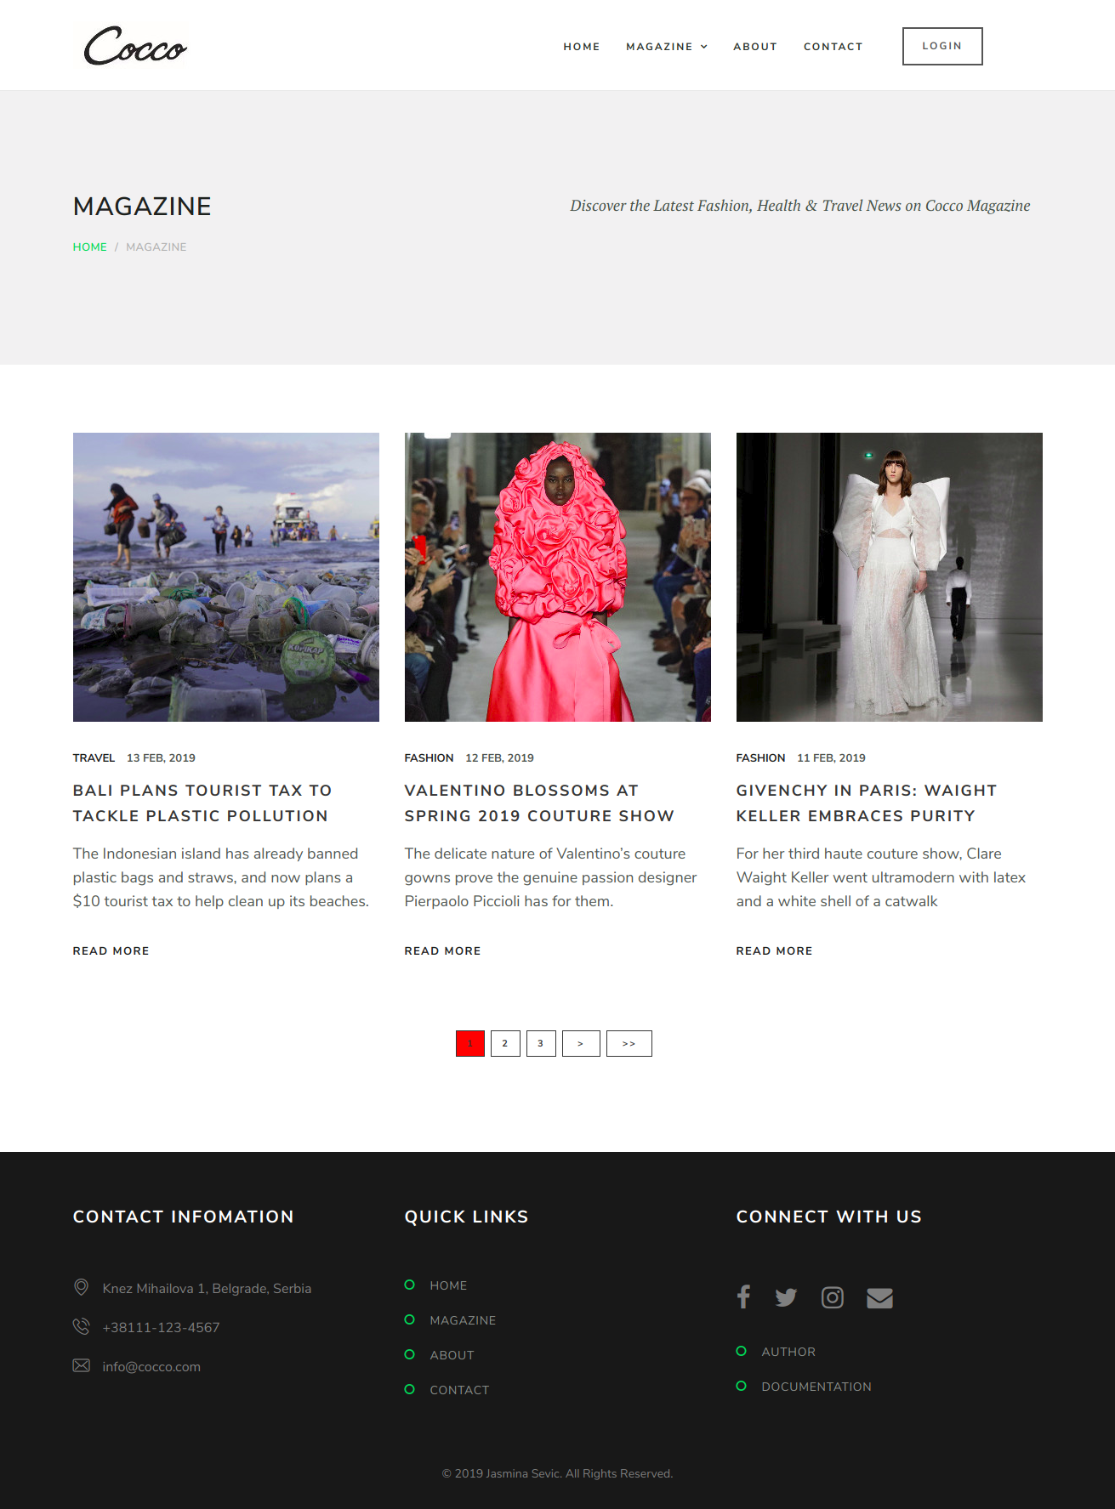

2.3.3. Prikaz pojedinačnih postova
- Klikom na određeni post, otvara se stranica sa tim postom koja se sastoji od slike i teksta. Sa desne strane se najpre prikazuje slika autora i njegova biografija. Klikom na sliku ili ime autora otvara se stranica sa više detalja o autoru. Klikom na “Read all posts” dugme ispod biografije autora prikazuju se svi postovi koje je taj autor napisao. Ispod dela o autoru, takođe sa desne strane, izlistane su sve kategorije, klikom na naziv kategorije, prikazuje se listing svih postova koji pripadaju toj kategoriji. Ispod kategorija se nalaze “Recent posts” - izlistana 3 najskorije objavljena posta. Ispod sadržaja posta se nalazi “Related posts” deo koji se sastoji od prikaza 2 posta koji se najskorije objavljeni a pripadaju istoj kategoriji kao i post iznad. Dat je prikaz stranice koja prikazuje jedan post iz Fashion kategorije.

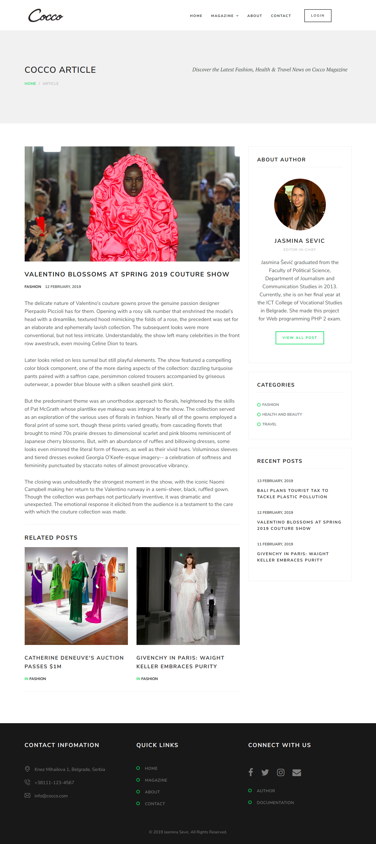
2.3.4. Blog Post Autor

– Blog – klikom na sliku ili ime autora bloga koje se nalazi sa desne strane posta, otvara se strana o autoru. Klikom na “Read all posts” ispod biografije autora otvara se stranica sa izlistanim samo onim postovima koje je autor objavio.

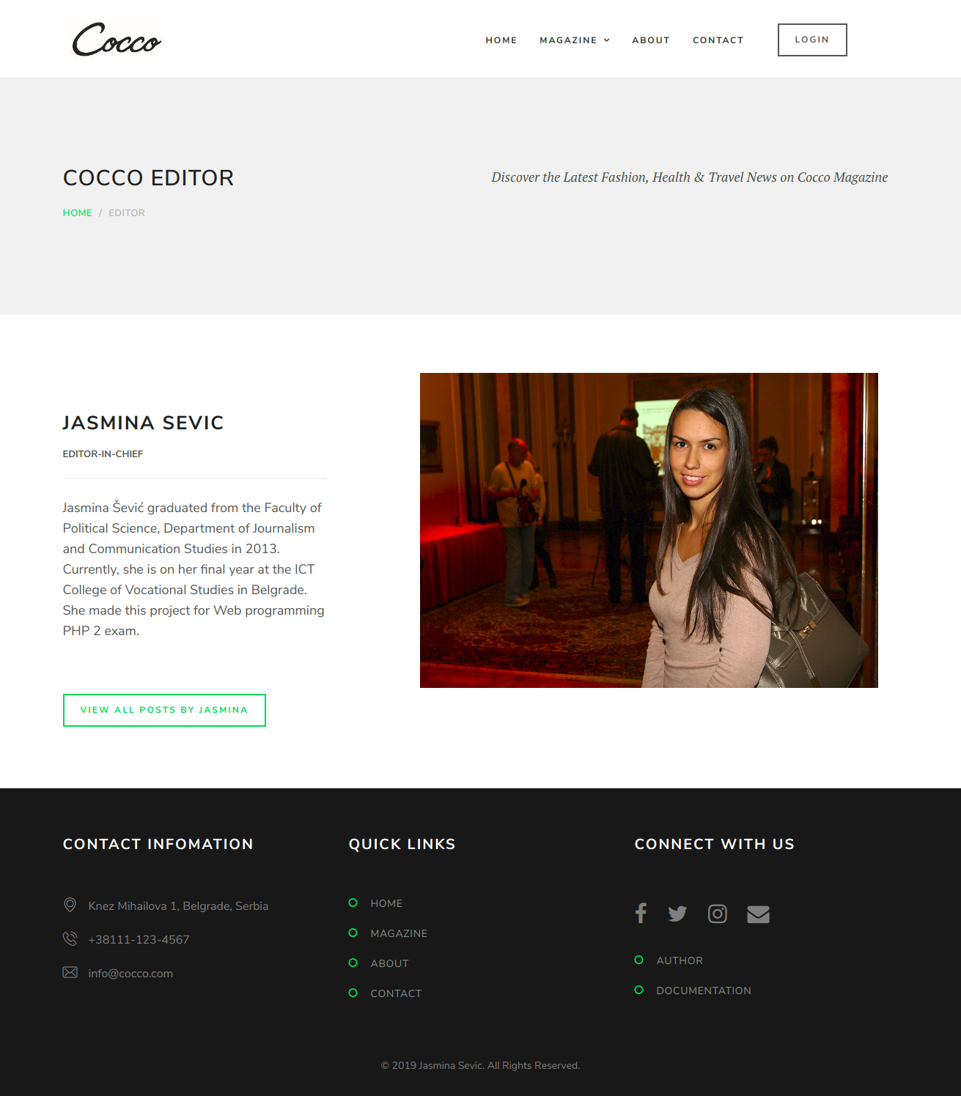

2.3.7. Logovanje i registracija

– Registracija i logovanje. Registracija je realizovana PHP-om i AJAX-om, obuhvata proveru unetih podataka i na klijentskoj i na severskoj strani. Logovanje je realizovano PHP-om. Nakon registracije, dobija se obaveštenje da je korisnik uspešno registrovan i da se može ulogovati. Nakon logovanja otvara se stranica sa anketom ukoliko se korisnik ne loguje kao admin. Ukoliko se logiuje kao admin biva redirektovan na admin panel.

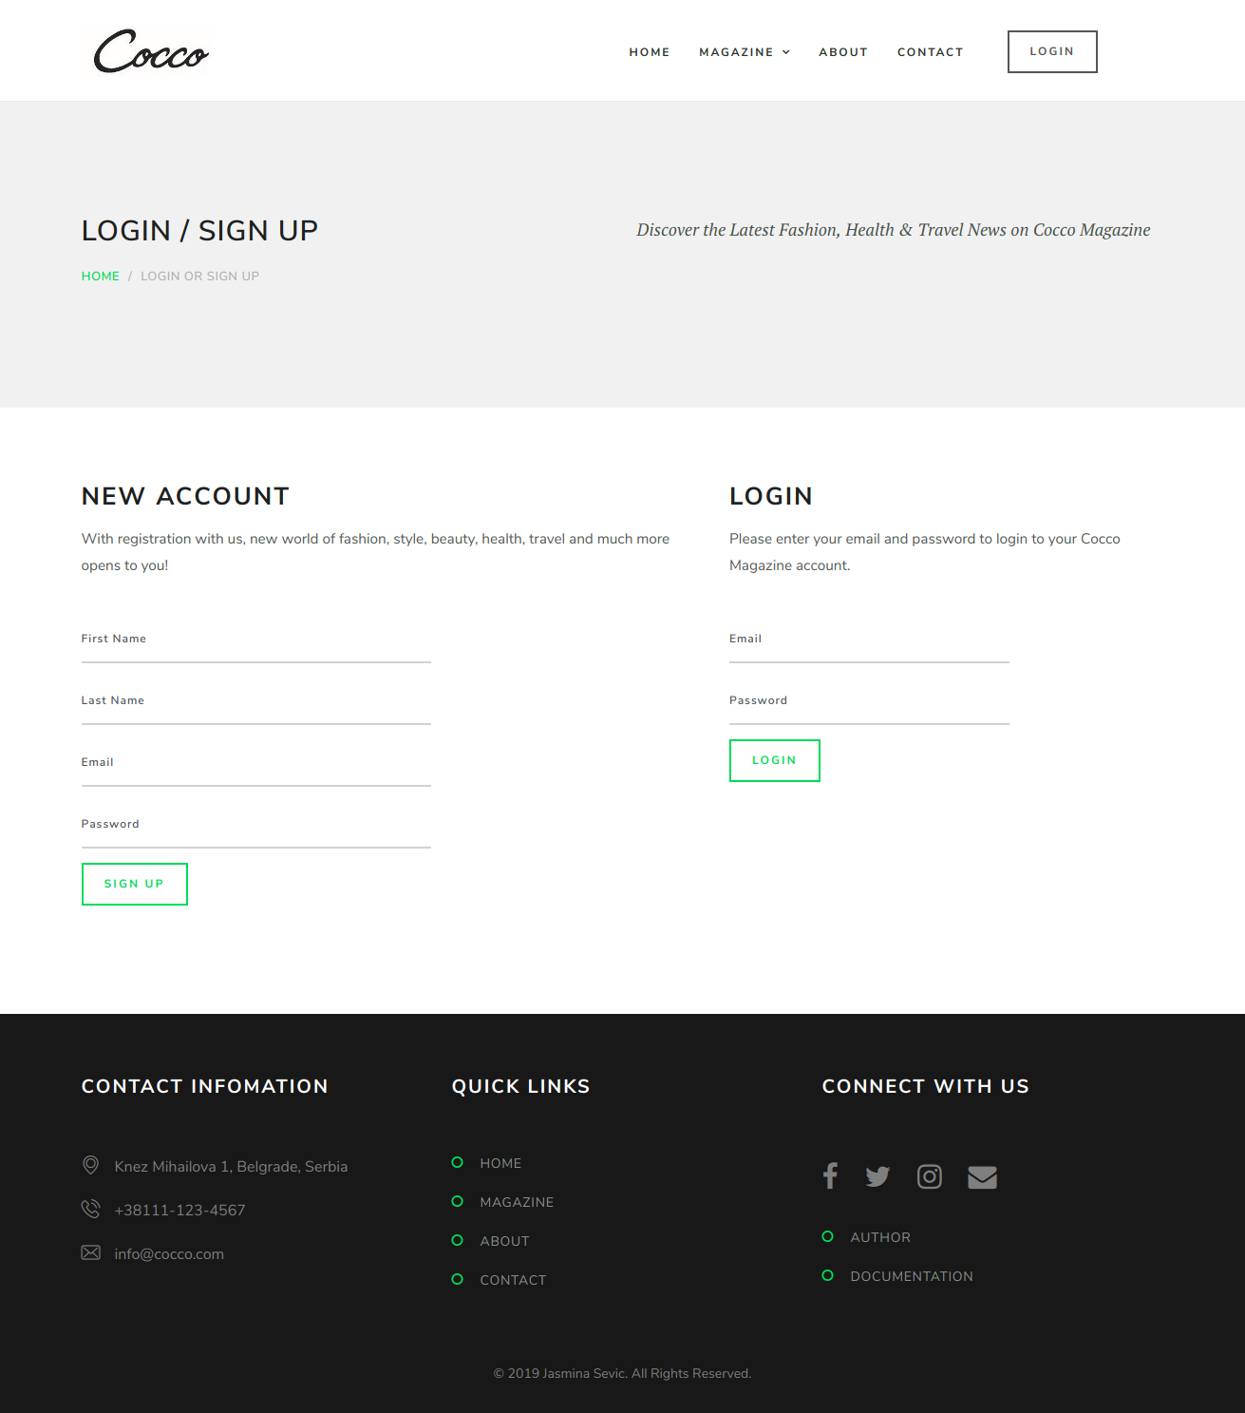

2.3.8. Kontakt forma
– Kontakt forma – realizovana PHP-om i AJAX-om, takođe obuhvata proveru unetih podataka i na klijentskoj i na severskoj strani. Ukoliko su uneti podaci ispravni, mejl se prosleđuje na određeni email.

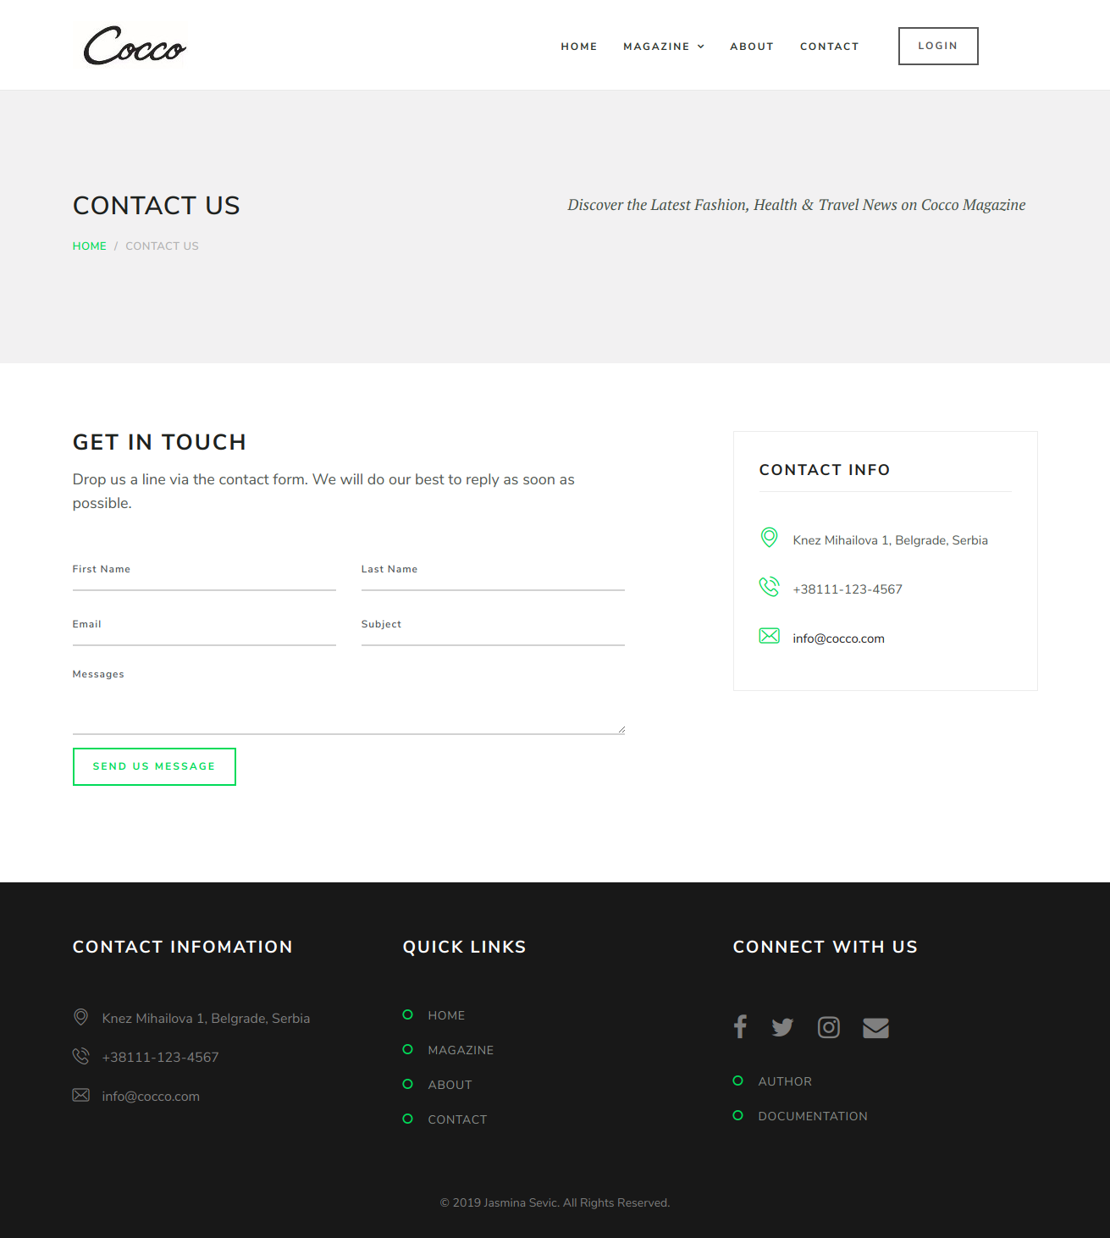

2.3.9. Anketa
– Anketa – realizovana upotrebom AJAX-a i PHP-a, moze je videti samo ulogovan korisnik. Jedan korisnik može glasati samo jednom. Ukoliko pokuša više puta dobija obaveštenje da je već glasao.

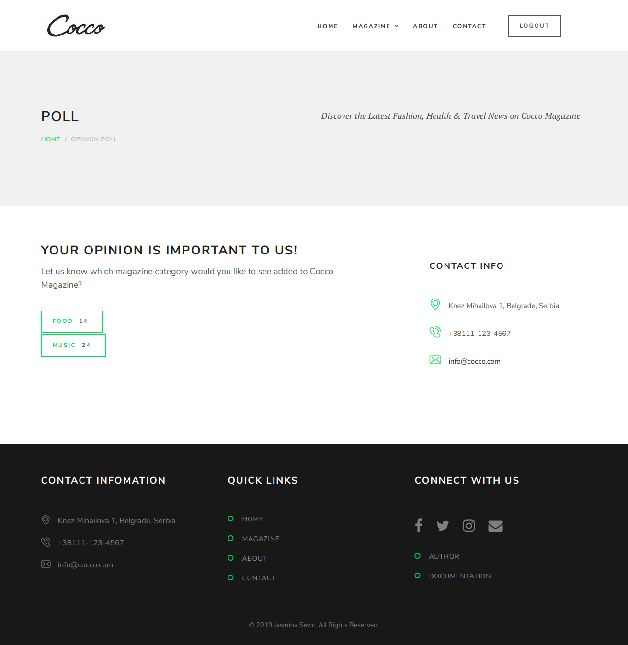

2.3.10. Admin panel

– Admin panel – realizovan PHP-om i AJAX-om, moze mu pristupiti samo ulogovan korisnik koji ima ulogu admin-a. Na slici ispod je prikazana inicijalna admin stranica, a potom i stranica za prikaz, dodavanje i brisanje korisnika.

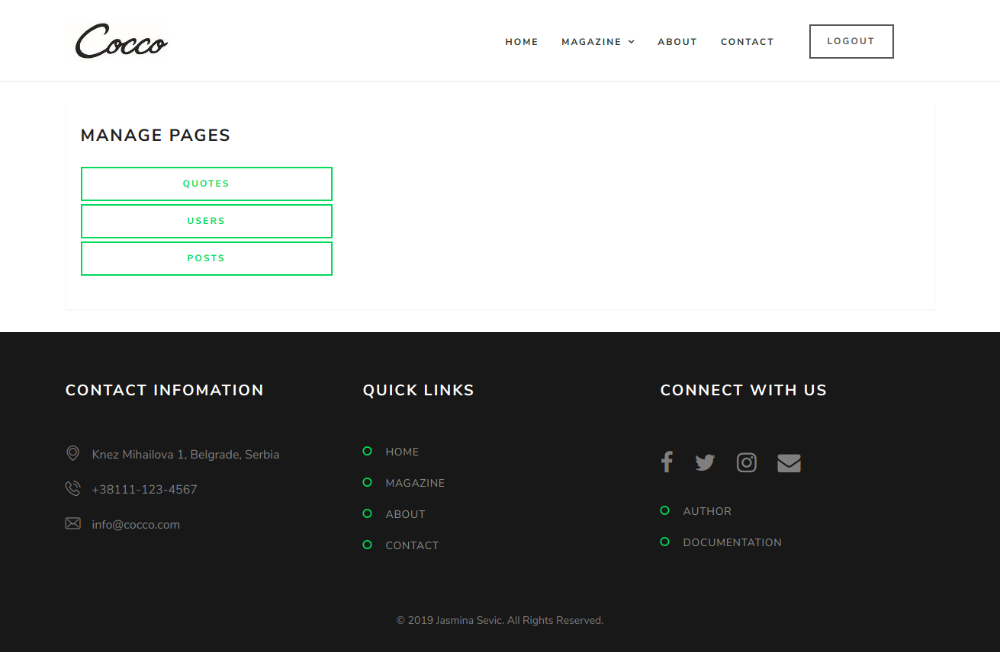
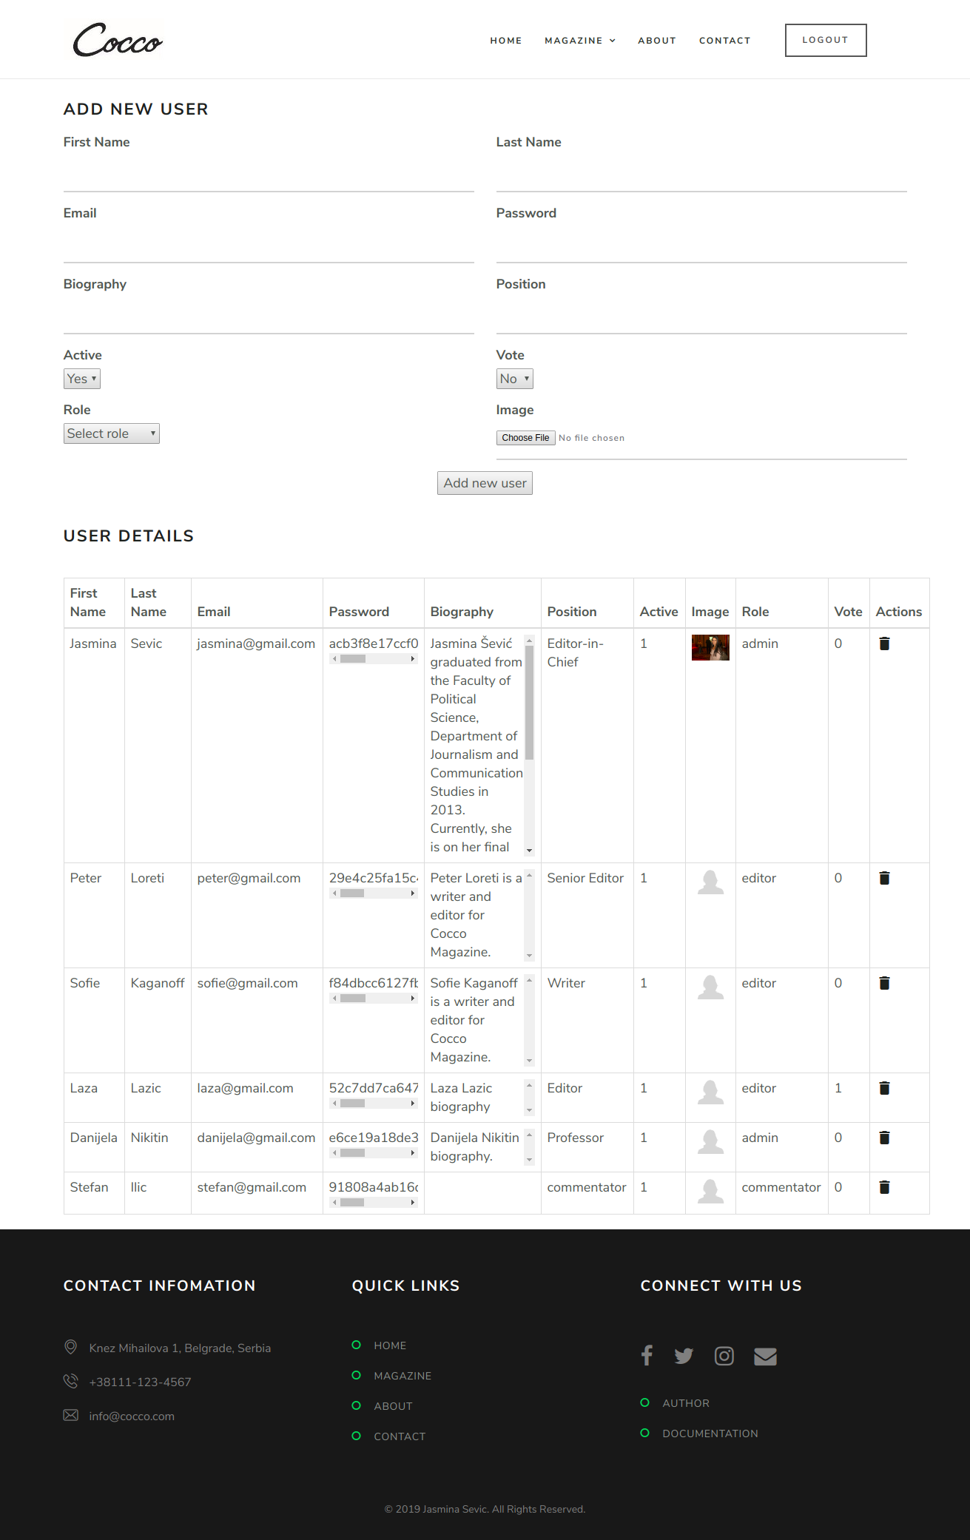

3. Baza podataka
U nastavku je dat pregled strukture baze podataka.

3.1. Users
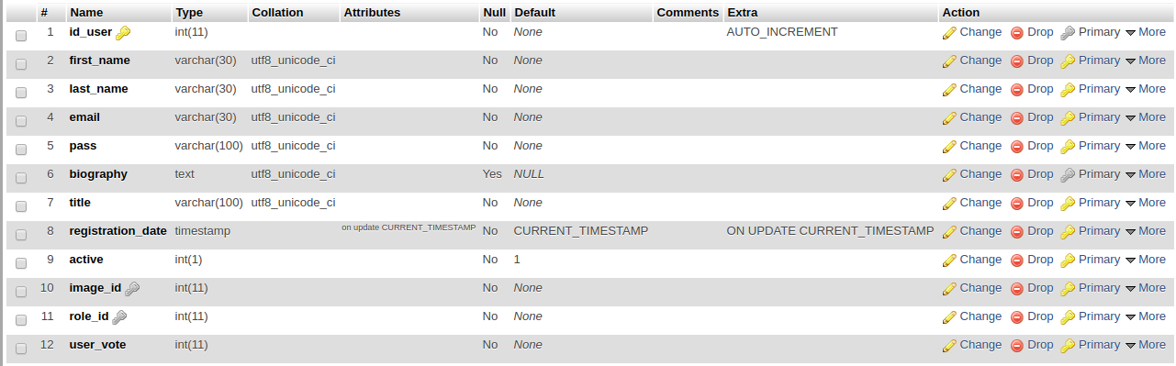

3.2. Roles

3.3. Quotes
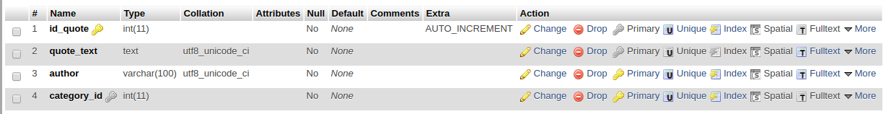

3.4. Poll

3.5. Posts
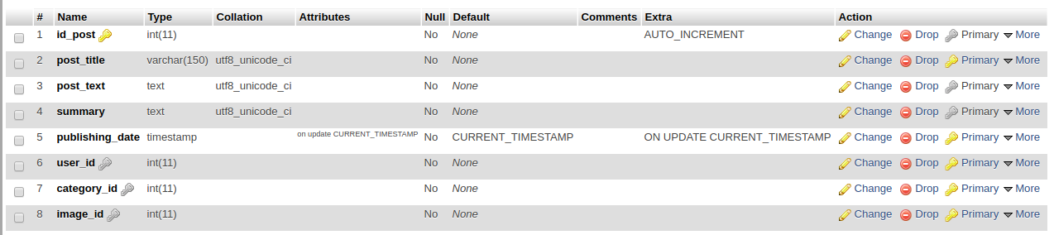

3.6. Navigation
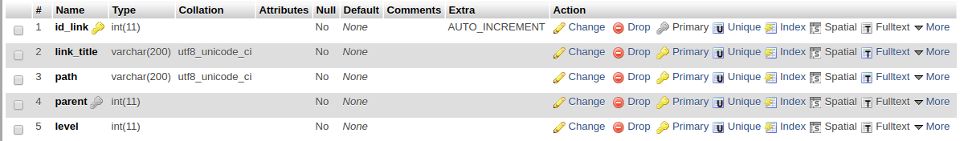

3.7. Main slider
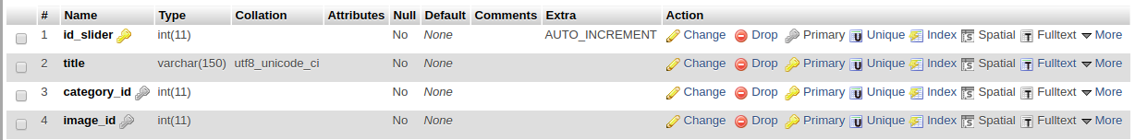

3.8. Images
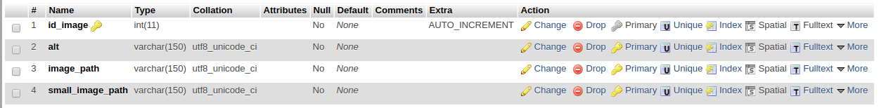

3.9 Categories

4. Kodovi

4.1. Index.php
<?php

session_start();
include "php/connection.php";

$page="";
if(isset($_GET['page'])){
$page = $_GET['page'];
}

include "views/head.php";

include "php/menu_builder.php";
include "php/admin-add-user.php";
include "php/admin-add-post.php";

include "views/nav.php";

switch($page){
case "main":
include "views/main.php";
break;
case "blog_listing":
include "views/blog_listing.php";
break;
case "single_blog":
include "views/single_blog.php";
break;
case "about_author":
include "views/about_author.php";
break;
case "about_us":
include "views/about_us.php";
break;
case "contact":
include "views/contact.php";
break;
case "author":
include "views/author.php";
break;
case "login":
include "views/login.php";
break;
case "admin":
include "views/admin.php";
break;
case "admin-post":
include "views/admin-post.php";
break;
case "admin-quote":
include "views/admin-quote.php";
break;
case "admin-user":
include "views/admin-user.php";
break;
case "poll":
include "views/poll.php";
break;
case "contact-form-submitted":
include "views/contact-form-submitted.php";
break;
default:
include "views/main.php";
break;

}
include "views/footer.php";

4.2. PHP

4.2.1. views/head.php
<!DOCTYPE html>
<html lang="en">

<head>
<meta charset="utf-8">

<meta name="robots" content="all,follow">
<meta name="googlebot" content="index,follow,snippet,archive">
<meta name="author" content="mailto:jasminasevic@yahoo.com" />
<meta name="keywords" content="beauty magazine, fashion tips, latest fashion news, travel magazine, travel tips" />
<meta name="description" content="Beauty, fashion, travel and lifestyle magazine" />
<meta name="copyright" content="Jasmina Sevic @ 2019" />
<meta name="language" content="english" />

<link rel="shortcut icon" type="image/png" href="images/favicon.png"/>

<!-- Admin panel -->
<link rel="stylesheet" href="https://fonts.googleapis.com/css?family=Roboto|Varela+Round|Open+Sans">
<link rel="stylesheet" href="https://fonts.googleapis.com/icon?family=Material+Icons">
<link rel="stylesheet" href="https://maxcdn.bootstrapcdn.com/font-awesome/4.7.0/css/font-awesome.min.css">
<link rel="stylesheet" href="https://maxcdn.bootstrapcdn.com/bootstrap/3.3.7/css/bootstrap.min.css">
<script src="https://ajax.googleapis.com/ajax/libs/jquery/1.12.4/jquery.min.js"></script>
<script src="https://maxcdn.bootstrapcdn.com/bootstrap/3.3.7/js/bootstrap.min.js"></script>
<!-- End admin panel -->

<meta http-equiv="X-UA-Compatible" content="IE=edge">
<meta name="viewport" content="width=device-width, initial-scale=1">
<!-- The above 3 meta tags *must* come first in the head; any other head content must come *after* these tags -->
<meta name="description" content="">
<meta name="keywords" content="">
<title>Cocco - Beauty, fashion, travel and lifestyle magazine</title>
<!-- Bootstrap -->
<link href="css/bootstrap.min.css" rel="stylesheet">
<!-- Style CSS -->
<link href="css/style.css" rel="stylesheet">
<!-- Google Fonts -->
<link href="https://fonts.googleapis.com/css?family=Nunito+Sans:200,200i,300,300i,400,400i,600,600i,700,700i,800,800i,900,900i"
rel="stylesheet">
<link href="https://fonts.googleapis.com/css?family=PT+Serif:400,400i,700,700i" rel="stylesheet">
<link href="css/owl.carousel.min.css" rel="stylesheet">
<link href="css/owl.theme.default.css" rel="stylesheet">
<!-- FontAwesome CSS -->
<link rel="stylesheet" type="text/css" href="css/fontello.css">
<link href="css/font-awesome.min.css" rel="stylesheet">
<!-- HTML5 shim and Respond.js for IE8 support of HTML5 elements and media queries -->
<!-- WARNING: Respond.js doesn't work if you view the page via file:// -->
<!--[if lt IE 9]>
<script src="https://oss.maxcdn.com/html5shiv/3.7.3/html5shiv.min.js"></script>
<script src="https://oss.maxcdn.com/respond/1.4.2/respond.min.js"></script>
<![endif]-->

<?php
if($page=='admin'){
echo '<link href="css/admintable.css" rel="stylesheet">';
}
?>

</head>

4.2.2. views/nav.php

<body>
<div class="header-wrapper">
<div class="container">
<div class="row">
<div class="col-lg-2 col-md-2 col-sm-12 col-xs-12">
<a href="index.php">
<img src="./images/cocco-logo.jpg" alt="cocco logo">
</a>
</div>

<div class="col-lg-8 col-md-10 col-sm-12 col-xs-12">
<div class="navigation">
<div id="navigation">

<?php echo build_menu($novi); ?>
</div>
</div>
</div>
<div class="col-lg-2 hidden-md hidden-sm hidden-xs">
<?php
if(isset($_SESSION['user'])):
?>
<div class="header-btn">
<a href="php/logout.php" class="btn btn-default">Logout</a>
</div>
<?php else: ?>
<div class="header-btn">
<a href="index.php?page=login" class="btn btn-default">Login</a>
</div>
<?php endif; ?>
</div>
</div>
</div>
</div>
<!-- header-section close -->

4.2.3. views/main.php

<!-- slider-start -->
<div class="slider">
<div class="owl-carousel slider">
<?php $slider_details = executeQuery("SELECT * FROM main_slider
INNER JOIN categories ON category_id = id_category
INNER JOIN images ON image_id = id_image");
foreach($slider_details as $slider):
?>

<div class="item">
<div class="slider-img">
<img src="<?= $slider->image_path; ?>" alt="<?= $slider->alt ?>">
</div>
<div class="container">
<div class="row">
<div class="col-lg-7 col-md-7 col-sm-12 col-xs-12"></div>
<div class="col-lg-5 col-md-5 col-sm-12 col-xs-12">
<div class="slider-captions">
<h1 class="slider-title"><?= $slider->title ?></h1>
<a href="index.php?page=blog_listing" class="btn btn-default btn-lg hidden-sm hidden-xs">Read all articles</a>
</div>
</div>
</div>
</div>
</div>
<?php endforeach;?>
</div>
</div>
<!-- slider-close -->

<!-- news-start -->
<div class="space-medium">
<div class="container">
<div class="row">
<div class="col-lg-12 col-md-12 col-sm-12 col-xs-12">
<div class="section-title">
<!-- section title start-->
<h1>Latest News</h1>
</div>
<!-- /.section title start-->
</div>
</div>
<div class="row">
<?php $articles = executeQuery("SELECT * FROM posts
INNER JOIN categories ON category_id = id_category
INNER JOIN images ON image_id = id_image
INNER JOIN users ON user_id = id_user
ORDER BY publishing_date DESC LIMIT 6");
foreach($articles as $article):
?>
<div class="col-lg-4 col-md-4 col-sm-4 col-xs-12">
<div class="post-block">
<div class="post-img">
<a href="index.php?page=single_blog&id=<?= $article->id_post; ?>" class="imghover">
<img src="<?= $article->small_image_path?>" alt="<?= $article->alt?>" class="img-responsive">
</a>
</div>
<!-- post block -->
<div class="post-content">
<div class="meta">
<span class="meta-categories">
<a href="index.php?page=blog_listing&id_category=<?= $article->id_category; ?>"><?= $article->category_title?></a>
</span>
<span class="meta-date">
<?php $publishing_date_time=explode(" ", $article->publishing_date);
$publishing_date = explode("-", $publishing_date_time[0]);
$publishing_time = explode(":", $publishing_date_time[1]);
$timestamp = mktime($publishing_time[0], $publishing_time[1], $publishing_time[2], $publishing_date[1], $publishing_date[2], $publishing_date[0]);
echo date("d M, Y", $timestamp);
?>
</span>
</div>
<h4>
<a href="index.php?page=single_blog&id=<?= $article->id_post; ?>" class="title"><?= $article->post_title?></a>
</h4>
<p><?= $article->summary?></p>
<a href="index.php?page=single_blog&id=<?= $article->id_post; ?>" class="btn-link">read more</a>
</div>
</div>
</div>
<?php endforeach;?>
</div>
</div>
</div>
<!-- news-close -->
<!-- testimonials-start -->
<div class="space-medium bg-light">
<div class="container">
<div class="testimonial-carousel">
<div class="owl-carousel slider">

<?php $quotes = executeQuery("SELECT * FROM quotes INNER JOIN categories ON category_id=id_category");
foreach($quotes as $quote):
?>

<div class="item">
<div class="col-lg-offset-3 col-lg-6 col-md-offset-3 col-md-6 col-sm-12 col-xs-12">
<div class="">
<div class="testimonial-content">
<div class="testimonial-icon">
<img src="./images/quote.png" alt="">
</div>
<span><small><?= $quote->category_title?></small></span>
<h2>Quotes of the day</h2>
<p class="testimonial-text"><?= $quote->quote_text?></p>
<div class="testimonial-meta">
<span>- <?= $quote->author?></span>
</div>
</div>
</div>
</div>
</div>

<?php endforeach; ?>
</div>
</div>
</div>
</div>
<!-- testimonials-close -->

4.2.4. views/footer.php
<!-- footer start -->
<div class="footer">
<div class="container">
<div class="row">
<!-- footer-about-start -->
<div class="col-lg-4 col-md-4 col-sm-4 col-xs-12 ">
<div class="footer-widget">
<h3 class="footer-title">Contact Infomation</h3>
<div class="">
<ul>
<li>
<i class="icon-placeholder"></i>Knez Mihailova 1, Belgrade, Serbia</li>
<li>
<i class="icon-phone-call"></i>+38111-123-4567</li>
<li>
<i class="icon-envelope"></i>info@cocco.com</li>
</ul>
</div>
</div>
</div>
<!-- footer-useful links-start -->
<div class=" col-lg-4 col-md-4 col-sm-4 col-xs-12">
<div class="footer-widget">
<h3 class="footer-title">Quick Links</h3>

<?php echo build_menu_without_childern($novi, $parent = 0); ?>

</div>
</div>
<!-- footer-useful links-close -->
<!-- footer-form-start -->
<div class=" col-lg-4 col-md-4 col-sm-4 col-xs-12">
<div class="footer-widget">
<h3 class="footer-title">Connect with us</h3>
<p class="social">
<a href="#" class="facebook external" data-animate-hover="shake">
<i class="fa fa-facebook"></i>
</a>
<a href="#" class="twitter external" data-animate-hover="shake">
<i class="fa fa-twitter"></i>
</a>
<a href="#" class="instagram external" data-animate-hover="shake">
<i class="fa fa-instagram"></i>
</a>
<a href="mailto:info@cocco.com" class="email external" data-animate-hover="shake">
<i class="fa fa-envelope"></i>
</a>
</p>
<ul class="angle angle-right">
<li>
<a href="index.php?page=about_author&id_user=1">Author </a>
</li>
<li>
<a href="#">Documentation </a>
</li>
</ul>

</div>
</div>
<!-- footer-tiny-text-start -->
<div class="col-lg-12 col-md-12 col-sm-12 col-xs-12">
<div class="tiny-footer">
<p>&copy; 2019 Jasmina Sevic. All Rights Reserved.</p>
</div>
</div>
<!-- footer-tiny-text-start -->
<!-- footer-form-close -->
</div>
</div>
</div>
<!-- jQuery (necessary for Bootstrap's JavaScript plugins) -->
<script src="js/jquery.min.js" type="text/javascript"></script>
<!-- Include all compiled plugins (below), or include individual files as needed -->
<script src="js/bootstrap.min.js" type="text/javascript"></script>
<script src="js/navigation.js" type="text/javascript"></script>
<script src="js/menumaker.js" type="text/javascript"></script>
<script type="text/javascript" src="js/jquery.sticky.js"></script>
<script type="text/javascript" src="js/sticky-header.js"></script>
<script type="text/javascript" src="js/owl.carousel.min.js"></script>
<script type="text/javascript" src="js/slider.js"></script>
<script type="text/javascript" src="js/testimonial-slider.js"></script>
<script type="text/javascript" src="js/user_registration.js"></script>
<script type="text/javascript" src="js/contact-form-check.js"></script>
<script type="text/javascript" src="js/poll-vote.js"></script>
<!-- <script type="text/javascript" src="js/toogle-admin-panel.js"></script> -->

<!-- Admin panel -->
<script type="text/javascript" src="js/admin-add-quote-ajax.js"></script>
<script type="text/javascript" src="js/admin-delete-quote-ajax.js"></script>
<script type="text/javascript" src="js/admin-add-user-ajax.js"></script>
<script type="text/javascript" src="js/admin-delete-user-ajax.js"></script>
<script type="text/javascript" src="js/admin-delete-post-ajax.js"></script>

</body>

</html>

4.2.5. views/blog-listing.php
<!-- page-header-start -->
<div class="page-header">
<div class="container">
<div class="row">
<div class="col-lg-6 col-md-6 col-sm-6 col-xs-12">
<div class="page-section">
<h1 class="page-title ">Magazine</h1>
<div class="page-breadcrumb">
<ol class="breadcrumb">
<li>
<a href="index.php?page=main">Home</a>
</li>
<li>Magazine</li>
</ol>
</div>
</div>
</div>
<div class="col-lg-6 col-md-6 col-sm-6 hidden-xs">
<div class="page-section">
<p>Discover the Latest Fashion, Health &amp; Travel News on Cocco Magazine</p>
</div>
</div>
</div>
</div>
</div>
<!-- page-header-close -->
<!-- news-start -->
<div class="space-medium">
<div class="container">
<div class="row">

<?php

// page is the current page, if there's nothing set, default is page 1
$curpage = isset($_GET['curpage']) ? $_GET['curpage'] : 1;

$id_category = "";
if(isset($_GET['id_category'])){
$id_category = "&id_category=" . $_GET['id_category'];
}

$id_user = "";
if(isset($_GET['id_user'])){
$id_user = "&id_user=" . $_GET['id_user'];
}

// set records or rows of data per page
$recordsPerPage = 3;
// calculate for the query LIMIT clause
$fromRecordNum = ($recordsPerPage * $curpage) - $recordsPerPage;
// select all data
$articles = executeQuery("SELECT * FROM posts
INNER JOIN categories ON category_id = id_category
INNER JOIN images ON image_id = id_image
INNER JOIN users ON user_id=id_user ".
($_GET['id_category'] ? " WHERE id_category=". $_GET['id_category'] : "")
.
($_GET['id_user'] ? " WHERE id_user=". $_GET['id_user'] : "")
. " ORDER BY publishing_date DESC LIMIT
{$fromRecordNum}, {$recordsPerPage}");

//get number of rows returned
$num = executeQuery("SELECT count(*) FROM posts");

foreach($articles as $article):
?>

<div class="col-lg-4 col-md-4 col-sm-4 col-xs-12">
<div class="post-block">
<div class="post-img">
<a href="index.php?page=single_blog&id=<?= $article->id_post; ?>" class="imghover">
<img src="<?= $article->small_image_path ?>" alt="<?= $article->alt?>" class="img-responsive">
</a>
</div>
<!-- post block -->
<div class="post-content">
<div class="meta">
<span class="meta-categories">
<a href="index.php?page=blog_listing&id_category=<?= $article->id_category; ?>"><?= $article->category_title?></a>
</span>
<span class="meta-date">
<?php $publishing_date_time=explode(" ", $article->publishing_date);
$publishing_date = explode("-", $publishing_date_time[0]);
$publishing_time = explode(":", $publishing_date_time[1]);
$timestamp = mktime($publishing_time[0], $publishing_time[1], $publishing_time[2], $publishing_date[1], $publishing_date[2], $publishing_date[0]);
echo date("d M, Y", $timestamp);
?>
</span>
</div>
<h4>
<a href="index.php?page=single_blog&id=<?= $article->id_post; ?>" class="title"><?= $article->post_title?></a>
</h4>
<p><?= $article->summary?></p>
<a href="index.php?page=single_blog&id=<?= $article->id_post; ?>" class="btn-link">read more</a>
</div>
</div>
</div>
<?php endforeach; ?>

<!-- pagination start -->
<div class="col-lg-12 col-md-12 col-sm-12 col-xs-12">
<div class="st-pagination">
<ul class="pagination">
<?php
if($curpage>1):
// ********** show the first page
echo "<li>";
echo "<a href='{$_SERVER['PHP_SELF']}?page=blog_listing{$id_user}{$id_category}&curpage=1' title='Go to the first page.' class='customBtn'>";
echo "<span style='margin:0 .5em;'> << </span>";
echo "</a>";
echo "</li>";

// ********** show the previous page
$prev_page = $curpage - 1;
echo "<li>";
echo "<a href='{$_SERVER['PHP_SELF']}?page=blog_listing{$id_user}{$id_category}&curpage={$prev_page}' title='Previous page is {$prev_page}.' class='customBtn'>";
echo "<span style='margin:0 .5em;'> < </span>";
echo "</a>";
echo "</li>";
endif;

// ********** show the number paging
// find out total pages
$row = executeQuery("SELECT COUNT(*) as total_rows FROM posts");
$total_rows = $row[0]->total_rows;
if(isset($_GET['id_category'])):
$id_categ = $_GET['id_category'];
$category_row_query = executeQuery("SELECT COUNT(*) as total_category_rows FROM posts
INNER JOIN categories ON category_id=id_category
WHERE category_id = {$id_categ}");
$total_category_rows = $category_row_query[0]->total_category_rows;

$total_pages = ceil($total_category_rows / $recordsPerPage);
else:
$total_pages = ceil($total_rows / $recordsPerPage);

if(isset($_GET['id_user'])):
$id_author = $_GET['id_user'];
$author_row_query = executeQuery("SELECT COUNT(*) as total_author_rows FROM posts
INNER JOIN users ON user_id=id_user
WHERE user_id = {$id_author}");
$total_author_rows = $author_row_query[0]->total_author_rows;

$total_pages = ceil($total_author_rows / $recordsPerPage);
else:
$total_pages = ceil($total_rows / $recordsPerPage);
endif;
endif;
// range of num links to show
$range = 3;
// display links to 'range of pages' around 'current page'
$initial_num = $curpage - $range;
$condition_limit_num = ($page + $range) + 1;
for ($x=$initial_num; $x<$condition_limit_num; $x++) {
// be sure '$x is greater than 0' AND 'less than or equal to the $total_pages'
if (($x > 0) && ($x <= $total_pages)) {
// current page
if ($x == $curpage) {
echo "<li>";
echo "<a href='#' class='customBtn' style='background:red;'>$x</a>";
echo "</li>";
}
// not current page
else {
echo "<li>";
echo " <a href='{$_SERVER['PHP_SELF']}?page=blog_listing{$id_user}{$id_category}&curpage=$x' class='customBtn'>$x</a> ";
echo "</li>";
}
}
}
// ***** for 'next' and 'last' pages
if($curpage<$total_pages){
// ********** show the next page
$next_page = $curpage + 1;
echo "<li>";
echo "<a href='{$_SERVER['PHP_SELF']}?page=blog_listing{$id_user}{$id_category}&curpage={$next_page}' title='Next page is {$next_page}.' class='customBtn'>";
echo "<span style='margin:0 .5em;'> > </span>";
echo "</a>";
echo "</li>";
// ********** show the last page
echo "<li>";
echo "<a href='{$_SERVER['PHP_SELF']}?page=blog_listing{$id_user}{$id_category}&curpage={$total_pages}' title='Last page is {$total_pages}.' class='customBtn'>";
echo "<span style='margin:0 .5em;'> >> </span>";
echo "</a>";
echo "</li>";
}
?>
</ul>
</div>
</div>

<!-- pagination close -->
</div>
</div>
</div>

<!-- news-close -->

4.2.6. views/single-blog.php
<!-- page-header-start -->
<div class="page-header">
<div class="container">
<div class="row">
<div class="col-lg-6 col-md-6 col-sm-6 col-xs-12">
<div class="page-section">
<h1 class="page-title ">Cocco Article</h1>
<div class="page-breadcrumb">
<ol class="breadcrumb">
<li><a href="index.php?page=main">Home</a></li>
<li>Article</li>
</ol>
</div>
</div>
</div>
<div class="col-lg-6 col-md-6 col-sm-6 hidden-xs">
<div class="page-section">
<p>Discover the Latest Fashion, Health &amp; Travel News on Cocco Magazine</p>
</div>
</div>
</div>
</div>
</div>
<!-- page-header-close -->

<div class="space-medium">
<div class="container">
<div class="row">
<div class="col-lg-8 col-md-8 col-sm-8 col-xs-12">
<div class="row">
<div class="col-lg-12 col-sm-12 col-md-12 col-xs-12">

<?php
if(isset($_GET['id'])) :
$id = $_GET['id'];

$query_prepare =$conn->prepare("SELECT p.post_title, p.post_text, p.publishing_date,
c.category_title, c.id_category,
u.id_user, u.first_name, u.last_name, u.biography, u.title, u.registration_date,
i.small_image_path AS user_small, i.alt AS user_alt,
im.image_path AS post_large, im.small_image_path AS post_small, im.alt AS post_alt
FROM posts p INNER JOIN categories c ON p.category_id=c.id_category
INNER JOIN users u ON p.user_id=u.id_user
INNER JOIN images i ON u.image_id = i.id_image
INNER JOIN images im ON im.id_image=p.image_id
WHERE id_post = :id"); //Pripremanje upita za izvrsavanje
$query_prepare->execute(array(":id"=>$id)); // Izvrsavanje upita sa konkretnim parametrom
$single_post = $query_prepare->fetch(); // Dohvatanje samo jednog reda kao rezultat

if(isset($single_post)):
?>

<div class="post-block">
<!-- post holder -->
<div class="post-img">
<!-- post img -->
<img src="<?= $single_post->post_large?>" alt="<?= $single_post->post_alt?>" class="img-responsive">
</div>
<!-- /.post img -->
<div class="post-content">
<!-- post content -->
<div class="post-header">
<!-- post header -->
<h2 class="post-title"><?= $single_post->post_title?></h2>
<div class="meta">
<span class="meta-categories">
<a href="index.php?page=blog_listing&id_category=<?= $single_post->id_category; ?>"><?= $single_post->category_title?></a>
</span>
<span class="meta-date">
<?php $publishing_date_time=explode(" ", $single_post->publishing_date);
$publishing_date = explode("-", $publishing_date_time[0]);
$publishing_time = explode(":", $publishing_date_time[1]);
$timestamp = mktime($publishing_time[0], $publishing_time[1], $publishing_time[2], $publishing_date[1], $publishing_date[2], $publishing_date[0]);
echo date("d F, Y", $timestamp);
?>

</span>
</div>
</div>
<!-- /.post header -->
<p> <?= $single_post->post_text?></p>
<div class="related-post-block">
<!-- related post block -->

<div class="row">
<div class="col-lg-12 col-sm-12 col-md-12 col-sm-12">
<h3 class="related-post-title">Related Posts</h3>
</div>
</div>
<div class="row">
<?php
$category=$single_post->id_category;
$related_posts = executeQuery("SELECT * FROM posts
INNER JOIN images ON image_id = id_image
INNER JOIN categories ON category_id=id_category
WHERE id_post != $id AND id_category = $category
ORDER BY publishing_date LIMIT 2");
foreach($related_posts as $related_post):
?>
<div class="col-lg-6 col-sm-6 col-md-6 col-xs-12">
<div class="related-post">
<!-- related post -->
<div class="related-img">
<a href="index.php?page=single_blog&id=<?=$related_post->id_post ?>" class="imghover">
<img src="<?= $related_post->small_image_path?>" alt="<?= $related_post->post_alt?>" class="img-responsive">
</a>
</div>
<div class="related-post-content">
<h4 class="related-title">
<a href="index.php?page=single_blog&id=<?=$related_post->id_post ?>" class="title"><?= $related_post->post_title?> </a>
</h4>
<div class="meta">
<span class="meta-categories">in
<a href="index.php?page=blog_listing&id_category=<?= $related_post->id_category; ?>" class=""><?= $related_post->category_title?></a>
</span>
</div>
</div>
</div>
<!-- /.related post -->
</div>
<?php endforeach; ?>
</div>
</div>
<!-- /.related post block -->
</div>
<!-- /.post content -->
</div>
<!-- /.post holder -->
</div>
</div>
</div>
<div class="col-lg-4 col-md-4 col-sm-4 col-xs-12">
<div class=" widget">
<!-- Post author -->
<h2 class="widget-title">About author</h2>
<div class=" author-block">
<div class="author-img">
<a href="index.php?page=about_author&id_user=<?= $single_post->id_user?>" class="imghover">
<img src="<?= $single_post->user_small?>" style="width:180px; height:180px; "class="img-circle" alt="<?= $single_post->user_alt ?>">
</a>
</div>
<div class="author-post-content ">
<div class="author-header">
<h3>
<a href="index.php?page=about_author&id_user=<?= $single_post->id_user?>" class="title"><?= $single_post->first_name .' '. $single_post->last_name?> </a>
</h3>
</div>
<div class="author-meta "><?= $single_post->title ?></div>
<div class="author-content">
<p><?= $single_post->biography?></p>
<a href="index.php?page=blog_listing&id_user=<?= $single_post->id_user ?>" class="btn btn-primary">View All Post</a>
</div>
</div>
</div>
</div>
<!-- /.post author -->
<?php endif;?>
<?php endif;?>

<!-- widget-search-start -->
<!-- <div class=" widget widget-search">
<form>
<div class="search-form">
<input type="text" class="form-control " placeholder="Search Here">
<button type="Submit"><i class="fa fa-search"></i></button>
</div>
</form>
</div> -->
<!-- widget-search-close -->
<!-- widget-categories-start -->
<div class=" widget widget-categories">
<h2 class="widget-title">Categories</h2>
<ul class="angle angle-right">
<?php $categories=executeQuery("SELECT * FROM categories");
foreach($categories as $category):
?>
<li>
<a href="index.php?page=blog_listing&id_category=<?= $category->id_category; ?>"><?= $category->category_title?></a>
</li>
<?php endforeach;?>
</ul>
</div>
<!-- widget-categories-close -->
<!-- widget-recent-post-start -->
<div class=" widget widget-recent-post">
<h2 class="widget-title mb20">Recent Posts</h2>
<ul>
<?php $articles = executeQuery("SELECT * FROM posts INNER JOIN categories ON category_id=id_category
ORDER BY publishing_date DESC LIMIT 3");
foreach($articles as $article):
?>
<li>
<div class="recent-post">
<div class="meta">
<span class="meta-date">
<?php $publishing_date_time=explode(" ", $article->publishing_date);
$publishing_date = explode("-", $publishing_date_time[0]);
$publishing_time = explode(":", $publishing_date_time[1]);
$timestamp = mktime($publishing_time[0], $publishing_time[1], $publishing_time[2], $publishing_date[1], $publishing_date[2], $publishing_date[0]);
echo date("d F, Y", $timestamp);
?>
</span></div>
<h5 class="recent-title "><a href="index.php?page=single_blog&id=<?= $article->id_post; ?>" class="title"><?= $article->post_title?></a></h5>
</div>
</li>
<?php endforeach;?>
</ul>
</div>
<!-- widget-recent-post-close-->
</div>
</div>
</div>
</div>

4.2.7. views/about-author.php
<!-- page-header-start -->
<div class="page-header">
<div class="container">
<div class="row">
<div class="col-lg-6 col-md-6 col-sm-6 col-xs-12">
<div class="page-section">
<h1 class="page-title ">Cocco Editor</h1>
<div class="page-breadcrumb">
<ol class="breadcrumb">
<li><a href="#">Home</a></li>
<li>Editor</li>
</ol>
</div>
</div>
</div>
<div class="col-lg-6 col-md-6 col-sm-6 hidden-xs">
<div class="page-section">
<p>Discover the Latest Fashion, Health &amp; Travel News on Cocco Magazine</p>
</div>
</div>
</div>
</div>
</div>
<!-- page-header-close -->
<div class="space-medium">
<div class="container">
<div class="row">

<?php
if(isset($_GET['id_user'])) :
$id = $_GET['id_user'];

$query_prepare =$conn->prepare("SELECT * FROM users
INNER JOIN images ON image_id = id_image
WHERE id_user = :id"); //Pripremanje upita za izvrsavanje
$query_prepare->execute(array(":id"=>$id)); // Izvrsavanje upita sa konkretnim parametrom
$single_user = $query_prepare->fetch(); // Dohvatanje samo jednog reda kao rezultat

if(isset($single_user)):
?>

<div class="col-lg-4 col-md-4 col-sm-12 col-xs-12">
<div class="about-section ">
<div class="about-title">
<h1><?= $single_user->first_name . " " . $single_user->last_name ?></h1>
<div class="meta"><?= $single_user->title?></div>
</div>
<p><?= $single_user->biography?></p>
</div>
<div class="author-content">
<a href="index.php?page=blog_listing&id_user=<?= $single_user->id_user ?>" class="btn btn-primary">View All Posts by <?= $single_user->first_name?></a>
</div>
</div>
<div class="col-lg-7 col-lg-offset-1 col-md-6 col-md-offset-1 col-sm-12 col-xs-12">
<img src="<?= $single_user->image_path?>" alt="<?= $single_user->alt?>" class="img-responsive">
</div>

<?php endif; ?>
<?php endif; ?>

</div>
</div>
</div>

4.2.8. views/login.php
<!-- page-header-start -->
<div class="page-header">
<div class="container">
<div class="row">
<div class="col-lg-6 col-md-6 col-sm-6 col-xs-12">
<div class="page-section">
<h1 class="page-title ">Login / Sign Up</h1>
<div class="page-breadcrumb">
<ol class="breadcrumb">
<li><a href="index.php">Home</a></li>
<li>Login or Sign Up</li>
</ol>
</div>
</div>
</div>
<div class="col-lg-6 col-md-6 col-sm-6 hidden-xs">
<div class="page-section">
<p>Discover the Latest Fashion, Health &amp; Travel News on Cocco Magazine</p>
</div>
</div>
</div>
</div>
</div>
<!-- page-header-close -->
<!-- testimonials-start -->
<div class="space-medium">
<div class="container">
<div class="row">
<div class="col-lg-7 col-md-7 col-sm-12 col-xs-12">

<?php
if (isset($_SESSION['user'])):
echo "<h3>You are now logged in.</h3>";
?>

<?php else: ?>
<div class="mb30">
<div class="contact-form">
<h1>New account</h1>
<p class="mb40">
<small>
With registration with us, new world of fashion, style, beauty, health, travel
and much more opens to you!
</small>
</p>
<div class="row">
<form id="signUpForm" action="<?= $_SERVER['PHP_SELF']. '?page=login' ?>" method="post" >
<div class="col-lg-7 col-md-7 col-sm-7 col-xs-7">
<div class="form-group">
<label class="control-label sr-only " for="firstName"></label><span class="star">* Enter valid first name</span>
<input id="regFirstName" name="regFirstName" type="text" placeholder="First Name" class="form-control register-input">
</div>
</div>
<div class="col-lg-7 col-md-7 col-sm-7 col-xs-7">
<div class="form-group">
<label class="control-label sr-only " for="lastName"></label><span class="star">* Enter valid last name</span>
<input id="regLastName" name="regLastName" type="text" placeholder="Last Name" class="form-control register-input">
</div>
</div>
<div class="col-lg-7 col-md-7 col-sm-7 col-xs-7">
<div class="form-group">
<label class="control-label sr-only " for="email"></label><span class="star">* Enter valid email address</span>
<input id="regEmail" name="regEmail" type="text" placeholder="Email" class="form-control register-input">
</div>
</div>
<div class="col-lg-7 col-md-7 col-sm-7 col-xs-7">
<div class="form-group">
<label class="control-label sr-only " for="password"></label><span class="star">* Enter valid password</span>
<input id="regPass" name="regPass" type="password" placeholder="Password" class="form-control register-input">
</div>
</div>
<div class="col-lg-12 col-md-12 col-sm-12 col-xs-12">
<button type="submit" class="btn btn-primary" id="btnSubmit" name="btnSubmit">Sign Up</button>
</div>
</div>
</div>
</form>
</div>
</div>
<div class="col-lg-5 col-md-5 col-sm-12 col-xs-12">
<div class="mb30">
<div class="contact-form">
<h1>Login</h1>
<p class="mb40">
<small>Please enter your email and password to login to your Cocco Magazine account.<br/></small>
</p>
<div class="row">
<form action="./php/login.php" method="POST">
<div class="col-lg-8 col-md-8 col-sm-8 col-xs-8">
<div class="form-group">
<label class="control-label sr-only " for="email"></label>
<input id="logEmail" name="logEmail" type="text" placeholder="Email" class="form-control">
</div>
</div>
<div class="col-lg-8 col-md-8 col-sm-8 col-xs-8">
<div class="form-group">
<label class="control-label sr-only " for="firstName"></label>
<input id="logPassword" name="logPassword" type="password" placeholder="Password" class="form-control">
</div>
</div>
<div class="col-lg-12 col-md-12 col-sm-12 col-xs-12">
<button type="submit" name="btnLogin" class="btn btn-primary">Login</button>
</div>
</div>
</div>
<?php
if (isset($_SESSION['errors'])):
echo "<div class='text-center'>
<strong>The email address or password you entered is not valid. Please try again.</strong>
</div>";
unset($_SESSION['errors']);
?>
<?php endif;?>
</form>
</div>
</div>
</div>
</div>
<?php endif; ?>

</div>
</div>

4.2.9 views/poll.php
<!-- page-header-start -->
<div class="page-header">
<div class="container">
<div class="row">
<div class="col-lg-6 col-md-6 col-sm-6 col-xs-12">
<div class="page-section">
<h1 class="page-title ">Poll</h1>
<div class="page-breadcrumb">
<ol class="breadcrumb">
<li><a href="index.php">Home</a></li>
<li>Opinion Poll</li>
</ol>
</div>
</div>
</div>
<div class="col-lg-6 col-md-6 col-sm-6 hidden-xs">
<div class="page-section">
<p>Discover the Latest Fashion, Health &amp; Travel News on Cocco Magazine</p>
</div>
</div>
</div>
</div>
</div>
<!-- page-header-close -->
<!-- testimonials-start -->
<div class="space-medium">
<div class="container">
<div class="row">
<div class="col-lg-7 col-md-7 col-sm-12 col-xs-12">
<div class="mb30">
<div class="contact-form">
<h1>Your opinion is important to us! </h1>
<p class="mb40">Let us know which magazine category
would you like to see added to Cocco Magazine?</p>
<div id="poll">
<?php
$query = "SELECT * FROM poll_votes";
$voting = executeQuery($query);
?>
<form action='<?php echo $_SERVER["PHP_SELF"]."?page=poll" ; ?>' method="POST">
<?php foreach($voting as $vote): ?>
<button type="button" class="btn btn-primary btnSubmitVote" data-id='<?= $vote->id_vote?>' value='<?= $vote->id_vote?>'>
<?= $vote->answer; ?>
<span class="badge badge-light">
<?= $vote->count_votes; ?>
</span>
</button><br/>
<?php endforeach;?>
</form>
</div>

</div>
</div>
</div>
<div class="col-lg-offset-1 col-lg-4 col-md-offset-1 col-md-4 col-sm-12 col-xs-12">
<div class="widget">
<h2 class="widget-title">
contact info</h2>
<div class="contact-info">
<ul>
<li><i class="icon-placeholder"></i>Knez Mihailova 1, Belgrade, Serbia</li>
<li><i class="icon-phone-call"></i>+38111-123-4567</li>
<li><i class="icon-envelope"></i><a href="mailto:info@cocco.com">info@cocco.com</a></li>
</ul>
</div>
</div>
</div>
</div>
</div>
</div>

4.2.10. views/contact.php
<!-- page-header-start -->
<div class="page-header">
<div class="container">
<div class="row">
<div class="col-lg-6 col-md-6 col-sm-6 col-xs-12">
<div class="page-section">
<h1 class="page-title ">Contact us</h1>
<div class="page-breadcrumb">
<ol class="breadcrumb">
<li><a href="index.php">Home</a></li>
<li>contact us</li>
</ol>
</div>
</div>
</div>
<div class="col-lg-6 col-md-6 col-sm-6 hidden-xs">
<div class="page-section">
<p>Discover the Latest Fashion, Health &amp; Travel News on Cocco Magazine</p>
</div>
</div>
</div>
</div>
</div>
<!-- page-header-close -->
<!-- testimonials-start -->
<div class="space-medium">
<div class="container">
<div class="row">
<div class="col-lg-7 col-md-7 col-sm-12 col-xs-12">
<div class="mb30">
<div class="contact-form">
<h1>Get In Touch</h1>
<p class="mb40">Drop us a line via the contact form. We will do our best to reply as soon as possible. </p>
<div class="row">
<form id="contactForm" action="<?= $_SERVER['PHP_SELF'].'?page=contact' ?>" action="post">
<div class="col-lg-6 col-md-6 col-sm-6 col-xs-12">
<div class="form-group">
<label class="control-label sr-only " for="firstName"></label>
<input id="contactFirstName" name="contactFirstName" type="text" placeholder="First Name" class="form-control">
</div>
</div>
<div class="col-lg-6 col-md-6 col-sm-6 col-xs-12">
<div class="form-group">
<label class="control-label sr-only " for="lastName"></label>
<input id="contactLastName" name="contactLastName" type="text" placeholder="Last Name" class="form-control">
</div>
</div>
<div class="col-lg-6 col-md-6 col-sm-6 col-xs-12">
<div class="form-group">
<label class="control-label sr-only " for="email"></label>
<input id="contactEmail" name="contactEmail" type="text" placeholder="Email" class="form-control">
</div>
</div>
<div class="col-lg-6 col-md-6 col-sm-6 col-xs-12">
<div class="form-group">
<label class="control-label sr-only " for="subject"></label>
<input id="contactSubject" name="contactSubject" type="text" placeholder="Subject" class="form-control">
</div>
</div>
<div class="col-lg-12 col-md-12 col-sm-12 col-xs-12">
<div class="form-group">
<label class="control-label sr-only" for="textarea"></label>
<textarea class="form-control" id="contactMessage" name="contactMessage" rows="4" placeholder="Messages"></textarea>
</div>
</div>
<div class="col-lg-12 col-md-12 col-sm-12 col-xs-12">
<button class="btn btn-primary" id="contactBtn" name="contactBtn">send us message</button>
</div>
</form>
</div>
</div>
</div>
</div>
<div class="col-lg-offset-1 col-lg-4 col-md-offset-1 col-md-4 col-sm-12 col-xs-12">
<div class="widget">
<h2 class="widget-title">
contact info</h2>
<div class="contact-info">
<ul>
<li><i class="icon-placeholder"></i>Knez Mihailova 1, Belgrade, Serbia</li>
<li><i class="icon-phone-call"></i>+38111-123-4567</li>
<li><i class="icon-envelope"></i><a href="mailto:info@cocco.com">info@cocco.com</a></li>
</ul>
</div>
</div>
</div>
</div>
</div>
</div>

4.2.11. views/contact-form-submitted.php
<!-- page-header-start -->
<div class="page-header">
<div class="container">
<div class="row">
<div class="col-lg-6 col-md-6 col-sm-6 col-xs-12">
<div class="page-section">
<h1 class="page-title ">Contact us</h1>
<div class="page-breadcrumb">
<ol class="breadcrumb">
<li><a href="index.php">Home</a></li>
<li>contact us</li>
</ol>
</div>
</div>
</div>
<div class="col-lg-6 col-md-6 col-sm-6 hidden-xs">
<div class="page-section">
<p>Discover the Latest Fashion, Health &amp; Travel News on Cocco Magazine</p>
</div>
</div>
</div>
</div>
</div>
<!-- page-header-close -->
<!-- testimonials-start -->
<div class="space-medium">
<div class="container">
<div class="row">
<div class="col-lg-7 col-md-7 col-sm-12 col-xs-12">
<div class="mb30">
<div class="contact-form">
<h1>Thank you for your message!</h1>
<p class="mb40">We will do our best to reply as soon as possible. </p>
</div>
</div>
</div>
<div class="col-lg-offset-1 col-lg-4 col-md-offset-1 col-md-4 col-sm-12 col-xs-12">
<div class="widget">
<h2 class="widget-title">
contact info</h2>
<div class="contact-info">
<ul>
<li><i class="icon-placeholder"></i>Knez Mihailova 1, Belgrade, Serbia</li>
<li><i class="icon-phone-call"></i>+38111-123-4567</li>
<li><i class="icon-envelope"></i><a href="mailto:info@cocco.com">info@cocco.com</a></li>
</ul>
</div>
</div>
</div>
</div>
</div>
</div>

4.2.12. views/admin.php
<?php
if($_SESSION['user']->role_title=="admin"):
?>
<div class="container">
<div class="table-wrapper">
<div class="table-title">
<div class="row">
<div class="col-sm-8"><h2>MANAGE PAGES</h2><br/></div>
<div class="col-sm-12">
<a href="index.php?page=admin-quote"><button class="btn btn-primary" name="btnAddQuote" style="width:30%">QUOTES</button></a>
</div>
<div class="col-sm-12">
<a href="index.php?page=admin-user"><button class="btn btn-primary" name="btnAddUser" style="width:30%">USERS</button></a>
</div>
<div class="col-sm-12">
<a href="index.php?page=admin-post"><button class="btn btn-primary" name="btnAddPost" style="width:30%">POSTS</button></a>
</div>
<!-- <div class="col-sm-12">
<a href="#"><button class="btn btn-primary" name="btnAddPost" style="width:30%">CATEGORIES</button></a>
</div>
<div class="col-sm-12">
<a href="#"><button class="btn btn-primary" name="btnAddPost" style="width:30%">ROLES</button></a>
</div>
<div class="col-sm-12">
<a href="#"><button class="btn btn-primary" name="btnAddPost" style="width:30%">MAIN SLIDER</button></a>
</div> -->
</div>
</div>
</div>
</div>
<?php else: ?>
<div class="container" style="min-height:300px;">
<br/>
<div class="table-wrapper">
<div class="row">
<div class="col-sm-12">
<div class="alert alert-danger">
You don't have access to this page
</div>
</div>
</div>
</div>
</div>
<?php endif; ?>

4.2.13. views/admin-user.php
<?php
if($_SESSION['user']->role_title=="admin"):
?>

<!-- ADD NEW USER -->
<div class="container toggle" style="display:visible">
<br/>
<div class="table-wrapper">
<div class="table-title">
<div class="row">
<div class="col-sm-8"><h2><b>Add new user</b></h2></div>
</div>
</div>

<form action="<?php echo $_SERVER['PHP_SELF']."?page=admin-user" ; ?>" method="POST" enctype="multipart/form-data">
<div class="form-group">
<div class="col-sm-12 ">
<?php echo $result; ?>
</div>
<div class="row">
<div class="col-sm-6">
<div class="form-group">
<label for="firstname">First Name</label>
<input type="text" class="form-control" id="tbUserFirstName" name="tbUserFirstName">
</div>
</div>
<div class="col-sm-6">
<div class="form-group">
<label for="lastname">Last Name</label>
<input type="text" class="form-control" id="tbUserLastName" name="tbUserLastName">
</div>
</div>
<div class="col-sm-6">
<div class="form-group">
<label for="email">Email</label>
<input type="text" class="form-control" id="tbUserEmail" name="tbUserEmail">
</div>
</div>
<div class="col-sm-6">
<div class="form-group">
<label for="password">Password</label>
<input type="text" class="form-control" id="tbUserPass" name="tbUserPass">
</div>
</div>
<div class="col-sm-6">
<div class="form-group">
<label for="biography">Biography</label>
<input type="text" class="form-control" id="tbUserBiography" name="tbUserBiography"></textarea>
</div>
</div>
<div class="col-sm-6">
<div class="form-group">
<label for="role">Position</label>
<input type="text" id="tbUserPosition" class="form-control" name="tbUserPosition">
</div>
</div>
<div class="col-sm-6">
<div class="form-group">
<label for="active">Active</label></br>
<select name="ddlActive" id="ddlActive">
<option value="1">Yes</option>
<option value="0">No</option>
</select>
</div>
</div>
<div class="col-sm-6">
<div class="form-group">
<label for="active">Vote</label></br>
<select name="ddlVote" id="ddlVote">
<option value="0">No</option>
<option value="1">Yes</option>
</select>
</div>
</div>
<div class="col-sm-6">
<div class="form-group">
<label for="role">Role</label><br/>
<select name="ddlUserRole" id="ddlUserRole">
<option value="0"> Select role </option>
<?php
$roles = executeQuery("SELECT * FROM roles");

foreach($roles as $role) : ?>
<option value="<?= $role->id_role; ?>"><?= $role->role_title; ?> </option>
<?php endforeach; ?>
</select>
</div>
</div>
<div class="col-sm-6">
<div class="form-group">
<label for="image">Image</label>
<input type="file" class="form-control" id="fUserImage" name="fUserImage">
</div>
</div>

<div class="col-sm-12 text-center">
<button type="submit" name="btnSaveUser" id="btnSaveUser">Add new user</button>

</div>
</div>
<!-- /.row -->
</form>
</div>

</div>
</div>
<!-- END ADDING NEW USER -->

<div class="container">
<div class="table-wrapper">
<div class="table-title">
<div class="row">
<div class="col-sm-8"><br/>
<h2>User details</h2>
</div>
<!-- <div class="col-sm-12">
<a href="#"><button class="btn btn-primary clasadruga" name="btnAddUser">Add new user</button></a>
</div> -->
</div>
</div>
<br/>
<table class="table table-bordered">
<thead>
<tr>
<th>First Name</th>
<th>Last Name</th>
<th>Email</th>
<th>Password</th>
<th>Biography</th>
<th>Position</th>
<th>Active</th>
<th>Image</th>
<th>Role</th>
<th>Vote</th>
<th>Actions</th>
</tr>
</thead>
<tbody>
<?php
$users = executeQuery('SELECT * FROM users
INNER JOIN roles ON role_id=id_role
INNER JOIN images ON image_id=id_image');
foreach($users as $user):
?>

<tr>
<td><?= $user->first_name; ?></td>
<td><?= $user->last_name; ?></td>
<td><?= $user->email; ?></td>
<td><div style="max-width: 120px; overflow-x: scroll;"><?= $user->pass; ?></div></td>
<td><div style="max-height: 300px; overflow-y: scroll;"> <?= $user->biography; ?></div></td>
<td><?= $user->title; ?></td>
<td><?= $user->active; ?></td>
<td><img src='<?= $user->image_path; ?>' alt='<?= $user->alt; ?>'/></td>
<td><?= $user->role_title; ?></td>
<td><?= $user->user_vote; ?></td>
<td>
<!-- <a class="edit" title="Edit" data-toggle="tooltip"><i class="material-icons">&#xE254;</i></a> -->
<a href="#" class="delete delete-user" data-id='<?= $user->id_user; ?>' title="Delete" data-toggle="tooltip"><i class="material-icons">&#xE872;</i></a>
</td>
</tr>
<?php endforeach;?>
</tbody>
</table>
</div>
</div>

<?php else: ?>
<div class="container" style="min-height:300px;">
<br/>
<div class="table-wrapper">
<div class="row">
<div class="col-sm-12">
<div class="alert alert-danger">
You don't have access to this page
</div>
</div>
</div>
</div>
</div>
<?php endif; ?>

4.2.14. views/admin-quote.php
<?php
if($_SESSION['user']->role_title=="admin"):
?>
<!-- ADD NEW QUOTE -->
<div class="container toggle" style="display:visible">
<br/>
<div class="table-wrapper">
<div class="table-title">
<div class="row">
<div class="col-sm-8"><h2><b>Add new quote</b></h2></div>
</div>
</div>

<form action="<?php echo $_SERVER['PHP_SELF']."?page=admin-quote" ; ?>" method="POST">
<div class="row">
<div class="col-sm-6">
<div class="form-group">
<label for="firstname">Quote Text</label>
<input type="text" class="form-control" id="tbQuoteText" name="tbQuoteText">
</div>
</div>
<div class="col-sm-6">
<div class="form-group">
<label for="lastname">Quote Author</label>
<input type="text" class="form-control" id="tbQuoteAuthor" name="tbQuoteAuthor">
</div>
</div>
<div class="col-sm-6">
<div class="form-group">
<label for="role">Category</label><br/>
<select name="ddlQuoteCategory" id="ddlQuoteCategory">
<option value="0"> Select category </option>
<?php
$categories = executeQuery("SELECT * FROM categories");

foreach($categories as $category) : ?>
<option value="<?= $category->id_category; ?>"><?= $category->category_title?> </option>
<?php endforeach; ?>
</select>
</div>
</div>
<div class="col-sm-12">
<div class="form-group">

</div>
</div>
<div class="col-sm-12 text-center">
<button type="submit" name="btnSaveQuote" id="btnSaveQuote">Add new quote</button>
</div>
</div>
<!-- /.row -->
</form>

</div>
</div>
<!-- END ADDING NEW QUOTE -->

<div class="container">
<div class="table-wrapper">
<div class="table-title">
<div class="row">
<div class="col-sm-8"><br/>
<h2>Quote details</h2>
</div>
<!-- <div class="col-sm-12">
<a href="#"><button class="btn btn-primary clasadruga" name="btnAddQuote">Add new quote</button></a>
</div> -->
</div>
</div>
<br/>
<table class="table table-bordered">
<thead>
<tr>
<th>Quote Text</th>
<th>Quote Author</th>
<th>Category</th>
<th>Action</th>
</tr>
</thead>
<tbody>
<?php
$quotes = executeQuery('SELECT * FROM quotes
INNER JOIN categories ON category_id=id_category');
foreach($quotes as $quote):
?>

<tr>
<td><?= $quote->quote_text; ?></td>
<td><?= $quote->author; ?></td>
<td><?= $quote->category_title; ?></td>
<td>
<!-- <a class="edit" title="Edit" data-toggle="tooltip">
<i class="material-icons">&#xE254;</i>
</a> -->
<a href="#" class="delete delete-quote" data-id='<?= $quote->id_quote; ?>' title="Delete" data-toggle="tooltip">
<i class="material-icons">&#xE872;</i>
</a>
</td>
</tr>
<?php endforeach;?>
</tbody>
</table>
</div>
</div>
<?php else: ?>
<div class="container" style="min-height:300px;">
<br/>
<div class="table-wrapper">
<div class="row">
<div class="col-sm-12">
<div class="alert alert-danger">
You don't have access to this page
</div>
</div>
</div>
</div>
</div>
<?php endif; ?>

4.2.15. views/admin-post.php
<?php
if($_SESSION['user']->role_title=="admin"):
?>
<!-- ADD NEW POST -->
<div class="container toggle" style="display:visible">
<br/>
<div class="table-wrapper">
<div class="table-title">
<div class="row">
<div class="col-sm-8"><h2><b>Add new post</b></h2></div>
</div>
</div>

<form action="<?php echo $_SERVER['PHP_SELF']."?page=admin-post" ?>" method="POST" enctype="multipart/form-data">
<div class="col-sm-12 ">
<?php echo $result; ?>
</div>
<div class="row">
<div class="col-sm-6">
<div class="form-group">
<label for="postTitle">Post Title</label>
<input type="text" class="form-control" id="tbPostTitle" name="tbPostTitle">
</div>
</div>
<div class="col-sm-6">
<div class="form-group">
<label for="postSUmmary">Summary</label>
<input type="text" class="form-control" id="tbPostSummary" name="tbPostSummary">
</div>
</div>
<div class="col-sm-12">
<div class="form-group">
<label for="postText">Text</label>
<textarea id="tbPostText" class="form-control" name="tbPostText"></textarea>
</div>
</div>
<div class="col-sm-6">
<div class="form-group">
<label for="role">Category</label><br/>
<select name="ddlPostCategory">
<option value="0"> Select category </option>
<?php
$categories = executeQuery("SELECT * FROM categories");

foreach($categories as $category) : ?>
<option value="<?= $category->id_category; ?>"><?= $category->category_title?> </option>
<?php endforeach; ?>
</select>
</div>
</div>
<div class="col-sm-6">
<div class="form-group">
<label for="image">Large image (360 x 340 px)</label>
<input type="file" class="form-control" id="fPostImage" name="fPostImage">
</div>
</div>
<div class="col-sm-12 text-center">
<button type="submit" id="btnSavePost" name="btnSavePost">Publish Post</button>

</div>
</div>
<!-- /.row -->
</form>

</div>
</div>
<!-- END ADDING NEW POST-->

<div class="container">
<div class="table-wrapper">
<div class="table-title">
<div class="row">
<div class="col-sm-8"><br/>
<h2>Post Details</h2>
</div>
<!-- <div class="col-sm-12">
<a href="#editcontent1"><button class="btn btn-primary clasadruga" name="btnAddPost" >Add new post</button></a>
</div> -->
</div>
</div>
<br/>
<table class="table table-bordered">
<thead>
<tr>
<th>Title</th>
<th>Summary</th>
<th>Text</th>
<th>Category</th>
<th>Image</th>
<th>Actions</th>
</tr>
</thead>
<tbody>
<?php
$posts = executeQuery('SELECT * FROM posts
INNER JOIN categories ON category_id=id_category
INNER JOIN images ON image_id=id_image
ORDER BY publishing_date DESC');
foreach($posts as $post):
?>

<tr>
<td><?= $post->post_title; ?></td>
<td><?= $post->summary; ?></td>
<td><div style="max-height: 300px; overflow-y: scroll;"> <?= $post->post_text; ?></div></td>
<td><?= $post->category_title; ?></td>
<td><img src='<?= $post->image_path; ?>' alt='<?= $post->alt; ?>'/></td>
<td>
<!-- <a class="edit" title="Edit" data-toggle="tooltip"><i class="material-icons">&#xE254;</i></a> -->
<a href="#" class="delete delete-post" data-id='<?= $post->id_post; ?>' title="Delete" data-toggle="tooltip">
<i class="material-icons">&#xE872;</i>
</a>
</td>
</tr>
<?php endforeach;?>
</tbody>
</table>
</div>
</div>
<?php else: ?>
<div class="container" style="min-height:300px;">
<br/>
<div class="table-wrapper">
<div class="row">
<div class="col-sm-12">
<div class="alert alert-danger">
You don't have access to this page
</div>
</div>
</div>
</div>
</div>
<?php endif; ?>

4.2.16. view/about-us.php
<!-- page-header-start -->
<div class="page-header">
<div class="container">
<div class="row">
<div class="col-lg-6 col-md-6 col-sm-6 col-xs-12">
<div class="page-section">
<h1 class="page-title ">About us</h1>
<div class="page-breadcrumb">
<ol class="breadcrumb">
<li><a href="#">Home</a></li>
<li>About us</li>
</ol>
</div>
</div>
</div>
<div class="col-lg-6 col-md-6 col-sm-6 hidden-xs">
<div class="page-section">
<p>Discover the Latest Fashion, Health &amp; Travel News on Cocco Magazine</p>
</div>
</div>
</div>
</div>
</div>
<!-- page-header-close -->
<div class="space-medium">
<div class="container">
<div class="content">
<div class="container">
<div class="row">
<div class="col-lg-8 col-md-8 col-sm-8 col-xs-12">
<div class="st-accordion">
<div class="panel-group" id="accordion" role="tablist" aria-multiselectable="true">
<div class="panel panel-default">
<div class="panel-heading" role="tab" id="headingOne">
<h5 class="panel-title">
<a role="button" data-toggle="collapse" data-parent="#accordion" href="#collapseOne" aria-expanded="true" aria-controls="collapseOne">ABOUT US</a></h5>
</div>
<div id="collapseOne" class="panel-collapse collapse in" role="tabpanel" aria-labelledby="headingOne">
<div class="panel-body">
<p>Cocco magazine aims to provide a unique experience for its readers in form of
in-depth and quality journalism. With strong enthusiasm, it became a pertinent
source of information and a relevant platform in producing engaging content.
<br/>
Our magazine offers a comprehensive coverage of
top events worldwide, alongside breaking news and tips, and elaborated
featured articles on three different topics: Fashion, Health and Beauty, Travel.</p>
</div>
</div>
</div>
<div class="panel panel-default">
<div class="panel-heading" role="tab" id="headingTwo">
<h5 class="panel-title">
<a class="collapsed" role="button" data-toggle="collapse" data-parent="#accordion" href="#collapseTwo" aria-expanded="false" aria-controls="collapseTwo">Advertise with us</a></h5>
</div>
<div id="collapseTwo" class="panel-collapse collapse" role="tabpanel" aria-labelledby="headingTwo">
<div class="panel-body">
Interested in showing your brand to a qualified audience of fashion and travel lovers and professionals?
With more than 30 millions impressions per annum, we can deliver any advertising campaign!
To receive more information on our Advertising Services, please contact us at info@cocco.com.
</div>
</div>
</div>
</div>
</div>
</div>
<div class="col-lg-4 col-md-4 col-sm-4 col-xs-12">
<div class="widget">
<h2 class="widget-title">
contact info</h2>
<div class="contact-info">
<ul>
<li><i class="icon-placeholder"></i>Knez Mihailova 1, Belgrade, Serbia</li>
<li><i class="icon-phone-call"></i>+38111-123-4567</li>
<li><i class="icon-envelope"></i>info@cocco.com</li>
</ul>
</div>
</div>
</div>
</div>
</div>
</div>
</div>
</div>
</div>

4.2.17. php/connection.php
<?php
$host = getenv("HOST");
$database = getenv("DATABASE");
$username = getenv("USERNAME");
$password = getenv("PASSWORD");

try{
$conn = new PDO("mysql:host=$host;dbname=$database;charset=utf8", $username, $password);
$conn->setAttribute(PDO::ATTR_ERRMODE, PDO::ERRMODE_EXCEPTION);
$conn->setAttribute(PDO::ATTR_DEFAULT_FETCH_MODE, PDO::FETCH_OBJ);
}
catch(PDOEXCEPTIONS $e){
echo $e->getMessage();
}

function executeQuery($upit){
global $conn;
$result = $conn->query($upit)->fetchAll();
return $result;
}

4.2.18. php/login.php
<?php

session_start();
if(isset($_POST['btnLogin'])){

$email = $_POST['logEmail'];
$pass = $_POST['logPassword'];

$logErrors = [];
$rePass = '/^[\S]{5,}$/';

if(!filter_var($email, FILTER_VALIDATE_EMAIL)){
$logErrors[] = "Email is not ok";
}
if(!preg_match($rePass, $pass)){
$logErrors[] = "Password is not ok";
}
if(count($logErrors)>0){
$_SESSION['errors'] = $logErrors;
header("Location: ../index.php?page=login");
}
else{
require_once "connection.php";
$pass = md5($pass);

$query = "SELECT id_user, first_name, last_name, email, role_title, user_vote FROM users
INNER JOIN roles ON role_id=id_role WHERE active = 1 AND email = :email AND pass = :pass";
$stmt = $conn->prepare($query);
$stmt->bindParam(":email", $email);
$stmt->bindParam(":pass", $pass);

$stmt->execute();

$user = $stmt->fetch();

if($user){
$_SESSION['user'] = $user;
if($_SESSION['user']->role_title=="admin"){
header("Location: ../index.php?page=admin");
}
else{
header("Location: ../index.php?page=poll");
}
}
else{
$_SESSION['errors'] = "Wrong email or password";
header("Location: ../index.php?page=login");
}
}
}

4.2.19. php/logout.php
<?php
session_start();

session_destroy();

header("Location: ../index.php?page=login");
?>

4.2.20. php/contact-validation.php
<?php

include "connection.php";

if(isset($_POST["contactBtn"])){

$firstName = trim($_POST['contactFirstName']);
$lastName = trim($_POST['contactLastName']);
$email = trim($_POST['contactEmail']);
$subject = trim($_POST['contactSubject']);
$message = $_POST['contactMessage'];

$errors = [];
$info = [];

$reName = "/^[A-Z][a-z]{2,14}(\s[A-Z][a-z]{2,14})*$/";
if(!preg_match($reName, $firstName)){
array_push($errors, "First name is not ok");
}

if(!preg_match($reName, $lastName)){
array_push($errors, "Last name is not ok");
}

if(!filter_var($email, FILTER_VALIDATE_EMAIL)){
array_push($errors, "Email is not ok");
}

$reSubject = "/^[A-Za-z0-9\s]{2,50}$/";
if(!preg_match($reSubject, $subject)){
array_push($errors, "Subject is not ok");
}

$reMessage = "/^[A-Za-z0-9\s\.,?!]{2,}$/";
if(!preg_match($reMessage, $message)){
array_push($errors, "Your message is not in a good format");
}

if(count($errors) > 0){

echo "<h4> Errors: </h4>";
echo "<ol class='bold'>";
foreach ($errors as $error) {
echo "<li> $error </li>";
}
echo "</ol>";
}

else {

$to = "jasminasevic@yahoo.com";
$subject = "New Email Address for Website";
$headers = "From: $email\n";
$message = "A visitor to your site has sent the following email address.\n
Email Address: $email";
// $user = "$email";
// $usersubject = "Thank You";
// $userheaders = "From: you@youremailaddress.com\n";
// $usermessage = "Thank you for your email. We'll get back to you as soon as possible.";
mail($to,$subject,$message,$headers);
// mail($user,$usersubject,$usermessage,$userheaders);
//echo "sve kul";
echo '<script>window.location.href = "index.php?page=contact-form-submitted";</script>';
// header("Location: ../index.php?page=contact-form-submitted");
}

}
?>

4.2.21. php/menu-builder.php
<?php
$upit = "SELECT * FROM navigation n";
$res = executeQuery($upit);
$novi = array();

//dynamic dropdown menu in nav bar
//1st part:
foreach ($res as $r) {
$novi[] = array("id" => intval($r->id_link),
"title" => $r->link_title,
"parent_id" => $r->parent,
"path" => $r->path,
"id_link" => $r->id_link,
);
}
//2nd part: checking if links in nav bar have children
function has_children($rows, $id){
foreach ($rows as $row) {
if ($row['parent_id'] == $id) {
return true;
}
}
return false;
}

//3rd part: making dynamic dropdown menu in nav bar
function build_menu($rows, $parent = 0){
$result = "<ul>";
foreach ($rows as $row) {
if ($row['parent_id'] == $parent) {
$result .= "<li><a href='" . $row['path'] . "'>"
. $row['title'] . "</a>";
if (has_children($rows, $row['id'])) {
$result .= build_menu($rows, $row['id']);
}
$result .= "</li>";
}
}
$result .= "</ul>";
return $result;
}

//dynamic menu in footer
function build_menu_without_childern($rows, $parent = 0){
$result = "<ul class='angle angle-right'>";
foreach ($rows as $row) {
if ($row['parent_id'] == $parent) {
$result .= "<li><a href='" . $row['path'] . "'>"
. $row['title'] . "</a>";
$result .= "</li>";
}
}
$result .= "</ul>";
return $result;
}

4.2.22. php/poll-vote.php
<?php
session_start();

$statusCode = 404;

if($_SERVER['REQUEST_METHOD'] != "POST"){
echo "You don't have access to this page";
}
if(!empty($_POST['id'])){
$id = $_POST['id'];

include "connection.php";

try{

$idUser = $_SESSION['user']->id_user;
$userVote = $_SESSION['user']->user_vote;
$flag = false;
if($userVote==1){
echo $flag;
//echo "You have already voted!";
}
else {

// $insertAnswer = $conn->prepare()

$updateUserVote = $conn->prepare("UPDATE users SET user_vote = 1 WHERE id_user = :id");
$updateUserVote->bindParam(":id", $idUser);
$userVoteUpdated = $updateUserVote->execute();
if($userVoteUpdated){
$query= $conn->prepare("UPDATE poll_votes SET count_votes=count_votes+1 WHERE id_vote = :id");
$query->bindParam(":id", $id);
$rezultat = $query->execute();
if($rezultat){
$_SESSION['user']->user_vote=1;
//echo $rezultat;
$statusCode = 204;
$flag = true;
}
else{
$statusCode = 500;
}
}
else{
$statusCode = 500;
}

}
echo $flag;
}
catch(PDOException $e){
$statusCode = 500;
echo $e->getMessage();
}
}
// status_response_code($statusCode);

?>

4.2.23. post/user-registration.php
<?php

include "connection.php";

if (isset($_POST["btnSubmit"])) {
$firstName = trim($_POST['regFirstName']);
$lastName = trim($_POST['regLastName']);
$email = trim($_POST['regEmail']);
$password = trim($_POST['regPass']);

# Validacija podataka

$reName = "/^[A-Z][a-z]{2,50}$/";
$rePassword = "/^[A-Za-z0-9]{5,}$/";

$errors = [];

if (!preg_match($reName, $firstName)) {
$errors[] = "Ime nije ok.";
}

if (!preg_match($reName, $lastName)) {
$errors[] = "Prezime nije ok.";
}

if (!filter_var($email, FILTER_VALIDATE_EMAIL)) {
$errors[] = "Email nije ok";
}

if (!preg_match($rePassword, $password)) {
$errors[] = "Lozinka nije ok.";
}

if (count($errors) > 0) {

# Ispis gresaka nastalih u toku validacije

echo "<ol>";

foreach ($errors as $error) {
echo "<li> $error </li>";
}

echo "</ol>";
} else {
# Ukoliko nema gresaka, upisujemo korisnika u bazu

$upit_unos = $conn->prepare("INSERT INTO users VALUES (null, :firstName, :lastName, :email, :pass,
null, :title, :registration_date, 1, 2, 3, 0)");

$title = "commentator";

// Zamena "placeholdera" iz upita sa vrednostima
$password = md5($password);
$upit_unos->bindParam(':firstName', $firstName);
$upit_unos->bindParam(':lastName', $lastName);
$upit_unos->bindParam(':email', $email);
$upit_unos->bindParam(':pass', $password);
$upit_unos->bindParam(':title', $title);

$d = time();
$dateTime = date("Y-m-d H:i:s", $d); // Dohvatanje trenutnog vremena i kreiranje formata u kom se belezi DATETIME tip kolone iz baze
$upit_unos->bindParam(':registration_date', $dateTime);

try {
// izvrsavanje upita

$rezultat = $upit_unos->execute();

if ($rezultat) {
echo "Your account has been successfully registered. You may login now";
} else {
echo "Ooops... Something went wrong, please try again";
}
} catch (PDOException $e) {
echo $e->getMessage();
}
}
}

4.2.24. post/admin-add-post.php
<?php

if (isset($_POST['btnSavePost'])) {

$id_user = $_SESSION['user']->id_user;

$result='';
$postTitle = trim($_POST['tbPostTitle']);
$postSummary = trim($_POST['tbPostSummary']);
$text = trim($_POST['tbPostText']);
$category = $_POST['ddlPostCategory'];

$postImage = $_FILES['fPostImage'];

$fileName = $postImage['name'];
$fileType = $postImage['type'];
$fileSize = $postImage['size'];
$tmpPath = $postImage['tmp_name'];

$errors = [];

$reTitle = "/^[A-Z][a-z0-9\s]{2,50}$/";
$reSummary = "/^[A-Z][a-z0-9.\ ]{5,125}$/";

$errors = [];

if (!preg_match($reTitle, $postTitle)) {
$errors[] = "Title is not ok.";
}

if (!preg_match($reSummary, $postSummary)) {
$errors[] = "Summary is not ok.";
}

if($category=="0"){
$errors[] = "You have to select category";
}
if($text=="0"){
$errors[] = "You have to add text";
}
$allowedFormats = array("image/jpg", "image/jpeg", "image/png", "image/gif");

if (!in_array($fileType, $allowedFormats)) {
$errors[] = "File type is not ok.";
}

if ($fileSize > 3000000) { // 3.000.000B ~ 3MB
$errors[] = "File size must be less than 3MB.";
}

if (count($errors) == 0) {
$imageName = time() . $fileName;
$newPath = "images/blog-images/" . $imageName;

if (move_uploaded_file($tmpPath, $newPath)) {
try {
$imageInsert = "INSERT INTO images VALUES(null, :alt, :image_path, :small_image_path)";
$prepareImageInsert = $conn->prepare($imageInsert);
$prepareImageInsert->bindParam(":alt", $postTitle);
$prepareImageInsert->bindParam(":image_path", $newPath);
$prepareImageInsert->bindParam(":small_image_path", $newPath);

$resultImageInsert= $prepareImageInsert->execute();
$last_image_id = executeQuery('SELECT LAST_INSERT_ID() as last_id FROM images');
$obj = $last_image_id[0];
$obj_last= $obj->last_id;
$obj_last = intval($obj_last);

$postInsert = "INSERT INTO posts VALUES(null, :postTitle, :postText, :summary,
null, :id_user, :category, :lastImage)";

$preparePostInsert = $conn->prepare($postInsert);

$preparePostInsert->bindParam(":postTitle", $postTitle);
$preparePostInsert->bindParam(":postText", $text);
$preparePostInsert->bindParam(":summary", $postSummary);
$preparePostInsert->bindParam(":id_user", $id_user);
$preparePostInsert->bindParam(":category", $category);
$preparePostInsert->bindParam(":lastImage", $obj_last);

$result= $preparePostInsert->execute();

if ($result) {
$result='<div class="alert alert-danger">New post has been added successfully!</div>';
}

} catch (PDOException $ex) {
echo $ex->getMessage();
}

} else {
$result='<div class="alert alert-danger">File upload failed!</div>';
}
} else {

$result='<div class="alert alert-danger">';
foreach ($errors as $error) {
$result.= $error . "<br/>";
}
$result.= '</div>';

}
}
else{
$result='';
}

// <!-- END ADDING NEW USER -->

4.2.25. post/add-quote.php

<?php

include "connection.php";
// $statusCode = 404;
if (isset($_POST["btnSaveQuote"])) {

$quoteText = trim($_POST['quoteText']);
$quoteAuthor = trim($_POST['quoteAuthor']);
$quoteCategory = $_POST['quoteCategory'];

# Validacija podataka

$reQuoteAuthor = "/^[A-z0-9-_?!\s\']{5,255}$/";

$errors = [];

if($quoteText==""){
$errors[] = "You have to add quote content.";
}

if (!preg_match($reQuoteAuthor, $quoteAuthor)) {
$errors[] = "Author name is not ok.";
}

if ($quoteCategory=="0") {
$errors[] = "Category has to be selected";
}

if (count($errors) > 0) {

foreach ($errors as $error) {
echo $error . " ";
}

} else {

$query = $conn->prepare("INSERT INTO quotes VALUES (null, :quoteText, :author, :category)");

$query->bindParam(':quoteText', $quoteText);
$query->bindParam(':author', $quoteAuthor);
$query->bindParam(':category', $quoteCategory);

try {
// izvrsavanje upita
$result = $query->execute();

if ($result) {
echo "Quote added";
} else {
echo "Error. Please try again";
}
} catch (PDOException $e) {
$statusCode = 500;
echo $e->getMessage();
}
}
}

4.2.26. post/add-user.php
<?php

if (isset($_POST['btnSaveUser'])) {

$result='';
$firstName = trim($_POST['tbUserFirstName']);
$lastName = trim($_POST['tbUserLastName']);
$email = trim($_POST['tbUserEmail']);
$pass = $_POST['tbUserPass'];
$biography = $_POST['tbUserBiography'];
$position = $_POST['tbUserPosition'];
$active = $_POST['ddlActive'];
$vote = $_POST['ddlVote'];
$userRole = $_POST['ddlUserRole'];

$userImage = $_FILES['fUserImage'];

$fileName = $userImage['name'];
$fileType = $userImage['type'];
$fileSize = $userImage['size'];
$tmpPath = $userImage['tmp_name'];

$errors = [];

$reName = "/^[A-Z][a-z]{2,50}$/";
$rePassword = "/^[\S]{5,}$/";

$errors = [];

if (!preg_match($reName, $firstName)) {
$errors[] = "First name is not ok.";
}

if (!preg_match($reName, $lastName)) {
$errors[] = "Last name is not ok.";
}

if (!filter_var($email, FILTER_VALIDATE_EMAIL)) {
$errors[] = "Email nije ok";
}

if (!preg_match($rePassword, $pass)) {
$errors[] = "Password is not ok.";
}

if($userRole=="0"){
$errors[] = "You have to select role";
}
$allowedFormats = array("image/jpg", "image/jpeg", "image/png", "image/gif");

if (!in_array($fileType, $allowedFormats)) {
$errors[] = "File type is not ok.";
}

if ($fileSize > 3000000) { // 3.000.000B ~ 3MB
$errors[] = "File size must be less than 3MB.";
}

if (count($errors) == 0) {

$imageName = time() . $fileName;
$newPath = "images/user-images/" . $imageName;

if (move_uploaded_file($tmpPath, $newPath)) {
try {
$imageInsert = "INSERT INTO images VALUES(null, :alt, :image_path, :small_image_path)";
$prepareImageInsert = $conn->prepare($imageInsert);
$prepareImageInsert->bindParam(":alt", $firstName);
$prepareImageInsert->bindParam(":image_path", $newPath);
$prepareImageInsert->bindParam(":small_image_path", $newPath);

$resultImageInsert= $prepareImageInsert->execute();
$last_image_id = executeQuery('SELECT LAST_INSERT_ID() as last_id FROM images');
$obj = $last_image_id[0];
$obj_last= $obj->last_id;
$obj_last = intval($obj_last);

$pass=md5($pass);
$userInsert = "INSERT INTO users VALUES(null, :firstName, :lastName, :email,
:pass, :biography, :position, null, '1', :lastImage, :role_id, :vote)";

$prepareUserInsert = $conn->prepare($userInsert);

$prepareUserInsert->bindParam(":firstName", $firstName);
$prepareUserInsert->bindParam(":lastName", $lastName);
$prepareUserInsert->bindParam(":email", $email);
$prepareUserInsert->bindParam(":pass", $pass);
$prepareUserInsert->bindParam(":biography", $biography);
$prepareUserInsert->bindParam(":position", $position);
$prepareUserInsert->bindParam(":lastImage", $obj_last);
//$prepareUserInsert->bindParam(":active", $active);
$prepareUserInsert->bindParam(":role_id", $userRole);
$prepareUserInsert->bindParam(":vote", $vote);

$result= $prepareUserInsert->execute();

if ($result) {
$result='<div class="alert alert-danger">New user has been added successfully!</div>';
}

} catch (PDOException $ex) {
echo $ex->getMessage();
}

} else {
$result='<div class="alert alert-danger">File upload failed!</div>';
}
} else {

$result='<div class="alert alert-danger">';
foreach ($errors as $error) {
$result.= $error . "<br/>";
}
$result.= '</div>';

}
}
else{
$result='';
}

// <!-- END ADDING NEW USER -->

4.2.27. post/admin-delete-post.php

<?php

$statusCode = 404;

if($_SERVER['REQUEST_METHOD'] != "POST"){
echo "Ne mozete pristupiti ovoj stranici";
}
if(!empty($_POST['id'])){

$id = $_POST['id'];

include "connection.php";
try{
$upit = $conn->prepare("DELETE FROM posts WHERE id_post = :id ");
$upit->bindParam(":id", $id);
$rezultat = $upit->execute();

if($rezultat){
$statusCode = 204;
}
else{
$statusCode = 500;
}

}
catch(PDOException $e){
$statusCode = 500;
echo $e->getMessage();
}
}
// status_response_code($statusCode);

?>

4.2.28. post/delete-quote.php
<?php

$statusCode = 404;

if($_SERVER['REQUEST_METHOD'] != "POST"){
echo "Ne mozete pristupiti ovoj stranici";
}
if(!empty($_POST['id'])){

$id = $_POST['id'];
include "connection.php";

try{
$upit = $conn->prepare("DELETE FROM quotes WHERE id_quote = :id ");
$upit->bindParam(":id", $id);
$rezultat = $upit->execute();

if($rezultat){
$statusCode = 204;
}
else{
$statusCode = 500;
}

}
catch(PDOException $e){
$statusCode = 500;
echo $e->getMessage();
}
}
// status_response_code($statusCode);

?>

4.2.28. post/delete-user.php
<?php

$statusCode = 404;

if($_SERVER['REQUEST_METHOD'] != "POST"){
echo "Ne mozete pristupiti ovoj stranici";
}
if(!empty($_POST['id'])){

$id = $_POST['id'];
include "connection.php";

try{
$upit = $conn->prepare("DELETE FROM users WHERE id_user = :id ");
$upit->bindParam(":id", $id);
$rezultat = $upit->execute();

if($rezultat){
$statusCode = 204;
}
else{
$statusCode = 500;
}

}
catch(PDOException $e){
$statusCode = 500;
echo $e->getMessage();
}
}
// status_response_code($statusCode);

?>

4.3. AJAX/JS/jQuery

4.3.1. js/user-registration.js
$(document).ready(function () {
$("#btnSubmit").click(function () {

var arrayOk = [];
var arrayNotOk = [];

var firstName = document.querySelector("#regFirstName").value;
var reName = /^[A-Z][a-z]{2,14}(\s[A-Z][a-z]{2,14})*$/;
var flag = true;

if (!reName.test(firstName)) {
document.querySelector("#regFirstName").style.border = "1px solid red";
$("#regFirstName")
.prev("span")
.show();
arrayNotOk.push("First name is not ok");
flag = false;
} else {
document.querySelector("#regFirstName").style.border = "1px solid #ccc";
$("#regFirstName")
.prev("span")
.hide();
}

var lastName = document.querySelector("#regLastName").value;
if (!reName.test(lastName)) {
document.querySelector("#regLastName").style.border = "1px solid red";
$("#regLastName")
.prev("span")
.show();
arrayNotOk.push("Last name is not ok");
flag = false;
} else {
document.querySelector("#regLastName").style.border = "1px solid #ccc";
$("#regLastName")
.prev("span")
.hide();
}

var email = document.querySelector("#regEmail").value;
var reEmail = /^[A-Za-z-_.]{2,15}@[A-Za-z._-]{2,10}\.[a-z]{2,5}$/;
if (!reEmail.test(email)) {
document.querySelector("#regEmail").style.border = "1px solid red";
$("#regEmail")
.prev("span")
.show();
arrayNotOk.push("Email is not ok");
flag = false;
} else {
document.querySelector("#regEmail").style.border = "1px solid #ccc";
$("#regEmail")
.prev("span")
.hide();
}

var pass = document.querySelector("#regPass").value;
var rePassword = /^[\S]{2,50}$/;
if (!rePassword.test(pass)) {
document.querySelector("#regPass").style.border = "1px solid red";
$("#regPass")
.prev("span")
.show();
arrayNotOk.push("Password is not ok");
flag = false;
} else {
document.querySelector("#regPass").style.border = "1px solid #ccc";
$("#regPass")
.prev("span")
.hide();
}

if (!flag) {
return flag;
}

$.ajax({
method: "POST",
url: "php/user_registration.php",
// dataType: "json",
data: {
btnSubmit: true,
regFirstName: firstName,
regLastName: lastName,
regEmail: email,
regPass: pass
},
success: function (podaci) {
alert(podaci);
// $('#signUpForm').children('input').val('');
$('.register-input').val('');
},
error: function (xhr, statusTxt, error) {
var status = xhr.status;
switch (status) {
case 500:
alert("Greska na serveru. Trenutno nije moguce uneti korisnika.");
break;
case 404:
alert("Stranica nije pronadjena.");
break;
default:
alert("Greska: " + status + " - " + statusTxt);
break;
}
}
});
});
});

4.3.2. js/poll-vote.js
// Poll vote - ajax

$(document).ready(function () {
$(".btnSubmitVote").click(function (e) {
var id = $(this).data("id");

$.ajax({
method: "POST",
url: "php/poll-vote.php",
//dataType: "json",
data: {
id: id
},
success: function (podaci) {
if (!podaci) {
alert("You have already voted!");
} else {
var $brojac = $(e.target)
.find(".badge")
.html();
$brojac = Number($brojac) + 1;
$(e.target)
.find(".badge")
.html($brojac);

alert("Thank you for your vote!");
}
},
error: function (xhr, statusTxt, error) {
alert(error);
alert(statusTxt);

var status = xhr.status;
switch (status) {
case 500:
alert("Server error. Role can not be deleted at the moment");
break;
case 404:
alert("Page can't be found");
break;
default:
alert("Error: " + status + " - " + statusTxt);
break;
}
}
});
});
});

4.3.3. js/contact-form-check.js
$(document).ready(function () {
$("#contactBtn").click(function (evt) {
evt.preventDefault();

//console.log("Contact form button works");

var arrayOk = [];
var arrayNotOk = [];

var flag = true;

var firstName = document.querySelector("#contactFirstName").value;
var reFirstLastName = /^[A-Z][a-z]{2,14}(\s[A-Z][a-z]{2,14})*$/;

if (!reFirstLastName.test(firstName)) {
document.querySelector("#contactFirstName").style.border = "1px solid red";
arrayNotOk.push("First name is not ok");
flag = false;
} else {
document.querySelector("#contactFirstName").style.border = "1px solid #ccc";
}

var lastName = document.querySelector("#contactLastName").value;

if (!reFirstLastName.test(lastName)) {
document.querySelector("#contactLastName").style.border = "1px solid red";
arrayNotOk.push("Last name is not ok");
flag = false;
} else {
document.querySelector("#contactLastName").style.border = "1px solid #ccc";
}

var email = document.querySelector("#contactEmail").value;
var reEmail = /^[A-Za-z-_.]{2,15}@[A-Za-z._-]{2,10}\.[a-z]{2,5}$/;

if (!reEmail.test(email)) {
document.querySelector("#contactEmail").style.border = "1px solid red";
arrayNotOk.push("Email is not ok");
flag = false;
} else {
document.querySelector("#contactEmail").style.border = "1px solid #ccc";
}

var subject = document.querySelector("#contactSubject").value;
var reSubject = /^[A-Za-z0-9\s]{2,50}$/;

if (!reSubject.test(subject)) {
document.querySelector("#contactSubject").style.border = "1px solid red";
arrayNotOk.push("Subject is not ok");
flag = false;
} else {
document.querySelector("#contactSubject").style.border = "1px solid #ccc";
}

var message = document.querySelector("#contactMessage").value;
var reMessage = /^[A-Za-z0-9\s\.,?!]{2,}$/;

if (!reMessage.test(message)) {
document.querySelector("#contactMessage").style.border = "1px solid red";
arrayNotOk.push("Message is not ok");
flag = false;
} else {
document.querySelector("#contactMessage").style.border = "1px solid #ccc";
}

if (!flag) {
return flag;
}

$.ajax({
method: "POST",
url: "php/contact_validation.php",
// dataType: "json",
data: {
contactBtn: true,
contactFirstName: firstName,
contactLastName: lastName,
contactEmail: email,
contactSubject: subject,
contactMessage: message
},
success: function (podaci) {

if (podaci) {
//$('#contact-form').hide();
//alert("You will now be redirected.");
window.location = "index.php?page=contact-form-submitted";
}
},
error: function (xhr, statusTxt, error) {
var status = xhr.status;
switch (status) {
case 500:
alert("Greska na serveru. Trenutno nije moguce uneti korisnika.");
break;
case 404:
alert("Stranica nije pronadjena.");
break;
default:
alert("Greska: " + status + " - " + statusTxt);
break;
}
}
});

});
});

4.3.4. js/admin-add-quote-ajax.js
// ADD NEW QUOTE

$(document).ready(function () {
$("#btnSaveQuote").on('click', function (e) {
e.preventDefault();

var tbQuoteText = document.getElementById("tbQuoteText").value;
var tbQuoteAuthor = document.getElementById("tbQuoteAuthor").value;
var ddlQuoteCategory = document.getElementById("ddlQuoteCategory").value;

var e = document.getElementById("ddlQuoteCategory");
var tbQuoteCategory = e.options[e.selectedIndex].value;

$.ajax({
method: "POST",
url: "php/admin-add-quote.php",
// dataType: "json",
data: {
btnSaveQuote: true,
quoteText: tbQuoteText,
quoteAuthor: tbQuoteAuthor,
quoteCategory: tbQuoteCategory
},
success: function (podaci) {
if (podaci == 'Quote added') {
$("#tbQuoteText, #tbQuoteAuthor").val("");
$('#ddlQuoteCategory').val('0');

alert("Quote successfully added!");
}
else {
alert(podaci);
}
},
error: function (xhr, statusTxt, error) {
var status = xhr.status;
switch (status) {
case 500:
alert("Server error. Quote cannot be added at the moment");
break;
case 404:
alert("Page can't be found");
break;
default:
alert("Error: " + status + " - " + statusTxt);
break;
}
}
});
});
});

4.3.5. js/admin-user-ajax.js
$(document).ready(function () {
$("#btnSaveUser").click(function (evt) {
evt.preventDefault();

// var firstName = querySelector('');

$.ajax({
method: "POST",
url: "php/admin-add-user.php",
// dataType: "json",
data: {
btnSaveUser: true,
firstName: firstName,
lastName: lastName,
contactEmail: email,
contactSubject: subject,
contactMessage: message
},
success: function (podaci) {

if (podaci) {
//$('#contact-form').hide();
//alert("You will now be redirected.");
window.location = "index.php?page=contact-form-submitted";
}
},
error: function (xhr, statusTxt, error) {
var status = xhr.status;
switch (status) {
case 500:
alert("Greska na serveru. Trenutno nije moguce uneti korisnika.");
break;
case 404:
alert("Stranica nije pronadjena.");
break;
default:
alert("Greska: " + status + " - " + statusTxt);
break;
}
}
});

});
});

4.3.6. js/admin-delete-post-ajax.js
// Delete post

$(document).ready(function () {
$(".delete-post").click(function (e) {
var id = $(this).data("id");
$.ajax({
method: "POST",
url: "php/admin-delete-post.php",
//dataType: "json",
data: {
id: id
},
success: function (podaci) {
$(e.target)
.parent()
.parent()
.parent()
.hide();
alert("Successfully deleted!");
},
error: function (xhr, statusTxt, error) {
alert(error);
alert(statusTxt);

var status = xhr.status;
switch (status) {
case 500:
alert("Server error. Role can not be deleted at the moment");
break;
case 404:
alert("Page can't be found");
break;
default:
alert("Error: " + status + " - " + statusTxt);
break;
}
}
});
});
});

4.3.7. js/admin-delete-quote-ajax.js
// Delete user

$(document).ready(function () {
$(".delete-quote").click(function (e) {
var id = $(this).data("id");
$.ajax({
method: "POST",
url: "php/admin-delete-quote.php",
//dataType: "json",
data: {
id: id
},
success: function (podaci) {
$(e.target)
.parent()
.parent()
.parent()
.hide();
alert("Successfully deleted!");
},
error: function (xhr, statusTxt, error) {
alert(error);
alert(statusTxt);

var status = xhr.status;
switch (status) {
case 500:
alert("Server error. Role can not be deleted at the moment");
break;
case 404:
alert("Page can't be found");
break;
default:
alert("Error: " + status + " - " + statusTxt);
break;
}
}
});
});
});

4.3.8. js/admin-delete-user-ajax.php
// Delete user

$(document).ready(function () {
$(".delete-user").click(function (e) {
var id = $(this).data("id");
$.ajax({
method: "POST",
url: "php/admin-delete-user.php",
//dataType: "json",
data: {
id: id
},
success: function (podaci) {
$(e.target)
.parent()
.parent()
.parent()
.hide();
alert("Successfully deleted!");
},
error: function (xhr, statusTxt, error) {
alert(error);
alert(statusTxt);

var status = xhr.status;
switch (status) {
case 500:
alert("Server error. Role can not be deleted at the moment");
break;
case 404:
alert("Page can't be found");
break;
default:
alert("Error: " + status + " - " + statusTxt);
break;
}
}
});
});
});

