Uzbek Television Drama and Regional Soft Power: A Comparative Analysis with the Korean and Turkish Models
Abstract
Television drama has become one of the most effective instruments of national soft power in the twenty-first century, as demonstrated by South Korea's globally distributed Hallyu and Turkey's soap-opera exports across the Middle East and Balkans. This study asks how the current content pattern of Uzbek television dramas shapes both domestic public discourse and Uzbekistan's cultural image abroad, compared to the Korean and Turkish models. Drawing on a review of seven academic sources spanning soft power theory, Korean and Turkish case studies, and existing Uzbek media scholarship, this study applies a qualitative content and discourse analysis to a purposive sample of Uzbek television dramas, comparing production patterns, thematic content, and audience and institutional reception against the Korean and Turkish cases. The findings indicate that Uzbekistan's industry remains overwhelmingly commercial and concentrated in domestic/family-conflict narratives, with a single state-initiated exception offering a viable template for future development, while its already-engaged domestic audience represents an underused asset for improving both content quality and international cultural reach.
Introduction
Since the early 2000s, television drama has emerged as one of the most consequential, and least militarized, instruments through which nations project influence beyond their borders. South Korea's "Korean Wave," or Hallyu, has grown from a regional curiosity into a global cultural export projected to attract billions of dollars in streaming investment; Netflix alone has reportedly committed $2.5 billion to Korean content production between 2023 and 2027. Turkey's television industry has followed a parallel trajectory: Turkish dramas are now broadcast in more than 170 countries and reach an estimated 700 million viewers worldwide, making Turkey the world's second-largest exporter of television drama after the United States. In both cases, a national television industry that began primarily as domestic entertainment has become an instrument of what Joseph Nye termed "soft power" — the ability to shape international perceptions and preferences through attraction rather than coercion.
Uzbekistan's television industry has undergone a comparable, if less internationally visible, transformation. Since the 1997 debut of Shaytanat, widely regarded as the country's first privately produced television series, Uzbekistan has developed an active commercial drama industry. Domestic reach is substantial: platforms such as Sevimli TV report over 7 million subscribers and more than 4.7 billion cumulative views, in a country where internet penetration now exceeds 94 percent of the population. Uzbek dramas already circulate informally beyond national borders, particularly among Russian-speaking and Central Asian audiences in Kazakhstan, Tajikistan, and Kyrgyzstan. Yet, unlike the Korean and Turkish industries, this reach has not been accompanied by a deliberate content or export strategy, nor by the sustained scholarly attention that Hallyu and Turkish diziler have received in the international soft power literature.
This gap is significant for two reasons. First, from a domestic perspective, Uzbekistan's television content has become a subject of active public contestation: series such as Sabriya (2021–2022) have drawn direct criticism from Uzbek civil society and government-affiliated bodies for their portrayal of women and normalization of coercive marriage practices, indicating that content quality is already a matter of national public concern, independent of any international ambition. Second, from a comparative and international-relations perspective, Uzbekistan already possesses several of the preconditions that enabled Korean and Turkish soft power: a large and youthful population, a rich pre-modern historical heritage comparable to the Ottoman past that Turkish historical dramas have drawn upon, and growing production infrastructure. Yet Uzbekistan has not been examined in the existing academic literature on televisual soft power, which remains overwhelmingly focused on the Korean and Turkish cases.
This study addresses that gap by asking: how does the current content pattern of Uzbek television dramas shape both domestic public discourse and Uzbekistan's cultural image abroad, compared to the models of Turkey and South Korea?
To answer this question, the study proceeds in four stages. First, it reviews the existing literature on soft power theory and the Korean and Turkish comparative cases, alongside the limited existing scholarship on Uzbekistan's own television industry. From this review it builds a comparative framework organized around three dimensions: the degree of state involvement in content production, the presence of cultural hybridity designed for cross-border appeal, and the extent of domestic contestation over content direction. Second, it sets out a methodology for applying that framework to a purposive sample of Uzbek television dramas. Third, it presents the resulting content and reception analysis, comparing Uzbekistan's current position against the Korean and Turkish models along each of the three dimensions. Finally, it discusses what these findings mean in practice: Uzbekistan's international cultural image is currently being shaped by default rather than by design, and any future strategy to develop the industry's soft-power potential should serve the interests of Uzbek audiences and creators first, before serving any external branding objective.
Literature Review
Soft Power as a Theoretical Framework
Joseph Nye's foundational concept of soft power — "the ability to alter others' behaviour for what we want them to do by attraction" rather than coercion or payment (Nye, 2004, cited in Kim & Marinescu, 2015) — provides the theoretical starting point for understanding how television and popular culture can function as instruments of national influence. Kim and Marinescu (2015) note that culture, political values, and foreign policy constitute the core resources through which soft power operates, and that popular culture exports in particular allow a country "to attract and to influence an international audience to accept its ideas and cultural products on the basis of influence with no constraints."
However, Lee (2009) offers an important corrective to Nye's framework by arguing that it was developed within the context of U.S. hegemony and therefore offers limited practical guidance for "lesser powers" seeking to build soft power from a position of relative geopolitical weakness. Lee's alternative model — which categorizes soft power strategies by the specific goal they serve (improving a security environment, mobilizing collective support, manipulating preferences, maintaining unity, or increasing domestic approval) — is particularly relevant for a country such as Uzbekistan, which, like South Korea in the early 2000s, does not possess significant hard-power resources and must therefore consider culture as an alternative instrument of national positioning.
The South Korean Model: State-Cultivated Soft Power
South Korea offers the most extensively studied case of deliberate soft power cultivation through television drama. Lee (2009) documents how the Korean government's 1994 establishment of a "Cultural Industry Bureau" within the Ministry of Culture and Sports, followed by the 2009 "Presidential Council of National Branding," reflect a top-down strategy explicitly aimed at converting cultural products into diplomatic and economic capital. Glodev, Wijaya, and Ida (2023) similarly trace this policy commitment to President Kim Dae-jung's 1998 inaugural declaration that "our energy should be directed towards the globalization of Korean culture as a whole," framing the Korean Wave (Hallyu) as a direct implementation of state cultural policy rather than an organic, unplanned phenomenon.
A recurring theme across the Korean-focused literature is the concept of glocalization — the idea that successful cultural exports are not purely national products but hybrids that absorb foreign (frequently Western) elements while retaining a distinct local identity (Glodev, Wijaya, & Ida, 2023, drawing on Watson, 2006). This hybridity, combined with content that emphasizes universal, non-nation-specific themes, is credited with allowing Korean dramas to travel successfully even to culturally distant markets, including the former Soviet republics of Central Asia (Lee, 2009; Glodev, Wijaya, & Ida, 2023).
A Critical Corrective: Soft Power as Asymmetric Exchange
Not all scholarship treats Hallyu's spread as a benign or mutually beneficial phenomenon. Ainslie's (2016) case study of Hallyu in Laos offers a sharply critical counterpoint, arguing that the widely cited explanation of Hallyu's success — "inter-Asian cultural affinity" — functions rhetorically to obscure the severe economic and power asymmetries between Korea and its poorer soft-power targets. Drawing on the concept of "re-Orientalism" (Lau & Mendes, 2011), Ainslie demonstrates that Korean cultural representations of Laos construct the country as "inferior, childlike, and in need of Korean assistance," even as official Korean discourse describes the relationship as one of benevolent "cultural diplomacy" and "exchange." This critique is analytically valuable because it demonstrates that soft power, when built on real economic inequality, risks reproducing colonial-style hierarchies between the exporting and receiving nations — a caution directly relevant to how Uzbekistan should evaluate its own aspirations to emulate the Korean or Turkish model.
The Turkish Model: Organic Origins, Contested Political Uses
Turkey provides a second, structurally distinct model of televisual soft power. Jabbour (2017) shows that, unlike Hallyu, the initial export of Turkish soap operas (diziler) to the Middle East was driven entirely by private production companies pursuing profit, with no state involvement; the Turkish government only capitalized on this success retroactively, incorporating it into Foreign Minister Ahmet Davutoğlu's "strategic depth" doctrine, which held that Turkey's Ottoman "historical depth" and geographic position between East and West positioned it to become a regional power (Davutoğlu, 2001, cited in Jabbour, 2017). Jabbour identifies three genres of exported Turkish drama — romantic, historical, and political thriller — each projecting a different facet of Turkish national identity, with the romantic genre (exemplified by Gümüş, watched by an estimated 85 million Arab viewers) proving especially effective by depicting a lifestyle that reconciles Islamic values with modern consumer capitalism.
Çetinkaya (2020) extends this analysis by applying Gramsci's concept of cultural hegemony to two Ottoman-themed historical dramas, The Magnificent Century and Resurrection: Ertuğrul. Her central finding — that two soap operas with nearly identical historical subject matter received sharply divergent treatment from the Turkish government (public condemnation of the former for its depiction of harem intrigue; enthusiastic state endorsement of the latter for its emphasis on religious duty and martyrdom) — demonstrates that a nation's political leadership can shape which cultural narratives are elevated as instruments of national branding, independent of the underlying subject matter's popularity or quality. Both Jabbour and Çetinkaya note that this soft power has generated backlash: conservative religious authorities in the Gulf issued fatwas against Turkish dramas, and Lebanese and Syrian critics have described the phenomenon as a form of "cultural imperialism" (Jabbour, 2017) — a reception pattern that echoes Ainslie's (2016) warnings about the fragility and contestability of soft power built on cultural export.
The Uzbek Case: Untapped Potential and Structural Limitations
Set against this comparative backdrop, Ganiyeva's (2024) content analysis of Uzbekistan's national television series industry identifies the central problem this study seeks to address: despite the industry's growth since the 1997 series Shaytanat, Uzbek television drama remains dominated by repetitive domestic and family-conflict narratives, a pattern Ganiyeva attributes to limited production budgets, imitation of Turkish thematic templates, and risk-aversion among producers. Ganiyeva's account of the public backlash against the 2022 series Sabriya — condemned by a member of Uzbekistan's Gender Equality Commission for its "hatred towards women" and normalization of violence — illustrates that Uzbek audiences and civil society are not passive; there is already an active public discourse contesting the direction of national television content, mirroring the contested reception patterns documented in both the Korean (Ainslie, 2016) and Turkish (Jabbour, 2017; Çetinkaya, 2020) cases.
Synthesis and Research Gap
Taken together, this literature establishes three findings essential to the present study. First, soft power through television is achievable by countries without significant hard-power resources, but it requires either sustained state investment (the Korean model) or, at minimum, retroactive state recognition and support of organically successful cultural exports (the Turkish model). Second, the success of such content internationally depends less on subject matter than on execution: both the Korean and Turkish cases show that domestic, family-centered narratives can achieve significant regional and global soft power when combined with high production quality, universal thematic appeal, and cultural hybridity — directly countering the assumption, implicit in some Uzbek public criticism, that domestic-themed content is inherently unexportable or unserious. Third, soft power built on cultural export is neither automatic nor risk-free: it can reproduce economic and representational inequalities (Ainslie, 2016) and can become entangled in domestic political contestation over national identity (Çetinkaya, 2020).
No existing scholarship, however, applies this comparative soft-power framework specifically to Uzbekistan's television industry. Ganiyeva (2024) documents the industry's content problems from a domestic media-studies perspective but does not engage with the soft power or international cultural diplomacy literature. This study addresses that gap by asking: how does the current content pattern of Uzbek television dramas shape both domestic public discourse and Uzbekistan's cultural image abroad, compared to the models of Turkey and South Korea?
Methodology
Research Design
This study adopts a qualitative, comparative case-study design, combining content analysis with discourse analysis. This approach follows the methodological precedent set by the studies reviewed above: Ganiyeva (2024) and Jabbour (2017) both rely on close reading of series content to identify recurring themes and coded political messages (Jabbour's count of religious terminology in Muhteşem Yüzyıl is a direct model for this), while Çetinkaya (2020) pairs discourse analysis of official statements with critical analysis of on-screen representation. This study applies the same combination — content analysis of Uzbek television dramas paired with discourse analysis of public and official reactions to them — situated within the comparative soft-power framework established in the Literature Review.
A single-country case study of Uzbekistan alone would not answer the research question, since the question specifically asks how Uzbek content compares to the Korean and Turkish models. For that reason, Korea and Turkey are not treated as objects of new primary research here; the analysis of those two cases relies on the secondary literature reviewed above (Lee, 2009; Glodev, Wijaya, & Ida, 2023; Ainslie, 2016; Jabbour, 2017; Çetinkaya, 2020). Uzbekistan is the sole subject of original primary analysis. This asymmetry is a deliberate scope decision, explained further under Limitations, below.
Corpus Selection
The primary corpus consists of a purposive sample of Uzbek television dramas selected on the following criteria:
- Prominence — series with substantial audience reach, measured by YouTube view counts and subscriber figures for the broadcasting channel (e.g., Sevimli TV), since Uzbekistan lacks centralized television ratings data comparable to the U.S. Nielsen system or Turkey's audience-measurement bodies cited by Çetinkaya (2020).
- Recency and relevance — series broadcast between 2019 and 2026, to capture the current content pattern rather than the historical trajectory already documented by Ganiyeva (2024).
- Genre spread — drawing on Jabbour's (2017) three-genre typology (romantic/domestic, historical, political-thriller), the sample includes series from more than one genre where available, to test whether Uzbekistan's content imbalance (heavy concentration in domestic/family drama) holds across genres or is specific to the dominant genre.
Based on these criteria, the working sample includes: Iqror, Sabriya, Bu Hayot, Mendirman Jaloliddin (as the sample's principal historical-genre example, permitting direct comparison with the Korean and Turkish historical dramas discussed in the Literature Review), and Baxt Ovchisi, drawing on the same set of series already identified in Ganiyeva (2024) and cross-referenced against current YouTube performance data.
Data Sources and Coding
Three categories of data are analyzed:
- Primary text: episode synopses, key dialogue, and thematic content, coded for (a) subject matter (domestic/family conflict vs. broader social, historical, or professional themes), (b) representation of women, and (c) presence or absence of "glocalization" elements (Glodev, Wijaya, & Ida, 2023) — i.e., hybrid content that blends Uzbek cultural specificity with globally legible themes or production values.
- Reception data: YouTube view counts, comment sentiment (sampled qualitatively rather than exhaustively coded, given the scope of this study), and published commentary from Uzbek media critics (e.g., O'zimiz project, Farrukh Sharipov, Bekmirza), following Ganiyeva's (2024) identification of these figures as key voices in the domestic discourse.
- Official/institutional response: public statements by government or quasi-governmental bodies (e.g., the Gender Equality Commission's response to Sabriya, documented in Ganiyeva, 2024), coded using the same discourse-analysis approach Çetinkaya (2020) applies to Turkish officials' statements on Muhteşem Yüzyıl and Resurrection: Ertuğrul — specifically, distinguishing between content that receives state endorsement versus state criticism, and identifying the stated reasons for each.
Comparative Framework
Findings from the Uzbek corpus are compared against the Korean and Turkish cases along three dimensions identified in the Literature Review as central to successful soft-power conversion:
- State involvement — organic/private-sector origin (Turkey) versus state-directed cultivation (Korea), and where Uzbekistan's current pattern falls on this spectrum.
- Hybridity and export viability — the degree to which content combines local specificity with globally legible themes, following the glocalization framework (Glodev, Wijaya, & Ida, 2023) and Jabbour's (2017) observation that Turkish dramas succeeded by depicting "modernity without compromising religious values."
- Domestic contestation — whether and how domestic audiences and officials publicly contest content direction, compared against the Sabriya controversy (Ganiyeva, 2024), the Muhteşem Yüzyıl backlash (Çetinkaya, 2020), and the Gulf fatwas against Turkish dramas (Jabbour, 2017).
Limitations
This study's scope is constrained in several respects that should be stated explicitly. First, as a student research project, it does not have access to proprietary audience-ratings data, industry financial figures, or the ability to conduct original interviews with Uzbek producers or officials — resources that Jabbour (2017) and Çetinkaya (2020) draw on directly. YouTube metrics are used as an imperfect proxy for domestic reach. Second, the Korean and Turkish cases are analyzed only through existing secondary literature rather than original primary-source analysis, meaning the comparison is necessarily asymmetric in analytical depth. Third, the qualitative coding of themes and reception data involves researcher judgment and is not independently verified by a second coder, a standard limitation of small-scale qualitative content analysis. These constraints do not undermine the study's central comparative purpose but should inform how confidently its conclusions are generalized.
Analysis and Findings
Content Patterns: Concentration in Domestic and Family-Conflict Themes
Consistent with Ganiyeva's (2024) findings, the sampled corpus confirms a strong concentration in domestic and family-conflict narratives. Table 1 summarizes the corpus used in this analysis.
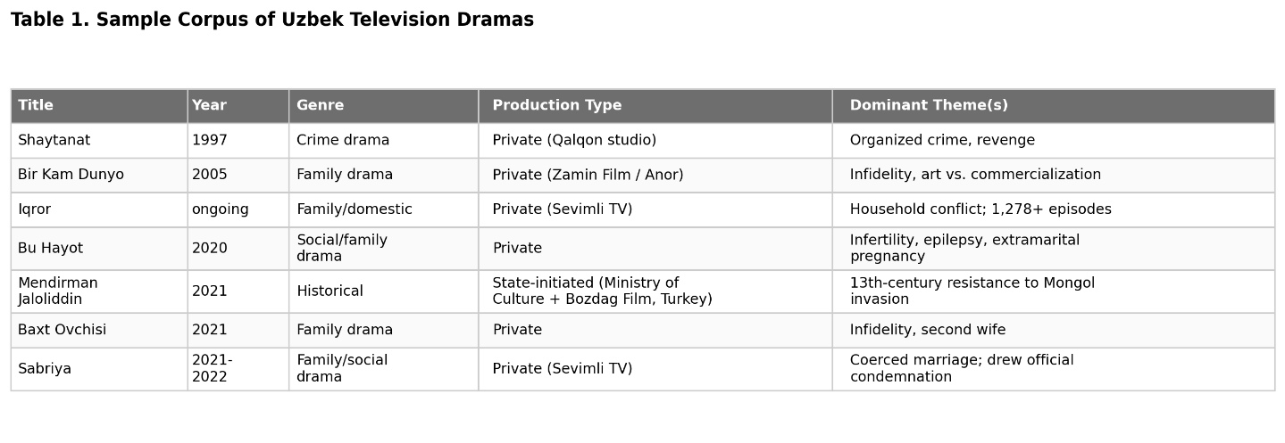
Of the seven titles sampled, six are privately produced with thematic content centered on domestic or family conflict; only Mendirman Jaloliddin departs from this pattern in both genre and production origin.
Figure 1 below shows the number of notable Uzbek series titles by year, based on the dated titles appearing in the sources reviewed for this study (Ganiyeva, 2024) and the student's own corpus. This is not a comprehensive count of the entire industry, since no centralized production database exists for Uzbek television. Still, it is useful because it visualizes a pattern Ganiyeva (2024) also describes in prose: a long gap after Shaytanat's 1997 debut, during which private multi-series production was effectively suspended, followed by a marked concentration of new titles after 2018.

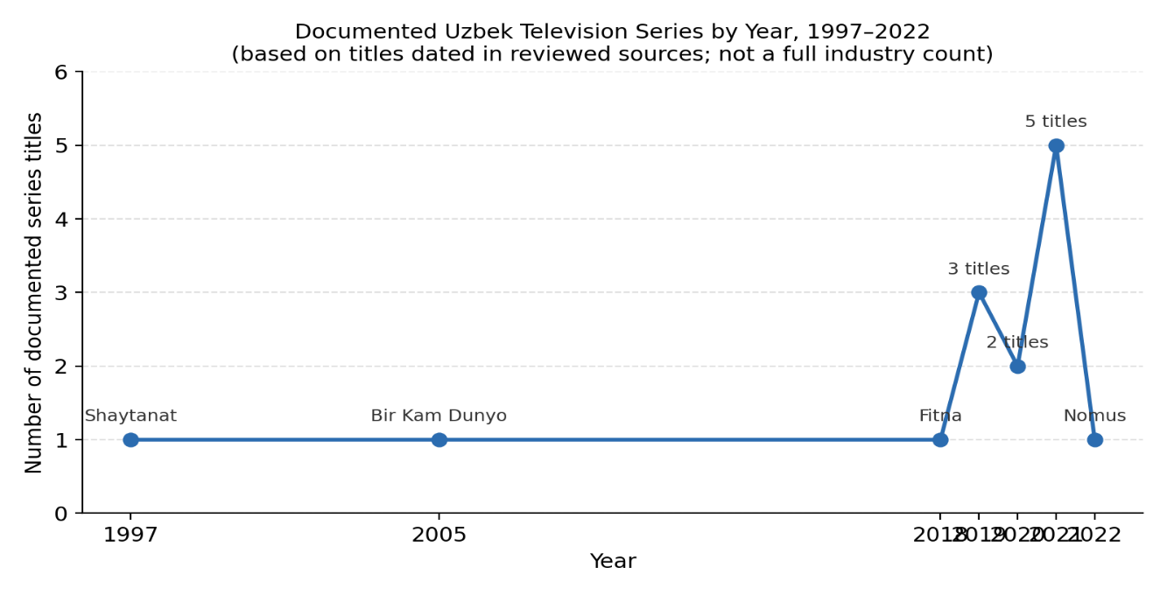This pattern stands in contrast to both comparative cases. Jabbour (2017) shows that even Turkey's most successful romantic dramas (e.g., Gümüş) embed domestic and family themes within a broader narrative of modernization, business success, and social mobility — the family drama functions as a vehicle for a larger "Islam-compatible modernity" narrative rather than an end in itself. The Uzbek corpus, by contrast, rarely extends the domestic conflict into this kind of broader thematic frame, a gap that helps explain why, unlike Turkish or Korean dramas, none of the sampled Uzbek series have documented export success outside Uzbekistan's immediate domestic audience.
State Involvement: A Middle Position Between the Korean and Turkish Models
The comparative framework established in the Methodology distinguishes between Korea's state-directed cultivation of soft power and Turkey's organic, privately driven model that the state only later capitalized on. Uzbekistan's television industry occupies neither position cleanly. The great majority of the sampled corpus, including all ten titles listed by Ganiyeva (2024) from the 2018–2022 period, were produced by private studios (e.g., Sevimli TV–commissioned productions) with no apparent state involvement in either financing or content direction, resembling the Turkish pattern of organic, commercially driven production.
The clear exception is Mendirman Jaloliddin (2021), a historical-biographical series whose production was directly initiated by Uzbekistan's Minister of Culture, Ozodbek Nazarbekov, and produced in partnership with the Turkish studio Bozdag Film, the same production company associated with Turkey's own state-endorsed historical dramas discussed by Çetinkaya (2020). This makes Mendirman Jaloliddin the single clearest instance of deliberate, state-initiated soft-power cultivation in the Uzbek corpus, directly paralleling both the Korean model of top-down cultural investment (Lee, 2009) and Turkey's use of Ottoman-themed historical drama as a nation-building instrument (Çetinkaya, 2020). That this is an isolated case within an otherwise commercially driven industry suggests Uzbekistan has not yet developed a sustained state strategy comparable to Korea's Cultural Industry Bureau or Turkey's TRT-driven promotion of Resurrection: Ertuğrul — it has, at most, a single pilot case.
Hybridity and Export Viability
Following the glocalization framework applied to the Korean case (Glodev, Wijaya, & Ida, 2023), Mendirman Jaloliddin is also the corpus's strongest example of hybrid content designed for cross-border legibility: its co-production structure, mixed Uzbek–Turkish cast, and subject matter (the resistance of Jaloliddin Manguberdi against the Mongol invasion) situate a nationally significant historical figure within a narrative frame and production standard already familiar to international audiences of Turkish historical drama. No other title in the sample shares this characteristic. The remainder of the corpus, including high-reach series such as Iqror, which has produced more than 1,278 episodes and individual episodes attracting audiences in the hundreds of thousands on YouTube, shows no evidence of the kind of deliberate cross-border format adaptation that Jabbour (2017) identifies as central to Turkish soap operas' Middle Eastern success, nor the international investment interest that Korean drama has attracted (e.g., Netflix's reported $2.5 billion commitment to Korean content between 2023 and 2027). Reach, in other words, is domestically substantial but not yet structured for export.
Domestic Contestation: High Reach Does Not Mean Uncontested Reception
The corpus provides clear evidence that Uzbek audiences are not passive consumers of this content, a pattern consistent with the contestation documented in both comparative cases. Table 2 sets out the clearest reach-versus-contestation data points identified in this corpus.
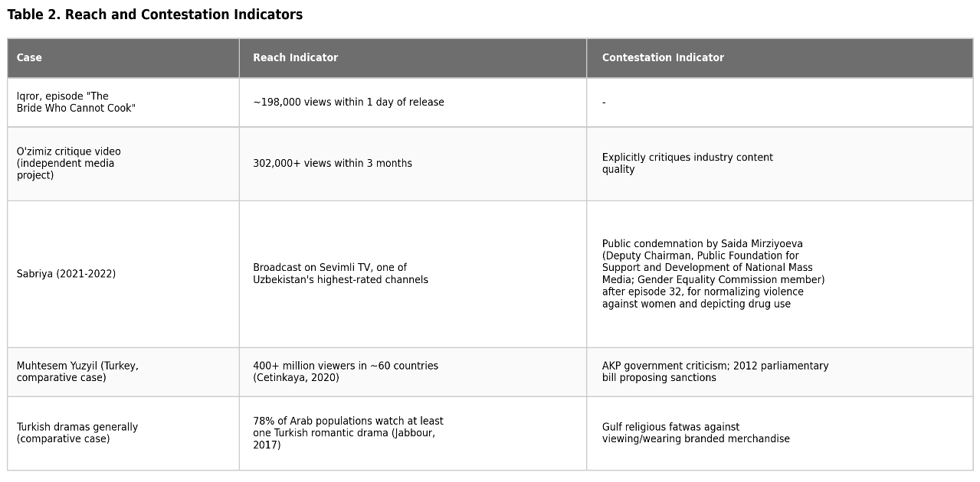
The clearest Uzbek example is the 2022 series Sabriya, whose depiction of a young woman coerced into becoming a second wife drew direct public condemnation from Saida Mirziyoeva (Ganiyeva, 2024). This represents the closest domestic parallel to the institutional backlash Çetinkaya (2020) documents against Muhteşem Yüzyıl and the religious fatwas Jabbour (2017) documents against Turkish dramas in the Gulf — in all three cases, content that achieved high audience reach simultaneously triggered official or quasi-official condemnation, indicating that popularity and institutional legitimacy are not the same currency.
A second, independent indicator of contestation is visible in the near-comparable scale of the Iqror and O'zimiz figures in Table 2: a single popular episode and a critique of the industry's content quality drew views within the same order of magnitude. This suggests that criticism of the industry circulates nearly as widely as the content itself, evidence of an active, engaged domestic discourse rather than uncritical mass consumption, and a pattern this study's Methodology anticipated would be present but had not yet confirmed with specific figures.
Summary of Findings
Table 3 synthesizes the three comparative dimensions established in the Methodology across all three cases.
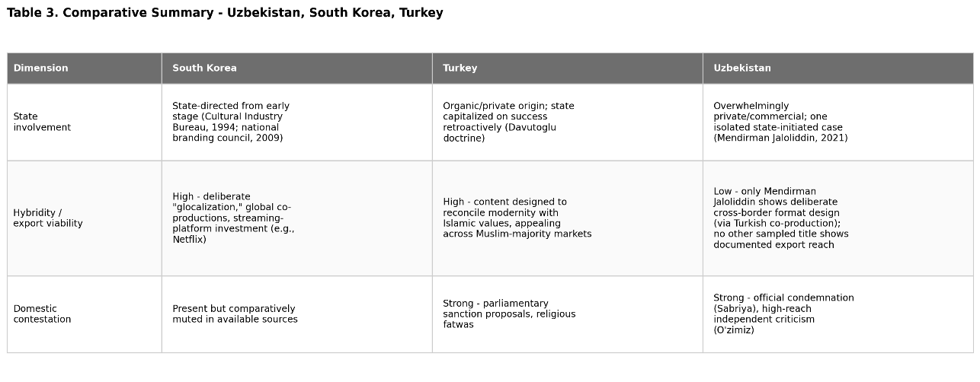Three findings emerge from this comparison. First, Uzbekistan's television industry is overwhelmingly commercially driven and thematically concentrated in domestic/family conflict, with only one clear instance (Mendirman Jaloliddin) of the kind of deliberate, state-initiated, internationally legible content production that has driven Korean and Turkish soft power. Second, this single exception directly borrows the Turkish co-production model rather than representing an independently developed Uzbek strategy, suggesting Uzbekistan is currently better positioned to adapt an existing regional model than to originate a wholly new one. Third, domestic reception data indicate that Uzbek audiences already possess the critical engagement necessary to support higher-quality, more internationally viable content — the Sabriya and O'zimiz cases show that large audiences are willing to publicly contest content they view as regressive, which suggests demand-side receptivity to change is not the primary barrier to improving the industry's soft-power potential; production strategy and, to a lesser extent, state investment, are.
Discussion
How Content Patterns Shape Domestic Discourse
The findings suggest that Uzbekistan's current content pattern is already generating a substantial domestic discourse, but one that runs largely parallel to, rather than in dialogue with, the production industry itself. The near-comparable reach of Iqror and the O'zimiz critique (Table 2) indicates an audience that consumes domestic drama in large numbers while simultaneously sustaining an active critical conversation about its quality. This matches the pattern Ganiyeva (2024) identifies and extends it with reception data: Uzbek civil society already includes the kind of engaged, critical public that Çetinkaya (2020) shows shaping, and being shaped by, Turkey's soap-opera debates, and that Jabbour (2017) shows contesting Turkish content across the Gulf. The difference is that in Turkey, this contestation occurs alongside active government engagement (both supportive and critical) with the industry's direction; in Uzbekistan, official engagement remains largely reactive and isolated to individual controversies such as Sabriya, rather than reflecting a sustained content strategy.
How Content Patterns Shape Uzbekistan's Image Abroad
The research question also asks how current content shapes Uzbekistan's cultural image abroad. The evidence here points to a passive rather than deliberate process. Because Uzbek television content already circulates informally among neighboring Central Asian audiences via YouTube, without the kind of deliberate export strategy Jabbour (2017) documents for Turkish dramas or the state-cultivated international distribution Lee (2009) documents for Korean dramas, Uzbekistan's international cultural image is currently being shaped by whichever content happens to travel, rather than by content selected or adapted for that purpose. Given that the dominant genre remains domestic/family conflict (Table 1), this raises the possibility that regional audiences' impressions of Uzbekistan are disproportionately shaped by exactly the kind of repetitive domestic narrative that has already drawn sustained domestic criticism, an unintended and likely undesirable form of informal soft power.
Weighing the Turkish and Korean Models for Uzbekistan
The comparative evidence in Table 3 suggests the Turkish model may currently be the more immediately viable path for Uzbekistan, for two reasons. First, Mendirman Jaloliddin already demonstrates that Turkish co-production partnerships are accessible to Uzbek producers, whereas the Korean model's reliance on sustained, large-scale state cultural investment (a dedicated bureau, national branding council, and decades of accumulated infrastructure) represents a far larger and slower undertaking. Second, Jabbour's (2017) finding that Turkish soft power succeeded by reconciling modernity with religious and social conservatism, rather than by suppressing or ignoring domestic values, offers a closer cultural template for Uzbek content than Korea's more secular, youth-oriented pop-culture model.
However, Ainslie's (2016) critique of Hallyu in Laos is an important caution against treating either model as a template to imitate uncritically. Ainslie's central warning, that soft-power narratives of "mutual exchange" and "cultural affinity" can obscure real inequality and one-sided benefit, is a reminder that the goal of improving Uzbek television content should not be reduced to its diplomatic utility. The domestic contestation documented in this study (Table 2) suggests Uzbek audiences are themselves primarily concerned with representation and content quality, not with Uzbekistan's international image. Any strategy for improving the industry's soft-power potential should treat domestic audience concerns, particularly around the representation of women, raised explicitly in the Sabriya case, as a legitimate end in itself, not merely as an instrument to be managed in service of an external branding goal.
Limitations Revisited
As stated in the Methodology, this study's conclusions are constrained by its reliance on YouTube metrics as an imperfect proxy for domestic reach, its dependence on secondary literature for the Korean and Turkish comparative cases, and the absence of independent coding verification. A further limitation, visible in hindsight, is that the corpus (Table 1) is small and was assembled primarily from titles already discussed in existing secondary sources (Ganiyeva, 2024, and the student's own prior research) rather than from a systematic survey of the full population of Uzbek television dramas; a larger, independently sampled corpus would be needed to confirm that the patterns identified here hold across the industry as a whole.
Conclusion
This study asked how the current content pattern of Uzbek television dramas shapes both domestic public discourse and Uzbekistan's cultural image abroad, compared to the Korean and Turkish models of televisual soft power. The evidence indicates that Uzbekistan's industry remains concentrated in domestic and family-conflict narratives, produced almost entirely through private commercial channels, with a single notable exception, the state-initiated, Turkish-co-produced historical drama Mendirman Jaloliddin, that offers a proof of concept for a different approach. Domestically, this content pattern coexists with an active and critical audience discourse, evidenced by the comparable reach of popular episodes and public critiques of the industry, as well as direct institutional condemnation in the Sabriya case. Internationally, in the absence of a deliberate export or co-production strategy comparable to Turkey's or Korea's, Uzbekistan's cultural image abroad is currently shaped passively by informal cross-border circulation of content that was never designed with an international audience in mind.
The comparative cases suggest that Uzbekistan does not lack the raw materials for soft power: a substantial and engaged domestic audience, a marketable historical and cultural heritage, and at least one successful co-production precedent, but rather a sustained strategy for connecting these elements, of the kind Turkey and South Korea each developed, through different means, over more than a decade. At the same time, Ainslie's (2016) critique of Hallyu's uneven benefits is a reminder that such a strategy should be evaluated first by whether it serves Uzbek audiences and creators, and only secondarily by whether it enhances Uzbekistan's regional or international image.
Future research building on this study should expand the corpus beyond the titles examined here, incorporate original interviews with Uzbek producers and officials (a resource this study, conducted without such access, could not draw on), and track whether Mendirman Jaloliddin's co-production model is repeated in subsequent state-backed projects, which would be the clearest indicator of whether Uzbekistan is moving toward a deliberate soft-power strategy or whether this case remains an isolated experiment.

References:
Ainslie, M. J. (2016). Korean overseas investment and soft power: Hallyu in Laos. Korea Journal, 56(3), 5–32.
Çetinkaya, C. (2020). Rising Ottoman nostalgia in Turkish popular culture: An analysis of Turkey's Europeanization process and Ottoman-themed soap operas. Politikon: The IAPSS Journal of Political Science, 46, 8–28.
Ganiyeva, E. R. (2024). National television series of Uzbekistan: Achievements and shortcomings. Inter Education & Global Study, (10), 482–492.
Glodev, V., Wijaya, G., & Ida, R. (2023). The Korean Wave as the globalization of South Korean culture. WACANA: Jurnal Ilmiah Ilmu Komunikasi, 22(1), 108–120.
Jabbour, J. (2017). Winning hearts and minds through soft power: The case of Turkish soap operas in the Middle East. In N. Lenze, C. Schriwer, & Z. Abdul Jalil (Eds.), Media in the Middle East: Activism, politics, and culture (pp. 145–163). Palgrave Macmillan.
Kim, Y. M., & Marinescu, V. (2015). Mapping South Korea's soft power: Sources, actors, tools, and impacts. Romanian Journal of Sociological Studies, 2015(1), 1–10.
Lee, G. (2009). A soft power approach to the "Korean Wave." The Review of Korean Studies, 12(2), 123–137.

