Power BI Assignment 1 – Data Transformation & Data Modeling

Prepared By: Jasmine S
Module: Data Analytics (DA) – Module 2
Tool Used: Microsoft Power BI

Introduction

This project focuses on performing data transformation, cleaning, aggregation, merging, and data modeling using Power BI. The dataset contains E-commerce sales information including order details, product categories, customer locations, and sales targets.

Dataset Information

The following datasets were imported into Power BI:

  - List of Orders
  - Order Details
  - Sales Target

Data Import & Transformation

The datasets were imported into Power BI and transformed using Power Query Editor. The following transformations were performed:

  - Restricted List of Orders to first 500 rows
  - Changed Order Date datatype to Date
  - Changed Amount and Target columns to Fixed Decimal Number
  - Formatted Customer Name into Proper Case
  - Created Location column by merging City and State
  - Created Profit Margin custom column
  - Added Profit Status conditional column

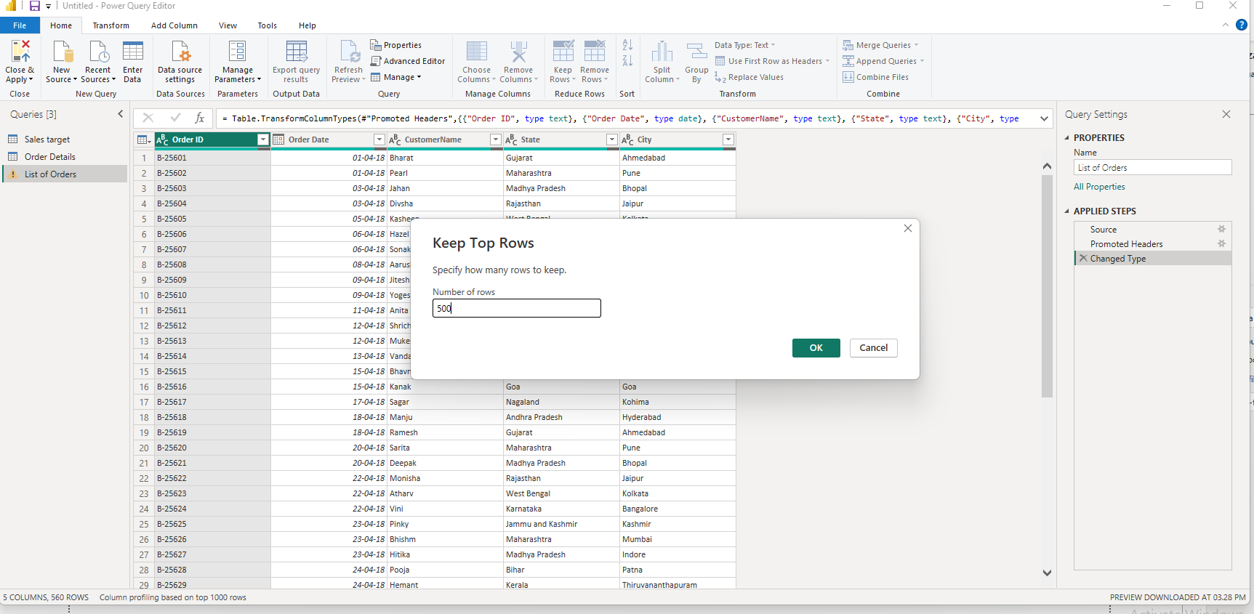

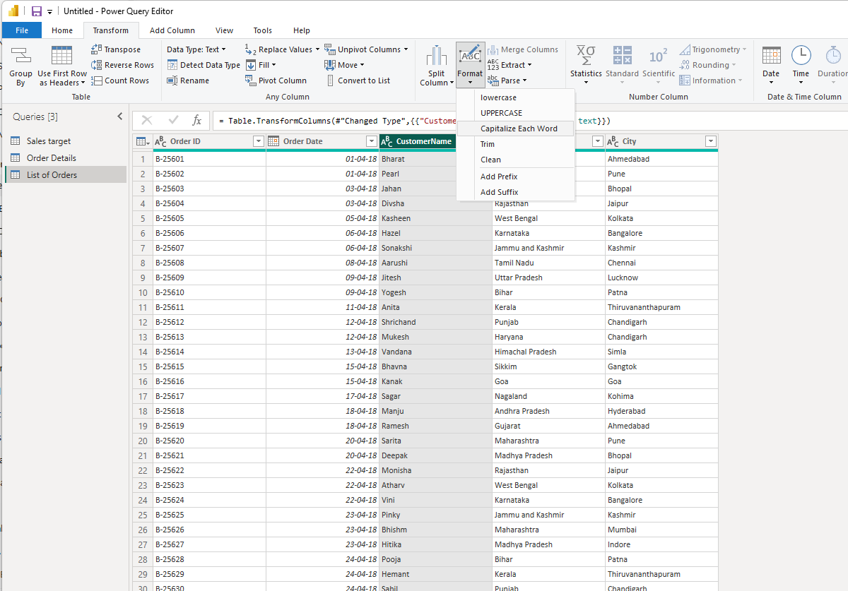

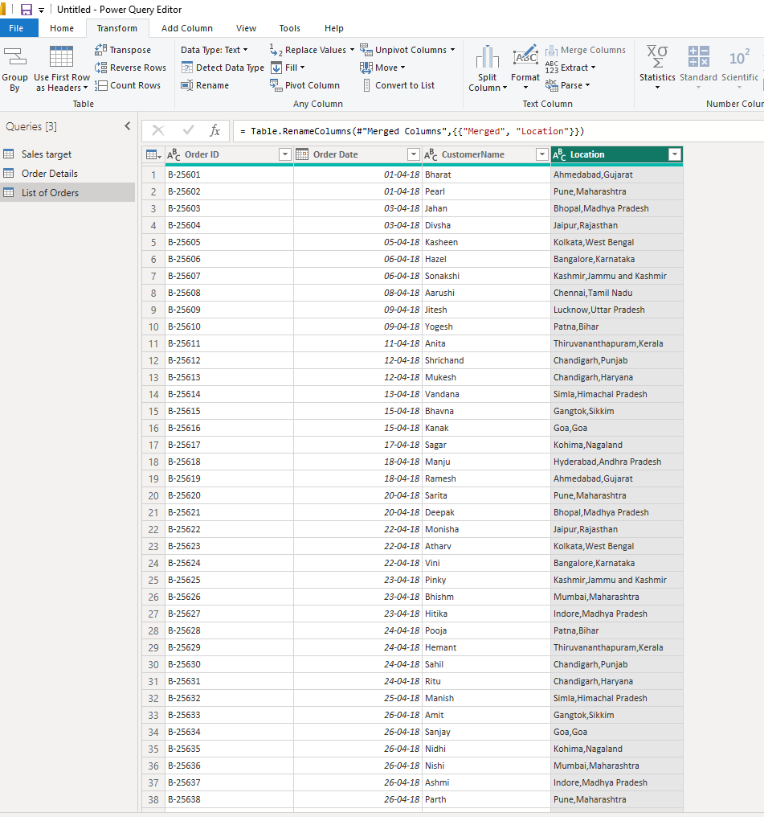

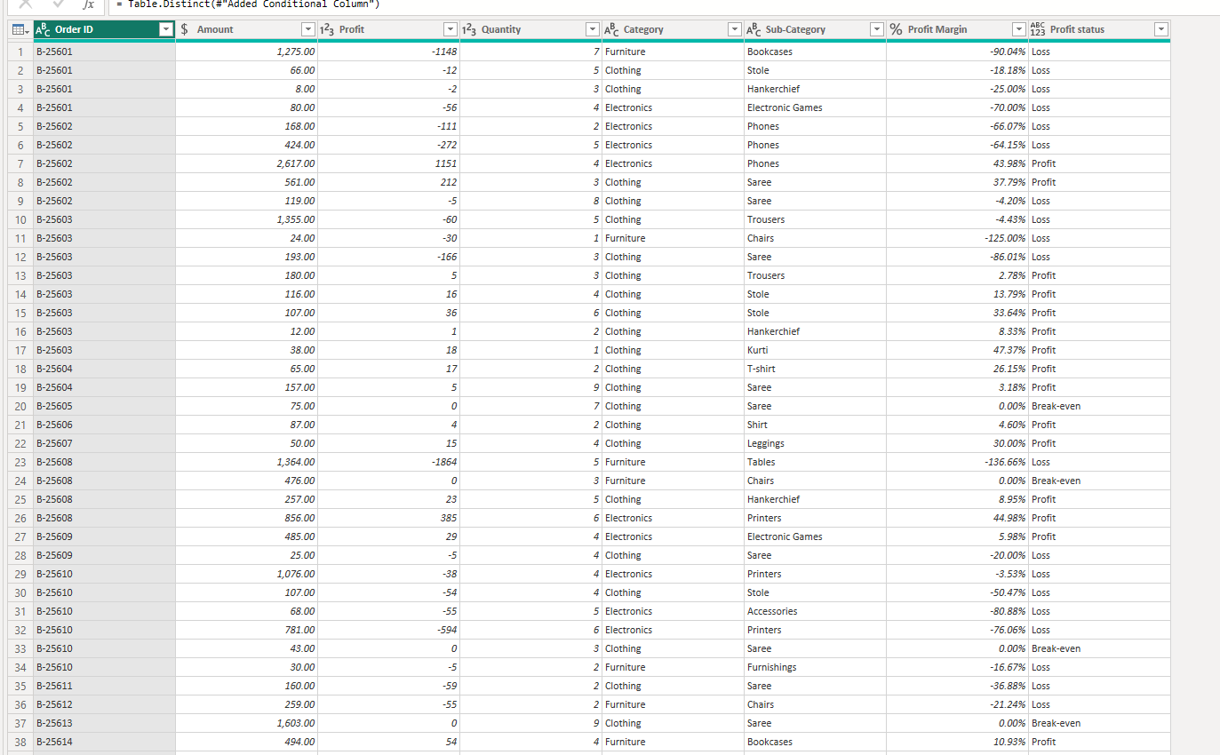

Data Merging

List of Orders and Order Details tables were merged using Order ID to create a consolidated table named Orders Data.

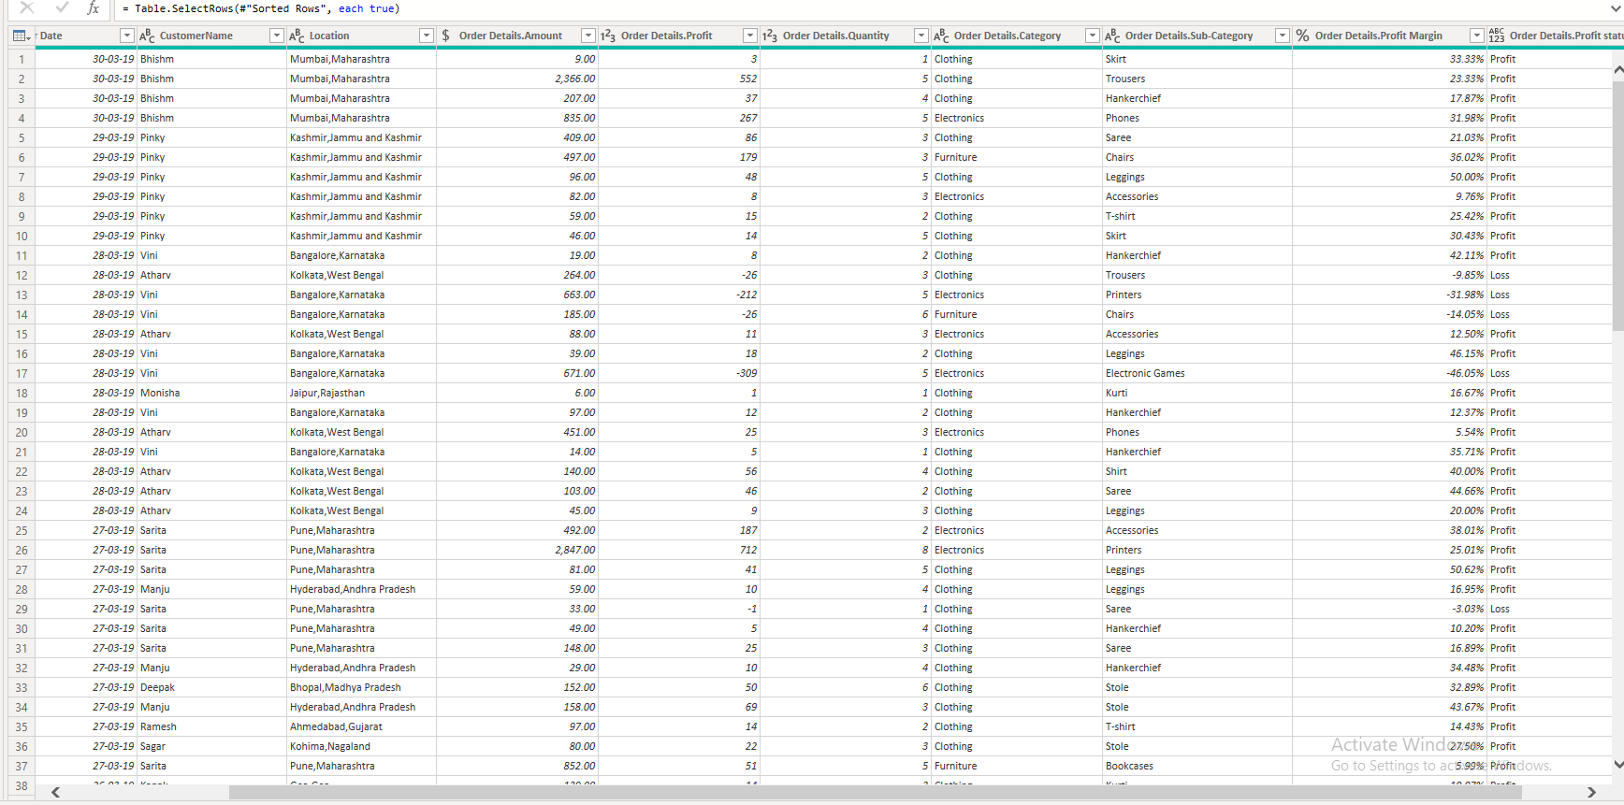

Missing Values & Duplicate Handling

The datasets were checked for missing values and duplicate records. Appropriate handling strategies such as retaining valid business records and removing unnecessary duplicates were applied.

Sorting & Filtering

The Orders Data table was sorted by Order Date in descending order. Filters were applied to analyze orders from specific states such as Tamil Nadu.

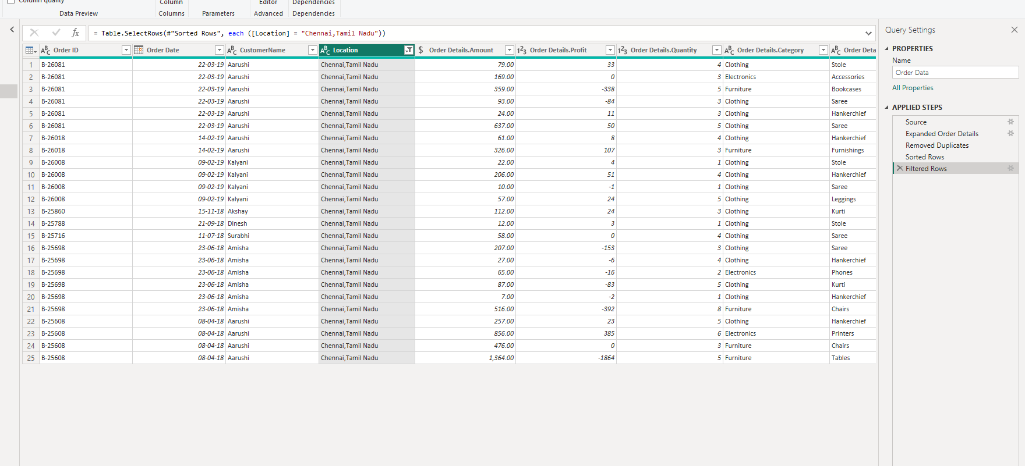

Grouping & Aggregation

Aggregated tables were created using duplicate queries:

  - Count of Order ID
  - Average Profit by Category
  - Total Amount by Sub-Category
  - Total Target by Month of Order Date

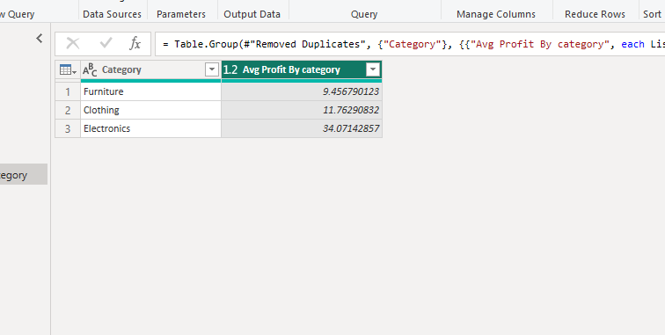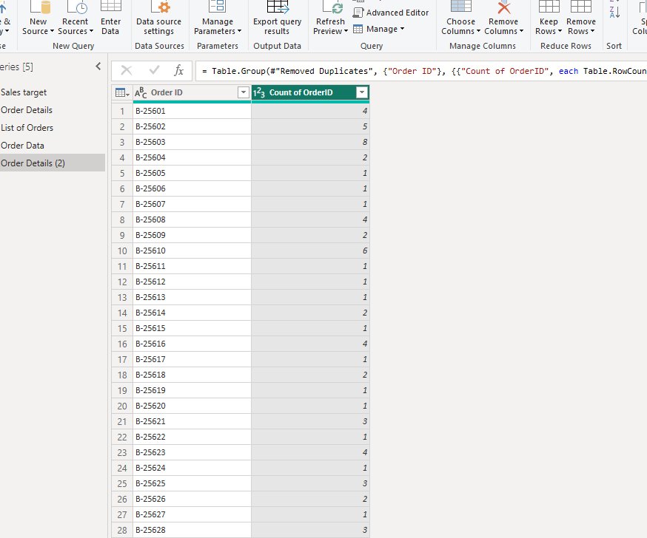

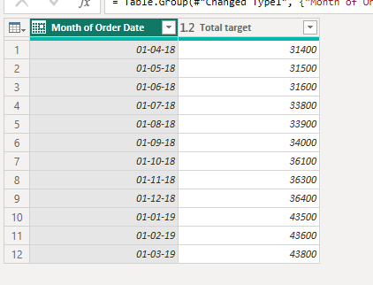

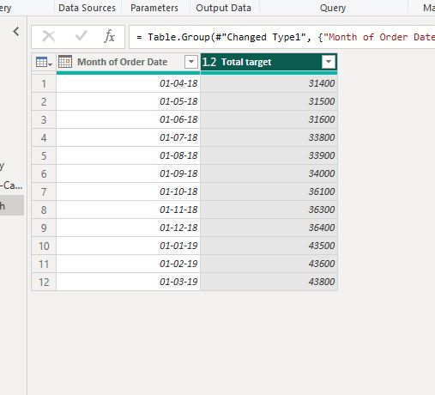

Data Modeling

Relationships were created and managed in Model View:

  - List of Orders ↔ Order Details using Order ID
  - Order Details ↔ Sales Target using Category

Relationships were active and correctly configured using Manage Relationships.

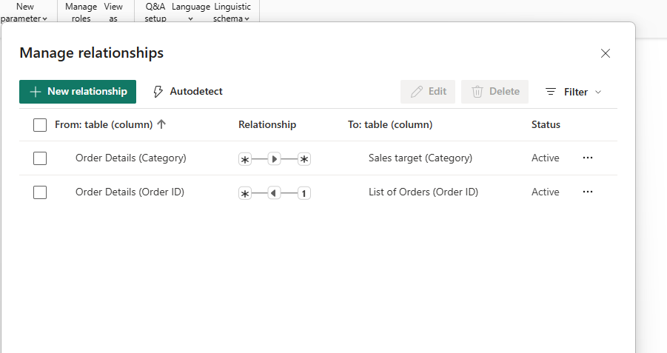

Conclusion

This project demonstrates practical knowledge of Power BI data transformation, aggregation, data integration, and relationship modeling techniques. The final data model was cleaned, structured, and prepared for business analysis.

