WEEK 1 TASK
Data Science Project Planning and Strategy Design
Hypothetical Project: Employee Attrition Risk Prediction Using Python

1. Project Background & Introduction
Employee turnover can increase recruitment costs, reduce productivity, and create knowledge gaps within an organization. This hypothetical data science project proposes a Python-based system to analyze employee information and predict the likelihood that an employee may leave the organization. The purpose is not to make employment decisions automatically, but to provide HR teams with evidence-based insights so that retention strategies can be planned responsibly.
The project will follow a structured data science lifecycle: problem definition, data collection, data cleaning, exploratory data analysis, feature engineering, model development, evaluation, interpretation, and reporting.

2. Project Motivation & Problem Statement
Organizations often have employee data such as tenure, job role, satisfaction, salary band, overtime, workload, performance, and promotion history. However, raw records do not directly reveal which factors are associated with attrition. A predictive approach can identify patterns and help decision-makers understand where retention efforts may be useful.
Problem statement: Develop and evaluate a hypothetical machine-learning pipeline that estimates an employee's attrition risk from historical employee attributes while emphasizing model validation, interpretability, privacy, and responsible use.

3. Project Objectives & Scope
Objectives:
- Define a clear target variable: whether an employee left the organization during the observation period.
- Prepare a reproducible Python workflow for data validation, cleaning, analysis, and modeling.
- Identify the major variables associated with employee attrition.
- Build baseline and machine-learning classification models.
- Compare models using appropriate validation metrics rather than accuracy alone.
- Produce interpretable findings and practical retention recommendations.
- Document limitations, ethical risks, and mitigation strategies.
In scope:
- Historical employee records and relevant HR attributes.
- Data quality assessment and preprocessing.
- Exploratory data analysis and visualization.
- Binary classification for attrition risk.
- Model comparison, validation, and error analysis.
- A final report/dashboard-style summary of findings.
Out of scope:
- Automatically deciding hiring, firing, promotion, or compensation.
- Real-time employee surveillance.
- Collecting unnecessary sensitive personal information.
- Deploying the model into a production HR system during this project.
- Guaranteeing that the model can predict an individual employee's future behavior.

4. Proposed Data & Variables
Category | Example Variables | Purpose
Employee profile | Age band, department, job role | Segment analysis
Work history | Years at company, years in role, promotions | Tenure and career progression
Work conditions | Overtime, workload indicator, work mode | Work environment patterns
Compensation | Salary band, bonus band | Compensation-related patterns
Engagement | Satisfaction score, engagement score | Employee experience
Performance | Performance rating, training hours | Performance and development
Target | Attrition (Yes/No) | Prediction target

5. Methodology & Strategy
The project will use a CRISP-DM-inspired workflow adapted for a Python data science project. Each stage will produce a clear output that becomes an input for the next stage.

5.1 Data Collection
For the hypothetical implementation, a structured CSV or database extract will be assumed. The dataset should contain a data dictionary describing each field, data type, allowed values, and the time period covered. Access permissions and privacy requirements will be confirmed before analysis.

5.2 Data Cleaning & Preprocessing
- Inspect dimensions, data types, unique values, and duplicate records.
- Measure missingness and decide whether to impute, remove, or flag missing values.
- Standardize category labels and date formats.
- Detect unreasonable values and investigate potential outliers.
- Encode categorical variables using one-hot or appropriate ordinal encoding.
- Scale numerical features where required by the selected model.
- Separate the target variable before modeling and prevent target leakage.
- Create a reproducible preprocessing pipeline.

5.3 Exploratory Data Analysis (EDA)
EDA will examine attrition rates across departments, roles, tenure groups, overtime status, satisfaction levels, salary bands, and other relevant variables. Histograms, bar charts, box plots, correlation analysis, and grouped summaries will be used. EDA findings will guide feature engineering and model selection without being treated as proof of causation.

5.4 Feature Engineering
- Create meaningful tenure groups from continuous tenure values.
- Create promotion-gap or role-stability indicators when appropriate.
- Convert suitable ordinal ratings into consistent numerical representations.
- Remove redundant or leakage-prone variables.
- Document every engineered feature and its rationale.

5.5 Modeling
The first model will be a Logistic Regression baseline because it is relatively interpretable. Additional candidates may include Decision Tree, Random Forest, and Gradient Boosting. A stratified train/validation/test strategy will be used where appropriate, with cross-validation on the training portion for model selection.

5.6 Evaluation
Because attrition classes may be imbalanced, evaluation will not rely only on accuracy. Precision, recall, F1-score, ROC-AUC, and confusion matrices will be considered. The project will also review false positives and false negatives because their practical impact can differ. If probabilities are produced, calibration will be considered.

5.7 Interpretation & Reporting
The final report will explain the strongest observed predictors, model performance, limitations, and practical recommendations. Feature importance or model explanation methods will be used carefully to distinguish association from causation.

6. Project Architecture / Workflow
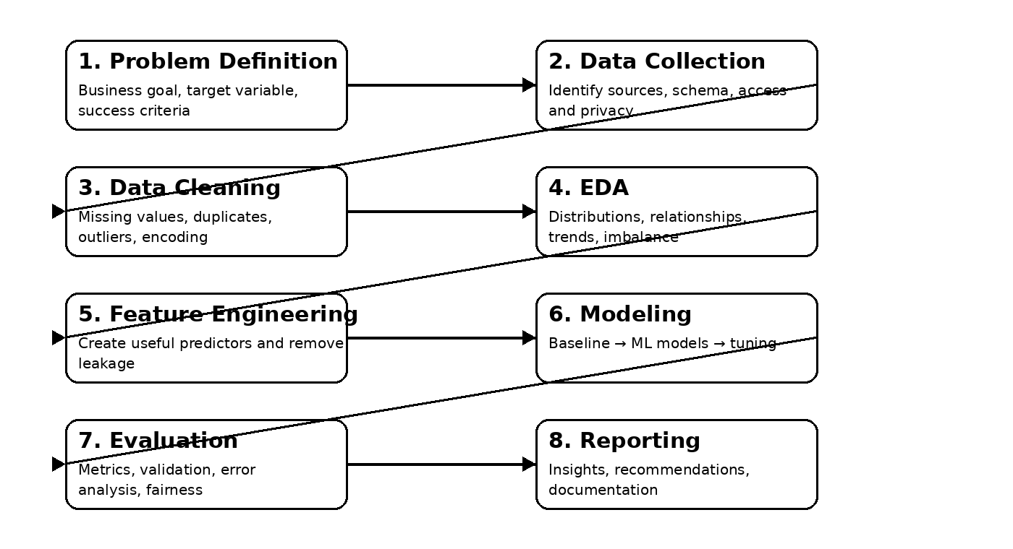
Figure 1. Proposed end-to-end data science workflow

7. Python Libraries & Tools
Tool / Library | Planned Use
Python | Primary programming language
Jupyter Notebook / VS Code | Development, experimentation, and documentation
Pandas | Data loading, cleaning, transformation, and tabular analysis
NumPy | Numerical operations
Matplotlib / Seaborn | Data visualization
Scikit-learn | Preprocessing, modeling, cross-validation, and metrics
Joblib | Saving preprocessing/model artifacts if required
Git / GitHub | Version control and project history

8. Timeline & Work Allocation (30–35 Hours)
Activity | Hours | Main Output
Project definition & success criteria | 2.5 | Problem statement, scope, target, assumptions
Data source & schema planning | 3.0 | Data dictionary and collection plan
Data cleaning strategy | 4.0 | Missing values, duplicates, validation rules
EDA plan & visualizations | 4.0 | Questions, plots, subgroup analysis
Feature engineering & preprocessing | 4.0 | Feature definitions and pipeline design
Model selection & experiment plan | 4.0 | Baseline, candidate models, CV
Evaluation & error analysis | 3.5 | Metrics, confusion matrix, model comparison
Risk, ethics & mitigation | 2.0 | Privacy, fairness, responsible-use controls
Documentation & diagrams | 3.0 | Report structure, flowchart, tables
Final review & submission | 2.0 | Quality check and formatting
Total planned effort: 32.0 hours.

9. Expected Outcomes & Benefits
- A clearly documented end-to-end data science project plan.
- A reproducible Python architecture for preparing and modeling HR data.
- A ranked set of model candidates with justified evaluation criteria.
- Identification of patterns associated with higher or lower attrition risk.
- A practical reporting structure that converts analytical findings into decision-support insights.
- A documented set of ethical and operational safeguards.

10. Anticipated Challenges & Mitigation Strategies
Challenge | Mitigation
Class imbalance | Use stratified splits, suitable metrics, class weights/resampling where justified, and inspect recall/precision.
Missing or inconsistent data | Create validation rules, document assumptions, and perform sensitivity checks.
Data leakage | Split data correctly and fit preprocessing only on training data.
Overfitting | Use cross-validation, regularization, simpler baselines, and hold-out testing.
Model interpretability | Prefer interpretable baselines and use feature-importance/explanation methods carefully.
Fairness concerns | Avoid unnecessary sensitive attributes, test subgroup performance where appropriate, and keep human oversight.
Privacy | Minimize personal data, use anonymized identifiers, restrict access, and follow organizational policies.
False alarms | Tune decision thresholds based on the intended use and communicate uncertainty.
Correlation mistaken for causation | State findings as associations and avoid unsupported causal claims.

11. Success Criteria
- The project plan clearly defines the problem, objectives, scope, inputs, outputs, and assumptions.
- The proposed workflow is logically organized and reproducible.
- The methodology covers collection, cleaning, exploration, modeling, and evaluation.
- Model evaluation uses multiple appropriate metrics and validation procedures.
- The plan explicitly addresses privacy, fairness, leakage, and limitations.
- The 30–35 hour work allocation is realistic and traceable to project activities.
- The final document contains clear diagrams/tables and can guide the later technical implementation.

12. Final Deliverables
- Project planning and strategy document.
- Data dictionary / assumed schema.
- EDA and preprocessing plan.
- Modeling and evaluation plan.
- Workflow diagram.
- Timeline and effort allocation.
- Risk, ethics, and mitigation section.
- Final recommendations and implementation roadmap.

13. Conclusion
This project plan establishes a structured approach to a hypothetical employee attrition prediction problem using Python. It emphasizes the complete data science lifecycle rather than focusing only on model building. By combining data quality checks, EDA, responsible feature engineering, multiple classification approaches, robust evaluation, and ethical safeguards, the project can produce useful decision-support insights while reducing the risks of misleading or inappropriate predictions.

Prepared for Week 1 – Data Science Project Planning and Strategy Design

