**What is Azure ?**  
  
Azure is a cloud platform designed to simplify the process of building modern applications.

**Key Azure services**

1. App hosting and compute: a. Azure App Service

b. Azure Virtual Machines

c. Azure Kubernetes Services

d. Azure Container Instances

2. Storage   
 Azure Blob Storage

3. Identity and Security

a. Azure Key Vault

b. Microsoft Intra Id

4. Management

Azure Monitor

**Source-code hosting**

who want to start **new development**, use the following chart to find the suggested hosting solution.

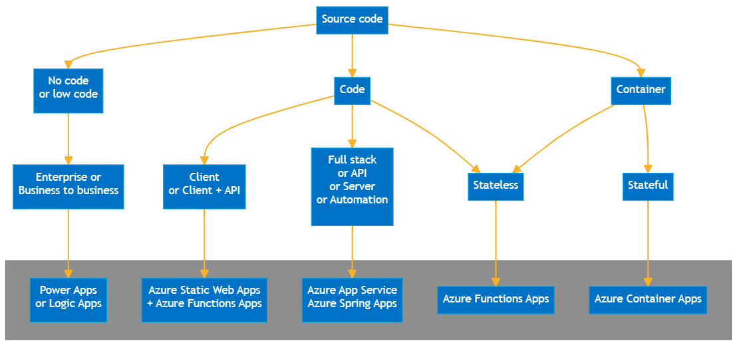

Azure Logic Apps is a cloud platform where you can create and run automated workflows with little to no code. By using the visual designer and selecting from prebuilt operations, you can quickly build a workflow that integrates and manages your apps, data, services, and systems.

[Azure Static Web Apps](https://learn.microsoft.com/en-us/azure/static-web-apps): deploy generated static web apps.

* [Azure Functions](https://learn.microsoft.com/en-us/azure/azure-functions): deploy code functions in supported languages without having to manage the application infrastructure.

**Code-first** hosting solutions are designed to host code. You can deploy your code directly to the hosting solution.

* [Azure App Service](https://learn.microsoft.com/en-us/azure/app-service): full-service web hosting.
* [Azure Spring Apps](https://learn.microsoft.com/en-us/azure/spring-apps): Spring Boot applications.

|  |  |
| --- | --- |
| * [Azure Container Apps](https://learn.microsoft.com/en-us/azure/container-apps): | serverless container hosting |
| * [Azure Container Instances](https://learn.microsoft.com/en-us/azure/container-instances): | simple, single container hosting |

Azure provides a container registry to store and manage your container images or you can use a third-party container registry.

| **Service** | **Use** |
| --- | --- |
| [Azure Container Registry](https://learn.microsoft.com/en-us/azure/container-registry) | Use when you build and host your own container images, which can be triggered with source code commits and base image updates. |

**Azure resource group**

**A Resource Group in Azure is a logical container to group Azure Resources together. Every Azure resource must belong to one and only one resource group.**

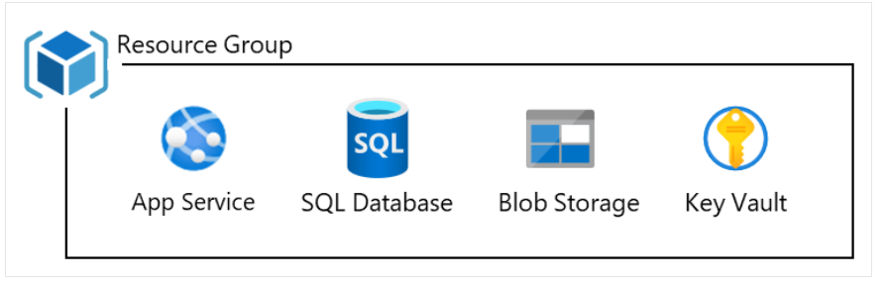

NOTE: **Stateless code** refers to applications or services that don’t retain any information between requests. Each request is treated as independent, with no memory of previous interactions. Stateless services can scale more easily because they don’t need to synchronize data between instances. built on Azure Functions, AKS, or Azure App Service

**Use Case**: Processing individual events such as HTTP requests, database changes, or messages from a queue.

**Example**: A function that responds to an HTTP request and returns a calculation result without needing to store any session data.

NOTE: **Stateful code** retains information (or state) between different requests or executions. This can involve managing user sessions, maintaining in-memory data, or tracking the progress of long-running processes. Azure offers several services to help manage stateful applications.  
built using Azure Durable Functions, Service Fabric, or AKS with persistent storage

• **Use Case**: Handling long-running workflows like order processing, where multiple steps are executed, and the system keeps track of progress.

**Example**: A durable function orchestrates a sequence of tasks (e.g., placing an order, charging a payment, and sending a confirmation email), and the state is saved across those steps.

**Infrastructure as a Service (IaaS) in Azure**

**Definition:** Infrastructure as a Service (IaaS) is a cloud computing model where you rent virtual computers (virtual machines), storage, and networking from a cloud provider. You manage the operating systems, applications, and data, while the provider takes care of the physical hardware and virtualization.  
  
**Azure Virtual Machines** are a key example of IaaS in Azure. They allow you to create and manage virtual computers that run various operating systems. You can use these virtual machines for different purposes, such as hosting websites, running applications, or testing software, without needing to buy or maintain physical hardware.

**Platform as a Service (PaaS)** is a cloud computing model that provides a ready-to-use platform to build, deploy, and manage applications without dealing with the underlying infrastructure. It includes everything needed for application development, such as operating systems, databases, and development tools, while the cloud provider handles the hardware and software maintenance.

**Azure App Services** is a prominent example of PaaS in Azure. It allows you to develop, deploy, and manage web applications and APIs without managing the underlying infrastructure.

**Software as a Service (SaaS)** is a cloud computing model where you access and use software applications over the internet. These applications are hosted and maintained by a cloud provider, so you don’t need to install or manage any software or hardware. You simply use the software through a web browser or client application.

**Use Cases:**

1. **Email and Communication:**
   * **Scenario:** Businesses need a reliable and scalable email and communication solution.
   * **Example:** Using Gmail or Microsoft 365 for business email, calendar, and collaboration tools.

**Create free tier account in azure Portal (** [**https://portal.azure.com/#home**](https://portal.azure.com/#home) **)**

1. Go to the Azure Website

* Open your browser and go to the official [Azure free account page](https://azure.microsoft.com/en-us/free/).

2. Click "Start for Free"

* On the free account page, click the "Start for free" button to begin the registration process.

3. Sign In or Create a Microsoft Account

* If you already have a Microsoft account (e.g., Outlook, Hotmail), sign in using those credentials.
* If you don’t have a Microsoft account, click on "Create one!" to set up a new account. You will need to provide your email address or phone number to sign up.

4. Provide Basic Information

* Enter your personal details, including your name, email, and phone number. This information is required for account verification.

5. Verify Your Identity

* You will be asked to verify your identity through a phone number. You can choose to receive a text or phone call for this purpose.
* After verifying your phone number, you will need to enter payment details (a credit or debit card) for identity verification. Azure will not charge you for free-tier services, but you need a valid payment method to activate the account.

6. Set Up Payment Information

* Enter your payment details (credit or debit card). This is for identity verification purposes. You won’t be charged unless you upgrade to a paid service or exceed the free tier limits.

7. Review and Agree to Terms

* Read the terms of service and privacy policy, then agree to them by checking the corresponding boxes.

8. Complete the Signup

* Once you've completed the above steps, click "Sign Up" to finish creating your free Azure account.
* You’ll be directed to the Azure portal, where you can start using the free services.

What's Included in the Azure Free Account:

* $200 in credits for 30 days to explore and use any Azure service.
* Free tier services include:
  + 750 hours of B1S virtual machines (Linux/Windows) for the first 12 months.
  + 5 GB of Azure Blob Storage, 250 GB of SQL Database storage, and more.
  + Certain services remain free after the 12-month period, within specific limits.

**Create a GitHub account and set ssh keys:**1. Create a GitHub Account

1. Go to GitHub:
   * Visit [GitHub's signup page](https://github.com/join).
2. Enter Your Details:
   * Username: Choose a unique username.
   * Email Address: Provide your email (you can use any email, including Gmail).
   * Password: Create a strong password.
3. Verify your Account:
   * Complete the CAPTCHA and click "Create account".
4. Choose Your Plan:
   * For personal use, select the Free plan. This gives you access to unlimited public and private repositories.
5. Complete Setup:
   * Follow the additional steps (like setting up a profile) and verify your email by clicking the link sent to your inbox.

2. **Generate and Set SSH Keys**

SSH keys allow you to authenticate to GitHub without needing to enter your username and password every time.

**Step 1: Check for Existing SSH Keys**

Before generating a new SSH key, check if you already have one.

1. Open a terminal on your machine.
2. Run the following command to see if you have any SSH keys:

ls -al ~/.ssh

If you see files like id_rsa and id_rsa.pub, you already have SSH keys. If not, proceed to generate a new one.

**Step 2: Generate a New SSH Key**

If you don’t have SSH keys or want to create a new one, follow these steps:

1. In the terminal, run the following command to generate a new SSH key:

ssh-keygen -t ed25519 -C "your_email@example.com"

Replace "your_email@example.com" with the email address you used for your GitHub account.

1. When prompted to "Enter a file in which to save the key", just press Enter to accept the default location (/home/your_user/.ssh/id_ed25519 for Linux/macOS, or C:\Users\your_user\.ssh\id_ed25519 for Windows).
2. You will be prompted to create a passphrase. You can either create one or leave it empty for no passphrase (not recommended for security).

**Step 3: Add the SSH Key to the SSH Agent**

1. Start the SSH agent:
   * For macOS/Linux:

eval "$(ssh-agent -s)"

* + For Windows (in Git Bash):

eval $(ssh-agent)

1. Add your SSH key to the agent:

ssh-add ~/.ssh/id_ed25519

**Step 4: Add the SSH Key to Your GitHub Account**

1. Copy the SSH key to your clipboard:

cat ~/.ssh/id_ed25519.pub

* + Select and copy the entire output.

1. Go to GitHub and sign in.
2. In the upper-right corner, click your profile photo, then go to Settings.
3. In the sidebar, click SSH and GPG keys.
4. Click New SSH key.
5. Give your key a title (like "My Laptop SSH Key"), then paste the key you copied into the Key field.
6. Click Add SSH key and confirm your GitHub password if prompted.

https://docs.github.com/en/authentication/connecting-to-github-with-ssh/generating-a-new-ssh-key-and-adding-it-to-the-ssh-agent

Create Azure DevOps Account :

**1. Sign Up for an Azure DevOps Account**

1. Go to the Azure DevOps Website:
   * Open your browser and go to the [Azure DevOps sign-up page](https://azure.microsoft.com/en-us/services/devops/).
2. **Sign In with a Microsoft Account with same as azure portal.**
3. **Enter Your Credentials**:
   * After signing in, you’ll be prompted to set up your Azure DevOps account.
   * **Choose an organization name**: This is your Azure DevOps organization, which will hold your projects. The name must be unique.
   * **Region**: Select the closest region to you for optimal performance.
   * Click **Continue**.

**2. Set Up Your First Azure DevOps Project**

1. **Create a New Project**:
   * Once your account is created, Azure DevOps will prompt you to create a project.
   * **Enter a project name**: Choose a descriptive name for your project.
   * **Visibility**: Choose between **Public** (for open-source projects) or **Private** (for internal/private use).
   * Click **Create Project**.
2. **Project Organization**:
   * Your new project will have tools like **Repos**, **Pipelines**, **Boards**, **Test Plans**, and **Artifacts** ready for use.
   * You can invite team members, manage repositories, create CI/CD pipelines, and manage work items.

**Some Azure Questions:**  
  
**What are the different types of storage services in Azure?**

* Answer: Azure offers several storage services including Azure Blob Storage (for unstructured data), Azure File Storage (for file shares), Azure Table Storage (for NoSQL data), and Azure Disk Storage (for VM disks).

**What is Azure Virtual Network (VNet)?**

* Answer: Azure VNet is a logically isolated network that allows you to securely connect Azure resources to each other and to on-premises networks. It provides features like subnets, IP address ranges, and network security groups.

**What is Azure Active Directory (AAD)?**

* Answer: Azure Active Directory is a cloud-based identity and access management service that helps you manage user identities and control access to applications and resources. It supports single sign-on (SSO), multi-factor authentication (MFA), and integration with on-premises directories.

**What are the different types of services offered by Azure?**

* Answer: Azure provides several types of services including Infrastructure as a Service (IaaS), Platform as a Service (PaaS), and Software as a Service (SaaS). These include virtual machines, app services, databases, and storage solutions.