# COM601 Assignment 2 Report

By Liam Kelly (B00716443) and Jasmine Ferris (B00715041)

Introduction

For this assignment, our task was to create an address book where a user could search through their contacts and perform functions like updating and deleting contacts. We used GitHub to help create our project and work better as a team. This was useful as we could view each other’s progress while working on the project separately.

Background Research

We decided to look at different address books/contact forms to get an idea of already existing programs. We first looked at Samsung contacts as we both have Samsung mobile phones. The contacts are sorted alphabetically which make it easy to browse through the list. It also starts to filter the contacts when you start typing into the search bar which is a nice feature, especially if a user cannot remember exactly how the contacts information has been entered. You are able to edit, share and delete contact information by clicking on each contact and then clicking ‘edit’. The process is quite long and could be simplified.

The ‘Contacts’ app in Apple devices has a more simplified design and focuses more on the UX design. It has a side panel of contacts and when a contact is selected, it appears on the right side of the screen. This makes the process of editing contacts quicker and more efficient. When the “edit” button is clicked, the fields become editable and can be changed. The system flows well and makes the process simple for the user.

Another address book example we looked at was Google Contacts. At the side bar, it has different features like ‘Frequently Contacted’, ‘Duplicates’ and ‘Labels’. A section like ‘Frequently Contacted’ is useful for a user as it makes it easier and quicker to find contacts that are regularly used.

JSON file and Faker

Loading from JSON to client-side

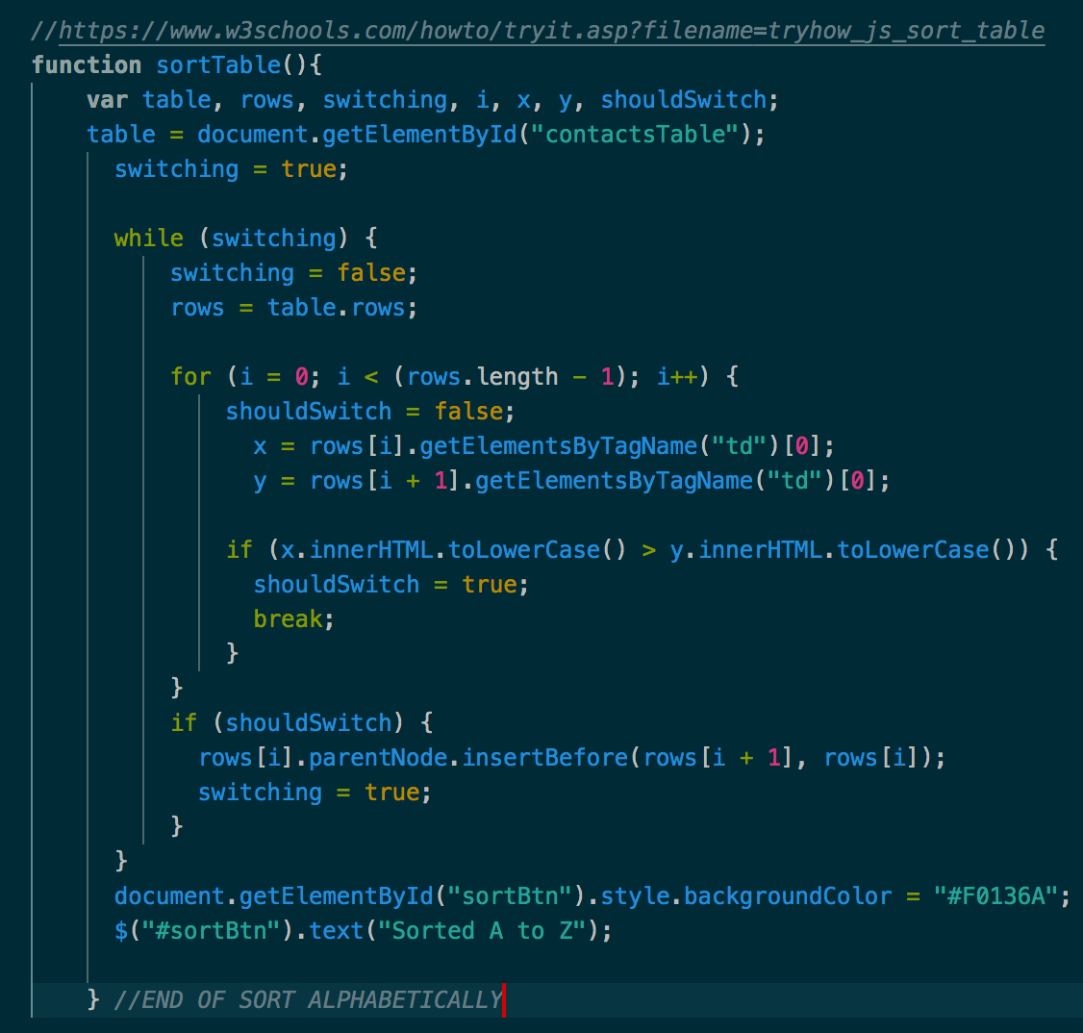Alphabetical Sorting

We decided to add a sorting button so users could decide if the contacts were displayed randomly or alphabetically. We used code from W3Schools to achieve this. The sortTable() is a while loop that goes through each row and looks at the table data (‘td’).

Once the button has been clicked, the background colour is changed to indicate it has been selected and the text changes to ‘Sorted A to Z’.

Bootstrap

For this assignment, we decided to use Bootstrap to build our address book. We used the Bootstrap CDN rather than installing it locally to ensure a shorter load time. We thought Bootstrap could be useful for this project as it is useful for form layouts and the structured grid layout

GitHub

We decided to use GitHub for this project in order to keep track of our progress and monitor how well we were working as a team. We were able to connect to the same repository and both used GitHub Desktop to commit our updates.

Package.json

Node Modules

Add contact

Delete Contact

Update Feature