7.1 PROBLEM DESCRIPTION

ONLINE SHOPPING
7.1.1 PROBLEM DESCRIPTION:
Customer can browse through the product catalog and add the items to shopping cart. They Can proceed to checkout as long as his shopping cart is not empty. customer will require to login to the system when he proceed to checkout, or he can create and account if he is not yet have one .he order will charge to the credit card registered in customer’s account. customer need to provides full name, email address, phone number, credit card and billing address details when creating an account. customer can login to the system to maintain his/her account information. once the order has been change they will mark the product and deliver the product to the customer. Online commerce has played a big role in many people’s lives. Online shopping is a growing area of technology. Establishing a store on the Internet, allows for retailers to expand their market. The purpose of this project is to provide an easy shopping facility online and easy selling facility to the merchants of all categories.

7.1.2 ADVANTAGES
- ACCESS - Online shopping allows you to shop from any vendor, at anytime, anywhere in the world. Virtual window shopping enables all users to shop at their leisure and across multiple marketplaces.

- TIME SAVER - You no longer have to get in your car and have to drive to the mall to shop. There are no lines and you can come back to your cart whenever you want.

- COMPARISON- Ease of Comparison Shopping

- AVAILABILITY - Extensive Product Mix Availability

7.1.3CONCLUSION
The project entitled Online shopping system was completed successfully. The system has been developed with much care and free of errors and at the same time it is efficient and less time consuming. The purpose of this project was to develop a web application and an android application for purchasing items from a shop.

This project helped us in gaining valuable information and practical knowledge on several topics like designing web pages using html & CSS usage of responsive templates, designing of android applications, and management of database using MYSQL. The entire system is secured. Also
the project helped us understanding about the development phases of a project and software development life cycle. We learned how to test different features of a project.
This project has given us great satisfaction in having designed an application which can be implemented to any nearby shops or branded shops selling various kinds of products by simple modifications.
There is a scope for further development in our project to a great extend. A number of features can be added to this system in future like providing moderator more control over products so that each moderator can maintain their own products. Another feature we wished to implement was providing classes for customers so that different offers can be given to each class. System may keep track of history of purchases of each customer and provide suggestions based on their history. These features could have implemented unless the time did not limited us.

7.2 DETAILED PROJECT OVERVIEW
7.2.1 PROJECT SCOPE:
- Online stores offer product description, pictures, comparisons, price and much more.
- Online shopping has made shopping painless and added more fun.

7.2.2 OBJECTIVE:
- The main objective of online shopping is to provide a system which controls the selling of items online.
- The users will consume less amount of time through shopping online rather visiting the shop directly.
- Costumer can login to get various information about products and purchase the suitable product with price and quality comparison.
- Customer can pay online, so security is must therefore online shopping provide secure transaction.

7.2.3 FRONT END AND BACKEND DESIGN

LANGUAGES AND PLATFORM USED
HTML
HTML stands for Hyper Text Markup Language, which is the most widely used language on Web to develop web pages. Hypertext refers to the way in which Web pages (HTML documents) are linked together. Thus the links available on a webpage are called Hypertext. As its name suggests, HTML is a Markup Language which means you use HTML to simply "mark up" a text document with tags that tell a Web browser how to structure it to display. HTML is being widely used to format web pages with the help of different tags available in HTML language.
The purpose of using Html in this project is it is highly flexible and it is supported on almost every browser. It is user friendly and it is easier to maintain and update sites. In transport management system the role of Html is to provide a descent front-end design with suitable attributes and to provide easy access to the user using it.
CSS
CSS is used to control the style of a web document in a simple and easy way.CSS is the acronym for "Cascading Style Sheet". Cascading Style Sheets, fondly referred to as CSS, is a simple design language intended to simplify the process of making web pages presentable.CSS handles the look and feel part of a web page. Using CSS, you can control the color of the text, the style of fonts, the spacing between paragraphs, how columns are sized and laid out, what background images or colors are used, layouts and designs in display for different devices and screen sizes as well as a variety of other effects.
The purpose of using CSS in this project is
CSS saves time, the Pages loads faster, it is easily maintained and has superior styles to Html. In transport management system the role of CSS is to provide various styles for the front-end design to make the page attractive.
JAVA SCRIPT
Java script is a dynamic computer programming language. It is lightweight and most commonly used as a part of web pages, whose implementations allow client-side script to interact with the user and make dynamic pages. It is an interpreted programming language with object-oriented capabilities. The general-purpose core of the language has been embedded in Netscape, Internet Explorer, and other web browsers.
The main purpose of using java script is allow client-side script to interact with the user and make dynamic pages. It also validates the login form to prevent unauthorized person entering the system.
PHP
PHP is a recursive acronym for "PHP: Hypertext Preprocessor". PHP is a server side scripting language that is embedded in HTML. It is used to manage dynamic content, databases, session tracking, even build entire e-commerce sites. It is integrated with a number of popular databases, including My SQL, Postgre SQL, Oracle, Sybase, Informix, and Microsoft SQL Server. PHP is pleasingly zippy in its execution, especially when compiled as an Apache module on the Unix side. The My SQL server, once started, executes even very complex queries with huge result sets in record-setting time.
The main purpose of using PHP is to handle forms,. To add, delete, modify elements within the database and to restrict users to access some pages of your website and also to can encrypt data.
BACKEND DATABASE USED: XAMPP DATABASE
Database design is the process of producing a detailed data model of database. This data model contains all the needed logical and physical design choices and physical storage parameters needed to generate a design in a data definition language, which can then be used to create a database. The term database design can be used to describe many different parts of the design of an overall database system.
The process of doing database design generally consists of a number of steps which will be carried out by the database designer. Usually, the designer must:
- Determine the data to be stored in the database.
- Determine the relationships between the different data elements.
- Superimpose a logical structure upon the data on the basis of these relationships
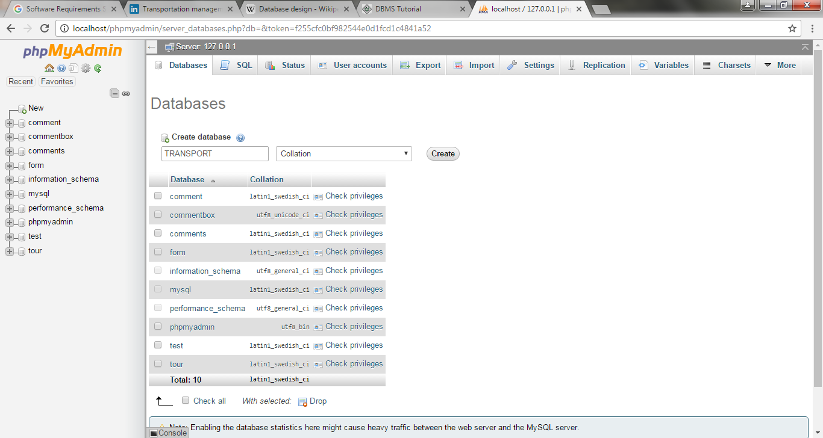
Fig 1. Creation of database

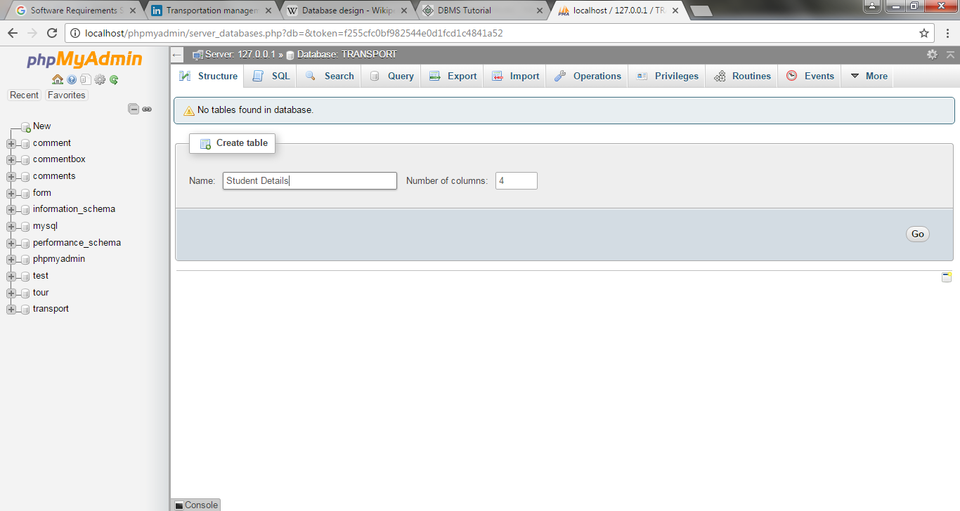

Fig 2. Creating table in database
XAMPP SERVER
XAMPP stands for Cross-Platform (X), Apache (A), My SQL (M), PHP (P) and Perl (P). It is a simple, lightweight Apache distribution that makes it extremely easy for developers to create a local web server for testing purposes. Everything you need to set up a web server – server application (Apache), database (My SQL), and scripting language (PHP) – is included in a simple extractable file. XAMPP is also cross-platform, which means it works equally well on Linux, Mac and Windows. Since most actual web server deployments use the same components as XAMPP, it makes transitioning from a local test server to a live server is extremely easy as well. Web development using XAMPP is especially beginner friendly. It has been designed to provide easy installation experience. It’s free and available for Windows, Mac OS and Linux.
7.4 MODULES DESCRIPTION
The users of the online shopping application, based on their roles, are customers (users) and the administrator (owner). These users are identified based on their experience and technical expertise.

1. ADMIN: The administrator is the owner of this online shopping application. One must have a basic understanding of computers and the internet as well as prior knowledge for operating the eclipse and Java programming languages. The administrator is responsible for maintaining all the training documents required for the system. The administrator can perform the following functions:
- Assign or change the price of the items, update the items in the list, and delete the items.
- Assign sales tax for different states at the time of checkout.
- View the history of the customers who purchased the items.
2. USERS: The users of this online shopping application are all customers who would shop to test the application. These users are anyone with shopping experience and the know-how to browse through a shopping application. They must have basic understandings about computers and the internet. The users should be able to perform the following functions using this system:
- View, browse, and select a category on the home page.
- View, add, and update items in the cart.
- Delete items from the cart.
- Check out the items from the application or continue shopping.
- Sign-on / login using a username and password.
- Place the order by completing the order form.

3. PRODUCT FUNCTION

The online shopping application would have the following basic functions:

1. Display all the categories available for shopping on the system’s main page.
2. Display all the items linked to each category listed on the main page.
3. Allow the administrator to add new items to the existing list of available items.
4. Allow users/administrator to remove items.
5. Allow the administrator to modify the price of each item.
6. Allow the administrator to update the description about each item.
7. Allow the administrator to view and edit information about each user that checkouts the items from the system.

II.FUNCTIONAL REQUIREMENTS

USES CASES

- USER LOGIN

Description of feature
This feature used by the user to login into system. A user must login with his user name and password to the system after registration. If they are invalid, the user not allowed to enter the system.

Functional requirement
- Username and password will be provided after user registration is confirmed.
- Password should be hidden from others while typing it in the field

- REGISTER NEW USER

Description of feature
A new user will have to register in the system by providing essential details in order to view the products in the system. The admin must accept a new user by unblocking him.

Functional requirement
- System must be able to verify and validate information.
- The system must encrypt the password of the customer to provide security.

- PURCHASING AN ITEM

Description of feature
The user can add the desired product into his cart by clicking add to cart option on the product. He can view his cart by clicking on the cart button. All products added by cart can be viewed in the cart. User can remove an item from the cart by clicking remove. After confirming the items in the cart the user can submit the cart by providing a delivery address. On successful submitting the cart will become empty.

Functional requirement
- System must ensure that, only a registered customer can purchase items.

- View Categories and Items
The users shall be able to see the home page of the online shopping-cart application when they first run the program. The users shall be able to view the different categories, select categories, browse through the items in each category, and add items to the shopping cart. The users shall be able to view the shopping cart and more information about each item.
- The users shall be able to view the categories on the application’s home page.
- The users shall be able to view items in different categories.
- The users shall be able add items to the cart.
- The users shall be able to view more information about an item before adding it to the cart.
- The users shall be able to able view the shopping cart.
- The users shall be able to browse through the available items.

- ADMIN

- MANAGE USER

Description of feature
The administrator can add user, delete user, view user and block user.

- MANAGE PRODUCTS

Description of feature
The administrator can add product, delete product and view product.

- MANAGE ORDERS

Description of feature
The administrator can view orders and delete orders.

Functional requirements
-The system must identify the login of the admin.
-Admin account should be secured so that only owner of the shop can access that account

III.NON FUNCTIONAL REQUIREMENTS

- EFFICIENCY REQUIREMENT

When an online shopping cart android application implemented customer can purchase product in an efficient manner.

- RELIABILITY REQUIREMENT

The system should provide a reliable environment to both customers and owner. All orders should be reaching at the admin without any errors.

- USABILITY REQUIREMENT

The android application is designed for user friendly environment and ease of use.

- IMPLEMENTATION REQUIREMENT

Implementation of the system using css and html in front end with jsp as back end and it will be used for database connectivity. And the database part is developed by PHP. Responsive web designing is used for making the website compatible for any type of screen.

- DELIVERY REQUIREMENT

The whole system is expected to be delivered in three months of time with a weekly evaluation by the project guide.

- DESIGN CONSTRAINTS

System design is the solution for the creation of a new system. This phase focuses on the detailed implementation of the feasible system. It emphasis on translating design. Specifications to performance specification. System design has two phases of development

- Logical design
- Physical design

During logical design phase the analyst describes inputs (sources), output (destinations), databases (data sores) and procedures (data flows) all in a format that meets the user requirements. The analyst also specifies the needs of the user at a level that virtually determines the information flow in and out of the system and the data resources. Here the logical design is done through data flow diagrams and database design. The physical design is followed by physical design or coding. Physical design produces the working system by defining the design specifications, which specify exactly what the candidate system must do. The programmers write the necessary programs that accept input from the user, perform necessary processing on accepted data and produce the required report on a hard copy or display it on the screen.

INPUT AND OUTPUT DESIGN

INPUT DESIGN:

Input design is the link that ties the information system into the world of its users. The input design involves determining the inputs, validating the data, minimizing the data entry and provides a multi-user facility. Inaccurate inputs are the most common cause of errors in data processing. Errors entered by the data entry operators can be controlled by input design. The user-originated inputs are converted to a computer based format in the input design. Input data are collected and organized into groups of similar data. Once identified, the appropriate input media are selected for processing. All the input data are validated and if any data violates any conditions, the user is warned by a message. If the data satisfies all the conditions, it is transferred to the appropriate tables in the database. In this project the student details are to be entered at the time of registration. A page is designed for this purpose which is user friendly and easy to use. The design is done such that users get appropriate messages when exceptions occur.

OUTPUT DESIGN:

Computer output is the most important and direct source of information to the user. Output design is a very important phase since the output needs to be in an efficient manner. Efficient and intelligible output design improves the system relationship with the user and helps in decision making. Allowing the user to view the sample screen is important because the user is the ultimate judge of the quality of output. The output module of this system is the selected notifications.

SAMPLE CODES
DETAILS

<!DOCTYPE html PUBLIC "-//W3C//DTD XHTML 1.0 Transitional//EN" "http://www.w3.org/TR/xhtml1/DTD/xhtml1-transitional.dtd">
<html xmlns="http://www.w3.org/1999/xhtml">
<head>
<title>Electronix Store - Details</title>
<meta http-equiv="Content-Type" content="text/html; charset=windows-1252" />
<link rel="stylesheet" type="text/css" href="style.css" />
<!--[if IE 6]>
<link rel="stylesheet" type="text/css" href="iecss.css" />
<![endif]-->
<script type="text/javascript" src="js/windowopen.js"></script>
<script type="text/javascript" src="js/boxOver.js"></script>
</head>
<body>
<div id="main_container">
<div class="top_bar">
<div class="top_search">
<div class="search_text"><a href="index.html">Advanced Search</a></div>
<input type="text" class="search_input" name="search" />
<input type="image" src="images/search.gif" class="search_bt"/>
</div>
<div class="languages">
<div class="lang_text">Languages:</div>
<a href="index.html" class="lang"><img src="images/en.gif" alt="" border="0" /></a> <a href="index.html" class="lang"><img src="images/de.gif" alt="" border="0" /></a> </div>
</div>
<div id="header">
<div id="logo"> <a href="index.html"><img src="images/logo.png" alt="" border="0" width="237" height="140" /></a> </div>
<div class="oferte_content">
<div class="top_divider"><img src="images/header_divider.png" alt="" width="1" height="164" /></div>
<div class="oferta">
<div class="oferta_content"> <img src="images/laptop.png" width="94" height="92" alt="" border="0" class="oferta_img" />
<div class="oferta_details">
<div class="oferta_title">Samsung GX 2004 LM</div>
<div class="oferta_text"> Lorem ipsum dolor sit amet, consectetur adipisicing elit, sed do eiusmod tempor incididunt ut labore et dolore magna aliqua. Ut enim ad minim veniam, quis nostrud exercitation ullamco </div>
<a href="details.html" class="details">details</a> </div>
</div>
<div class="oferta_pagination"> <span class="current">1</span> <a href="index.html">2</a> <a href="index.html">3</a> <a href="index.html">4</a> <a href="index.html">5</a> </div>
</div>
<div class="top_divider"><img src="images/header_divider.png" alt="" width="1" height="164" /></div>
</div>
<!-- end of oferte_content-->
</div>
<div id="main_content">
<div id="menu_tab">
<div class="left_menu_corner"></div>
<ul class="menu">
<li><a href="index.html" class="nav1"> Home</a></li>
<li class="divider"></li>
<li><a href="index.html" class="nav2">Products</a></li>
<li class="divider"></li>
<li><a href="index.html" class="nav3">Specials</a></li>
<li class="divider"></li>
<li><a href="index.html" class="nav4">My account</a></li>
<li class="divider"></li>
<li><a href="index.html" class="nav4">Sign Up</a></li>
<li class="divider"></li>
<li><a href="index.html" class="nav5">Shipping</a></li>
<li class="divider"></li>
<li><a href="contact.html" class="nav6">Contact Us</a></li>
<li class="divider"></li>
<li class="currencies">Currencies
<select>
<option>Rupees</option>
<option>US Dollar</option>
<option>Euro</option>
</select>
</li>
</ul>
<div class="right_menu_corner"></div>
</div>
<!-- end of menu tab -->
<div class="crumb_navigation"> Navigation: <a href="http://all-free-download.com/free-website-templates/">Home</a> &lt; <span class="current">Category name</span> </div>
<div class="left_content">
<div class="title_box">Categories</div>
<ul class="left_menu">
<li class="odd"><a href="index.html">Processors</a></li>
<li class="even"><a href="index.html">Motherboards</a></li>
<li class="odd"><a href="index.html">Desktops</a></li>
<li class="even"><a href="index.html">Laptops &amp; Notebooks</a></li>
<li class="odd"><a href="index.html">Processors</a></li>
<li class="even"><a href="index.html">Motherboards</a></li>
<li class="odd"><a href="index.html">Processors</a></li>
<li class="even"><a href="index.html">Motherboards</a></li>
<li class="odd"><a href="index.html">Desktops</a></li>
<li class="even"><a href="index.html">Laptops &amp; Notebooks</a></li>
<li class="odd"><a href="index.html">Processors</a></li>
<li class="even"><a href="index.html">Motherboards</a></li>
</ul>
<div class="title_box">Special Products</div>
<div class="border_box">
<div class="product_title"><a href="details.html">Motorola 156 MX-VL</a></div>
<div class="product_img"><a href="details.html"><img src="images/laptop.png" alt="" border="0" /></a></div>
<div class="prod_price"><span class="reduce">350INR</span> <span class="price">270INR</span></div>
</div>
<div class="title_box">Newsletter</div>
<div class="border_box">
<input type="text" name="newsletter" class="newsletter_input" value="your email"/>
<a href="www.gmail.com" class="join">join</a> </div>
<div class="banner_adds"> <a href="index.html"><img src="images/bann2.jpg" alt="" border="0" /></a> </div>
</div>
<!-- end of left content -->
<div class="center_content">
<div class="center_title_bar">Motorola 156 MX-VL</div>
<div class="prod_box_big">
<div class="top_prod_box_big"></div>
<div class="center_prod_box_big">
<div class="product_img_big"> <a href="javascript:popImage('images/big_pic.jpg','Some Title')" title="header=[Zoom] body=[&nbsp;] fade=[on]"><img src="images/laptop.gif" alt="" border="0" /></a>
<div class="thumbs"> <a href="index.html" title="header=[Thumb1] body=[&nbsp;] fade=[on]"><img src="images/thumb1.gif" alt="" border="0" /></a> <a href="index.html" title="header=[Thumb2] body=[&nbsp;] fade=[on]"><img src="images/thumb1.gif" alt="" border="0" /></a> <a href="index.html" title="header=[Thumb3] body=[&nbsp;] fade=[on]"><img src="images/thumb1.gif" alt="" border="0" /></a> </div>
</div>
<div class="details_big_box">
<div class="product_title_big">My Cinema-U3000/DVBT, USB 2.0 TV BOX External, White</div>
<div class="specifications"> Disponibilitate: <span class="blue">In stoc</span><br />
Garantie: <span class="blue">24 luni</span><br />
Tip transport: <span class="blue">Mic</span><br />
Pretul include <span class="blue">TVA</span><br />
</div>
<div class="prod_price_big"><span class="reduce">350INR</span> <span class="price">270INR</span></div>
<a href="index.html" class="addtocart">add to cart</a> <a href="index.html" class="compare">compare</a> </div>
</div>
<div class="bottom_prod_box_big"></div>
</div>
<div class="center_title_bar">Similar products</div>
<div class="prod_box">
<div class="top_prod_box"></div>
<div class="center_prod_box">
<div class="product_title"><a href="details.html">Motorola 156 MX-VL</a></div>
<div class="product_img"><a href="details.html"><img src="images/laptop.gif" alt="" border="0" /></a></div>
<div class="prod_price"><span class="reduce">350INR</span> <span class="price">270INR</span></div>
</div>
<div class="bottom_prod_box"></div>
<div class="prod_details_tab"> <a href="index.html" title="header=[Add to cart] body=[&nbsp;] fade=[on]"><img src="images/cart.gif" alt="" border="0" class="left_bt" /></a> <a href="index.html" title="header=[Specials] body=[&nbsp;] fade=[on]"><img src="images/favs.gif" alt="" border="0" class="left_bt" /></a> <a href="index.html" title="header=[Gifts] body=[&nbsp;] fade=[on]"><img src="images/favorites.gif" alt="" border="0" class="left_bt" /></a> <a href="details.html" class="prod_details">details</a> </div>
</div>
<div class="prod_box">
<div class="top_prod_box"></div>
<div class="center_prod_box">
<div class="product_title"><a href="details.html">Iphone Apple</a></div>
<div class="product_img"><a href="details.html"><img src="images/p4.gif" alt="" border="0" /></a></div>
<div class="prod_price"><span class="price">270INR</span></div>
</div>
<div class="bottom_prod_box"></div>
<div class="prod_details_tab"> <a href="index.html" title="header=[Add to cart] body=[&nbsp;] fade=[on]"><img src="images/cart.gif" alt="" border="0" class="left_bt" /></a> <a href="index.html" title="header=[Specials] body=[&nbsp;] fade=[on]"><img src="images/favs.gif" alt="" border="0" class="left_bt" /></a> <a href="index.html" title="header=[Gifts] body=[&nbsp;] fade=[on]"><img src="images/favorites.gif" alt="" border="0" class="left_bt" /></a> <a href="details.html" class="prod_details">details</a> </div>
</div>
<div class="prod_box">
<div class="top_prod_box"></div>
<div class="center_prod_box">
<div class="product_title"><a href="details.html">Samsung Webcam</a></div>
<div class="product_img"><a href="details.html"><img src="images/p5.gif" alt="" border="0" /></a></div>
<div class="prod_price"><span class="reduce">350INR</span> <span class="price">270INR</span></div>
</div>
<div class="bottom_prod_box"></div>
<div class="prod_details_tab"> <a href="index.html" title="header=[Add to cart] body=[&nbsp;] fade=[on]"><img src="images/cart.gif" alt="" border="0" class="left_bt" /></a> <a href="index.html" title="header=[Specials] body=[&nbsp;] fade=[on]"><img src="images/favs.gif" alt="" border="0" class="left_bt" /></a> <a href="index.html" title="header=[Gifts] body=[&nbsp;] fade=[on]"><img src="images/favorites.gif" alt="" border="0" class="left_bt" /></a> <a href="details.html" class="prod_details">details</a> </div>
</div>
</div>
<!-- end of center content -->
<div class="right_content">
<div class="shopping_cart">
<div class="cart_title">Shopping cart</div>
<div class="cart_details"> 3 items <br />
<span class="border_cart"></span> Total: <span class="price">350INR</span> </div>
<div class="cart_icon"><a href="index.html" title="header=[Checkout] body=[&nbsp;] fade=[on]"><img src="images/shoppingcart.png" alt="" width="48" height="48" border="0" /></a></div>
</div>
<div class="title_box">What’s new</div>
<div class="border_box">
<div class="product_title">Motorola 156 MX-VL</div>
<div class="product_img"><a href="index.html"><img src="images/p2.gif" alt="" border="0" /></a></div>
<div class="prod_price"><span class="reduce">350INR</span> <span class="price">270INR</span></div>
</div>
<div class="title_box">Manufacturers</div>
<ul class="left_menu">
<li class="odd"><a href="index.html">Sony</a></li>
<li class="even"><a href="index.html">Samsung</a></li>
<li class="odd"><a href="index.html">Daewoo</a></li>
<li class="even"><a href="index.html">LG</a></li>
<li class="odd"><a href="index.html">Fujitsu Siemens</a></li>
<li class="even"><a href="index.html">Motorola</a></li>
<li class="odd"><a href="index.html">Phillips</a></li>
<li class="even"><a href="index.html">Beko</a></li>
</ul>
<div class="banner_adds"> <a href="index.html"><img src="images/bann1.jpg" alt="" border="0" /></a> </div>
</div>
<!-- end of right content -->
</div>
<!-- end of main content -->
<div class="footer">
<div class="left_footer"> <img src="images/footer_logo.png" alt="" width="170" height="49"/> </div>
<div class="center_footer"> Template name. All Rights Reserved 2008<br />
<a href="http://csscreme.com"><img src="images/csscreme.jpg" alt="csscreme" border="0" /></a><br />
<img src="images/payment.gif" alt="" /> </div>
<div class="right_footer"> <a href="index.html">home</a> <a href="index.html">about</a> <a href="index.html">sitemap</a> <a href="index.html">rss</a> <a href="contact.html">contact us</a> </div>
</div>
</div>
<!-- end of main_container-->
</html>

LOGIN PAGE

<%@include file="template/top.jsp" %>
<%@include file="template/menu_public.jsp" %>
<%@include file="template/body_start.jsp" %>
<form id="form" action="loginbaseselect.jsp">
<table>
<tr>
<td><input type="text" name="uname" id="uname" placeholder="username" required=""/> </td>
</tr>
<tr>
<td><input type="password" name="upass" id="upass" placeholder="password" required=""/></td>
</tr>
<tr>
<td><button class="button" type="submit" id="search-submit">Login</button> </td>
<td><div id="result"></div></td>
</tr>
</table>
</form>
<script type="text/javascript">
<% if (request.getParameter("login") != null && request.getParameter("login").contentEquals("failed")) {
%>
alert("Login Failed !!!");
<% }
%>
<%
if (request.getParameter("login") != null && request.getParameter("login").contentEquals("dissabled")) {
%>
alert("User Blocked !!!");
<% }
%>
<%
if (request.getParameter("login") != null && request.getParameter("login").contentEquals("unknown")) {
%>
alert("Unknown user !!!");
<% } %>
</script>
%@include file="template/body_end.jsp" %

REGISTRATION

<%@page import="DataBase.DB"%>
<%@page import="java.sql.ResultSet"%>
<%@include file="template/top.jsp" %>
<%@include file="template/menu_public.jsp" %>
<%@include file="template/body_start.jsp" %>
<h2 class="title"><a href="#">Register </a></h2>
<div class="entry">
<form action="dbregister.jsp" onsubmit="return check()">
<table>
<tr>
<td>User Name
</td>
<td><input type="text" required="" name="uname" id="uname" />
</td>
</tr>
<tr>
<td>Password
</td>
<td><input type="password" required="" name="upass" id="upass" />
</td>
</tr>
<tr>
<td>Login Name
</td>
<td><input type="text" required="" name="lname" id="lname" />
</td>
</tr>
<tr>
<td>Email
</td>
<td><input type="email" name="emailid" id="emailid" />
</td>
</tr>
<tr>
<td>Mobile No.
</td>
<td><input type="text" name="mobno" id="mobno" />
</td>
</tr>
<tr>
<td>
</td>
<td><button class="button" type="submit">Register</button>
</td>
</tr>
</table>
</form>
</div>
<script type="text/javascript">
<%
if (request.getParameter("reg") != null && request.getParameter("reg").contentEquals("failed")) {
%>
alert("Registration Failed !!!");
<% } %>
<% if (request.getParameter("reg") != null && request.getParameter("reg").contentEquals("success")) {
%>
alert("Registration Completed")
<% }
%>
</script>
%@include file="template/body_end.jsp" %

DB REGISTRATION

<%@page import="config.Config"%>
<%@page import="java.io.File"%>
<%@page import="java.sql.ResultSet"%>
<%@page import="DataBase.DB"%>
<%
if (DB.executeUpdate("insert into login values("
+ "null" + ",'" + request.getParameter("uname") + "',SHA1('"
+ request.getParameter("upass") + "'),'"
+ "user" + "','"
+ "false" + "')")) {
ResultSet r = DB.executeQuery("select max(uid) from login");
r.next();
String uid = r.getString(1);
if (DB.executeUpdate("insert into userdetails values("
+ uid + ",'"
+ request.getParameter("lname") + "','"
+ request.getParameter("emailid") + "','"
+ request.getParameter("mobno") + "')")) {
// this code generates the qr code inside the QR_Code folder in the c drive
response.sendRedirect("index.jsp?reg=success");
}
} else {
response.sendRedirect("register.jsp?reg=failed");
} %>

LOGIN BASE SELECTION

<%@page import="DataBase.DB"%>
<%@page import="java.sql.ResultSet"%>
<%
String uname = request.getParameter("uname");
String upass = request.getParameter("upass");
ResultSet r = DB.executeQuery("select * from login where uname='" + uname + "' and upass=SHA1('" + upass + "')");
if (r != null && r.next()) {
if (r.getString("enabled") != null && r.getString("enabled").contentEquals("true")) {
session.setAttribute("uname", uname);
session.setAttribute("uid", r.getString("uid"));
session.setAttribute("utype",r.getString("utype"));
if (r.getString("utype").contentEquals("admin")) {
response.sendRedirect("adminindex.jsp");
} else if (r.getString("utype").contentEquals("mod")) {
response.sendRedirect("modindex.jsp");
} else if (r.getString("utype").contentEquals("user")) {
response.sendRedirect("userindex.jsp");
} else {
session.setAttribute("uname", null);
session.setAttribute("uid", null);
session.setAttribute("utype",null);
response.sendRedirect("login.jsp?login=unknown");
}
} else {
response.sendRedirect("login.jsp?login=dissabled");
}
} else { response.sendRedirect("login.jsp?login=failed");
}
%>

DATABASE CONNECTION

package DataBase;
import java.sql.*;
public class DB {
static Connection con = null;
static Statement stmt = null;
static ResultSet rs = null;
public static Connection getConnection() {
try {
Class.forName("com.mysql.jdbc.Driver");
con = DriverManager.getConnection("jdbc:mysql://localhost:3306/online_shopping", "root", "root");
} catch (Exception e) {
System.out.println("Exception" + e);
}
return con;
}
public static boolean executeUpdate(String query) {
boolean f = false;
try {
con = getConnection();
stmt = con.createStatement();
int b = stmt.executeUpdate(query);
if (b > 0) {
f = true;
} else {
f = false;
}
} catch (Exception e) {
System.out.println("Exception" + e);
}
return f;
}
public static ResultSet executeQuery(String sql) {
try {
con = getConnection();
stmt = con.createStatement();
rs = stmt.executeQuery(sql);
return rs;
} catch (Exception e) {
System.out.println("Exception" + e);
return null;
}
}
public static void close() {
try {
con.close();
stmt.close();
rs.close();
} catch (Exception e) {
System.out.println("Exception" + e);
}
}
}

INDEX

<!DOCTYPE html PUBLIC "-//W3C//DTD XHTML 1.0 Transitional//EN" "http://www.w3.org/TR/xhtml1/DTD/xhtml1-transitional.dtd">
<html xmlns="http://www.w3.org/1999/xhtml">
<head>
<title>Electronix Store</title>
<meta http-equiv="Content-Type" content="text/html; charset=windows-1252" />
<link rel="stylesheet" type="text/css" href="style.css" />
<!--[if IE 6]>
<link rel="stylesheet" type="text/css" href="iecss.css" />
<![endif]-->
<script type="text/javascript" src="js/boxOver.js"></script>
</head>
<body>
<div id="main_container">
<div class="top_bar">
<div class="top_search">
<div class="search_text"><a href="index.html">Advanced Search</a></div>
<input type="text" class="search_input" name="search" />
<input type="image" src="images/search.gif" class="search_bt"/>
</div>
<div class="languages">
<div class="lang_text">Languages:</div>
<a href="index.html" class="lang"><img src="images/en.gif" alt="" border="0" /></a> <a href="index.html" class="lang"><img src="images/de.gif" alt="" border="0" /></a> </div>
</div>
<div id="header">
<div id="logo"> <a href="index.html"><img src="images/logo.png" alt="" border="0" width="237" height="140" /></a> </div>
<div class="oferte_content">
<div class="top_divider"><img src="images/header_divider.png" alt="" width="1" height="164" /></div>
<div class="oferta">
<div class="oferta_content"> <img src="images/laptop.png" width="94" height="92" alt="" border="0" class="oferta_img" />
<div class="oferta_details">
<div class="oferta_title">Samsung GX 2004 LM</div>
<div class="oferta_text"> Lorem ipsum dolor sit amet, consectetur adipisicing elit, sed do eiusmod tempor incididunt ut labore et dolore magna aliqua. Ut enim ad minim veniam, quis nostrud exercitation ullamco </div>
<a href="details.html" class="details">details</a> </div>
</div>
<div class="oferta_pagination"> <span class="current">1</span> <a href="index.html">2</a> <a href="index.html">3</a> <a href="index.html">4</a> <a href="index.html">5</a> </div>
</div>
<div class="top_divider"><img src="images/header_divider.png" alt="" width="1" height="164" /></div>
</div>
<!-- end of oferte_content-->
</div>
<div id="main_content">
<div id="menu_tab">
<div class="left_menu_corner"></div>
<ul class="menu">
<li><a href="index.html" class="nav1"> Home</a></li>
<li class="divider"></li>
<li><a href="index.html" class="nav2">Products</a></li>
<li class="divider"></li>
<li><a href="index.html" class="nav3">Specials</a></li>
<li class="divider"></li>
<li><a href="index.html" class="nav4">My account</a></li>
<li class="divider"></li>
<li><a href="index.html" class="nav4">Sign Up</a></li>
<li class="divider"></li>
<li><a href="index.html" class="nav5">Shipping</a></li>
<li class="divider"></li>
<li><a href="contact.html" class="nav6">Contact Us</a></li>
<li class="divider"></li>
<li class="currencies">Currencies
<select>
<option>Rupees</option>
<option>US Dollar</option>
<option>Euro</option>
</select>
</li>
</ul>
<div class="right_menu_corner"></div>
</div>
<!-- end of menu tab -->
<div class="crumb_navigation"> Navigation: <span class="current">Home</span> </div>
<div class="left_content">
<div class="title_box">Categories</div>
<ul class="left_menu">
<li class="odd"><a href="index.html">Processors</a></li>
<li class="even"><a href="index.html">Motherboards</a></li>
<li class="odd"><a href="index.html">Desktops</a></li>
<li class="even"><a href="index.html">Laptops &amp; Notebooks</a></li>
<li class="odd"><a href="index.html">Processors</a></li>
<li class="even"><a href="index.html">Motherboards</a></li>
<li class="odd"><a href="index.html">Processors</a></li>
<li class="even"><a href="index.html">Motherboards</a></li>
<li class="odd"><a href="index.html">Desktops</a></li>
<li class="even"><a href="index.html">Laptops &amp; Notebooks</a></li>
<li class="odd"><a href="index.html">Processors</a></li>
<li class="even"><a href="index.html">Motherboards</a></li>
</ul>
<div class="title_box">Special Products</div>
<div class="border_box">
<div class="product_title"><a href="details.html">Motorola 156 MX-VL</a></div>
<div class="product_img"><a href="details.html"><img src="images/laptop.png" alt="" border="0" /></a></div>
<div class="prod_price"><span class="reduce">350INR</span> <span class="price">270INR</span></div>
</div>
<div class="title_box">Newsletter</div>
<div class="border_box">
<input type="text" name="newsletter" class="newsletter_input" value="your email"/>
<a href="success.html" class="join">join</a> </div>
<div class="banner_adds"> <a href="index.html"><img src="images/bann2.jpg" alt="" border="0" /></a> </div>
</div>
<!-- end of left content -->
<div class="center_content">
<div class="center_title_bar">Latest Products</div>
<div class="prod_box">
<div class="top_prod_box"></div>
<div class="center_prod_box">
<div class="product_title"><a href="details.html">Motorola 156 MX-VL</a></div>
<div class="product_img"><a href="details.html"><img src="images/laptop.gif" alt="" border="0" /></a></div>
<div class="prod_price"><span class="reduce">350INR</span> <span class="price">270INR</span></div>
</div>
<div class="bottom_prod_box"></div>
<div class="prod_details_tab"> <a href="index.html" title="header=[Add to cart] body=[&nbsp;] fade=[on]"><img src="images/cart.gif" alt="" border="0" class="left_bt" /></a> <a href="index.html" title="header=[Specials] body=[&nbsp;] fade=[on]"><img src="images/favs.gif" alt="" border="0" class="left_bt" /></a> <a href="index.html" title="header=[Gifts] body=[&nbsp;] fade=[on]"><img src="images/favorites.gif" alt="" border="0" class="left_bt" /></a> <a href="details.html" class="prod_details">details</a> </div>
</div>
<div class="prod_box">
<div class="top_prod_box"></div>
<div class="center_prod_box">
<div class="product_title"><a href="details.html">Iphone Apple</a></div>
<div class="product_img"><a href="details.html"><img src="images/p4.gif" alt="" border="0" /></a></div>
<div class="prod_price"><span class="price">270INR</span></div>
</div>
<div class="bottom_prod_box"></div>
<div class="prod_details_tab"> <a href="index.html" title="header=[Add to cart] body=[&nbsp;] fade=[on]"><img src="images/cart.gif" alt="" border="0" class="left_bt" /></a> <a href="index.html" title="header=[Specials] body=[&nbsp;] fade=[on]"><img src="images/favs.gif" alt="" border="0" class="left_bt" /></a> <a href="index.html" title="header=[Gifts] body=[&nbsp;] fade=[on]"><img src="images/favorites.gif" alt="" border="0" class="left_bt" /></a> <a href="details.html" class="prod_details">details</a> </div>
</div>
<div class="prod_box">
<div class="top_prod_box"></div>
<div class="center_prod_box">
<div class="product_title"><a href="details.html">Samsung Webcam</a></div>
<div class="product_img"><a href="details.html"><img src="images/p5.gif" alt="" border="0" /></a></div>
<div class="prod_price"><span class="reduce">350INR</span> <span class="price">270INR</span></div>
</div>
<div class="bottom_prod_box"></div>
<div class="prod_details_tab"> <a href="index.html" title="header=[Add to cart] body=[&nbsp;] fade=[on]"><img src="images/cart.gif" alt="" border="0" class="left_bt" /></a> <a href="index.html" title="header=[Specials] body=[&nbsp;] fade=[on]"><img src="images/favs.gif" alt="" border="0" class="left_bt" /></a> <a href="index.html" title="header=[Gifts] body=[&nbsp;] fade=[on]"><img src="images/favorites.gif" alt="" border="0" class="left_bt" /></a> <a href="details.html" class="prod_details">details</a> </div>
</div>
<div class="prod_box">
<div class="top_prod_box"></div>
<div class="center_prod_box">
<div class="product_title"><a href="details.html">Motorola 156 MX-VL</a></div>
<div class="product_img"><a href="details.html"><img src="images/laptop.gif" alt="" border="0" /></a></div>
<div class="prod_price"><span class="reduce">350INR</span> <span class="price">270INR</span></div>
</div>
<div class="bottom_prod_box"></div>
<div class="prod_details_tab"> <a href="index.html" title="header=[Add to cart] body=[&nbsp;] fade=[on]"><img src="images/cart.gif" alt="" border="0" class="left_bt" /></a> <a href="index.html" title="header=[Specials] body=[&nbsp;] fade=[on]"><img src="images/favs.gif" alt="" border="0" class="left_bt" /></a> <a href="index.html" title="header=[Gifts] body=[&nbsp;] fade=[on]"><img src="images/favorites.gif" alt="" border="0" class="left_bt" /></a> <a href="details.html" class="prod_details">details</a> </div>
</div>
<div class="prod_box">
<div class="top_prod_box"></div>
<div class="center_prod_box">
<div class="product_title"><a href="details.html">Iphone Apple</a></div>
<div class="product_img"><a href="details.html"><img src="images/p4.gif" alt="" border="0" /></a></div>
<div class="prod_price"><span class="price">270INR</span></div>
</div>
<div class="bottom_prod_box"></div>
<div class="prod_details_tab"> <a href="index.html" title="header=[Add to cart] body=[&nbsp;] fade=[on]"><img src="images/cart.gif" alt="" border="0" class="left_bt" /></a> <a href="index.html" title="header=[Specials] body=[&nbsp;] fade=[on]"><img src="images/favs.gif" alt="" border="0" class="left_bt" /></a> <a href="index.html" title="header=[Gifts] body=[&nbsp;] fade=[on]"><img src="images/favorites.gif" alt="" border="0" class="left_bt" /></a> <a href="details.html" class="prod_details">details</a> </div>
</div>
<div class="prod_box">
<div class="top_prod_box"></div>
<div class="center_prod_box">
<div class="product_title"><a href="details.html">Samsung Webcam</a></div>
<div class="product_img"><a href="details.html"><img src="images/p5.gif" alt="" border="0" /></a></div>
<div class="prod_price"><span class="reduce">350INR</span> <span class="price">270INR</span></div>
</div>
<div class="bottom_prod_box"></div>
<div class="prod_details_tab"> <a href="http://all-free-download.com/free-website-templates/" title="header=[Add to cart] body=[&nbsp;] fade=[on]"><img src="images/cart.gif" alt="" border="0" class="left_bt" /></a> <a href="http://all-free-download.com/free-website-templates/" title="header=[Specials] body=[&nbsp;] fade=[on]"><img src="images/favs.gif" alt="" border="0" class="left_bt" /></a> <a href="http://all-free-download.com/free-website-templates/" title="header=[Gifts] body=[&nbsp;] fade=[on]"><img src="images/favorites.gif" alt="" border="0" class="left_bt" /></a> <a href="details.html" class="prod_details">details</a> </div>
</div>
<div class="center_title_bar">Recommended Products</div>
<div class="prod_box">
<div class="top_prod_box"></div>
<div class="center_prod_box">
<div class="product_title"><a href="details.html">Motorola 156 MX-VL</a></div>
<div class="product_img"><a href="details.html"><img src="images/laptop.gif" alt="" border="0" /></a></div>
<div class="prod_price"><span class="reduce">350INR</span> <span class="price">270INR</span></div>
</div>
<div class="bottom_prod_box"></div>
<div class="prod_details_tab"> <a href="index.html" title="header=[Add to cart] body=[&nbsp;] fade=[on]"><img src="images/cart.gif" alt="" border="0" class="left_bt" /></a> <a href="index.html" title="header=[Specials] body=[&nbsp;] fade=[on]"><img src="images/favs.gif" alt="" border="0" class="left_bt" /></a> <a href="index.html" title="header=[Gifts] body=[&nbsp;] fade=[on]"><img src="images/favorites.gif" alt="" border="0" class="left_bt" /></a> <a href="details.html" class="prod_details">details</a> </div>
</div>
<div class="prod_box">
<div class="top_prod_box"></div>
<div class="center_prod_box">
<div class="product_title"><a href="details.html">Iphone Apple</a></div>
<div class="product_img"><a href="details.html"><img src="images/p4.gif" alt="" border="0" /></a></div>
<div class="prod_price"><span class="price">270INR</span></div>
</div>
<div class="bottom_prod_box"></div>
<div class="prod_details_tab"> <a href="index.html" title="header=[Add to cart] body=[&nbsp;] fade=[on]"><img src="images/cart.gif" alt="" border="0" class="left_bt" /></a> <a href="index.html" title="header=[Specials] body=[&nbsp;] fade=[on]"><img src="images/favs.gif" alt="" border="0" class="left_bt" /></a> <a href="index.html" title="header=[Gifts] body=[&nbsp;] fade=[on]"><img src="images/favorites.gif" alt="" border="0" class="left_bt" /></a> <a href="details.html" class="prod_details">details</a> </div>
</div>
<div class="prod_box">
<div class="top_prod_box"></div>
<div class="center_prod_box">
<div class="product_title"><a href="details.html">Samsung Webcam</a></div>
<div class="product_img"><a href="details.html"><img src="images/p5.gif" alt="" border="0" /></a></div>
<div class="prod_price"><span class="reduce">350INR</span> <span class="price">270INR</span></div>
</div>
<div class="bottom_prod_box"></div>
<div class="prod_details_tab"> <a href="index.html" title="header=[Add to cart] body=[&nbsp;] fade=[on]"><img src="images/cart.gif" alt="" border="0" class="left_bt" /></a> <a href="index.html" title="header=[Specials] body=[&nbsp;] fade=[on]"><img src="images/favs.gif" alt="" border="0" class="left_bt" /></a> <a href="index.html" title="header=[Gifts] body=[&nbsp;] fade=[on]"><img src="images/favorites.gif" alt="" border="0" class="left_bt" /></a> <a href="details.html" class="prod_details">details</a> </div>
</div>
</div>
<!-- end of center content -->
<div class="right_content">
<div class="shopping_cart">
<div class="cart_title">Shopping cart</div>
<div class="cart_details"> 3 items <br />
<span class="border_cart"></span> Total: <span class="price">350INR</span> </div>
<div class="cart_icon"><a href="index.html" title="header=[Checkout] body=[&nbsp;] fade=[on]"><img src="images/shoppingcart.png" alt="" width="48" height="48" border="0" /></a></div>
</div>
<div class="title_box">What’s new</div>
<div class="border_box">
<div class="product_title"><a href="details.html">Motorola 156 MX-VL</a></div>
<div class="product_img"><a href="details.html"><img src="images/p2.gif" alt="" border="0" /></a></div>
<div class="prod_price"><span class="reduce">350INR</span> <span class="price">270INR</span></div>
</div>
<div class="title_box">Manufacturers</div>
<ul class="left_menu">
<li class="odd"><a href="index.html">Sony</a></li>
<li class="even"><a href="index.html">Samsung</a></li>
<li class="odd"><a href="index.html">Daewoo</a></li>
<li class="even"><a href="index.html">LG</a></li>
<li class="odd"><a href="index.html">Fujitsu Siemens</a></li>
<li class="even"><a href="index.html">Motorola</a></li>
<li class="odd"><a href="index.html">Phillips</a></li>
<li class="even"><a href="index.html">Beko</a></li>
</ul>
<div class="banner_adds"> <a href="index.html"><img src="images/bann1.jpg" alt="" border="0" /></a> </div>
</div>
<!-- end of right content -->
</div>
<!-- end of main content -->
<div class="footer">
<div class="left_footer"> <img src="images/footer_logo.png" alt="" width="170" height="49"/> </div>
<div class="center_footer"> Template name. All Rights Reserved 2008<br />
<a href="http://csscreme.com"><img src="images/csscreme.jpg" alt="csscreme" border="0" /></a><br />
<img src="images/payment.gif" alt="" /> </div>
<div class="right_footer"> <a href="index.html">home</a> <a href="index.html">about</a> <a href="index.html">sitemap</a> <a href="index.html">rss</a> <a href="contact.html">contact us</a> </div>
</div>
</div>
<!-- end of main_container
<div align=center>This template downloaded form <a href='http://all-free-download.com/free-website-templates/'>free website templates</a></div></body>
<ml>-->
<a href="contact.html">contact us</a> </div>
</div>
</div>
<!-- end of main_container-->

CONTACT

<!DOCTYPE html PUBLIC "-//W3C//DTD XHTML 1.0 Transitional//EN" "http://www.w3.org/TR/xhtml1/DTD/xhtml1-transitional.dtd">
<html xmlns="http://www.w3.org/1999/xhtml">
<head>
<title>Electronix Store - Contact</title>
<meta http-equiv="Content-Type" content="text/html; charset=windows-1252" />
<link rel="stylesheet" type="text/css" href="style.css" />
<!--[if IE 6]>
<link rel="stylesheet" type="text/css" href="iecss.css" />
<![endif]-->
<script type="text/javascript" src="js/boxOver.js"></script>
</head>
<body>
<div id="main_container">
<div class="top_bar">
<div class="top_search">
<div class="search_text"><a href="index.html">Advanced Search</a></div>
<input type="text" class="search_input" name="search" />
<input type="image" src="images/search.gif" class="search_bt"/>
</div>
<div class="languages">
<div class="lang_text">Languages:</div>
<a href="index.html" class="lang"><img src="images/en.gif" alt="" border="0" /></a> <a href="index.html" class="lang"><img src="images/de.gif" alt="" border="0" /></a> </div>
</div>
<div id="header">
<div id="logo"> <a href="index.html"><img src="images/logo.png" alt="" border="0" width="237" height="140" /></a> </div>
<div class="oferte_content">
<div class="top_divider"><img src="images/header_divider.png" alt="" width="1" height="164" /></div>
<div class="oferta">
<div class="oferta_content"> <img src="images/laptop.png" width="94" height="92" alt="" border="0" class="oferta_img" />
<div class="oferta_details">
<div class="oferta_title">Samsung GX 2004 LM</div>
<div class="oferta_text"> Lorem ipsum dolor sit amet, consectetur adipisicing elit, sed do eiusmod tempor incididunt ut labore et dolore magna aliqua. Ut enim ad minim veniam, quis nostrud exercitation ullamco </div>
<a href="index.html" class="details">details</a> </div>
</div>
<div class="oferta_pagination"> <span class="current">1</span> <a href="index.html">2</a> <a href="index.html">3</a> <a href="index.html">4</a> <a href="index.html">5</a> </div>
</div>
<div class="top_divider"><img src="images/header_divider.png" alt="" width="1" height="164" /></div>
</div>
<!-- end of oferte_content-->
</div>
<div id="main_content">
<div id="menu_tab">
<div class="left_menu_corner"></div>
<ul class="menu">
<li><a href="index.html" class="nav1"> Home</a></li>
<li class="divider"></li>
<li><a href="index.html" class="nav2">Products</a></li>
<li class="divider"></li>
<li><a href="index.html" class="nav3">Specials</a></li>
<li class="divider"></li>
<li><a href="index.html" class="nav4">My account</a></li>
<li class="divider"></li>
<li><a href="index.html" class="nav4">Sign Up</a></li>
<li class="divider"></li>
<li><a href="index.html" class="nav5">Shipping</a></li>
<li class="divider"></li>
<li><a href="contact.html" class="nav6">Contact Us</a></li>
<li class="divider"></li>
<li class="currencies">Currencies
<select>
<option>Rupees</option>
<option>US Dollar</option>
<option>Euro</option>
</select>
</li>
</ul>
<div class="right_menu_corner"></div>
</div>
<!-- end of menu tab -->
<div class="crumb_navigation"> Navigation: <a href="index.html">Home</a> &lt; <span class="current">Category name</span> </div>
<div class="left_content">
<div class="title_box">Categories</div>
<ul class="left_menu">
<li class="odd"><a href="index.html">Processors</a></li>
<li class="even"><a href="index.html">Motherboards</a></li>
<li class="odd"><a href="index.html">Desktops</a></li>
<li class="even"><a href="index.html">Laptops &amp; Notebooks</a></li>
<li class="odd"><a href="index.html">Processors</a></li>
<li class="even"><a href="index.html">Motherboards</a></li>
<li class="odd"><a href="index.html">Processors</a></li>
<li class="even"><a href="index.html">Motherboards</a></li>
<li class="odd"><a href="index.html">Desktops</a></li>
<li class="even"><a href="index.html">Laptops &amp; Notebooks</a></li>
<li class="odd"><a href="index.html">Processors</a></li>
<li class="even"><a href="index.html">Motherboards</a></li>
</ul>
<div class="title_box">Special Products</div>
<div class="border_box">
<div class="product_title">Motorola 156 MX-VL</div>
<div class="product_img"><a href="index.html"><img src="images/laptop.png" alt="" border="0" /></a></div>
<div class="prod_price"><span class="reduce">350INR</span> <span class="price">270INR</span></div>
</div>
<div class="title_box">Newsletter</div>
<div class="border_box">
<input type="text" name="newsletter" class="newsletter_input" value="your email"/>
<a href="index.html" class="join">join</a> </div>
<div class="banner_adds"> <a href="index.html"><img src="images/bann2.jpg" alt="" border="0" /></a> </div>
</div>
<!-- end of left content -->
<div class="center_content">
<div class="center_title_bar">Contact Us</div>
<div class="prod_box_big">
<div class="top_prod_box_big"></div>
<div class="center_prod_box_big">
<div class="contact_form">
<div class="form_row">
<label class="contact"><strong>Name:</strong></label>
<input type="text" class="contact_input" />
</div>
<div class="form_row">
<label class="contact"><strong>Email:</strong></label>
<input type="text" class="contact_input" />
</div>
<div class="form_row">
<label class="contact"><strong>Phone:</strong></label>
<input type="text" class="contact_input" />
</div>
<div class="form_row">
<label class="contact"><strong>Company:</strong></label>
<input type="text" class="contact_input" />
</div>
<div class="form_row">
<label class="contact"><strong>Message:</strong></label>
<textarea class="contact_textarea" ></textarea>
</div>
<div class="form_row"> <a href="success.html" class="contact">send</a> </div>
</div>
</div>
<div class="bottom_prod_box_big"></div>
</div>
</div>
<!-- end of center content -->
<div class="right_content">
<div class="shopping_cart">
<div class="cart_title">Shopping cart</div>
<div class="cart_details"> 3 items <br />
<span class="border_cart"></span> Total: <span class="price">350INR</span> </div>
<div class="cart_icon"><a href="index.html" title="header=[Checkout] body=[&nbsp;] fade=[on]"><img src="images/shoppingcart.png" alt="" width="48" height="48" border="0" /></a></div>
</div>
<div class="title_box">What’s new</div>
<div class="border_box">
<div class="product_title">Motorola 156 MX-VL</div>
<div class="product_img"><a href="index.html"><img src="images/p2.gif" alt="" border="0" /></a></div>
<div class="prod_price"><span class="reduce">350INR</span> <span class="price">270INR</span></div>
</div>
<div class="title_box">Manufacturers</div>
<ul class="left_menu">
<li class="odd"><a href="index.html">Sony</a></li>
<li class="even"><a href="index.html">Samsung</a></li>
<li class="odd"><a href="index.html">Daewoo</a></li>
<li class="even"><a href="index.html">LG</a></li>
<li class="odd"><a href="index.html">Fujitsu Siemens</a></li>
<li class="even"><a href="index.html">Motorola</a></li>
<li class="odd"><a href="index.html">Phillips</a></li>
<li class="even"><a href="index.html">Beko</a></li>
</ul>
<div class="banner_adds"> <a href="index.html"><img src="images/bann1.jpg" alt="" border="0" /></a> </div>
</div>
<!-- end of right content -->
</div>
<!-- end of main content -->
<div class="footer">
<div class="left_footer"> <img src="images/footer_logo.png" alt="" width="170" height="49"/> </div>
<div class="center_footer"> Template name. All Rights Reserved 2008<br />
<a href="http://csscreme.com"><img src="images/csscreme.jpg" alt="csscreme" border="0" /></a><br />
<img src="images/payment.gif" alt="" /> </div>
<div class="right_footer"> <a href="index.html">home</a> <a href="index.html">about</a> <a href="index.html">sitemap</a> <a href="index.html">rss</a> <a href="contact.html">contact us</a> </div>
</div>
</div>
<!-- end of main_container -->
</body>
</html>

SUCCESS

<!DOCTYPE html PUBLIC "-//W3C//DTD XHTML 1.0 Transitional//EN" "http://www.w3.org/TR/xhtml1/DTD/xhtml1-transitional.dtd">
<html xmlns="http://www.w3.org/1999/xhtml">
<head>
<title>Electronix Store - Contact</title>
<meta http-equiv="Content-Type" content="text/html; charset=windows-1252" />
<link rel="stylesheet" type="text/css" href="style.css" />
<!--[if IE 6]>
<link rel="stylesheet" type="text/css" href="iecss.css" />
<![endif]-->
<script type="text/javascript" src="js/boxOver.js"></script>
</head>
<body>
<div id="main_container">
<div class="top_bar">
<div class="top_search">
<div class="search_text"><a href="index.html">Advanced Search</a></div>
<input type="text" class="search_input" name="search" />
<input type="image" src="images/search.gif" class="search_bt"/>
</div>
<div class="languages">
<div class="lang_text">Languages:</div>
<a href="index.html" class="lang"><img src="images/en.gif" alt="" border="0" /></a> <a href="index.html" class="lang"><img src="images/de.gif" alt="" border="0" /></a> </div>
</div>
<div id="header">
<div id="logo"> <a href="index.html"><img src="images/logo.png" alt="" border="0" width="237" height="140" /></a> </div>
<div class="oferte_content">
<div class="top_divider"><img src="images/header_divider.png" alt="" width="1" height="164" /></div>
<div class="oferta">
<div class="oferta_content"> <img src="images/laptop.png" width="94" height="92" alt="" border="0" class="oferta_img" />
<div class="oferta_details">
<div class="oferta_title">Samsung GX 2004 LM</div>
<div class="oferta_text"> Lorem ipsum dolor sit amet, consectetur adipisicing elit, sed do eiusmod tempor incididunt ut labore et dolore magna aliqua. Ut enim ad minim veniam, quis nostrud exercitation ullamco </div>
<a href="index.html" class="details">details</a> </div>
</div>
<div class="oferta_pagination"> <span class="current">1</span> <a href="index.html">2</a> <a href="index.html">3</a> <a href="index.html">4</a> <a href="index.html">5</a> </div>
</div>
<div class="top_divider"><img src="images/header_divider.png" alt="" width="1" height="164" /></div>
</div>
<!-- end of oferte_content-->
</div>
<div id="main_content">
<div id="menu_tab">
<div class="left_menu_corner"></div>
<ul class="menu">
<li><a href="index.html" class="nav1"> Home</a></li>
<li class="divider"></li>
<li><a href="index.html" class="nav2">Products</a></li>
<li class="divider"></li>
<li><a href="index.html" class="nav3">Specials</a></li>
<li class="divider"></li>
<li><a href="index.html" class="nav4">My account</a></li>
<li class="divider"></li>
<li><a href="index.html" class="nav4">Sign Up</a></li>
<li class="divider"></li>
<li><a href="index.html" class="nav5">Shipping</a></li>
<li class="divider"></li>
<li><a href="contact.html" class="nav6">Contact Us</a></li>
<li class="divider"></li>
<li class="currencies">Currencies
<select>
<option>Rupees</option>
<option>US Dollar</option>
<option>Euro</option>
</select>
</li>
</ul>
<div class="right_menu_corner"></div>
</div>
<!-- end of menu tab -->
<div class="crumb_navigation"> Navigation: <a href="index.html">Home</a> &lt; <span class="current">Category name</span> </div>
<div class="left_content">
<div class="title_box">Categories</div>
<ul class="left_menu">
<li class="odd"><a href="index.html">Processors</a></li>
<li class="even"><a href="index.html">Motherboards</a></li>
<li class="odd"><a href="index.html">Desktops</a></li>
<li class="even"><a href="index.html">Laptops &amp; Notebooks</a></li>
<li class="odd"><a href="index.html">Processors</a></li>
<li class="even"><a href="index.html">Motherboards</a></li>
<li class="odd"><a href="index.html">Processors</a></li>
<li class="even"><a href="index.html">Motherboards</a></li>
<li class="odd"><a href="index.html">Desktops</a></li>
<li class="even"><a href="index.html">Laptops &amp; Notebooks</a></li>
<li class="odd"><a href="index.html">Processors</a></li>
<li class="even"><a href="index.html">Motherboards</a></li>
</ul>
<div class="title_box">Special Products</div>
<div class="border_box">
<div class="product_title">Motorola 156 MX-VL</div>
<div class="product_img"><a href="index.html"><img src="images/laptop.png" alt="" border="0" /></a></div>
<div class="prod_price"><span class="reduce">350INR</span> <span class="price">270INR</span></div>
</div>
<div class="title_box">Newsletter</div>
<div class="border_box">
<input type="text" name="newsletter" class="newsletter_input" value="your email"/>
<a href="index.html" class="join">join</a> </div>
<div class="banner_adds"> <a href="index.html"><img src="images/bann2.jpg" alt="" border="0" /></a> </div>
</div>
<!-- end of left content -->
<h1>Successfully sent</h1>
<!-- end of center content -->
<div class="right_content">
<right><div class="shopping_cart">
<div class="cart_title">Shopping cart</div>
<div class="cart_details"> 3 items <br />
<span class="border_cart"></span> Total: <span class="price">350INR</span> </div>
<div class="cart_icon"><a href="index.html" title="header=[Checkout] body=[&nbsp;] fade=[on]"><img src="images/shoppingcart.png" alt="" width="48" height="48" border="0" /></a></div>
</div>
<div class="title_box">What’s new</div>
<div class="border_box">
<div class="product_title">Motorola 156 MX-VL</div>
<div class="product_img"><a href="index.html"><img src="images/p2.gif" alt="" border="0" /></a></div>
<div class="prod_price"><span class="reduce">350INR</span> <span class="price">270INR</span></div>
</div>
<div class="title_box">Manufacturers</div>
<ul class="left_menu">
<li class="odd"><a href="index.html">Sony</a></li>
<li class="even"><a href="index.html">Samsung</a></li>
<li class="odd"><a href="index.html">Daewoo</a></li>
<li class="even"><a href="index.html">LG</a></li>
<li class="odd"><a href="index.html">Fujitsu Siemens</a></li>
<li class="even"><a href="index.html">Motorola</a></li>
<li class="odd"><a href="index.html">Phillips</a></li>
<li class="even"><a href="index.html">Beko</a></li>
</ul>
<div class="banner_adds"> <a href="index.html"><img src="images/bann1.jpg" alt="" border="0" /></a> </div></right>
</div>
<!-- end of right content -->
</div>
<!-- end of main content -->
<div class="footer">
<div class="left_footer"> <img src="images/footer_logo.png" alt="" width="170" height="49"/> </div>
<div class="center_footer"> Template name. All Rights Reserved 2008<br />
<a href="http://csscreme.com"><img src="images/csscreme.jpg" alt="csscreme" border="0" /></a><br />
<img src="images/payment.gif" alt="" /> </div>
<div class="right_footer"> <a href="index.html">home</a> <a href="index.html">about</a> <a href="index.html">sitemap</a> <a href="index.html">rss</a> <a href="contact.html">contact us</a> </div>
</div>
</div>
<!-- end of main_container -->
</body>
</html>
SCREENSHOTS

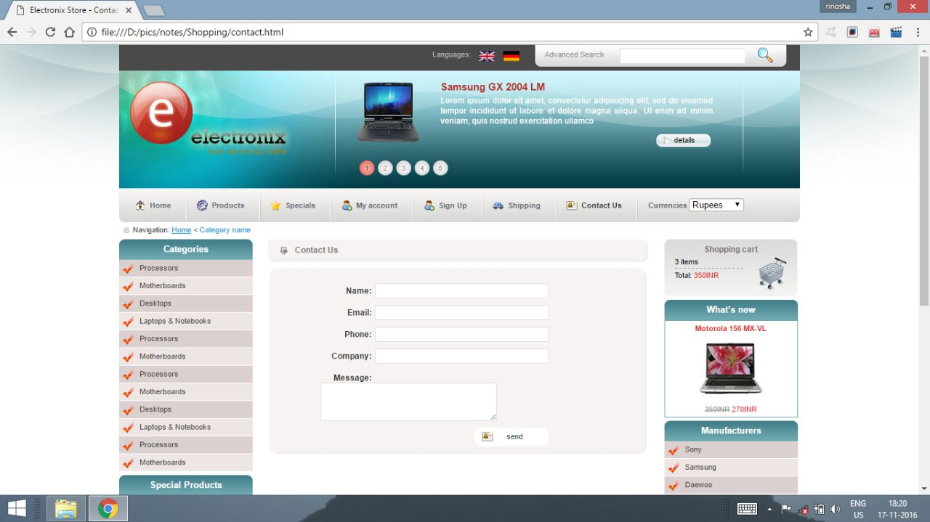

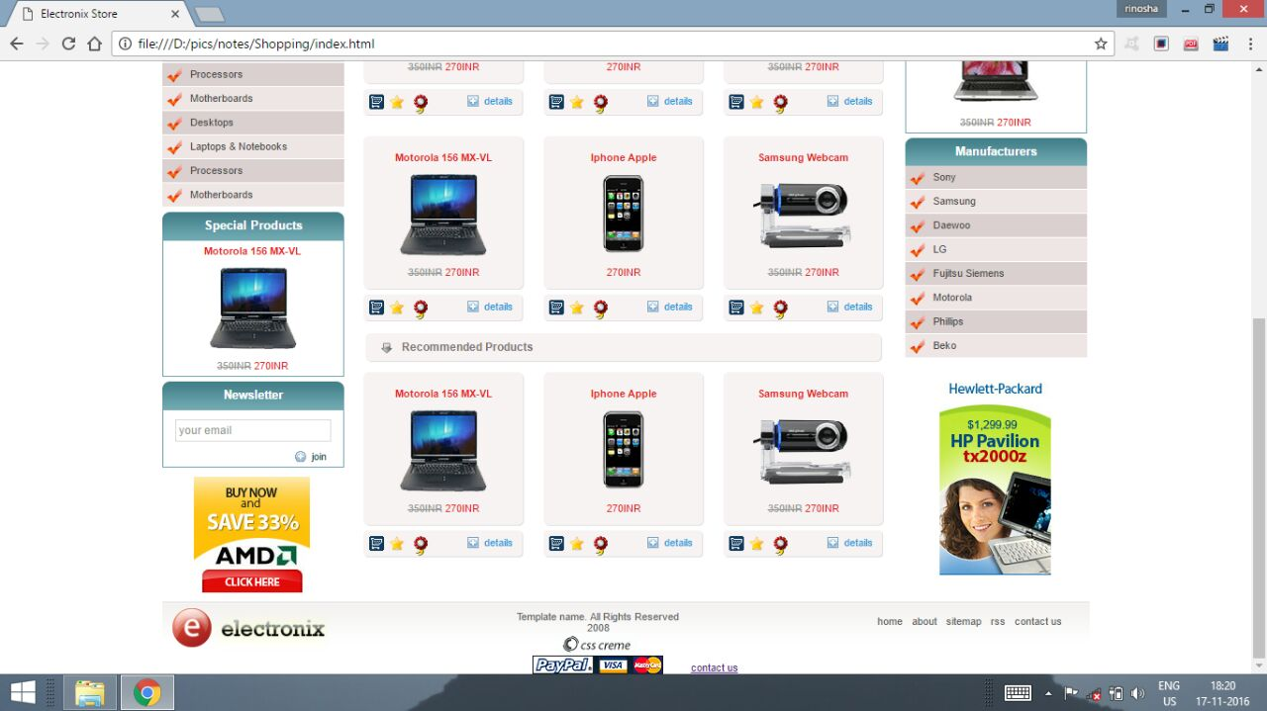

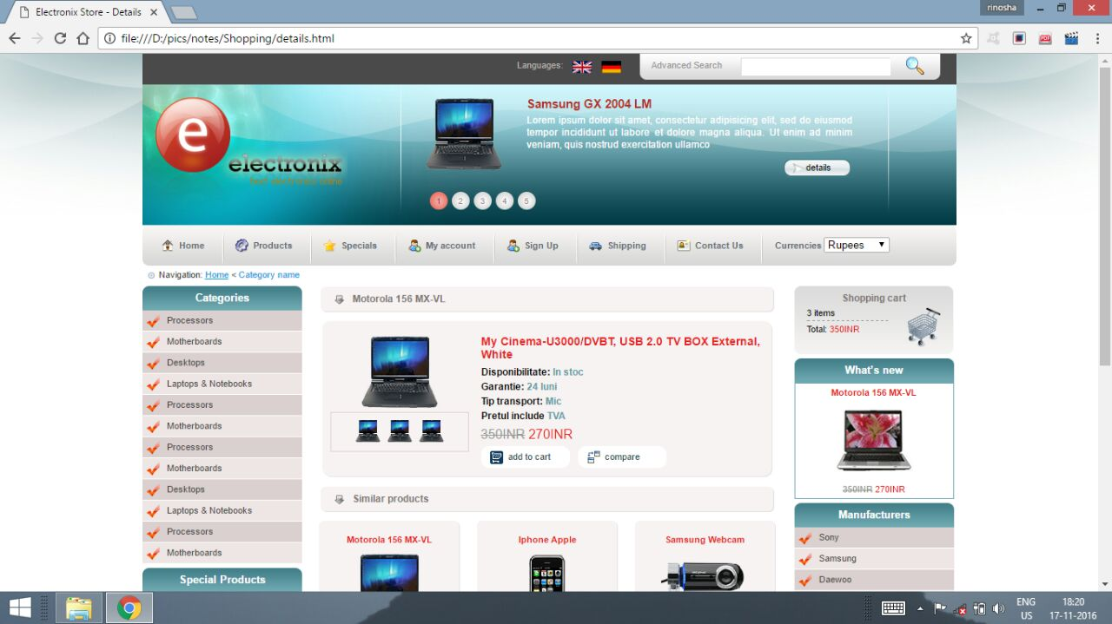

TABLES

- LOGIN TABLE

- USER DETAILS

- PRODUCT DETAILS

- PRODUCT ORDERS

CONCLUSION
The project entitled Online shopping system was completed successfully. The system has been developed with much care and free of errors and at the same time it is efficient and less time consuming. The purpose of this project was to develop a web application and an android application for purchasing items from a shop.

This project helped us in gaining valuable information and practical knowledge on several topics like designing web pages using html & CSS usage of responsive templates, designing of android applications, and management of database using MYSQL. The entire system is secured. Also the project helped us understanding about the development phases of a project and software development life cycle. We learned how to test different features of a project.
This project has given us great satisfaction in having designed an application which can be implemented to any nearby shops or branded shops selling various kinds of products by simple modifications.
There is a scope for further development in our project to a great extend. A number of features can be added to this system in future like providing moderator more control over products so that each moderator can maintain their own products. Another feature we wished to implement was providing classes for customers so that different offers can be given to each class. System may keep track of history of purchases of each customer and provide suggestions based on their history. These features could have implemented unless the time did not limited us.

PROJECT GITHUB DETAILS

11. PROJECT GITHUB DETAILS:
11.1 To Upload a Code

Step 1
To perform operations we have to sign-up into github. Fig.11.1.2 shows sign-up page.
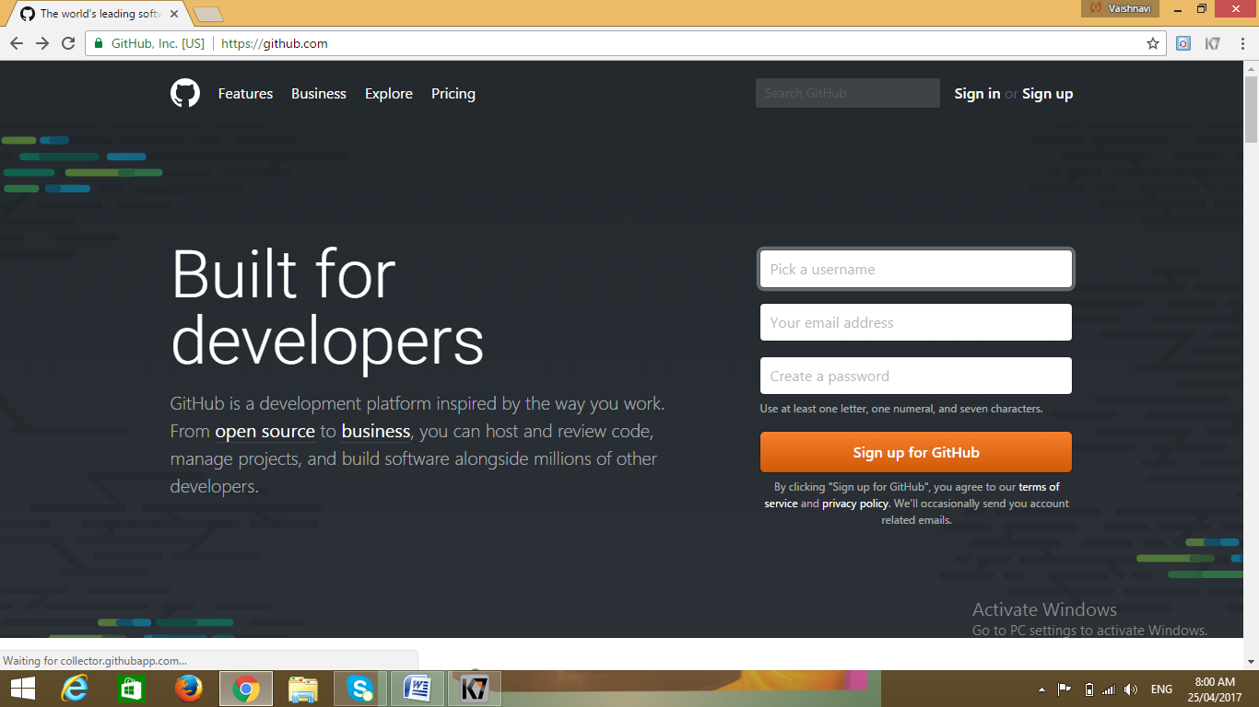
Fig 11.1.1 Front / Home Page

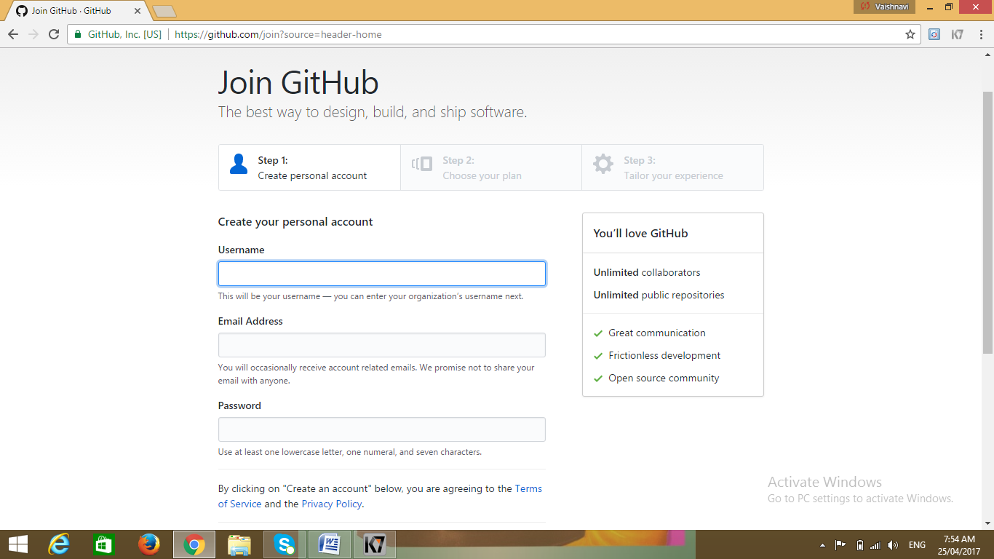
Fig 11.1.2 Sign-Up Page Step
Step 2
To enter into our account, we have to sign-in. Fig 11.1.3 shows the sign-in page.
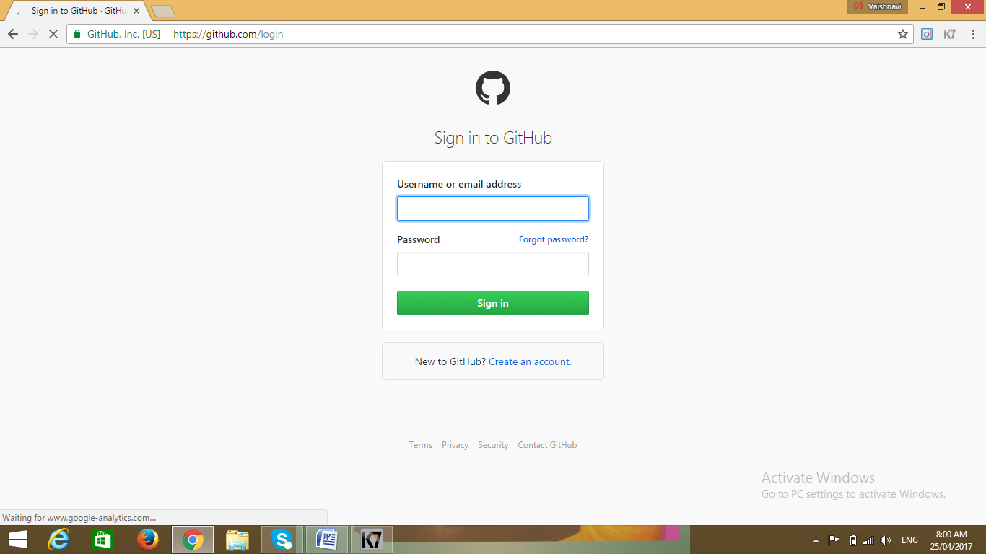
Fig 11.1.3 Sign-in Page

Step 3
After login to create a new repository, click CREATE REPOSITORY. Fig 11.1.4 shows the starting page with create repository option.
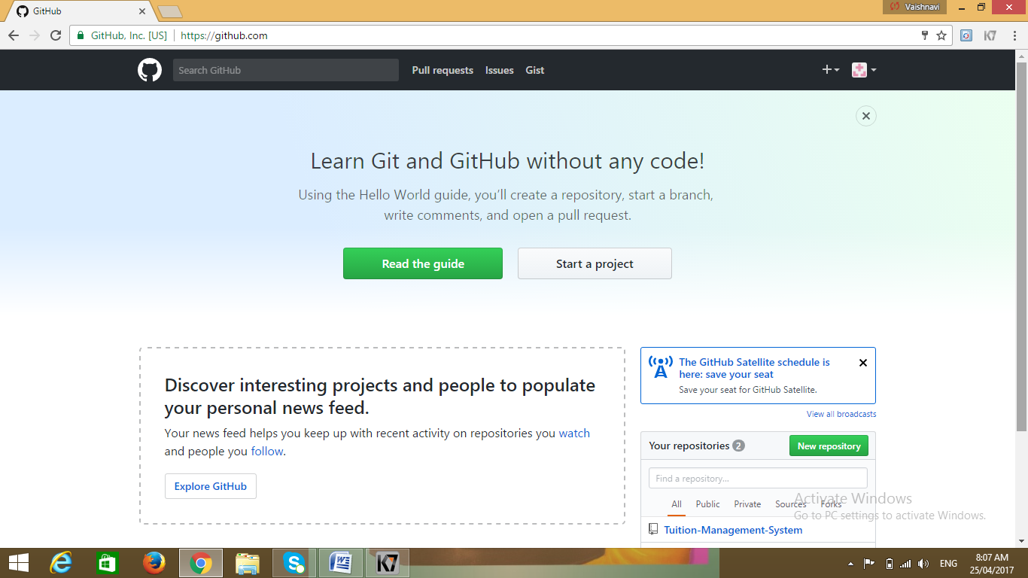
Fig 11.1.4 Starting Page
Step 4
In this page, enter repository name, description and the specifications and then click create repository. Fig.11.1.5 shows the creation of repository.
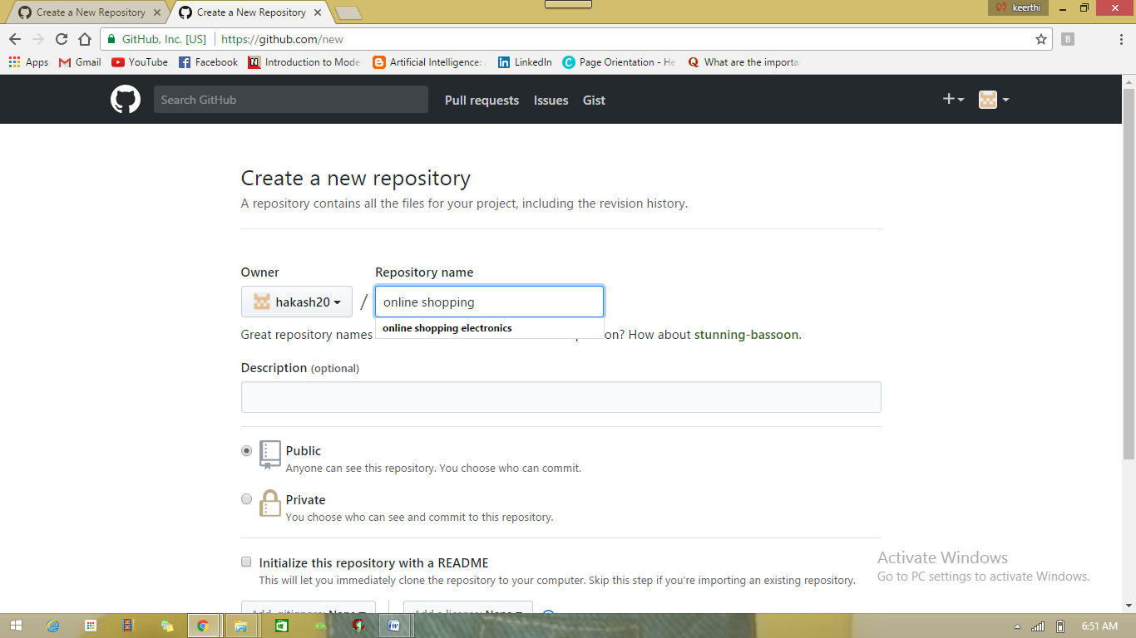
Fig 11.1.5 Create Repository

11.2 To Get a Code/ Project
Step 1
After entering into GitHub page, click explore option. Fig 11.2.1 shows opening page with explore option. 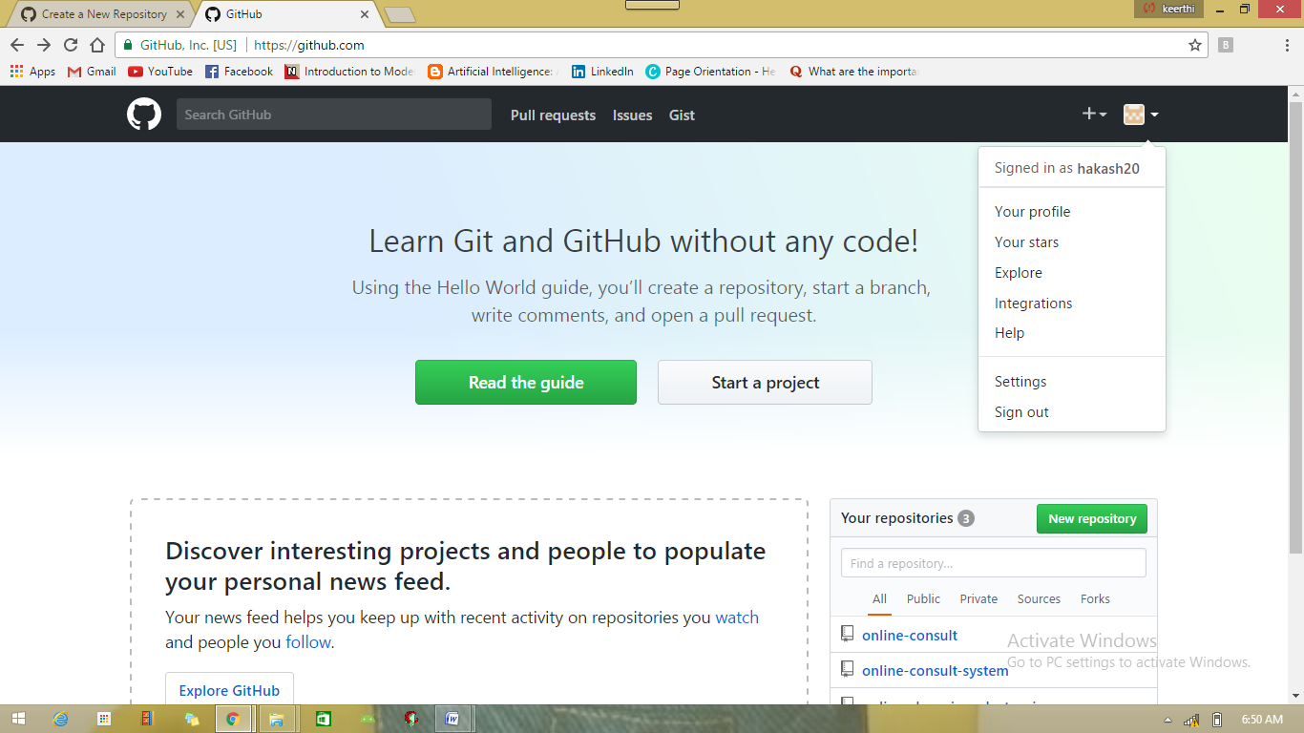
Fig 11.2.1 Opening Page
Step 2
A page containing all projects details will be displayed. Fig 11.2.2 shows all project details available.
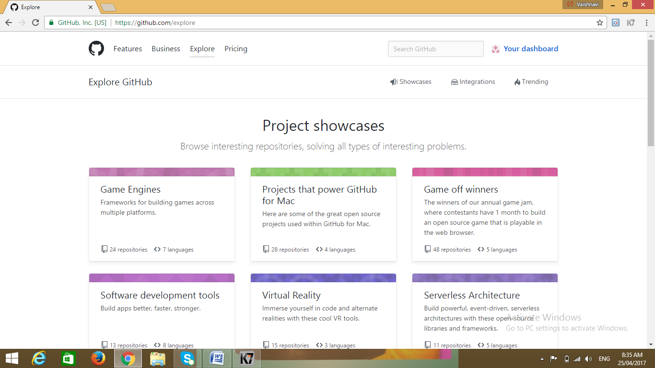
Fig 11.2.2 Showcase Of Projects

Step 3
Click the project title with required language platform. Fig 11.2.3 shows list of projects.
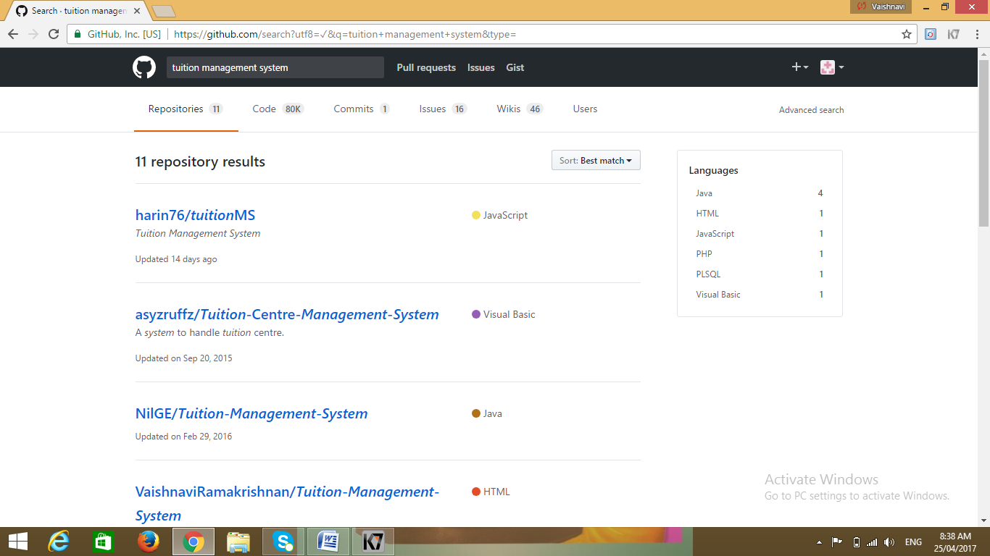
Fig 11.2.3 List Of Projects
Step 4
In this page, this project can be downloaded or cloned by Download/Clone Option. Fig 11.2.4 shows download option page.
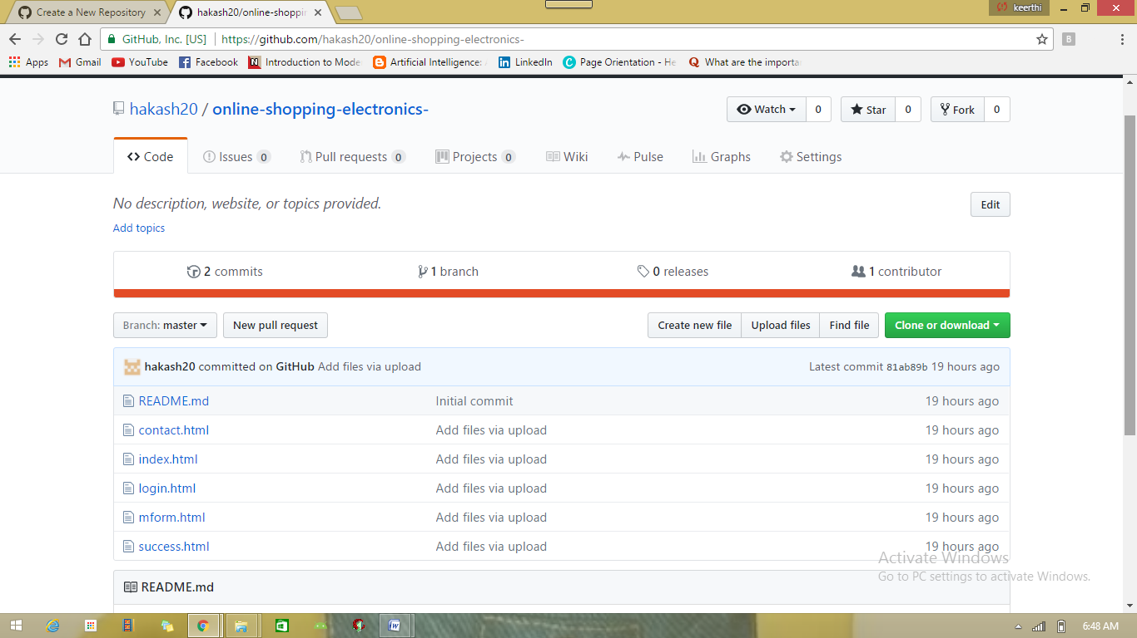 Fig 11.2.4 Page With Download Zip Option
11.3 To Delete A Code
Step 1
Sign-In into our GitHub account. Fig 11.3.1 shows sign-in page of our account.
Fig 11.3.1 Sign-In Page

Step 2
This page shows the list of repositories created by the user. Select the repository to be deleted, go to settings and delete the repository. Fig 11.3.2 shows the page with delete option.
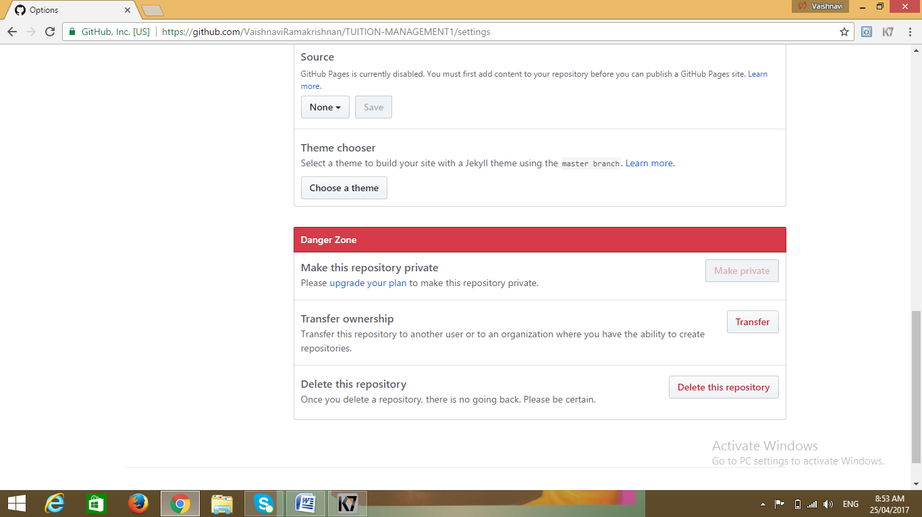

Fig 11.3.2 Page With Delete Repository Option

