ELEC 475 Lab 2

AdaIN

Jasmine Klein | 20154586

Matthew Valiquette |20151953

October 24th, 2023

# Network Training Specification

Our network was trained on a Nvidia GTX 3090 graphics card for both 1k and 10k datasets. We used Adam optimizer with a learning rate of 1e-4 and an exponential LR scheduler with a gamma of 0.9. The training was run for 20 epochs with a batch size of 40.

The loss curves for the 1k and 10k with a style weight of 5 and content weight of one vary slightly. The loss in the 10k dataset is lower and can be accounted for simply due to the larger dataset. The loss plot for the 1k however does seem to converge more this could be explained by the network becoming less generalized.

The output of the 10k is significantly better than our 1k output. With the 1k dataset our decoder lost some of the content as well as the style. With the 10k dataset the content is retained much better and the original content of the image is clearly visible. The style also performs much better on the 10k, the style is distinctly noticeable in the output images.

# Model

We implemented the forward function based off the AdaIN architecture from the slides and the example GitHub provided in the lab’s instructional pdf. Our forward encodes the style and content features, passes them through AdaIN and passes the output through the decoder. This output is then encoded again to calculate the style and content loss.

# Training

An argument parser was used to extract the hyperparameters specified in as command line arguments. To train our model, the command **python train.py -z 8 -e 50 -b 2048 -s MLP.8.pth -p loss.MLP.8.png** can be entered on a PyCharm terminal and the following function will run.

The train_transform function was used to resize the images to 512x512 and then random cropped 256x256 images to increase the data size and robustness.

### Loss Plots

The total loss, content loss and style loss for 20 epochs were plotted on the 10k dataset with varying style and a content weight of 1. The style and total loss were normalized for plotting.

Figure : style_weight=1 Figure : style_weight=5 Figure : style_weight=10

The total loss, content loss and style loss for 20 epochs were plotted on the 1k dataset with style weight of 5 and a content weight of 1. The style and total loss were normalized for plotting.

Figure : Style_weight=5

# Output Images

The alpha values from left to right for each style series is 0.1, 0.5 and 0.9. These images were the output of our decoder model after training on the 10k datasets and a style weight of 5.

The outputs are generated by running the testbat.bat file which contains all the python commands to apply the three styles to the two content images.

### Style 1: Andy Warhol

#### 10k dataset

#### 1k dataset

### Style 2 – Brushstrokes

#### 10k dataset

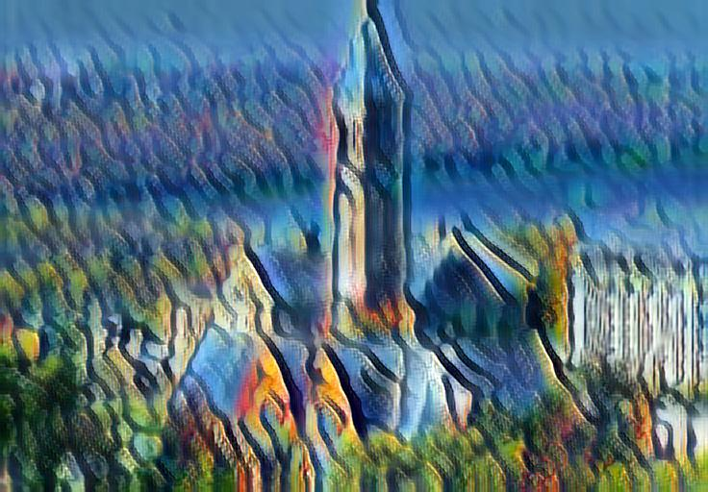

#### 1k dataset

### Style 3 - The Persistence of Memory

#### 10k dataset

#### 1k dataset

