Greenspace Accessibility and Socioeconomic Inequality in Urban Areas - Washington D.C. Case Study

## Introduction

Urban green spaces, such as parks, community gardens, and tree canopies, play a critical role in promoting physical and mental well-being. These spaces provide opportunities for exercise, relaxation, and social connection, while also mitigating urban heat, reducing air pollution, and offering psychological restoration. Access to greenspaces has been associated with improved cardiovascular health, reduced stress, and lower mortality rates (Yeager, Smith, and Bhatnagar 2020). However, the distribution of these spaces is often unequal, reflecting systemic disparities that disproportionately disadvantage low-income and minority-majority neighborhoods (Shukla 2020). This project examines the relationship between socioeconomic factors and greenspace availability in urban areas, aiming to provide evidence that can inform equitable urban planning and policy decisions.

## Literature Review

Disparities in greenspace access and quality are deeply rooted in historical and contemporary inequities shaped by institutional and societal structures, policies, and norms in the United States. Practices such as segregation, redlining, and foreclosure have historically influenced urban planning and continue to shape modern landscapes, perpetuating health inequities. These structural inequities intersect with social, economic, and environmental determinants of health, including housing, income, and the physical environment, leading to uneven greenspace distribution and access, which disproportionately impacts marginalized communities (National Academies of Sciences et al. 2017).

The distribution of greenspace varies notably across communities with different income levels and racial compositions. The below figure from Heo and Bell, shows that census block groups with lower percentages of low-income individuals and people of color generally have higher greenspace availability. Conversely, neighborhoods with higher proportions of low-income individuals and people of color tend to have less greenspace. Interestingly, while greenspace coverage is lower in these disadvantaged areas, accessibility to park entrances appears to be relatively higher, suggesting that while parks may be closer to these communities, the overall greenspace available is limited(Heo and Bell 2023). This disparity reflects systemic inequities, where wealthier and predominantly white communities enjoy more extensive greenspaces, while marginalized groups often contend with smaller and more fragmented green areas. 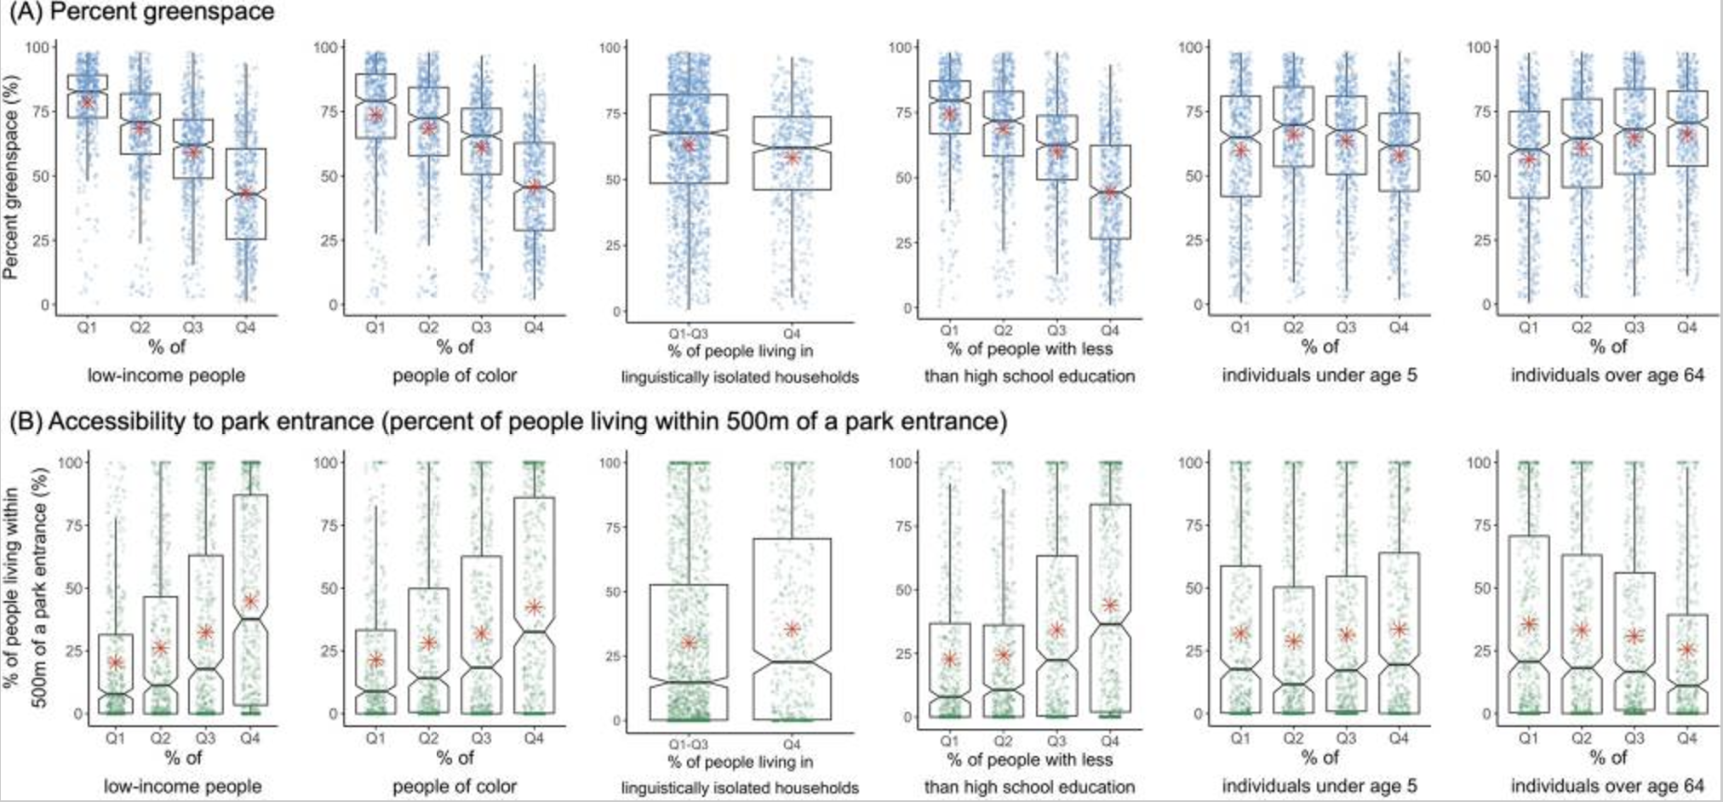

## Data

In this study, we utilized two primary datasets from the District of Columbia’s open data repositories:

**ACS 5-Year Economic Characteristics - DC Census Tract:** This dataset provides comprehensive economic characteristics derived from the American Community Survey (ACS) 5-year estimates, delineated by 2020 Census Tract boundaries. It encompasses various economic indicators, including income levels, employment status, and industry sectors, offering a detailed view of the economic landscape across different tracts within Washington, D.C (DC 2024).

**Parks and Recreation Areas** : This dataset identifies properties managed by the Department of Parks and Recreation (DPR) within Washington, D.C. It includes spatial data representing the locations and extents of parks and recreational areas, serving as a vital resource for urban planning, environmental studies, and public health assessments (DC and City of Washington 2024).

## Methodology

To explore the relationship between greenspace accessibility and sociodemographic factors, this project operationalizes abstract concepts like income inequality, poverty level, and greenspace availability into measurable variables for analysis.

**Independent Variables**

***Median Household Income***: Measured as the percentage of total households with earnings in inflation-adjusted dollars for 2022. This variable is represented by the DP03_0064E field.

***Poverty threshold***: Measured as the percentage of individuals aged 18 to 64 whose income in the past 12 months is below the poverty level. This variable is represented by the DP03_0134P field.

***Park Accessibility***: Defined as the accessibility to the nearest park, calculated using the inverse of the minimum distance (in meters) from the population centroid of each census tract to the centroid of the nearest park, which reflects relative accessibility, with higher values indicating closer proximity to parks and greater accessibility.

**Dependent Variables**

***Percent Greenspace***: Represents the percentage of total land area within each block group that overlaps with parks and recreation areas. This metric was calculated by intersecting census tract polygons with park boundaries and measuring the proportion of the tract’s total area covered by park land.

## Exploratory Data Analysis (EDA)

**Parks and Recreation Areas** :

The map below, maintained by the Department of Parks and Recreation (DPR), provides a detailed inventory of DPR-managed properties designated as parks and recreation areas, offering insights into the spatial distribution of green spaces in the city (DC and City of Washington 2024).

**ACS 5-Year Economic Characteristics - DC Census Tract**

The graph below provides an interactive visualization of median household income distribution across census tracts in Washington, D.C. Using a gradient color scale where darker shades represent higher incomes and lighter shades indicate lower incomes, the map highlights income disparities geographically (DC 2024).

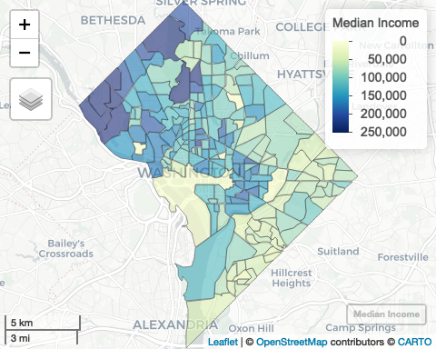

Source: [Article Notebook](https://jasminejia434.github.io/gisproject/index.qmd.html)

## Regression and Hypthesis Testing

**Hypothesis**:

***First-Order Property Hypothesis***: Census tracts with lower median household income and higher poverty rates will have less greenspace coverage compared to wealthier tracts.

***Second-Order Property Hypothesis***: Census tracts with high poverty rates are spatially clustered, and these clusters coincide with areas of low park accessibility.

The regression table above provides the results where Greenspace Percentage is the dependent variable, and the independent variables are Median Income, Poverty Rate, and Park Accessibility.

***Poverty Rate***: This indicates a positive and statistically significant (p < 0.05) association between poverty rate and greenspace percentage. For each percentage point increase in poverty rate, greenspace percentage increases by 0.128 units. This counterintuitive result may suggest that areas with higher poverty rates have slightly more greenspace or that other factors, such as land use policies, are influencing this relationship. The statistically significant positive relationship between poverty rate and greenspace percentage is notable but may require further investigation to understand causality or confounding variables.

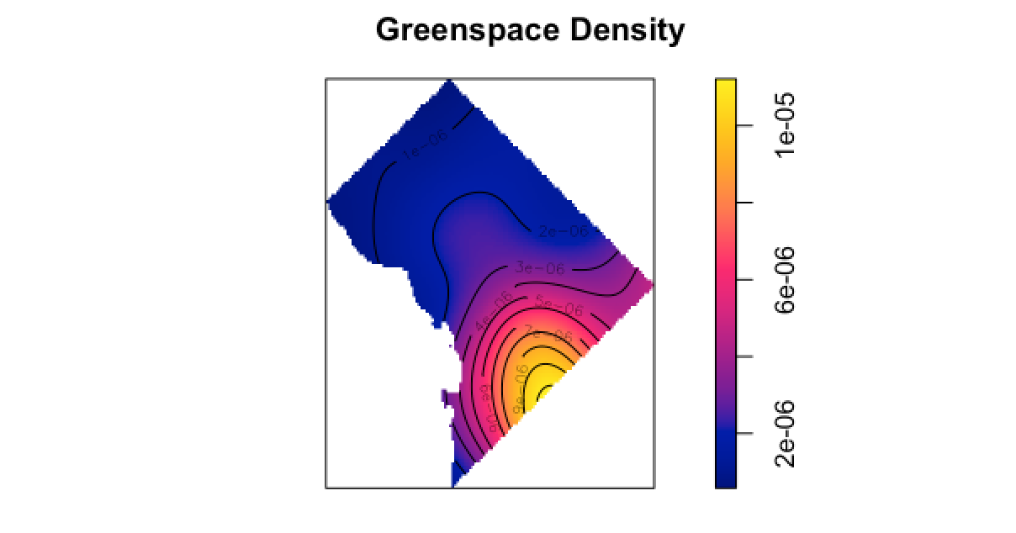

The greenspace density plot shows the spatial distribution of greenspace density across the study area. The intensity increases from blue (low density) to yellow (high density). The regions with the highest greenspace density are concentrated in specific tracts. This suggests unequal greenspace distribution, potentially aligning with socioeconomic disparities in the area.

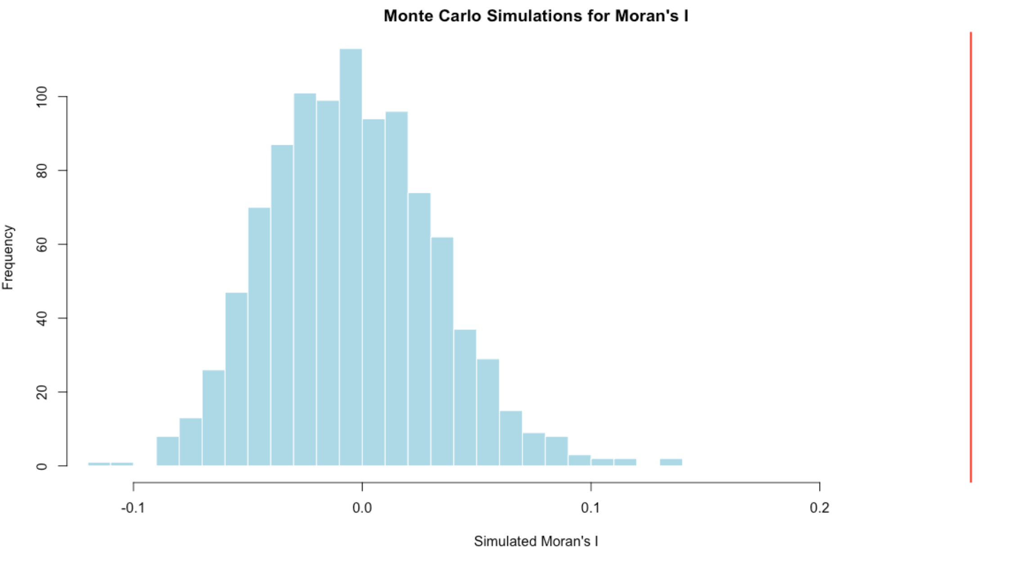

The histogram shows the distribution of Moran’s I values generated from the Monte Carlo simulations. These values represent the expected spatial autocorrelation under the null hypothesis of random spatial distribution.

The red line indicates the observed Moran’s I value from your actual dataset. In this case, the observed value is far to the right of the simulated values, suggesting that the observed spatial autocorrelation is much stronger than what would be expected under randomness. The observed Moran’s I being outside the range of simulated values indicates that the spatial autocorrelation in your data is significant.

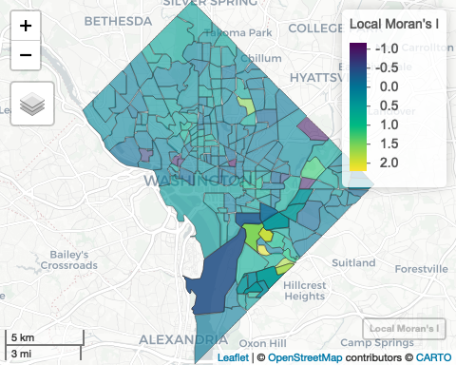

Source: [Article Notebook](https://jasminejia434.github.io/gisproject/index.qmd.html)

The choropleth map shows Local Moran’s I values for poverty rates, with colors ranging from purple (negative spatial association) to yellow (positive spatial association). This supports the second-order hypothesis of spatial clustering of poverty rates. The map also identifies potential areas for targeted policy intervention.

## Conclusion

This project examines the spatial relationship between greenspace accessibility, poverty rates, and income in urban areas. The findings provide partial support for the hypotheses.

**First-Order Property Hypothesis:** Contrary to expectations, the regression results suggest that poverty rates are positively and significantly associated with greenspace percentage, indicating that areas with higher poverty rates may have slightly more greenspace coverage. Median income, however, shows no significant relationship with greenspace percentage. These results may reflect complex historical or policy-driven factors influencing greenspace distribution, requiring further investigation.

**Second-Order Property Hypothesis:** The second-order hypothesis is strongly supported. Global Moran’s I indicates significant spatial clustering of poverty rates, confirmed by the Monte Carlo simulations, which show the observed Moran’s I far exceeds the range of simulated values under the null hypothesis of randomness. This suggests that poverty is geographically concentrated in specific areas, highlighting potential inequality in park accessibility and greenspace distribution.

## Policy Implication

This report focuses only on Washington, D.C., revealing spatial inequities in greenspace distribution and accessibility in relation to poverty rates. These findings have important implications for urban planning, public health, and environmental justice in D.C. and serve as a foundation for broader applications in other urban and rural contexts. Here are some directions for further researches:

***Expanding to Other Urban Areas***

Further research is needed to assess whether similar spatial patterns of greenspace inequality and poverty clustering are present in other urban areas across the United States. Comparing D.C. with cities of varying sizes, demographics, and urban planning histories can provide a more comprehensive understanding of greenspace inequities.

***Exploring Rural Areas***

Greenspace accessibility in rural areas, where land use and population density differ significantly from urban settings, requires distinct policy considerations. Future studies should explore greenspace availability in rural areas with high poverty rates to understand the unique challenges and opportunities.

***Chrono-Health Score Analysis***

A chrono-health score, which integrates environmental and temporal factors affecting health (e.g., access to greenspace over time, exposure to pollutants, and changes in healthcare access), could provide deeper insights. Linking chrono-health data with spatial analysis could help identify long-term health impacts of greenspace inequities and guide targeted interventions.

***Examining Broader Social Determinants of Health***

Expanding the research to include other social determinants (e.g., education, employment, and housing) could provide a holistic view of how greenspace interacts with socioeconomic and health disparities.

DC, Open Data. 2024. “ACS 5-Year Economic Characteristics - DC Census Tract.” <https://opdatahub.dc.gov/datasets/DCGIS::acs-5-year-economic-characteristics-dc-census-tract/explore>.

DC, Open Data, and DC City of Washington. 2024. “Parks and Recreation Areas.” Open Data DC. <https://opendata.dc.gov/datasets/DCGIS::parks-and-recreation-areas/explore?location=38.899015%2C-77.029746%2C11.18>.

Heo, Seulkee, and Michelle L. Bell. 2023. “Investigation on Urban Greenspace in Relation to Sociodemographic Factors and Health Inequity Based on Different Greenspace Metrics in 3 US Urban Communities.” *Journal of Exposure Science & Environmental Epidemiology* 33 (2): 218–28. <https://doi.org/10.1038/s41370-022-00468-z>.

National Academies of Sciences, Engineering, Medicine, Health, Medicine Division, Board on Population Health, Public Health Practice, and Committee on Community-Based Solutions to Promote Health Equity in the United States. 2017. *Communities in Action: Pathways to Health Equity*. Edited by Alina Baciu, Yamrot Negussie, Amy Geller, and James N. Weinstein. Washington, DC: National Academies Press (US). <https://www.ncbi.nlm.nih.gov/books/NBK425845/>.

Shukla, Shivani. 2020. “Racial Disparities in Access to Public Green Space.” *Chicago Policy Review*. <https://chicagopolicyreview.org/2020/09/23/racial-disparity-in-access-to-public-green-space/>.

Yeager, Rebecca A., Theodore R. Smith, and Aruni Bhatnagar. 2020. “Green Environments and Cardiovascular Health.” *Trends in Cardiovascular Medicine* 30 (4): 241–46. <https://doi.org/10.1016/j.tcm.2019.06.005>.