Real-Time Campus Aeroallergen Dispersion Modeling Using Gaussian Plume Theory and Satellite-Based Vegetation Detection
Jasmine J. Zhang
June 2026
Abstract
We present Campus AeroAllergen Mapping (CAM), a web-based system for modeling hyperlocal pollen dispersion across a school campus at meter-scale resolution. The framework couples a two-dimensional potential-flow wind field, which deflects and channels the wind around building footprints, with a steady-state Gaussian plume model that disperses pollen along the local flow, evaluating concentration at student breathing height ($z=1.5$ m). Individual tree canopies are identified from high-resolution satellite imagery using color-based segmentation with watershed splitting, and building rooftops are detected with the Segment Anything Model (SAM); both are refined through human-in-the-loop correction. Temporal emission variability is captured by species-specific Gaussian phenological gate functions, and building footprints define indoor exclusion zones where concentration is zeroed. The system is applied to two campuses—Henry M. Gunn High School (Palo Alto, CA) and the Stanford University core—modeling thousands of individual trees and buildings, and produces concentration fields at meter scale in a few seconds. A fixed annual color scale enables intuitive seasonal comparison, showing summer concentrations at roughly 6% of the spring peak. The system integrates exposure along student walking paths to report lower-exposure routes; these predictions have not yet been validated against measured pollen counts.
Keywords: potential-flow wind field, Gaussian plume model, pollen dispersion, aeroallergen mapping, satellite vegetation detection, deep-learning segmentation, phenological modeling

Introduction
Allergic rhinitis affects 10–30% of the global population, with airborne pollen constituting the dominant environmental trigger . On school campuses where students transit between buildings through corridors lined with allergenic flora, localized pollen concentrations can vary by orders of magnitude over distances of tens of meters due to source proximity, wind channeling, and structural aerodynamic effects.
Existing pollen monitoring relies on regional stations reporting area-averaged counts at temporal resolutions of hours to days . These measurements cannot resolve the hyperlocal concentration gradients determining individual exposure during a 5-minute walking transit. We address this gap by developing a physics-based framework that:
- Computes a 2D potential-flow wind field that deflects and channels the wind around campus buildings;
- Solves the atmospheric advection-diffusion equation analytically (Gaussian plume) at meter-scale resolution, driven by the local wind at each source;
- Identifies pollen sources (tree canopies) and building rooftops from satellite imagery, the latter with a deep-learning segmentation model;
- Modulates emissions temporally using species-specific phenological functions;
- Masks indoor building volumes from the exposure field.
The system is deployed on two campuses of contrasting scale and layout: Henry M. Gunn High School (Palo Alto, CA), a 25-hectare campus, and the core of Stanford University; together they contain thousands of individually mapped trees and buildings.

Atmospheric Dispersion Model

Physical Picture
When a tree releases pollen grains into the air, two physical processes determine where those grains end up:
- Advection (bulk transport by wind): The wind carries the pollen cloud bodily in the downwind direction, like a river carrying a dye patch. If the wind blows from the southwest at 3 m/s, the pollen cloud moves northeast at 3 m/s.
- Diffusion (turbulent spreading): Atmospheric turbulence—random gusts and eddies—causes the pollen cloud to spread out in all directions as it travels. The cloud starts concentrated near the tree and becomes progressively wider and more dilute downwind, forming a cone-shaped plume.
The combination produces a characteristic pattern: highest concentration immediately downwind of the tree, decreasing with distance as the plume spreads, and zero concentration upwind.

Governing Equation
These processes are described mathematically by the advection-diffusion equation:
$$\underset{\text{concentration change}}{\underset{⏟}{\frac{∂C}{∂t}}}+\underset{\text{wind carries pollen (advection)}}{\underset{⏟}{u\frac{∂C}{∂x}+v\frac{∂C}{∂y}}}=\underset{\text{turbulence spreads pollen (diffusion)}}{\underset{⏟}{K_{x}\frac{∂^{2}C}{∂x^{2}}+K_{y}\frac{∂^{2}C}{∂y^{2}}+K_{z}\frac{∂^{2}C}{∂z^{2}}}}−\underset{\text{settling/removal}}{\underset{⏟}{λC}}+\underset{\text{tree emitting pollen}}{\underset{⏟}{Qδ(x−x_{s})}}$$
Each term has a clear physical meaning:
- $C(x,y,z,t)$ — Pollen concentration (grains/m$​^{3}$) at position $(x,y,z)$ and time $t$. This is what a student breathes in.
- $(u,v)$ — Wind velocity components (m/s). $u$ is the east-west wind speed, $v$ is the north-south wind speed. Measured from weather station or API. A 4 m/s southwest wind means $u≈2.8$ m/s (eastward) and $v≈2.8$ m/s (northward).
- $K_{x},K_{y},K_{z}$ — Turbulent eddy diffusivity (m$​^{2}$/s). These quantify how vigorously the atmosphere mixes. On a calm, stable morning ($K≈1$ m$​^{2}$/s), pollen stays concentrated near the source. On a windy, sunny afternoon ($K≈50$ m$​^{2}$/s), turbulent eddies rapidly dilute the pollen cloud. $K_{z}$ (vertical) is typically smaller than $K_{x},K_{y}$ (horizontal) because vertical mixing is suppressed by gravity.
- $λ$ — Deposition/removal rate (s$​^{−1}$). Pollen is continuously removed from the air by gravitational settling onto the ground, impaction on surfaces, and washout by rain. Heavier pollen (Pine, 60 $μ$m diameter) has $λ$ about $5×$ larger than light pollen (Oak, 20 $μ$m), meaning Pine falls out of the air much faster.
- $Q$ — Source emission rate (grains/s). How many pollen grains the tree releases per second. A mature Oak at peak bloom emits $∼$500 grains/s from its canopy.
- $δ(x−x_{s})$ — Dirac delta function. Indicates that emission occurs at a single point $x_{s}$ (the tree’s location). This is the “point source” approximation.

Gaussian Plume Solution
Solving the full PDE numerically at every timestep would be computationally expensive. Instead, we use the steady-state analytical solution (assuming wind conditions change slowly relative to pollen transport time). This yields the famous Gaussian plume formula :
$$C(x^{′},y^{′},z)=\underset{\text{dilution factor}}{\underset{⏟}{\frac{Q}{2πUσ_{y}σ_{z}}}}⋅\underset{\text{crosswind spread}}{\underset{⏟}{exp​\left(​−\frac{y^{′}​^{2}}{2σ_{y}^{2}}\right)}}⋅\underset{\text{vertical profile}}{\underset{⏟}{V(z)}}$$
Each factor has a physical interpretation:
- $\frac{Q}{2πUσ_{y}σ_{z}}$ — Dilution factor. The faster the wind ($U$ large) and the wider the plume ($σ_{y},σ_{z}$ large), the more diluted the pollen becomes. Doubling wind speed halves the concentration everywhere.
- $exp(−y^{′}​^{2}/2σ_{y}^{2})$ — Crosswind Gaussian profile. Concentration is highest on the plume centerline ($y^{′}=0$, directly downwind) and drops off as a bell curve to either side. $σ_{y}$ is the “width” of this bell curve—how far sideways the pollen has spread.
- $V(z)$ — Vertical profile with ground reflection:
$$V(z)=\underset{\text{direct path from source}}{\underset{⏟}{exp​\left(​−\frac{(z−H)^{2}}{2σ_{z}^{2}}\right)}}+\underset{\text{ground-reflected path}}{\underset{⏟}{exp​\left(​−\frac{(z+H)^{2}}{2σ_{z}^{2}}\right)}}$$
The first term is pollen arriving directly from the tree canopy at height $H$. The second term accounts for pollen that has hit the ground and “bounced” back up (mathematically modeled as a mirror image source below ground). This ensures no pollen is lost through the ground surface.

Key Parameters Explained

$σ_{y}$ and $σ_{z}$: Plume Spread (meters)
These are the most important parameters. They control how wide ($σ_{y}$) and tall ($σ_{z}$) the plume is at any given downwind distance:
- Near the tree ($x^{′}=10$ m): $σ_{y}≈0.8$ m, $σ_{z}≈0.6$ m. The plume is narrow—only a few meters wide. Concentration is very high.
- 50 m downwind: $σ_{y}≈3.5$ m, $σ_{z}≈2.5$ m. The plume has spread to about 7 m wide.
- 200 m downwind: $σ_{y}≈12$ m, $σ_{z}≈8$ m. The plume is now 24 m wide but much more dilute.
They grow with distance because turbulence has more time to mix the pollen sideways and vertically. The growth rate depends on atmospheric stability:
$$σ_{y}=a_{y}⋅(x^{′})^{b_{y}}, σ_{z}=a_{z}⋅(x^{′})^{b_{z}}$$

Atmospheric Stability Classes (A–F)
Stability describes how much the atmosphere resists or encourages vertical mixing:
- Class A (very unstable): Hot sunny afternoon. Strong updrafts vigorously mix pollen vertically. Plume spreads rapidly, diluting quickly. Paradoxically, unstable conditions produce lower ground-level concentrations because pollen is lofted upward.
- Class D (neutral): Overcast, moderate wind. Default condition. Moderate mixing.
- Class F (very stable): Clear, calm night or early morning. Very little vertical mixing. Plume stays narrow and concentrated near emission height. Worst case for ground-level exposure if source is low.
We estimate stability from two observable quantities:
- Wind speed $<$ 2 m/s + clear sky $→$ Class A/B (unstable, strong solar heating)
- Wind speed 3–5 m/s + partly cloudy $→$ Class C/D (neutral)
- Wind speed $>$ 6 m/s $→$ Class D (mechanical turbulence dominates)
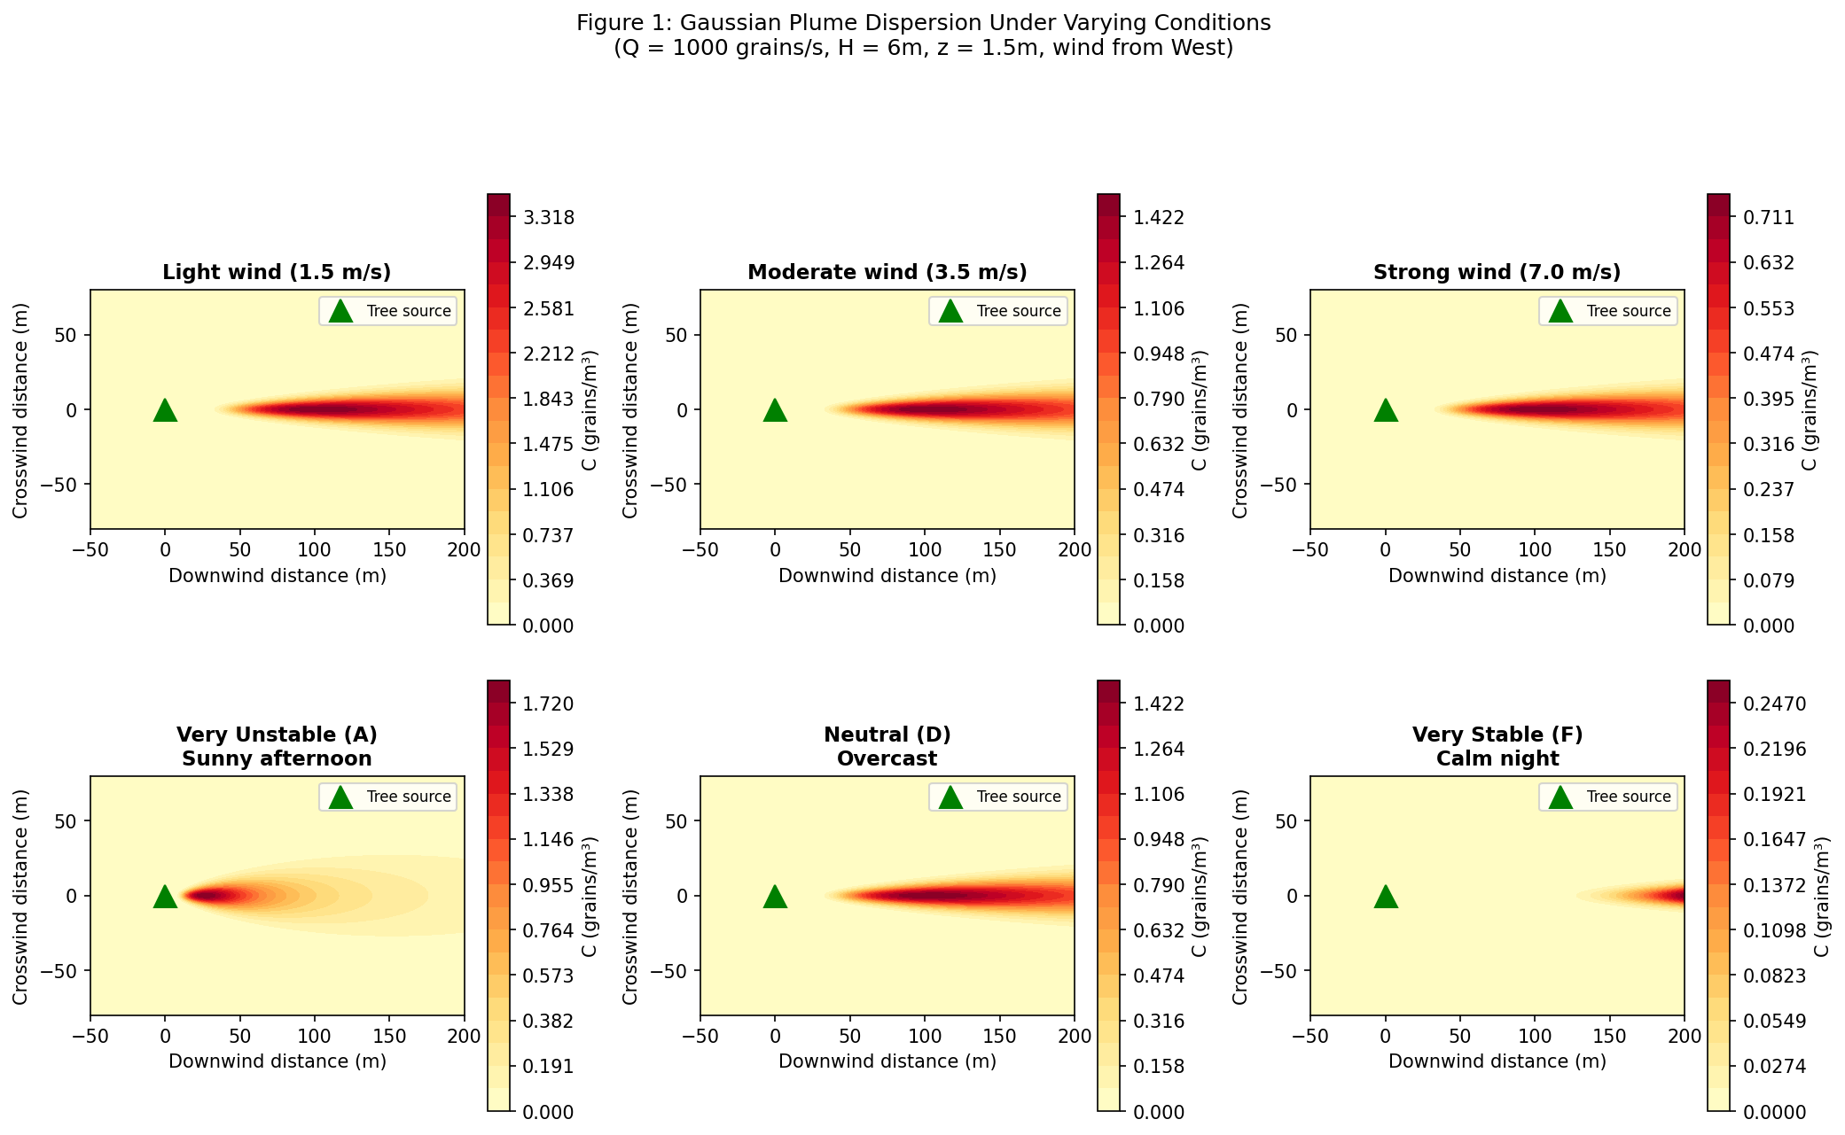
Gaussian plume concentration fields under varying conditions. Top row: effect of wind speed (stability class D). Stronger winds dilute and elongate the plume. Bottom row: effect of atmospheric stability (wind = 3.5 m/s). Unstable conditions (A) spread pollen rapidly; stable conditions (F) confine it in a narrow, concentrated plume.

$U$: Wind Speed (m/s)
Mean horizontal wind speed at reference height (typically 10 m). Obtained from OpenWeatherMap API. Physical effects:
- Strong wind ($U>5$ m/s): Pollen is rapidly carried far downwind but heavily diluted. Concentration drops quickly with distance.
- Light wind ($U<2$ m/s): Pollen lingers near the source tree. High concentrations in a small area. The model sets a minimum of $U=0.5$ m/s to avoid division by zero (calm conditions are handled as very light drift).

$H$: Effective Source Height (meters)
The height at which pollen enters the atmosphere. For trees, this is the canopy height where catkins/flowers release grains. We use $H=6.0$ m (average for campus trees ranging from 4 m shrubs to 15 m oaks). The concentration at ground level ($z=1.5$ m) depends on how far pollen must fall/mix downward from height $H$.

$z$: Receptor Height (meters)
Fixed at $z=1.5$ m—the height of a student’s nose and mouth (breathing zone). This is where inhaled dose matters for allergic response.

$(x^{′},y^{′})$: Wind-Aligned Coordinates
The plume always points downwind. To compute concentration at any campus location, we transform from map coordinates to a frame aligned with the current wind direction:
$$\begin{aligned}x^{′}&=Δxcosα+Δysinα \text{(downwind distance from tree)} \\ y^{′}&=−Δxsinα+Δycosα \text{(crosswind offset)}\end{aligned}$$
where $α=\frac{π}{180}({270}^{∘}−θ)$ converts the meteorological wind direction $θ$ (degrees clockwise from North) to a mathematical angle. Key consequences:
- If you are directly downwind of a tree ($y^{′}=0$): maximum exposure.
- If you are perpendicular to the wind ($x^{′}=0$): zero concentration (upwind or crosswind).
- If the wind shifts direction, the entire plume rotates to point the new way.

Humidity Effects on Pollen Dispersion
Relative humidity (RH) affects pollen transport through multiple mechanisms that our model incorporates:

Hygroscopic Swelling
Pollen grains are hygroscopic—they absorb water vapor from humid air and swell. The effective aerodynamic diameter increases with humidity following a growth factor:
$$d_{p}(RH)=d_{p,dry}⋅{\left(1+κ⋅\frac{RH}{100−RH}\right)}^{1/3}$$
where $κ$ is the species-specific hygroscopicity parameter ($κ≈0.05$–$0.15$ for pollen). At 80% RH, Oak pollen swells from 22 $μ$m to approximately 25 $μ$m, increasing its settling velocity by $∼$30%:
$$v_{s}(RH)=v_{s,dry}⋅{\left(\frac{d_{p}(RH)}{d_{p,dry}}\right)}^{2}⋅\frac{ρ_{p}(RH)}{ρ_{p,dry}}$$
The density ratio accounts for water uptake reducing the effective density. The net effect: humid conditions cause pollen to settle faster, reducing far-field concentrations but increasing deposition near the source.

Humidity-Dependent Emission Suppression
Most tree species suppress pollen release under high humidity. Anthers (the pollen-bearing structures) require drying to dehisce (split open). The emission rate is modulated by a humidity factor:
$$Q_{i}(t,RH)=Q_{i}(t)⋅f_{RH}(RH)$$
where:
$$f_{RH}(RH)=\left\{\begin{matrix}1.0 & RH<50\% \\ 1.0−0.8⋅\frac{RH−50}{50} & 50\%≤RH<90\% \\ 0.1 & RH≥90\%\end{matrix}\right.$$
At 50% RH, emission is unrestricted. At 90% RH (foggy morning), emission drops to just 10% of the dry-air maximum. This explains why pollen counts are typically highest on dry, warm afternoons and lowest during humid mornings or after rainfall.

Osmotic Rupture and Sub-Pollen Particles
When relative humidity rapidly exceeds $∼$95% (e.g., during thunderstorms), pollen grains can undergo osmotic rupture: the grain absorbs water faster than its wall can expand, causing it to burst and release hundreds of sub-pollen particles (SPP) of 0.5–4 $μ$m diameter. These SPPs:
- Are small enough to penetrate deep into the lower respiratory tract (bronchi and alveoli), unlike intact grains which deposit in the nose/throat
- Have negligible settling velocity ($v_{s}<0.01$ cm/s), remaining airborne for hours
- Carry the same allergenic proteins as the parent grain
- Are implicated in “thunderstorm asthma” events
We model this as a conditional burst event. If $RH>95\%$ and $ΔRH/Δt>10\%$/hr (rapid humidity spike):
$$Q_{SPP,i}(t)=N_{SPP}⋅Q_{i}(t)⋅f_{rupture}$$
where $N_{SPP}≈700$ is the number of sub-pollen particles per ruptured grain and $f_{rupture}≈0.3$ is the fraction of airborne grains that rupture. The SPPs are then modeled as a separate Gaussian plume with near-zero settling velocity and greatly extended atmospheric lifetime.

Wet Deposition (Rainfall Washout)
Rain removes pollen from the atmosphere through below-cloud scavenging. The washout rate is modeled as an additional first-order removal term:
$$λ_{wet}=Λ⋅P^{0.7}$$
where $P$ is the rainfall intensity (mm/hr) and $Λ≈5×{10}^{−4}$ s$​^{−1}$/(mm/hr)$​^{0.7}$ is the scavenging coefficient for pollen-sized particles. During moderate rain (5 mm/hr), washout removes pollen with an effective half-life of $∼$20 minutes, rapidly clearing the atmosphere. The total removal rate becomes:
$$λ_{total}=λ_{dry}+λ_{wet}$$

Implementation
Our system obtains current relative humidity from the weather API (OpenWeatherMap provides RH as a standard field). The humidity corrections are applied as:
- Emission rate adjusted by $f_{RH}$ (Eq. [eq:rh_emission])
- Settling velocity adjusted by hygroscopic swelling (Eq. [eq:hygroscopic])
- SPP burst event triggered if RH exceeds 95% with rapid onset
- Wet deposition added during active precipitation
On a typical Palo Alto afternoon (RH $≈$ 40–55%), humidity corrections are minimal. During marine-layer mornings (RH $≈$ 80–90%), emission is suppressed by 50–80%, significantly reducing campus pollen load—explaining why early-morning commuters often experience fewer symptoms than those arriving mid-morning after the fog burns off.
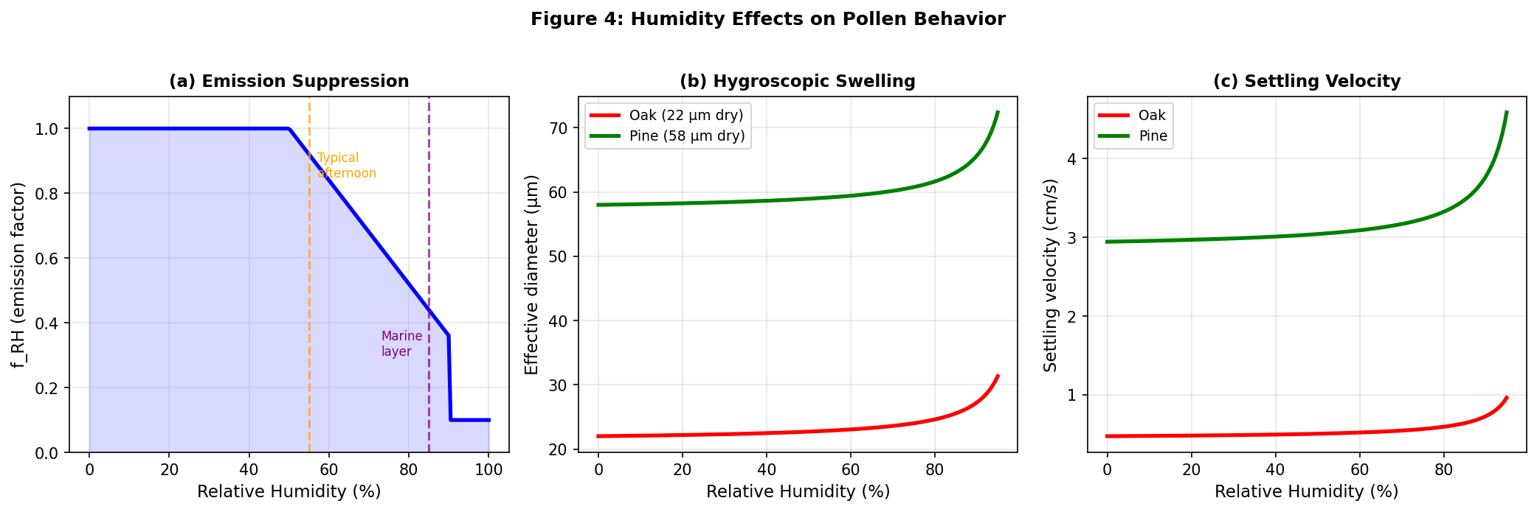
Humidity effects on pollen behavior. (a) Emission suppression factor $f_{RH}$: pollen release drops sharply above 50% RH. (b) Hygroscopic swelling increases grain diameter at high humidity. (c) Resulting increase in gravitational settling velocity.

Species-Dependent Particle Dynamics
Pollen grains vary significantly in aerodynamic properties across species, affecting their atmospheric transport behavior. Three key species-dependent parameters modify the dispersion model:

Gravitational Settling Velocity
Pollen grains are not neutrally buoyant; they settle under gravity at a terminal velocity $v_{s}$ governed by Stokes’ law for spherical particles in laminar flow:
$$v_{s}=\frac{ρ_{p} d_{p}^{2} g}{18 μ}$$
where $ρ_{p}$ is the pollen grain density (kg m$​^{−3}$), $d_{p}$ is the aerodynamic diameter (m), $g=9.81$ m s$​^{−2}$ is gravitational acceleration, and $μ=1.81×{10}^{−5}$ Pa$⋅$s is the dynamic viscosity of air at 20°C.
Table 1 lists the physical properties and resulting settling velocities for each campus species. Pine pollen, with its large diameter ($∼$60 $μ$m), settles at 3.1 cm/s—roughly $6×$ faster than the small Oak grains ($∼$22 $μ$m, 0.5 cm/s). This means Pine pollen deposits closer to the source tree, while Oak pollen remains airborne longer and disperses further downwind.
Pollen grain physical properties and settling velocities.
Species | $d_{p}$ ($μ$m) | $ρ_{p}$ (kg/m$​^{3}$) | $v_{s}$ (cm/s) | Airborne half-life
Valley Oak | 22 | 1050 | 0.5 | Long (hours)
Coast Live Oak | 20 | 1050 | 0.4 | Long (hours)
Pine | 58 | 550 | 3.1 | Short (minutes)
Redwood | 30 | 800 | 1.0 | Moderate
Cedar | 45 | 560 | 1.5 | Moderate
Chinese Elm | 28 | 1000 | 1.1 | Moderate
Sycamore | 20 | 1020 | 0.4 | Long (hours)

Tilted Plume: Gravitational Modification
The settling velocity tilts the plume centerline downward. The effective plume height decreases with downwind distance:
$$H_{eff}(x^{′})=H−\frac{v_{s,i}⋅x^{′}}{U}$$
where $H$ is the initial emission height, $v_{s,i}$ is the species-specific settling velocity, $x^{′}$ is the downwind distance, and $U$ is the wind speed. For heavy Pine pollen in light winds ($U=2$ m/s), the plume centerline drops by 1 m over just 65 m of travel, causing rapid ground-level concentration increase near the source.
Substituting into the Gaussian plume (Eq. [eq:plume]), the species-dependent vertical term becomes:
$$V_{i}(z,x^{′})=exp​\left(​−\frac{(z−H_{eff,i})^{2}}{2σ_{z}^{2}}\right)+exp​\left(​−\frac{(z+H_{eff,i})^{2}}{2σ_{z}^{2}}\right)$$

Deposition Velocity and First-Order Decay
Pollen removal from the atmosphere occurs through gravitational settling (dry deposition) and impaction on surfaces. The effective decay rate $λ_{i}$ in Eq. [eq:advdiff] is species-dependent:
$$λ_{i}=\frac{v_{d,i}}{H_{mix}}$$
where $v_{d,i}$ is the total deposition velocity (combining gravitational settling and surface impaction) and $H_{mix}$ is the mixing height. Larger grains have higher deposition velocities, resulting in faster atmospheric removal:
$$v_{d,i}=v_{s,i}+v_{imp,i}$$
The impaction velocity $v_{imp}$ depends on grain inertia (Stokes number) and surface roughness. For campus-scale transport over grass and pavement, typical values are $v_{imp}≈0.2$–$0.5$ cm/s for small grains and $1$–$2$ cm/s for large grains.

Turbulent Diffusivity
The lateral ($K_{y}$) and vertical ($K_{z}$) eddy diffusivities in Eq. [eq:advdiff] are properties of the atmosphere, not the particle. However, the effective vertical diffusivity for heavy particles is reduced because gravitational settling counteracts upward turbulent mixing:
$$K_{z,eff,i}=K_{z}⋅exp​\left(−\frac{v_{s,i}}{u_{*}}\right)$$
where $u_{*}≈0.1$–$0.4$ m/s is the friction velocity. For small Oak pollen ($v_{s}=0.5$ cm/s $≪u_{*}$), the correction is negligible ($K_{z,eff}≈K_{z}$), and the particle behaves as a passive tracer. For heavy Pine pollen ($v_{s}=3.1$ cm/s), the effective diffusivity is reduced by $∼$10%, confining the plume closer to the ground.

Species-Specific Plume Behavior Summary
Combining these effects, the full species-dependent Gaussian plume is:
$$C_{i}(x^{′},y^{′},z)=\frac{Q_{i}(t)}{2πUσ_{y}σ_{z,i}}exp​\left(−\frac{y^{′}​^{2}}{2σ_{y}^{2}}\right)V_{i}(z,x^{′})⋅e^{−λ_{i}x^{′}/U}$$
This produces qualitatively different spatial patterns by species:
- Oak ($v_{s}$ small, $λ$ small): Wide, far-reaching plumes. Concentration remains elevated hundreds of meters downwind. Dominates campus-wide background.
- Pine ($v_{s}$ large, $λ$ large): Narrow, rapidly decaying plumes. High concentration within 20–50 m of source, then sharp falloff. Creates localized “hot spots” near pine trees.
- Redwood/Elm (intermediate): Moderate plume extent, 50–150 m effective range.
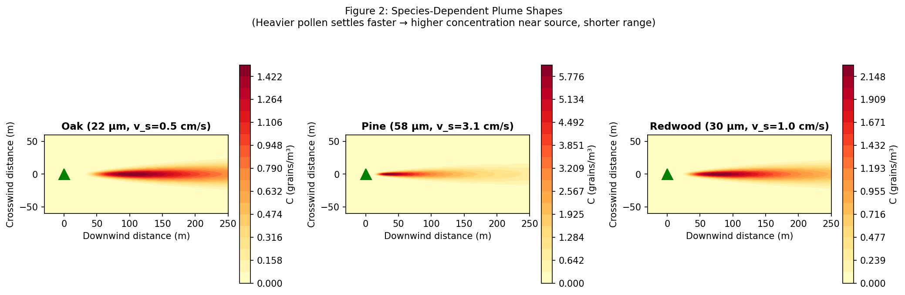
Species-dependent plume shapes due to different settling velocities. Oak pollen (small, light grains) produces wide, far-reaching plumes. Pine pollen (large, heavy grains) creates intense but localized concentration near the source tree.

Dispersion Coefficients
The crosswind ($σ_{y}$) and vertical ($σ_{z}$) standard deviations follow Pasquill-Gifford power-law relations :
$$σ_{y}=a_{y}(x^{′})^{b_{y}}, σ_{z}=a_{z}(x^{′})^{b_{z}}$$
with coefficients $(a,b)$ tabulated for atmospheric stability classes A–F (Table 2). Stability is estimated from wind speed and cloud cover using Turner’s method .
Pasquill-Gifford dispersion coefficients.
Class | $a_{y}$​ | $b_{y}$​ | $a_{z}$​ | $b_{z}$​
A | 0.22 | 0.894 | 0.20 | 0.894
B | 0.16 | 0.894 | 0.12 | 0.894
C | 0.11 | 0.894 | 0.08 | 0.894
D | 0.08 | 0.894 | 0.06 | 0.894
E | 0.06 | 0.894 | 0.03 | 0.894
F | 0.04 | 0.894 | 0.016 | 0.894

2D Potential-Flow Wind Field Around Buildings
Rather than treating the wind as spatially uniform, we compute a two-dimensional wind field that deflects and channels around the campus buildings, and use the local wind at each tree to drive that tree’s plume. We model the horizontal flow as incompressible and irrotational (potential flow), so the velocity is the gradient of a scalar velocity potential $ϕ$ satisfying Laplace’s equation:
$$∇^{2}ϕ=0, (u,v)=\left(\frac{∂ϕ}{∂x},\frac{∂ϕ}{∂y}\right).$$
We impose a uniform free stream $(u_{∞},v_{∞})$ from the ambient wind on the domain boundary (Dirichlet), and a no-penetration condition on building walls, $∂ϕ/∂n=0$ (Neumann), which forces the flow to go around rather than through each footprint. Equation [eq:laplace] is solved on the same $120×120$ grid used for concentration by successive over-relaxation, with building cells rasterized from the detected footprints (Section 4.5). The resulting field speeds up where the flow is squeezed between buildings and slows near windward faces, reproducing the channeling and diversion that a uniform wind cannot.
Honest limitation. Potential flow is inviscid: it has no boundary-layer separation, and therefore no turbulent wake or recirculation zone behind a building. It captures how wind is diverted by obstacles but not the low-velocity, pollen-trapping lee zone, which would require a viscous (e.g. RANS/CFD) treatment beyond the scope of a real-time system. It is used here as a computationally cheap, physically motivated approximation to spatial wind variation.

Coupling to the Gaussian Plume
The potential-flow field supplies the wind; the Gaussian plume (Eq. [eq:plume]) supplies the dispersion. For each source $i$ at location $(x_{i},y_{i})$, we sample the local wind $(u_{i},v_{i})$ from the field at that cell and convert it to a local speed $U_{i}=\sqrt{u_{i}^{2}+v_{i}^{2}}$ and direction $θ_{i}$. The plume for source $i$ is then evaluated with $(U_{i},θ_{i})$ in place of a single campus-wide wind, so plumes bend and stretch according to the flow around nearby buildings. (For comparison, the system also retains a simpler uniform-wind mode with empirical building-downwash corrections, but the potential-flow coupling above is the default.)

Multi-Source Superposition
By linearity of Eq. [eq:advdiff], the total field from $N$ sources is:
$$C_{total}(x,y)=\sum_{i=1}^{N}{C_{i}}(x,y)$$
evaluated via NumPy vectorized broadcasting over the full $120×120$ spatial grid.

Building Footprint Masking
At $z=1.5$ m within a building, there is no outdoor air exposure. Building rooftops detected from satellite imagery (Section 4.5) are rasterized to a binary mask, and the concentration inside them is zeroed:
$$C_{masked}(x,y)=C_{total}(x,y)⋅\left(1−M_{building}(x,y)\right).$$
The mask is computed directly from the current building polygons, so it always matches the buildings displayed on the map.

Phenological Emission Model

Temporal Gate Function
Species-specific seasonal emission is modeled as:
$$Q_{i}(t)=Q_{base,i}⋅W_{i}⋅Γ_{i}(t)$$
The three factors are:
- $Q_{base,i}$ (Base Emission Rate, grains s$​^{−1}$): The maximum pollen production rate of species $i$ at peak bloom under ideal conditions. This represents the intrinsic reproductive output of the plant and depends on species physiology, tree maturity, and canopy volume. Values are derived from aerobiological literature; for example, a mature Coast Live Oak may release $∼$500 grains/s at peak, while a Pine produces $∼$400 grains/s. Formally:
$$Q_{base,i}=ρ_{i}⋅A_{canopy,i}$$
- where $ρ_{i}$ is the species-specific pollen flux density (grains s$​^{−1}$ m$​^{−2}$) and $A_{canopy,i}$ is the canopy surface area. In our implementation, a per-species reference rate is assigned from literature values (Table 3) and then scaled by the mapped canopy size of each individual tree. Since a canopy’s projected area scales with the square of its radius $r_{i}$, and each tree’s radius is estimated during detection (and can be corrected by a reviewer), the per-tree base emission is
$$Q_{base,i}=Q_{ref,species(i)}⋅clip​\left({\left(\frac{r_{i}}{r_{0}}\right)}^{2}, 0.1, 10\right),$$
- where $r_{0}=4$ m is a nominal reference canopy radius and the clip keeps a hand-edited radius from producing physically implausible emission. Thus a large mapped oak emits proportionally more pollen than a small one of the same species.
- $W_{i}$ (Allergen Potency Weight, dimensionless, 0–5): A clinical severity index quantifying the allergenic impact of species $i$ relative to other pollen types. This accounts for the fact that equal grain counts of different species produce vastly different immune responses. For instance, Oak pollen ($W=4.0$–$4.5$) triggers severe rhinitis and asthma at lower concentrations than Pine pollen ($W=2.0$), whose large grains are less immunologically reactive. The potency weight scales the effective emission to reflect health impact rather than raw grain count:
$$Q_{effective,i}(t)=Q_{base,i}⋅W_{i}⋅Γ_{i}(t)$$
- Values are calibrated from clinical allergenicity databases and regional symptom prevalence data.
- $Γ_{i}(t)$ (Temporal Gate Function, dimensionless, 0–1): A smooth envelope controlling the seasonal on/off behavior of pollen release. Modeled as a truncated Gaussian:
$$Γ_{i}(t)=\left\{\begin{matrix}exp​\left(−\frac{(t−t_{peak})^{2}}{2σ_{t}^{2}}\right) & t_{start}≤t≤t_{end} \\ 0 & \text{otherwise}\end{matrix}\right.$$
Here $t$ is the Julian day of year (1–365), $t_{start}$ and $t_{end}$ define the pollination window boundaries, $t_{peak}$ is the day of maximum bloom intensity ($Γ=1$), and $σ_{t}$ (days) controls the width of the blooming bell curve. Outside the window $[t_{start},t_{end}]$, the tree is dormant and releases zero pollen regardless of weather.
Physical Interpretation. The product $Q_{base}⋅W⋅Γ(t)$ yields a time-varying “effective allergenic emission” in potency-weighted grains per second. On the peak bloom day ($Γ=1$) of a high-potency species ($W=4.5$), the effective source strength is $Q_{base}×4.5$. By mid-summer when $Γ=0$ for all tree species, the effective emission is zero regardless of $Q_{base}$ or $W$.
Base emission rates and potency weights by species.
Species | $Q_{base}$ (grains/s) | $W$ (potency)
Valley Oak | 550 | 4.5
Coast Live Oak | 500 | 4.0
Coast Redwood | 300 | 2.5
Cedar | 400 | 3.0
Pine | 400 | 2.0
Chinese Elm | 350 | 3.0
Western Sycamore | 400 | 3.5

Species Phenological Parameters
Table 4 lists the temporal parameters for the seven genera modeled on campus, derived from Bay Area regional data . Most bloom in late winter through spring; Cedar (Cedrus) is the notable exception, pollinating in the fall (October–December), so it produces a secondary autumn peak that the other genera do not.
Species phenological parameters.
Species | $t_{s}$​ | $t_{e}$​ | $t_{p}$​ | $σ_{t}$​ | $W$​
Valley Oak | 60 | 120 | 95 | 21 | 4.5
Coast Live Oak | 60 | 120 | 91 | 21 | 4.0
Redwood | 32 | 91 | 60 | 21 | 2.5
Cedar | 274 | 335 | 305 | 21 | 3.0
Pine | 91 | 181 | 135 | 30 | 2.0
Chinese Elm | 244 | 305 | 274 | 21 | 3.0
Sycamore | 74 | 121 | 100 | 18 | 3.5

Generic “Other” Species Class
Reliable species-level identification from RGB satellite imagery alone is imperfect, and some campus trees belong to genera we do not model individually. We therefore assign each mapped canopy either to one of the modeled genera or to a generic Other class. To keep the labeling faithful to the real campus rather than to imagery color alone, the Gunn species proportions are anchored to the 2009 PAUSD arborist inventory (Section 6): oaks and redwood dominate ($∼$41% and $∼$20% of canopies respectively), with smaller shares of cedar, sycamore, elm, and pine, and the remaining $∼$22% (the inventory’s long tail of ornamental/non-native genera) assigned to Other.
An Other tree still emits pollen: rather than being dropped from the dispersion sum, it is assigned a generic moderate-emitter profile—a base rate between that of a strong and a weak emitter, a mid-range potency, and a broad spring pollination window—so that unclassified canopies contribute a plausible background load without overstating the allergenic impact of any particular genus. The generic profile is deliberately conservative; refining an Other tree to a specific genus (Section 4.6) sharpens both its emission timing and its potency weighting. This design keeps the model honest about classification uncertainty: campus-wide background pollen is driven by the abundant oaks and redwoods, while the Other sources contribute a diffuse baseline.
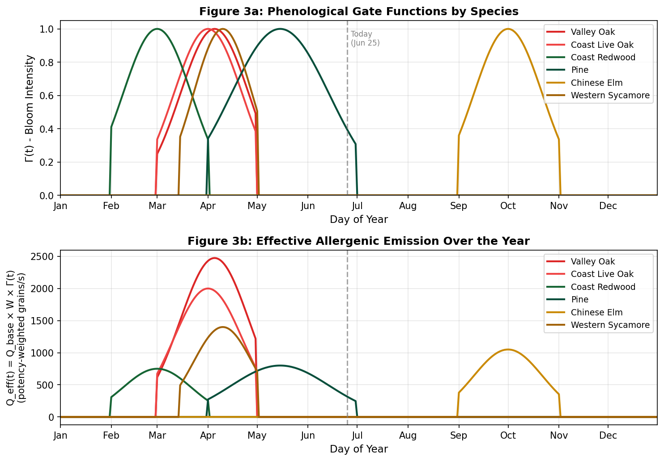
Phenological emission model. (a) Temporal gate functions $Γ_{i}(t)$ showing blooming intensity across the year for each species. (b) Effective allergenic emission $Q_{eff}(t)=Q_{base}×W×Γ(t)$. The dashed line marks today (June 25), when most tree species are dormant and only Pine retains weak late-season emission.

Satellite-Based Vegetation Detection

Image Acquisition
High-resolution satellite imagery (0.5 m/pixel) is obtained from the Esri World Imagery REST export API, covering the full campus (557 m $×$ 637 m) at $1600×1398$ pixels.

Calibrated Color Segmentation
Tree canopy pixels are classified using thresholds calibrated from 771 human-verified positive samples:
$$\text{is_tree}=(g_{e}>4)∧(35<\overset{‾}{I}<155)∧(r<165)∧(b<125)$$
where $g_{e}=g−(r+b)/2$ is the green excess and $\overset{‾}{I}=(r+g+b)/3$ the mean brightness.

Watershed Segmentation
Adjacent canopies are separated using marker-controlled watershed :
- Binary mask is eroded (3 iterations) to generate seed markers
- Euclidean distance transform computed on the mask
- Watershed algorithm segments using inverted distance as elevation

Peak-Based Detection
An alternative pipeline computes a “tree-ness” score:
$$S(x,y)=max(g_{e},0)⋅\frac{max(155−\overset{‾}{I},0)}{120}$$
convolved with a Gaussian ($σ=4$ px). Local maxima with minimum spacing of 7 pixels identify individual tree centers. Canopy radius is estimated from the score falloff profile.

Building Rooftop Detection with Deep-Learning Segmentation
Rooftops are harder to isolate by color alone than tree canopies, because roofs, pavement, and dry ground occupy overlapping color ranges. We therefore detect buildings with the Segment Anything Model (SAM) , a pretrained promptable segmentation network. SAM’s automatic mask generator proposes class-agnostic masks over the campus image; we then retain only masks that look like rooftops, using a color test (gray/white or warm red-tile roofs, with vegetation excluded), a building-scale size test, and a compactness test. Because SAM downsamples its input internally, we run it on a grid of overlapping image tiles so that small rooftops are resolved at higher effective resolution, then merge detections with spatial de-duplication. Each retained mask is reduced to a rotated minimum-area rectangle, so angled and non-axis-aligned buildings are represented at their true orientation. SAM inference is run once at cache-generation time and the results are stored; the deployed server never runs the network.

Human-in-the-Loop Calibration
Both tree and building detections undergo iterative refinement through an interactive map editor: automated detection proposes candidates, and a reviewer corrects them directly on the satellite basemap. For trees, the reviewer can delete false positives (e.g. shrubs or shadows mistaken for canopy), relocate a canopy by dragging it to its true position, resize its canopy radius (which rescales that tree’s emission via the canopy-area law of Eq. [eq:area_scaling]), and reclassify its species—including promoting a generic Other tree (Section 3.3) to a specific genus or vice versa. For buildings, the reviewer edits each footprint’s name, floor count, position, and shape; footprints are not constrained to axis-aligned rectangles but may be dragged into arbitrary convex quadrilaterals (parallelograms, trapezoids) to match obliquely oriented or non-rectangular rooftops, and rotated freely. Each correction is persisted to the per-campus detection cache that the server serves, so the physical model (emission strengths, indoor exclusion masks, and the potential-flow obstacle field) always reflects the reviewed geometry. For each building the height is taken as (floors $×$ 3 m), which sets the indoor exclusion volume.

Multi-Campus Imagery
The pipeline is campus-agnostic: a campus is defined by its geographic bounds, from which the satellite image and detections are generated. Gunn High School uses Esri World Imagery; the Stanford core uses USGS NAIP imagery (whose true-color rendering shows the characteristic red-tile roofs), fetched seam-free by stitching Web-Mercator tiles.

Exposure Assessment

Path-Integrated Dose
Cumulative exposure along walking path $γ$ at speed $v_{w}=1.4$ m/s:
D=γ​Ctotal(x(s))⋅dsvw≈k​C(xk)⋅Δtk

Clinical Risk Mapping
Dose is mapped to actionable risk levels: Low ($D<50$), Moderate ($50$–$200$), High ($200$–$500$), Very High ($>500$ grain$⋅$s/m$​^{3}$).

Results

Detection Performance
On the Gunn campus the detection pipeline maps roughly 900 trees, which we label against the seven allergenic genera modeled here (Valley Oak, Coast Live Oak, Coast Redwood, Cedar, Western Sycamore, Pine, and Chinese Elm) plus a generic Other class (Section 3.3); the exact counts evolve as the set is refined through the interactive editor. The species proportions are anchored to the 2009 PAUSD arborist inventory of the campus , which surveyed 455 numbered trees. In that inventory the dominant genera are Valley Oak (116 trees, 25.5%), Coast Redwood (92, 20.2%), Coast Live Oak (70, 15.4%), Cedar (27, 5.9%), Western Sycamore (21, 4.6%), and Chinese Elm (20, 4.4%); all oaks together account for 192 trees (42.2%). The remaining $∼$17% comprises a long tail of ornamental and non-native genera (e.g. hawthorn, privet, sweetgum, pepper) that are not individually modeled and are assigned to the Other class. On the larger Stanford core, tiled SAM detection identifies on the order of ${10}^{3}$ building rooftops and $∼$${10}^{4}$ tree canopies, giving comprehensive coverage of the full campus. Detection and imagery are cached per campus, so no machine-learning model runs on the live server.

Seasonal Concentration
Using a fixed scale (500 grains/m$​^{3}$ = spring peak):
- April 1 (day 91): $C_{max}=273$ grains/m$​^{3}$ (55% of scale); 8 active species
- June 25 (day 176): $C_{max}=30$ grains/m$​^{3}$ (6%); Pine only
- January (day 15): $C_{max}≈0$; all species dormant

Spatial Patterns
The concentration field exhibits: (i) plumes bending along the potential-flow streamlines as the wind is diverted around buildings; (ii) zero concentration over building footprints; (iii) locally elevated concentration where flow is channeled between closely spaced buildings; and (iv) elevated concentrations in oak-dense corridors.

Discussion
The coupled potential-flow and Gaussian-plume approach is computationally efficient (a few seconds per full field, even with thousands of sources) and suitable for real-time interactive use. It captures how wind is diverted and channeled around buildings, which a spatially uniform wind cannot. Its key physical limitation is that potential flow is inviscid: it produces no turbulent wake or recirculation behind buildings, so pollen trapping in lee zones is not represented; a viscous CFD treatment would be required for that. Other limitations include RGB-only tree-species classification (improvable with hyperspectral data), uniform assumed building heights where floor counts are unknown, and the absence of ground-truth pollen measurements for quantitative validation.
The human-in-the-loop calibration workflow drove most of the accuracy gain: automated detection alone achieved approximately 75% precision, improved to $>95\%$ after three interactive correction rounds. For campus-scale applications, then, semi-automated approaches combining algorithmic detection with targeted human verification are more practical than fully autonomous methods.
The fixed annual scale reveals that allergy risk communication should emphasize seasonal context: a June reading of 30 grains/m$​^{3}$ might alarm students if presented without reference to the 500 grains/m$​^{3}$ spring peak that constitutes the actual high-risk period.

Conclusion
We built a complete pipeline for hyperlocal pollen dispersion modeling, from satellite-based source identification, through a potential-flow wind field coupled to Gaussian-plume transport, to path-integrated exposure. The system resolves concentration gradients at meter scale across two campuses of contrasting scale—Gunn High School and the Stanford core—with thousands of individually mapped trees and buildings, and recomputes the full field in a few seconds as wind and season change. Whether the routes it recommends actually reduce measured exposure is the validation step that remains.

Data Availability
The complete source code and campus data are publicly available at https://github.com/jasminejz2021ai/pollenWebApp. A live, interactive deployment of the system is accessible at https://pollen-web-app-seven.vercel.app/. The tree inventory is derived from the PAUSD 2009 arborist survey supplemented by satellite detection.

Acknowledgments
The author thanks the Palo Alto Unified School District for access to campus tree inventory records.
10
J. Bousquet, N. Khaltaev, A. A. Cruz, et al. Allergic rhinitis and its impact on asthma (ARIA) 2008 update. Allergy, 63(S86):8–160, 2008.
F. Pasquill. The estimation of the dispersion of windborne material. Meteorological Magazine, 90:33–49, 1961.
F. A. Gifford. Use of routine meteorological observations for estimating atmospheric dispersion. Nuclear Safety, 2:47–51, 1961.
D. B. Turner. A diffusion model for an urban area. Journal of Applied Meteorology, 3(1):83–91, 1964.
L. L. Schulman and J. S. Scire. Buoyant line and point source (BLP) dispersion model user’s guide. Technical report, Environmental Research and Technology, 1980.
M. Sofiev, P. Siljamo, H. Ranta, T. Linkosalo, et al. A numerical model of birch pollen emission and dispersion in the atmosphere. Int. J. Biometeorology, 57:45–58, 2013.
K. Bastl, M. Kmenta, U. Berger. Defining pollen seasons: background and recommendations. Current Allergy and Asthma Reports, 18:73, 2016.
S. Beucher and F. Meyer. The morphological approach to segmentation: the watershed transformation. In Mathematical Morphology in Image Processing, pp. 433–481, 1992.
A. Kirillov, E. Mintun, N. Ravi, et al. Segment Anything. In Proceedings of the IEEE/CVF International Conference on Computer Vision (ICCV), 2023.
N. Helbig, B. Vogel, H. Vogel, F. Fiedler. Numerical modelling of pollen dispersion on the regional scale. Aerobiologia, 20:3–19, 2004.
Palo Alto Unified School District. Gunn High School arborist survey and tree inventory. Technical report, PAUSD Facilities Department, 2009.

