Physics-Based Mapping of Hyperlocal Campus Pollen Exposure Using Gaussian Plume Modeling

Jasmine J. Zhang^1 and [Senior Author Name]^2
^1 Henry M. Gunn High School, Palo Alto, CA 94306, USA
^2 [Senior author affiliation - Department, Institution, City, State]

[SENIOR AUTHOR REQUIRED: JEI requires an adult senior author who supervised the research. Replace the placeholder above with their name and affiliation before submitting.]

SUMMARY
Allergic rhinitis affects 10-30% of people, and airborne pollen is its leading environmental trigger. Regional pollen forecasts report a single value for an entire city, so they cannot explain why symptoms differ between one campus walkway and another only tens of meters away. We asked whether the pollen exposure a student experiences while walking across a school campus can be predicted at meter scale from the physics of how pollen travels through air. We hypothesized that combining a steady-state Gaussian plume solution of the atmospheric advection-diffusion equation with the measured positions of individual trees would reproduce the sharp, building- and wind-dependent concentration gradients that regional monitors miss. To test this, we built Campus AeroAllergen Mapping (CAM), a web system that locates every tree on a 25-hectare campus from satellite imagery, models each tree as a pollen source, and superposes their plumes at a student breathing height of 1.5 m. Applied to a campus with 1,018 detected trees across six allergenic genera, the model produced meter-scale concentration fields in under one second, showing plume elongation along the wind, near-zero concentration over buildings, and elevated pollen in tree-dense corridors. Using a fixed seasonal scale, summer concentrations were about 6% of the spring peak. These results support the hypothesis that hyperlocal pollen exposure is predictable from physical modeling. The system reports lower-exposure walking routes, though we have not yet validated its predictions against measured pollen counts.

INTRODUCTION
Allergic rhinitis affects an estimated 10-30% of the global population, with airborne pollen constituting the dominant environmental trigger (1). For students with pollen allergies, the school day involves repeated outdoor transits between buildings, often along walkways lined with allergenic trees. Anecdotally, symptoms can change dramatically over very short distances, suggesting that pollen concentration is not uniform across a campus but varies sharply with the position of individual trees, the direction of the wind, and the layout of buildings.
Existing pollen monitoring relies on regional stations that report area-averaged counts at temporal resolutions of hours to days (2). A single citywide number cannot resolve the concentration gradients that determine what an individual actually breathes during a five-minute walk between classes. The physics governing how pollen moves through air, however, is well established: pollen released from a source is carried by wind (advection) and spread by turbulence (diffusion), a process described by the advection-diffusion equation whose steady-state solution is the Gaussian plume model (3, 4). This model is widely used for industrial emissions but is rarely applied at the meter scale of a single campus, and rarely with the true positions of hundreds of individual biological sources.
We therefore asked whether the hyperlocal pollen exposure experienced by a student walking across a campus can be predicted from first-principles atmospheric physics. We hypothesized that a steady-state Gaussian plume model, driven by the measured positions of individual trees, real-time wind, species-specific bloom timing, and building geometry, would reproduce the sharp spatial concentration gradients that regional monitoring cannot capture, and would do so quickly enough for interactive daily use. To test this, we developed Campus AeroAllergen Mapping (CAM), a system that (i) identifies pollen sources from satellite imagery, (ii) solves the advection-diffusion equation analytically at each source, (iii) modulates emission by species-specific phenology, (iv) accounts for building-induced flow changes, and (v) integrates exposure along student walking paths. We deployed and evaluated the system at Henry M. Gunn High School (Palo Alto, CA), a 25-hectare campus with over 1,000 trees.

RESULTS
To test whether campus pollen exposure could be predicted from physical modeling, we first needed the locations of the pollen sources. We detected trees from high-resolution satellite imagery using color-based segmentation with watershed splitting, followed by three rounds of human verification to remove false positives (see Materials and Methods). This process identified 1,018 trees across six allergenic genera: 414 Coast Live Oak, 239 Coast Redwood, 159 Valley Oak, 110 Pine, 76 Western Sycamore, and 20 Chinese Elm. Automated detection alone achieved approximately 75% precision; after three interactive correction rounds, the false-positive rate fell below 5%, indicating that the source map used as input to the physical model was reliable.
We then computed the pollen concentration field by modeling each detected tree as a Gaussian plume source and summing the contributions at a student breathing height of 1.5 m. The resulting fields displayed the spatial structure predicted by advection-diffusion physics (Figure 1). Concentration was highest immediately downwind of dense tree clusters and fell off as a bell-shaped curve to either side of the plume centerline; stronger modeled winds elongated and diluted the plumes, while more stable atmospheric conditions confined them into narrow, concentrated bands. These patterns match the behavior the Gaussian plume solution predicts.
Because pollen grains differ in size and density, we compared modeled plumes across species (Figure 2). Small, light Oak grains (settling velocity approximately 0.5 cm/s) produced wide, far-reaching plumes that kept concentrations elevated hundreds of meters downwind, whereas large, heavy Pine grains (approximately 3.1 cm/s) produced intense but localized concentrations that decayed sharply within 20-50 m of the source. This species dependence means the model predicts distinct exposure hot spots near pines but broad background exposure from oaks.
Pollen emission is strongly seasonal, so we modulated each source by a species-specific temporal gate function (Figure 3). Using a fixed annual concentration scale (500 grains/m^3 defined as the spring peak) to enable seasonal comparison, the modeled maximum concentration was 273 grains/m^3 on April 1 (day 91), with eight species actively emitting; 30 grains/m^3 on June 25 (day 176), when only Pine remained weakly active; and effectively zero in mid-January, when all species were dormant. Summer concentrations were therefore approximately 6% of the spring peak, quantifying how strongly exposure depends on the time of year.
We also incorporated relative humidity, which suppresses pollen emission as anthers require drying to release grains and increases grain settling through hygroscopic swelling (Figure 4). Under the modeled humidity response, emission dropped to as little as 10% of its dry-air value at 90% relative humidity, consistent with the common observation that pollen loads are lowest during humid marine-layer mornings and highest on dry afternoons.
Finally, the complete concentration field over the campus showed four consistent features: plume elongation along the prevailing wind, near-zero concentration over building footprints (where outdoor air is excluded), enhanced accumulation in the low-wind wake zones behind buildings, and elevated concentrations in oak-dense corridors. Each full-campus field was computed in under 500 ms on a standard server, fast enough for interactive, real-time use.

DISCUSSION
Our results support the hypothesis that the pollen exposure experienced while walking across a campus can be predicted at meter scale from the physics of atmospheric transport, rather than requiring a dense network of physical sensors. By modeling each of 1,018 detected trees as a Gaussian plume source, the system reproduced the concentration gradients that regional, city-scale monitoring inherently averages away: sharp downwind plumes, species-dependent hot spots, building exclusion zones, and wake accumulation. The sub-second computation time makes the approach practical as an interactive tool that a student could consult before choosing a route to class.
Several limitations should temper interpretation of these results. First, and most importantly, the model has not yet been validated against ground-truth pollen measurements; our results demonstrate that the system reproduces the qualitative spatial structure predicted by dispersion theory, but they do not establish quantitative accuracy of the predicted concentrations. Direct comparison against co-located pollen samplers is the essential next step. Second, the model assumes a spatially uniform wind field; real airflow is channeled and deflected by buildings in ways that would require computational fluid dynamics to capture fully, and our Schulman-Scire wake correction is only an empirical approximation. Third, species were classified from RGB satellite imagery and a size-based heuristic, which is imperfect; hyperspectral imagery or ground surveys would improve species assignment, which in turn affects emission timing and potency. Fourth, several physical parameters (base emission rates, potency weights, phenological windows) are drawn from the literature rather than measured on site, so absolute concentrations should be treated as modeled estimates rather than measurements.
The human-in-the-loop calibration workflow proved important: fully automated detection reached only about 75% precision, but three rounds of targeted human correction raised it above 95%. This suggests that for campus-scale problems, semi-automated pipelines that combine algorithmic detection with focused human verification are more practical than fully autonomous detection. It also highlights that the quality of the physical prediction depends directly on the quality of the source map that feeds it.
A practical implication concerns risk communication. Because absolute counts are hard to interpret without context, the fixed annual scale is useful: a June reading of 30 grains/m^3 could alarm a student if shown in isolation, but is clearly low when displayed against the 500 grains/m^3 spring peak that represents the true high-risk period. Future work should focus on quantitative validation against physical pollen samplers, incorporation of building-resolved airflow, and prospective testing of whether model-recommended routes actually reduce measured symptoms. In summary, we built and deployed a physics-based system that predicts hyperlocal campus pollen exposure at meter scale in real time, and our findings support its central hypothesis while clearly defining the validation work still needed.

MATERIALS AND METHODS
Atmospheric dispersion model
Pollen transport was modeled with the steady-state solution of the atmospheric advection-diffusion equation, the Gaussian plume model (3, 4). For a single source, the concentration at a receptor is C(x',y',z) = [Q / (2 pi U sigma_y sigma_z)] * exp(-y'^2 / 2 sigma_y^2) * V(z), where Q is the source emission rate (grains/s), U is the mean wind speed (m/s), x' and y' are downwind and crosswind distances in a wind-aligned coordinate frame, and sigma_y and sigma_z are the crosswind and vertical plume spreads. The vertical term V(z) includes a ground-reflection image source so that no pollen is lost through the ground. Receptor height was fixed at z = 1.5 m (student breathing height) and effective source height at H = 6.0 m (mean campus canopy).
Plume spreads followed Pasquill-Gifford power laws, sigma_y = a_y (x')^b_y and sigma_z = a_z (x')^b_z, with coefficients tabulated for atmospheric stability classes A-F (Table 1). Stability was estimated from wind speed and cloud cover using Turner's method (5). Species-dependent gravitational settling was included via Stokes' law, tilting the plume centerline downward with distance, and building wakes were represented using the Schulman-Scire downwash model (6), which inflates the dispersion coefficients near structures and imposes a uniform cavity concentration within the near-wake recirculation zone. Because the governing equation is linear, the total field from all N sources was obtained by superposition, C_total = sum of C_i, evaluated with vectorized array operations over a 120 x 120 spatial grid (5.3 m resolution). Concentration over detected building footprints was set to zero to represent indoor exclusion.
Phenological emission model
Each species' time-varying emission was modeled as Q_i(t) = Q_base,i * W_i * Gamma_i(t), where Q_base,i is the peak base emission rate (grains/s), W_i is a dimensionless allergen potency weight (0-5), and Gamma_i(t) is a truncated Gaussian temporal gate, Gamma_i(t) = exp(-(t - t_peak)^2 / (2 sigma_t^2)) within the pollination window [t_start, t_end] and zero otherwise, with t the Julian day of year. Base emission rates, potency weights, and phenological windows for the six campus genera were taken from aerobiological literature and Bay Area regional data (7) (Table 2). Relative humidity, obtained from the weather service, further suppressed emission (anthers require drying to dehisce) and increased grain settling through hygroscopic swelling.
Satellite-based vegetation detection
Campus satellite imagery (approximately 0.5 m/pixel) was obtained from the Esri World Imagery REST export service for the campus bounding box (557 m x 637 m; 1600 x 1398 pixels). Tree-canopy pixels were classified with color thresholds calibrated on human-verified samples using green excess g_e = g - (r + b)/2 and mean brightness. Adjacent canopies were separated using marker-controlled watershed segmentation (8): the binary canopy mask was eroded to form seed markers, a Euclidean distance transform was computed, and the watershed algorithm segmented individual canopies. Each detected canopy was assigned a species using a size- and position-based heuristic. Detected canopies were converted from pixel coordinates to latitude/longitude and then to local meters relative to the campus center for use as plume sources. Building rooftops were detected as low-saturation, high-brightness connected regions and used to define the indoor exclusion mask.
Human-in-the-loop calibration
Detection was refined iteratively: automated detection proposed candidate trees, a reviewer removed false positives through an interactive map interface, and the verified positions were persisted and used to update the detection thresholds. Three rounds reduced the false-positive rate from approximately 25% to below 5%.
Exposure assessment
Cumulative exposure (dose) along a walking path was computed by numerically integrating the concentration field along the route at a walking speed of 1.4 m/s, D = sum over path segments of C(x_k) * delta t_k. Dose was mapped to interpretable risk levels (Low, Moderate, High, Very High) using fixed thresholds.
Implementation and availability
The computational engine was implemented in Python (NumPy, SciPy, scikit-image) behind a Flask web service, with a React/TypeScript front end rendering an interactive campus map and pollen heatmap. Weather inputs were obtained from a public weather API, with mock data used when no API key was configured. The complete source code and campus data are available at https://github.com/jasminejz2021ai/pollenWebApp, and a live deployment is available at https://pollen-web-app-seven.vercel.app/.

ACKNOWLEDGMENTS
The author thanks the Palo Alto Unified School District for access to campus tree inventory records. [Add any mentors, teachers, or advisors who assisted but are not authors. Per JEI policy, disclose any assistance here.]

REFERENCES
1. Bousquet, J., Khaltaev, N., Cruz, A. A., et al. Allergic rhinitis and its impact on asthma (ARIA) 2008 update. Allergy 63 (Suppl. 86), 8-160 (2008).
2. Sofiev, M., Siljamo, P., Ranta, H., Linkosalo, T., et al. A numerical model of birch pollen emission and dispersion in the atmosphere. International Journal of Biometeorology 57, 45-58 (2013).
3. Pasquill, F. The estimation of the dispersion of windborne material. Meteorological Magazine 90, 33-49 (1961).
4. Gifford, F. A. Use of routine meteorological observations for estimating atmospheric dispersion. Nuclear Safety 2, 47-51 (1961).
5. Turner, D. B. A diffusion model for an urban area. Journal of Applied Meteorology 3, 83-91 (1964).
6. Schulman, L. L. and Scire, J. S. Buoyant line and point source (BLP) dispersion model user's guide. Technical report, Environmental Research and Technology (1980).
7. Bastl, K., Kmenta, M. and Berger, U. Defining pollen seasons: background and recommendations. Current Allergy and Asthma Reports 18, 73 (2016).
8. Beucher, S. and Meyer, F. The morphological approach to segmentation: the watershed transformation. In Mathematical Morphology in Image Processing, 433-481 (1992).

FIGURES
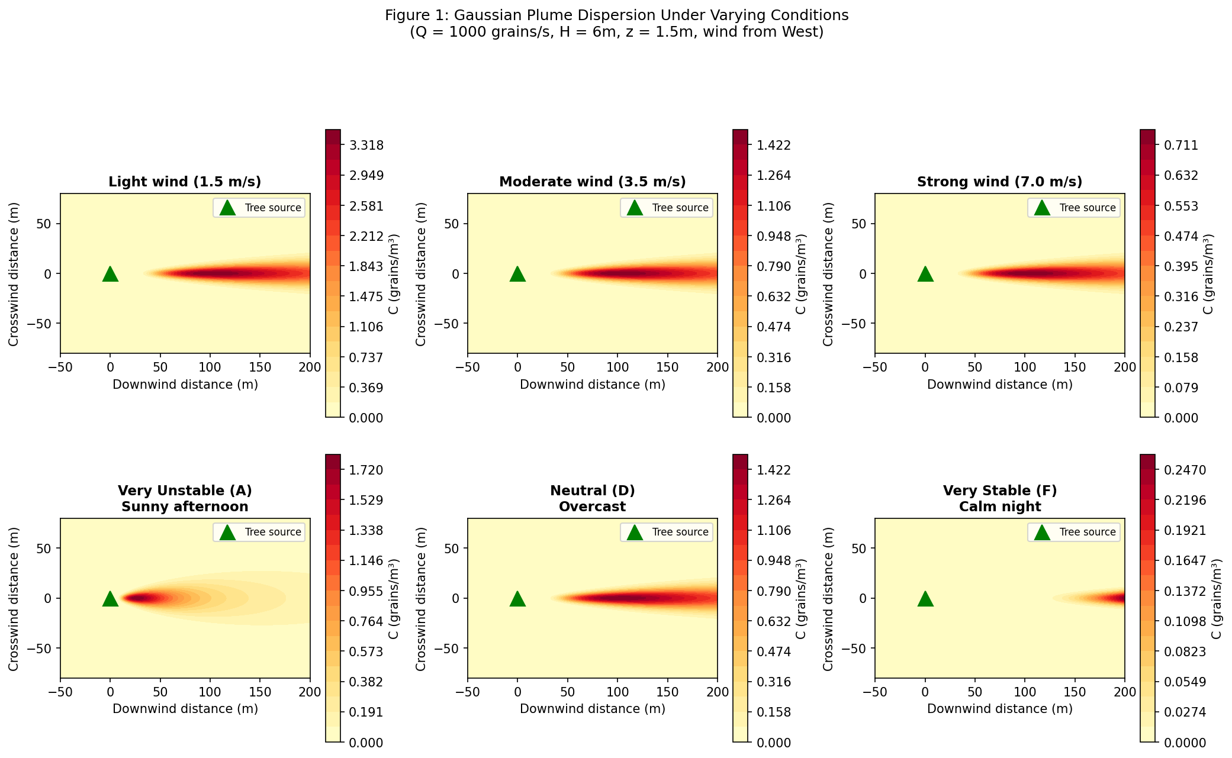
Figure 1. Modeled Gaussian plume concentration fields under varying conditions. Top row: effect of wind speed at neutral stability (class D); stronger winds dilute and elongate the plume. Bottom row: effect of atmospheric stability at fixed wind speed (3.5 m/s); unstable conditions (A) spread pollen rapidly, while stable conditions (F) confine it in a narrow, concentrated plume.

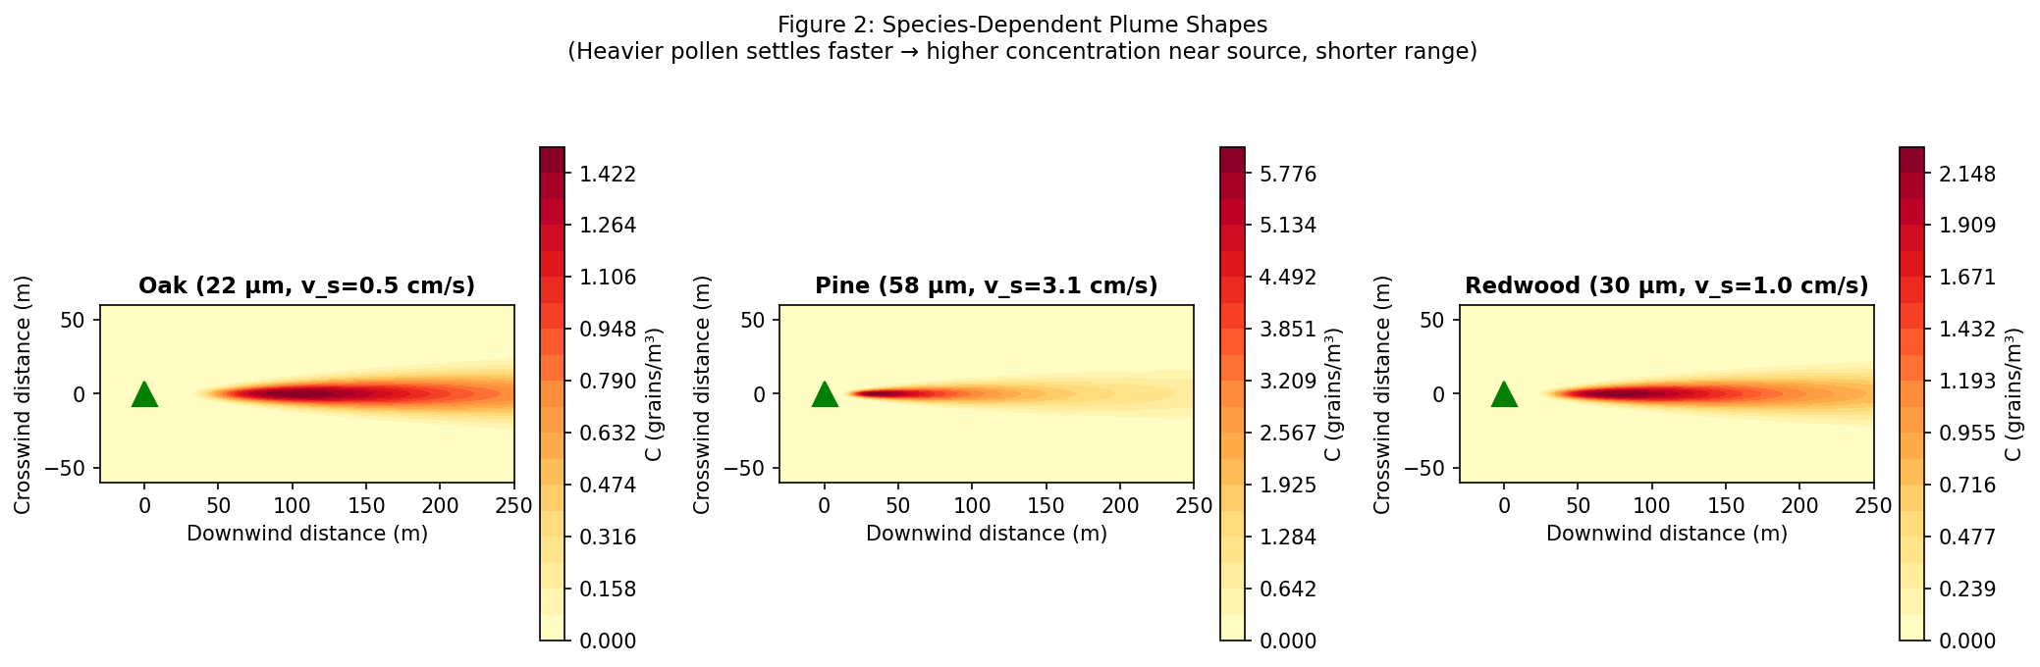
Figure 2. Species-dependent plume shapes resulting from different grain settling velocities. Small, light Oak grains produce wide, far-reaching plumes, whereas large, heavy Pine grains produce intense but localized concentrations near the source tree.

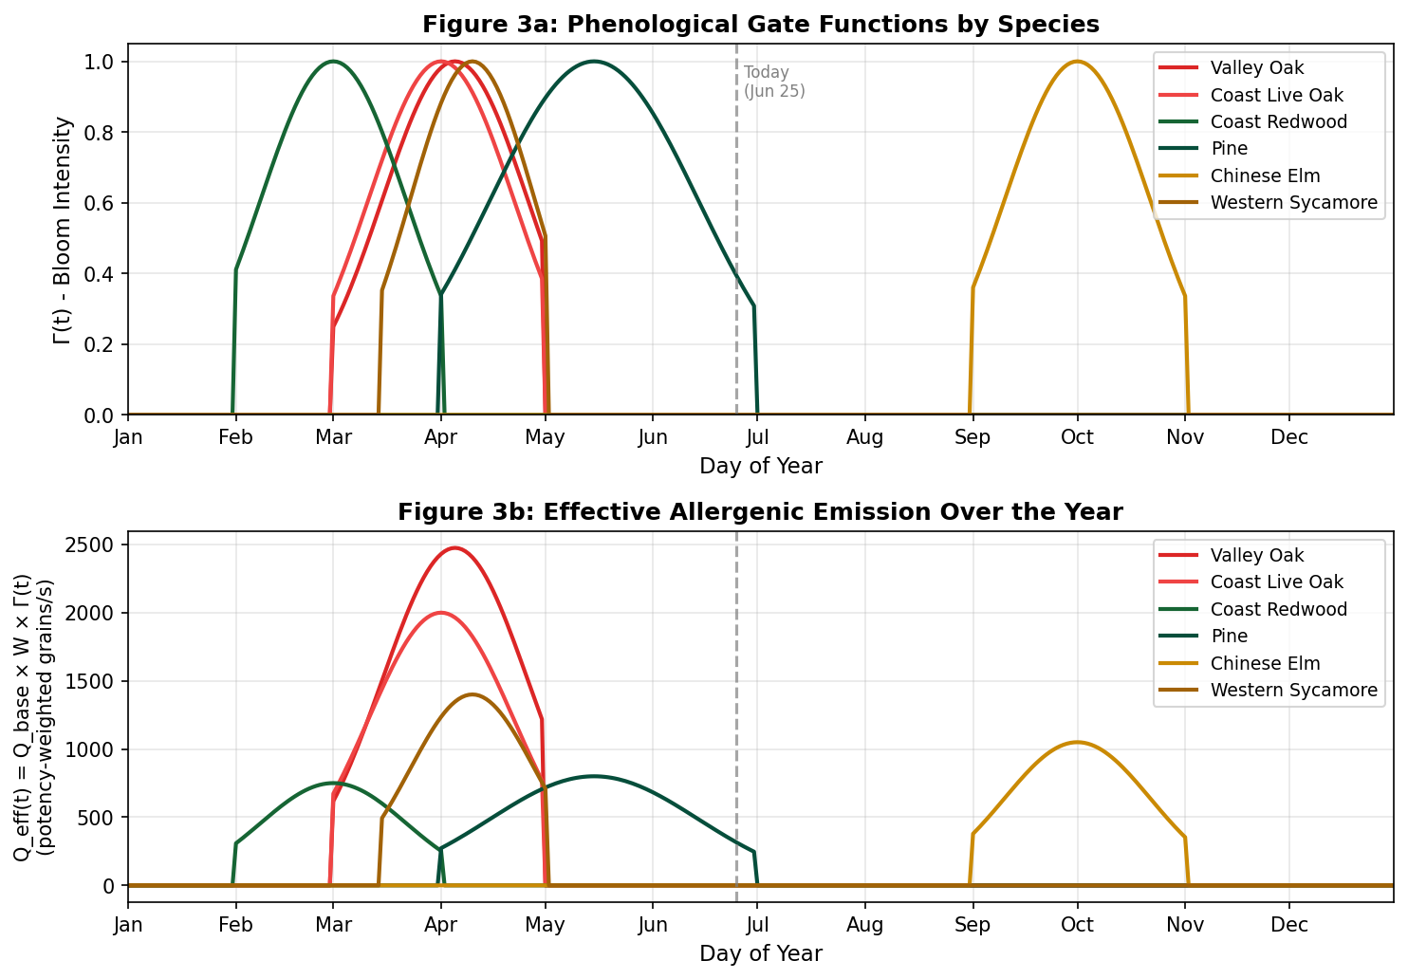
Figure 3. Phenological emission model. (a) Temporal gate functions Gamma_i(t) showing blooming intensity across the year for each species. (b) Effective allergenic emission Q_eff(t) = Q_base x W x Gamma(t). The dashed line marks June 25, when most tree species are dormant and only Pine retains weak late-season emission.

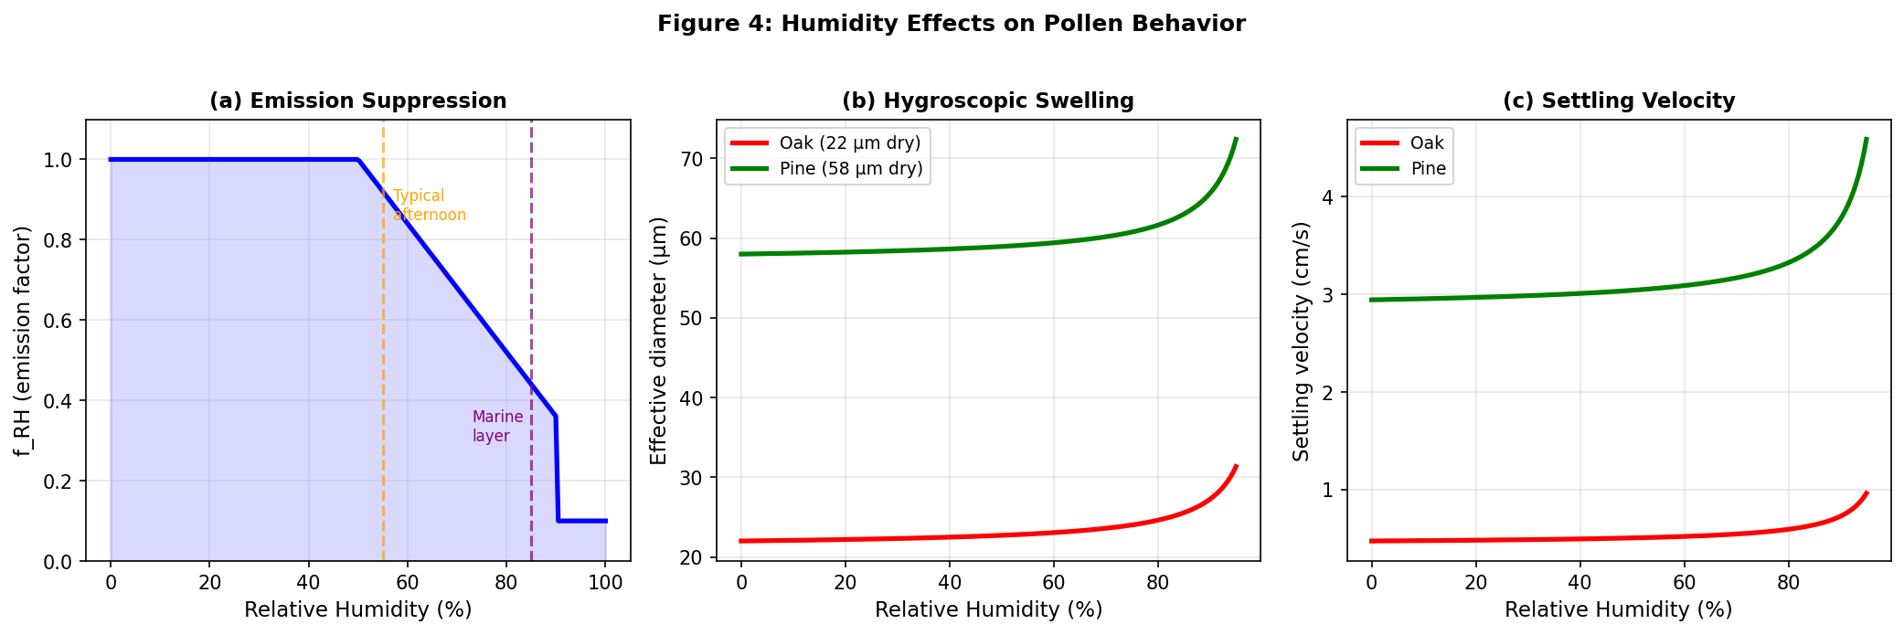
Figure 4. Modeled humidity effects on pollen behavior. (a) Emission suppression factor: pollen release drops sharply above 50% relative humidity. (b) Hygroscopic swelling increases grain diameter at high humidity. (c) Resulting increase in gravitational settling velocity.

