

American Journal of Pedagogical and Educational Research **ISSN (E):** 2832-9791| Volume 15, | August, 2023



|  |  |
| --- | --- |
| **A B S T R A C T** | **K E Y W O R D S** |
| In this research work, students studying in the field of information technology use tasks aimed at the development of personality, reflecting the structure and content of the skills of analytical analysis of the appropriate formation of analytical skills, directing independent work of students mainly in research activities in the process of studying bio informational technologies, relying on the model of implemented projects using bio informational technologies, the focus of the educator and students was defined and justified such conditions as the implementation of the interaction of the person standing. | bio informational technologies, analytical analysis, formation-formation, educational material, educational goals, issue-task, cognitive issue task, etc. |

**Introduction**   
When learning analytical skills in students, it is advisable to use the concept of" formation-formation". This understanding is of urgent importance for our research work.

Formation-formation is understood as the process of a person's occurrence, decision – making under the influence of all-environmental, economic, social, ideological, psychological factors, without any exception, as opposed to the social one.

The educator, oriented towards the personality model of pedagogical interaction, should actively support the independent educational and educational processes of students, strive to activate the learner himself. The use of bioinformational technologies for personality-developing education implies not just the concentration of knowledge and skills, but the mechanism of self-organization and self-realization of the future specialist, the formation of a flexible and constant, the emergence of his analytical skills and abilities. When applying such technologies, the educational environment creates much more free conditions. These conditions provide the student with the opportunity to choose an individual development trajectory, not having the same problem of normative construction of his activities. The educator forms, builds the content of Education, relying on the identified interests and subjective experience of the educator. It must be perceived by the learner as a person of importance to himself, as "missed" content through his personal subjective experience.

The direction of the pedagogical process to the individual, the search and development of abilities that nature places on each individual, the construction of a pedagogical system aimed at the individual are

P a g e | **30**  www.americanjournal.org

American Journal of Pedagogical and Educational Research Volume 15 August, 2023



important requirements for today's Education, strictly dictating the need to change the traditional approaches to education. The assistance of modern pedagogical technologies to identify and formulate their competencies in connection with the competence and interests of future specialists as individuals gives preference to the intended educational methods.

The style of projects is considered one such style. It allows you to ensure the systematic integration of scientific knowledge and practical actions, develop the interest of the learner in the process of obtaining independent knowledge and his reflexive positions in this process, build his own activities based on concrete practical requirements, form skills for establishing, acquire the experience of independent creative activity and conscious choice of ways of self-realization. Teaching on the basis of the style of projects increases motivation for studying, provides the basis for the formation of skills for cooperation and Inter-chassis communication, allows you to successfully adapt to the significantly changing conditions of human life in modern society. Students acquire the skills of transferring knowledge to another context, to a modified situation, trying not to simply memorize the facts, but to search for information, to carry it out analytically , tasks independently. As a result of training, it happens not only to master new knowledge, skills and abilities, but also to form analytical skills. These guarantee that the graduate's mobile and non-slip (flexible), future professional activities will be successful.

Thus, the analysis of the requirements of state educational standards for the results of professional training of graduates, the specificity of the professional activities of software creators provides an opportunity to clarify the requirements for the analytical activities of a specialist in the field of bioinformational technologies. This activity is based on the formation of analytical skills. Based on the results of the conducted analysis, a model for the formation of analytical skills of students was developed. This model provides an opportunity to reveal the content of the components of this process: targeted, theoretical-methodological, consequential-tolerating components (figure 1.2).

The target component involves the goals and objectives of the formation of analytical skills. And these goals and objectives are determined by the requirements of state educational standards for the results of professional education of graduates and the specificity of the future professional activity of graduates.

The theoretical-methodological component embodies the foundations of the formation of analytical skills based on such principles as professional orientation, reflexivity, independence and activity, the provision of the choice of individual educational trajectory, cooperation within the framework of approaches to personality, competency, technology and activity.

The content component describes the organization and implementation of the educational process aimed at the formation of analytical skills and promotes the restoration of the content of future professional activities in the process of mastering the block of professionally oriented disciplines. The methodological component of the model reflects the comprehensively effective forms, methods and means of organizing education, pedagogical conditions in order to form analytical skills in the process of training IT specialists.

P a g e | **31**  www.americanjournal.org

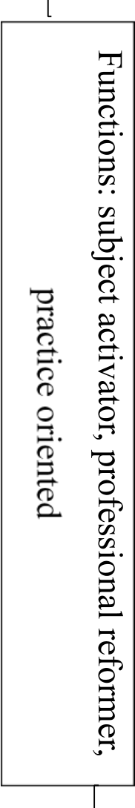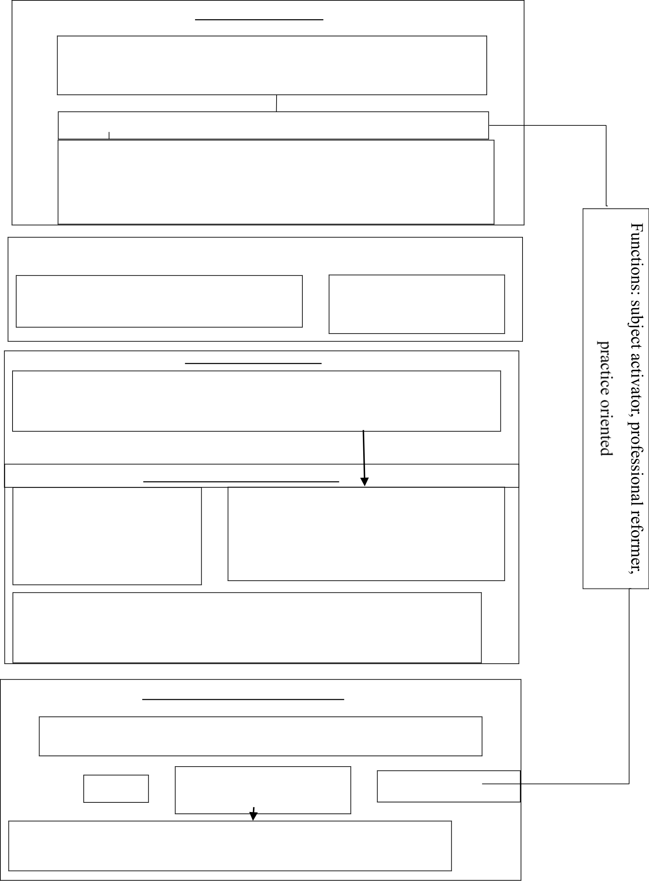

American Journal of Pedagogical and Educational Research Volume 15 August, 2023



**TARGET COMPONENT**

- Social order for specialist training   
- Employer requirements   
- State educational qualities requirements   
- Types and tasks of professional activities   
- Professional standards

**Purpose:** Formation of analysis skills in students-specialists of the field of information technology

**ASSIGNMENTS:**  
-To acquaint students with the essence and structure of the analytical skills necessary for their   
 professional activities:   
-Formation of motivation for the acquisition of analytical skills as a professionally significant   
 skill in students;   
-Formation of analysis skills;   
-Exercise control.

**THEORETICAL-METHODOLOGICAL COMPONENT**

|  |  |
| --- | --- |
| **Approaches:**  person-oriented; component; technological; activity-related; | **Principles:**  Professional orientation; reflexivity;  independence and activism; ensuring  the ability to choose an individual  educational trajectory; cooperation. |

**CONTENT COMPONENT**

**Content:** Organization and implementation of reading-cognitive activity aimed at the formation of analytical skills based on a block of disciplines oriented towards the profession, such as” Informatics“,” programming“,” structures and algorithms for processing data“,” databases“,” data analysis“, “ human-machine interaction".

**METHODOLOGICAL COMPONENT**

**SHAPES AND STYLES:**  **Tools:**   
- Lectures, practical classes; - working programs of Sciences;   
- Research work of students (design of - educational and methodological manuals: "Informatics", course and diploma work); "programming", "computer praktikum", "structures and - Training and production practices; algorithms for processing data", " data analysis”; - Style of projects; - a set of developing tasks; electronic-educational, Internet - Stimulation and motivating techniques; resources;   
- style of educational tasks. - technical means of training.

**PEDAGOGICAL CONDITIONS:**  
- Use of developing tasks that reflect the structure and content of analysis skills;   
- Directing the independent work of students to research activities in the process of studying information technology;   
- Implementation of the interaction of educators and students towards the individual on the basis of the method of projects implemented using information technology.

**RESULTANT-EVALUATION COMPONENT**

**The degree of formation of analysis skills**   
**ASSESSMENT METHODS AND TOOLS**   
(questionnaire filling, test-surveys, diagnostic tasks)

|  |  |  |
| --- | --- | --- |
| Self- | **CONTROL PROCEDURE** | Correction of the teaching |
| Criteria: motivational, cognitive, |
| control | reflexive, creative | process |

Levels: high, medium, low

**Result:** Formation of analysis skills in students-specialists in the field of   
Information Technology

Figure 1. Applied bioinformatics technologypolitical analysis of the leather cover molding model.

P a g e | **32**  www.americanjournal.org

American Journal of Pedagogical and Educational Research Volume 15 August, 2023



The result-assessment component involves diagnosing the methods and means of assessing to what extent analytical skills are formed, the degree of formation of these skills in accordance with the motational, cognitive, reflexive and creative criteria, their indicators and distinguished levels. In higher education, the model for the formation of analytical skills of specialists in the field of bioinformative technologies I provides for the implementation of functions that activate the subject, professionally reform, are oriented towards practice.

The function of activating the subject determines the main role of the student as a subject of education in the educational process. In the process of interaction with educators, the student acquires methods of self-education, self-knowledge and self-realization. This function, when viewed from the position of each individual person, makes it necessary to provide pedagogical support for professional education, motivational and subjectively conditioned increase in its importance, to be prepared for it throughout life, the evolution of another position held by a person in all social processes, to change the status occupied by the learner in education. The position of the subject of knowledge is realized in the student if he: if he independently acquires new knowledge and uses existing knowledge creatively, using the experience of his personal life activity extensively; if he consciously chooses and actively uses methods of educational work that characterize not only the achieved result, but also the process of acquiring knowledge; makes independent and responsible decisions to choose the educational tools that apply to him, and thus actively influences what and how he learns; if he plans his educational work, analyzes, predicts and evaluates its results; if individual interests, taking into account needs, build cooperation relations with other people, respecting their national, spiritual, cultural traditions; when, in the process of working together, he coordinates his personal point of view with the opinions of others.

The professional reform function creates conditions for updating the knowledge of the learner and overcoming stereotypes of his experience, puts mechanisms for updating concepts formed in practical professional activities (as a result of personal experience, such as trying and making mistakes, victory and failure). In this case, it will be necessary to professionally train the future creators of software, taking into account the concrete sectors and IT sectors of the economy, based on the demand and their qualifications that are happening to them in the labor market.

The practice-oriented function reflects the presence of analytical skills in students in solving a problem situation, the need for a technological approach to tracing any professional situation in which a program of professional behavior is developed in relation to shui.

At the higher educational institution, the methodological basis of the model for the formation of the student's analytical skills is the field of approaches to the shasx, competency, technological and activity.

Within the framework of the approach towards the individual, the idea of the priority of the social, active and creative essence of the individual was decided, the development of the professional qualities of the shaskh was determined to be important, it was envisaged to take into account that the individuality of the future IT specialist is unique. Student-the main subject of the educational process. The student retains the right of educational work to the student to acquire knowledge, skills, establish his place in knowledge and realize himself by acquiring methods that provide adequate tools in their application in situations not foreseen in education.

A competency approach makes it possible to accurately determine the goals of pedagogical activity at a higher educational institution in order to ensure that the specialist is able to apply his analytical skills

P a g e | **33**  www.americanjournal.org

American Journal of Pedagogical and Educational Research Volume 15 August, 2023



in a consistent, consequential way, as opposed to the structural components of professional competence. A specific task, which is considered important in the profession, requires the future programmer to show competence when solving the range of issues on the basis of knowledge, skills, qualifications, abilities, guidance, values acquired during professional education.

The question of readiness for action is considered by researchers from two different perspectives: functional and personality-specific. The first position figures define readiness, shaylik as a separate functional state, a psychological condition for the success of the activity performed against the background of the general activity of the organism, as opposed to the socially recorded instruction. Proponents of the personality approach view readiness as a complex intagral personality education. Its components are considered the formation of psychic processes, States and properties of the individual.

Readiness to conduct activities provides for the presence in learners of the following structural elements: a positive attitude to various manifestations of activity, occupation; aspects of character, abilities, temperament corresponding to the requirements of activity, occupation; necessary knowledge, skills, qualifications; stable professionally significant characteristics of perception, attention, thinking, emotional and volitional processes.

As opposed to the integrated quality of the professional's readiness, shaylik is considered the main condition for the specialist's rapid adaptation to professional activities, adaptation, further professional growth and continuous, inexhaustible increase in his qualifications.

The technological approach implies the organization of such an educational process, in which the acquisition of ways and methods of organizing the process of formation of analytical activity skills, analytical skills is ensured through the implementation of a problematic, developing issue-tasks. Programming is related to the task solving process, an issue that the student implements. To solve the problem-tasks, he mentally looks for different ways, chooses suitable instruments or prepares them himself mutsaqil. Programming is a kind of knowledge of the world, in which the first plan comes out one or another issue-the search, formation of ideas and concepts that will be necessary for solving tasks. Learning begins with practical action and perception, moves from them to words and concepts, and ends with the development of some characteristic of the mental structure.

Educational tools used to form students analytical skills include the following components: training and production equipment as opposed to computers, in which learners develop professional skills and qualifications; educational and methodological support designed to support the course transition; electronic and educational resources and Internet resources.

As a result of the application of interactive technologies, the following issues of the educational process will find a solution: to increase the efficiency and optimality of mastering the educational material; to arouse the interest of the individual in the study of the subjects provided for in the curriculum, to strengthen motivation; to bring the educational information provided closer to the; teaching to respect the right of the participant who is working together to express personal opinion; the formation of life and professional skills.

Both practical classes and lectures are conducted in an interactive form. A problematic lecture, a lecture with deliberately allowed errors, a lecture-visualization is separated. In the process of professional training of specialists in the field of bioinformational technologies I, a number of specific and expected goals were aimed at achieving from the application of interactive technologies: strengthening motivation for obtaining active knowledge; formation of analytical skills and reflexive

P a g e | **34**  www.americanjournal.org

American Journal of Pedagogical and Educational Research Volume 15 August, 2023



apparent qualities; formation of skills to master modern technical means and technologies of information processing; formation and cultivation of the ability to determine the validity of information independent topi shva; formation of self-organization skills.

Thus, the corresponding model takes the field in the process of professional education as an approximate basis for the realization of the process of formation of analytical skills in future specialists of the field I of bioinformational technologies.

**Conclusion/ Recommendations**   
Bioinformational technologies I, a number of specific and expected goals were aimed at achieving from the application of interactive technologies: strengthening motivation for obtaining active knowledge; formation of analytical skills and reflexive apparent qualities; formation of skills to master modern technical means and technologies of information processing; formation and cultivation of the ability to determine the validity of information independent topi shva; formation of self-organization skills.

**List of Literature Used**   
1. Ganesh Naik - Biomedical Signal Processing_ Advances in Theory, Algorithms and Applications- Springer Singapore. Publisher: Springer; 1st ed. 2020 edition (November 25, 2020). Paperback: 444 pages, ISBN-10: 9811390991, ISBN-13: 978-9811390999.

2. Suresh R. Devasahayam - Signals and Systems in Biomedical Engineering_ Physiological Systems Modeling and Signal Processing-Springer Singapore. Publisher : Springer; 2nd ed. 2013 edition (November 8, 2012), Hardcover: 404 pages, ISBN-10:1461453313, ISBN-13: 978-1461453314. 3. Немирко А.П., Манило Л.А., Калиниченко А.Н. - Математический анализ биомедицинских сигналов и данных-Лань. Москва: Физматлит, 2017. 248 стр.

4. В.С.Кубланов, В.И.Борисов, А.Ю.Долганов. Анализ биомедицинских сигналов в среде MATLAB. Анализ биомедицинских сигналов в среде MATLAB : учебное пособие / Екатеринбург: Изд-во Урал. ун-та, 2016. – 120 с.

5. З.З.Мирюсупов, Ж.Х.Джуманов. «Компьютер архитектураси». /TATУ. 144 бет. Тошкент, 2017.

6. Ergashev, N. (2023, May). RAQAMLI TEXNOLOGIYALAR MUHITIDA TA’LIMNI

|  |  |  |  |  |  |
| --- | --- | --- | --- | --- | --- |
| RIVOJLANTIRISHNING | YETAKCHI | TENDENSIYALARI | VA | ISTIQBOLLARI. | In |

International Scientific and Practical Conference on Algorithms and Current Problems of Programming.

7. Gayratovich, E. N. (2023). A MODEL OF THE STRUCTURAL STRUCTURE OF PEDAGOGICAL STRUCTURING OF EDUCATION IN THE CONTEXT OF DIGITAL TECHNOLOGIES. American Journal of Pedagogical and Educational Research, 13, 64-69. 8. G’ayratovich, E. N. (2022). The Problem of Training Future Engineer Personnel on the Basis of Cloud Technology in Technical Specialties of Higher Education. Eurasian Scientific Herald, 13, 1- 4.

9. Ergashev, N. (2022). Theoretical staff training using cloud technology in continuing education. In International Conference on Problems of Improving Education and Science (Vol. 1, No. 02). 10. G‘ayratovich, E. N. (2022). The Theory of the Use of Cloud Technologies in the Implementation of Hierarchical Preparation of Engineers. Eurasian Research Bulletin, 7, 18-21.

P a g e | **35**  www.americanjournal.org