Jasmine Nguyen

100352240

https://github.com/jasminenguyenn/TestProject

Allen Ferriols

100376316

https://github.com/Ayamelicious/TestProject

Assignment 3 INFO 1113 S11

Dr.Abhijit Sen

November 9th, 2018

Table of Contents

Introduction: 2

Functions: 2

Screen Shots 3

Use Case Diagram 3

Use Case Descriptions 4

Conclusion: 8

# Introduction:

In a world where people are more likely to blame a certain breed of dog for their brutality rather than the way it is brought up, it is necessary for an app where dog owners can find other owners and set up dates with their dogs. With our app the dogs can learn to socialize with others ensuring that dogs meeting another will not be a stressful occurrence but an exciting and heart warming one. Of course, all this would only be possible for dogs that have a loving owner. What about those without a loving home yet? This app will also help owners find local dogs that match their personalities and preference leaving both dog and hooman happy.

# Functions:

Looking for other dog mates:

Create Profile

* Create Dog Profile – provide information about your dog to generate the best matches
* Customize User Profile – provide information about your human to generate the best matches
* Upload up to 5 pictures—there is a limit of 5 pictures to upload so choose your best ones

Privatize location—turn on or off your location and distance from other matches

Search for match—a fast way to decide if you want the match

Adoption Process:

Pet Search – option to show dogs available for adoption

* Option to refine search—narrow down your search for adoptable dogs
* View suggestions based on profile—algorithm will show your best match that suits your profile
* Search bar for dog adoption— want to be more specific with your process of adoption

Create Profile

* Create Dog Profile – provide information about your dog to generate the best matches
* Customize User Profile – provide information about your human to generate the best matches
* Upload up to 5 pictures—there is a limit of 5 pictures to upload so choose your best ones

# Screen Shots

## Use Case Diagram

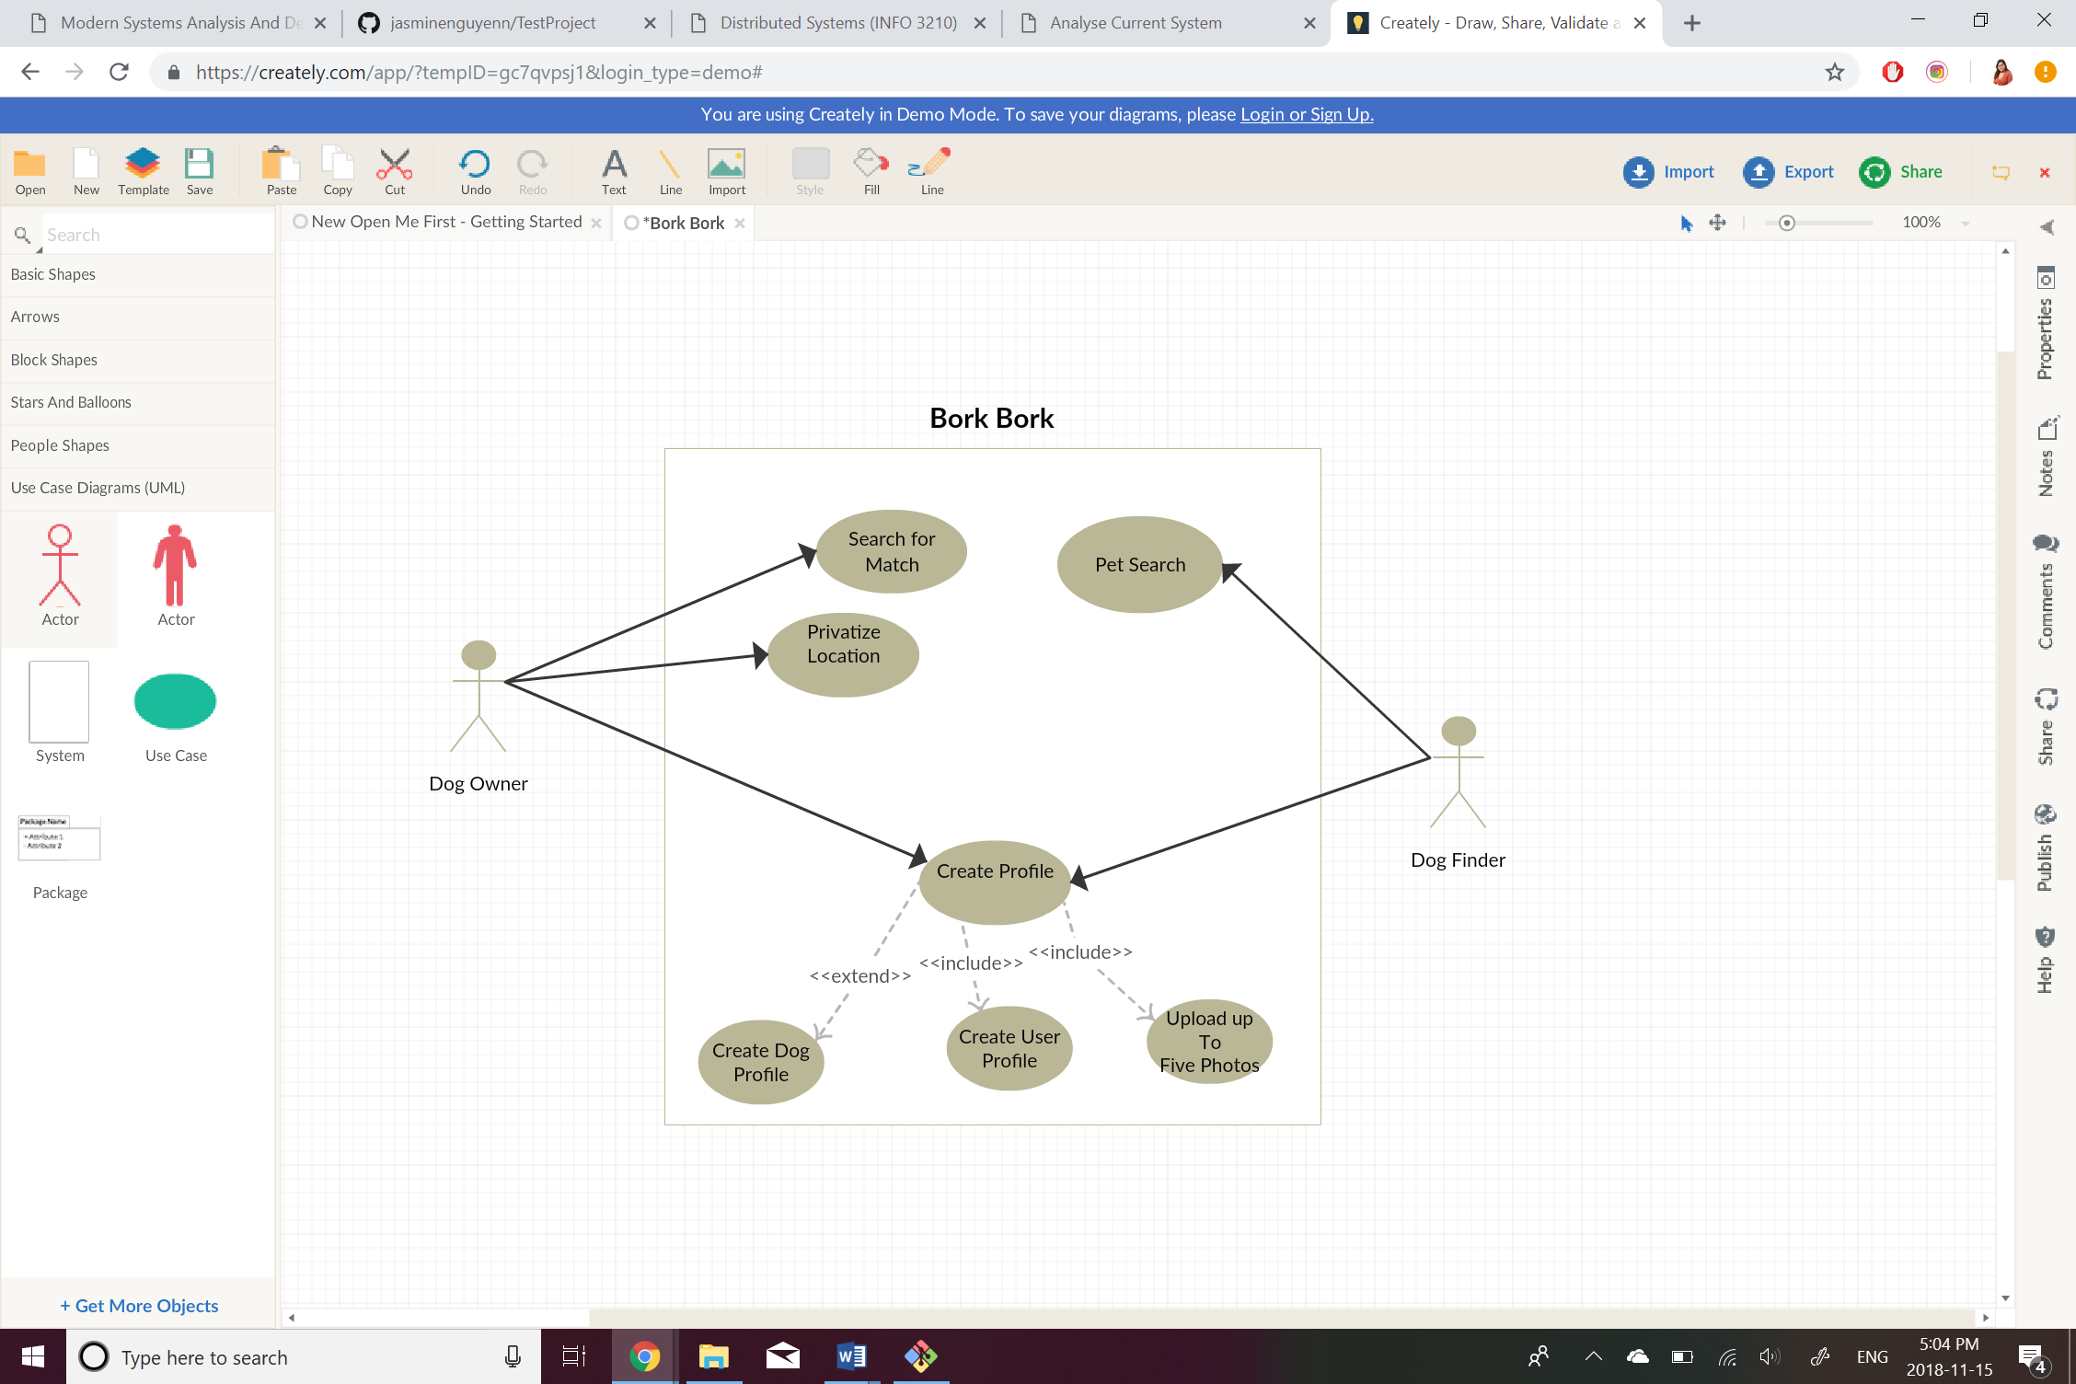

In the use case diagram we have to actors who are “Dog Owner” and “Dog finder”. The “create profile” has 2 include relationships as it is required for both actors to enter information to access the full functionality of the app. The “Create Dog Profile” use case is an extension as the actor “Dog Finder” would not have a dog to create a profile. We have three abstract use cases, after “Create profile” which don’t interact directly with the actor.

## Use Case Descriptions

|  |
| --- |
| Use Case Title: Create Profile |
| Primary Actor: Dog Owner/Dog Finder |
| Level: Sea Level |
| Stakeholder: Dog Owner/Dog Finder |
| Precondition: Dog owner/Dog Finder needs Wi-Fi |
| Minimal guarantee: Limited information is entered into the system, limiting app use* |
| Success guarantee: User’s profile is entered into system correctly |
| Trigger: User accesses the app |
| Main Success Scenario:   1. Enter owner information 2. User prompted to verify account through email 3. User creates profile for dog 4. User uploads 5 photos 5. Profile is created successfully |
| Extensions:  1.a. Data entered is not accepted by system  1.a.1. User quits app  1.a.2 User enters right info  2.a. Email does not exist  2.a.1. User quits app  2.a.2. User enters new email  2.b. Email never got sent  2.b.1. User quits app  2.b.2. User changes email  3.a. User has no pets  3.a.1. User redirected to pet search  4.a. Photos are too large  4.a.1. User crops photo  5.a. User’s information is erased  5.a.1. User quits  5.b.1 User retrieves information from the verification email |

Written Use Case by Jasmine Nguyen

*Minimal guarantee added by Allen Ferriols

|  |
| --- |
| Use Case Title: Search dogs |
| Primary Actor: Dog Finder |
| Level: Sea Level |
| Stakeholder: Dog Owner/Dog Finder |
| Precondition: Dog finder’s profile is already created |
| Minimal guarantee: Results shown are not comprehensive |
| Success guarantee: User is shown results of search |
| Trigger: User accesses the app |
| Main Success Scenario:   1. User selects what kind of dog they want to adopt (e.g. big, small, breed,) 2. User selects age of dog they prefer (e.g. puppy, old,) 3. User selects “Dog information” to get detailed information on dog 4. User clicks on thumbnail photo of dog to get regular-sized photo to view 5. User selects clears define search to have more options |
| Extensions:  1-3. a. The requested search does not load or cannot be found  1-2. a.1. User quits app  1-2. a.2 User gets a “search not found” error page in app  1-2. a.3 User refreshes search and the search still does not load properly; user quits app  4.a. Full- sized image does not load  3.a.1. User gets a broken-link symbol  3.a.2. User presses refresh button and the photo loads  3.a.3. User presses refresh button and the photo does not load; customer quits app |

Written Use Case by Jasmine Nguyen



Written Use Case by Allen Ferriols



Written Use Case by Allen Ferriols

Changed “Swipe right or left for dog match” to “Search for match” so that it would be more clear edited by Jasmine

# Conclusion:

As a two-person group we struggled coming up with specific descriptions for our use cases. We also had trouble thinking of minimal guarantee’s coming up with possible outputs that could be expected if our app failed to work. Another struggle we faced, was having proper use cases for our diagrams because it was difficult to reduce crowding as there was too many functions in the beginning. However, as there was only two of us, we are proud of each other for working through this by staying at the library every and figuring the assignment/project out.