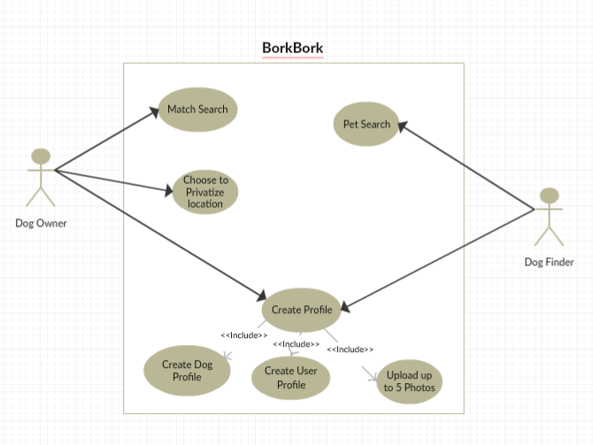

Change “Pet search” to “Find Pet”

Change “Match Search” to “Search for Match”

Other wise everything looks good

Our use cases must start with a verb first

Edited by Jasmine Nguyen