FHL_code_draft1

Jasmine Reighard

2023-09-20

#download data  
  
#all data  
cym_dat <- read.csv("data/rawdata_allcombinedSep28.csv")  
  
#NND data  
nnd_df <- read.csv("data/rawdata_combined_NND_9.28.csv")  
  
#spontaneous turns  
spon_turn <- read.csv("data/sp_turn_10-9-23.csv")  
  
#categorize by s and w  
cym_dat$s_w_reactor <- ifelse(substr(cym_dat$responder, 1, 1) == "s", "s", "w")  
  
  
wave_dat <- subset(cym_dat, substr(responder, 1, 1) == "w")  
  
#make sure variables are as they are supposed to be  
  
cym_dat$s_w_reactor <- as.factor(cym_dat$s_w_reactor)  
cym_dat$size <- as.factor(cym_dat$size)  
cym_dat$school <- as.factor(cym_dat$school)  
cym_dat$stimulus <- as.factor(cym_dat$stimulus)

#Define thresholds for fast and slow responses for small and large  
  
#look at averages  
turnrate_result <- aggregate(turning_rate ~ size, data = spon_turn, FUN = mean)  
print(turnrate_result)

## size turning_rate  
## 1 large 0.2243052  
## 2 small 0.2435468

#large 0.2243052  
#small 0.243546  
  
#Mann-Whitney test  
manwhit_spon <- wilcox.test(turning_rate ~ size, data = spon_turn)  
print(manwhit_spon)

##   
## Wilcoxon rank sum exact test  
##   
## data: turning_rate by size  
## W = 213, p-value = 0.6281  
## alternative hypothesis: true location shift is not equal to 0

# p-value is less not less than 0.05, conclusion: there is no statistically significant difference in the distributions of "turning_rate" between the two size.  
  
  
spon_anova <- aov(turning_rate ~ size, data = spon_turn)  
print(summary(spon_anova))

## Df Sum Sq Mean Sq F value Pr(>F)  
## size 1 0.0039 0.003938 0.356 0.554  
## Residuals 42 0.4649 0.011068

plot(spon_anova)

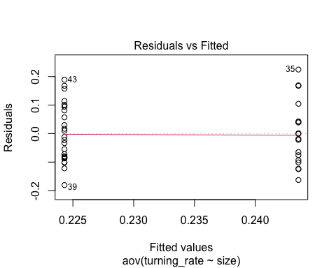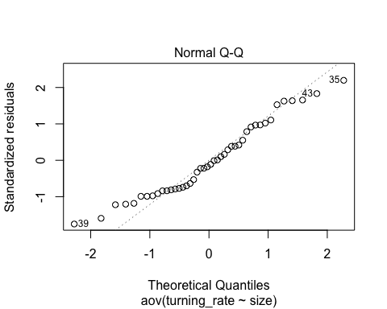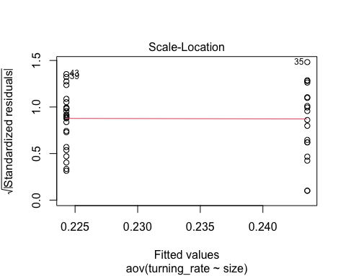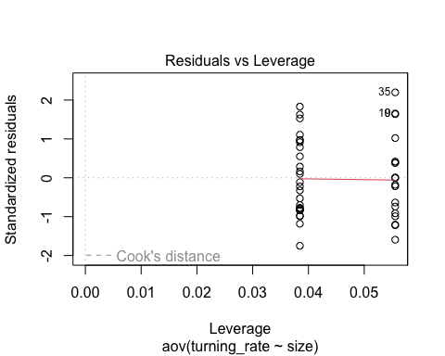

shapiro.test(spon_anova$residuals)

##   
## Shapiro-Wilk normality test  
##   
## data: spon_anova$residuals  
## W = 0.95688, p-value = 0.09945

par(mfrow=c(2,2))  
plot(spon_anova)

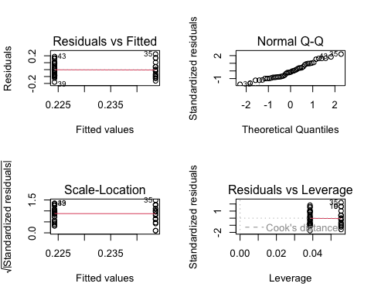

#normal and homogeneity pass  
  
  
#homogeneity of variances  
leveneTest(turning_rate ~ size, data = spon_turn)

## Warning in leveneTest.default(y = y, group = group, ...): group coerced to  
## factor.

## Levene's Test for Homogeneity of Variance (center = median)  
## Df F value Pr(>F)  
## group 1 0.0169 0.8972  
## 42

t.test(turning_rate ~ size, data = spon_turn)

##   
## Welch Two Sample t-test  
##   
## data: turning_rate by size  
## t = -0.58589, df = 34.338, p-value = 0.5618  
## alternative hypothesis: true difference in means between group large and group small is not equal to 0  
## 95 percent confidence interval:  
## -0.08596025 0.04747703  
## sample estimates:  
## mean in group large mean in group small   
## 0.2243052 0.2435468

avg_turnrate <- mean(spon_turn$turning_rate)  
print(avg_turnrate)

## [1] 0.2321768

#avg turn rate is .2321768

#calculate turning duration on all data  
# Calculate density   
  
cym_dat_frames <- read.csv("data/rawdata_allcombinedSep28_start_end.csv")  
cym_dat_frames <- cym_dat_frames %>%   
 mutate(turning_duration = (frame_end - frame_st)/240 * 1000)  
  
#add turning duration to cym_dat df  
cym_dat$turning_duration <- cym_dat_frames$turning_duration  
  
#calculate turning rate  
cym_dat <- cym_dat %>%   
 mutate(turning_rate = turning_angle_absolute_value / turning_duration)  
  
#categorize responses  
  
cym_dat$response_type <- ifelse(  
 (cym_dat$size == "large" & cym_dat$turning_rate > 0.22) |  
 (cym_dat$size == "small" & cym_dat$turning_rate > 0.24),  
 "fast",  
 "slow"  
)  
  
#make sure variables are as they are supposed to be  
  
cym_dat$s_w_reactor <- as.factor(cym_dat$s_w_reactor)  
cym_dat$size <- as.factor(cym_dat$size)  
cym_dat$school <- as.factor(cym_dat$school)  
cym_dat$stimulus <- as.factor(cym_dat$stimulus)  
cym_dat$response_type <- as.factor(cym_dat$response_type)

#visualize data fast and slow responses  
  
#all together  
ggplot(cym_dat,aes(x=turning_duration,y=turning_angle_absolute_value,color=size))+  
 geom_point()+  
 geom_smooth(method=lm,fullrange=TRUE,  
 aes(color=size))+  
 scale_color_manual(name='Size',  
 breaks=c('large', 'small'),  
 values=c('large'='#E69F00', 'small'='#0C7BDC'))+  
 theme(legend.title=element_text(size=14),  
 legend.text=element_text(size=14))+  
 theme_classic()

## `geom_smooth()` using formula = 'y ~ x'

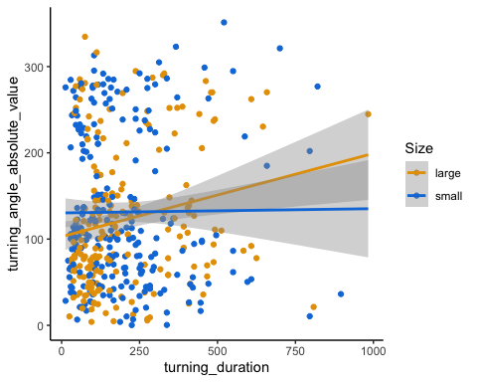

#visualize percent slow  
summary_table <- cym_dat %>%  
 group_by(size, response_type) %>%  
 summarise(count = n()) %>%  
 mutate(percentage = count / sum(count) * 100)

## `summarise()` has grouped output by 'size'. You can override using the  
## `.groups` argument.

ggplot(summary_table, aes(x = size, y = percentage, fill = response_type)) +  
 geom_bar(stat = "identity", position = "dodge") +  
 labs(title = "Percentage of Fast and Slow Responses by Size Group", y = "Percentage") +  
 scale_fill_fish_d(option = "Trimma_lantana") +  
 theme_minimal()

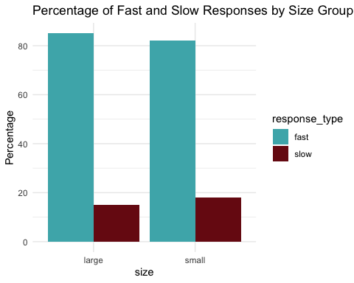

#frequency of fast and slow  
summary_table <- cym_dat %>%  
 group_by(size, response_type) %>%  
 summarise(count = n())

## `summarise()` has grouped output by 'size'. You can override using the  
## `.groups` argument.

ggplot(summary_table, aes(x = size, y = count, fill = response_type)) +  
 geom_bar(stat = "identity", position = "dodge") +  
 labs(title = "Frequency of Fast and Slow Responses by Size Group", y = "Frequency") +  
 scale_fill_fish_d(option = "Trimma_lantana") +  
 theme_minimal()

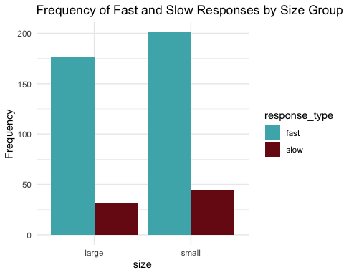

#scatter plot grouped by fast and slow  
  
ggplot(cym_dat,aes(x=turning_duration,y=turning_angle_absolute_value,color=response_type))+  
 geom_point()+  
 geom_smooth(method=lm,fullrange=TRUE,  
 aes(color=response_type))+  
 scale_color_manual(name='Response Type',  
 breaks=c('fast', 'slow'),  
 values=c('large'='#E69F00', 'slow'='#0C7BDC'))+  
 theme(legend.title=element_text(size=14),  
 legend.text=element_text(size=14))+  
 theme_classic()

## `geom_smooth()` using formula = 'y ~ x'

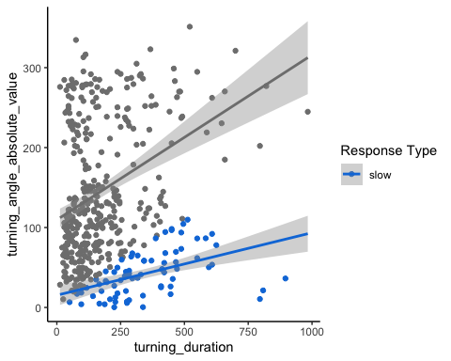

# Calculating NND for each responder within the same school and stimulus group  
#NAs come from two having the same nearest neighbor distance  
  
nnd_df <- nnd_df %>%  
 group_by(school, stimulus) %>%  
 mutate(  
 NND = sqrt((s_head_x - lag(s_head_x))^2 + (s_head_y - lag(s_head_y))^2)  
 ) %>%  
 ungroup()  
  
#If we want:  
# Replace NA values in the NND column with 0   
#nnd_df$NND[is.na(nnd_df$NND)] <- 0  
  
cym_dat$NND <- nnd_df$NND  
  
#add nnd to wave df  
nnd_wave_dat <- merge(wave_dat, nnd_df[, c('school', 'stimulus', 'responder', 'NND')],   
 by = c('school', 'stimulus', 'responder'),   
 all.x = TRUE)  
  
#average NND   
avgNND_result <- aggregate(NND ~ size, data = cym_dat, FUN = function(x) mean(x, na.rm = TRUE))  
print(avgNND_result)

## size NND  
## 1 large 19.66457  
## 2 small 13.98682

manwhit_NND <- wilcox.test(NND ~ size, data = cym_dat)  
print(manwhit_NND)

##   
## Wilcoxon rank sum test with continuity correction  
##   
## data: NND by size  
## W = 31680, p-value = 1.444e-09  
## alternative hypothesis: true location shift is not equal to 0

#they are significantly different from each other and further apart!   
  
boxplot(NND ~ size, data = cym_dat, main = "Boxplot of NND by Size",  
 xlab = "Size", ylab = "NND")

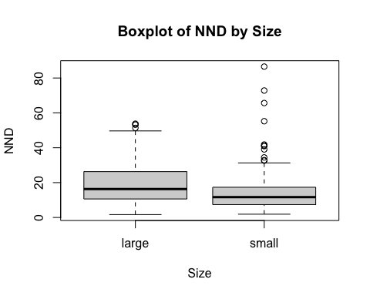

#ANCOVA  
ancova_mod <- aov(turning_rate ~ size + response_type, data = cym_dat)  
summary(ancova_mod)

## Df Sum Sq Mean Sq F value Pr(>F)   
## size 1 16.4 16.42 6.93 0.00877 **   
## response_type 1 109.7 109.68 46.28 3.27e-11 ***  
## Residuals 450 1066.4 2.37   
## ---  
## Signif. codes: 0 '***' 0.001 '**' 0.01 '*' 0.05 '.' 0.1 ' ' 1

par(mfrow=c(2,2))  
plot(ancova_mod)

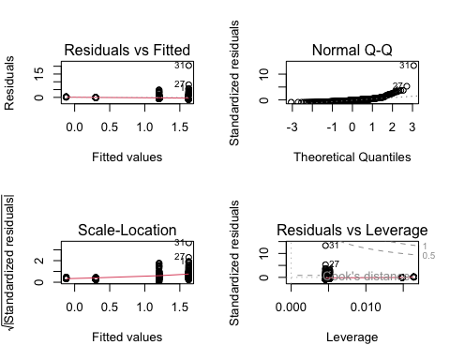

wilcox.test(turning_rate ~ response_type, data = cym_dat)

##   
## Wilcoxon rank sum test with continuity correction  
##   
## data: turning_rate by response_type  
## W = 28341, p-value < 2.2e-16  
## alternative hypothesis: true location shift is not equal to 0

# p-value <2.2e-16, conclusion: there is a statistically significant difference in the distributions of "turning_rate" between the two response types.

#Only interested in fast responses, making new dataset excluding slow responses  
  
fast_dat <- cym_dat %>%  
 filter(response_type == "fast")  
  
#glm for fast  
mod_fast <- glm(latency_ms ~ s_w_reactor + distance_from_stimulus + size+ angle_between_fish_and_stimulus + distance_from_first_responder +NND, data = fast_dat, family=poisson, na.action = na.exclude)

## Warning in dpois(y, mu, log = TRUE): non-integer x = 4.200000

## Warning in dpois(y, mu, log = TRUE): non-integer x = 12.500000

## Warning in dpois(y, mu, log = TRUE): non-integer x = 20.800000  
  
## Warning in dpois(y, mu, log = TRUE): non-integer x = 20.800000

## Warning in dpois(y, mu, log = TRUE): non-integer x = 41.700000

## Warning in dpois(y, mu, log = TRUE): non-integer x = 16.700000

## Warning in dpois(y, mu, log = TRUE): non-integer x = 54.200000

## Warning in dpois(y, mu, log = TRUE): non-integer x = 41.700000

## Warning in dpois(y, mu, log = TRUE): non-integer x = 112.500000

## Warning in dpois(y, mu, log = TRUE): non-integer x = 104.200000

## Warning in dpois(y, mu, log = TRUE): non-integer x = 108.300000

## Warning in dpois(y, mu, log = TRUE): non-integer x = 141.700000

## Warning in dpois(y, mu, log = TRUE): non-integer x = 187.500000

## Warning in dpois(y, mu, log = TRUE): non-integer x = 179.200000

## Warning in dpois(y, mu, log = TRUE): non-integer x = 216.700000

## Warning in dpois(y, mu, log = TRUE): non-integer x = 195.800000

## Warning in dpois(y, mu, log = TRUE): non-integer x = 220.800000

## Warning in dpois(y, mu, log = TRUE): non-integer x = 8.300000

## Warning in dpois(y, mu, log = TRUE): non-integer x = 20.800000

## Warning in dpois(y, mu, log = TRUE): non-integer x = 33.300000

## Warning in dpois(y, mu, log = TRUE): non-integer x = 29.200000

## Warning in dpois(y, mu, log = TRUE): non-integer x = 41.700000

## Warning in dpois(y, mu, log = TRUE): non-integer x = 83.300000

## Warning in dpois(y, mu, log = TRUE): non-integer x = 70.800000

## Warning in dpois(y, mu, log = TRUE): non-integer x = 104.200000

## Warning in dpois(y, mu, log = TRUE): non-integer x = 112.500000

## Warning in dpois(y, mu, log = TRUE): non-integer x = 91.700000

## Warning in dpois(y, mu, log = TRUE): non-integer x = 195.800000

## Warning in dpois(y, mu, log = TRUE): non-integer x = 191.700000

## Warning in dpois(y, mu, log = TRUE): non-integer x = 241.700000

## Warning in dpois(y, mu, log = TRUE): non-integer x = 308.300000

## Warning in dpois(y, mu, log = TRUE): non-integer x = 237.500000

## Warning in dpois(y, mu, log = TRUE): non-integer x = 483.300000

## Warning in dpois(y, mu, log = TRUE): non-integer x = 987.500000

## Warning in dpois(y, mu, log = TRUE): non-integer x = 379.200000

## Warning in dpois(y, mu, log = TRUE): non-integer x = 233.300000  
  
## Warning in dpois(y, mu, log = TRUE): non-integer x = 233.300000

## Warning in dpois(y, mu, log = TRUE): non-integer x = 291.700000

## Warning in dpois(y, mu, log = TRUE): non-integer x = 308.300000

## Warning in dpois(y, mu, log = TRUE): non-integer x = 433.300000

## Warning in dpois(y, mu, log = TRUE): non-integer x = 504.200000

## Warning in dpois(y, mu, log = TRUE): non-integer x = 295.800000

## Warning in dpois(y, mu, log = TRUE): non-integer x = 133.300000

## Warning in dpois(y, mu, log = TRUE): non-integer x = 287.500000

## Warning in dpois(y, mu, log = TRUE): non-integer x = 420.800000

## Warning in dpois(y, mu, log = TRUE): non-integer x = 458.300000

## Warning in dpois(y, mu, log = TRUE): non-integer x = 470.800000

## Warning in dpois(y, mu, log = TRUE): non-integer x = 508.300000

## Warning in dpois(y, mu, log = TRUE): non-integer x = 658.300000

## Warning in dpois(y, mu, log = TRUE): non-integer x = 495.800000

## Warning in dpois(y, mu, log = TRUE): non-integer x = 8.300000

## Warning in dpois(y, mu, log = TRUE): non-integer x = 37.500000

## Warning in dpois(y, mu, log = TRUE): non-integer x = 41.700000

## Warning in dpois(y, mu, log = TRUE): non-integer x = 37.500000

## Warning in dpois(y, mu, log = TRUE): non-integer x = 45.800000

## Warning in dpois(y, mu, log = TRUE): non-integer x = 66.700000

## Warning in dpois(y, mu, log = TRUE): non-integer x = 154.200000

## Warning in dpois(y, mu, log = TRUE): non-integer x = 62.500000

## Warning in dpois(y, mu, log = TRUE): non-integer x = 112.500000

## Warning in dpois(y, mu, log = TRUE): non-integer x = 154.200000

## Warning in dpois(y, mu, log = TRUE): non-integer x = 183.300000

## Warning in dpois(y, mu, log = TRUE): non-integer x = 195.800000

## Warning in dpois(y, mu, log = TRUE): non-integer x = 266.700000

## Warning in dpois(y, mu, log = TRUE): non-integer x = 33.300000

## Warning in dpois(y, mu, log = TRUE): non-integer x = 58.300000

## Warning in dpois(y, mu, log = TRUE): non-integer x = 133.300000

## Warning in dpois(y, mu, log = TRUE): non-integer x = 154.200000  
  
## Warning in dpois(y, mu, log = TRUE): non-integer x = 154.200000

## Warning in dpois(y, mu, log = TRUE): non-integer x = 170.800000

## Warning in dpois(y, mu, log = TRUE): non-integer x = 241.700000

## Warning in dpois(y, mu, log = TRUE): non-integer x = 170.800000

## Warning in dpois(y, mu, log = TRUE): non-integer x = 233.300000

## Warning in dpois(y, mu, log = TRUE): non-integer x = 170.800000

## Warning in dpois(y, mu, log = TRUE): non-integer x = 212.500000

## Warning in dpois(y, mu, log = TRUE): non-integer x = 229.200000

## Warning in dpois(y, mu, log = TRUE): non-integer x = 233.300000

## Warning in dpois(y, mu, log = TRUE): non-integer x = 383.300000

## Warning in dpois(y, mu, log = TRUE): non-integer x = 12.500000

## Warning in dpois(y, mu, log = TRUE): non-integer x = 16.700000

## Warning in dpois(y, mu, log = TRUE): non-integer x = 45.800000

## Warning in dpois(y, mu, log = TRUE): non-integer x = 66.700000

## Warning in dpois(y, mu, log = TRUE): non-integer x = 87.500000

## Warning in dpois(y, mu, log = TRUE): non-integer x = 95.800000

## Warning in dpois(y, mu, log = TRUE): non-integer x = 133.300000

## Warning in dpois(y, mu, log = TRUE): non-integer x = 141.700000

## Warning in dpois(y, mu, log = TRUE): non-integer x = 137.500000

## Warning in dpois(y, mu, log = TRUE): non-integer x = 141.700000

## Warning in dpois(y, mu, log = TRUE): non-integer x = 158.300000

## Warning in dpois(y, mu, log = TRUE): non-integer x = 204.200000

## Warning in dpois(y, mu, log = TRUE): non-integer x = 320.800000

## Warning in dpois(y, mu, log = TRUE): non-integer x = 95.800000

## Warning in dpois(y, mu, log = TRUE): non-integer x = 270.800000

## Warning in dpois(y, mu, log = TRUE): non-integer x = 233.300000

## Warning in dpois(y, mu, log = TRUE): non-integer x = 241.700000

## Warning in dpois(y, mu, log = TRUE): non-integer x = 420.800000

## Warning in dpois(y, mu, log = TRUE): non-integer x = 416.700000

## Warning in dpois(y, mu, log = TRUE): non-integer x = 516.700000

## Warning in dpois(y, mu, log = TRUE): non-integer x = 29.200000

## Warning in dpois(y, mu, log = TRUE): non-integer x = 33.300000

## Warning in dpois(y, mu, log = TRUE): non-integer x = 91.700000

## Warning in dpois(y, mu, log = TRUE): non-integer x = 341.700000

## Warning in dpois(y, mu, log = TRUE): non-integer x = 395.800000

## Warning in dpois(y, mu, log = TRUE): non-integer x = 166.700000

## Warning in dpois(y, mu, log = TRUE): non-integer x = 212.500000

## Warning in dpois(y, mu, log = TRUE): non-integer x = 245.800000

## Warning in dpois(y, mu, log = TRUE): non-integer x = 262.500000

## Warning in dpois(y, mu, log = TRUE): non-integer x = 283.300000

## Warning in dpois(y, mu, log = TRUE): non-integer x = 41.700000

## Warning in dpois(y, mu, log = TRUE): non-integer x = 45.800000

## Warning in dpois(y, mu, log = TRUE): non-integer x = 116.700000

## Warning in dpois(y, mu, log = TRUE): non-integer x = 145.800000

## Warning in dpois(y, mu, log = TRUE): non-integer x = 233.300000

## Warning in dpois(y, mu, log = TRUE): non-integer x = 583.300000

## Warning in dpois(y, mu, log = TRUE): non-integer x = 170.800000

## Warning in dpois(y, mu, log = TRUE): non-integer x = 204.200000

## Warning in dpois(y, mu, log = TRUE): non-integer x = 233.300000

## Warning in dpois(y, mu, log = TRUE): non-integer x = 237.500000

## Warning in dpois(y, mu, log = TRUE): non-integer x = 241.700000

## Warning in dpois(y, mu, log = TRUE): non-integer x = 337.500000

## Warning in dpois(y, mu, log = TRUE): non-integer x = 58.300000

## Warning in dpois(y, mu, log = TRUE): non-integer x = 87.500000

## Warning in dpois(y, mu, log = TRUE): non-integer x = 116.700000

## Warning in dpois(y, mu, log = TRUE): non-integer x = 458.300000

## Warning in dpois(y, mu, log = TRUE): non-integer x = 112.500000

## Warning in dpois(y, mu, log = TRUE): non-integer x = 187.500000  
  
## Warning in dpois(y, mu, log = TRUE): non-integer x = 187.500000

## Warning in dpois(y, mu, log = TRUE): non-integer x = 258.300000

## Warning in dpois(y, mu, log = TRUE): non-integer x = 262.500000

## Warning in dpois(y, mu, log = TRUE): non-integer x = 12.500000  
  
## Warning in dpois(y, mu, log = TRUE): non-integer x = 12.500000

## Warning in dpois(y, mu, log = TRUE): non-integer x = 45.800000

## Warning in dpois(y, mu, log = TRUE): non-integer x = 62.500000

## Warning in dpois(y, mu, log = TRUE): non-integer x = 91.700000

## Warning in dpois(y, mu, log = TRUE): non-integer x = 162.500000

## Warning in dpois(y, mu, log = TRUE): non-integer x = 120.800000

## Warning in dpois(y, mu, log = TRUE): non-integer x = 133.300000

## Warning in dpois(y, mu, log = TRUE): non-integer x = 154.200000

## Warning in dpois(y, mu, log = TRUE): non-integer x = 162.500000

## Warning in dpois(y, mu, log = TRUE): non-integer x = 233.300000

## Warning in dpois(y, mu, log = TRUE): non-integer x = 287.500000

## Warning in dpois(y, mu, log = TRUE): non-integer x = 366.700000

## Warning in dpois(y, mu, log = TRUE): non-integer x = 370.800000

## Warning in dpois(y, mu, log = TRUE): non-integer x = 379.200000

## Warning in dpois(y, mu, log = TRUE): non-integer x = 391.700000

## Warning in dpois(y, mu, log = TRUE): non-integer x = 404.200000

## Warning in dpois(y, mu, log = TRUE): non-integer x = 29.200000

## Warning in dpois(y, mu, log = TRUE): non-integer x = 37.500000

## Warning in dpois(y, mu, log = TRUE): non-integer x = 66.700000

## Warning in dpois(y, mu, log = TRUE): non-integer x = 91.700000  
  
## Warning in dpois(y, mu, log = TRUE): non-integer x = 91.700000

## Warning in dpois(y, mu, log = TRUE): non-integer x = 166.700000

## Warning in dpois(y, mu, log = TRUE): non-integer x = 179.200000

## Warning in dpois(y, mu, log = TRUE): non-integer x = 216.700000

## Warning in dpois(y, mu, log = TRUE): non-integer x = 229.200000

## Warning in dpois(y, mu, log = TRUE): non-integer x = 258.300000

## Warning in dpois(y, mu, log = TRUE): non-integer x = 329.200000

## Warning in dpois(y, mu, log = TRUE): non-integer x = 441.700000

## Warning in dpois(y, mu, log = TRUE): non-integer x = 483.300000

## Warning in dpois(y, mu, log = TRUE): non-integer x = 8.300000

## Warning in dpois(y, mu, log = TRUE): non-integer x = 20.800000

## Warning in dpois(y, mu, log = TRUE): non-integer x = 170.800000

## Warning in dpois(y, mu, log = TRUE): non-integer x = 179.200000

## Warning in dpois(y, mu, log = TRUE): non-integer x = 216.700000

## Warning in dpois(y, mu, log = TRUE): non-integer x = 304.200000

## Warning in dpois(y, mu, log = TRUE): non-integer x = 312.500000

## Warning in dpois(y, mu, log = TRUE): non-integer x = 341.700000

## Warning in dpois(y, mu, log = TRUE): non-integer x = 512.500000

## Warning in dpois(y, mu, log = TRUE): non-integer x = 591.700000

## Warning in dpois(y, mu, log = TRUE): non-integer x = 1087.500000

## Warning in dpois(y, mu, log = TRUE): non-integer x = 91.700000

## Warning in dpois(y, mu, log = TRUE): non-integer x = 104.200000  
  
## Warning in dpois(y, mu, log = TRUE): non-integer x = 104.200000

## Warning in dpois(y, mu, log = TRUE): non-integer x = 162.500000

## Warning in dpois(y, mu, log = TRUE): non-integer x = 516.700000

## Warning in dpois(y, mu, log = TRUE): non-integer x = 283.300000

## Warning in dpois(y, mu, log = TRUE): non-integer x = 362.500000

## Warning in dpois(y, mu, log = TRUE): non-integer x = 383.300000

## Warning in dpois(y, mu, log = TRUE): non-integer x = 445.800000

## Warning in dpois(y, mu, log = TRUE): non-integer x = 454.200000

## Warning in dpois(y, mu, log = TRUE): non-integer x = 458.300000

## Warning in dpois(y, mu, log = TRUE): non-integer x = 41.700000

## Warning in dpois(y, mu, log = TRUE): non-integer x = 79.200000

## Warning in dpois(y, mu, log = TRUE): non-integer x = 141.700000

## Warning in dpois(y, mu, log = TRUE): non-integer x = 1391.700000

## Warning in dpois(y, mu, log = TRUE): non-integer x = 91.700000

## Warning in dpois(y, mu, log = TRUE): non-integer x = 216.700000

## Warning in dpois(y, mu, log = TRUE): non-integer x = 233.300000

## Warning in dpois(y, mu, log = TRUE): non-integer x = 308.300000

## Warning in dpois(y, mu, log = TRUE): non-integer x = 612.500000

## Warning in dpois(y, mu, log = TRUE): non-integer x = 429.200000

## Warning in dpois(y, mu, log = TRUE): non-integer x = 262.500000

## Warning in dpois(y, mu, log = TRUE): non-integer x = 8.300000

## Warning in dpois(y, mu, log = TRUE): non-integer x = 20.800000

## Warning in dpois(y, mu, log = TRUE): non-integer x = 137.500000

## Warning in dpois(y, mu, log = TRUE): non-integer x = 145.800000

## Warning in dpois(y, mu, log = TRUE): non-integer x = 204.200000

## Warning in dpois(y, mu, log = TRUE): non-integer x = 220.800000

## Warning in dpois(y, mu, log = TRUE): non-integer x = 329.200000

## Warning in dpois(y, mu, log = TRUE): non-integer x = 404.200000

## Warning in dpois(y, mu, log = TRUE): non-integer x = 1366.700000

## Warning in dpois(y, mu, log = TRUE): non-integer x = 283.300000

## Warning in dpois(y, mu, log = TRUE): non-integer x = 316.700000  
  
## Warning in dpois(y, mu, log = TRUE): non-integer x = 316.700000

## Warning in dpois(y, mu, log = TRUE): non-integer x = 345.800000

## Warning in dpois(y, mu, log = TRUE): non-integer x = 570.800000

## Warning in dpois(y, mu, log = TRUE): non-integer x = 695.800000

## Warning in dpois(y, mu, log = TRUE): non-integer x = 720.800000

## Warning in dpois(y, mu, log = TRUE): non-integer x = 29.200000  
  
## Warning in dpois(y, mu, log = TRUE): non-integer x = 29.200000

## Warning in dpois(y, mu, log = TRUE): non-integer x = 308.300000

## Warning in dpois(y, mu, log = TRUE): non-integer x = 220.800000

## Warning in dpois(y, mu, log = TRUE): non-integer x = 391.700000

## Warning in dpois(y, mu, log = TRUE): non-integer x = 512.500000

## Warning in dpois(y, mu, log = TRUE): non-integer x = 566.700000

## Warning in dpois(y, mu, log = TRUE): non-integer x = 1070.800000

## Warning in dpois(y, mu, log = TRUE): non-integer x = 12.500000

## Warning in dpois(y, mu, log = TRUE): non-integer x = 104.200000

## Warning in dpois(y, mu, log = TRUE): non-integer x = 329.200000

## Warning in dpois(y, mu, log = TRUE): non-integer x = 1679.200000

## Warning in dpois(y, mu, log = TRUE): non-integer x = 12.500000

## Warning in dpois(y, mu, log = TRUE): non-integer x = 33.300000

## Warning in dpois(y, mu, log = TRUE): non-integer x = 37.500000

## Warning in dpois(y, mu, log = TRUE): non-integer x = 41.700000

## Warning in dpois(y, mu, log = TRUE): non-integer x = 137.500000

## Warning in dpois(y, mu, log = TRUE): non-integer x = 162.500000

## Warning in dpois(y, mu, log = TRUE): non-integer x = 187.500000

## Warning in dpois(y, mu, log = TRUE): non-integer x = 220.800000

## Warning in dpois(y, mu, log = TRUE): non-integer x = 395.800000

## Warning in dpois(y, mu, log = TRUE): non-integer x = 441.700000

## Warning in dpois(y, mu, log = TRUE): non-integer x = 504.200000

## Warning in dpois(y, mu, log = TRUE): non-integer x = 537.500000

## Warning in dpois(y, mu, log = TRUE): non-integer x = 558.300000

## Warning in dpois(y, mu, log = TRUE): non-integer x = 1295.800000

## Warning in dpois(y, mu, log = TRUE): non-integer x = 62.500000

## Warning in dpois(y, mu, log = TRUE): non-integer x = 91.700000

## Warning in dpois(y, mu, log = TRUE): non-integer x = 116.700000

## Warning in dpois(y, mu, log = TRUE): non-integer x = 195.800000

## Warning in dpois(y, mu, log = TRUE): non-integer x = 329.200000

## Warning in dpois(y, mu, log = TRUE): non-integer x = 158.300000

## Warning in dpois(y, mu, log = TRUE): non-integer x = 212.500000

## Warning in dpois(y, mu, log = TRUE): non-integer x = 262.500000

## Warning in dpois(y, mu, log = TRUE): non-integer x = 304.200000

## Warning in dpois(y, mu, log = TRUE): non-integer x = 479.200000

## Warning in dpois(y, mu, log = TRUE): non-integer x = 33.300000

## Warning in dpois(y, mu, log = TRUE): non-integer x = 41.700000

## Warning in dpois(y, mu, log = TRUE): non-integer x = 54.200000

## Warning in dpois(y, mu, log = TRUE): non-integer x = 116.700000

## Warning in dpois(y, mu, log = TRUE): non-integer x = 637.500000

## Warning in dpois(y, mu, log = TRUE): non-integer x = 383.300000

## Warning in dpois(y, mu, log = TRUE): non-integer x = 487.500000

## Warning in dpois(y, mu, log = TRUE): non-integer x = 1241.700000

## Warning in dpois(y, mu, log = TRUE): non-integer x = 1383.300000

## Warning in dpois(y, mu, log = TRUE): non-integer x = 37.500000

## Warning in dpois(y, mu, log = TRUE): non-integer x = 45.800000  
  
## Warning in dpois(y, mu, log = TRUE): non-integer x = 45.800000

## Warning in dpois(y, mu, log = TRUE): non-integer x = 62.500000

## Warning in dpois(y, mu, log = TRUE): non-integer x = 70.800000

## Warning in dpois(y, mu, log = TRUE): non-integer x = 87.500000

## Warning in dpois(y, mu, log = TRUE): non-integer x = 120.800000

## Warning in dpois(y, mu, log = TRUE): non-integer x = 129.200000

## Warning in dpois(y, mu, log = TRUE): non-integer x = 141.700000

## Warning in dpois(y, mu, log = TRUE): non-integer x = 162.500000

## Warning in dpois(y, mu, log = TRUE): non-integer x = 204.200000

## Warning in dpois(y, mu, log = TRUE): non-integer x = 212.500000

## Warning in dpois(y, mu, log = TRUE): non-integer x = 283.300000

## Warning in dpois(y, mu, log = TRUE): non-integer x = 391.700000

## Warning in dpois(y, mu, log = TRUE): non-integer x = 395.800000

## Warning in dpois(y, mu, log = TRUE): non-integer x = 404.200000

## Warning in dpois(y, mu, log = TRUE): non-integer x = 566.700000

## Warning in dpois(y, mu, log = TRUE): non-integer x = 29.200000

## Warning in dpois(y, mu, log = TRUE): non-integer x = 83.300000

## Warning in dpois(y, mu, log = TRUE): non-integer x = 245.800000

## Warning in dpois(y, mu, log = TRUE): non-integer x = 383.300000

## Warning in dpois(y, mu, log = TRUE): non-integer x = 395.800000

## Warning in dpois(y, mu, log = TRUE): non-integer x = 262.500000

## Warning in dpois(y, mu, log = TRUE): non-integer x = 287.500000

## Warning in dpois(y, mu, log = TRUE): non-integer x = 308.300000

## Warning in dpois(y, mu, log = TRUE): non-integer x = 358.300000

## Warning in dpois(y, mu, log = TRUE): non-integer x = 366.700000

## Warning in dpois(y, mu, log = TRUE): non-integer x = 429.200000

## Warning in dpois(y, mu, log = TRUE): non-integer x = 54.200000

## Warning in dpois(y, mu, log = TRUE): non-integer x = 70.800000

## Warning in dpois(y, mu, log = TRUE): non-integer x = 95.800000

## Warning in dpois(y, mu, log = TRUE): non-integer x = 116.700000

## Warning in dpois(y, mu, log = TRUE): non-integer x = 179.200000

## Warning in dpois(y, mu, log = TRUE): non-integer x = 212.500000

## Warning in dpois(y, mu, log = TRUE): non-integer x = 179.200000

## Warning in dpois(y, mu, log = TRUE): non-integer x = 183.300000

## Warning in dpois(y, mu, log = TRUE): non-integer x = 287.500000

## Warning in dpois(y, mu, log = TRUE): non-integer x = 345.800000  
  
## Warning in dpois(y, mu, log = TRUE): non-integer x = 345.800000

## Warning in dpois(y, mu, log = TRUE): non-integer x = 370.800000

## Warning in dpois(y, mu, log = TRUE): non-integer x = 645.800000

summary(mod_fast)

##   
## Call:  
## glm(formula = latency_ms ~ s_w_reactor + distance_from_stimulus +   
## size + angle_between_fish_and_stimulus + distance_from_first_responder +   
## NND, family = poisson, data = fast_dat, na.action = na.exclude)  
##   
## Deviance Residuals:   
## Min 1Q Median 3Q Max   
## -19.775 -9.307 -3.078 3.434 58.017   
##   
## Coefficients:  
## Estimate Std. Error z value Pr(>|z|)   
## (Intercept) 4.159e+00 1.507e-02 275.930 < 2e-16 ***  
## s_w_reactorw 5.642e-01 8.873e-03 63.583 < 2e-16 ***  
## distance_from_stimulus 1.732e-02 3.357e-04 51.610 < 2e-16 ***  
## sizesmall 5.673e-01 7.711e-03 73.568 < 2e-16 ***  
## angle_between_fish_and_stimulus -3.794e-04 4.777e-05 -7.942 1.98e-15 ***  
## distance_from_first_responder 3.501e-03 2.616e-04 13.380 < 2e-16 ***  
## NND -5.084e-04 3.109e-04 -1.635 0.102   
## ---  
## Signif. codes: 0 '***' 0.001 '**' 0.01 '*' 0.05 '.' 0.1 ' ' 1  
##   
## (Dispersion parameter for poisson family taken to be 1)  
##   
## Null deviance: 68771 on 361 degrees of freedom  
## Residual deviance: 48263 on 355 degrees of freedom  
## (16 observations deleted due to missingness)  
## AIC: Inf  
##   
## Number of Fisher Scoring iterations: 5

par(mfrow=c(2,2))  
plot(mod_fast)

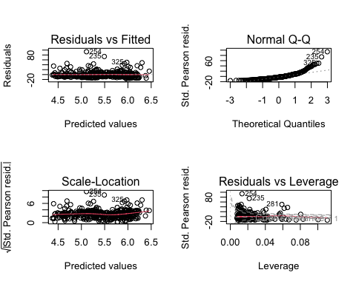

#subsetting just the wave  
wave_dat_fast <- subset(fast_dat, substr(responder, 1, 1) == "w")  
  
#glm for wave  
glm_wave_fast <- glm(latency_ms ~ size+ angle_between_fish_and_stimulus+distance_from_first_responder +NND, data = wave_dat_fast, family=Gamma(link = "log"), na.action = na.exclude)  
summary(glm_wave_fast)

##   
## Call:  
## glm(formula = latency_ms ~ size + angle_between_fish_and_stimulus +   
## distance_from_first_responder + NND, family = Gamma(link = "log"),   
## data = wave_dat_fast, na.action = na.exclude)  
##   
## Deviance Residuals:   
## Min 1Q Median 3Q Max   
## -1.3409 -0.4967 -0.1336 0.2082 1.6107   
##   
## Coefficients:  
## Estimate Std. Error t value Pr(>|t|)   
## (Intercept) 5.4347868 0.1305232 41.638 < 2e-16 ***  
## sizesmall 0.4656562 0.0901161 5.167 5.64e-07 ***  
## angle_between_fish_and_stimulus -0.0008496 0.0006864 -1.238 0.21723   
## distance_from_first_responder 0.0085481 0.0031592 2.706 0.00739 **   
## NND -0.0016675 0.0041097 -0.406 0.68536   
## ---  
## Signif. codes: 0 '***' 0.001 '**' 0.01 '*' 0.05 '.' 0.1 ' ' 1  
##   
## (Dispersion parameter for Gamma family taken to be 0.3461998)  
##   
## Null deviance: 75.546 on 208 degrees of freedom  
## Residual deviance: 62.990 on 204 degrees of freedom  
## AIC: 2726.9  
##   
## Number of Fisher Scoring iterations: 6

par(mfrow=c(2,2))  
plot(glm_wave_fast)

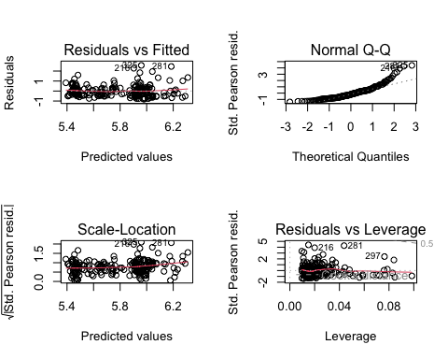

with(summary(glm_wave_fast), 1 - deviance/null.deviance)

## [1] 0.1661971

#taking out all insignificant variables  
glm_size_distfr <- glm(latency_ms ~ size + distance_from_first_responder , data = wave_dat_fast, family=Gamma(link = "log"))  
summary(glm_size_distfr)

##   
## Call:  
## glm(formula = latency_ms ~ size + distance_from_first_responder,   
## family = Gamma(link = "log"), data = wave_dat_fast)  
##   
## Deviance Residuals:   
## Min 1Q Median 3Q Max   
## -1.3469 -0.5065 -0.1143 0.2011 1.5153   
##   
## Coefficients:  
## Estimate Std. Error t value Pr(>|t|)   
## (Intercept) 5.371731 0.101721 52.809 < 2e-16 ***  
## sizesmall 0.482675 0.084874 5.687 4.39e-08 ***  
## distance_from_first_responder 0.007346 0.003004 2.446 0.0153 *   
## ---  
## Signif. codes: 0 '***' 0.001 '**' 0.01 '*' 0.05 '.' 0.1 ' ' 1  
##   
## (Dispersion parameter for Gamma family taken to be 0.3458747)  
##   
## Null deviance: 75.546 on 208 degrees of freedom  
## Residual deviance: 63.585 on 206 degrees of freedom  
## AIC: 2725  
##   
## Number of Fisher Scoring iterations: 6

par(mfrow=c(2,2))  
plot(glm_size_distfr)

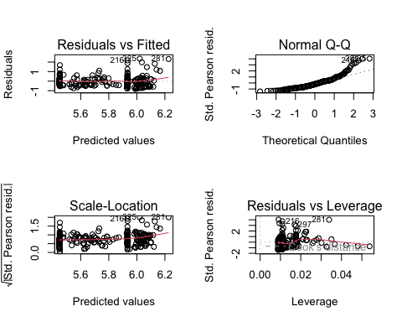

#size is more significant  
  
#calculate McFadden's R-squared for model for size and distance from first responder glm  
with(summary(glm_size_distfr), 1 - deviance/null.deviance)

## [1] 0.1583209

glm_size <- glm(latency_ms ~ size, data = wave_dat_fast, family=Gamma(link = "log"))  
summary(glm_size)

##   
## Call:  
## glm(formula = latency_ms ~ size, family = Gamma(link = "log"),   
## data = wave_dat_fast)  
##   
## Deviance Residuals:   
## Min 1Q Median 3Q Max   
## -1.3583 -0.4910 -0.1352 0.2313 1.8493   
##   
## Coefficients:  
## Estimate Std. Error t value Pr(>|t|)   
## (Intercept) 5.57289 0.06235 89.384 < 2e-16 ***  
## sizesmall 0.43549 0.08479 5.136 6.46e-07 ***  
## ---  
## Signif. codes: 0 '***' 0.001 '**' 0.01 '*' 0.05 '.' 0.1 ' ' 1  
##   
## (Dispersion parameter for Gamma family taken to be 0.3731722)  
##   
## Null deviance: 75.546 on 208 degrees of freedom  
## Residual deviance: 65.891 on 207 degrees of freedom  
## AIC: 2730.8  
##   
## Number of Fisher Scoring iterations: 5

par(mfrow=c(2,2))  
plot(glm_size)

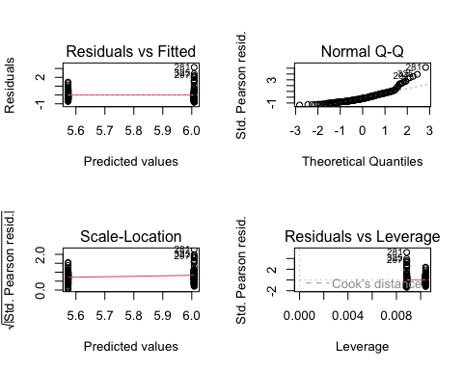

with(summary(glm_size), 1 - deviance/null.deviance)

## [1] 0.1277931

#linear model for just the wave  
lm_wavedat_fast <- lm(latency_ms ~ size, data=wave_dat_fast)  
summary(lm_wavedat_fast)

##   
## Call:  
## lm(formula = latency_ms ~ size, data = wave_dat_fast)  
##   
## Residuals:  
## Min 1Q Median 3Q Max   
## -336.02 -125.69 -38.19 82.61 1272.38   
##   
## Coefficients:  
## Estimate Std. Error t value Pr(>|t|)   
## (Intercept) 263.19 23.46 11.220 < 2e-16 ***  
## sizesmall 143.63 31.90 4.502 1.12e-05 ***  
## ---  
## Signif. codes: 0 '***' 0.001 '**' 0.01 '*' 0.05 '.' 0.1 ' ' 1  
##   
## Residual standard error: 229.8 on 207 degrees of freedom  
## Multiple R-squared: 0.08918, Adjusted R-squared: 0.08478   
## F-statistic: 20.27 on 1 and 207 DF, p-value: 1.123e-05

#normality  
shapiro.test(lm_wavedat_fast$residuals)

##   
## Shapiro-Wilk normality test  
##   
## data: lm_wavedat_fast$residuals  
## W = 0.81504, p-value = 5.023e-15

#homogeneity of variances  
bartlett.test(latency_ms ~ size, data=wave_dat_fast)

##   
## Bartlett test of homogeneity of variances  
##   
## data: latency_ms by size  
## Bartlett's K-squared = 71.483, df = 1, p-value < 2.2e-16

wilcox.test(latency_ms ~ size, data = wave_dat_fast)

##   
## Wilcoxon rank sum test with continuity correction  
##   
## data: latency_ms by size  
## W = 3683.5, p-value = 6.5e-05  
## alternative hypothesis: true location shift is not equal to 0

#Correlation and Principal Component Analysis, not using this  
  
  
#new df with specified columns  
wave_fast_forPCA <- wave_dat_fast[, c("latency_ms", "s_w_reactor", "distance_from_stimulus", "size", "angle_between_fish_and_stimulus", "distance_from_first_responder","NND")]  
  
  
#make small 0 and large 1  
wave_fast_forPCA <- wave_fast_forPCA %>%  
 mutate(size_ID = ifelse(size == "small", 0, 1))  
  
  
  
#use sapply to make wave_dat_fast numeric  
  
wave_fast_new <- wave_fast_forPCA[sapply(wave_fast_forPCA, is.numeric)]  
  
#correlation  
wave_corr <- sapply(wave_fast_new[, setdiff(names(wave_fast_new), "latency_ms")], function(x) {  
 cor(wave_fast_new$latency_ms, x, method = "pearson")  
})  
print(wave_corr)

## distance_from_stimulus angle_between_fish_and_stimulus   
## 0.05041053 -0.07227380   
## distance_from_first_responder NND   
## 0.07761140 -0.11248255   
## size_ID   
## -0.29863354

#quick visualization   
ggplot(wave_dat_fast) +  
 geom_point(aes(x = distance_from_first_responder, y = latency_ms, color = size)) +  
 geom_smooth(aes(x = distance_from_first_responder, y = latency_ms, color = size), method = "lm") +  
 scale_color_fish_d(option = "Trimma_lantana")

## `geom_smooth()` using formula = 'y ~ x'

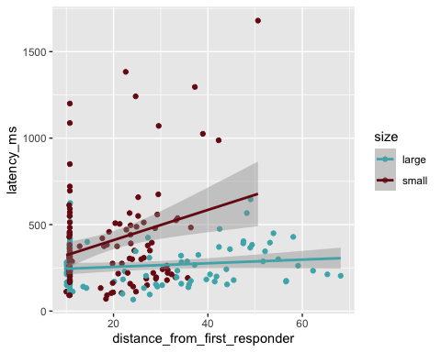

ggplot(cym_dat,aes(x=turning_duration,y=turning_angle_absolute_value,color=response_type))+  
 geom_point()+  
 geom_smooth(method=lm,fullrange=TRUE,  
 aes(color=response_type))+  
 scale_color_manual(name='Response Type',  
 breaks=c('fast', 'slow'),  
 values=c('large'='#E69F00', 'slow'='#0C7BDC'))+  
 theme(legend.title=element_text(size=14),  
 legend.text=element_text(size=14))+  
 theme_classic()

## `geom_smooth()` using formula = 'y ~ x'



# Predict the values using the fitted model  
predicted_values <- predict(glm_size_distfr, type = "response")  
  
# Create a data frame for plotting  
plot_data <- data.frame(Observed = wave_dat_fast$latency_ms, Predicted = predicted_values)  
  
#scatterplot  
ggplot(plot_data, aes(x = Observed, y = Predicted)) +  
 geom_point() +  
 geom_abline(intercept = 0, slope = 1, color = "red", linetype = "dashed") + # Add a reference line  
 labs(x = "Observed", y = "Predicted") +  
 theme_minimal()

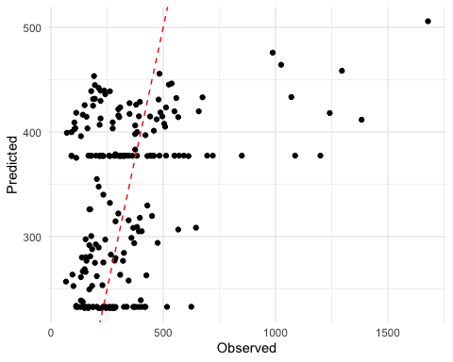

ggplt <- ggplot(wave_dat,aes(x=distance_from_first_responder,y=latency_ms,color=size))+  
 geom_point()+  
 theme_classic()  
  
ggplt+geom_smooth(method=lm,fullrange=TRUE,  
 aes(color=size))

## `geom_smooth()` using formula = 'y ~ x'

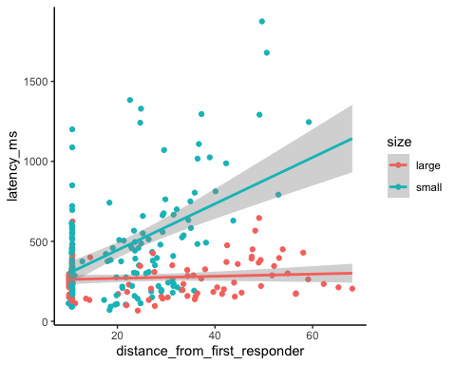

ggplt+scale_color_manual(values=c("#E69F00","#0C7BDC"))

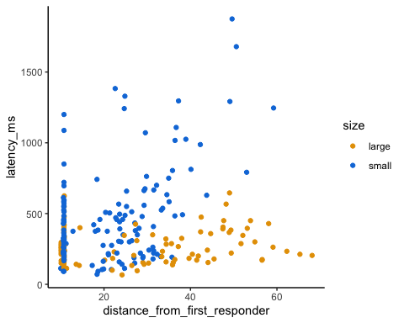

ggplt+scale_color_manual(name='Size',  
 breaks=c('large', 'small'),  
 values=c('large'='#E69F00', 'small'='#0C7BDC'))+  
 theme(legend.title=element_text(size=14),  
 legend.text=element_text(size=14))

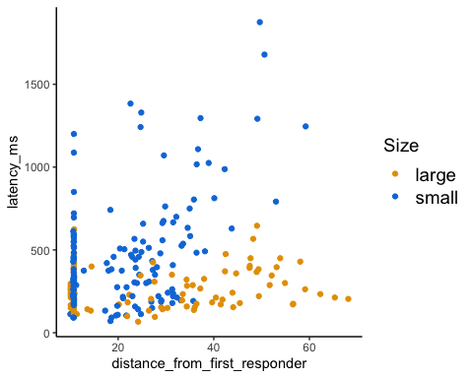

#plots   
  
ggplot(wave_dat_fast,aes(x=distance_from_first_responder,y=latency_ms,color=size))+  
 geom_point()+  
 geom_smooth(method=lm,fullrange=TRUE,  
 aes(color=size))+  
 scale_color_manual(name='Size',  
 breaks=c('large', 'small'),  
 values=c('large'='#E69F00', 'small'='#0C7BDC'))+  
 theme(legend.title=element_text(size=14),  
 legend.text=element_text(size=14))+  
 theme_classic()

## `geom_smooth()` using formula = 'y ~ x'

