TY B.Tech. (CSE) – II [ 2024-25 ]

6CS371: Advanced Database System Lab.

Assignment No. 12

Spatial and Geographic Data Geospatial is the natural domain for Graph Database

Use Neo4j and Neo4j Spatial Problem

Statement: Finding Things Close to Other Things. Application in: location-based services on the web

1. Added Location points with data – City name, Latitude , Longitude . 12000 records with different cities all over world.

LOAD CSV WITH HEADERS FROM 'file:///clean_worldcities.csv' AS row  
CREATE (:City {  
name: row.city_ascii,  
latitude: toFloat(row.lat),  
longitude: toFloat(row.lng)  
});

Create Near relationship among cities within 1000km and get graph

MATCH (a:City), (b:City)

WHERE id(a) < id(b)

AND point.distance(a.location, b.location) < 1000000

CREATE (a)-[:NEAR {distance: point.distance(a.location, b.location)}]->(b);

To see results:

MATCH (c:City)-[r:NEAR]->(n:City)

RETURN c, r, n

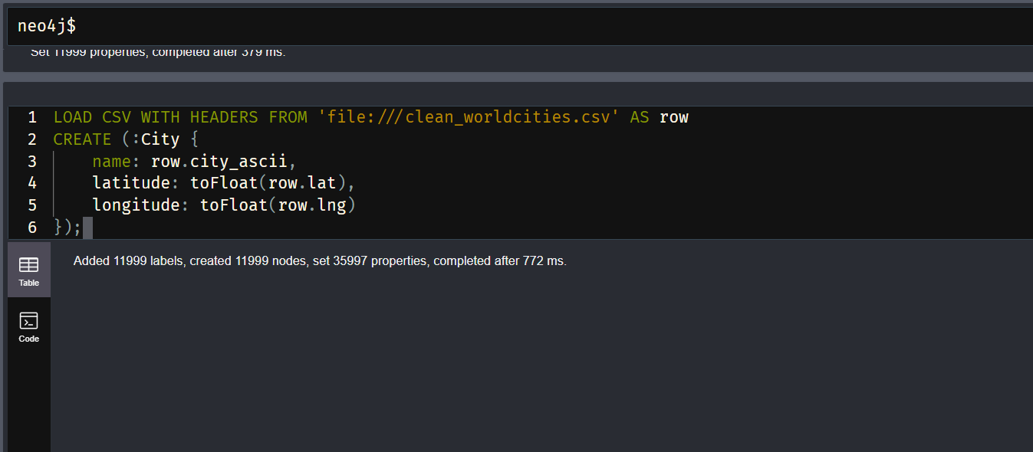

1. Use the point() , distance() function of Neo4j to answer the queries which things close/nearest to which other things

Cities near to Mumbai

MATCH (c1:City {name: "Mumbai"}), (c2:City)

WHERE c1 <> c2

WITH c1, c2, point.distance(point({latitude: c1.latitude, longitude: c1.longitude}), point({latitude: c2.latitude, longitude: c2.longitude})) AS dist

WHERE dist < 100000 // 100 km

RETURN c1,

c2,

{distance_in_km: dist/1000} AS connectionProperties

ORDER BY connectionProperties.distance_in_km ASC;

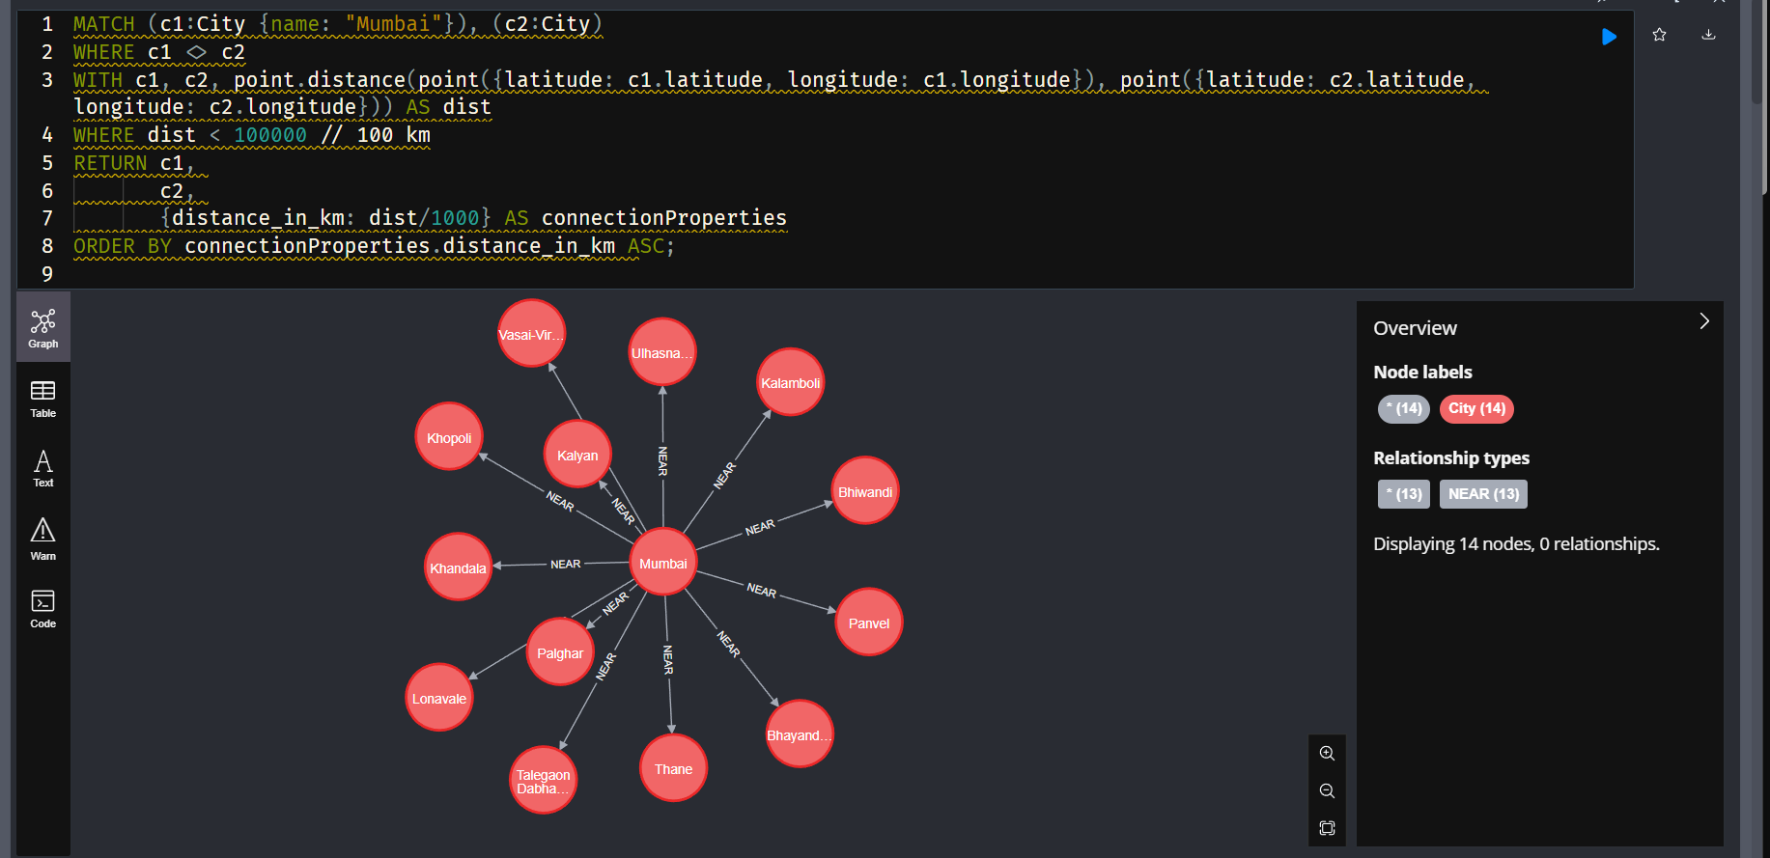

Query to find up to 2000 pairs of *nearby cities* (less than 500 km apart) from the first 500 cities, avoiding duplicate comparisons and optimizing distance checks

MATCH (c1:City)

WITH c1

LIMIT 500

MATCH (c2:City)

WHERE id(c1) < id(c2)

  AND abs(c1.latitude - c2.latitude) <= 5

  AND abs(c1.longitude - c2.longitude) <= 5

WITH c1, c2,

     point({latitude: c1.latitude, longitude: c1.longitude}) AS p1,

     point({latitude: c2.latitude, longitude: c2.longitude}) AS p2

WITH c1, c2, point.distance(p1, p2)/1000 AS dist_km

WHERE dist_km < 500

RETURN c1, c2, dist_km

ORDER BY dist_km ASC

LIMIT 2000;

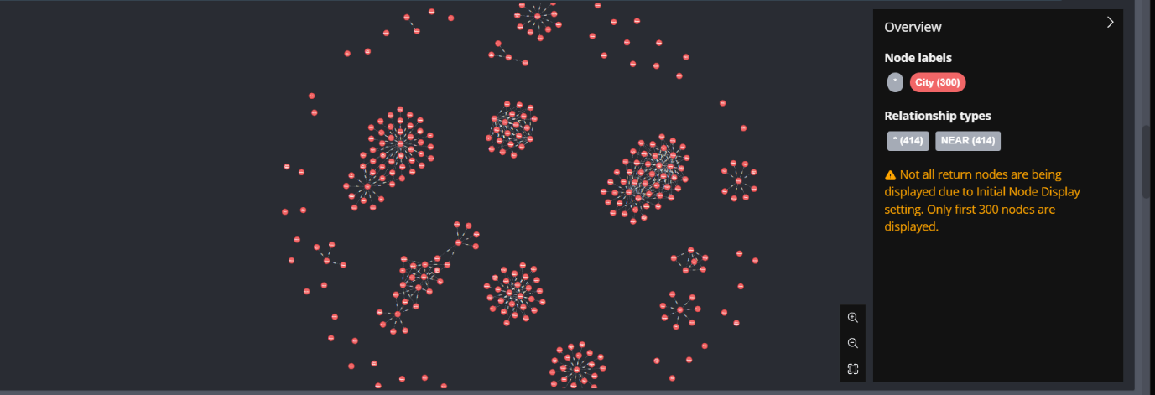

1. Cities within 100km area near Pune

