**TY B.Tech. (CSE) – II [ 2024-25]**

**6CS371: Advanced Database System Lab.**

**Assignment No. 6**

**Name: Jasmine I. Sayyad**

**PRN: 22510033**

**Batch: T2**

**Objective:** To design and implement a data warehouse for a customer order processing system in a company.

* Retrieve **store information** for specific products.
* Track **customer orders** and fulfilment by different stores.
* Analyse **inventory levels** and stock management.
* Generate insights on **customer purchasing behaviour** (walk-in, mail-order, or both).
* Provide **quick and efficient querying** for business intelligence and reporting.

**Scope of the Project**

1. **Data Integration & Storage**
   1. Extract data from **operational databases** (SalesDB, HeadquarterDB).
   2. Transform and load data into a **structured Data Warehouse (OLAP model)**.
2. **Schema Design**
   1. Implement **Fact and Dimension tables** to store historical data.
   2. Establish **relationships between customers, orders, stores, and inventory**.
3. **Query Optimization & Reporting**
   1. Enable **complex analytical queries** for decision-making.
   2. Generate **business reports** for sales performance and stock level

Relational Schema:

Headquarter Database:

Relation Customer (Customer_id, Customer_name, City_id, First_order_date)

Relation Walk-in_customers (*Customer_id, tourism_guide, Time)

Relation Mail_order_customers (*Customer_id, post_address, Time)

ER diagram:

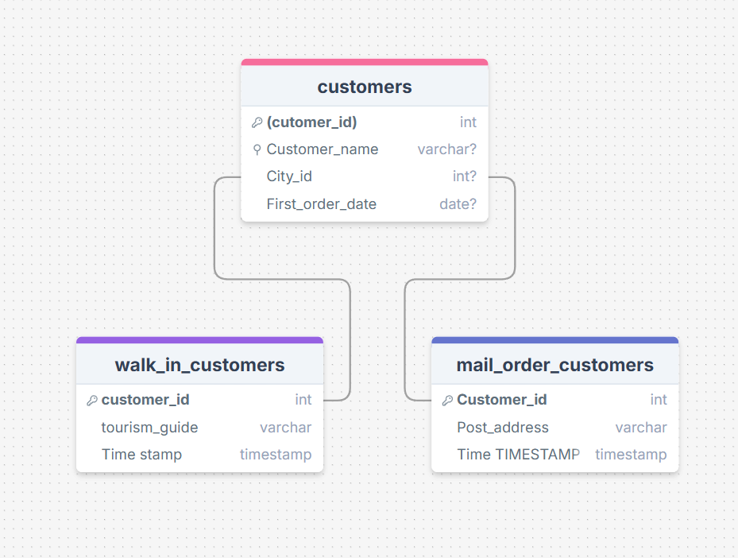

Sales Databases:

Relation Headqarters (City_id, City_name, Headquarter_addr, State, Time)

Relation Stores (Store_id, *City_id, Phone, Time)

Relation Items (Item_id, Description, Size, Weight, Unit_price, Time)

Relation Stored_items (*Store_id, *Item_id, Quantity_held, Time)

Relation Order (Order_no, Order_date, Customer_id)

Relation Ordered_item (*Order_no, *Item_id, Quantity_ordered, Ordered_price, Time)

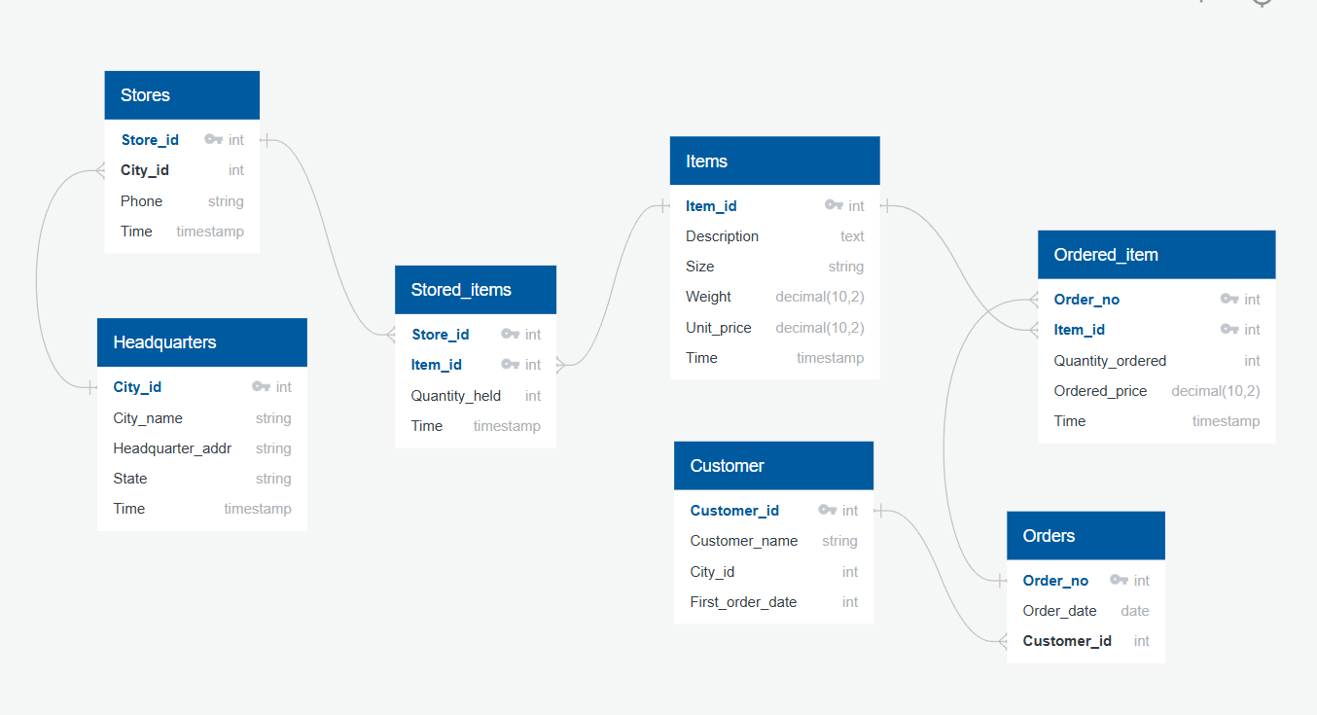

**2. Business Requirement – Application Specification**

The data warehouse is designed for **store managers, sales teams, and business analysts** to analyse sales, inventory, and customer behaviour. Users can track **order fulfilment, stock levels, and sales performance across multiple stores**. It helps in **decision-making, demand forecasting, and improving business efficiency**.

**3. Functional Specification – Input & Output**

* **Input:** Sales transactions, customer details, inventory data, and store information.
* **Output:** Reports on **sales trends, stock availability, customer orders, store performance**, and more.

4. **Data Warehousing Design – Methodology & Star Schema**

1. **Identify business needs** – Define key metrics and reporting requirements.
2. **Extract, Transform, Load (ETL)** – Gather data from operational databases, clean, and load into the warehouse.
3. **Schema Design (Star Schema)**
   * **Fact Table:** Stores order transactions.

Contains business events or transactions (e.g., sales, orders, stock levels).

Stores measurable data (e.g., sales amount, quantity ordered, stock levels).

Contains foreignkeys linking to the dimensiontables.

* + **Dimension Tables:** Customers, stores, items, cities, and headquarters.

Store **descriptive attributes** about business data (e.g., customer details, product info, store locations).

Help in slicing and dicing the data for analysis.

1. **Build indexes & optimize queries** for fast retrieval.

5. **Data Cube Implementation**

* Data cubes are built using **OLAP tools** to store aggregated data for faster analysis.
* The process involves **loading data from the warehouse, precomputing summaries**, and enabling multidimensional queries (e.g., sales by store, city, and product).

6. **Observations**

**a) OLAP Reports**

* Users can generate **dynamic reports** on orders, sales, and inventory trends using simple commands or dashboard panels.

**b) Data Verification**

* OLAP reports are **validated against raw transactional data** from relational tables to ensure accuracy.

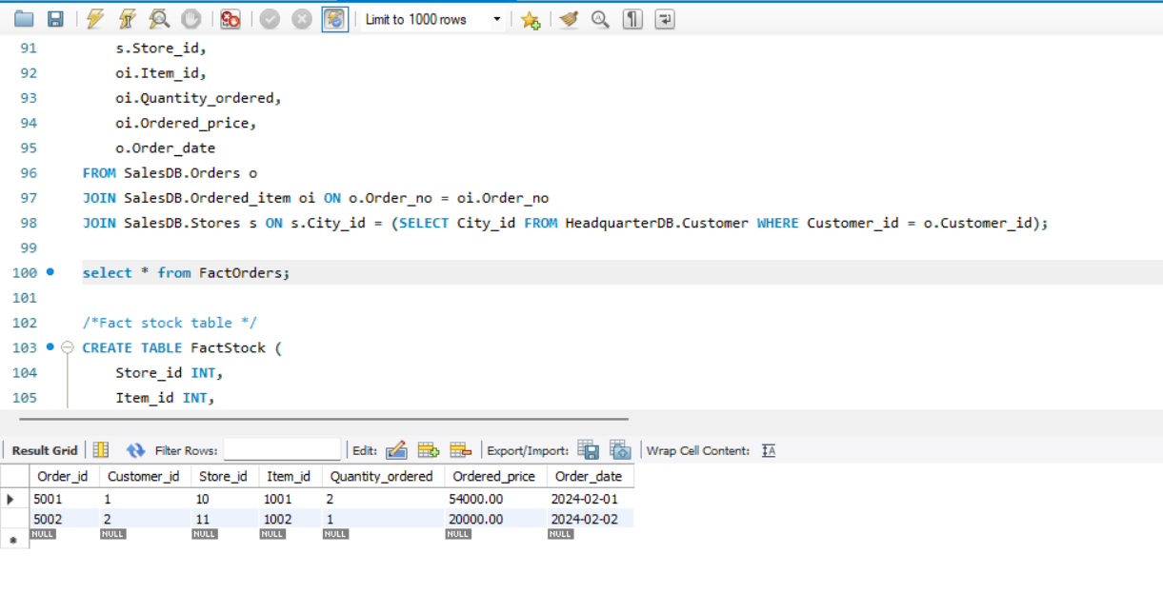

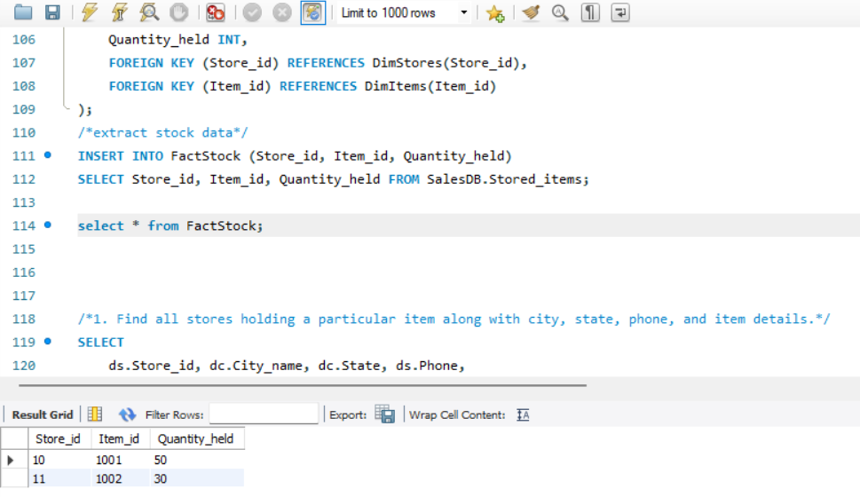

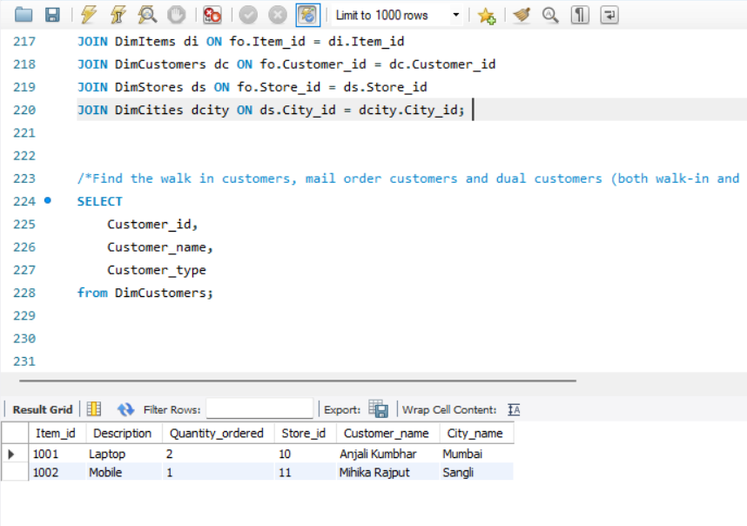

**7. Conclusion**

The data warehouse enables **quick and efficient business analysis**, helping users **track sales, monitor stock levels, and improve customer service**. With **OLAP capabilities**, businesses can make **data-driven decisions** to optimize operations and increase profitability.