**TY B.Tech. (CSE) – II [ 2024-25]**

**6CS371: Advanced Database System Lab.**

**Assignment No. 7**

**Name: Jasmine I. Sayyad**

**PRN: 22510033**

**Batch: T-2**

**Problem Statement:** X-Mart is having different malls in city, where daily sales take place for various products. Higher management is facing an issue while decision making due to nonavailability of integrated data they can’t do study on their data as per their requirement.

So objective is to design a system which can help them quickly in decision making and provide Return on Investment (ROI).

Star Schema:

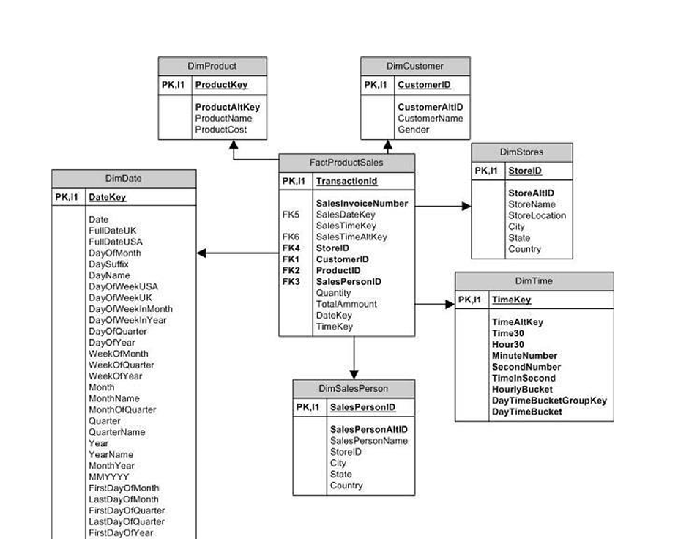

Fact Table

The fact table contains numerical data (measures) and foreign keys linking to various dimension tables. It provides statistics for sales, categorized by customer, salesperson, product, period, and store.

Types of fact tables include:

* Transactional Fact Table
* Cumulative Fact Table
* Snapshot Fact Table

Fact Sales Table Attributes

Foreign Key Columns:

* Sales Date Key
* Sales Time Key
* Invoice Number
* Salesperson ID
* Store ID
* Customer ID

Measures:

* Actual Cost
* Total Sales
* Quantity Sold
* Fact Table Record Count

**Dimension Tables** provide descriptive attributes (e.g., product details, salesperson info, store locations).

Here below are some Dimensional tables

* DimDate: This table contains date-related information to support time-based analysis.  
  Each row represents a unique date.
* DimProduct: Stores product-related details. Helps analyse **which products sell best** and their impact on revenue.
* DimStores: Stores details about each store. Helps analyse whichstores **or** cities **are** performingbest.
* DimSalesPerson: Stores details of sales employees. Helps analyse top**-**performingsalespeople based on revenue generated.

1. **Sales Summary**

Total revenue generated per day, month, store, and city.

Product-wise total sales on a specific date (e.g., March 1, 2024).

1. **Store Performance**

Ranking of stores based on total revenue.

Identification of the **best-performing cities**.

1. **Product Performance**

Top-selling products on a specific date.

Monthly revenue trends for different products.

1. **Salesperson Performance**

Top 5 best salespeople based on revenue.

Store-wise contribution of sales staff.

**Recommended Schema:** **Star Schema**

* The **Star Schema** is preferred due to its hierarchical attribute model, making analysis efficient and improving query performance.
* In this model, the **fact table** sits at the center, surrounded by **dimension tables**, resembling a star

**Objective:** Build the data warehouse for X-Mart. Store sales, customer purchases, product demand, and time-based analysis

**Functional Specifications**

* **Input:** Sales transactions from multiple X-Mart stores.
* **Output:** OLAP reports for sales trends, store performance, and customer insights.

OLAP stands for Online Analytical Processing. It is a technology that helps businesses organize and analyse large amounts of data. OLAP is used to support business intelligence, decision support, and various types of business forecasting and reporting.

**Data Warehouse Design using Star Schema**

Facttable**:** FactProductSales

Dimension Table: DimProduct, DimCustomer, DimStores, DimTime, DimSalesPerson

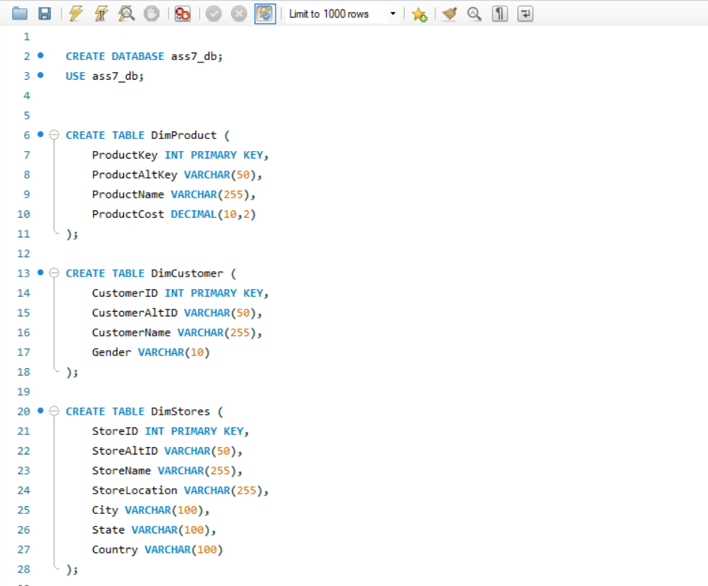

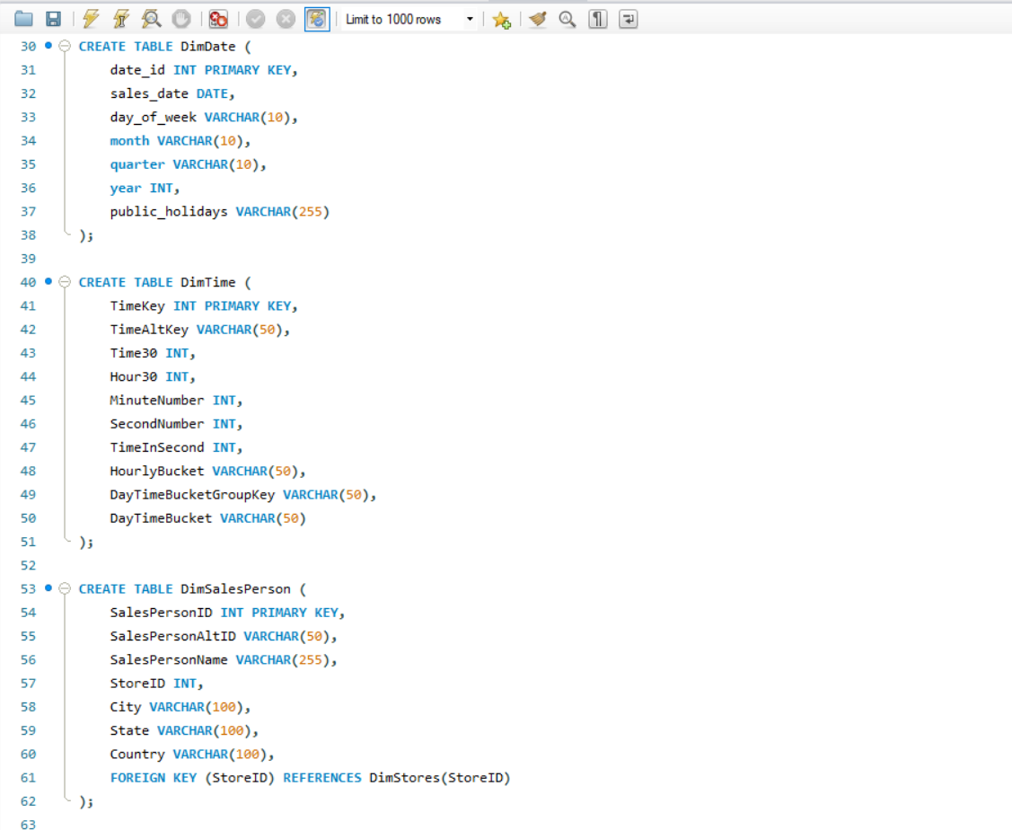

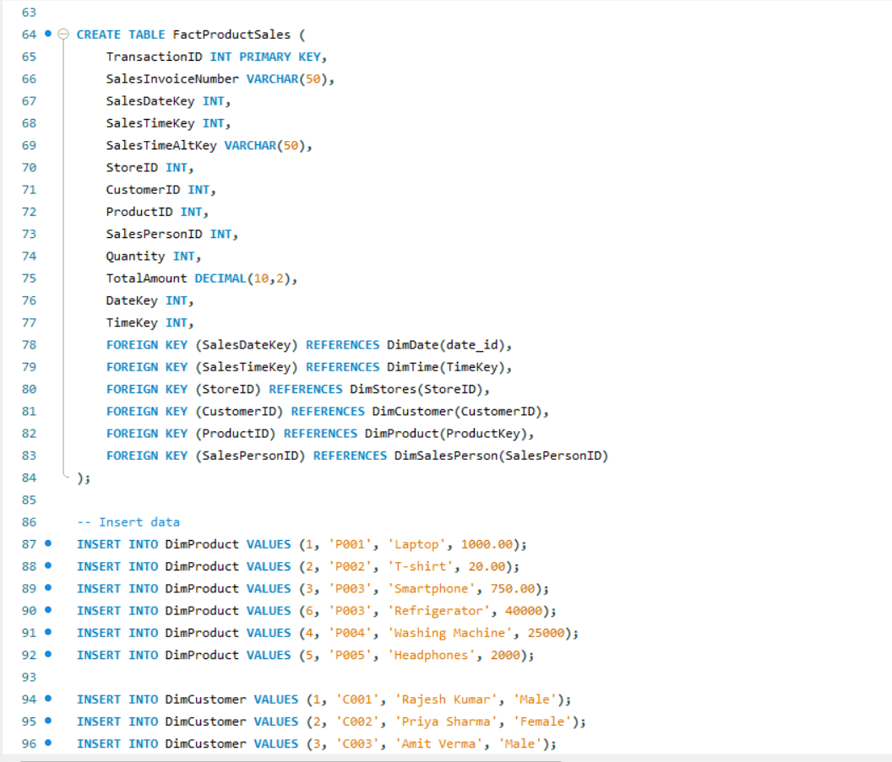

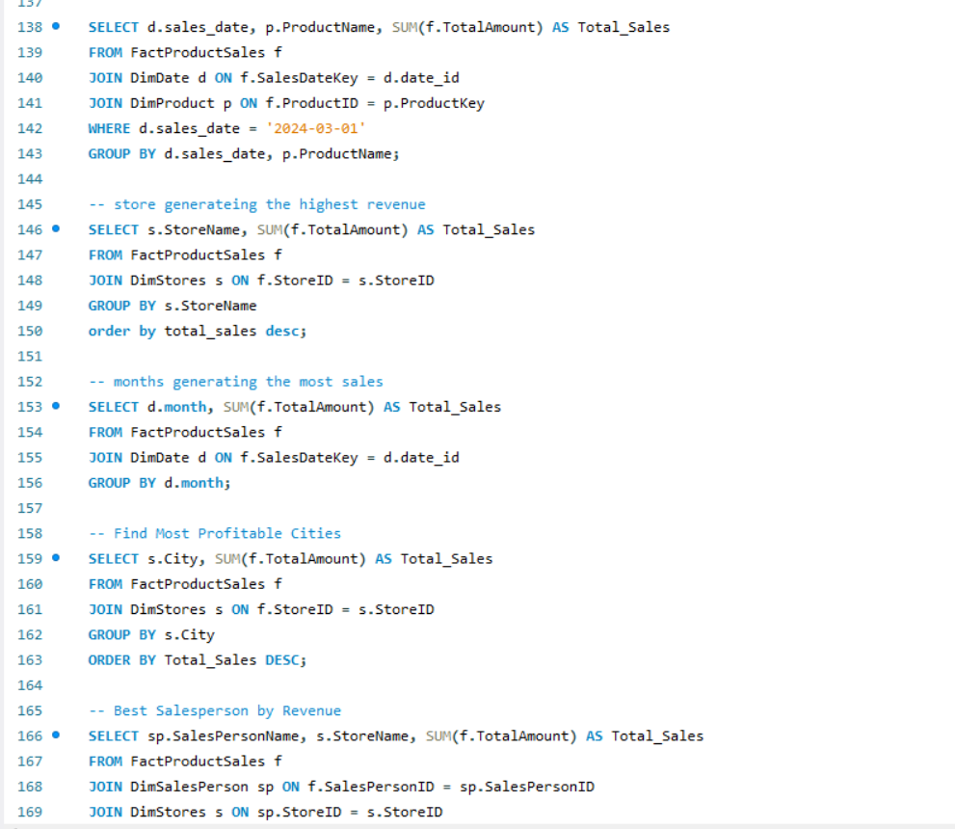

-- Materialized View for Sales Analysis

CREATE MATERIALIZED VIEW Sales_Cube

BUILD IMMEDIATE

REFRESH COMPLETE ON DEMAND

ENABLE QUERY REWRITE

AS

SELECT

d.sales_date,

t.HourlyBucket AS time_band,

p.ProductName AS category,

s.StoreName AS store_name,

SUM(f.TotalAmount) AS Total_Sales,

SUM(p.ProductCost * f.Quantity) AS Total_Cost,

SUM(f.TotalAmount - (p.ProductCost * f.Quantity)) AS Total_Profit

FROM FactProductSales f

JOIN DimDate d ON f.SalesDateKey = d.date_id

JOIN DimTime t ON f.SalesTimeKey = t.TimeKey

JOIN DimProduct p ON f.ProductID = p.ProductKey

JOIN DimStores s ON f.StoreID = s.StoreID

GROUP BY CUBE (d.sales_date, t.HourlyBucket, p.ProductName, s.StoreName);

