High Performance Computing Lab
Practical No. 6
Name: Jasmine Imtiyaj Sayyad
PRN: 22510033
Batch: B-8

Title of practical:
Installation of MPI & Implementation of basic functions of MPI

Problem Statement 1:
Implement a simple hello world program by setting number of processes equal to 10
#include <mpi.h>
#include <stdio.h>

int main(int argc, char** argv) {
MPI_Init(NULL, NULL);

int world_size;
MPI_Comm_size(MPI_COMM_WORLD, &world_size);

int world_rank;
MPI_Comm_rank(MPI_COMM_WORLD, &world_rank);

printf("Hello from process %d of %d\n", world_rank, world_size);

MPI_Finalize();
return 0;
}
Screenshots:
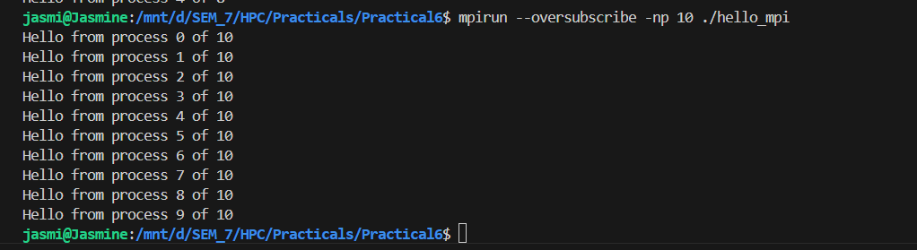

Information 1:
MPI_Init(&argc, &argv):
Initializes the MPI environment. Must be the first MPI call in any program.
MPI_COMM_WORLD
A default communicator that includes all processes created by mpirun.
MPI_Comm_size(MPI_COMM_WORLD, &world_size);
Gets the size of the communicator MPI_COMM_WORLD.
MPI_COMM_WORLD includes all processes launched by mpirun.
After this call, world_size = number of processes you started with -np.

MPI_Comm_rank(MPI_COMM_WORLD, &world_rank);
Gets the rank of this process within the communicator.
Each process gets a unique world_rank between 0 and world_size-1.

MPI_Finalize();
Shuts down the MPI environment.
No MPI functions can be called after this.
Always call this before return 0;.

Problem Statement 2:
Implement a program to display rank and communicator group of five processes
#include <mpi.h>
#include <stdio.h>
int main(int argc, char **argv)
{
MPI_Init(&argc, &argv);
int world_rank, world_size;
MPI_Comm_rank(MPI_COMM_WORLD, &world_rank);
MPI_Comm_size(MPI_COMM_WORLD, &world_size);

printf("Process %d out of %d in MPI_COMM_WORLD\n", world_rank, world_size);
MPI_Finalize();
return 0;
}
Screenshots:
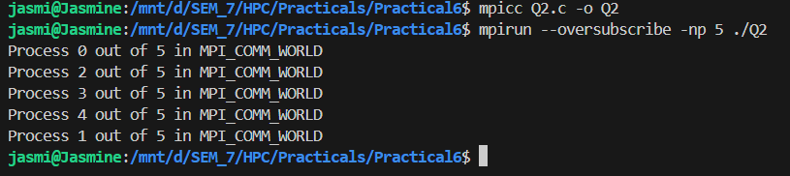
Concepts Used
- MPI_Comm_rank → gives the rank (ID) of the process
- MPI_Comm_size → gives the total number of processes in the communicator
- MPI_COMM_WORLD → default communicator that includes all processes

Q3: Implement a MPI program to give an example of Deadlock.
A deadlock occurs when two or more processes wait on each other to do something — and none of them can proceed. In MPI, this often happens with blocking communication functions like:
- MPI_Send (blocking send)
- MPI_Recv (blocking receive)
If two processes both try to send to each other first, and neither posts a matching receive, both will wait forever — this is deadlock.
2 processes
- Each tries to MPI_Send to the other before calling MPI_Recv
- Because both are sending, and no one is receiving, they get stuck — deadlock.
#include <mpi.h>
#include <stdio.h>

int main(int argc, char** argv) {
MPI_Init(&argc, &argv);
int rank;
MPI_Comm_rank(MPI_COMM_WORLD, &rank);
int send_data = rank;
int recv_data;
if (rank == 0) {
// Rank 0 sends to 1 first, then receives
MPI_Ssend(&send_data, 1, MPI_INT, 1, 0, MPI_COMM_WORLD);
printf("Rank 0 sent data to Rank 1\n");
MPI_Recv(&recv_data, 1, MPI_INT, 1, 0, MPI_COMM_WORLD, MPI_STATUS_IGNORE);
printf("Rank 0 received data %d from Rank 1\n", recv_data);
} else if (rank == 1) {
// Rank 1 sends to 0 first, then receives
MPI_Ssend(&send_data, 1, MPI_INT, 0, 0, MPI_COMM_WORLD);
printf("Rank 1 sent data to Rank 0\n");
MPI_Recv(&recv_data, 1, MPI_INT, 0, 0, MPI_COMM_WORLD, MPI_STATUS_IGNORE);
printf("Rank 1 received data %d from Rank 0\n", recv_data);
}
MPI_Finalize();
return 0;
}

Program and screenshots
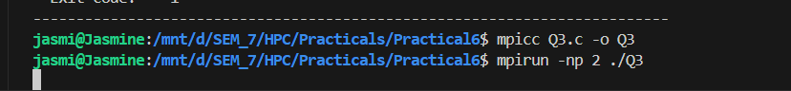
How to Fix It?
- Reorder operations: receive before send.
- Use non-blocking functions: MPI_Isend and MPI_Irecv.
- Use MPI_Sendrecv (safe for bidirectional communication).

Q4. Implement blocking MPI send & receive to demonstrate Nearest neighbor exchange of data in a ring topology.
In a ring topology of N processes:
- Each process sends data to its right neighbor ((rank + 1) % N)
- Each process receives data from its left neighbor ((rank - 1 + N) % N)
This forms a closed loop (ring).
Each process will:
- Prepare some data (its rank, for simplicity)
- Send it to its right neighbor
- Receive from its left neighbor
We use blocking MPI_Send and MPI_Recv.

#include <mpi.h>
#include <stdio.h>

int main(int argc, char** argv) {
MPI_Init(&argc, &argv);
int rank, size;
int send_data, recv_data;
MPI_Comm_rank(MPI_COMM_WORLD, &rank);
MPI_Comm_size(MPI_COMM_WORLD, &size);

int right = (rank + 1) % size;
int left = (rank - 1 + size) % size;
send_data = rank;

MPI_Send(&send_data, 1, MPI_INT, right, 0, MPI_COMM_WORLD);
MPI_Recv(&recv_data, 1, MPI_INT, left, 0, MPI_COMM_WORLD, MPI_STATUS_IGNORE);
printf("Process %d received data %d from process %d\n", rank, recv_data, left);
MPI_Finalize();
return 0;
}

Program and screenshots
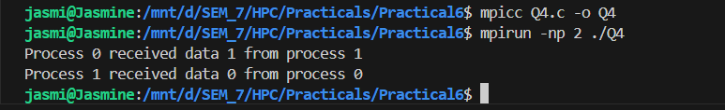

Q5. Write a MPI program to find the sum of all the elements of an array A of size
n. Elements of an array can be divided into two equals groups. The first [n/2]
elements are added by the first process, P0, and last [n/2] elements the by second process, P1. The two sums then are added to get the final result.
Array A of size n
- First n/2 elements summed by process P0
- Last n/2 elements summed by process P1
- Final sum is computed by adding both partial sums
Concepts Used :
- MPI_Init, MPI_Finalize
- MPI_Comm_rank, MPI_Comm_size
- MPI_Send, MPI_Recv (for passing partial sum)
#include <mpi.h>
#include <stdio.h>
#include <stdlib.h>
#include <time.h>
int main(int argc, char** argv) {
const int n = 8; // Size of array (must be even)
int A[n];
int local_sum = 0, total_sum = 0;
MPI_Init(&argc, &argv);
int rank, size;
MPI_Comm_rank(MPI_COMM_WORLD, &rank);
MPI_Comm_size(MPI_COMM_WORLD, &size);
if (size != 2) {
if (rank == 0)
printf("This program requires exactly 2 processes.\n");
MPI_Finalize();
return 1;
}
// Process 0 initializes the array with random numbers
if (rank == 0) {
srand(time(NULL));
printf("Full array A: ");
for (int i = 0; i < n; i++) {
A[i] = rand() % 100; // Random number between 0-99
printf("%d ", A[i]);
}
printf("\n");
}
// Broadcast the array from P0 to all
MPI_Bcast(A, n, MPI_INT, 0, MPI_COMM_WORLD);
// Compute start and end indices for this process
int start = (rank == 0) ? 0 : n / 2;
int end = (rank == 0) ? n / 2 : n;
// Each process computes its partial sum
for (int i = start; i < end; i++) {
local_sum += A[i];
}
// Each process prints its partial sum
printf("Process %d computed partial sum = %d\n", rank, local_sum);
// Combine partial sums
if (rank == 0) {
int remote_sum;
MPI_Recv(&remote_sum, 1, MPI_INT, 1, 0, MPI_COMM_WORLD, MPI_STATUS_IGNORE);
total_sum = local_sum + remote_sum;
printf("Final total sum = %d\n", total_sum);
} else if (rank == 1) {
MPI_Send(&local_sum, 1, MPI_INT, 0, 0, MPI_COMM_WORLD);
}

MPI_Finalize();
return 0;
}

Program and screenshots:
