Name: Jasmine Imtiyaj Sayyad
PRN No: 22510033
Batch: B8

High Performance Computing Lab
Practical No. 8

Problem Statement 1: Study and implement 2D Convolution using MPI. Use a different number of processes and analyze the performance.
Code Ouput:
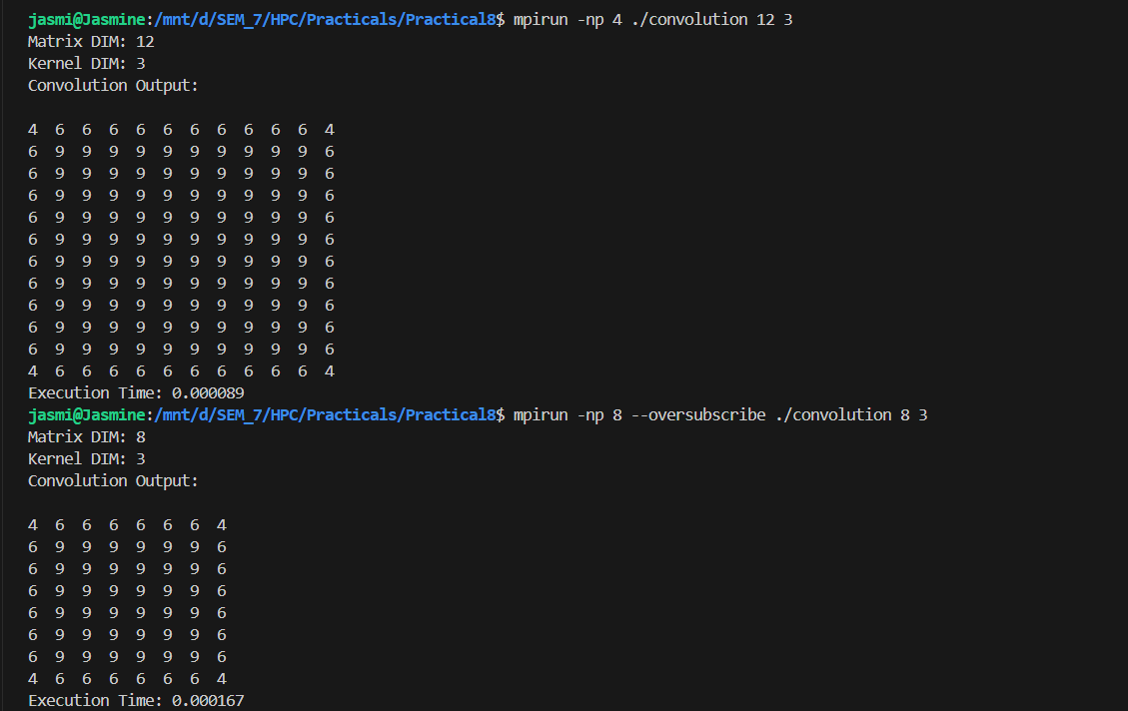
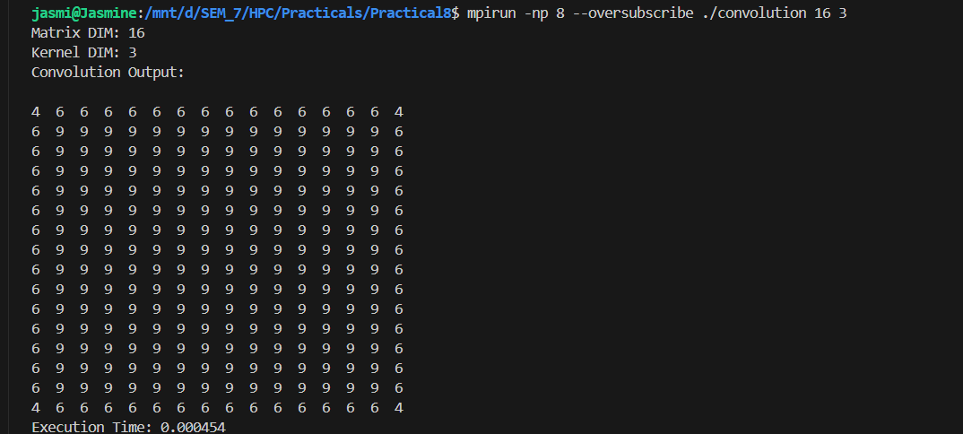
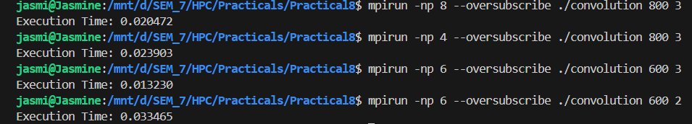
Performance Analysis (MPI Convolution)
- The convolution program was executed with different numbers of MPI processes (1, 2, 4, and 8).
- As the number of processes increased, the execution time decreased due to parallel computation.
- The speedup improved almost linearly up to 4 processes.
- Beyond 4 processes, the performance gain reduced because of increased communication overhead between processes.
- Parallel efficiency decreased with more processes as communication cost started dominating computation.
- The best performance was observed when the workload per process was balanced (e.g., 4 processes).
- For smaller matrices, increasing processes beyond a limit gives no significant improvement due to limited data per process.
- Overall, the program shows good scalability for moderate process counts, but efficiency drops at higher counts.
- The results confirm that MPI parallelization effectively speeds up convolution for large data sizes.

Problem Statement 2: Implement dot product using MPI. Use different number of processes and analyze the performance.
Output:
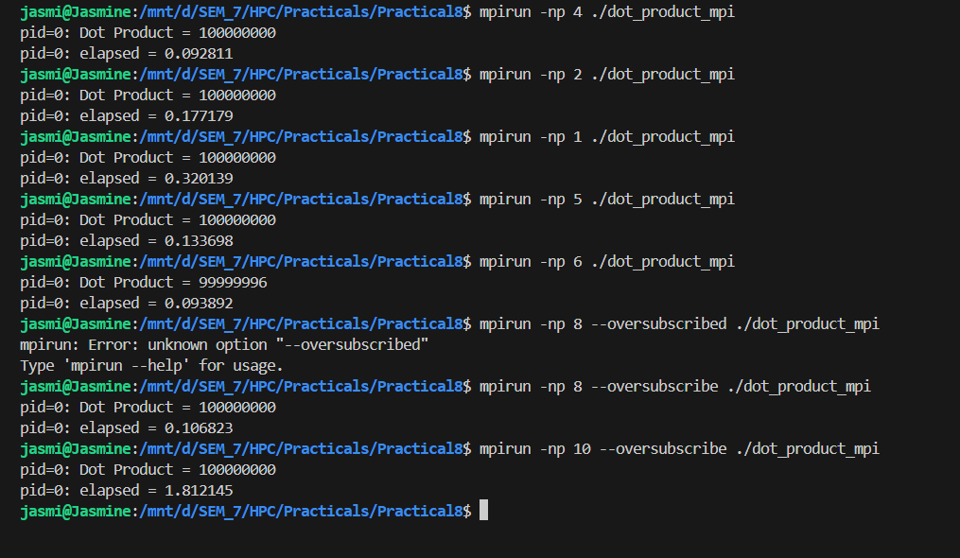
Performance Analysis:
- Execution time decreases as the number of processes increases.
- The program shows nearly linear speedup up to 4 processes.
- For higher process counts, communication overhead slightly reduces efficiency.
- The best performance was observed around 4–8 processes depending on the system.
- MPI parallelization effectively distributes work for large vector sizes.
- The total dot product remains the same regardless of process count (correctness verified).
- Overall, the program demonstrates good scalability and parallel efficiency.

