**SMART PUBLIC TOILET**

INRODUCTION:

In the digital age, enhancing public amenities is essential, and our "Smart Public Toilet IOT" project represents a leap forward. Leveraging cutting-edge sensor technology, this innovative endeavor aims to create a more user-friendly and efficient experience for the public. By integrating various sensors, including occupancy, cleanliness, and odor detectors, we have re-imagined public toilets as intelligent, responsive spaces. This project report delves into the design, implementation, and outcomes of our IOT-based solution, showcasing how it contributes to better sanitation, energy conservation, and overall public satisfaction. Through real-time monitoring and smart maintenance, we are revolutionizing the way people interact with public restrooms, making them cleaner, more accessible, and eco-friendly.

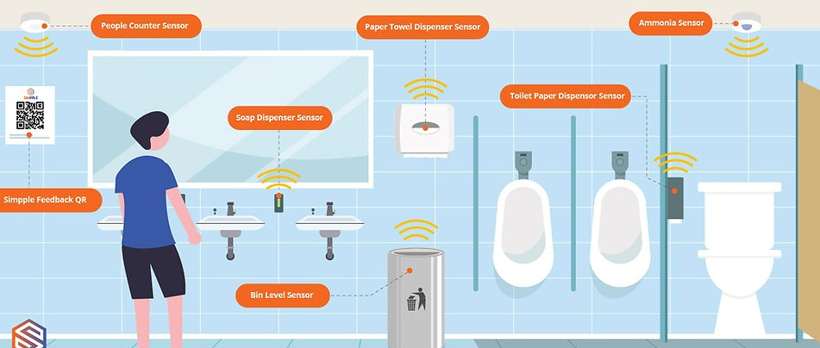

**Fig1.** Smart public toilet overview

**INNOVATION WITH SENSORS:**

The Smart Public Toilet IoT project represents a groundbreaking innovation in urban infrastructure. By harnessing advanced sensor technology, these intelligent facilities are revolutionizing the public restroom experience. This report explores the seamless integration of IoT sensors, enhancing user-friendliness, accessibility, and hygiene in these essential amenities, ultimately improving the quality of urban life. By our innovation of smart public toilet and sensors used for this innovation explained below.

**SENSORS AND THEIR USAGE IN SMART PUBLIC TOILET:**

**ODOR SENSORS:**

Gas Sensors (e.g., methane or ammonia detectors) : These sensors continuously monitor air quality in the toilet. If unusual odors are detected, the system can activate a ventilation system to improve air quality.

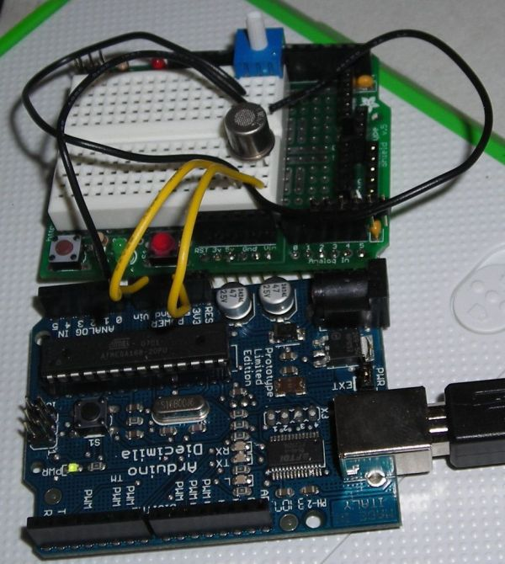

**FIG2**. ODOR SENSOR WITH ARDUINO

**WORKING PRINCIPLE:**

* A gas sensor in a smart public toilet, connected to an Arduino, operates by measuring the concentration of specific gases, like methane or hydrogen sulfide, in the air.
* It uses a gas-sensitive material that changes its electrical properties when exposed to these gases.
* The Arduino reads these changes and converts them into digital data.
* If gas levels exceed safe limits, the Arduino triggers an alarm or ventilation system, ensuring public safety.
* This real-time monitoring enhances hygiene and prevents accidents in public restrooms.

**PIN CONNECTION WITH ARDUINO:**

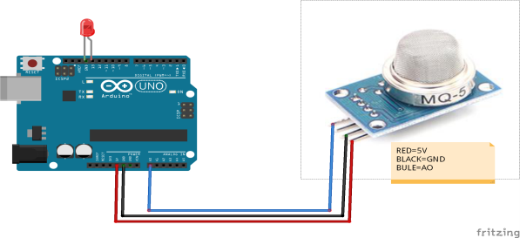 RED-5V, BLACK-GND, BLUE-AD

**TEMPERATURE AND HUMIDITY SENSOR:**

* To monitor restroom conditions, which could be useful for maintenance or user comfort.

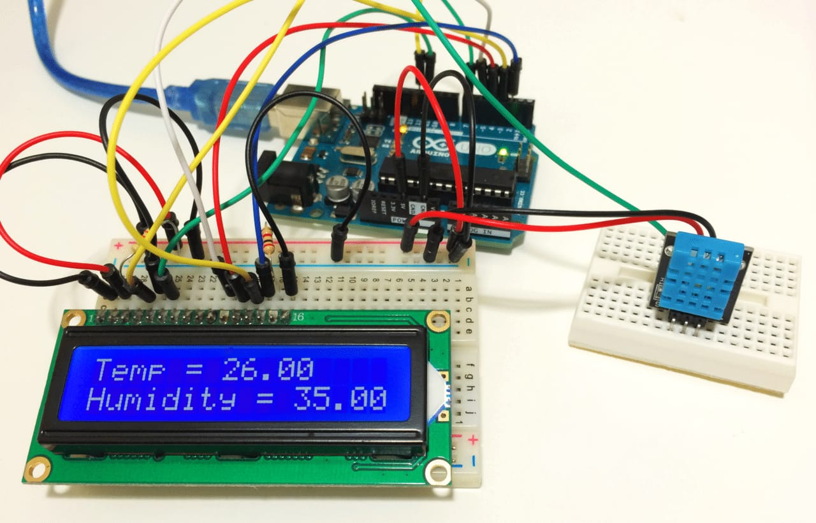

**FIG3.** Temperature and humidity sensor

**WORKING PRINCIPLE:**

* A temperature and humidity sensor, like the DHT22, is connected to an Arduino in a smart public toilet.
* The sensor measures ambient temperature and humidity levels.
* The Arduino reads data from the sensor through its digital pins and converts it into meaningful values. These values can be displayed on an LCD screen or sent to a central control system for monitoring and control.
* The system can trigger actions like activating fans or heaters based on these readings, ensuring user comfort and efficient energy use.
* This makes the smart public toilet more user-friendly and environmentally friendly.

**PIN CONNECTION WITH ARDUINO:**

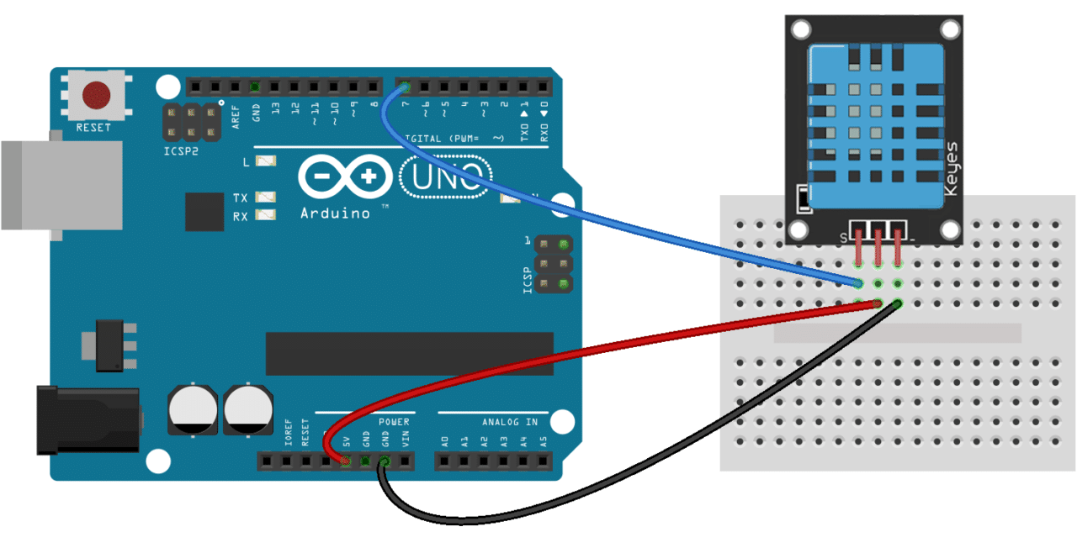

* Connect GND Pin of T&H sensor to GND on Arduino
* Connect Vcc Pin of T&H sensor to 5V on Arduino
* Connect Data Pin of T&H sensor to D3 on Arduino

**HAND DRYER SENSOR:**

Proximity Sensors: When a user places their hands under the hand dryer, these sensors detect their presence and activate the dryer. Some advanced systems can also adjust the airflow and heat based on user preferences.

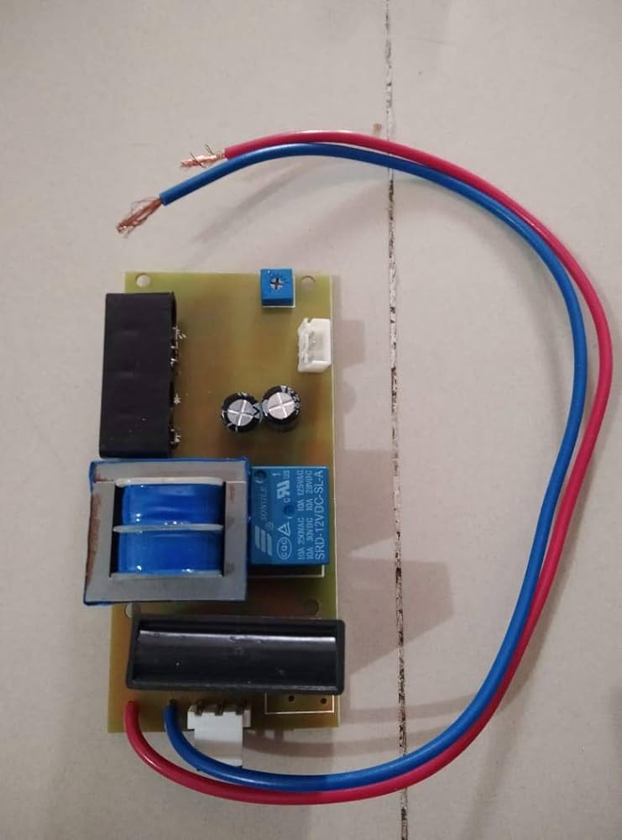

**FIG4.** ProximitySensor

**WORKING PRINCIPLE:**

* Infrared (IR) sensor detects hand presence when placed near the dryer.
* Arduino processes the sensor data and triggers the dryer's motor and heating element.
* The motor starts the airflow, while the heating element warms the air.
* A timer or another sensor monitors the drying time or hand removal.
* Once the preset time or hand removal is detected, the dryer stops.
* This automation enhances hygiene and energy efficiency in public restrooms.

**PINCONNECTION WITH ARDUINO:**

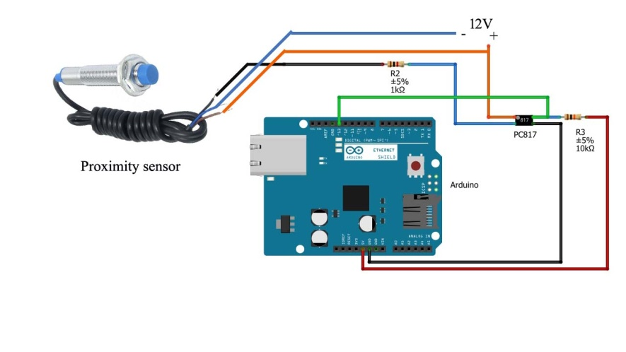

**FLUSH SESNSOR:**

Infrared Sensors: These sensors can detect when the user has finished and left the toilet. They trigger an automatic flush to ensure cleanliness. Some advanced systems can also adjust the flush intensity based on the waste volume detected.

It also work in same as the above principle mentioned above.

**MOTION SENSOR:**

To detect when a person enters or leaves the restroom, helping to avoid unnecessary flushes.

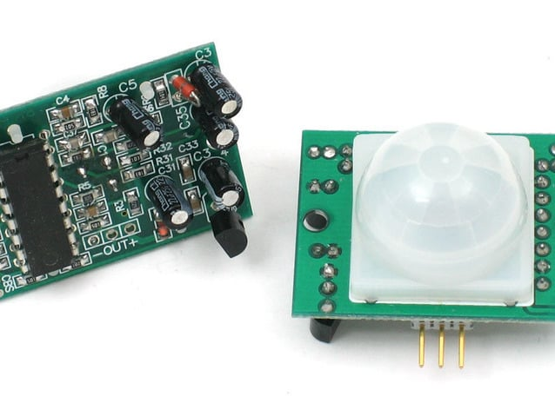

**FIG5.**MOTION SENSOR

**WORKING PRINCIPLE:**

* A motion sensor with Arduino in a smart public toilet works by detecting changes in infrared radiation emitted by moving objects.
* It consists of an infrared sensor that sends out pulses and a receiver that detects reflected pulses.
* When motion occurs, the reflected pulses change, triggering the Arduino to activate various functions like turning on lights or flushing toilets.
* This technology enhances user experience by providing automated and energy-efficient features in public restrooms.

**PINCONNECTION WITH ARDUINO:**

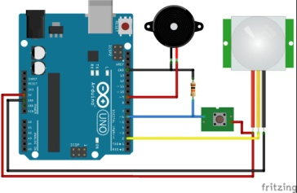

**OCCUPANCY SENSOR:**

**Infrared** **Sensors**: These sensors can detect the presence of a user within the toilet stall. When someone enters, the sensor triggers the lighting and ventilation systems to turn on, ensuring a well-lit and comfortable environment.

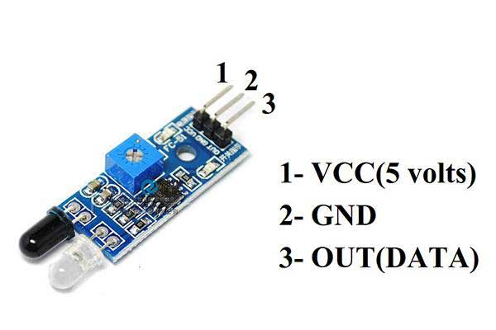

**FIG5.** INFRAREDSENSOR

**WORKING PRINCIPLE:**

* An infrared occupancy sensor in a smart public toilet operates by emitting infrared light.
* When a person enters, their body heat reflects this light back to the sensor.
* Arduino processes the signal, triggering actions like activating lights, flushing, or opening doors.
* The sensor continually monitors for changes in the infrared signal, allowing it to detect occupancy and respond accordingly.
* This efficient, non-contact method ensures an automated and hygienic user experience in the smart toilet facility.

**PIN CONNECTION WITH ARDUINO:**

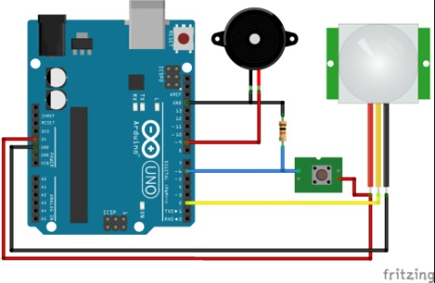

* Connect the VCC pin of the infrared sensor to the 5V pin of the Arduino.
* Connect the GND pin of the infrared sensor to the GND pin of the Arduino.
* Connect the OUT pin of the infrared sensor to any digital pin of the Arduino.

**WATER LEVEL SENSOR:**

* To monitor the water level in the toilet tank and ensure it's adequate for flushing.

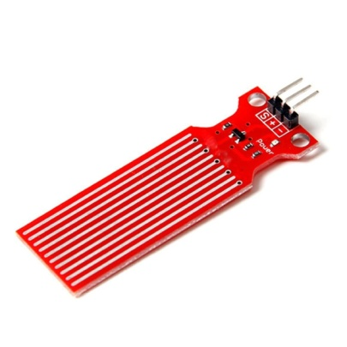

**FIG7.** WATER LEVEL SENSOR

**WORKING PRINCIPLE:**

A water level sensor in a smart public toilet typically operates using capacitive or ultrasonic technology.

* It measures the distance between the sensor and the water surface.
* When the water level rises, the sensor detects the change and sends this data to an Arduino microcontroller.
* The Arduino processes the information and can trigger actions such as flushing or alerting maintenance when the water level is too high.
* This ensures efficient water usage and timely maintenance in the public toilet, improving hygiene and resource management.

**PIN CONNECTION WITH ARDUINO:**

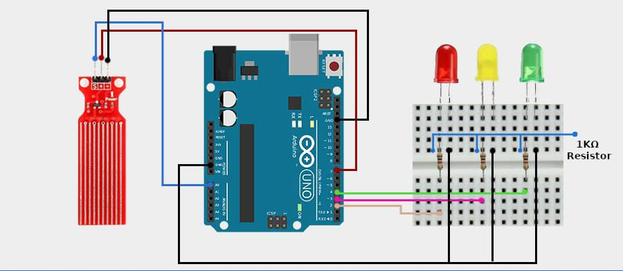

* Connect the VCC of the sensor to the Digital pin 7 of the Arduino.
* Connect GND of the sensor to the Ground of the Arduino.
* Connect the cathode of RED, YELLOW, GREEN LED to the 2,3,4 digital pin of the Arduino respectively.
* Connect all anodes of the LED commonly to the GND pin of the Arduino

**Backend database:**

**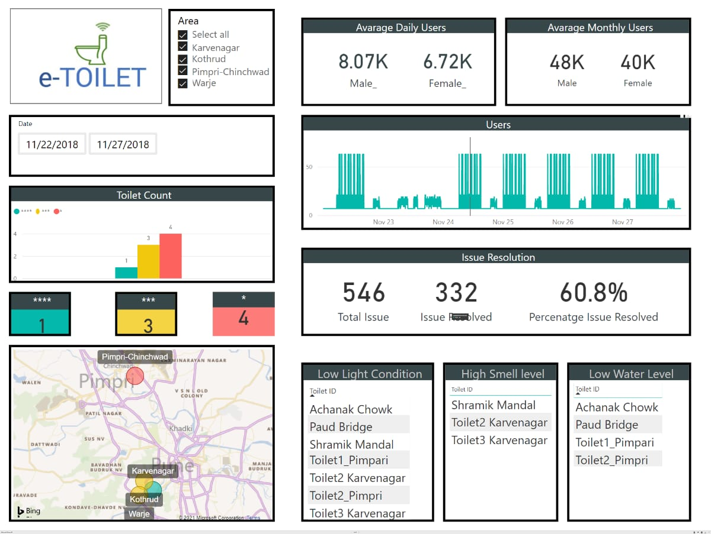  
CODE:**

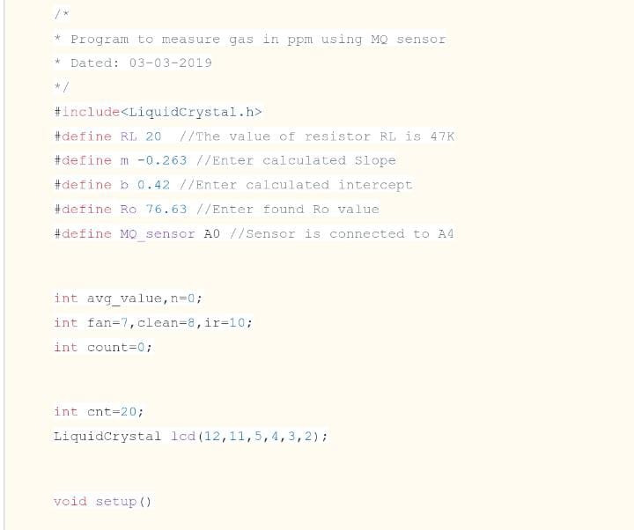

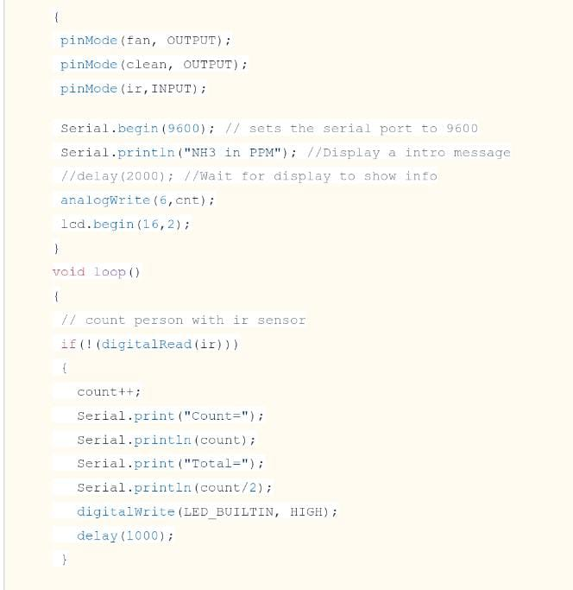

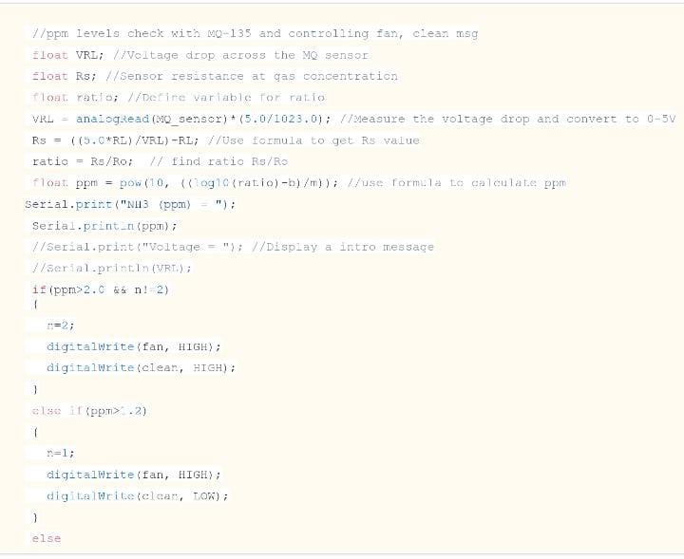

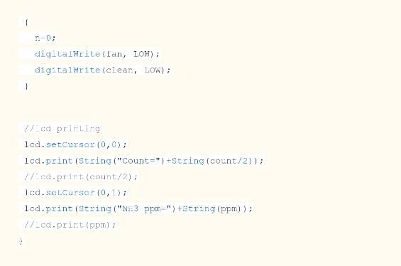

**CONCLUSION:**

Finally our conclusion is that, IOT-enabled smart public restroom project has demonstrated significant advantages in terms of efficiency, cleanliness, and user satisfaction. The real-time monitoring of restroom conditions, including occupancy and supply levels, ensures optimal resource allocation. User-friendly mobile apps enhance the overall experience by providing essential information. Cost savings through predictive maintenance and resource optimization make this system economically viable. Furthermore, the data collected can be used for data-driven decision-making and future improvements. Overall, our smart restroom solution offers a tangible and beneficial upgrade to public facilities.

NOTE:

File naming Convention: IOT_Phase2