HW1_Jasmin_Moore.R
n344790
2026-05-27
#install package to load in data
library(haven)
## Warning: package 'haven' was built under R version 4.5.3
#Load in the packages
#tryCatch(require(pacman),finally=utils:::install.packages(pkgs='pacman',repos='http://cran.r-project.org'));
#require(pacman)
pacman::p_load(Hmisc,
checkmate,
corrr,
conflicted,
readxl,
dplyr,
tidyr,
ggplot2,
knitr,
evaluate,
#iopsych,
psych,
quantreg,
lavaan,
xtable,
reshape2,
GPArotation,
Amelia,
esquisse,
expss,
multilevel,
janitor,
mice,
lmtest,
naniar,
tidylog
)
#Load in the data
SAQ <- read_sav("SAQ.sav")
#Look for the percent of data missing
percentmissing = function (x){ sum(is.na(x))/length(x) * 100}
missing <- apply(SAQ, 1, percentmissing) # we will use an apply function to loop it. 1 indicates rows and 2 indicates columns
table(round(missing, 1)) #There is 0% data missing.
##
## 0
## 2571
### Outliers
#Isolate only the items
SAQ_23 <- SAQ[,1:23]
# Set up seed to keep the random constant.
set.seed(2026)
# Compute the chi-square cutoff for identifying multivariate outliers.
cutoff <- qchisq(
p = .999,
df = ncol(SAQ_23)
)# Cutoff is 49.72823
mahal = mahalanobis(SAQ_23,
colMeans(SAQ_23), # multivariate mean used as a reference point
cov(SAQ_23)) #covariance matrix for variable scale and correlation
#cutoff value
cutoff
## [1] 49.72823
# number of variables is 23
ncol(SAQ_23)
## [1] 23
# view to see how many cases exceed cutoff, and therefore, outliers
summary(mahal < cutoff) ### 97 are labeled outliers
## Mode FALSE TRUE
## logical 97 2474
SAQ_mahal <- SAQ_23 %>% # creating a new data frame to view just outliers
bind_cols(mahal) %>% #adding column
tidylog::rename(mahal = `...24`) # renaming the new column "mahal" + 1 column
## New names:
## rename: renamed one variable (mahal)
## • `` -> `...24`
# Isolating only outliers (97)
mahal_out <- SAQ_mahal %>%
tidylog::filter(mahal > cutoff) %>%
arrange(desc(mahal)) # sort mahal values from most to least
## filter: removed 2,474 rows (96%), 97 rows remaining
## Create a df with removed outliers
noout <- SAQ_23 %>%
tidylog::filter(mahal < cutoff)
## filter: removed 97 rows (4%), 2,474 rows remaining
## Additivity (Checking for linearity)
correl = cor(noout, use = "pairwise.complete.obs")
symnum(correl)
## Q_01 Q_02 Q_03 Q_04 Q_05 Q_06 Q_07 Q_08 Q_09 Q_10 Q_11 Q_12 Q_13
## Question_01 1
## Question_02 1
## Question_03 . . 1
## Question_04 . . 1
## Question_05 . . . 1
## Question_06 1
## Question_07 . . . . . 1
## Question_08 . . . 1
## Question_09 . . 1
## Question_10 . 1
## Question_11 . . . . . . , 1
## Question_12 . . . . . . . 1
## Question_13 . . . . . . . . . . 1
## Question_14 . . . . . . . . .
## Question_15 . . . . . . . . .
## Question_16 . . . . . . . . .
## Question_17 . . . . . , , . .
## Question_18 . . . . . . . . . .
## Question_19 .
## Question_20 . .
## Question_21 . . . . . . . . .
## Question_22
## Question_23
## Q_14 Q_15 Q_16 Q_17 Q_18 Q_19 Q_20 Q_21 Q_22 Q_23
## Question_01
## Question_02
## Question_03
## Question_04
## Question_05
## Question_06
## Question_07
## Question_08
## Question_09
## Question_10
## Question_11
## Question_12
## Question_13
## Question_14 1
## Question_15 . 1
## Question_16 . . 1
## Question_17 . . . 1
## Question_18 . . . . 1
## Question_19 1
## Question_20 1
## Question_21 . . . . . . 1
## Question_22 1
## Question_23 1
## attr(,"legend")
## [1] 0 ' ' 0.3 '.' 0.6 ',' 0.8 '+' 0.9 '*' 0.95 'B' 1
correl #No multicollinearity issues, all 1s are on the diagonal
## Question_01 Question_02 Question_03 Question_04 Question_05
## Question_01 1.00000000 -0.09564516 -0.3394120 0.44356524 0.40683612
## Question_02 -0.09564516 1.00000000 0.3403275 -0.11535211 -0.12750749
## Question_03 -0.33941198 0.34032755 1.0000000 -0.38501916 -0.31188888
## Question_04 0.44356524 -0.11535211 -0.3850192 1.00000000 0.41311634
## Question_05 0.40683612 -0.12750749 -0.3118889 0.41311634 1.00000000
## Question_06 0.21642795 -0.09409007 -0.2364366 0.27450232 0.25262203
## Question_07 0.31830059 -0.15146503 -0.3888337 0.41073259 0.35683807
## Question_08 0.35970427 -0.05150263 -0.2718204 0.35532444 0.28485684
## Question_09 -0.09735681 0.34107119 0.3121586 -0.13853293 -0.10449784
## Question_10 0.20718614 -0.09690482 -0.2000051 0.21945052 0.24494916
## Question_11 0.37639745 -0.14986851 -0.3593173 0.37921625 0.30764567
## Question_12 0.36296740 -0.20647399 -0.4213259 0.44652908 0.35086220
## Question_13 0.36393293 -0.16223708 -0.3365851 0.34860223 0.30253499
## Question_14 0.35652805 -0.18215985 -0.3762200 0.35739840 0.32248586
## Question_15 0.25226994 -0.17019220 -0.3178184 0.34153652 0.26939559
## Question_16 0.49696876 -0.17745629 -0.4208369 0.42290818 0.40795250
## Question_17 0.38340729 -0.09727568 -0.3311392 0.37644360 0.32028257
## Question_18 0.37623424 -0.16729714 -0.3976746 0.39166256 0.34466207
## Question_19 -0.19273206 0.22571071 0.3581167 -0.20759579 -0.18525677
## Question_20 0.22712216 -0.21523224 -0.3266163 0.25872701 0.21311727
## Question_21 0.34426480 -0.21391337 -0.4336355 0.41958580 0.36194548
## Question_22 -0.10457188 0.25028516 0.2155666 -0.12649321 -0.14277734
## Question_23 -0.01544328 0.10567285 0.1583330 -0.04247334 -0.05693478
## Question_06 Question_07 Question_08 Question_09 Question_10
## Question_01 0.21642795 0.31830059 0.359704271 -0.097356807 0.20718614
## Question_02 -0.09409007 -0.15146503 -0.051502627 0.341071191 -0.09690482
## Question_03 -0.23643658 -0.38883370 -0.271820371 0.312158588 -0.20000510
## Question_04 0.27450232 0.41073259 0.355324438 -0.138532934 0.21945052
## Question_05 0.25262203 0.35683807 0.284856845 -0.104497841 0.24494916
## Question_06 1.00000000 0.53363050 0.235239319 -0.134138078 0.32562494
## Question_07 0.53363050 1.00000000 0.311551945 -0.137951567 0.28570275
## Question_08 0.23523932 0.31155195 1.000000000 0.004414116 0.17208292
## Question_09 -0.13413808 -0.13795157 0.004414116 1.000000000 -0.14437725
## Question_10 0.32562494 0.28570275 0.172082923 -0.144377253 1.00000000
## Question_11 0.34720392 0.36394420 0.645561669 -0.125660682 0.26278685
## Question_12 0.32463303 0.42835549 0.260041296 -0.188030097 0.25545078
## Question_13 0.48119806 0.46913918 0.335912534 -0.191141492 0.30106099
## Question_14 0.41067316 0.45132805 0.295700965 -0.140583541 0.26148441
## Question_15 0.37132397 0.39896365 0.312609295 -0.209655036 0.30124219
## Question_16 0.26157255 0.39026576 0.341856316 -0.196389345 0.28888431
## Question_17 0.29033521 0.40050472 0.607264448 -0.060008831 0.22004286
## Question_18 0.53564484 0.51924098 0.296357802 -0.166331510 0.32773688
## Question_19 -0.19434313 -0.28179738 -0.182826882 0.257208925 -0.13302464
## Question_20 0.09960499 0.22221657 0.200285197 -0.168290274 0.09134585
## Question_21 0.28028089 0.48323678 0.309998901 -0.151430462 0.20332338
## Question_22 -0.18495653 -0.18544749 -0.105454105 0.285347499 -0.12178841
## Question_23 -0.07307044 -0.06563211 -0.050427999 0.165983438 -0.06049506
## Question_11 Question_12 Question_13 Question_14 Question_15
## Question_01 0.3763974 0.36296740 0.36393293 0.3565280 0.25226994
## Question_02 -0.1498685 -0.20647399 -0.16223708 -0.1821598 -0.17019220
## Question_03 -0.3593173 -0.42132586 -0.33658510 -0.3762200 -0.31781841
## Question_04 0.3792163 0.44652908 0.34860223 0.3573984 0.34153652
## Question_05 0.3076457 0.35086220 0.30253499 0.3224859 0.26939559
## Question_06 0.3472039 0.32463303 0.48119806 0.4106732 0.37132397
## Question_07 0.3639442 0.42835549 0.46913918 0.4513281 0.39896365
## Question_08 0.6455617 0.26004130 0.33591253 0.2957010 0.31260929
## Question_09 -0.1256607 -0.18803010 -0.19114149 -0.1405835 -0.20965504
## Question_10 0.2627868 0.25545078 0.30106099 0.2614844 0.30124219
## Question_11 1.0000000 0.34140893 0.44362602 0.3463327 0.37438219
## Question_12 0.3414089 1.00000000 0.50259162 0.4405299 0.34756600
## Question_13 0.4436260 0.50259162 1.00000000 0.4465351 0.36827082
## Question_14 0.3463327 0.44052991 0.44653507 1.0000000 0.38799703
## Question_15 0.3743822 0.34756600 0.36827082 0.3879970 1.00000000
## Question_16 0.3771590 0.41419718 0.36951002 0.4202687 0.45003587
## Question_17 0.6093433 0.34043554 0.41248389 0.3494621 0.38806347
## Question_18 0.3978584 0.49956410 0.55019249 0.5026376 0.36303891
## Question_19 -0.2122948 -0.28553047 -0.25575048 -0.2694598 -0.22293558
## Question_20 0.2675185 0.30152135 0.21500906 0.2281466 0.22559760
## Question_21 0.3591919 0.43850465 0.38500498 0.3960666 0.31533342
## Question_22 -0.1802655 -0.19247298 -0.20970778 -0.1789014 -0.18108675
## Question_23 -0.0924981 -0.04901162 -0.06044059 -0.0600950 -0.07152116
## Question_16 Question_17 Question_18 Question_19 Question_20
## Question_01 0.49696876 0.38340729 0.37623424 -0.1927321 0.22712216
## Question_02 -0.17745629 -0.09727568 -0.16729714 0.2257107 -0.21523224
## Question_03 -0.42083690 -0.33113924 -0.39767457 0.3581167 -0.32661632
## Question_04 0.42290818 0.37644360 0.39166256 -0.2075958 0.25872701
## Question_05 0.40795250 0.32028257 0.34466207 -0.1852568 0.21311727
## Question_06 0.26157255 0.29033521 0.53564484 -0.1943431 0.09960499
## Question_07 0.39026576 0.40050472 0.51924098 -0.2817974 0.22221657
## Question_08 0.34185632 0.60726445 0.29635780 -0.1828269 0.20028520
## Question_09 -0.19638935 -0.06000883 -0.16633151 0.2572089 -0.16829027
## Question_10 0.28888431 0.22004286 0.32773688 -0.1330246 0.09134585
## Question_11 0.37715901 0.60934335 0.39785838 -0.2122948 0.26751848
## Question_12 0.41419718 0.34043554 0.49956410 -0.2855305 0.30152135
## Question_13 0.36951002 0.41248389 0.55019249 -0.2557505 0.21500906
## Question_14 0.42026874 0.34946207 0.50263764 -0.2694598 0.22814660
## Question_15 0.45003587 0.38806347 0.36303891 -0.2229356 0.22559760
## Question_16 1.00000000 0.41795652 0.43213319 -0.2750407 0.27996205
## Question_17 0.41795652 1.00000000 0.38775677 -0.1875743 0.22485820
## Question_18 0.43213319 0.38775677 1.00000000 -0.2819246 0.24510669
## Question_19 -0.27504071 -0.18757433 -0.28192464 1.0000000 -0.25279285
## Question_20 0.27996205 0.22485820 0.24510669 -0.2527928 1.00000000
## Question_21 0.42221207 0.36837433 0.43288139 -0.2814537 0.49045434
## Question_22 -0.17204435 -0.13450689 -0.19099701 0.2402900 -0.10112202
## Question_23 -0.09718849 -0.10123323 -0.08827266 0.1367694 -0.04440591
## Question_21 Question_22 Question_23
## Question_01 0.34426480 -0.1045719 -0.01544328
## Question_02 -0.21391337 0.2502852 0.10567285
## Question_03 -0.43363547 0.2155666 0.15833302
## Question_04 0.41958580 -0.1264932 -0.04247334
## Question_05 0.36194548 -0.1427773 -0.05693478
## Question_06 0.28028089 -0.1849565 -0.07307044
## Question_07 0.48323678 -0.1854475 -0.06563211
## Question_08 0.30999890 -0.1054541 -0.05042800
## Question_09 -0.15143046 0.2853475 0.16598344
## Question_10 0.20332338 -0.1217884 -0.06049506
## Question_11 0.35919193 -0.1802655 -0.09249810
## Question_12 0.43850465 -0.1924730 -0.04901162
## Question_13 0.38500498 -0.2097078 -0.06044059
## Question_14 0.39606664 -0.1789014 -0.06009500
## Question_15 0.31533342 -0.1810868 -0.07152116
## Question_16 0.42221207 -0.1720443 -0.09718849
## Question_17 0.36837433 -0.1345069 -0.10123323
## Question_18 0.43288139 -0.1909970 -0.08827266
## Question_19 -0.28145374 0.2402900 0.13676942
## Question_20 0.49045434 -0.1011220 -0.04440591
## Question_21 1.00000000 -0.1386220 -0.06999931
## Question_22 -0.13862196 1.0000000 0.23243564
## Question_23 -0.06999931 0.2324356 1.00000000
## Correlation adequacy Bartlett's test
cortest.bartlett(correl, n = nrow(noout))
## $chisq
## [1] 19534.27
##
## $p.value
## [1] 0
##
## $df
## [1] 253
##$chisq 19534.27, $p.value 0, $df 253 p value is significant meaning items are correlated enough for EFA. Correlations do exist.
## Kaiser, Meyer, Olkin Measure of Sampling Adequacy (KMO) Test
KMO(correl[,1:23]) # We have a large enough sample as overall MSA is .93 which is excellent.
## Kaiser-Meyer-Olkin factor adequacy
## Call: KMO(r = correl[, 1:23])
## Overall MSA = 0.93
## MSA for each item =
## Question_01 Question_02 Question_03 Question_04 Question_05 Question_06
## 0.94 0.88 0.95 0.96 0.96 0.90
## Question_07 Question_08 Question_09 Question_10 Question_11 Question_12
## 0.94 0.88 0.85 0.96 0.91 0.96
## Question_13 Question_14 Question_15 Question_16 Question_17 Question_18
## 0.95 0.97 0.95 0.94 0.93 0.95
## Question_19 Question_20 Question_21 Question_22 Question_23
## 0.95 0.89 0.93 0.89 0.79
## Multivariate normality
library("MVN")
## Warning: package 'MVN' was built under R version 4.5.3
## Registered S3 method overwritten by 'car':
## method from
## na.action.merMod lme4
mvn(noout[,1:23],
mvn_test = "mardia")
## $multivariate_normality
## Test Statistic p.value Method MVN
## 1 Mardia Skewness 7366.602 <0.001 asymptotic ✗ Not normal
## 2 Mardia Kurtosis 46.464 <0.001 asymptotic ✗ Not normal
##
## $univariate_normality
## Test Variable Statistic p.value Normality
## 1 Anderson-Darling Question_01 188.884 <0.001 ✗ Not normal
## 2 Anderson-Darling Question_02 264.574 <0.001 ✗ Not normal
## 3 Anderson-Darling Question_03 97.115 <0.001 ✗ Not normal
## 4 Anderson-Darling Question_04 130.914 <0.001 ✗ Not normal
## 5 Anderson-Darling Question_05 149.116 <0.001 ✗ Not normal
## 6 Anderson-Darling Question_06 156.790 <0.001 ✗ Not normal
## 7 Anderson-Darling Question_07 108.042 <0.001 ✗ Not normal
## 8 Anderson-Darling Question_08 221.595 <0.001 ✗ Not normal
## 9 Anderson-Darling Question_09 94.463 <0.001 ✗ Not normal
## 10 Anderson-Darling Question_10 216.015 <0.001 ✗ Not normal
## 11 Anderson-Darling Question_11 185.268 <0.001 ✗ Not normal
## 12 Anderson-Darling Question_12 138.521 <0.001 ✗ Not normal
## 13 Anderson-Darling Question_13 154.424 <0.001 ✗ Not normal
## 14 Anderson-Darling Question_14 113.629 <0.001 ✗ Not normal
## 15 Anderson-Darling Question_15 131.031 <0.001 ✗ Not normal
## 16 Anderson-Darling Question_16 139.879 <0.001 ✗ Not normal
## 17 Anderson-Darling Question_17 191.283 <0.001 ✗ Not normal
## 18 Anderson-Darling Question_18 109.244 <0.001 ✗ Not normal
## 19 Anderson-Darling Question_19 114.652 <0.001 ✗ Not normal
## 20 Anderson-Darling Question_20 111.207 <0.001 ✗ Not normal
## 21 Anderson-Darling Question_21 118.881 <0.001 ✗ Not normal
## 22 Anderson-Darling Question_22 101.333 <0.001 ✗ Not normal
## 23 Anderson-Darling Question_23 128.547 <0.001 ✗ Not normal
##
## $descriptives
## Variable n Mean Std.Dev Median Min Max 25th 75th Skew Kurtosis
## 1 Question_01 2474 2.357 0.801 2 1 5 2 3 0.626 3.638
## 2 Question_02 2474 1.627 0.836 1 1 5 1 2 1.410 4.741
## 3 Question_03 2474 2.612 1.059 3 1 5 2 3 0.055 2.248
## 4 Question_04 2474 2.755 0.924 3 1 5 2 3 0.373 2.756
## 5 Question_05 2474 2.711 0.942 3 1 5 2 3 0.464 2.586
## 6 Question_06 2474 2.207 1.092 2 1 5 1 3 0.930 3.232
## 7 Question_07 2474 2.890 1.074 3 1 5 2 4 0.202 2.187
## 8 Question_08 2474 2.228 0.849 2 1 5 2 3 1.050 4.584
## 9 Question_09 2474 2.847 1.247 3 1 5 2 4 -0.073 1.870
## 10 Question_10 2474 2.270 0.848 2 1 5 2 3 0.819 3.610
## 11 Question_11 2474 2.235 0.849 2 1 5 2 3 0.810 3.948
## 12 Question_12 2474 3.134 0.883 3 1 5 3 4 0.190 2.868
## 13 Question_13 2474 2.433 0.919 2 1 5 2 3 0.598 3.063
## 14 Question_14 2474 2.843 0.968 3 1 5 2 3 0.277 2.697
## 15 Question_15 2474 2.745 0.976 3 1 5 2 3 0.434 2.607
## 16 Question_16 2474 2.853 0.886 3 1 5 2 3 0.388 2.928
## 17 Question_17 2474 2.444 0.852 2 1 5 2 3 0.755 3.559
## 18 Question_18 2474 2.544 1.023 2 1 5 2 3 0.473 2.825
## 19 Question_19 2474 2.295 1.085 2 1 5 1 3 0.459 2.269
## 20 Question_20 2474 3.604 1.019 4 1 5 3 4 -0.358 2.354
## 21 Question_21 2474 3.141 0.957 3 1 5 2 4 0.129 2.250
## 22 Question_22 2474 2.889 1.014 3 1 5 2 4 -0.085 2.347
## 23 Question_23 2474 3.432 1.024 4 1 5 3 4 -0.594 2.878
##
## $data
## # A tibble: 2,474 × 23
## Question_01 Question_02 Question_03 Question_04 Question_05 Question_06
## <dbl+lbl> <dbl+lbl> <dbl+lbl> <dbl+lbl> <dbl+lbl> <dbl+lbl>
## 1 2 [Agree] 1 [Strongl… 4 [Disagre… 2 [Agree] 2 [Agree] 2 [Agree]
## 2 1 [Strongly agre… 1 [Strongl… 4 [Disagre… 3 [Neither] 2 [Agree] 2 [Agree]
## 3 2 [Agree] 3 [Neither] 2 [Agree] 2 [Agree] 4 [Disagre… 1 [Strongl…
## 4 3 [Neither] 1 [Strongl… 1 [Strongl… 4 [Disagre… 3 [Neither] 3 [Neither]
## 5 2 [Agree] 1 [Strongl… 3 [Neither] 2 [Agree] 2 [Agree] 3 [Neither]
## 6 2 [Agree] 1 [Strongl… 3 [Neither] 2 [Agree] 4 [Disagre… 4 [Disagre…
## 7 2 [Agree] 3 [Neither] 3 [Neither] 2 [Agree] 2 [Agree] 2 [Agree]
## 8 2 [Agree] 2 [Agree] 3 [Neither] 2 [Agree] 2 [Agree] 2 [Agree]
## 9 3 [Neither] 3 [Neither] 1 [Strongl… 4 [Disagre… 5 [Strongl… 3 [Neither]
## 10 2 [Agree] 4 [Disagre… 4 [Disagre… 3 [Neither] 2 [Agree] 1 [Strongl…
## # ℹ 2,464 more rows
## # ℹ 17 more variables: Question_07 <dbl+lbl>, Question_08 <dbl+lbl>,
## # Question_09 <dbl+lbl>, Question_10 <dbl+lbl>, Question_11 <dbl+lbl>,
## # Question_12 <dbl+lbl>, Question_13 <dbl+lbl>, Question_14 <dbl+lbl>,
## # Question_15 <dbl+lbl>, Question_16 <dbl+lbl>, Question_17 <dbl+lbl>,
## # Question_18 <dbl+lbl>, Question_19 <dbl+lbl>, Question_20 <dbl+lbl>,
## # Question_21 <dbl+lbl>, Question_22 <dbl+lbl>, Question_23 <dbl+lbl>
##
## $subset
## NULL
##
## $outlierMethod
## [1] "none"
##
## attr(,"class")
## [1] "mvn"
#Mardia skewness and kurtosis are significant #p <.001 meaning the 23 items violate MVN. Rules out using ML estimation. Univariate normality for test items show as not normal.
#Because the dataset is ordinal and not normal, use PAF and polychoric correlation matrix as input.
poly_cor <- polychoric(noout[,1:23])$rho
#EFA using polychoric correlation matrix and PAF extraction method, with oblimin rotation
fa(poly_cor, nfactors = 5, rotate = "oblimin",
fm = "pa", n.obs = nrow(noout))
## Factor Analysis using method = pa
## Call: fa(r = poly_cor, nfactors = 5, n.obs = nrow(noout), rotate = "oblimin",
## fm = "pa")
## Standardized loadings (pattern matrix) based upon correlation matrix
## PA4 PA2 PA3 PA5 PA1 h2 u2 com
## Question_01 -0.06 0.74 0.09 0.04 -0.03 0.55 0.45 1.1
## Question_02 0.05 0.02 0.02 0.58 -0.18 0.41 0.59 1.2
## Question_03 -0.01 -0.25 -0.07 0.37 -0.25 0.52 0.48 2.6
## Question_04 0.07 0.54 0.07 0.03 0.12 0.48 0.52 1.2
## Question_05 0.08 0.56 0.01 0.00 0.02 0.40 0.60 1.0
## Question_06 0.88 -0.10 0.05 0.00 -0.07 0.69 0.31 1.0
## Question_07 0.59 0.10 0.04 0.02 0.19 0.58 0.42 1.3
## Question_08 -0.06 0.02 0.90 0.07 0.00 0.76 0.24 1.0
## Question_09 0.00 -0.03 0.07 0.67 0.04 0.43 0.57 1.0
## Question_10 0.36 0.19 0.06 -0.09 -0.15 0.25 0.75 2.2
## Question_11 0.08 -0.05 0.81 -0.10 0.03 0.74 0.26 1.1
## Question_12 0.30 0.32 -0.06 -0.09 0.24 0.51 0.49 3.1
## Question_13 0.51 0.11 0.14 -0.08 0.08 0.54 0.46 1.3
## Question_14 0.42 0.26 0.00 -0.05 0.11 0.48 0.52 1.9
## Question_15 0.29 0.18 0.18 -0.16 0.00 0.38 0.62 3.0
## Question_16 0.03 0.64 0.06 -0.14 0.01 0.57 0.43 1.1
## Question_17 0.06 0.12 0.70 0.01 0.01 0.67 0.33 1.1
## Question_18 0.59 0.20 -0.01 -0.04 0.12 0.62 0.38 1.3
## Question_19 -0.08 -0.03 -0.04 0.35 -0.19 0.29 0.71 1.7
## Question_20 -0.10 -0.05 0.10 -0.10 0.66 0.47 0.53 1.1
## Question_21 0.16 0.09 0.06 0.03 0.66 0.65 0.35 1.2
## Question_22 -0.09 0.03 -0.10 0.53 0.13 0.30 0.70 1.3
## Question_23 0.01 0.05 -0.13 0.36 0.13 0.12 0.88 1.6
##
## PA4 PA2 PA3 PA5 PA1
## SS loadings 2.90 2.66 2.44 1.81 1.60
## Proportion Var 0.13 0.12 0.11 0.08 0.07
## Cumulative Var 0.13 0.24 0.35 0.43 0.50
## Proportion Explained 0.25 0.23 0.21 0.16 0.14
## Cumulative Proportion 0.25 0.49 0.70 0.86 1.00
##
## With factor correlations of
## PA4 PA2 PA3 PA5 PA1
## PA4 1.00 0.54 0.49 -0.34 0.36
## PA2 0.54 1.00 0.60 -0.32 0.56
## PA3 0.49 0.60 1.00 -0.20 0.39
## PA5 -0.34 -0.32 -0.20 1.00 -0.38
## PA1 0.36 0.56 0.39 -0.38 1.00
##
## Mean item complexity = 1.5
## Test of the hypothesis that 5 factors are sufficient.
##
## df null model = 253 with the objective function = 10.03 with Chi Square = 24726.43
## df of the model are 148 and the objective function was 0.46
##
## The root mean square of the residuals (RMSR) is 0.02
## The df corrected root mean square of the residuals is 0.02
##
## The harmonic n.obs is 2474 with the empirical chi square 293.57 with prob < 1.2e-11
## The total n.obs was 2474 with Likelihood Chi Square = 1144.42 with prob < 1.6e-153
##
## Tucker Lewis Index of factoring reliability = 0.93
## RMSEA index = 0.052 and the 90 % confidence intervals are 0.049 0.055
## BIC = -11.99
## Fit based upon off diagonal values = 1
## Measures of factor score adequacy
## PA4 PA2 PA3 PA5 PA1
## Correlation of (regression) scores with factors 0.83 0.69 0.83 0.79 0.71
## Multiple R square of scores with factors 0.68 0.48 0.69 0.62 0.50
## Minimum correlation of possible factor scores 0.37 -0.04 0.39 0.24 0.01
#Final result of our adequacy testing made into df dataframe
df = noout
#view columns
colnames(df)
## [1] "Question_01" "Question_02" "Question_03" "Question_04" "Question_05"
## [6] "Question_06" "Question_07" "Question_08" "Question_09" "Question_10"
## [11] "Question_11" "Question_12" "Question_13" "Question_14" "Question_15"
## [16] "Question_16" "Question_17" "Question_18" "Question_19" "Question_20"
## [21] "Question_21" "Question_22" "Question_23"
##Ensuring random data is constant
set.seed(2026)
Let’s create an ID variable for our data set.
df <- df %>%
tidylog::mutate(id = row_number())
## mutate: new variable 'id' (integer) with 2,474 unique values and 0% NA
#Move ID column to the front
df <- df %>%
dplyr::select(id, everything())
#Splitting the data using the 50/50 method and creating a training and test dataset
training <- sample(df$id, length(df$id)*0.5)
df_training <- subset(df, id %in% training)
df_test <- subset(df, !(id %in% training))
#histograms
hist(df_training$Question_01, breaks = 5)
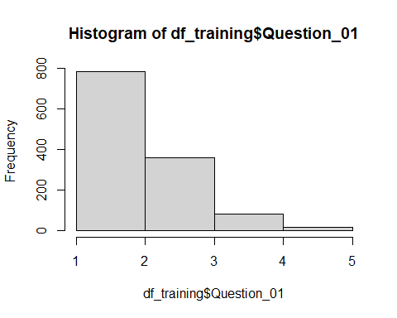
hist(df_training$Question_02, breaks = 5)
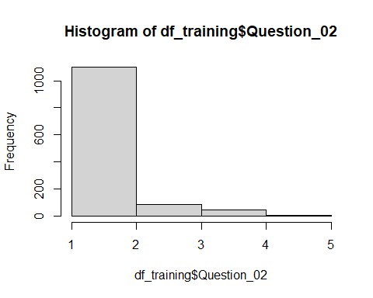
hist(df_training$Question_03, breaks = 5)
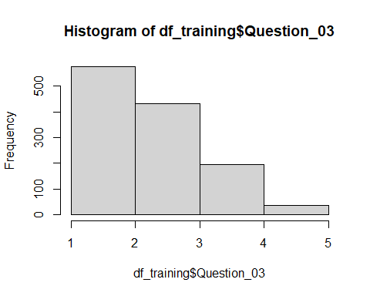
hist(df_training$Question_04, breaks = 5)
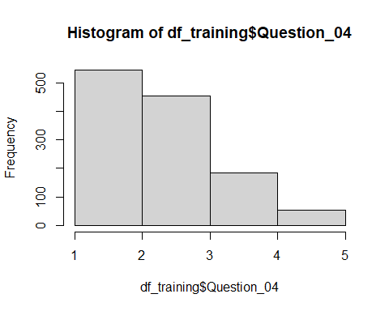
hist(df_training$Question_05, breaks = 5)
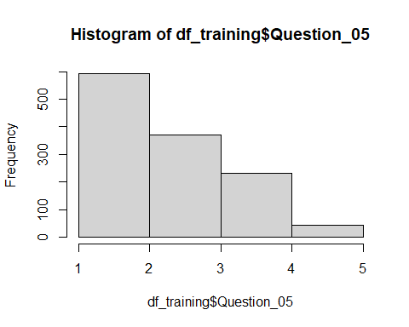
hist(df_training$Question_06, breaks = 5)
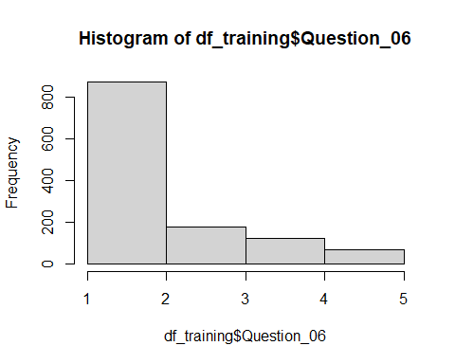
hist(df_training$Question_07, breaks = 5)
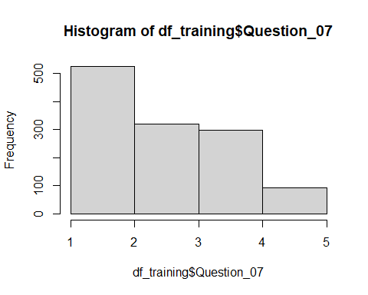
hist(df_training$Question_08, breaks = 5)
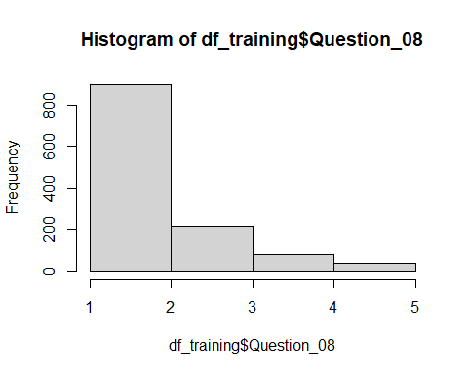
hist(df_training$Question_09, breaks = 5)
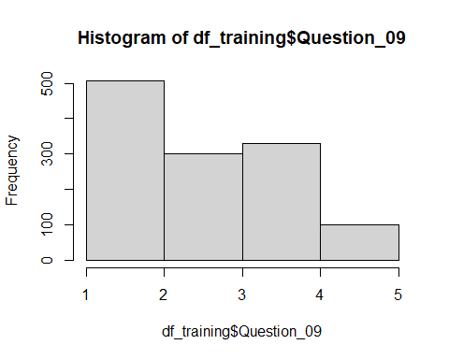
hist(df_training$Question_10, breaks = 5)
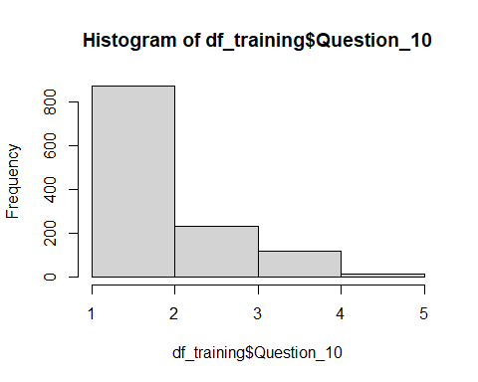
hist(df_training$Question_11, breaks = 5)
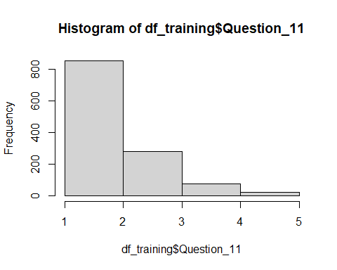
hist(df_training$Question_12, breaks = 5)
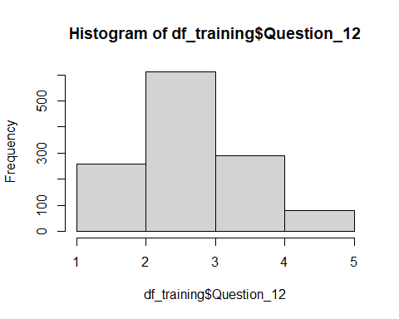
hist(df_training$Question_13, breaks = 5)
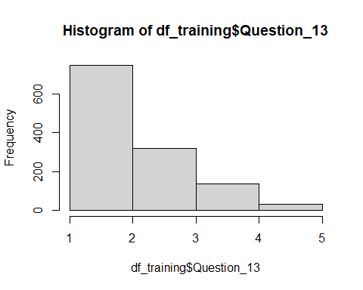
hist(df_training$Question_14, breaks = 5)
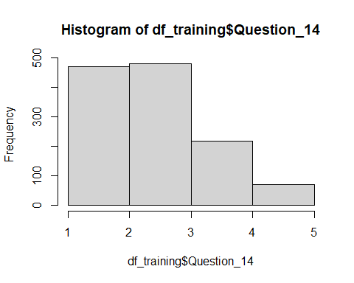
hist(df_training$Question_15, breaks = 5)
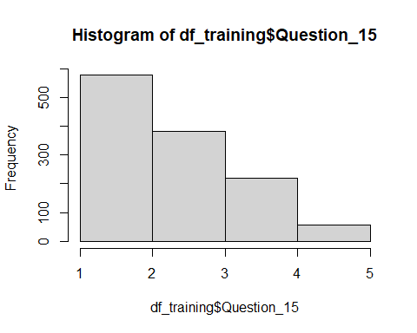
hist(df_training$Question_16, breaks = 5)
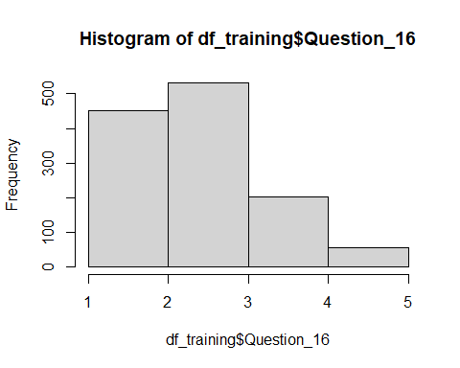
hist(df_training$Question_17, breaks = 5)
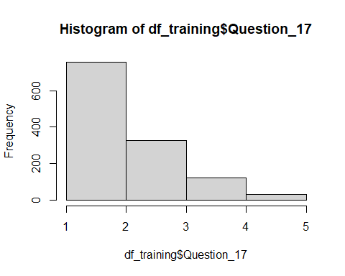
hist(df_training$Question_18, breaks = 5)
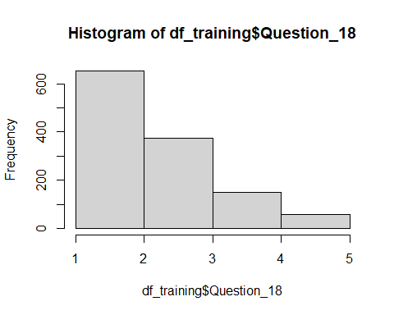
hist(df_training$Question_19, breaks = 5)
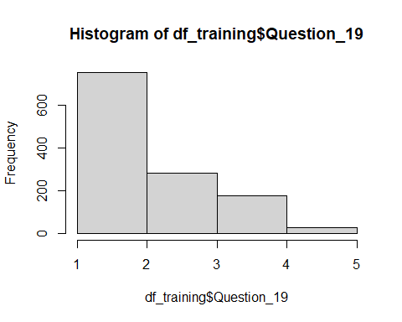
hist(df_training$Question_20, breaks = 5)
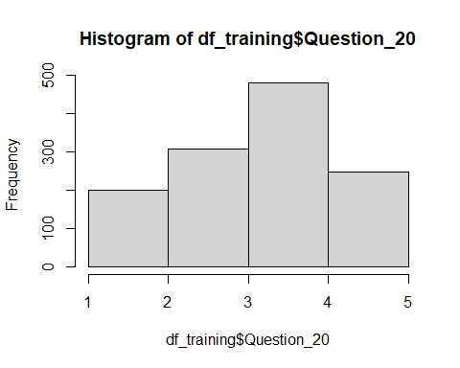
hist(df_training$Question_21, breaks = 5)
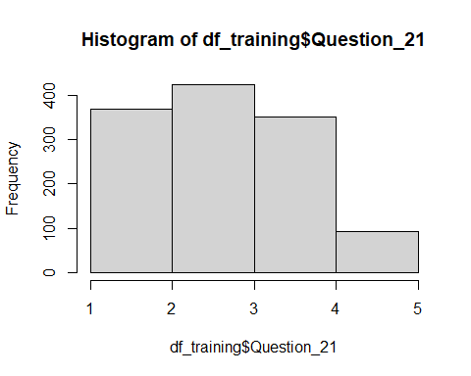
hist(df_training$Question_22, breaks = 5)
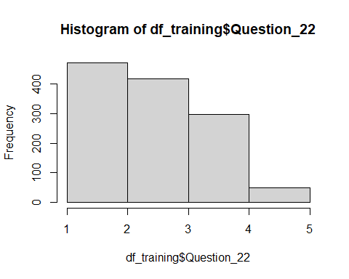
hist(df_training$Question_23, breaks = 5)
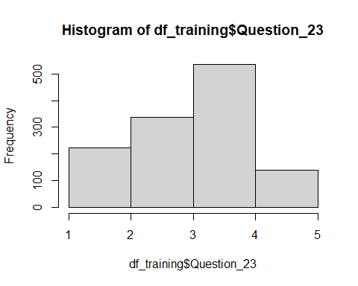
# Flatten Correlation Matrix Function
flattenCorrMatrix <- function(cormat, pmat, nmat) {
ut <- upper.tri(cormat)
data.frame(
row = rownames(cormat)[row(cormat)[ut]],
column = rownames(cormat)[col(cormat)[ut]],
cor =(cormat)[ut],
p = pmat[ut],
n = nmat[ut]
)
}
#matrix
df_training_MAT <- as.matrix(df_training)
res <- rcorr(df_training_MAT)
print(res)
## id Question_01 Question_02 Question_03 Question_04 Question_05
## id 1.00 0.06 -0.06 -0.07 0.02 0.00
## Question_01 0.06 1.00 -0.12 -0.35 0.45 0.40
## Question_02 -0.06 -0.12 1.00 0.36 -0.14 -0.15
## Question_03 -0.07 -0.35 0.36 1.00 -0.40 -0.30
## Question_04 0.02 0.45 -0.14 -0.40 1.00 0.41
## Question_05 0.00 0.40 -0.15 -0.30 0.41 1.00
## Question_06 -0.01 0.20 -0.13 -0.22 0.26 0.24
## Question_07 0.04 0.31 -0.19 -0.36 0.41 0.34
## Question_08 0.02 0.40 -0.10 -0.31 0.40 0.30
## Question_09 -0.08 -0.06 0.33 0.29 -0.12 -0.07
## Question_10 -0.02 0.18 -0.08 -0.17 0.20 0.23
## Question_11 0.03 0.41 -0.20 -0.38 0.41 0.32
## Question_12 0.05 0.38 -0.23 -0.44 0.46 0.36
## Question_13 0.06 0.34 -0.19 -0.34 0.35 0.31
## Question_14 0.04 0.34 -0.20 -0.35 0.33 0.29
## Question_15 0.02 0.27 -0.20 -0.35 0.36 0.27
## Question_16 0.00 0.51 -0.20 -0.43 0.43 0.43
## Question_17 0.02 0.42 -0.13 -0.36 0.40 0.34
## Question_18 0.00 0.37 -0.22 -0.41 0.38 0.36
## Question_19 -0.04 -0.19 0.22 0.35 -0.20 -0.19
## Question_20 0.06 0.27 -0.25 -0.37 0.26 0.21
## Question_21 0.05 0.35 -0.24 -0.42 0.39 0.35
## Question_22 -0.08 -0.08 0.25 0.21 -0.13 -0.10
## Question_23 -0.08 0.03 0.09 0.18 -0.02 -0.04
## Question_06 Question_07 Question_08 Question_09 Question_10
## id -0.01 0.04 0.02 -0.08 -0.02
## Question_01 0.20 0.31 0.40 -0.06 0.18
## Question_02 -0.13 -0.19 -0.10 0.33 -0.08
## Question_03 -0.22 -0.36 -0.31 0.29 -0.17
## Question_04 0.26 0.41 0.40 -0.12 0.20
## Question_05 0.24 0.34 0.30 -0.07 0.23
## Question_06 1.00 0.52 0.21 -0.16 0.29
## Question_07 0.52 1.00 0.31 -0.13 0.27
## Question_08 0.21 0.31 1.00 0.02 0.16
## Question_09 -0.16 -0.13 0.02 1.00 -0.11
## Question_10 0.29 0.27 0.16 -0.11 1.00
## Question_11 0.35 0.38 0.67 -0.10 0.24
## Question_12 0.34 0.43 0.30 -0.18 0.26
## Question_13 0.47 0.48 0.34 -0.18 0.29
## Question_14 0.41 0.43 0.29 -0.11 0.23
## Question_15 0.38 0.39 0.36 -0.22 0.28
## Question_16 0.27 0.39 0.37 -0.19 0.27
## Question_17 0.28 0.40 0.62 -0.04 0.23
## Question_18 0.54 0.51 0.30 -0.17 0.31
## Question_19 -0.19 -0.29 -0.18 0.25 -0.13
## Question_20 0.10 0.24 0.25 -0.17 0.11
## Question_21 0.28 0.48 0.31 -0.14 0.19
## Question_22 -0.20 -0.21 -0.10 0.28 -0.10
## Question_23 -0.08 -0.08 -0.04 0.19 -0.06
## Question_11 Question_12 Question_13 Question_14 Question_15
## id 0.03 0.05 0.06 0.04 0.02
## Question_01 0.41 0.38 0.34 0.34 0.27
## Question_02 -0.20 -0.23 -0.19 -0.20 -0.20
## Question_03 -0.38 -0.44 -0.34 -0.35 -0.35
## Question_04 0.41 0.46 0.35 0.33 0.36
## Question_05 0.32 0.36 0.31 0.29 0.27
## Question_06 0.35 0.34 0.47 0.41 0.38
## Question_07 0.38 0.43 0.48 0.43 0.39
## Question_08 0.67 0.30 0.34 0.29 0.36
## Question_09 -0.10 -0.18 -0.18 -0.11 -0.22
## Question_10 0.24 0.26 0.29 0.23 0.28
## Question_11 1.00 0.37 0.44 0.34 0.41
## Question_12 0.37 1.00 0.51 0.45 0.36
## Question_13 0.44 0.51 1.00 0.44 0.37
## Question_14 0.34 0.45 0.44 1.00 0.38
## Question_15 0.41 0.36 0.37 0.38 1.00
## Question_16 0.41 0.42 0.39 0.40 0.45
## Question_17 0.62 0.37 0.40 0.34 0.42
## Question_18 0.42 0.52 0.58 0.51 0.37
## Question_19 -0.20 -0.30 -0.25 -0.22 -0.23
## Question_20 0.28 0.32 0.25 0.26 0.24
## Question_21 0.33 0.41 0.39 0.38 0.31
## Question_22 -0.15 -0.19 -0.18 -0.18 -0.19
## Question_23 -0.09 -0.03 -0.02 -0.06 -0.10
## Question_16 Question_17 Question_18 Question_19 Question_20
## id 0.00 0.02 0.00 -0.04 0.06
## Question_01 0.51 0.42 0.37 -0.19 0.27
## Question_02 -0.20 -0.13 -0.22 0.22 -0.25
## Question_03 -0.43 -0.36 -0.41 0.35 -0.37
## Question_04 0.43 0.40 0.38 -0.20 0.26
## Question_05 0.43 0.34 0.36 -0.19 0.21
## Question_06 0.27 0.28 0.54 -0.19 0.10
## Question_07 0.39 0.40 0.51 -0.29 0.24
## Question_08 0.37 0.62 0.30 -0.18 0.25
## Question_09 -0.19 -0.04 -0.17 0.25 -0.17
## Question_10 0.27 0.23 0.31 -0.13 0.11
## Question_11 0.41 0.62 0.42 -0.20 0.28
## Question_12 0.42 0.37 0.52 -0.30 0.32
## Question_13 0.39 0.40 0.58 -0.25 0.25
## Question_14 0.40 0.34 0.51 -0.22 0.26
## Question_15 0.45 0.42 0.37 -0.23 0.24
## Question_16 1.00 0.45 0.43 -0.29 0.31
## Question_17 0.45 1.00 0.41 -0.17 0.25
## Question_18 0.43 0.41 1.00 -0.27 0.30
## Question_19 -0.29 -0.17 -0.27 1.00 -0.26
## Question_20 0.31 0.25 0.30 -0.26 1.00
## Question_21 0.42 0.36 0.44 -0.28 0.49
## Question_22 -0.20 -0.13 -0.21 0.23 -0.11
## Question_23 -0.09 -0.09 -0.09 0.15 -0.06
## Question_21 Question_22 Question_23
## id 0.05 -0.08 -0.08
## Question_01 0.35 -0.08 0.03
## Question_02 -0.24 0.25 0.09
## Question_03 -0.42 0.21 0.18
## Question_04 0.39 -0.13 -0.02
## Question_05 0.35 -0.10 -0.04
## Question_06 0.28 -0.20 -0.08
## Question_07 0.48 -0.21 -0.08
## Question_08 0.31 -0.10 -0.04
## Question_09 -0.14 0.28 0.19
## Question_10 0.19 -0.10 -0.06
## Question_11 0.33 -0.15 -0.09
## Question_12 0.41 -0.19 -0.03
## Question_13 0.39 -0.18 -0.02
## Question_14 0.38 -0.18 -0.06
## Question_15 0.31 -0.19 -0.10
## Question_16 0.42 -0.20 -0.09
## Question_17 0.36 -0.13 -0.09
## Question_18 0.44 -0.21 -0.09
## Question_19 -0.28 0.23 0.15
## Question_20 0.49 -0.11 -0.06
## Question_21 1.00 -0.16 -0.07
## Question_22 -0.16 1.00 0.26
## Question_23 -0.07 0.26 1.00
##
## n= 1237
##
##
## P
## id Question_01 Question_02 Question_03 Question_04 Question_05
## id 0.0521 0.0413 0.0165 0.4274 0.9469
## Question_01 0.0521 0.0000 0.0000 0.0000 0.0000
## Question_02 0.0413 0.0000 0.0000 0.0000 0.0000
## Question_03 0.0165 0.0000 0.0000 0.0000 0.0000
## Question_04 0.4274 0.0000 0.0000 0.0000 0.0000
## Question_05 0.9469 0.0000 0.0000 0.0000 0.0000
## Question_06 0.8269 0.0000 0.0000 0.0000 0.0000 0.0000
## Question_07 0.1630 0.0000 0.0000 0.0000 0.0000 0.0000
## Question_08 0.3981 0.0000 0.0002 0.0000 0.0000 0.0000
## Question_09 0.0034 0.0358 0.0000 0.0000 0.0000 0.0093
## Question_10 0.5582 0.0000 0.0044 0.0000 0.0000 0.0000
## Question_11 0.3701 0.0000 0.0000 0.0000 0.0000 0.0000
## Question_12 0.1052 0.0000 0.0000 0.0000 0.0000 0.0000
## Question_13 0.0361 0.0000 0.0000 0.0000 0.0000 0.0000
## Question_14 0.1234 0.0000 0.0000 0.0000 0.0000 0.0000
## Question_15 0.5911 0.0000 0.0000 0.0000 0.0000 0.0000
## Question_16 0.9138 0.0000 0.0000 0.0000 0.0000 0.0000
## Question_17 0.4230 0.0000 0.0000 0.0000 0.0000 0.0000
## Question_18 0.8672 0.0000 0.0000 0.0000 0.0000 0.0000
## Question_19 0.1378 0.0000 0.0000 0.0000 0.0000 0.0000
## Question_20 0.0233 0.0000 0.0000 0.0000 0.0000 0.0000
## Question_21 0.1011 0.0000 0.0000 0.0000 0.0000 0.0000
## Question_22 0.0040 0.0030 0.0000 0.0000 0.0000 0.0008
## Question_23 0.0028 0.3339 0.0013 0.0000 0.4512 0.1470
## Question_06 Question_07 Question_08 Question_09 Question_10
## id 0.8269 0.1630 0.3981 0.0034 0.5582
## Question_01 0.0000 0.0000 0.0000 0.0358 0.0000
## Question_02 0.0000 0.0000 0.0002 0.0000 0.0044
## Question_03 0.0000 0.0000 0.0000 0.0000 0.0000
## Question_04 0.0000 0.0000 0.0000 0.0000 0.0000
## Question_05 0.0000 0.0000 0.0000 0.0093 0.0000
## Question_06 0.0000 0.0000 0.0000 0.0000
## Question_07 0.0000 0.0000 0.0000 0.0000
## Question_08 0.0000 0.0000 0.4163 0.0000
## Question_09 0.0000 0.0000 0.4163 0.0001
## Question_10 0.0000 0.0000 0.0000 0.0001
## Question_11 0.0000 0.0000 0.0000 0.0004 0.0000
## Question_12 0.0000 0.0000 0.0000 0.0000 0.0000
## Question_13 0.0000 0.0000 0.0000 0.0000 0.0000
## Question_14 0.0000 0.0000 0.0000 0.0000 0.0000
## Question_15 0.0000 0.0000 0.0000 0.0000 0.0000
## Question_16 0.0000 0.0000 0.0000 0.0000 0.0000
## Question_17 0.0000 0.0000 0.0000 0.1915 0.0000
## Question_18 0.0000 0.0000 0.0000 0.0000 0.0000
## Question_19 0.0000 0.0000 0.0000 0.0000 0.0000
## Question_20 0.0003 0.0000 0.0000 0.0000 0.0000
## Question_21 0.0000 0.0000 0.0000 0.0000 0.0000
## Question_22 0.0000 0.0000 0.0005 0.0000 0.0004
## Question_23 0.0041 0.0047 0.1318 0.0000 0.0435
## Question_11 Question_12 Question_13 Question_14 Question_15
## id 0.3701 0.1052 0.0361 0.1234 0.5911
## Question_01 0.0000 0.0000 0.0000 0.0000 0.0000
## Question_02 0.0000 0.0000 0.0000 0.0000 0.0000
## Question_03 0.0000 0.0000 0.0000 0.0000 0.0000
## Question_04 0.0000 0.0000 0.0000 0.0000 0.0000
## Question_05 0.0000 0.0000 0.0000 0.0000 0.0000
## Question_06 0.0000 0.0000 0.0000 0.0000 0.0000
## Question_07 0.0000 0.0000 0.0000 0.0000 0.0000
## Question_08 0.0000 0.0000 0.0000 0.0000 0.0000
## Question_09 0.0004 0.0000 0.0000 0.0000 0.0000
## Question_10 0.0000 0.0000 0.0000 0.0000 0.0000
## Question_11 0.0000 0.0000 0.0000 0.0000
## Question_12 0.0000 0.0000 0.0000 0.0000
## Question_13 0.0000 0.0000 0.0000 0.0000
## Question_14 0.0000 0.0000 0.0000 0.0000
## Question_15 0.0000 0.0000 0.0000 0.0000
## Question_16 0.0000 0.0000 0.0000 0.0000 0.0000
## Question_17 0.0000 0.0000 0.0000 0.0000 0.0000
## Question_18 0.0000 0.0000 0.0000 0.0000 0.0000
## Question_19 0.0000 0.0000 0.0000 0.0000 0.0000
## Question_20 0.0000 0.0000 0.0000 0.0000 0.0000
## Question_21 0.0000 0.0000 0.0000 0.0000 0.0000
## Question_22 0.0000 0.0000 0.0000 0.0000 0.0000
## Question_23 0.0019 0.2297 0.5746 0.0249 0.0003
## Question_16 Question_17 Question_18 Question_19 Question_20
## id 0.9138 0.4230 0.8672 0.1378 0.0233
## Question_01 0.0000 0.0000 0.0000 0.0000 0.0000
## Question_02 0.0000 0.0000 0.0000 0.0000 0.0000
## Question_03 0.0000 0.0000 0.0000 0.0000 0.0000
## Question_04 0.0000 0.0000 0.0000 0.0000 0.0000
## Question_05 0.0000 0.0000 0.0000 0.0000 0.0000
## Question_06 0.0000 0.0000 0.0000 0.0000 0.0003
## Question_07 0.0000 0.0000 0.0000 0.0000 0.0000
## Question_08 0.0000 0.0000 0.0000 0.0000 0.0000
## Question_09 0.0000 0.1915 0.0000 0.0000 0.0000
## Question_10 0.0000 0.0000 0.0000 0.0000 0.0000
## Question_11 0.0000 0.0000 0.0000 0.0000 0.0000
## Question_12 0.0000 0.0000 0.0000 0.0000 0.0000
## Question_13 0.0000 0.0000 0.0000 0.0000 0.0000
## Question_14 0.0000 0.0000 0.0000 0.0000 0.0000
## Question_15 0.0000 0.0000 0.0000 0.0000 0.0000
## Question_16 0.0000 0.0000 0.0000 0.0000
## Question_17 0.0000 0.0000 0.0000 0.0000
## Question_18 0.0000 0.0000 0.0000 0.0000
## Question_19 0.0000 0.0000 0.0000 0.0000
## Question_20 0.0000 0.0000 0.0000 0.0000
## Question_21 0.0000 0.0000 0.0000 0.0000 0.0000
## Question_22 0.0000 0.0000 0.0000 0.0000 0.0000
## Question_23 0.0012 0.0011 0.0014 0.0000 0.0260
## Question_21 Question_22 Question_23
## id 0.1011 0.0040 0.0028
## Question_01 0.0000 0.0030 0.3339
## Question_02 0.0000 0.0000 0.0013
## Question_03 0.0000 0.0000 0.0000
## Question_04 0.0000 0.0000 0.4512
## Question_05 0.0000 0.0008 0.1470
## Question_06 0.0000 0.0000 0.0041
## Question_07 0.0000 0.0000 0.0047
## Question_08 0.0000 0.0005 0.1318
## Question_09 0.0000 0.0000 0.0000
## Question_10 0.0000 0.0004 0.0435
## Question_11 0.0000 0.0000 0.0019
## Question_12 0.0000 0.0000 0.2297
## Question_13 0.0000 0.0000 0.5746
## Question_14 0.0000 0.0000 0.0249
## Question_15 0.0000 0.0000 0.0003
## Question_16 0.0000 0.0000 0.0012
## Question_17 0.0000 0.0000 0.0011
## Question_18 0.0000 0.0000 0.0014
## Question_19 0.0000 0.0000 0.0000
## Question_20 0.0000 0.0000 0.0260
## Question_21 0.0000 0.0209
## Question_22 0.0000 0.0000
## Question_23 0.0209 0.0000
#flattened correlation matrix for easier view of strong positive and negative correlations
df_Flat_Cor_Mat <- flattenCorrMatrix(res$r, res$P, res$n) #these p values match SPSS
df_Flat_Cor_Mat[,3:5] <- round(df_Flat_Cor_Mat[,3:5], 3)
#Adding * to any correlation with p<0.05
df_Flat_Cor_Mat <- df_Flat_Cor_Mat %>%
tidylog::mutate(Sig = ifelse(p < 0.05, paste0(p, "*"),
p)) %>%
tidylog::filter(row != "id") # Removing ID since it is not an item
## mutate: new variable 'Sig' (character) with 39 unique values and 0% NA
## filter: removed 23 rows (8%), 253 rows remaining
df_Flat_Cor_Mat
## row column cor p n Sig
## 1 Question_01 Question_02 -0.123 0.000 1237 0*
## 2 Question_01 Question_03 -0.348 0.000 1237 0*
## 3 Question_02 Question_03 0.360 0.000 1237 0*
## 4 Question_01 Question_04 0.454 0.000 1237 0*
## 5 Question_02 Question_04 -0.139 0.000 1237 0*
## 6 Question_03 Question_04 -0.404 0.000 1237 0*
## 7 Question_01 Question_05 0.405 0.000 1237 0*
## 8 Question_02 Question_05 -0.152 0.000 1237 0*
## 9 Question_03 Question_05 -0.304 0.000 1237 0*
## 10 Question_04 Question_05 0.409 0.000 1237 0*
## 11 Question_01 Question_06 0.197 0.000 1237 0*
## 12 Question_02 Question_06 -0.133 0.000 1237 0*
## 13 Question_03 Question_06 -0.223 0.000 1237 0*
## 14 Question_04 Question_06 0.257 0.000 1237 0*
## 15 Question_05 Question_06 0.244 0.000 1237 0*
## 16 Question_01 Question_07 0.308 0.000 1237 0*
## 17 Question_02 Question_07 -0.189 0.000 1237 0*
## 18 Question_03 Question_07 -0.363 0.000 1237 0*
## 19 Question_04 Question_07 0.414 0.000 1237 0*
## 20 Question_05 Question_07 0.344 0.000 1237 0*
## 21 Question_06 Question_07 0.522 0.000 1237 0*
## 22 Question_01 Question_08 0.401 0.000 1237 0*
## 23 Question_02 Question_08 -0.104 0.000 1237 0*
## 24 Question_03 Question_08 -0.313 0.000 1237 0*
## 25 Question_04 Question_08 0.401 0.000 1237 0*
## 26 Question_05 Question_08 0.299 0.000 1237 0*
## 27 Question_06 Question_08 0.210 0.000 1237 0*
## 28 Question_07 Question_08 0.310 0.000 1237 0*
## 29 Question_01 Question_09 -0.060 0.036 1237 0.036*
## 30 Question_02 Question_09 0.331 0.000 1237 0*
## 31 Question_03 Question_09 0.291 0.000 1237 0*
## 32 Question_04 Question_09 -0.122 0.000 1237 0*
## 33 Question_05 Question_09 -0.074 0.009 1237 0.009*
## 34 Question_06 Question_09 -0.159 0.000 1237 0*
## 35 Question_07 Question_09 -0.134 0.000 1237 0*
## 36 Question_08 Question_09 0.023 0.416 1237 0.416
## 37 Question_01 Question_10 0.177 0.000 1237 0*
## 38 Question_02 Question_10 -0.081 0.004 1237 0.004*
## 39 Question_03 Question_10 -0.171 0.000 1237 0*
## 40 Question_04 Question_10 0.202 0.000 1237 0*
## 41 Question_05 Question_10 0.230 0.000 1237 0*
## 42 Question_06 Question_10 0.294 0.000 1237 0*
## 43 Question_07 Question_10 0.272 0.000 1237 0*
## 44 Question_08 Question_10 0.160 0.000 1237 0*
## 45 Question_09 Question_10 -0.108 0.000 1237 0*
## 46 Question_01 Question_11 0.405 0.000 1237 0*
## 47 Question_02 Question_11 -0.198 0.000 1237 0*
## 48 Question_03 Question_11 -0.375 0.000 1237 0*
## 49 Question_04 Question_11 0.410 0.000 1237 0*
## 50 Question_05 Question_11 0.324 0.000 1237 0*
## 51 Question_06 Question_11 0.351 0.000 1237 0*
## 52 Question_07 Question_11 0.380 0.000 1237 0*
## 53 Question_08 Question_11 0.668 0.000 1237 0*
## 54 Question_09 Question_11 -0.101 0.000 1237 0*
## 55 Question_10 Question_11 0.244 0.000 1237 0*
## 56 Question_01 Question_12 0.381 0.000 1237 0*
## 57 Question_02 Question_12 -0.226 0.000 1237 0*
## 58 Question_03 Question_12 -0.443 0.000 1237 0*
## 59 Question_04 Question_12 0.461 0.000 1237 0*
## 60 Question_05 Question_12 0.356 0.000 1237 0*
## 61 Question_06 Question_12 0.338 0.000 1237 0*
## 62 Question_07 Question_12 0.434 0.000 1237 0*
## 63 Question_08 Question_12 0.304 0.000 1237 0*
## 64 Question_09 Question_12 -0.182 0.000 1237 0*
## 65 Question_10 Question_12 0.264 0.000 1237 0*
## 66 Question_11 Question_12 0.375 0.000 1237 0*
## 67 Question_01 Question_13 0.340 0.000 1237 0*
## 68 Question_02 Question_13 -0.189 0.000 1237 0*
## 69 Question_03 Question_13 -0.338 0.000 1237 0*
## 70 Question_04 Question_13 0.353 0.000 1237 0*
## 71 Question_05 Question_13 0.305 0.000 1237 0*
## 72 Question_06 Question_13 0.468 0.000 1237 0*
## 73 Question_07 Question_13 0.479 0.000 1237 0*
## 74 Question_08 Question_13 0.343 0.000 1237 0*
## 75 Question_09 Question_13 -0.181 0.000 1237 0*
## 76 Question_10 Question_13 0.293 0.000 1237 0*
## 77 Question_11 Question_13 0.441 0.000 1237 0*
## 78 Question_12 Question_13 0.506 0.000 1237 0*
## 79 Question_01 Question_14 0.342 0.000 1237 0*
## 80 Question_02 Question_14 -0.199 0.000 1237 0*
## 81 Question_03 Question_14 -0.347 0.000 1237 0*
## 82 Question_04 Question_14 0.332 0.000 1237 0*
## 83 Question_05 Question_14 0.287 0.000 1237 0*
## 84 Question_06 Question_14 0.407 0.000 1237 0*
## 85 Question_07 Question_14 0.434 0.000 1237 0*
## 86 Question_08 Question_14 0.286 0.000 1237 0*
## 87 Question_09 Question_14 -0.111 0.000 1237 0*
## 88 Question_10 Question_14 0.230 0.000 1237 0*
## 89 Question_11 Question_14 0.337 0.000 1237 0*
## 90 Question_12 Question_14 0.449 0.000 1237 0*
## 91 Question_13 Question_14 0.439 0.000 1237 0*
## 92 Question_01 Question_15 0.274 0.000 1237 0*
## 93 Question_02 Question_15 -0.197 0.000 1237 0*
## 94 Question_03 Question_15 -0.352 0.000 1237 0*
## 95 Question_04 Question_15 0.362 0.000 1237 0*
## 96 Question_05 Question_15 0.268 0.000 1237 0*
## 97 Question_06 Question_15 0.378 0.000 1237 0*
## 98 Question_07 Question_15 0.390 0.000 1237 0*
## 99 Question_08 Question_15 0.361 0.000 1237 0*
## 100 Question_09 Question_15 -0.216 0.000 1237 0*
## 101 Question_10 Question_15 0.284 0.000 1237 0*
## 102 Question_11 Question_15 0.409 0.000 1237 0*
## 103 Question_12 Question_15 0.363 0.000 1237 0*
## 104 Question_13 Question_15 0.372 0.000 1237 0*
## 105 Question_14 Question_15 0.378 0.000 1237 0*
## 106 Question_01 Question_16 0.514 0.000 1237 0*
## 107 Question_02 Question_16 -0.202 0.000 1237 0*
## 108 Question_03 Question_16 -0.428 0.000 1237 0*
## 109 Question_04 Question_16 0.429 0.000 1237 0*
## 110 Question_05 Question_16 0.427 0.000 1237 0*
## 111 Question_06 Question_16 0.267 0.000 1237 0*
## 112 Question_07 Question_16 0.389 0.000 1237 0*
## 113 Question_08 Question_16 0.365 0.000 1237 0*
## 114 Question_09 Question_16 -0.193 0.000 1237 0*
## 115 Question_10 Question_16 0.268 0.000 1237 0*
## 116 Question_11 Question_16 0.408 0.000 1237 0*
## 117 Question_12 Question_16 0.422 0.000 1237 0*
## 118 Question_13 Question_16 0.392 0.000 1237 0*
## 119 Question_14 Question_16 0.405 0.000 1237 0*
## 120 Question_15 Question_16 0.448 0.000 1237 0*
## 121 Question_01 Question_17 0.423 0.000 1237 0*
## 122 Question_02 Question_17 -0.127 0.000 1237 0*
## 123 Question_03 Question_17 -0.357 0.000 1237 0*
## 124 Question_04 Question_17 0.396 0.000 1237 0*
## 125 Question_05 Question_17 0.339 0.000 1237 0*
## 126 Question_06 Question_17 0.277 0.000 1237 0*
## 127 Question_07 Question_17 0.400 0.000 1237 0*
## 128 Question_08 Question_17 0.615 0.000 1237 0*
## 129 Question_09 Question_17 -0.037 0.192 1237 0.192
## 130 Question_10 Question_17 0.225 0.000 1237 0*
## 131 Question_11 Question_17 0.623 0.000 1237 0*
## 132 Question_12 Question_17 0.366 0.000 1237 0*
## 133 Question_13 Question_17 0.395 0.000 1237 0*
## 134 Question_14 Question_17 0.342 0.000 1237 0*
## 135 Question_15 Question_17 0.421 0.000 1237 0*
## 136 Question_16 Question_17 0.445 0.000 1237 0*
## 137 Question_01 Question_18 0.372 0.000 1237 0*
## 138 Question_02 Question_18 -0.220 0.000 1237 0*
## 139 Question_03 Question_18 -0.409 0.000 1237 0*
## 140 Question_04 Question_18 0.377 0.000 1237 0*
## 141 Question_05 Question_18 0.360 0.000 1237 0*
## 142 Question_06 Question_18 0.544 0.000 1237 0*
## 143 Question_07 Question_18 0.510 0.000 1237 0*
## 144 Question_08 Question_18 0.301 0.000 1237 0*
## 145 Question_09 Question_18 -0.171 0.000 1237 0*
## 146 Question_10 Question_18 0.308 0.000 1237 0*
## 147 Question_11 Question_18 0.425 0.000 1237 0*
## 148 Question_12 Question_18 0.524 0.000 1237 0*
## 149 Question_13 Question_18 0.578 0.000 1237 0*
## 150 Question_14 Question_18 0.505 0.000 1237 0*
## 151 Question_15 Question_18 0.368 0.000 1237 0*
## 152 Question_16 Question_18 0.433 0.000 1237 0*
## 153 Question_17 Question_18 0.407 0.000 1237 0*
## 154 Question_01 Question_19 -0.189 0.000 1237 0*
## 155 Question_02 Question_19 0.217 0.000 1237 0*
## 156 Question_03 Question_19 0.354 0.000 1237 0*
## 157 Question_04 Question_19 -0.203 0.000 1237 0*
## 158 Question_05 Question_19 -0.187 0.000 1237 0*
## 159 Question_06 Question_19 -0.188 0.000 1237 0*
## 160 Question_07 Question_19 -0.287 0.000 1237 0*
## 161 Question_08 Question_19 -0.180 0.000 1237 0*
## 162 Question_09 Question_19 0.251 0.000 1237 0*
## 163 Question_10 Question_19 -0.129 0.000 1237 0*
## 164 Question_11 Question_19 -0.203 0.000 1237 0*
## 165 Question_12 Question_19 -0.304 0.000 1237 0*
## 166 Question_13 Question_19 -0.248 0.000 1237 0*
## 167 Question_14 Question_19 -0.225 0.000 1237 0*
## 168 Question_15 Question_19 -0.231 0.000 1237 0*
## 169 Question_16 Question_19 -0.291 0.000 1237 0*
## 170 Question_17 Question_19 -0.169 0.000 1237 0*
## 171 Question_18 Question_19 -0.269 0.000 1237 0*
## 172 Question_01 Question_20 0.268 0.000 1237 0*
## 173 Question_02 Question_20 -0.253 0.000 1237 0*
## 174 Question_03 Question_20 -0.365 0.000 1237 0*
## 175 Question_04 Question_20 0.265 0.000 1237 0*
## 176 Question_05 Question_20 0.215 0.000 1237 0*
## 177 Question_06 Question_20 0.102 0.000 1237 0*
## 178 Question_07 Question_20 0.237 0.000 1237 0*
## 179 Question_08 Question_20 0.253 0.000 1237 0*
## 180 Question_09 Question_20 -0.167 0.000 1237 0*
## 181 Question_10 Question_20 0.114 0.000 1237 0*
## 182 Question_11 Question_20 0.280 0.000 1237 0*
## 183 Question_12 Question_20 0.323 0.000 1237 0*
## 184 Question_13 Question_20 0.252 0.000 1237 0*
## 185 Question_14 Question_20 0.255 0.000 1237 0*
## 186 Question_15 Question_20 0.239 0.000 1237 0*
## 187 Question_16 Question_20 0.309 0.000 1237 0*
## 188 Question_17 Question_20 0.249 0.000 1237 0*
## 189 Question_18 Question_20 0.300 0.000 1237 0*
## 190 Question_19 Question_20 -0.260 0.000 1237 0*
## 191 Question_01 Question_21 0.348 0.000 1237 0*
## 192 Question_02 Question_21 -0.237 0.000 1237 0*
## 193 Question_03 Question_21 -0.421 0.000 1237 0*
## 194 Question_04 Question_21 0.394 0.000 1237 0*
## 195 Question_05 Question_21 0.354 0.000 1237 0*
## 196 Question_06 Question_21 0.278 0.000 1237 0*
## 197 Question_07 Question_21 0.482 0.000 1237 0*
## 198 Question_08 Question_21 0.311 0.000 1237 0*
## 199 Question_09 Question_21 -0.144 0.000 1237 0*
## 200 Question_10 Question_21 0.191 0.000 1237 0*
## 201 Question_11 Question_21 0.332 0.000 1237 0*
## 202 Question_12 Question_21 0.413 0.000 1237 0*
## 203 Question_13 Question_21 0.390 0.000 1237 0*
## 204 Question_14 Question_21 0.376 0.000 1237 0*
## 205 Question_15 Question_21 0.310 0.000 1237 0*
## 206 Question_16 Question_21 0.422 0.000 1237 0*
## 207 Question_17 Question_21 0.358 0.000 1237 0*
## 208 Question_18 Question_21 0.436 0.000 1237 0*
## 209 Question_19 Question_21 -0.277 0.000 1237 0*
## 210 Question_20 Question_21 0.487 0.000 1237 0*
## 211 Question_01 Question_22 -0.084 0.003 1237 0.003*
## 212 Question_02 Question_22 0.255 0.000 1237 0*
## 213 Question_03 Question_22 0.208 0.000 1237 0*
## 214 Question_04 Question_22 -0.126 0.000 1237 0*
## 215 Question_05 Question_22 -0.095 0.001 1237 0.001*
## 216 Question_06 Question_22 -0.201 0.000 1237 0*
## 217 Question_07 Question_22 -0.212 0.000 1237 0*
## 218 Question_08 Question_22 -0.099 0.001 1237 0.001*
## 219 Question_09 Question_22 0.280 0.000 1237 0*
## 220 Question_10 Question_22 -0.100 0.000 1237 0*
## 221 Question_11 Question_22 -0.152 0.000 1237 0*
## 222 Question_12 Question_22 -0.192 0.000 1237 0*
## 223 Question_13 Question_22 -0.181 0.000 1237 0*
## 224 Question_14 Question_22 -0.177 0.000 1237 0*
## 225 Question_15 Question_22 -0.188 0.000 1237 0*
## 226 Question_16 Question_22 -0.203 0.000 1237 0*
## 227 Question_17 Question_22 -0.130 0.000 1237 0*
## 228 Question_18 Question_22 -0.209 0.000 1237 0*
## 229 Question_19 Question_22 0.234 0.000 1237 0*
## 230 Question_20 Question_22 -0.115 0.000 1237 0*
## 231 Question_21 Question_22 -0.159 0.000 1237 0*
## 232 Question_01 Question_23 0.027 0.334 1237 0.334
## 233 Question_02 Question_23 0.091 0.001 1237 0.001*
## 234 Question_03 Question_23 0.179 0.000 1237 0*
## 235 Question_04 Question_23 -0.021 0.451 1237 0.451
## 236 Question_05 Question_23 -0.041 0.147 1237 0.147
## 237 Question_06 Question_23 -0.082 0.004 1237 0.004*
## 238 Question_07 Question_23 -0.080 0.005 1237 0.005*
## 239 Question_08 Question_23 -0.043 0.132 1237 0.132
## 240 Question_09 Question_23 0.186 0.000 1237 0*
## 241 Question_10 Question_23 -0.057 0.043 1237 0.043*
## 242 Question_11 Question_23 -0.088 0.002 1237 0.002*
## 243 Question_12 Question_23 -0.034 0.230 1237 0.23
## 244 Question_13 Question_23 -0.016 0.575 1237 0.575
## 245 Question_14 Question_23 -0.064 0.025 1237 0.025*
## 246 Question_15 Question_23 -0.102 0.000 1237 0*
## 247 Question_16 Question_23 -0.092 0.001 1237 0.001*
## 248 Question_17 Question_23 -0.093 0.001 1237 0.001*
## 249 Question_18 Question_23 -0.091 0.001 1237 0.001*
## 250 Question_19 Question_23 0.148 0.000 1237 0*
## 251 Question_20 Question_23 -0.063 0.026 1237 0.026*
## 252 Question_21 Question_23 -0.066 0.021 1237 0.021*
## 253 Question_22 Question_23 0.257 0.000 1237 0*
#parallel analysis isolating only the items to see the suggested number of factors
fa.parallel(df_training[c(2:24)])
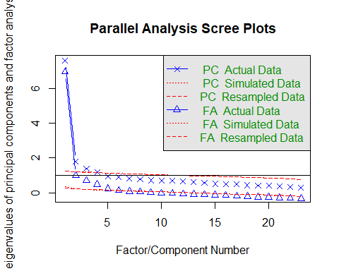
## Parallel analysis suggests that the number of factors = 5 and the number of components = 4
#suggesting 5 as the number of factors and 4 as the number of components
##Because the dataset is ordinal and not normal, use PAF and polychoric correlation matrix as input.
poly_cor_df_training <- polychoric(df_training[2:24])$rho
fa_pa_5_trn <- fa(poly_cor_df_training, nfactors = 5,
fm = "pa",
n.obs = nrow(df_training))
print(fa_pa_5_trn$loadings, cutoff = .3)
##
## Loadings:
## PA1 PA2 PA4 PA3 PA5
## Question_01 0.737
## Question_02 0.493
## Question_03 0.359
## Question_04 0.530
## Question_05 0.567
## Question_06 0.872
## Question_07 0.596
## Question_08 0.924
## Question_09 0.646
## Question_10 0.350
## Question_11 0.788
## Question_12 0.352 0.319
## Question_13 0.579
## Question_14 0.472
## Question_15
## Question_16 0.687
## Question_17 0.679
## Question_18 0.644
## Question_19 0.345
## Question_20 0.638
## Question_21 0.526
## Question_22 0.532
## Question_23 0.445
##
## PA1 PA2 PA4 PA3 PA5
## SS loadings 2.521 1.998 2.101 1.497 1.064
## Proportion Var 0.110 0.087 0.091 0.065 0.046
## Cumulative Var 0.110 0.196 0.288 0.353 0.399
##Based on the flattened matrix, these items are correlated, therefore, we are using an oblique rotation.
fa_pa_5_trn <- fa(poly_cor_df_training, nfactors = 5,
fm = "pa",
rotate = "oblimin",
n.obs = nrow(df_training))
#pattern matrix with 5 factors
print(fa_pa_5_trn)
## Factor Analysis using method = pa
## Call: fa(r = poly_cor_df_training, nfactors = 5, n.obs = nrow(df_training),
## rotate = "oblimin", fm = "pa")
## Standardized loadings (pattern matrix) based upon correlation matrix
## PA2 PA1 PA5 PA4 PA3 h2 u2 com
## Question_01 -0.06 0.74 0.10 0.09 0.01 0.58 0.42 1.1
## Question_02 0.01 0.02 -0.02 0.49 -0.26 0.39 0.61 1.5
## Question_03 0.01 -0.25 -0.11 0.36 -0.27 0.54 0.46 3.0
## Question_04 0.08 0.53 0.12 0.01 0.07 0.48 0.52 1.2
## Question_05 0.11 0.57 0.00 0.03 0.01 0.40 0.60 1.1
## Question_06 0.87 -0.10 0.03 -0.03 -0.12 0.68 0.32 1.1
## Question_07 0.60 0.08 0.07 -0.01 0.13 0.56 0.44 1.2
## Question_08 -0.07 0.00 0.92 0.05 0.03 0.80 0.20 1.0
## Question_09 0.00 -0.04 0.12 0.65 -0.01 0.42 0.58 1.1
## Question_10 0.35 0.17 0.05 -0.05 -0.13 0.22 0.78 1.9
## Question_11 0.12 -0.03 0.79 -0.08 0.01 0.74 0.26 1.1
## Question_12 0.35 0.32 -0.03 -0.05 0.23 0.54 0.46 2.8
## Question_13 0.58 0.08 0.09 0.00 0.14 0.56 0.44 1.2
## Question_14 0.47 0.19 0.01 -0.01 0.13 0.45 0.55 1.5
## Question_15 0.26 0.20 0.23 -0.21 -0.06 0.41 0.59 4.0
## Question_16 0.04 0.69 0.03 -0.17 -0.03 0.61 0.39 1.1
## Question_17 0.08 0.17 0.68 0.00 -0.04 0.68 0.32 1.2
## Question_18 0.64 0.13 0.00 -0.02 0.16 0.65 0.35 1.2
## Question_19 -0.07 -0.10 0.00 0.34 -0.19 0.28 0.72 1.8
## Question_20 -0.03 -0.03 0.12 -0.10 0.64 0.49 0.51 1.1
## Question_21 0.23 0.12 0.05 0.01 0.53 0.56 0.44 1.5
## Question_22 -0.09 0.03 -0.06 0.53 0.08 0.31 0.69 1.1
## Question_23 0.02 0.11 -0.15 0.45 0.13 0.18 0.82 1.5
##
## PA2 PA1 PA5 PA4 PA3
## SS loadings 3.14 2.69 2.51 1.73 1.46
## Proportion Var 0.14 0.12 0.11 0.08 0.06
## Cumulative Var 0.14 0.25 0.36 0.44 0.50
## Proportion Explained 0.27 0.23 0.22 0.15 0.13
## Cumulative Proportion 0.27 0.51 0.72 0.87 1.00
##
## With factor correlations of
## PA2 PA1 PA5 PA4 PA3
## PA2 1.00 0.54 0.48 -0.37 0.32
## PA1 0.54 1.00 0.62 -0.27 0.54
## PA5 0.48 0.62 1.00 -0.18 0.35
## PA4 -0.37 -0.27 -0.18 1.00 -0.33
## PA3 0.32 0.54 0.35 -0.33 1.00
##
## Mean item complexity = 1.5
## Test of the hypothesis that 5 factors are sufficient.
##
## df null model = 253 with the objective function = 10.4 with Chi Square = 12771.09
## df of the model are 148 and the objective function was 0.56
##
## The root mean square of the residuals (RMSR) is 0.02
## The df corrected root mean square of the residuals is 0.02
##
## The harmonic n.obs is 1237 with the empirical chi square 170.23 with prob < 0.1
## The total n.obs was 1237 with Likelihood Chi Square = 686.32 with prob < 3.2e-70
##
## Tucker Lewis Index of factoring reliability = 0.926
## RMSEA index = 0.054 and the 90 % confidence intervals are 0.05 0.058
## BIC = -367.5
## Fit based upon off diagonal values = 1
## Measures of factor score adequacy
## PA2 PA1 PA5 PA4 PA3
## Correlation of (regression) scores with factors 0.83 0.69 0.85 0.78 0.70
## Multiple R square of scores with factors 0.69 0.48 0.72 0.61 0.49
## Minimum correlation of possible factor scores 0.37 -0.04 0.43 0.22 -0.01
print(fa_pa_5_trn$loadings, cutoff = .3)
##
## Loadings:
## PA2 PA1 PA5 PA4 PA3
## Question_01 0.737
## Question_02 0.493
## Question_03 0.359
## Question_04 0.530
## Question_05 0.567
## Question_06 0.872
## Question_07 0.596
## Question_08 0.924
## Question_09 0.646
## Question_10 0.350
## Question_11 0.788
## Question_12 0.352 0.319
## Question_13 0.579
## Question_14 0.472
## Question_15
## Question_16 0.687
## Question_17 0.679
## Question_18 0.644
## Question_19 0.345
## Question_20 0.638
## Question_21 0.526
## Question_22 0.532
## Question_23 0.445
##
## PA2 PA1 PA5 PA4 PA3
## SS loadings 2.521 1.998 2.101 1.497 1.064
## Proportion Var 0.110 0.087 0.091 0.065 0.046
## Cumulative Var 0.110 0.196 0.288 0.353 0.399
#Strong loading on PA3, however if we went to a 4 factor loading, would it balance better.
# Also, PA3 only has 2 items loading on it
##Because the dataset is ordinal and not normal, use PAF and polychoric correlation matrix as input
fa_pa_4_trn <- fa(poly_cor_df_training, nfactors = 4,
fm = "pa",
rotate = "oblimin",
n.obs = nrow(df_training))
#pattern matrix with 4 factors
print(fa_pa_4_trn)
## Factor Analysis using method = pa
## Call: fa(r = poly_cor_df_training, nfactors = 4, n.obs = nrow(df_training),
## rotate = "oblimin", fm = "pa")
## Standardized loadings (pattern matrix) based upon correlation matrix
## PA1 PA3 PA2 PA4 h2 u2 com
## Question_01 0.05 0.30 0.51 0.06 0.51 0.49 1.7
## Question_02 0.04 0.01 -0.09 0.60 0.39 0.61 1.1
## Question_03 0.01 -0.16 -0.32 0.48 0.55 0.45 2.0
## Question_04 0.14 0.26 0.43 -0.02 0.47 0.53 1.9
## Question_05 0.19 0.16 0.40 0.01 0.37 0.63 1.8
## Question_06 0.89 0.00 -0.18 0.03 0.69 0.31 1.1
## Question_07 0.60 0.08 0.16 -0.05 0.55 0.45 1.2
## Question_08 -0.09 0.93 0.00 0.05 0.77 0.23 1.0
## Question_09 -0.02 0.11 0.09 0.67 0.40 0.60 1.1
## Question_10 0.39 0.11 0.00 0.00 0.21 0.79 1.2
## Question_11 0.10 0.80 -0.06 -0.08 0.73 0.27 1.1
## Question_12 0.38 0.02 0.40 -0.14 0.54 0.46 2.2
## Question_13 0.57 0.09 0.17 -0.04 0.55 0.45 1.2
## Question_14 0.49 0.04 0.24 -0.05 0.45 0.55 1.5
## Question_15 0.30 0.29 0.04 -0.19 0.40 0.60 2.7
## Question_16 0.15 0.22 0.40 -0.18 0.52 0.48 2.4
## Question_17 0.09 0.75 0.05 0.02 0.68 0.32 1.0
## Question_18 0.65 0.01 0.22 -0.07 0.65 0.35 1.3
## Question_19 -0.07 -0.01 -0.15 0.43 0.29 0.71 1.3
## Question_20 -0.07 0.08 0.41 -0.31 0.35 0.65 2.0
## Question_21 0.20 0.04 0.47 -0.18 0.49 0.51 1.7
## Question_22 -0.11 -0.06 0.19 0.52 0.30 0.70 1.4
## Question_23 0.02 -0.14 0.28 0.41 0.18 0.82 2.0
##
## PA1 PA3 PA2 PA4
## SS loadings 3.36 3.03 2.42 2.22
## Proportion Var 0.15 0.13 0.11 0.10
## Cumulative Var 0.15 0.28 0.38 0.48
## Proportion Explained 0.30 0.27 0.22 0.20
## Cumulative Proportion 0.30 0.58 0.80 1.00
##
## With factor correlations of
## PA1 PA3 PA2 PA4
## PA1 1.00 0.52 0.39 -0.43
## PA3 0.52 1.00 0.49 -0.29
## PA2 0.39 0.49 1.00 -0.33
## PA4 -0.43 -0.29 -0.33 1.00
##
## Mean item complexity = 1.6
## Test of the hypothesis that 4 factors are sufficient.
##
## df null model = 253 with the objective function = 10.4 with Chi Square = 12771.09
## df of the model are 167 and the objective function was 0.75
##
## The root mean square of the residuals (RMSR) is 0.02
## The df corrected root mean square of the residuals is 0.02
##
## The harmonic n.obs is 1237 with the empirical chi square 254.43 with prob < 1.5e-05
## The total n.obs was 1237 with Likelihood Chi Square = 917.75 with prob < 5.7e-104
##
## Tucker Lewis Index of factoring reliability = 0.909
## RMSEA index = 0.06 and the 90 % confidence intervals are 0.057 0.064
## BIC = -271.37
## Fit based upon off diagonal values = 1
## Measures of factor score adequacy
## PA1 PA3 PA2 PA4
## Correlation of (regression) scores with factors 0.86 0.88 0.76 0.80
## Multiple R square of scores with factors 0.73 0.77 0.58 0.65
## Minimum correlation of possible factor scores 0.46 0.53 0.16 0.29
print(fa_pa_4_trn$loadings, cutoff = .3)
##
## Loadings:
## PA1 PA3 PA2 PA4
## Question_01 0.514
## Question_02 0.604
## Question_03 -0.320 0.479
## Question_04 0.426
## Question_05 0.399
## Question_06 0.894
## Question_07 0.596
## Question_08 0.932
## Question_09 0.666
## Question_10 0.391
## Question_11 0.796
## Question_12 0.376 0.402
## Question_13 0.575
## Question_14 0.491
## Question_15
## Question_16 0.396
## Question_17 0.754
## Question_18 0.651
## Question_19 0.426
## Question_20 0.405 -0.307
## Question_21 0.467
## Question_22 0.519
## Question_23 0.411
##
## PA1 PA3 PA2 PA4
## SS loadings 2.705 2.482 1.761 1.898
## Proportion Var 0.118 0.108 0.077 0.083
## Cumulative Var 0.118 0.226 0.302 0.385
##Because question 3 (PA2, PA4), 12 (PA1,PA2), and 20 (PA2, PA4) are loading on 2 factors,
#question 3 has a Communality of 2 and question 15 did not make the .3 cutoff, I am dropping
df_training_MOD <- df_training %>%
dplyr::select(-c(Question_03, Question_12, Question_15, Question_20, Question_23))
#checking colnames to see where everything is
colnames(df_training_MOD)
## [1] "id" "Question_01" "Question_02" "Question_04" "Question_05"
## [6] "Question_06" "Question_07" "Question_08" "Question_09" "Question_10"
## [11] "Question_11" "Question_13" "Question_14" "Question_16" "Question_17"
## [16] "Question_18" "Question_19" "Question_21" "Question_22"
#redo analysis with questions removed
poly_cor_df_training_MOD <- polychoric(df_training_MOD[2:19])$rho
fa_pa_4_trn_MOD <- fa(poly_cor_df_training_MOD, nfactors = 4,
fm = "pa",
rotate = "oblimin",
n.obs = nrow(df_training))
#final pattern matrix with items removed
print(fa_pa_4_trn_MOD)
## Factor Analysis using method = pa
## Call: fa(r = poly_cor_df_training_MOD, nfactors = 4, n.obs = nrow(df_training),
## rotate = "oblimin", fm = "pa")
## Standardized loadings (pattern matrix) based upon correlation matrix
## PA1 PA4 PA2 PA3 h2 u2 com
## Question_01 -0.05 0.70 0.13 0.05 0.56 0.44 1.1
## Question_02 0.05 -0.05 -0.07 0.62 0.41 0.59 1.0
## Question_04 0.08 0.53 0.14 -0.01 0.46 0.54 1.2
## Question_05 0.11 0.59 -0.01 0.02 0.42 0.58 1.1
## Question_06 0.87 -0.15 0.03 0.02 0.65 0.35 1.1
## Question_07 0.60 0.19 0.04 -0.04 0.57 0.43 1.2
## Question_08 -0.09 0.04 0.91 0.04 0.79 0.21 1.0
## Question_09 0.02 0.04 0.07 0.68 0.43 0.57 1.0
## Question_10 0.35 0.09 0.06 0.00 0.20 0.80 1.2
## Question_11 0.11 -0.07 0.84 -0.09 0.77 0.23 1.1
## Question_13 0.55 0.12 0.13 -0.08 0.54 0.46 1.3
## Question_14 0.47 0.26 0.01 -0.04 0.44 0.56 1.6
## Question_16 0.05 0.64 0.04 -0.16 0.59 0.41 1.1
## Question_17 0.09 0.15 0.67 0.04 0.66 0.34 1.2
## Question_18 0.65 0.21 0.00 -0.06 0.65 0.35 1.2
## Question_19 -0.06 -0.17 -0.01 0.39 0.26 0.74 1.4
## Question_21 0.23 0.44 0.00 -0.13 0.43 0.57 1.7
## Question_22 -0.08 0.08 -0.07 0.49 0.27 0.73 1.1
##
## PA1 PA4 PA2 PA3
## SS loadings 2.76 2.52 2.36 1.44
## Proportion Var 0.15 0.14 0.13 0.08
## Cumulative Var 0.15 0.29 0.42 0.51
## Proportion Explained 0.30 0.28 0.26 0.16
## Cumulative Proportion 0.30 0.58 0.84 1.00
##
## With factor correlations of
## PA1 PA4 PA2 PA3
## PA1 1.00 0.52 0.49 -0.42
## PA4 0.52 1.00 0.62 -0.32
## PA2 0.49 0.62 1.00 -0.20
## PA3 -0.42 -0.32 -0.20 1.00
##
## Mean item complexity = 1.2
## Test of the hypothesis that 4 factors are sufficient.
##
## df null model = 153 with the objective function = 7.82 with Chi Square = 9613.26
## df of the model are 87 and the objective function was 0.29
##
## The root mean square of the residuals (RMSR) is 0.01
## The df corrected root mean square of the residuals is 0.02
##
## The harmonic n.obs is 1237 with the empirical chi square 82.99 with prob < 0.6
## The total n.obs was 1237 with Likelihood Chi Square = 355.22 with prob < 4.2e-34
##
## Tucker Lewis Index of factoring reliability = 0.95
## RMSEA index = 0.05 and the 90 % confidence intervals are 0.045 0.055
## BIC = -264.26
## Fit based upon off diagonal values = 1
## Measures of factor score adequacy
## PA1 PA4 PA2 PA3
## Correlation of (regression) scores with factors 0.81 0.73 0.84 0.78
## Multiple R square of scores with factors 0.66 0.54 0.71 0.61
## Minimum correlation of possible factor scores 0.33 0.08 0.41 0.21
print(fa_pa_4_trn_MOD$loadings, cutoff = .3)
##
## Loadings:
## PA1 PA4 PA2 PA3
## Question_01 0.702
## Question_02 0.624
## Question_04 0.534
## Question_05 0.592
## Question_06 0.868
## Question_07 0.595
## Question_08 0.913
## Question_09 0.680
## Question_10 0.354
## Question_11 0.841
## Question_13 0.548
## Question_14 0.466
## Question_16 0.642
## Question_17 0.666
## Question_18 0.651
## Question_19 0.386
## Question_21 0.437
## Question_22 0.485
##
## PA1 PA4 PA2 PA3
## SS loadings 2.291 1.994 2.058 1.305
## Proportion Var 0.127 0.111 0.114 0.073
## Cumulative Var 0.127 0.238 0.352 0.425
#TLI increased and RMSR remains adequate, so 4 factor is better
##Add items as a column
fa_pa_4_factor_loadings <- as.data.frame(round(unclass(fa_pa_4_trn_MOD$loadings), 3)) %>%
tibble::rownames_to_column("items")
print(fa_pa_4_factor_loadings)
## items PA1 PA4 PA2 PA3
## 1 Question_01 -0.046 0.702 0.128 0.050
## 2 Question_02 0.048 -0.048 -0.066 0.624
## 3 Question_04 0.078 0.534 0.140 -0.012
## 4 Question_05 0.114 0.592 -0.008 0.024
## 5 Question_06 0.868 -0.146 0.026 0.022
## 6 Question_07 0.595 0.192 0.041 -0.035
## 7 Question_08 -0.086 0.035 0.913 0.044
## 8 Question_09 0.022 0.036 0.065 0.680
## 9 Question_10 0.354 0.086 0.062 0.004
## 10 Question_11 0.108 -0.071 0.841 -0.091
## 11 Question_13 0.548 0.122 0.131 -0.077
## 12 Question_14 0.466 0.261 0.006 -0.039
## 13 Question_16 0.050 0.642 0.041 -0.160
## 14 Question_17 0.088 0.154 0.666 0.038
## 15 Question_18 0.651 0.210 0.002 -0.056
## 16 Question_19 -0.064 -0.173 -0.010 0.386
## 17 Question_21 0.231 0.437 0.003 -0.130
## 18 Question_22 -0.077 0.075 -0.070 0.485
###Scale building
#remove id from columns
library(dplyr)
statistics_items <- df_training_MOD %>%
dplyr::select(-c(id))
#coding the items
library(skimr)
## Warning: package 'skimr' was built under R version 4.5.3
skim(statistics_items)
Data summary
Name | statistics_items
Number of rows | 1237
Number of columns | 18
_______________________
Column type frequency:
numeric | 18
________________________
Group variables | None
Variable type: numeric
skim_variable | n_missing | complete_rate | mean | sd | p0 | p25 | p50 | p75 | p100 | hist
Question_01 | 0 | 1 | 2.36 | 0.79 | 1 | 2 | 2 | 3 | 5 | ▂▇▅▁▁
Question_02 | 0 | 1 | 1.59 | 0.81 | 1 | 1 | 1 | 2 | 5 | ▇▅▁▁▁
Question_04 | 0 | 1 | 2.73 | 0.95 | 1 | 2 | 3 | 3 | 5 | ▂▇▇▃▁
Question_05 | 0 | 1 | 2.71 | 0.95 | 1 | 2 | 3 | 3 | 5 | ▁▇▆▃▁
Question_06 | 0 | 1 | 2.24 | 1.11 | 1 | 1 | 2 | 3 | 5 | ▅▇▂▂▁
Question_07 | 0 | 1 | 2.90 | 1.08 | 1 | 2 | 3 | 4 | 5 | ▂▇▆▆▂
Question_08 | 0 | 1 | 2.25 | 0.89 | 1 | 2 | 2 | 3 | 5 | ▂▇▂▁▁
Question_09 | 0 | 1 | 2.81 | 1.25 | 1 | 2 | 3 | 4 | 5 | ▆▆▇▇▂
Question_10 | 0 | 1 | 2.27 | 0.85 | 1 | 2 | 2 | 3 | 5 | ▂▇▂▂▁
Question_11 | 0 | 1 | 2.26 | 0.86 | 1 | 2 | 2 | 3 | 5 | ▂▇▃▁▁
Question_13 | 0 | 1 | 2.44 | 0.92 | 1 | 2 | 2 | 3 | 5 | ▂▇▅▂▁
Question_14 | 0 | 1 | 2.85 | 0.96 | 1 | 2 | 3 | 3 | 5 | ▁▇▇▃▁
Question_16 | 0 | 1 | 2.85 | 0.89 | 1 | 2 | 3 | 3 | 5 | ▁▆▇▃▁
Question_17 | 0 | 1 | 2.46 | 0.88 | 1 | 2 | 2 | 3 | 5 | ▁▇▃▂▁
Question_18 | 0 | 1 | 2.55 | 1.02 | 1 | 2 | 2 | 3 | 5 | ▃▇▆▂▁
Question_19 | 0 | 1 | 2.30 | 1.08 | 1 | 1 | 2 | 3 | 5 | ▆▇▅▃▁
Question_21 | 0 | 1 | 3.12 | 0.97 | 1 | 2 | 3 | 4 | 5 | ▁▆▇▆▂
Question_22 | 0 | 1 | 2.84 | 1.03 | 1 | 2 | 3 | 4 | 5 | ▂▇▇▆▁
#group the items under their respective factors based on the factor loadings
statistics_keys_list <- list(
"Insecure about using computers" = c("Question_06", "Question_07", "Question_10", "Question_13", "Question_14", "Question_18"),
"Fear of Statistics" = c("Question_01", "Question_04", "Question_05", "Question_16", "Question_21"),
"Difficulty computing Mathematics" = c("Question_08", "Question_11", "Question_17"),
"Insecure about using SPSS" = c("Question_02", "Question_09", "Question_19", "Question_22")
)
statistics_keys <- make.keys(statistics_items, statistics_keys_list, item.labels = colnames(statistics_items))
scores <- scoreItems(statistics_keys, statistics_items, impute = "none",
min = 1, max = 5, digits = 3)
head(scores$scores)
## Insecure about using computers Fear of Statistics
## [1,] 3.333333 3.4
## [2,] 2.666667 2.0
## [3,] 2.000000 2.0
## [4,] 2.000000 2.0
## [5,] 1.666667 2.0
## [6,] 3.000000 3.0
## Difficulty computing Mathematics Insecure about using SPSS
## [1,] 2.000000 2.25
## [2,] 2.000000 3.00
## [3,] 2.000000 3.25
## [4,] 2.000000 3.50
## [5,] 1.666667 4.00
## [6,] 2.000000 2.00
scores_df <- as.data.frame(scores$scores)
Viewing of the scores for each factor
#PA4 (COMPUTERS)
Computers_ALPHA <- psych::alpha(x = statistics_items[, statistics_keys_list$"Insecure about using computers"])
Computers_total <- round(as.data.frame(Computers_ALPHA$total), 3)
Computers_alpha_drop <- round(as.data.frame(Computers_ALPHA$alpha.drop), 3)
Computers_item_stat <- round(as.data.frame(Computers_ALPHA$item.stats), 3)
#PA3(STATISTICS)
Statistics_ALPHA <- psych::alpha(x = statistics_items[, statistics_keys_list$"Fear of Statistics"])
Statistics_total <- round(as.data.frame(Statistics_ALPHA$total), 3)
Statistics_alpha_drop <- round(as.data.frame(Statistics_ALPHA$alpha.drop), 3)
Statistics_item_stat <- round(as.data.frame(Statistics_ALPHA$item.stats), 3)
#PA2(MATHEMATICS)
Mathematics_ALPHA <- psych::alpha(x = statistics_items[, statistics_keys_list$"Difficulty computing Mathematics"])
Mathematics_total <- round(as.data.frame(Mathematics_ALPHA$total), 3)
Mathematics_alpha_drop <- round(as.data.frame(Mathematics_ALPHA$alpha.drop), 3)
Mathematics_item_stat <- round(as.data.frame(Mathematics_ALPHA$item.stats), 3)
#PA1 (SPSS)
SPSS_ALPHA <- psych::alpha(x = statistics_items[, statistics_keys_list$"Insecure about using SPSS"])
SPSS_total <- round(as.data.frame(SPSS_ALPHA$total), 3)
SPSS_alpha_drop <- round(as.data.frame(SPSS_ALPHA$alpha.drop), 3)
SPSS_item_stat <- round(as.data.frame(SPSS_ALPHA$item.stats), 3)

