Class 6: R functions

Jasmin Revanna

1/24/2020

## This is level 2 heading

This is **regular** old *text*!

and a list of stuff

* toy
* garage
* shoe

plot(1:5, col="light blue", type="o")

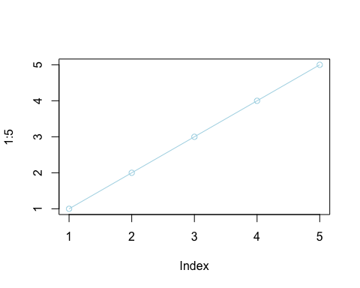

let’s insert a code chunk with the shortcut Option-CMD-i:

x <- c(1:10)  
x

## [1] 1 2 3 4 5 6 7 8 9 10

Here is my analysis of your new data. It looks ok.. the mean of your data is 5.5.

We will use the read.table function

x <- read.csv("test1.txt")

y <- read.table("test2.txt", header = TRUE, sep = "$")

z <- read.table("test3.txt")

## Our first function

This is an example function add withinputs ax and y

add <- function(x, y=1) {  
 # Sum the input x and y  
 x + y  
}

Let’s try to use it

add(x=c(1, 4, 7), y=4)

## [1] 5 8 11

rescale2 <- function(x) {  
 rng <-range(x, na.rm = TRUE)  
 (x - rng[1]) / (rng[2] - rng[1])  
}

rescale2(c(1:10, NA))

## [1] 0.0000000 0.1111111 0.2222222 0.3333333 0.4444444 0.5555556 0.6666667  
## [8] 0.7777778 0.8888889 1.0000000 NA

rescale <- function(x, na.rm=TRUE, plot=FALSE) {  
 if(na.rm) {  
 rng <-range(x, na.rm=TRUE)  
 } else {  
 rng <-range(x)  
 }  
 print("Hello")  
 answer <- (x - rng[1]) / (rng[2] - rng[1])  
 return(answer)  
 print("is it me you are looking for?")  
 if(plot) {  
 plot(answer, typ="b", lwd=4)  
 }  
 print("I can see it in ...")  
}

##rescale3(x)