Jasmin Revanna HW6

Jasmin Revanna

1/31/2020

library(bio3d)  
s1 <- read.pdb("4AKE") # kinase with drug

## Note: Accessing on-line PDB file

s2 <- read.pdb("1AKE") # kinase no drug

## Note: Accessing on-line PDB file  
## PDB has ALT records, taking A only, rm.alt=TRUE

s3 <- read.pdb("1E4Y") # kinase with drug

## Note: Accessing on-line PDB file

s1.chainA <- trim.pdb(s1, chain="A", elety="CA")  
s2.chainA <- trim.pdb(s2, chain="A", elety="CA")  
s3.chainA <- trim.pdb(s3, chain="A", elety="CA")  
  
s1.b <- s1.chainA$atom$b  
s2.b <- s2.chainA$atom$b  
s3.b <- s3.chainA$atom$b  
  
plotb3(s1.b, sse=s1.chainA, typ="l", ylab="Bfactor")

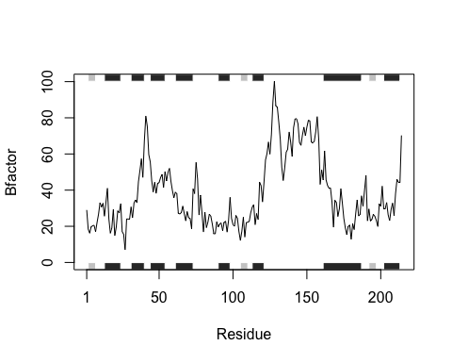

plotb3(s2.b, sse=s2.chainA, typ="l", ylab="Bfactor")

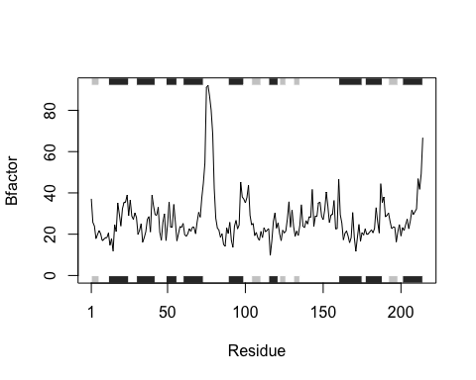

plotb3(s3.b, sse=s3.chainA, typ="l", ylab="Bfactor")

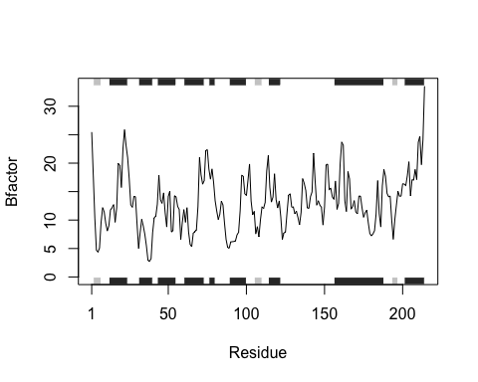

## Q6. How would you generalize the original code above to work with any set of input protein structures?

### I would isolate each function by breaking them down to the core (read pdb file -> trim residues from pdb ->

### get chain and atom columns from file -> plot the data on one graph to see similarties ->

### plot which protein structures are the most similar

compare <- function(x) {  
 #retrieve protein pdb file from the pdb database  
 readx <- read.pdb(x)  
 #trim the file to the parts we want  
 trimmedx <- trim.pdb(readx, chain="A", elety="CA")  
 #call on the column and rows we want to plot  
 atomx <- trimmedx$atom$b  
 #plot our graph as a line; X is the atom column and Y is the B factor.  
 plotb3(atomx, sse=trimmedx, typ="l", ylab="Bfactor")  
   
}

#create a vector of multiple PDB codes to run to gather all graphs together while only having to run the function once  
y <- ( c("4AKE", "1AKE", "1E4Y"))  
#the lapply function applies all parts of the list vector y to the function we created (compare) and runs the function  
lapply(y, compare)

## Note: Accessing on-line PDB file

## Warning in get.pdb(file, path = tempdir(), verbose = FALSE): /var/folders/9l/  
## czdvhdxj477bs50jw19b18c40000gn/T//Rtmpk9ky3o/4AKE.pdb exists. Skipping download

## Note: Accessing on-line PDB file

## Warning in get.pdb(file, path = tempdir(), verbose = FALSE): /var/folders/9l/  
## czdvhdxj477bs50jw19b18c40000gn/T//Rtmpk9ky3o/1AKE.pdb exists. Skipping download



## PDB has ALT records, taking A only, rm.alt=TRUE

## Note: Accessing on-line PDB file

## Warning in get.pdb(file, path = tempdir(), verbose = FALSE): /var/folders/9l/  
## czdvhdxj477bs50jw19b18c40000gn/T//Rtmpk9ky3o/1E4Y.pdb exists. Skipping download



## [[1]]  
## NULL  
##   
## [[2]]  
## NULL  
##   
## [[3]]  
## NULL