# 

# **Tasks**

**Learners have to develop a dashboard to support the answers to the following questions and suggestions for places for newer restaurants.**

**Objective Questions**:

1. What is the total no. of tables present in the data?

Ans: 2 tables

1. Restaurant Table
2. Country Table
3. What is the total no. of attributes present in the data?

Ans:20 attributes in 1st table

2 attributes in 2nd table

1. How many categorical columns are there in the data? [Search about categorical and continuous data, and try to answer this question]

Ans:

1. Restaurant
2. Country
3. Cuisines
4. Currency
5. Average Cost
6. Rating
7. Year of Opening
8. City
9. Price Range
10. Voters
11. Onine Delivery
12. Table Booking
13. Locality
14. The data consists of some inconsistent and missing values so ensure that the data used for further analysis is cleaned.

Added “American” to Cuisines Column for missing values because missing values was there for USA country only. And also added year column to find no. of restaurants opened each year using =LEFT(W2,4) function.

1. Using the LookUp functions, fill up the countries in the original data using the country code.

Ans: Done

=VLOOKUP(C:C,'country description'!A:B,2,0)

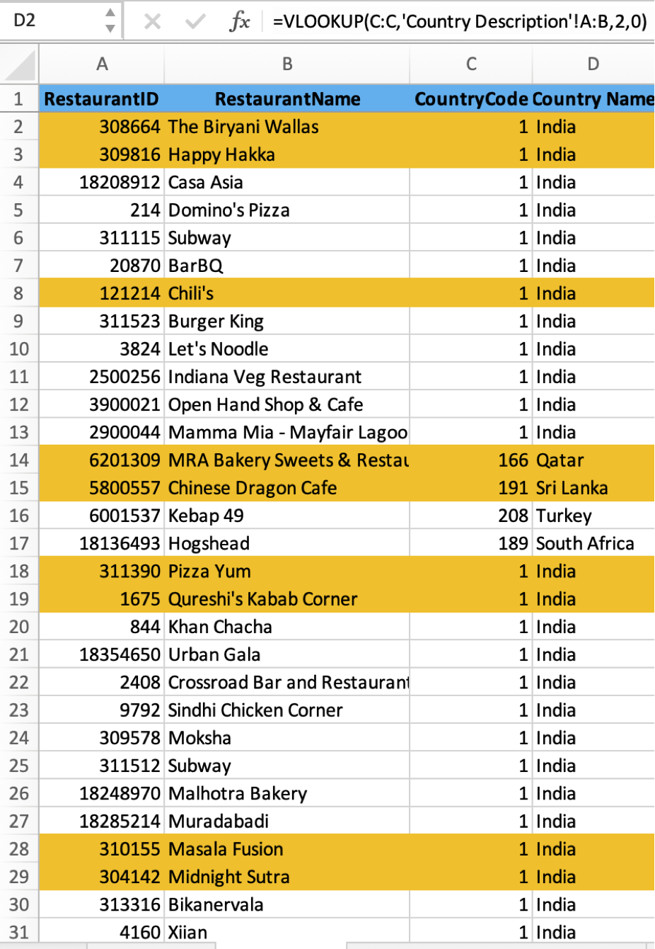

1. Create a table to represent the number of restaurants opened in each country.

Ans : For this I have used the pivot table. In which “Country Name” is putted in the rows and “Restaurant Id” is putted in value field and changed the field setting to count of “Restaurant Id” of pivot table, so that we can get count of restaurants for each country.

|  |  |
| --- | --- |
| **Country Name** | **Count of RestaurantID** |
| Australia | 24 |
| Brazil | 60 |
| Canada | 4 |
| India | 8652 |
| Indonesia | 21 |
| New Zealand | 40 |
| Philippines | 22 |
| Qatar | 20 |
| Singapore | 20 |
| South Africa | 60 |
| Sri Lanka | 20 |
| Turkey | 34 |
| United Arab Emirates | 60 |
| United Kingdom | 80 |
| United States of America | 434 |
| **Grand Total** | **9551** |

1. Also, the management wants to look at the number of restaurants opened each year, so provide them with something here.

Ans: For this I have used the pivot table. In which “Year of Opening” column is putted in the rows and “Restaurant Id” is putted in value field and changed the field setting to count of “Restaurant Id” of pivot table, so that we can get count of restaurants for each year.

|  |  |
| --- | --- |
| **Year** | **Count of RestaurantID** |
| 2010 | 1080 |
| 2011 | 1098 |
| 2012 | 1022 |
| 2013 | 1061 |
| 2014 | 1051 |
| 2015 | 1024 |
| 2016 | 1027 |
| 2017 | 1086 |
| 2018 | 1102 |
| **Grand Total** | **9551** |

1. What is the total number of restaurants in India in the price range of 4?

Ans: 388 =COUNTIFS('New Data'!D:D,"India",'New Data'!S:S,"4")

Using conditional aggregation function COUNTIFS we can achieve this, because we have to look for 2 criteria here, first one is where country is “India” and second one is having “price range” is equals to 4. So, I’ve putted the country name column range in criteria_range_1 (first parameter of COUNTIFS function), “India” in criteria1 (second parameter of COUNTIFS function), Price Range column range in criteria_range_2 (third parameter of COUNTIFS function) and “4” in criteria2 (fourth parameter of COUNTIFS function), to get the desired result as shown below.

1. What is the average number of voters for the restaurants in each country according to the data?

Ans: For this I have used the pivot table. In which “Country Name” column is putted in the rows and “Voters” is putted in value field and changed the field setting to average of “Restaurant Id” of pivot table, so that we can get average number of voters for the restaurants in each country.

|  |  |
| --- | --- |
| **Country Name** | **Average of Votes** |
| Australia | 111.42 |
| Brazil | 19.62 |
| Canada | 103.00 |
| India | 137.21 |
| Indonesia | 772.10 |
| New Zealand | 243.03 |
| Philippines | 407.41 |
| Qatar | 163.80 |
| Singapore | 31.90 |
| South Africa | 315.17 |
| Sri Lanka | 146.45 |
| Turkey | 431.47 |
| United Arab Emirates | 493.52 |
| United Kingdom | 205.49 |
| United States of America | 428.22 |
| **Grand Total** | **156.91** |

1. Calculate the average rating for all the restaurants that have price_range < 4 and provide online delivery. Use only the “IF” function, Logical Operators, and Aggregation functions to solve this problem. **[Note: Don’t use Conditional aggregation in this question.]**

Ans: 3.27381151

=AVERAGEIFS('New Data'!V:V,'New Data'!P:P,"Yes",'New Data'!S:S,"<4")

1. Using Conditional formatting highlight the rows of restaurants that are located in the countries or cities that you’ve suggested to the management for opening new restaurants.

Ans:

Highlighted row on following conditions:

1. Countries with less restaurants than 200.
2. Restaurants in that country which has rating >=3.
3. Restaurants in that country which has average price for 2 is Rs 800 and not Rs 0.
4. Votes(no. of persons visited) should be greater than 100 in that restaurants.
5. Create a new customized price column that consists of the abbreviation/symbol of the currency along with the Average_cost_for_two value. [Use string operations to do this task]

Ans: Done and new column name is Price =CONCAT(U2,N2)

1. How can you create an array formula in Excel or Google Sheets to count the number of restaurants listed that do not offer online delivery, are in the lowest price range, and have an average cost for two people less than or equal to 250 Indian Rupees?

Ans: 1720

=COUNTIFS('New Data'!P:P,"No",'New Data'!Z:Z,"<=250")

**Subjective Question:**

1. Suggest a few countries where the team can open newer restaurants with lesser competition. Which visualization/technique will you use here to justify the suggestions?

Ans: In the Raw data, state is not available ,so created a pivot with country and city in row and restaurants Id in value and used count function. Rating in value and used Average function. Filtered countries where the no. of restaurants is less than 50 and whose rating is less then 4.

After filtering got few countries and cities for opening new restaurants.And that 4 countries are Australia,Canada,Singapore and Sri Lanka.

|  |  |  |
| --- | --- | --- |
| **Country Name** | **Count of RestaurantID** | **Average of Rating** |
| Australia | 24 | 3.66 |
| Canada | 4 | 3.58 |
| Singapore | 20 | 3.58 |
| Sri Lanka | 20 | 3.87 |

1. Come up with the names of States and cities in the suggested countries suitable for opening restaurants.

Ans Listed all the cities in the selected countries along with average rating for the city.In that Pivot Table added the country column in row with their cities and average of rating in values.

Arranged data in ascending order of Rating then filtered out cities having rating less than 3.7 for lesser competition.As a result, found few cities from all suggested countries where we can open new restaurants.

|  |  |  |
| --- | --- | --- |
| **Country Name** | **City** | **Average of Rating** |
| **Canada** | Chatham-Kent | 3.70 |
|  | Consort | 3.00 |
| **Singapore** | Singapore | 3.58 |
| **Australia** | Armidale | 3.50 |
|  | Balingup | 3.20 |
|  | Dicky Beach | 3.60 |
|  | Forrest | 3.70 |
|  | Lorn | 3.60 |
|  | Macedon | 3.50 |
|  | Paynesville | 2.60 |
|  | Phillip Island | 3.70 |
|  | Victor Harbor | 3.60 |

1. According to the countries you suggested, what is the current quality regarding ratings for restaurants that are open there?

Ans: All details are given in question 2.

1. Also, what is the current expenditure on food in the suggested countries, so we can keep our financial expenditure in control?

Ans: For this question, First listed down currency of different currency in Country Description sheet and using VLOOKUP added that to original sheet.

=VLOOKUP(C2,'Country Description'!A:C,3,0)

Then added new column Price in (Rs.) multiplyimg country_rate and average_cost_of_two using =U2*E2

And created pivot table added country in Rows and Average of Price in Rs. In values and then filtered selected countries.

|  |  |
| --- | --- |
| **Country Name** | **Average of Price (Rs.)** |
| Australia | 1315.19 |
| Canada | 2221.04 |
| Singapore | 9648.71 |
| Sri Lanka | 641.25 |

1. Come up with the names of restaurants from the recommended states that are our biggest competitors and also those that are rated in the lower brackets, i.e. 1-2 or 2-3.

Ans: Created Pivot Table and used rating filter in both cases, more than 3.8 for Biggest Competitors and Less than 3.7 for no competitions. And also used filter on city.

1. Which cuisines should we focus on in the newer restaurants to get better feedback? Does the choice of cuisines affect the restaurant ratings?

Ans : First listed all the cuisines which are getting served in the selected countries along with average rating.Now I have selected cuisines rated below 3.8 for lesser competitions.

1. According to our current data, should we go for online delivery and table booking? Does that affect the customer’s ratings?

Ans: Created two different Pivot table for online delivery and for table booking.Created pie chart for better visualization.

|  |  |  |  |  |  |  |
| --- | --- | --- | --- | --- | --- | --- |
|  |  |  |  |  |  |  |
|  |  |  |  |  |  |  |
|  | **Has_Table_booking** | **Average of Rating** |  | **Has_Online_delivery** | **Average of Rating** |  |
|  | No | 2.81 |  | No | 2.75 |  |
|  | Yes | 3.48 |  | Yes | 3.29 |  |
|  |  |  |  |  |  |  |
| |  | | --- | |  | |  |  |  |  | | |
|  |  |  |  |
|  |  |  |  |
|  |  |  |  |
|  |  |  |  |
|  |  |  |  |
|  |  |  |  |
|  |  |  |  |
|  |  |  |  |
|  |  |  |  |
|  |  |  |  |
|  |  |  |  |
|  |  |  |  |
|  |  |  |  |  |  |  |

1. Should the team keep the rate of cuisines higher? Will that affect the feedback? According to our data are the rates of cuisines and ratings, correlated?

Ans Created Pivot Chart,Cuisines in row and average rating anf sum of price in values.

According to our data, the rates of cuisines and ratings are not directly correlated. But the quality and ratings are directly related. To get a higher rating, We must keep the rate of cuisines in the middle range and keep high quality cuisines in our newer Restaurants.

|  |  |  |
| --- | --- | --- |
| **Cuisines** | **Sum of Price_range** | **Average of Rating** |
| American | 95 | 3.76 |
| Cafe | 517 | 3.05 |
| Chinese | 525 | 2.41 |
| Continental | 63 | 3.61 |
| Desserts | 61 | 2.96 |
| Italian | 161 | 3.73 |

1. What is the distribution of the number of restaurants of different price ranges in all the countries?

Ans: Created Pivot Table to fetch different price range of restaurants of all the countries,add price range in row and restaurant count in value.

As a result, we can see that there are less no. of restaurants having higher pricerange.

|  |  |  |  |  |  |  |
| --- | --- | --- | --- | --- | --- | --- |
|  |  |  |  |  |  |  |
|  | **Price_range** | **Count of RestaurantID** | **Count of City** |  |  |  |
|  | 1 | 4444 | 4444 |  |  |  |
|  | 2 | 3113 | 3113 |  |  |  |
|  | 3 | 1408 | 1408 |  |  |  |
|  | 4 | 586 | 586 |  |  |  |
|  |  |  |  |  |  |  |
|  |  |  |  |  |  |  |
| |  | | --- | |  | |  |  |  |  |  |  |
|  |  |  |  |  |  |  |
|  |  |  |  |  |  |  |
|  |  |  |  |  |  |  |
|  |  |  |  |  |  |  |
|  |  |  |  |  |  |  |
|  |  |  |  |  |  |  |
|  |  |  |  |  |  |  |
|  |  |  |  |  |  |  |
|  |  |  |  |  |  |  |
|  |  |  |  |  |  |  |
|  |  |  |  |  |  |  |
|  |  |  |  |  |  |  |
|  |  |  |  |  |  |  |
|  |  |  |  |  |  |  |
|  |  |  |  |  |  |  |
|  |  |  |  |  |  |  |

1. Explain your approach in brief for suggesting countries/cities in order to open new restaurants, if the objective and subjective questions would have not been given to assist you. **[you have to give bullet pointers in order to answer this question]**

**Ans:**

**Main Findings**

* Three main findings emphasize on the following:

1. Higher the number of services/cuisines provided by a restaurant, more likely it is to receive higher ratings.
2. Variety & quality of cuisines attracts the customers.
3. Higher Cost-for-2 for a Restaurant, the less likely it is to be popular.

**Conclusion**

1. Top 4 selected countries for our expansion are Australia, Canada, Singapore, Sri Lanka.
2. Our Major Focus will be on Australia, As this Country has most suitable cities.
3. In our newer restaurants, we should focus majorly on American food, Italian food and Continental food. The Choice and variety of Cuisines affects the restaurant ratings.
4. To get a higher rating, We must keep the rate of cuisines in the middle range and keep high quality cuisines in our newer Restaurants.
5. We must offer more services like online delivery and table booking to increase the customer’s ratings because customers enjoy additional ease & convenience in their dining experience.

**The dashboard must consist of Year-wise and country slicers.**

