Presenter Guide — Part 3
Meteorological Confound & Spatial Variation
Air Quality After Policy Intervention: Beijing’s Pollution Trends After the 2013 Clean Air Action Plan
Notebook & analysis by Kishan Batra • Prepared for Jasmin Zheng (presenter)
Bottom line (if you remember one thing)
Weather is a first-order driver of Beijing’s PM2.5. Once we hold the weather fixed — looking only at calm, stagnant days — the 2014→2016 PM2.5 “improvement” disappears. A large part of the headline −17% decline is simply that 2016 was windier than 2014, not that emissions fell.
This is exactly what our hypothesis predicted: PM2.5’s improvement is real but modest and partly a weather effect, unlike SO₂ (Part 2), whose >50% drop is far too big to be weather.

Where Part 3 fits
Part 1 showed PM2.5 swings far more within a year (seasons, time of day) than between years — so raw annual averages are shaky. Part 2 measured the trend and found SO2 fell most clearly, with PM2.5 declining a more modest ~17%. My job in Part 3 is the reality check: is that PM2.5 decline actually cleaner air, or did the weather just cooperate? I answer it in four figures — two that measure how strongly weather controls PM2.5, one that maps where in the city the pollution sits, and one that puts the decline to the test.

Walking through the four figures

Figure 1 — PM2.5 falls sharply as wind speed rises
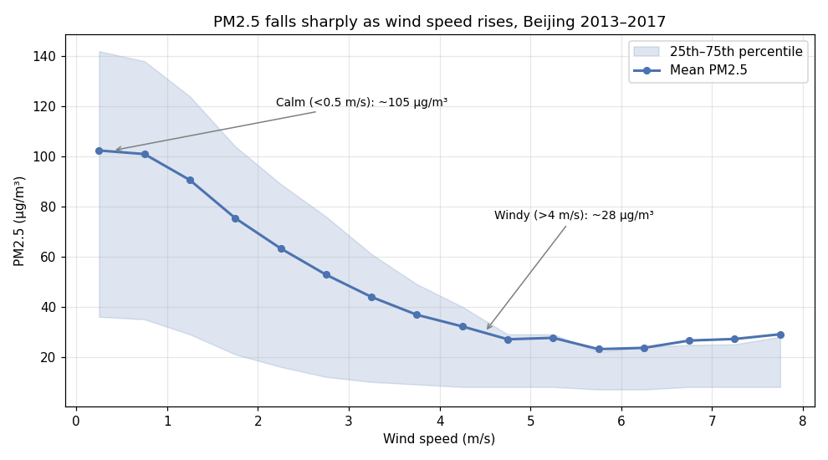
What I did: Binned every hour by its wind speed and plotted mean PM2.5 in each bin; the shaded band is the 25th–75th percentile spread.
What it shows: A steep, curved inverse relationship — stronger wind ventilates the air and dilutes the particles.
Numbers to quote:
- Calm hours (<0.5 m/s): mean PM2.5 ≈ 105 µg/m³
- Windy hours (>4 m/s): mean PM2.5 ≈ 28 µg/m³ — about a 3.5× drop
- Overall correlation r = −0.27 (understates it because the curve is non-linear)
Say this:
“Wind is the single biggest lever on fine-particle pollution here. On near-calm hours the average is around 105 micrograms; once the wind picks up past about 4 metres per second it falls to under 30 — a factor of three and a half. And notice the spread collapses too: calm air can be clean or catastrophic, but windy air is reliably clean. So if one year is just windier than another, it will look cleaner even with identical emissions. Hold that thought — it’s the whole point of my last figure.”

Figure 2 — The pollution rose: where the dirty air comes from
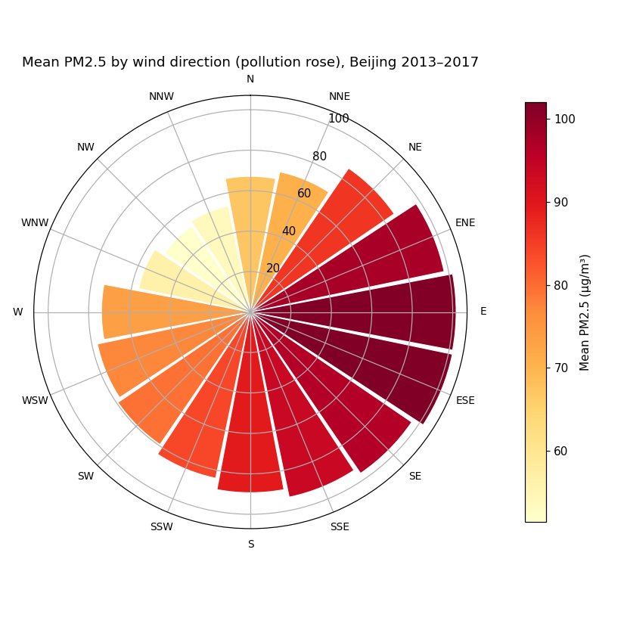
What I did: For each of the 16 compass directions, computed the mean PM2.5 when the wind blows from that direction. Bar length and colour both encode concentration.
What it shows: A strong directional asymmetry set by Beijing’s geography — industrial plain to the southeast, clean mountains to the northwest.
Numbers to quote:
- Dirtiest: E / ESE / ENE ≈ 100 µg/m³ (air off the industrial North China Plain)
- Cleanest: NW / WNW / NNW ≈ 51 µg/m³ (air descending off the mountains) — roughly half
Say this:
“Direction matters as much as speed, because it decides which air arrives. When the wind comes from the east and south-east — off the heavily industrialised plain — we average around 100 micrograms. When it swings round to the north-west, clean mountain air, it’s about half that. So that’s a second, independent way the weather sets our pollution: a year with more south-easterly flow looks worse, a year with more north-westerly flushing looks better — again, regardless of emissions.”

Figure 3 — Urban core vs. background stations
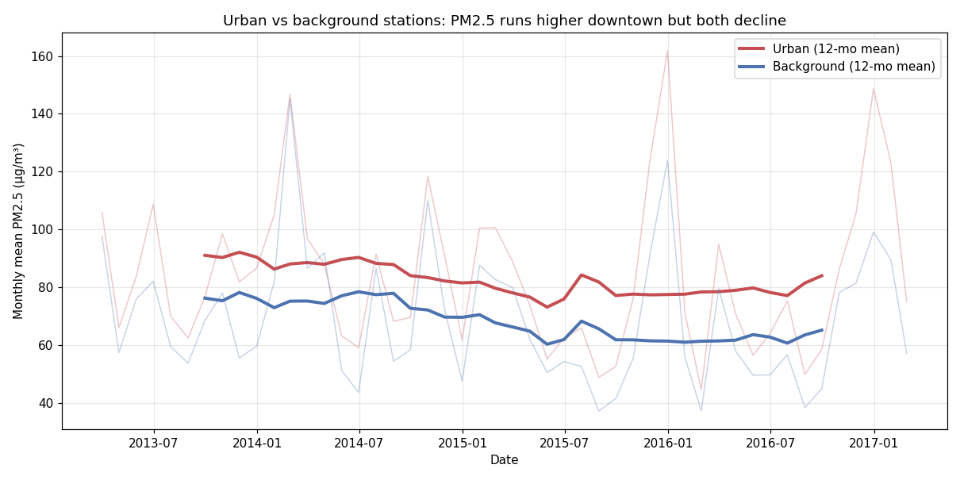
What I did: Split the 12 stations into an urban core (Dongsi, Tiantan, Wanshouxigong, Guanyuan) and background sites (Dingling, Huairou, Changping), and plotted each group’s monthly mean with a 12-month smoothed line.
What it shows: The core is persistently dirtier, but both groups fall together — the decline is citywide, not an artefact of a few stations.
Numbers to quote:
- Urban core averages ~11–17 µg/m³ higher than background throughout, and the gap does not close
- 2014→2016: urban −12%, background −21% — both improve; background improves more in relative terms
Say this:
“These stations aren’t interchangeable. The downtown core — more traffic, more people — runs consistently 11 to 17 micrograms above the suburban background sites, and that gap stays open. But the key point is that both groups come down together, so the improvement Part 2 found is a genuine citywide signal, not just a couple of stations. Interestingly the background sites improve a bit more in percentage terms — they’re less dominated by local traffic, so they respond more visibly to region-wide changes.”

Figure 4 — Does the decline survive the weather? (the key figure)
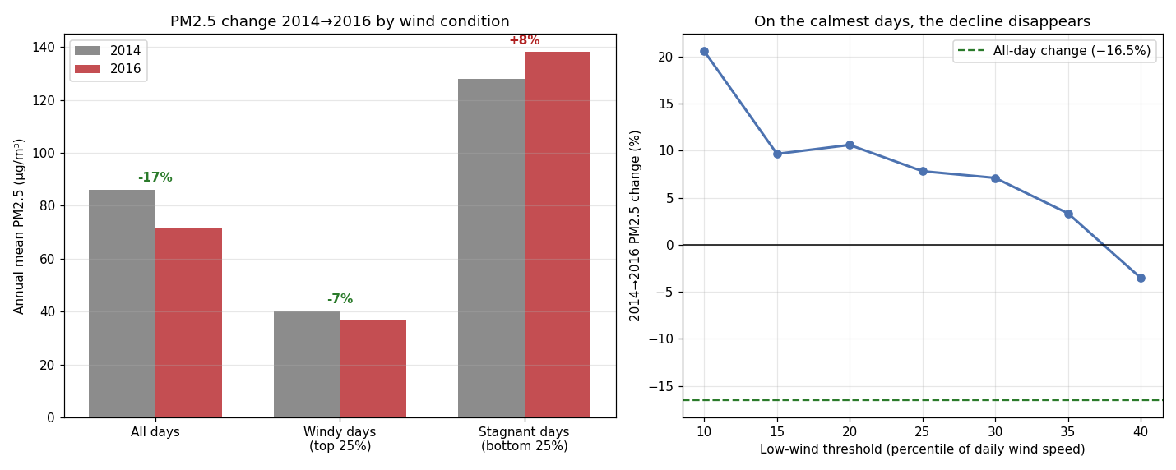
What I did: Built a daily citywide series, defined stagnant days as the calmest 25% of days (a fixed cutoff, 1.24 m/s), then recomputed the 2014→2016 change on all days, windy days, and stagnant days. The right panel checks that the result holds no matter where the low-wind line is drawn.
What it shows: The decline is concentrated on windy days and vanishes on calm days — because 2016 was simply less stagnant than 2014.
Numbers to quote:
- All days: −17% • Windy days: −7% • Stagnant days: +8% (flat-to-worse)
- Mean daily wind rose 1.64 → 1.84 m/s (2014→2016); stagnant days fell 98 → 72
- Right panel: across every low-wind cutoff (calmest 10–30%), the change stays at/above zero — nowhere near −17%
Say this:
“This is the test. If the improvement were really about cleaner emissions, it should show up even on stagnant days — the days when there’s no wind to rescue us. It doesn’t. On all days PM2.5 fell about 17%; on windy days only about 7%; and on the calmest quarter of days it actually ticked up. The reason is on the left: 2016 was genuinely windier, with 72 stagnant days versus 98 in 2014. So a real chunk of that headline 17% is just better weather. The right-hand panel shows this isn’t me cherry-picking a threshold — wherever you draw the calm-day line, the decline stays near zero.”
One honesty note if asked: stagnant-day means rest on ~70–100 days a year and are dominated by a few extreme haze episodes, so the exact +8% is noisy. The robust claim is the direction — the decline is weather-aided and doesn’t hold on calm days.

How this answers our question
Our hypothesis was that coal-linked SO2 fell sharply and cleanly, while PM2.5 improved more modestly and was partly masked — and, it turns out, partly flattered — by the weather. Part 3 confirms exactly that. PM2.5 is heavily weather-controlled (Figures 1–2), the decline is citywide and real (Figure 3), but a substantial share of the 2014→2016 improvement is favourable meteorology rather than emissions (Figure 4). That’s the clean contrast with SO2, which Part 2 showed falling by more than half — a drop far too large for wind to explain. So across all three notebooks the story is consistent: SO2 is the unambiguous policy signal; PM2.5’s gain is real but genuinely entangled with the weather.

If someone asks…
Q. Why define stagnant days as the calmest 25%?
A. It’s a simple, transparent cutoff, and I fixed it across the whole record so 2014 and 2016 are judged on the same yardstick. The right panel of Figure 4 shows the conclusion doesn’t depend on that choice.
Q. Aren’t you just saying the policy did nothing?
A. No. The decline is real and citywide (Figure 3), and SO2 fell dramatically (Part 2). The point is narrower: the size of the raw PM2.5 drop overstates the emissions part, because 2016’s weather helped.
Q. Could this be a data artefact?
A. Missing data is tiny (~2% PM2.5, <0.1% wind speed). Wind speed and direction come co-located with the pollutant measurements, and the pattern is consistent across all 12 stations.
Q. Why does PM2.5 rise on stagnant days but SO2 still fell overall?
A. Different sources and chemistry. SO2 is tied directly to coal burning, which the policy cut hard; PM2.5 has many sources and is far more sensitive to how well the atmosphere disperses it, so weather leaves a bigger fingerprint.

The 30-second version
If you’re short on time, say only this:
“Wind controls Beijing’s PM2.5 — calm air is three-and-a-half times dirtier than windy air, and the dirtiest air blows in from the industrial south-east. The pollution fell citywide from 2014 to 2016, but when I isolate the calm, stagnant days, the improvement disappears — because 2016 was simply windier. So PM2.5’s decline is real but partly a weather effect, exactly as we predicted — unlike SO2, which fell far too much to be anything but the policy.”

