WEEK 2 - PL/SQL PROGRAMMING -HANDS ON - EXERCISES

**Exercise-1: Control Structures**

**Scenario-1:***The bank wants to apply a discount to loan interest rates for customers above 60 years old.*

**Question:** *Write a PL/SQL block that loops through all customers, checks their age, and if they are above 60, apply a 1% discount to their current loan interest rates.*

**Query:**

DECLARE

    TYPE customer_record IS RECORD (

        customer_id NUMBER,

        name VARCHAR2(100),

        age NUMBER,

        loan_interest_rate NUMBER

    );

    TYPE customer_table IS TABLE OF customer_record;

    customers customer_table;

  new_customer_id NUMBER;

    new_name VARCHAR2(100);

    new_age NUMBER;

    new_loan_interest_rate NUMBER;

BEGIN

    customers := customer_table(

        customer_record(1, 'Sri', 65, 5.00),

        customer_record(2, 'Ram', 72, 4.50),

        customer_record(3, 'Sitha', 58, 6.00),

        customer_record(4, 'Krishna', 62, 3.75),

        customer_record(5, 'Rukmini', 54, 5.25)

    );

    FOR i IN 1 .. customers.COUNT LOOP

        new_customer_id := customers(i).customer_id;

        new_name := customers(i).name;

        new_age := customers(i).age;

        new_loan_interest_rate := customers(i).loan_interest_rate;

        IF new_age > 60 THEN

            new_loan_interest_rate := new_loan_interest_rate * 0.99;

            DBMS_OUTPUT.PUT_LINE('Updated customer ID: ' || new_customer_id ||

                                 ', Name: ' || new_name ||

                                 ', Age: ' || new_age ||

                                 ' - New interest rate: ' || new_loan_interest_rate);

        END IF;

    END LOOP;

EXCEPTION

    WHEN OTHERS THEN

        DBMS_OUTPUT.PUT_LINE('An error occurred: ' || SQLERRM);

END;

**OUTPUT:**

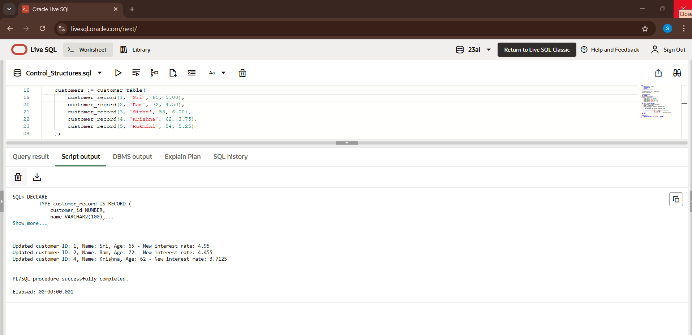

**Scenario-2:**  *A customer can be promoted to VIP status based on their balance.*

**Question:** *Write a PL/SQL block that iterates through all customers and sets a flag IsVIP to TRUE for those with a balance over $10,000.*

**Query:**

DECLARE

    TYPE customer_type IS RECORD (

        customer_id NUMBER,

        name VARCHAR2(100),

        balance NUMBER,

        is_vip BOOLEAN

    );

    TYPE customer_table IS TABLE OF customer_type;

    customers customer_table := customer_table(

        customer_type(1, 'Raghu',  11000, FALSE),

        customer_type(2, 'Maithili', 9000, FALSE),

        customer_type(3, 'Shyam', 19000, FALSE),

        customer_type(4, 'Satya', 25000, FALSE),

        customer_type(5, 'Mithra', 8000, FALSE)

    );

    vip_threshold CONSTANT NUMBER := 10000;

BEGIN

    DBMS_OUTPUT.PUT_LINE('VIP Promotion Processing');

    DBMS_OUTPUT.PUT_LINE('------------------------');

    FOR i IN 1..customers.COUNT LOOP

        IF customers(i).balance > vip_threshold THEN

            customers(i).is_vip := TRUE;

            DBMS_OUTPUT.PUT_LINE('Promoted to VIP: ' || customers(i).name ||

                                ' (Balance: $' || customers(i).balance || ')');

        ELSE

            DBMS_OUTPUT.PUT_LINE('Not qualified: ' || customers(i).name ||

                                ' (Balance: $' || customers(i).balance || ')');

        END IF;

    END LOOP;

    DBMS_OUTPUT.PUT_LINE(CHR(10) || 'Final VIP Status:');

    DBMS_OUTPUT.PUT_LINE('-----------------');

    FOR i IN 1..customers.COUNT LOOP

        DBMS_OUTPUT.PUT_LINE(

            RPAD(customers(i).name, 15) || ' | ' ||

            RPAD('$' || customers(i).balance, 10) || ' | ' ||

            CASE WHEN customers(i).is_vip THEN 'VIP' ELSE 'Not a VIP' END

        );

    END LOOP;

EXCEPTION

    WHEN OTHERS THEN

        DBMS_OUTPUT.PUT_LINE('Error: ' || SQLERRM);

END;

/

**OUTPUT:**

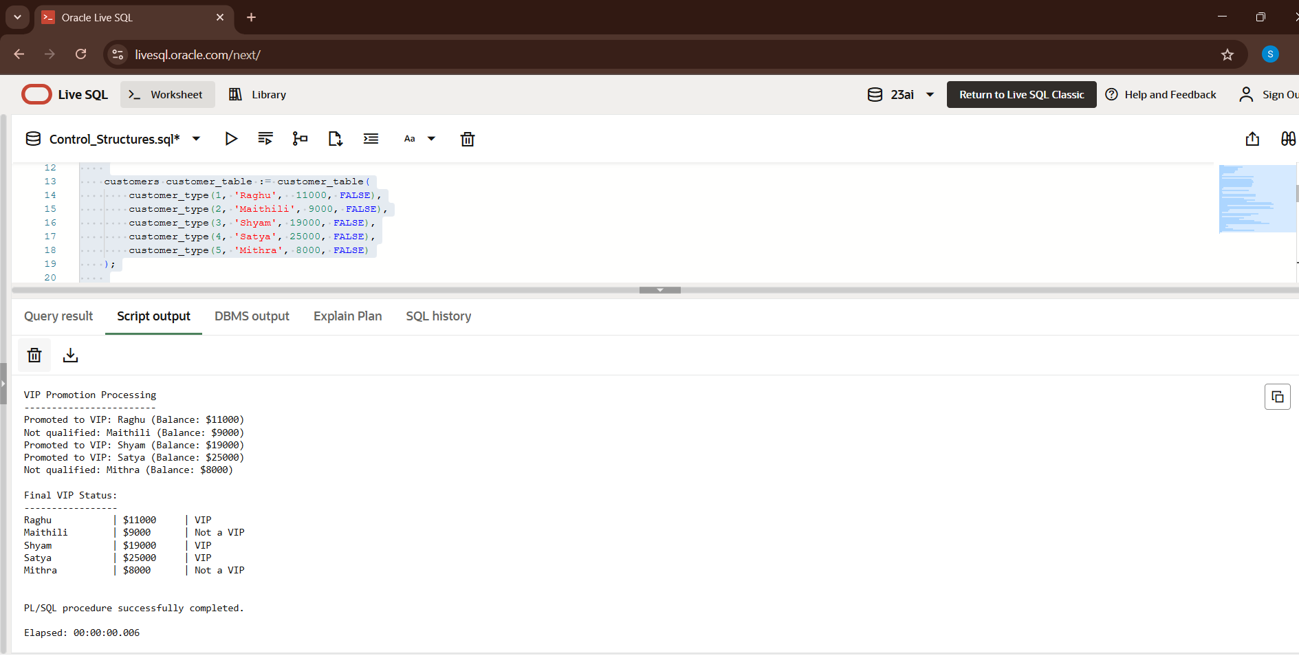

**Scenario 3:** *The bank wants to send reminders to customers whose loans are due within the next 30 days*.

**Question:** *Write a PL/SQL block that fetches all loans due in the next 30 days and prints a reminder message for each customer.*

**Query:**

DECLARE

    TYPE loan_type IS RECORD (

        loan_id NUMBER,

        customer_name VARCHAR2(100),

        due_date DATE,

        amount NUMBER,

        is_reminder_sent BOOLEAN

    );

    TYPE loan_table IS TABLE OF loan_type;

    loans loan_table := loan_table(

        loan_type(101, 'Gopal', SYSDATE + 15, 3000, FALSE),

        loan_type(102, 'Sakshi', SYSDATE + 60, 6000, FALSE),

        loan_type(103, 'Priya', SYSDATE + 28, 13000, FALSE),

        loan_type(104, 'Devansh', SYSDATE + 31, 4000, FALSE)

    );

    c_reminder_days CONSTANT NUMBER := 30;

    BEGIN

    DBMS_OUTPUT.PUT_LINE('LOAN REMINDER PROCESSING');

    DBMS_OUTPUT.PUT_LINE('------------------------');

    FOR i IN 1..loans.COUNT LOOP

        IF loans(i).due_date <= SYSDATE + c_reminder_days THEN

            loans(i).is_reminder_sent := TRUE;

            DBMS_OUTPUT.PUT_LINE('REMINDER: ' || loans(i).customer_name ||

                                CHR(10) || 'Loan ID: ' || loans(i).loan_id ||

                                CHR(10) || 'Amount Due: $' || loans(i).amount ||

                                CHR(10) || 'Due Date: ' || TO_CHAR(loans(i).due_date, 'DD-MON-YYYY') ||

                                CHR(10) || 'Days Remaining: ' || (loans(i).due_date - SYSDATE) ||

                                CHR(10) || '-----------------------------------');

        END IF;

END LOOP;

    DBMS_OUTPUT.PUT_LINE(CHR(10) || 'REMINDER SUMMARY');

    DBMS_OUTPUT.PUT_LINE('----------------');

        FOR i IN 1..loans.COUNT LOOP

        DBMS_OUTPUT.PUT_LINE(

            RPAD(loans(i).customer_name, 20) || ' | ' ||

            RPAD('#' || loans(i).loan_id, 10) || ' | ' ||

            RPAD(TO_CHAR(loans(i).due_date, 'DD-MON'), 10) || ' | ' ||

            CASE WHEN loans(i).is_reminder_sent THEN 'REMINDER SENT' ELSE 'Scheduled for Later' END

        );

    END LOOP;

    EXCEPTION

    WHEN OTHERS THEN

        DBMS_OUTPUT.PUT_LINE('Error processing reminders: ' || SQLERRM);

END;

/

**OUTPUT:**

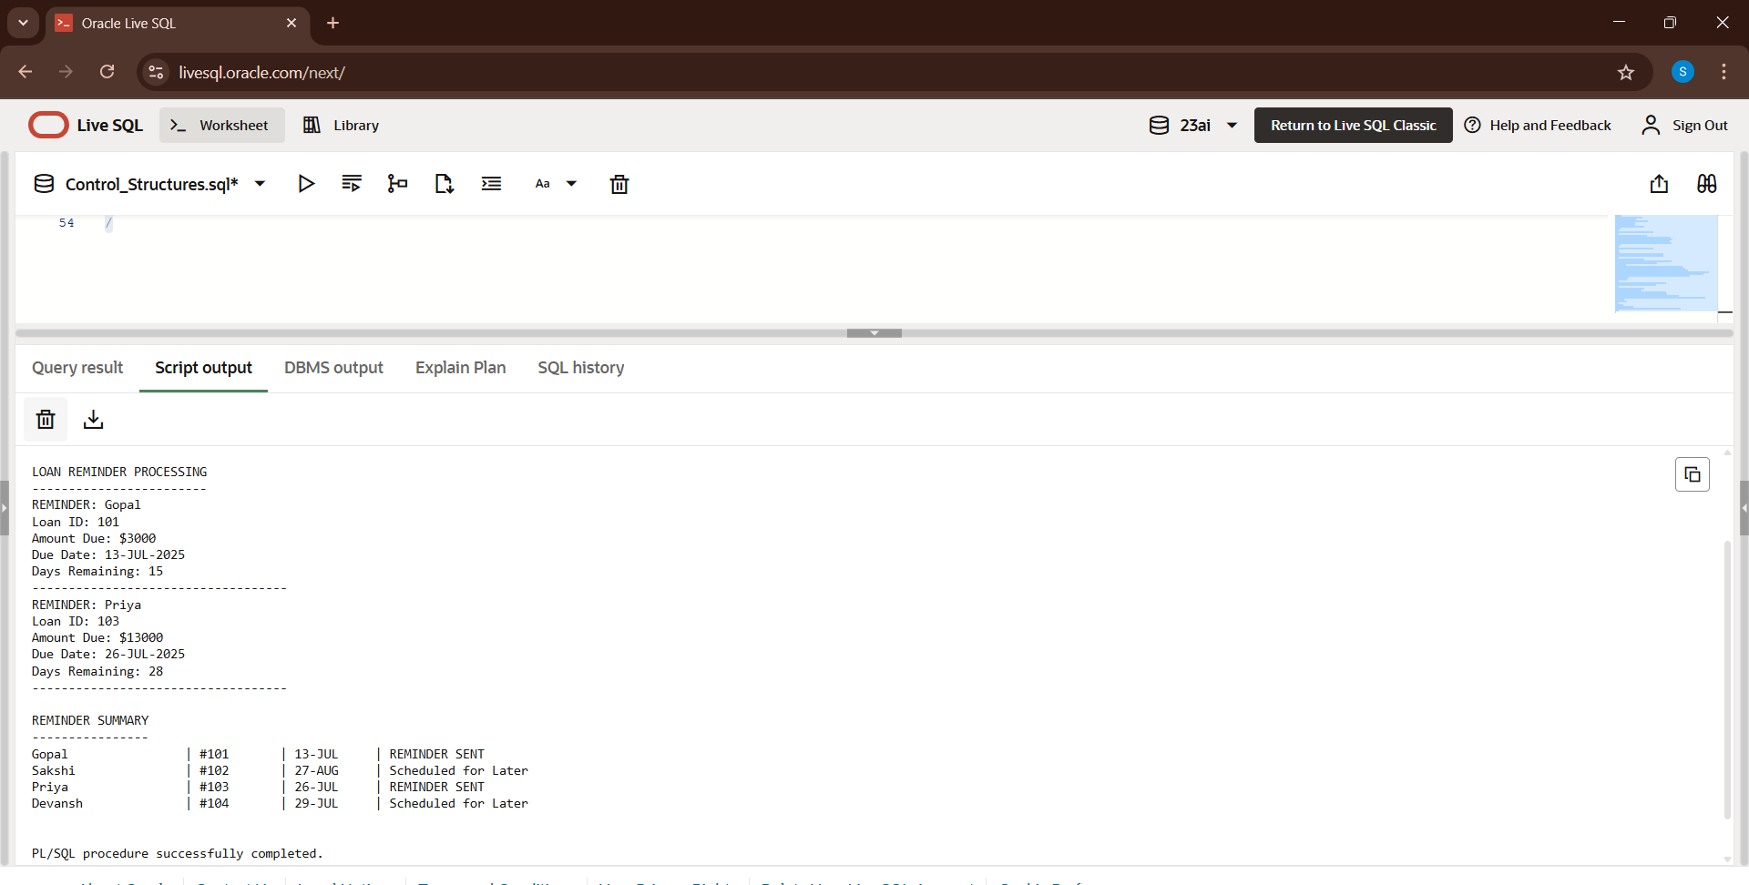

**Exercise 3: Stored Procedures**

**Scenario 1:** *The bank needs to process monthly interest for all savings accounts.*

**Question:** *Write a stored procedure* ***ProcessMonthlyInterest*** *that calculates and updates the balance of all savings accounts by applying an interest rate of 1% to the current balance.*

**Query:**

DECLARE

   TYPE AccountRecord IS RECORD (

      account_id NUMBER,

      account_holder VARCHAR2(100),

      balance NUMBER(10, 2),

      last_interest_date DATE

   );

   TYPE AccountTable IS TABLE OF AccountRecord INDEX BY PLS_INTEGER;

   accounts AccountTable;

   PROCEDURE ProcessMonthlyInterest IS

      v_interest_rate CONSTANT NUMBER := 0.01;

   BEGIN

      FOR i IN 1 .. accounts.COUNT LOOP

         accounts(i).balance := accounts(i).balance * (1 + v_interest_rate);

         accounts(i).last_interest_date := SYSDATE;

      END LOOP;

      DBMS_OUTPUT.PUT_LINE('Applied 1% interest to all savings accounts.');

   END ProcessMonthlyInterest;

BEGIN

   accounts(1) := AccountRecord(1, 'Aadya', 25000.00, NULL);

   accounts(2) := AccountRecord(2, 'Shiv', 10000.00, NULL);

   accounts(3) := AccountRecord(3, 'Arnav', 19500.00, NULL);

   DBMS_OUTPUT.PUT_LINE('=== Initial Balances ===');

   FOR i IN 1 .. accounts.COUNT LOOP

      DBMS_OUTPUT.PUT_LINE(

         RPAD(accounts(i).account_holder, 15) || ': $' ||

         TO_CHAR(accounts(i).balance, '999,990.00')

      );

   END LOOP;

   ProcessMonthlyInterest();

   DBMS_OUTPUT.PUT_LINE('=== Balances After Interest ===');

   FOR i IN 1 .. accounts.COUNT LOOP

      DBMS_OUTPUT.PUT_LINE(

         RPAD(accounts(i).account_holder, 15) || ': $' ||

         TO_CHAR(accounts(i).balance, '999,990.00')

      );

   END LOOP;

END;

/

**OUTPUT:**

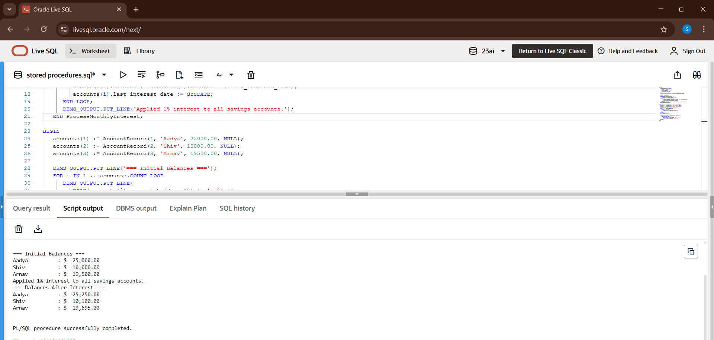

**Scenario 2:** *The bank wants to implement a bonus scheme for employees based on their performance.*

**Question:** *Write a stored procedure* ***UpdateEmployeeBonus*** *that updates the salary of employees in a given department by adding a bonus percentage passed as a parameter.*

**Query:**

DECLARE

   TYPE EmployeeRecord IS RECORD (

      employee_id NUMBER,

      employee_name VARCHAR2(100),

      department VARCHAR2(50),

      salary NUMBER(10, 2),

      bonus_percentage NUMBER(5, 2),

      updated_salary NUMBER(10, 2)

   );

   TYPE EmployeeTable IS TABLE OF EmployeeRecord INDEX BY PLS_INTEGER;

   employees EmployeeTable;

   PROCEDURE UpdateEmployeeBonus(

      p_dept VARCHAR2,

      p_bonus_percent NUMBER

   ) IS

   BEGIN

      DBMS_OUTPUT.PUT_LINE('Applying ' || p_bonus_percent || '% bonus to ' || p_dept || ' department');

      FOR i IN 1..employees.COUNT LOOP

         IF employees(i).department = p_dept THEN

            employees(i).bonus_percentage := p_bonus_percent;

            employees(i).updated_salary := employees(i).salary * (1 + p_bonus_percent/100);

            DBMS_OUTPUT.PUT_LINE(' - ' || employees(i).employee_name ||

                               ': ' || employees(i).salary || ' → ' ||

                               employees(i).updated_salary);

         END IF;

      END LOOP;

   END UpdateEmployeeBonus;

BEGIN

   employees(1) := EmployeeRecord(101, 'Raj', 'Sales', 50000, 0, 50000);

   employees(2) := EmployeeRecord(102, 'Kritika', 'Sales', 45000, 0, 55000);

   employees(3) := EmployeeRecord(103, 'Sameer', 'IT', 60000, 0, 60000);

   employees(4) := EmployeeRecord(104, 'purvi', 'HR', 30000, 0, 45000);

   employees(5) := EmployeeRecord(105, 'Viswa', 'IT', 75000, 0, 65000);

   DBMS_OUTPUT.PUT_LINE('=== Initial Salaries ===');

   FOR i IN 1..employees.COUNT LOOP

      DBMS_OUTPUT.PUT_LINE(

         RPAD(employees(i).employee_name, 15) ||

         RPAD(' (' || employees(i).department || ')', 10) ||

         ': $' || TO_CHAR(employees(i).salary, '999,990.00')

      );

   END LOOP;

   UpdateEmployeeBonus('Sales', 10);

   UpdateEmployeeBonus('IT', 5);

   DBMS_OUTPUT.PUT_LINE('=== Updated Salaries ===');

   FOR i IN 1..employees.COUNT LOOP

      DBMS_OUTPUT.PUT_LINE(

         RPAD(employees(i).employee_name, 15) ||

         RPAD(' (' || employees(i).department || ')', 10) ||

         ': $' || TO_CHAR(employees(i).updated_salary, '999,990.00')

      );

   END LOOP;

END;

/

**OUTPUT:**

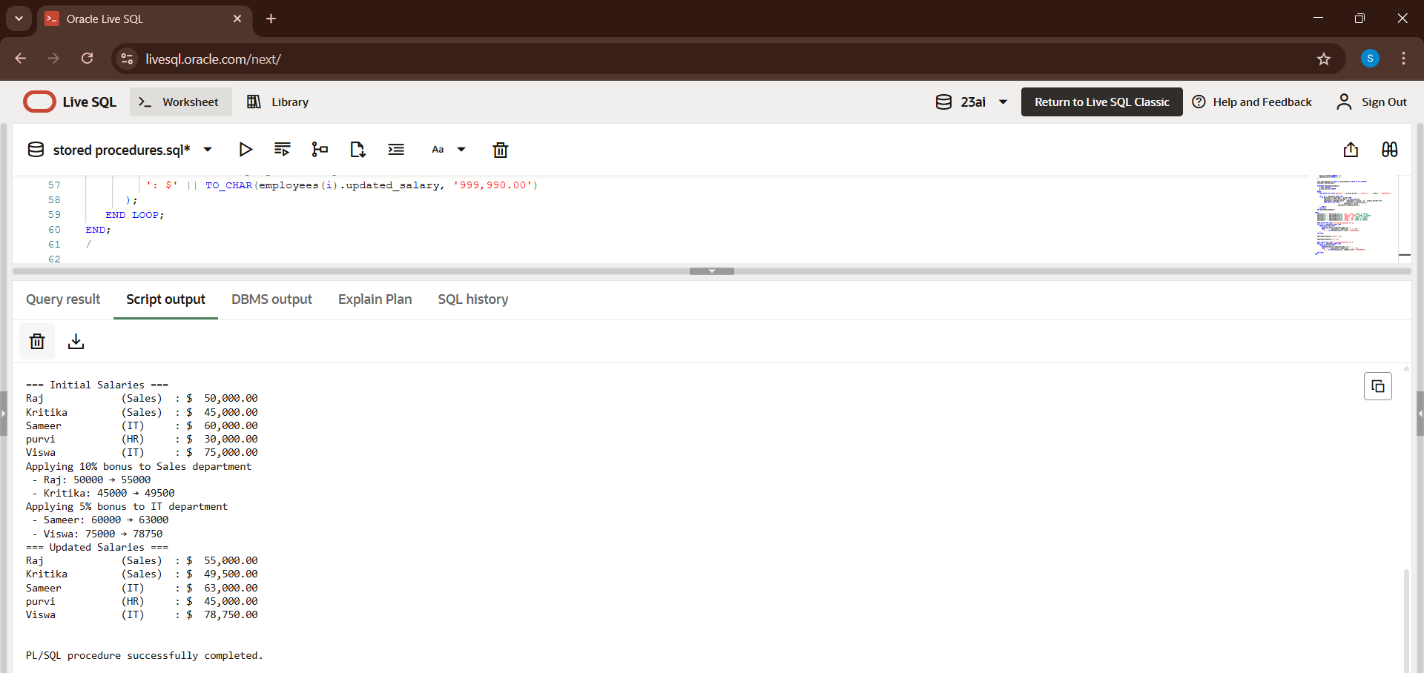

**Scenario 3:** Customers should be able to transfer funds between their accounts.

**Question:** *Write a stored procedure* ***TransferFunds*** *that transfers a specified amount from one account to another, checking that the source account has sufficient balance before making the transfer.*

***Query:***

DECLARE

   TYPE AccountRecord IS RECORD (

      account_id NUMBER,

      account_holder VARCHAR2(100),

      balance NUMBER(10, 2)

   );

   TYPE AccountTable IS TABLE OF AccountRecord INDEX BY PLS_INTEGER;

   accounts AccountTable;

   PROCEDURE TransferFunds(

      p_from_account_id NUMBER,

      p_to_account_id NUMBER,

      p_amount NUMBER

   ) IS

      v_from_balance NUMBER;

      v_to_balance NUMBER;

      v_from_account_found BOOLEAN := FALSE;

      v_to_account_found BOOLEAN := FALSE;

   BEGIN

      FOR i IN 1 .. accounts.COUNT LOOP

         IF accounts(i).account_id = p_from_account_id THEN

            v_from_balance := accounts(i).balance;

            v_from_account_found := TRUE;

         ELSIF accounts(i).account_id = p_to_account_id THEN

            v_to_balance := accounts(i).balance;

            v_to_account_found := TRUE;

         END IF;

      END LOOP;

      IF NOT v_from_account_found THEN

         DBMS_OUTPUT.PUT_LINE('Error: Source account not found.');

         RETURN;

      ELSIF NOT v_to_account_found THEN

         DBMS_OUTPUT.PUT_LINE('Error: Destination account not found.');

         RETURN;

      END IF;

      IF v_from_balance < p_amount THEN

         DBMS_OUTPUT.PUT_LINE('Error: Insufficient balance in source account.');

         RETURN;

      END IF;

      FOR i IN 1 .. accounts.COUNT LOOP

         IF accounts(i).account_id = p_from_account_id THEN

            accounts(i).balance := accounts(i).balance - p_amount;

         ELSIF accounts(i).account_id = p_to_account_id THEN

            accounts(i).balance := accounts(i).balance + p_amount;

         END IF;

      END LOOP;

      DBMS_OUTPUT.PUT_LINE('Transfer successful: $' || p_amount ||

                           ' transferred from account ' || p_from_account_id ||

                           ' to account ' || p_to_account_id);

   END TransferFunds;

BEGIN

   accounts(1) := AccountRecord(101, 'Ankith', 13000.00);

   accounts(2) := AccountRecord(102, 'Pragna', 16400.00);

   accounts(3) := AccountRecord(103, 'Sagar', 9300.00);

   DBMS_OUTPUT.PUT_LINE('=== Initial Balances ===');

   FOR i IN 1 .. accounts.COUNT LOOP

      DBMS_OUTPUT.PUT_LINE(

         'Account ID: ' || accounts(i).account_id ||

         ', Holder: ' || accounts(i).account_holder ||

         ', Balance: $' || TO_CHAR(accounts(i).balance, '999,990.00')

      );

   END LOOP;

   TransferFunds(101, 102, 1600);

   TransferFunds(102, 103, 1000);

   TransferFunds(101, 103, 3800);

   DBMS_OUTPUT.PUT_LINE('=== Updated Balances ===');

   FOR i IN 1 .. accounts.COUNT LOOP

      DBMS_OUTPUT.PUT_LINE(

         'Account ID: ' || accounts(i).account_id ||

         ', Holder: ' || accounts(i).account_holder ||

         ', Balance: $' || TO_CHAR(accounts(i).balance, '999,990.00')

      );

   END LOOP;

END;

/

**OUTPUT:**

