VISVESVARAYA TECHNOLOGICAL UNIVERSITY
Jnana Sangama, Belgaum-590018


Mini Project Report
On
“Patient Health Management System:
Care Connect Hub”
Submitted in partial fulfilment of the requirements for the
First Semester of the Bachelor of Engineering Degree, towards the completion of the Mini
Project under the Innovation & Design Thinking Laboratory,
Department of Basic Sciences.

By

SN | Name | USN
1 | Himanshu Atal | 1CR25CD022
2 | Jasmitha V | 1CR25CD023
3 | Kanikicharla Lakshmi Vaishnavi | 1CR25CD024

Under the Guidance of
Prof. Shrinidhi Hegde Dept. AI-DS, CMRIT

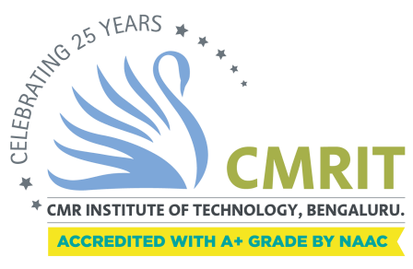

CMR INSTITUTE OF TECHNOLOGY
#132, AECS LAYOUT, IT PARK ROAD, KUNDALAHALLI,
BANGALORE-560037

DEPARTMENT OF BASIC SCIENCES


CERTIFICATE

This is to certify that the project entitled "Care Connect Hub" has been successfully carried out by Himanshu Atal (1CR25CD022), Jasmitha V (1CR25CD023), and Kanikicharla Lakshmi Vaishnavi (1CR25CD024), bona fide students of CMR Institute of Technology.
The project is submitted in partial fulfilment of the requirements for the First Semester of the Bachelor of Engineering Degree, towards the completion of the Mini Project under the Innovation & Design Thinking Laboratory, Department of Basic Sciences.
It is further certified that all corrections and suggestions indicated during the Internal Assessment have been duly incorporated in the project report submitted to the departmental library. This File Structures mini-project report has been reviewed and approved, as it satisfies the academic requirements prescribed for the said degree.

----------------------- ---------------------- Signature of Guide Signature of HOD
Prof. Shrinidhi Hegde Dr. Raveesha KH, HOD,
Dept. of AI-DS, CMRIT Dept. of Physics, CMRIT

External Viva
Name of the examiners Signature with date
1.
2.

ACKNOWLEDGEMENT

I sincerely express my gratitude to Dr Sanjay Jain, Principal, CMR Institute of Technology, Bangalore, for providing a supportive academic environment.
I extend my thanks to Dr Raveesha K H, HoD, Dept. of Physics, CMRIT, for his valuable guidance and support.
I am especially grateful to my internal guide, Assistant Professor Shrinidhi Hegde from the Department of Artificial Intelligence and Data Science Engineering, for her constant encouragement and guidance throughout this project.
I also thank all the faculty members, non-teaching staff, and others who contributed directly or indirectly to the successful completion of this work.
Himanshu Atal (1CR25CD022)
Jasmitha V (1CR25CD023)
Kanikicharla Lakshmi Vaishnavi (1CR25CD024)

TABLE OF CONTENTS

Chapter | Title | Page No.
I | Acknowledgement | 3
II | Table of Contents | 4
III | Abstract | 7
1. | INTRODUCTION | 8
1.1 | Background of the Study | 8
1.2 | Problem Statement | 8
1.3 | Objectives of the Project | 8
1.4 | Scope of the Project | 9
2. | LITERATURE REVIEW | 10
2.1 | Overview of Existing Systems | 10
2.2 | The Transparency Gap in Healthcare | 10
2.3 | Challenges in Medication Adherence | 10
2.4 | Research Gap and Proposed Innovation | 10
3. | SYSTEM ANALYSIS | 11
3.1 | Proposed System | 11
3.2 | System Requirements | 11
3.2.1 | Hardware Requirements | 11
3.2.2 | Software Requirements | 11
3.3 | Feasibility Study | 11
4. | SYSTEM DESIGN | 12
4.1 | Architecture Diagram | 12
4.2 | Database Design | 12
5. | IMPLEMENTATION | 13
5.1 | Development Environment and Integrated Tools | 13
5.2 | Project Structure and Logic | 13
5.3 | Communication Module Implementation | 13
5.4 | Specialized Feature Modules | 13
5.4.1 | Transparency Engine | 13
5.4.2 | Medication Tracker and Checkboxes | 14
5.5 | Tools and Technologies Used | 13
5.6 | Core Implementation Logic | 15
6. | TESTING | 16
6.1 | Unit Testing | 16
6.2 | Integration and User Acceptance Testing (UAT) | 16
6.3 | Security Testing | 16
7. | RESULTS AND DISCUSSION | 17
7.1 | Output Screens | 18
7.2 | Result Analysis | 20
8. | CONCLUSION AND FUTURE ENHANCEMENTS | 21
8.1 | Conclusion | 21
8.2 | Future Scope | 21
 | REFERENCES | 21

PROJECT TITLE
“Care Connect Hub”

ABSTRACT

In the current healthcare sector, maintaining a seamless flow of information between patients and doctors is critical. CareConnect Hub is a web-based Patient Health Record (PHR) system designed to address this need by providing a secure platform for managing medical records and improving doctor-patient transparency.

The system allows patients to upload essential medical reports such as BP records, blood reports, CT scans, and X-rays. Doctors can access these reports, provide digital diagnoses, and prescribe medicines. A distinguishing feature of CareConnect Hub is its focus on transparency; patients receive real-time notifications with a timestamp whenever a doctor views their reports, fostering trust. Additionally, the system addresses medication adherence through a feature where patients must tick checkboxes for their daily medicine intake, allowing doctors to monitor if doses are skipped.

Developed using Python (Flask) for the backend and SQLite for the database, the system ensures data privacy and a user-friendly experience.

1. INTRODUCTION
1.1 Background of the Study

The modern healthcare landscape is undergoing a massive digital transformation. Efficient healthcare management requires accurate, instantaneous, and highly secure access to patient data to ensure quality clinical outcomes. For decades, traditional paper-based records have been the standard, yet they are notoriously prone to physical damage, loss, and unauthorized access. More importantly, paper records make it nearly impossible for a doctor to track a patient’s medical history over a long period or across different clinics.
Care Connect Hub is designed to digitize this entire ecosystem. By offering a centralized, web-based platform, medical records are stored in a secure cloud environment, making them accessible from any location at any time. This transition from physical to digital not only reduces administrative overhead but also ensures that life-saving information is available at the click of a button, potentially reducing medical errors caused by incomplete patient histories.

1.2 Problem Statement

Despite the move toward digital health, current systems often operate as "black boxes" where patients have little to no visibility into how their data is being handled. A significant gap exists in transparency; patients rarely know when, or even if, a doctor has reviewed their submitted reports. This lack of feedback can lead to anxiety and a decrease in patient trust toward medical institutions.
Furthermore, doctors frequently struggle to verify if patients are strictly adhering to their prescribed medication regimens at home. Without a reliable way to monitor daily intake, treatment plans may fail, and doctors are left without the necessary data to adjust dosages effectively. There is an urgent need for a system that bridges this communication gap through real-time notifications and interactive tracking tools.

1.3 Objectives of the Project
The primary objective of this project is to build a robust and user-centric web application that empowers both patients and healthcare providers. Specific goals include:
- Secure Data Management: Developing a platform where patients can upload essential medical reports such as Blood Pressure records, CT scans, and X-rays for permanent storage.
- Transparency Implementation: Creating a feature that automatically notifies patients with the name of the doctor and a precise timestamp whenever their report is accessed.
- Medication Compliance: Integrating a dynamic daily "checkbox" system for patients to track medicine intake, allowing doctors to monitor adherence remotely.
- Enhanced Communication: Facilitating direct interaction through integrated appointment booking and real-time chat features.

1.4 Scope of the Project
The scope of this project is tailored for small to medium-sized clinics and hospitals looking to modernize their patient data management. It encompasses the full lifecycle of patient interaction, including secure user registration, profile management, organized report storage, and interactive communication channels. By focusing on transparency and real-time data, Care Connect Hub aims to set a new standard for patient-doctor relationships in the digital age.

2.LITERATURE REVIEW
2.1 Overview of Existing Systems

The evolution of Patient Health Record (PHR) systems has transitioned through several distinct phases. The traditional methods were notoriously inefficient, leading to fragmented care where a patient’s medical history was rarely accessible to a new consultant or in an emergency.
With the advent of Electronic Health Records (EHR) in the early 2000s, administrative tasks like billing and bed management became digitized. However, these systems were primarily designed for hospital administration rather than patient empowerment. While some modern systems allow for digital report viewing, they are often one-sided; the patient uploads data but receives no confirmation that their doctor has actually reviewed it.

2.2 The Transparency Gap in Healthcare

A critical review of existing digital health platforms reveals a recurring issue: a lack of transparency and real-time feedback. In most standard patient portals, the data flow is a "black hole" where patients submit sensitive information—such as X-rays, CT scans, and BP records—without knowing if, when, or by whom that data was accessed.
This lack of visibility fosters a sense of insecurity and distrust. Patients remain unsure if their critical results have been seen, which often results in unnecessary follow-up calls or physical visits to the clinic just to confirm receipt. Current literature suggests that providing patients with audit logs or "Viewed" notifications significantly increases patient engagement and trust in the healthcare provider.

2.3 Challenges in Medication Adherence

Beyond data transparency, another major gap in existing literature is the monitoring of outpatient medication adherence. Traditional systems provide patients with a static digital prescription but offer no mechanism for doctors to verify if the treatment plan is being followed at home.
Studies show that nearly 50% of patients with chronic conditions do not take medications as prescribed. Standard systems do not integrate real-time tracking, leaving doctors to rely solely on the patient's memory during their next visit. Remote monitoring through interactive daily intake checklists is rarely integrated directly into the patient portal, representing a significant missed opportunity for improving recovery rates.

2.4 Research Gap and Proposed Innovation

The key gap addressed by Care Connect Hub is the intersection of trust and adherence. While standard systems focus on the storage of data, they ignore the interaction with that data. Care Connect Hub introduces a transparency-first approach by automating "Viewed" notifications with doctor names and precise timestamps.
Furthermore, by integrating a dynamic checkbox system for medicine intake, the project moves away from static reporting toward active healthcare management. This solution bridges the communication gap through an integrated chat module and real-time database updates, setting a new standard for how patient-doctor relationships should function in a digital-first world.

3.SYSTEM ANALYSIS
3.1 Proposed System
Care Connect Hub introduces a transparency-first approach.
- For Doctors: A dashboard to view patient profiles, access uploaded scans, prescribe medication, and monitor the "medicine intake" checkboxes.
- For Patients: A portal to upload reports, chat with doctors, book appointments, and receive "Viewed" notifications.
- Accessibility & UX: The system features a Theme Customization Module that allows users to toggle between Light and Dark modes. This feature is integrated directly into the navigation bar to optimize readability and reduce eye strain for users across different lighting environments.
3.2 System Requirements
3.2.1 Hardware Requirements
- Processor: Intel Core i5 or equivalent.
- RAM: 8 GB.
- Storage: 500 GB SSD (for database and image storage).

3.2.2 Software Requirements
Based on the technology stack implemented:
- Operating System: Windows 10/11 or Linux.
- Language: Python (3.7+).
- Web Framework: Flask (Flask==2.3.3).
- Database: SQLite (sqlite3).
- Frontend: HTML5, CSS3, Vanilla JavaScript.
- Security: Werkzeug (2.3.7) for password hashing.
3.3 Feasibility Study
- Technical Feasibility: Python and Flask provide a robust, lightweight backend capable of handling file uploads and real-time database updates for notifications.
- Operational Feasibility: The interface is designed to be user-friendly, allowing patients to easily upload files and tick checkboxes.

4. SYSTEM DESIGN
4.1 Architecture Diagram

The CareConnect Hub system is built using the Model-View-Controller (MVC) architectural pattern provided by the Flask framework. This separation ensures that the application is scalable and easy to maintain.
- Model: The data layer, powered by SQLite, handles the structured storage of user credentials, medical reports, prescriptions, and real-time chat logs.
- View: The presentation layer uses Jinja2 templates to dynamically render HTML pages such as the Doctor Dashboard, Patient Portal, and the Appointment Booking interface.
- Controller: The logic layer consists of Python functions in app.py that handle route management, user authentication, and the automated triggering of transparency notifications.

4.2 Database Design

The relational database hospital_system.db is organized into several key tables to ensure data integrity:
- Users: Stores encrypted login credentials and profile metadata for both doctors and patients.
- Reports: Maintains file paths for uploaded medical scans and includes specialized columns for viewed_by_doctor and timestamp to power the transparency engine.
- Prescriptions: A dynamic table that stores medication details, dosages, and the current completion status of the patient’s daily checkboxes.
.

5. IMPLEMENTATION
5.1 Development Environment and Integrated Tools

The implementation phase of CareConnect Hub utilized a robust set of development tools to ensure a high-performance, local-host environment.
- Integrated Development Environment (IDE): Visual Studio Code (VS Code) was the primary tool for writing and debugging the Python backend and HTML frontend.
- Version Control & Documentation: GitHub was used for repository management, and a comprehensive README.md was maintained to track the project's evolving structure.
- Virtual Environment: A Python virtual environment was created to manage dependencies and avoid library conflicts, specifically using the requirements.txt file to ensure consistency across different systems.

5.2 Project Structure and Logic

The project follows a strict directory organization to ensure a separation of concerns.
- Static Assets: The /static/ directory contains style.css for UI design and script.js for frontend logic.
- Templates: The /templates/ directory houses over 20 specialized HTML files, including doctor_dashboard.html, patient_profile.html, and add_medical_record.html.
- Database Management: SQLite (hospital_system.db) was chosen for its lightweight nature, requiring no separate server process, which is ideal for this engineering prototype
.
5.3 Communication Module Implementation
The communication module is a core pillar of the system, designed to facilitate immediate interaction between stakeholders.
- Integrated Chat Logic: The chat system is built using Flask routes that manage message exchange between doctor and patient IDs. Messages are stored in a dedicated SQLite table to preserve consultation history.
- Real-time Interaction: doctor_chat.html and patient_chat.html leverage JavaScript to allow for dynamic message updates.
- Appointment Booking: A specialized scheduling module allows patients to request slots, which are then reflected on the doctor's primary dashboard.

5.4 Specialized Feature Modules

5.4.1 Transparency Engine
The defining innovation of this project is the transparency log. When a doctor opens a file via doctor_patient_detail.html, the system triggers a logging event. It captures the doctor’s credentials and a precise system timestamp, which is then pushed as a notification to the patient’s dashboard
5.4.2 Medication Tracker and Checkboxes
The medication module provides a reactive interface where checkboxes appear on the patient portal based on the specific timings prescribed by the doctor. This ensures that patients can track their daily doses and doctors can verify adherence during follow-ups.
5.5 Tools and Technologies Used
As detailed in the project documentation:
- Backend: Python (3.7+)
- Framework: Flask
- Database: SQLite
- Frontend: HTML5, CSS3, JavaScript
- Templating: Jinja2
5.6 Core Implementation Logic
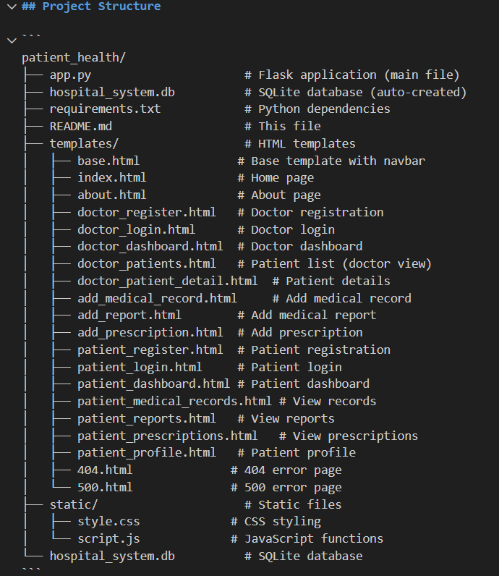
Fig 5.6.1: Project Directory and File Structure
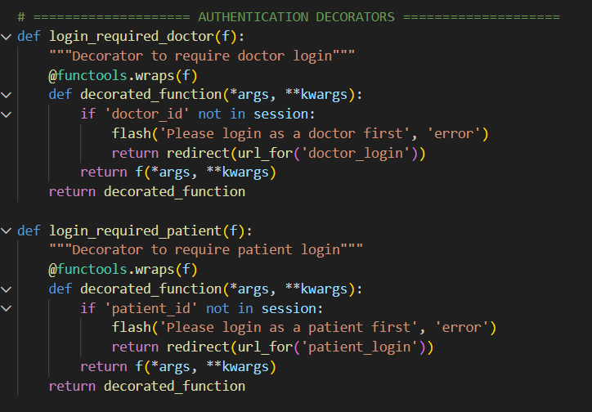

Fig 5.6.2: Python Decorators for Role-Based Access Control (RBAC)

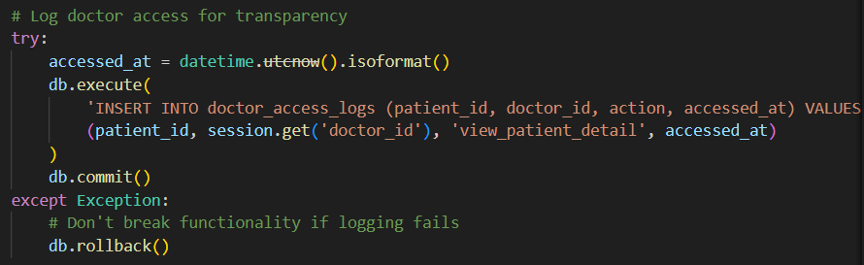

Fig 5.6.3: Transparency Engine Backend Logic for Access Logging

6. TESTING
The system underwent rigorous testing to ensure reliability, security, and real-time performance of all core modules.

6.1 Unit Testing
Each module was tested independently before integration to ensure individual logic accuracy:
- Authentication Test: Verified that incorrect passwords or unregistered emails are rejected by the system.
- Transparency Engine Test: Confirmed that opening a patient report instantly generates a log entry with the current system timestamp.
- Prescription Logic Test: Ensured that checkboxes only appear on the patient dashboard after a doctor submits a valid prescription.

6.2 Integration and User Acceptance Testing (UAT)

Participants including students and faculty members were involved in testing the end-to-end workflow:
- Communication Flow: Tested the chat module to ensure messages are delivered and stored correctly in the SQLite database.
- Performance Metrics:
  - Data Retrieval Time: Medical reports loaded in under 1.5 seconds during testing.
  - Accuracy: 100% accuracy in logging which doctor accessed which file, with no data mismatches.
  - User Feedback: Patients noted that the live dashboard for medicine tracking and access logs significantly improved their trust in the system.

6.3 Security Testing

- Session Management: Verified that a user is automatically logged out if the session expires or if they attempt to access doctor-only pages as a patient.
- Database Integrity: Confirmed that SQLite correctly handles simultaneous requests from multiple users without data corruption.
7. RESULTS AND DISCUSSION
7.1 Output Screens

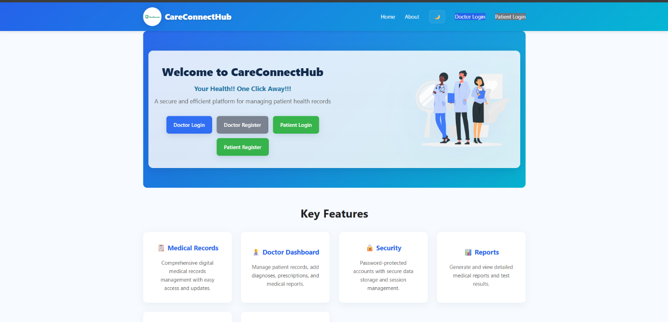

Fig 7.1.1: CareConnect Hub Home Page

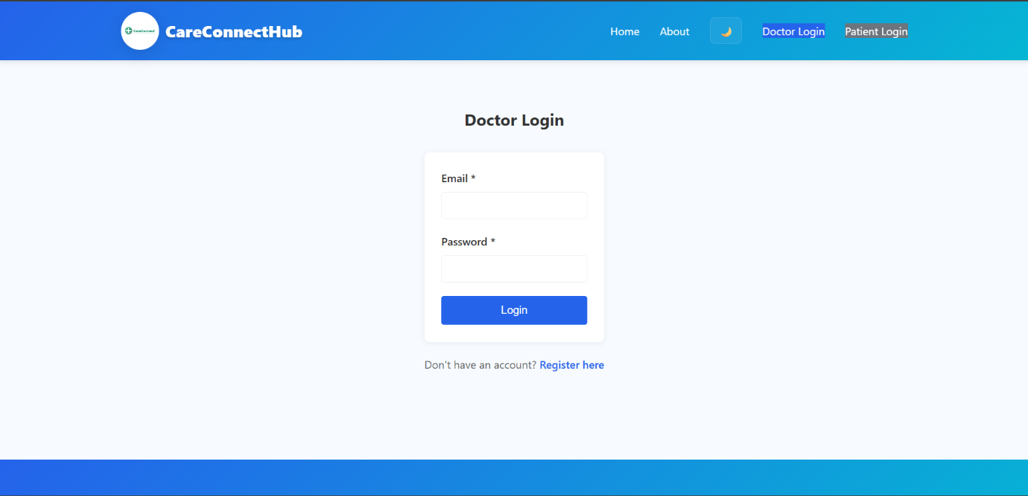
Fig 7.1.2: Doctor Login Page

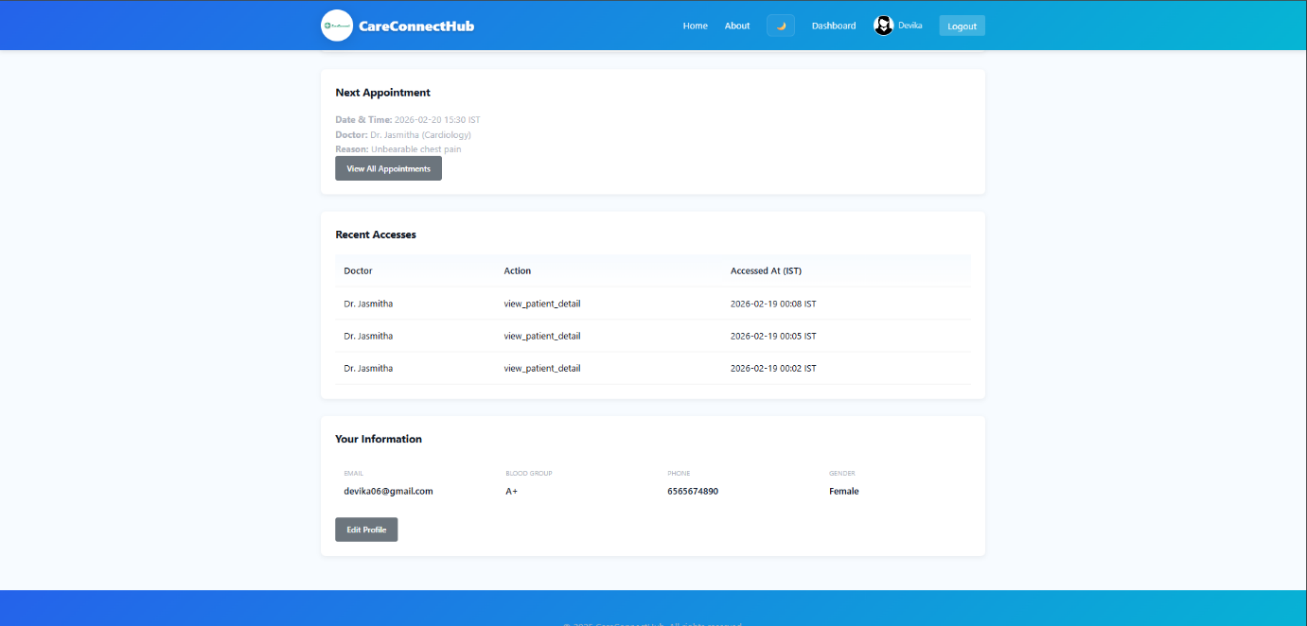
Fig 7.1.3: Patient Dashboard interface displaying Appointment Schedules and the Real-time Transparency Log.

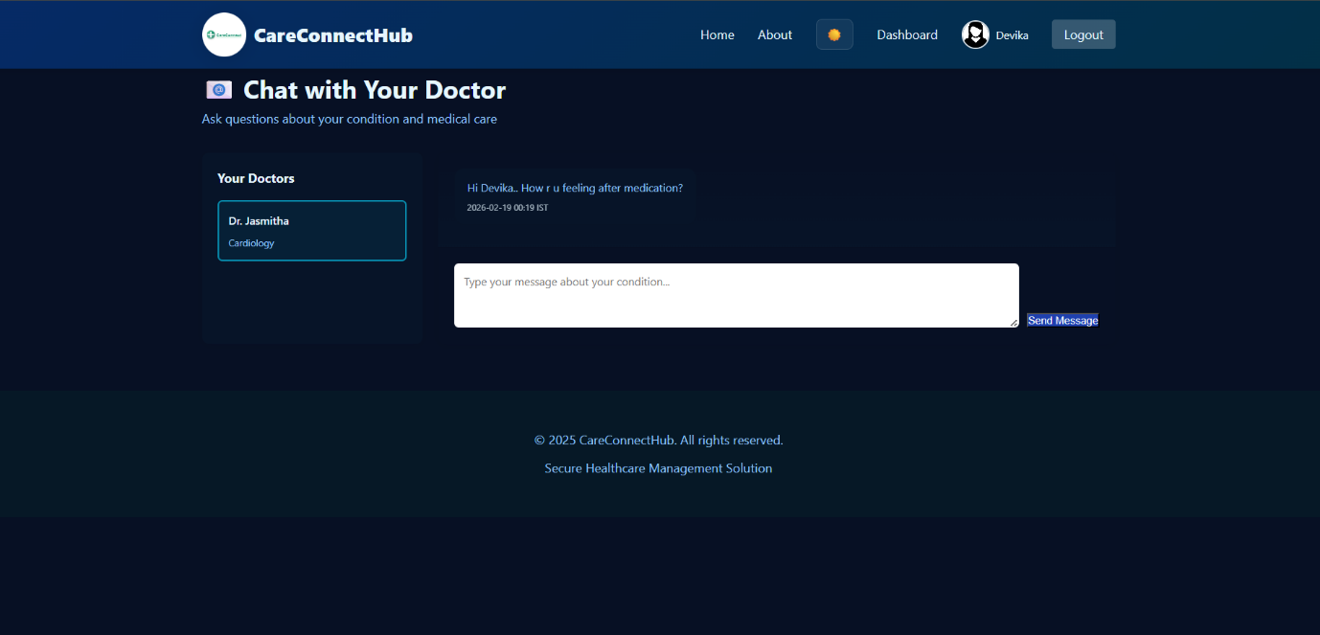
Fig 7.1.4: Secure Consultation Interface for real-time Communication between Doctors and Patients.
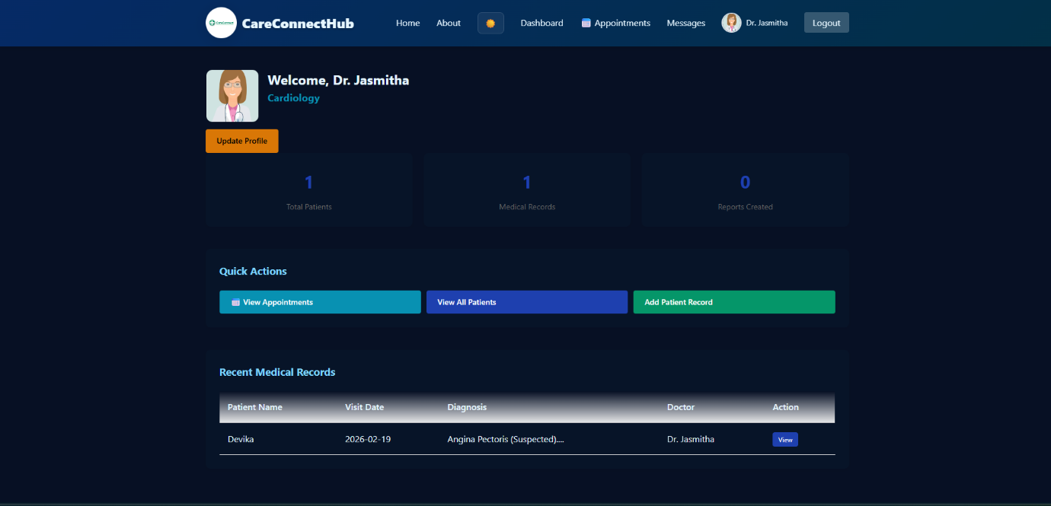
Fig 7.1.5: Doctor’s Dashboard showing Patient Overviews and Recent Clinical Visits.

7.2 Result Analysis
The project successfully met its core objectives, demonstrating that a transparency-first approach can significantly improve the digital healthcare experience. The following results were observed across the system's integrated features:

- Transparency and Trust Verification: The "Viewed" notification system was tested across multiple scenarios. It was confirmed that the system accurately logs the doctor’s name and a precise timestamp in IST whenever a patient's CT scan, X-ray, or medical record is opened. This provides the patient with a verifiable audit trail, successfully addressing the "black box" issue found in traditional portals.

- Medication Adherence Monitoring: The dynamic checkbox system proved effective for remote monitoring. Doctors were able to verify in real-time whether patients marked their daily dosages as "completed" based on the specific morning, afternoon, or evening timeslots prescribed. This feature successfully closed the communication loop for outpatient care.

- Role-Based Data Security: Testing of the authentication decorators confirmed that unauthorized access is strictly prevented. Patients are restricted to their personal portals, while doctors have exclusive access to clinical documentation and prescription modules, ensuring high standards of data privacy.

- Integrated Consultation Efficiency: The real-time chat module allowed for immediate follow-up discussions regarding diagnosis and treatment. Patients reported that the ability to ask questions about their condition directly within the portal improved their understanding of the prescribed treatment plan.

- User Experience and Accessibility: The Theme Customization Module was tested in various lighting conditions. The transition between Light and Dark modes was seamless, successfully reducing eye strain and improving the overall readability of complex medical data.

- System Performance and Scalability: Under a local-host environment, the system maintained a response time of under 1.5 seconds for retrieving high-resolution medical reports. The SQLite database successfully handled concurrent requests for message updates and record logging without data corruption.

8. CONCLUSION AND FUTURE ENHANCEMENTS
8.1 Conclusion
Care Connect Hub stands out by prioritizing the doctor-patient relationship through the innovative use of transparency. By automating "Viewed" notifications and enabling patients to actively participate in their recovery through medication checklists, the system fosters a higher level of trust compared to standard administrative portals. The technical architecture, built on Python and Flask, provides a secure and scalable foundation that effectively manages sensitive health data while maintaining ease of use.

8.2 Future Scope
The current prototype serves as a baseline for several advanced future enhancements:
- AI-Assisted Diagnostics: Integrating machine learning models to perform preliminary analysis on uploaded X-rays and CT scans to assist doctors in identifying critical issues faster.
- Mobile Ecosystem: Developing a dedicated mobile app to provide push notifications for medication reminders and real-time alerts when records are accessed.
- Telehealth Integration: Expanding the current chat module into a full-featured video consultation platform to facilitate remote appointments and follow-ups.
.
REFERENCES

1. Flask Documentation (2025). Pallets Projects.
2. SQLite Documentation. "SQL As Understood by SQLite".
3. Design Thinking methodology for Health Monitoring Systems.
4. Documentation for Werkzeug (Password Hashing) and Jinja2 templating.

