SOP 6: Monitoring Field Transects

**Revision History Log**

|  |  |  |  |
| --- | --- | --- | --- |
| Revision Date | Author | Changes Made | Reason for Change |
| June 2014 | Rochefort, Boetsch and Antonova |  | Updates to enhance clarity and reflect minor descriptive changes to the field forms |
|  |  |  |  |
|  |  |  |  |
|  |  |  |  |
|  |  |  |  |

**Overview**

This SOP describes the methods used to monitor vegetation cover types along transects in the prairies of San Juan Island National Historical Park.

**Equipment**

A GPS unit is needed to monitor the prairie transects. The unit must be of high accuracy. Currently the unit used is a Trimble GeoExplorer XT. Data will primarily be recorded on paper data forms; the GPS unit will be configured to automatically number each segment of vegetation cover type mapped in sequence for linking the GPS coordinate data to the field data entered into the project database at the end of the field season. The data form is presented at the end of this SOP (Figures 6.1, 6.2). Data forms should be copied on Rite-in-the-rain or a similar water resistant paper.

A compass is a useful tool to help the crew sight on a distant target as a means of staying on the transect line. In addition, a range finder can be useful for creating offsets for GPS positions where navigation is restricted by dense vegetation.

**Procedure for Monitoring Transects**

A set of transects will be monitored on a yearly basis; these are the annual panel. A second set will be monitored on a rotating basis; these are the rotating panels. The annual panel in American Camp has 20 transects while the annual panel in English Camp has 15 transects. There are five rotating panels in each camp, composed of 5 transects each, for a total of 25 transects per camp. Five transects of the rotating panel are sampled each year. The rotating panel transect sampling will be completed in a 5-year cycle. This means that each year, 25 transects will be monitored at American Camp (20 annual and 5 rotating) and 20 transects (15 annual and 5 rotating) will be monitored at English Camp. The transect lines being surveyed that year will be loaded onto the GPS unit as background layers by the GIS Specialist at the start of the field season. The coordinates of the transect start and end points will also be available as a project database export so that the Field Crew can take a hardcopy into the field.

Monitoring should be accomplished with teams comprising at least two individuals. One person will be responsible for mapping vegetation cover type changes along each transect with the GPS unit and the other will record the observations on the paper data form. The individual operating the GPS unit will ensure that the field crew remains on the transect using the background layers on the GPS unit as guide while sampling. The other individual will be responsible for observing the changes in the vegetation communities (% nativeness as well as growth form) and filling out the data form.

The Field Crew begins by positioning themselves at the beginning of the transect, that is at the south end of the transect for American Camp, and at the west end for English Camp. See **SOP 5: GPS Use: Navigation, Data Collection and Downloading** for specifics of using the GPS to navigate to the transect start. They observe and record the vegetation cover type of the first segment in front of them. This information is entered onto the data form and the GPS is used to map the location, which is both the start of the transect and the beginning of the first segment. The crew will then continue to walk the transect from beginning to end documenting the vegetation in terms of physiognomic type (i.e., herbaceous, shrub, tree, bare, or developed), nativeness of the vegetation (i.e., exotic or native), and a disturbance modifier (grazed or not). The transect is divided into segments which are defined by physiognomic type, nativeness, and disturbance and mapped at a resolution of 1 meter (in length). Therefore, if the physiognomic type, nativeness of the vegetation, or presence of grazing changes for a distance equal to or greater than 1 meter, then a GPS point is taken and new cover type is recorded. The observers then continue to walk the transect, mapping a new segment each time the vegetation composition or structure changes. This continues until the end of the transect is reached and the end point is recorded with the GPS.

Steps for Monitoring Transects

* Navigate to the beginning of the transect using the GPS unit.
* Monitoring transects should always begin at the southern end of the transect and moving northward in American Camp, and the western end of the transect moving eastward in English Camp.
* At the beginning of the transect, collect a GPS point according to procedures in **SOP 5**. This initial GPS point documents both the beginning of the transect and the southern or western end of segment 1.
* As the observers progress along the line, GPS points are collected to mark the beginning of each segment. Segments are defined by physiognomic type, nativeness of vegetation, and a disturbance modifier (animal activity recognized by grazing or burrows) (Table 4). If any one of these three conditions changes, for more than 1 meter along the transect, a new segment is defined. Review the decision tree (below in descriptive form, and also in Figure 6.3) to determine when to identify a new segment.
* Although the sampling unit is a line transect, when determining the vegetative cover type it may be helpful to visually examine vegetation 0.5 meters on either side of this line.
* Whenever possible complete the transect in one day using the same GPS unit and file. When this is not possible, then start a new file when finishing the transect and name the GPS files in a manner that indicates they are from different days (e.g., use same file name with an “a” or “b” at the end).
* When completing sampling in a new GPS file, be sure to change the starting segment number in the GPS unit so that numbering is continuous with data already recorded for that transect.
* During the course of sampling, the crew may make a determination that some of the data already recorded needs to be changed – for example, the point at which a segment starts or ends, or a distinct segment is not necessary, or a new segment needs to be added in a section of the transect already sampled. Where a new segment needs to be added in a previously-sampled section, the crew should simply record a new segment number on the field form and in the GPS – no renumbering is necessary. Where a GPS point needs to be moved, either delete the point from the GPS and recollect the point with the same segment number, or collect a new point and indicate that the old segment number needs to be deleted from GPS later on. If it is decided that a distinct segment is not necessary, no action is required; however it should be noted on the field form.

**The Data Form**

One technician in each crew (usually the Crew Lead) will be responsible for ensuring that these data are completely recorded. Upon completing each transect, the field crew should review the data form to ensure that all the fields are filled out and no information is missing before moving on to the next transect. At the end of the field day, the full set of data forms should be checked and compiled in a folder for processing later in the office.

Fill out the form as follows:

*Camp (AC or EC):* Indicate in which camp the transect is located (AC for American Camp and EC for English Camp)

*Transect:* Record the transect number in the format #-#. For example transect 5 in panel 1 is numbered 1-5.

*Start date*: Month, day and year the sampling occurred.

*Start time*: Record the start time for the transect sampling, use the 24-hour format.

*End date*: Month, day and year the sampling was completed if not accomplished in a single day.

*Total Hours Spent:* When you complete the transect, record the total time (in hours rounded to 0.25 hours) that you spent to complete the transect. Only record the time you worked on the transect (i.e., subtract lunch breaks or any other break times).

*Observers*: Last name and first initials of individuals sampling the transect.

*Transect Starting Point*: Record the easting and northing of the transect starting point. The start and end points of each transect are permanent locations; a table of these coordinates can be found in the project workpace.

*GPS file*: Record the file name entered on the GPS unit. Refer to **SOP 5** on GPS use for GPS file naming conventions.

*Weather*: Record the weather in broad terms; rain, sunny, windy, etc.

*Event notes*: (Optional) This is a space to note unusual sightings (wildlife, for example) or other information that may be useful. If sampling occurred over more than one day, note here any changes in observers, weather, or other pertinent information.

*Phenology*: Record the phenological stage for target species (*Pteridium aquilinum*, *Camassia quamash* and *Festuca roemeri*) after the transect is completed. Record the stage that best describes the population as a whole.

* *Not visible* – Presence not evident at the time of sampling
* *Emerging (Pteridium only)* – Present in an early growth stage where the leaves have not yet expanded fully, and fiddleheads are still the predominant phase.
* *Average height (Pteridium only)* – Record the average maximum height of the plants at the site, in meters to the nearest 0.1 m.
* *Vegetative* – Present in vegetative form without the onset of reproductive parts.
* *Flowering* – Present and primarily with the onset of flowering parts
* *Fruiting –* Present and primarily with the onset of fruit.
* *Leaves Senescent –*  Predominantly with leaves that are dry and non-photosynthetic.

*Segment Number:* The segment number is assigned through an “auto-numbering” routine in the GPS unit, check the GPS segment number each time you record the segment number. Segments should be numbered sequentially starting with 1 at each transect and increasing numerically until the end of the transect. It is important that segment numbers be unique within each transect and match exactly between the GPS and the field form.

*UTM N / E*: Record the last four digits of the northing UTM (at American Camp) or the easting UTM (at English camp) from the GPS unit (see **SOP 5**). The UTMs are recorded at the beginning of a new cover type.

*X if no GPS:* If no GPS point is taken, an X is marked in this column. This may occur at the end of transects where satellite coverage is limited due to forest cover or steep slopes. Occasionally, satellite coverage may not be adequate in dense vegetative cover; in such cases, the crew should wait for satellites and/or move to a place with reception and record an offset.

*GPS Offset bearing/distance*: If you cannot obtain a GPS reading to map a cover type change at that location (e.g. due to satellite availability, inability to traverse dense shrubs, or if you feel it is unsafe to stand at the starting point due to and eroding cliff), record GPS coordinates where you can obtain a reading. Then enter the bearing (degrees) and distance (m) from that point (i.e. the point where you can obtain a reading) to the true location of the cover type change. The unadjusted GPS location recorded on the form will be adjusted using the bearing and distance to derive a final set of coordinates. Procedures for entering offset information into the GPS unit are described in **SOP 5**.

*Veg Type*: Assign the cover type into one of 6 categories (H = herbaceous, S = shrub, T = tree, U = unvegetated (bare ground with <10% vegetation), D = developed (road or trail), End = end of transect).

*Veg Origin*: Record if the segment is Native (N) or Exotic (E) or, in the case of a Developed or Unvegetated types or the transect End, record not applicable (NA).

*Herbaceous Subveg Origin and Cover*: Cover class of the exotic or native component of the vegetation; recorded for exotic species cover where Veg_Origin = N, and for native species cover where Veg Origin = E. Default for all non-herbaceous types should be “NA”. Should be filled out for each segment, even though in many cases this will be “NA” (as indicated in the decision tree). If a value is accidentally not recorded in Herbaceous types, record as “Not observed”.

*Grazed:* Required for Herbaceous types, and optional (blank) for other vegetated types. Record “Y” (yes) if grazed or shows evidence of rabbit browse or burrowing activity. Record “N” (no) if not grazed.

*Predominant Substrate*: Required for Unvegetated types, optional for other types. Record sand, rock, gravel, log, soil or water.

*Notes:* Observations that may be helpful later are recorded here. The species that make up the segment, fresh rabbit activity, and new disturbance of some kind are examples of helpful notes. Also, notes that might explain any unexpected recorded values (e.g., Herbaceous Subveg Origin and Cover values in tree types).

The following items will be filled in as the data are entered in the database, after the crew returns to the office:

*Entered by/date: ____________________*: Initials and date to indicate when and by whom the data were entered into the database (office only)

*Updated by/date: ____________________*: Initials and date to indicate when and by whom the field data were updated after returning from the field (office only)

*Verified by/date: ____________________*: Initials and date to indicate when and by whom the data were verified for accuracy in the database (office only)

*Page___ of ___:* Be sure to fill out this section; this will be helpful when the data are entered.

* The following decision tree (also shown in Figure 6.3) will lead to the identification of the vegetation type and help to fill out other information about each segment:
  + Is the area a road or a trail >1 meter wide?
    - Record as D for developed. Neither Veg Origin, Subveg Origin, nor Cover attributes apply here, so enter “NA” in for these on the data form. Grazed should be left blank. Use Notes field to document whether road or trail and paved or unpaved.
  + Is vegetation cover <=10%? If it is not a road or trail and is >1 meter in length along the transect:
* Record U (unvegetated) for Veg Type. Enter “NA” for Veg Origin, Subveg Origin and Cover; Grazed may be left blank. Record the predominated substrate:
  + Sand – Fine-grained sand
  + Gravel – Includes loose rocks including small pebbles and large cobbles
  + Rock – Large or embedded rocks
  + Soil – Soil substrates other than sand, gravel or rock
  + Log – Beach logs providing the primary substrate
  + Water – Open water such as lagoons or ponded water
* Is the cover ≥50% trees?
  + - Record as T (tree) for Veg Type. If the ≥50% of the tree cover is provided by native species, then record N for Veg Origin. If the <50% of the tree cover is native (so this means exotic tree cover must be >50%), then record E for exotic. Subveg Origin and Cover may be recorded as “NA”. Grazed may be left blank.
  + Is the cover >50% shrubs?
    - Record S (shrub) for Veg Type. If ≥50% of the shrub cover is composed of native species, record N for Veg Origin. If it is ≤50% cover of native species, record E for exotic. Subveg Origin and Cover may be recorded as “NA”. Grazed may be left blank.
* If Veg Type cannot be classified as Developed, Unvegetated, Trees or Shrubs, it is Herbaceous.
  + - If the cover of native species in herbaceous types is ≥50%, record N for Veg Origin. If the cover by native species – including the minor cover contributed by native shrub and tree species – is <50%, record E for exotic. ***Note*** that cover can add up to more than 100% due to multiple canopy layers; therefore it is possible to have >50% native cover and >50% exotic cover. Since the origin of a segment is determined by the cover of native species, a segment could be considered native even with >50% exotic cover of herbaceous species. This kind of situation is addressed by Subveg Origin and Cover (see next step).
    - In herbaceous segments, we are interested in the quality of the herbaceous cover and one method we are using to evaluate the origin and cover is the “herbaceous subvegetation”. If the segment is determined to be native, the “herbaceous subvegetation” is the non-native (exotic) component. In the Herbaceous Subveg Origin & Cover column of your data sheet, record E (for exotic) and the percent cover of the non-native (exotic) vegetation. Non-native cover is recorded using the following cover classes: 1-10%, 11-49%, or ≥50%.
    - If the segment is determined to be exotic, the percent cover of the native vegetation must also be recorded using the following cover classes: 0-10% or 11-49%. If the cover of natives was greater than 49% it would be considered a native herbaceous community; hence only the first two cover classes should be used for native subvegetation cover in segments classified as Exotic.
    - If more than 25% of the herbaceous vegetation is grazed, record Y for yes; if less than 25% is grazed, then record N for no.
* A few rules to remember while filling out and reviewing the field form:
  + Segment Number, UTM N / E, and Veg Type are all required to be filled out for each segment, as indicated by shading on the field form.
  + Veg Origin, Herbaceous Subveg Origin & Cover should also be filled out for each segment, even though in many cases this will be “NA” (as indicated in the decision tree), or occasionally “Not observed” for Cover in Herbaceous types.
  + Herbaceous Subveg Origin and Cover should be “NA” for Developed and Unvegetated types. For Tree/Shrub types, these should be “NA” ; however, values may be recorded in special cases for Tree/Shrub types if desired, in which case the recorder should make a note on the form as to why these unexpected values were recorded for that segment.
  + Grazed is required for Herbaceous types, and optional for other vegetated types.
  + Predominant Substrate is optional for all except Unvegetated.

**Photo Documentation**

Photo documentation is not required for the sampling of transects. However, if while sampling transects field personnel find that photos would be helpful, follow the guidelines in **SOP 9** for file naming convention and storage.

**Cautionary Note**

Cover of some native species that are encountered on the transects may be difficult to estimate. *Rubus ursinus* is often trailing under the grasses, and cover estimates may be difficult because it is hidden by other species and because a lot of the cover is due to the stems rather than leaves. *Pteridium aquilinum* is another species that may be difficult because it is taller than the other plants, and its fronds grow rapidly over the course of the summer. Due to the rapid expansion of the fronds, we try to complete all the transects within 1-2 weeks to eliminate variation between transects based on phenology. This is also the reason that we are recording data on the bracken fern height and frond development. Observe these species carefully; often these species have a higher cover value than it may appear initially. In addition to estimating the cover, you may find that you are assigning a Native cover to a segment that is dominated by either of these species, despite the fact that there are no other natives in the segment. This is the correct answer and the modifier you assign (i.e. amount of exotic cover) will document the fact that this is a native cover type with low quality.

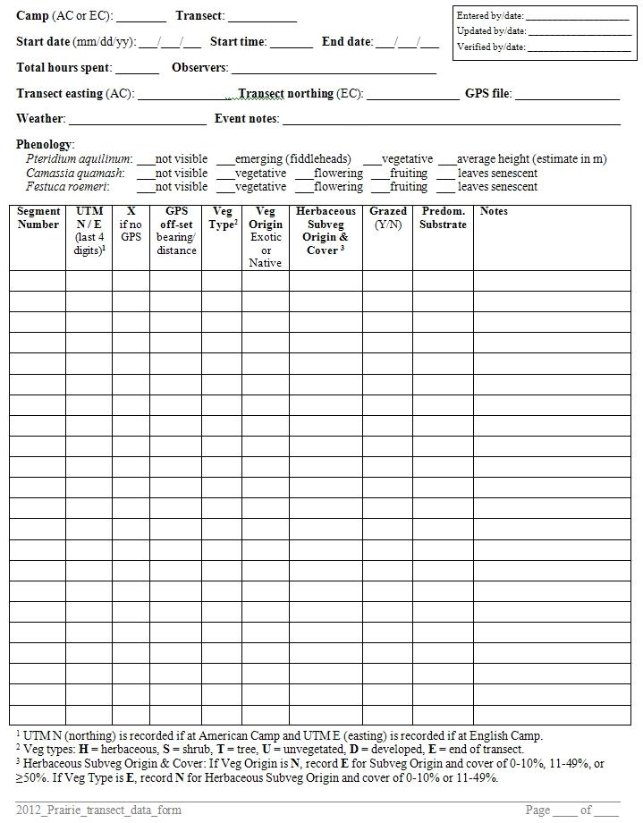

**Figure 6.1**. Prairie Vegetation Monitoring Field Form: Transect Data (page 1).

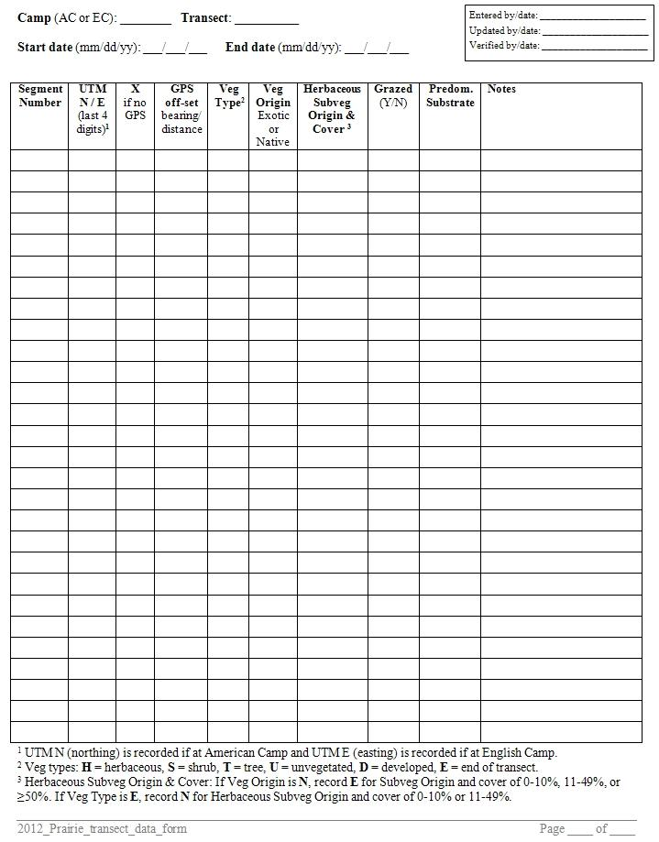

**Figure 6.2**. Prairie Vegetation Monitoring Field Form: Transect Data (page 2).

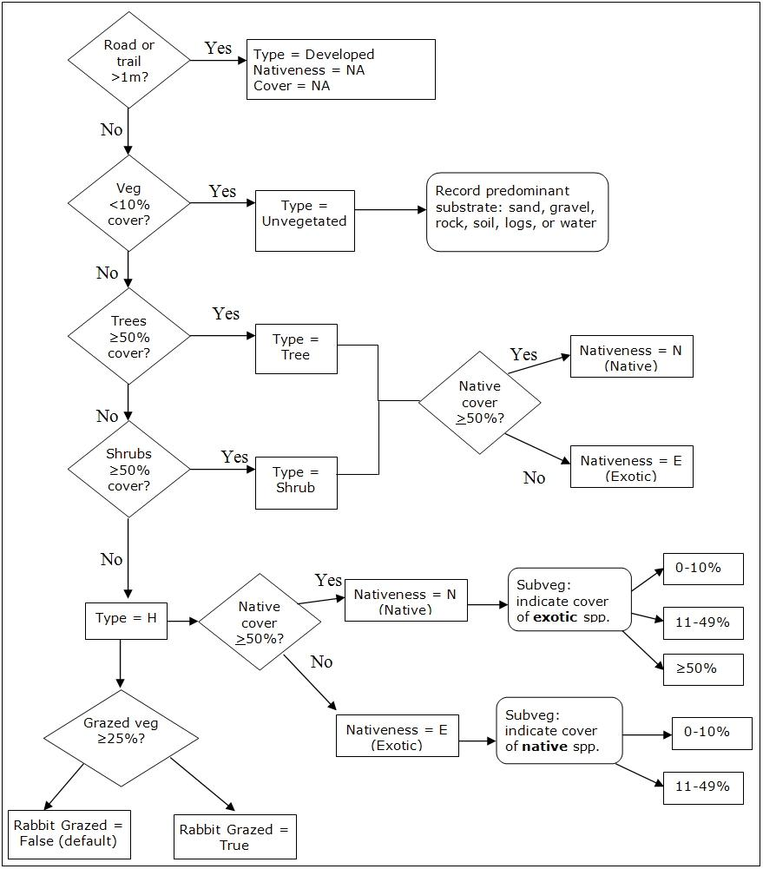

**Figure 6.3**. Cover type decision tree. During data collection and data recording, fields that are not specifically addressed in a given branch of the decision tree (e.g., Grazed for non-herbaceous types) are filled with ‘NA’ or occasionally left blank as indicated elsewhere in this SOP.