Software Test Plan
[Chitkara University – Official Website]

Test Plan Id : TP001
Project Name : Chitkara University official Website
Version : 1.0
Prepared By : Jasnoor Kaur

- Refrences
- Software Requirement Specifications (SRS) – University Website
- IEEE 829 Test Documentation Standard
- Chitkara University Official Website

- Introduction :
This document describes the test plan for the Chitkara University website .
The main purpose of the test plan is to whether the Chitkara website works properly and easy for users like students , visitors to use and adapt.

- Test Items :
The following modules of the website will be tested:
- Home page
- Admission section
- Academic Programs Pages
- Student Login Portals
- Faculty information pages'
- Contact us & inquiry forms
- Navigation menu and footer links

- Software Risk issues
Key software risk issues and security focus area for the Chitkara University Website include :
- Common Web Application Vulnerabilities
- Malware and External Attacks
- Zero-Day vulnerabilities
- Data privacy and Unauthorized Access
- Phishing and Social Engineering
- System Vulnerability in Development
- Features to be tested
Key features to test on the website include:
- Admission and application form
- Online payment gateway
- Course finder and information
- Registration/Login portals
- Mobile Responsiveness
- Navigation and links
- Site search functionality Content accuracy
- Page load speed
- Document download
- Images representation

- Features not to be tested
- Backend Database Structures
- International University ERP Systems
- Payment Gateway integration (if any)
- Third – party hosted services

- Approach
Testing will be performed using:
- Manual testing for UI, navigation, and usability
- Functional Testing for forms and login
- Compatibility Testing across browsers
- Basic Security Testing for login validation

- Item Pass/Fail Criteria:
- Pass: Features works as expected without errors.
- Fail: Features deviates from expected behaviour or produces incorrect output.

- Suspension Criteria and Resumption Requirements:
- Suspension criteria:
- Website server is unavailable.
- Critical defects block further testing
- Resumption Requirements:
- Server stability restored Blocking defects fixed and verified
- Test Deliverables:
  - Test case document
  - Test plan document
  - Defect/Bug reports
  - Test summary reports
- Remaining Test Tasks :
- Re-testing after fixing bugs after bug fixes.
- performance testing during high traffic.
- Security vulnerability assessment.
- Environmental Needs:
Hardware:
- Desktop
- Mobile devices
- Laptop
Software:
- Windows OS
- Browsers: Chrome,firefox,Edge
- Internet Connection

- Staffing and Training Needs:
  - 1 test Engineet
  - Basic knowledge of software testing
  - miliarity with website navigation

- Responsibility
- Test planning: Tester
- Test Execution: Tester
- Defect Reporting: Tester
- Documentation: Tester
- Schedule:
Activity | Duration
Test Planning | 1 Day
Writing Test Cases | 1-2 Days
Testing Website | 2 days
Report Preprations | 1 day

- Planning Risks and Contingencies:
Risk: Website changes during testing
  - Contingency: Update test cases accordingly
Risk: Limited access to some modules
  - Contingency:Test publicly available features only
- Approval:
  - Test leader
  - Test manager

Test Case Design for testing Login Fuctionality of Website

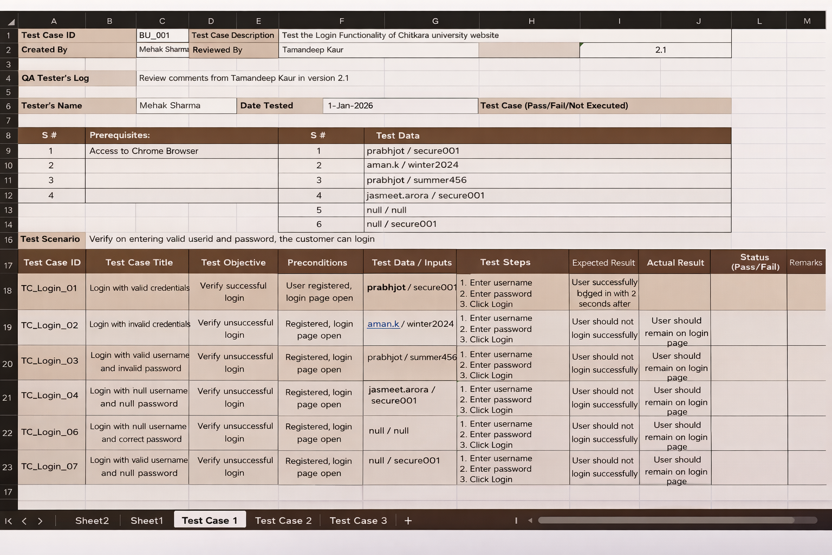

Errors in E – Commerce Website

1. Syntax Errors
- Incorrect use of brackets.
- Missing semicolons.
- Using parentheses instead of brackets.
- Failure to declare variables or items.

2. Logical Errors
- Incorrect calculation of the total amount of ordered items.
- Adding the discount to the item price instead of subtracting it.
- Sales percentage not applied properly.
- Exploitation issues related to gift cards or wallets.
- Reusing the same gift card multiple times.
- Negative balance allowed in wallet.

3. Functional Defects
- The website does not allow login with valid credentials.
- Shopping cart bugs:
  - Items disappear from cart.
  - Quantity not updating.
  - Duplicate items added automatically.
- Errors in promotions and coupon application:
  - Coupon applies to wrong category.
  - Expired coupon still works.
  - Multiple coupons applied when only one allowed.
- Mobile-specific compatibility issues:
  - Buttons too small.
4. UI Defects
• Unnecessary horizontal scrolling.
• Missing or broken images.
404 image errors.
Product images not loading.
Slow CDN.
• Non-functional 'Add to Cart' button.
Button click event not attached.
Disabled due to javascript error.
Stock not updated in real-time.
• Incorrect stock status display.
Shows “In stock” when out of stock.
Shows “Out of stock” when available.
Stock not updated in real-time.

