Project Title: Library Management System

Description:

This is a simple project on “ Library Management System”.

We will create a simple website where a user can log into the website and search for necessary books. This website will basically deal with the signup and storing data of signed users in the database where a user can issue 3 books at a time and enjoy reading.

At first in the website a user can see all the available books . Based on the requirement,
the user can issue a book of his choice. In order to issue a book the user needs to sign up if he/she is not already an existing user to create his own account providing his details after which the book issue will be possible.

As soon as the user will select a book the data will be stored in the database. Based on the user’s choice books can be returned before time as well.Similar changes will be reflected in the database. A particular late fee also has to be paid in case the books are returned after a certain amount of time.

Some other pages such as “About Us” will also be provided where contact numbers and other valuable information will be provided about the creators so that people can reach out to us whenever any issue arises.

Modules of the Library Management System :

The Library Management system (LMS) project has the two major Module descriptions:

- Admin / Librarian Module : Their main purpose is to control and manage the library management system. They are responsible for the process of maintaining the records of library information.

It is sub-divided into following minor modules:
    - Admin login : Admin will login via this module.
    - Book Author Management : Add/Update/Delete Author Details.
    - Publisher Management : Add/Update/Delete Publisher Details.
    - Book Inventory : Add/Update/Delete Book Details.
    - Book Issuing Process : Issue/Return Books.

- User Module : When the user is registered, they can get their own username and the password, by using this they can enter and view the library information. They can view the details of the available book, issue new books and view the return date and due amount from the library.

It is sub-divided into following minor modules:
    - Member Signup : New users can sign up via this module.
    - Member Login : Signed up users will login.
    - Profile : Users can manage their personal information and view issued books.

- Apart from these there is a “View Books” module which is generic and can be accessed by everyone where information regarding list of available books will be visible.

Use Case Diagram :
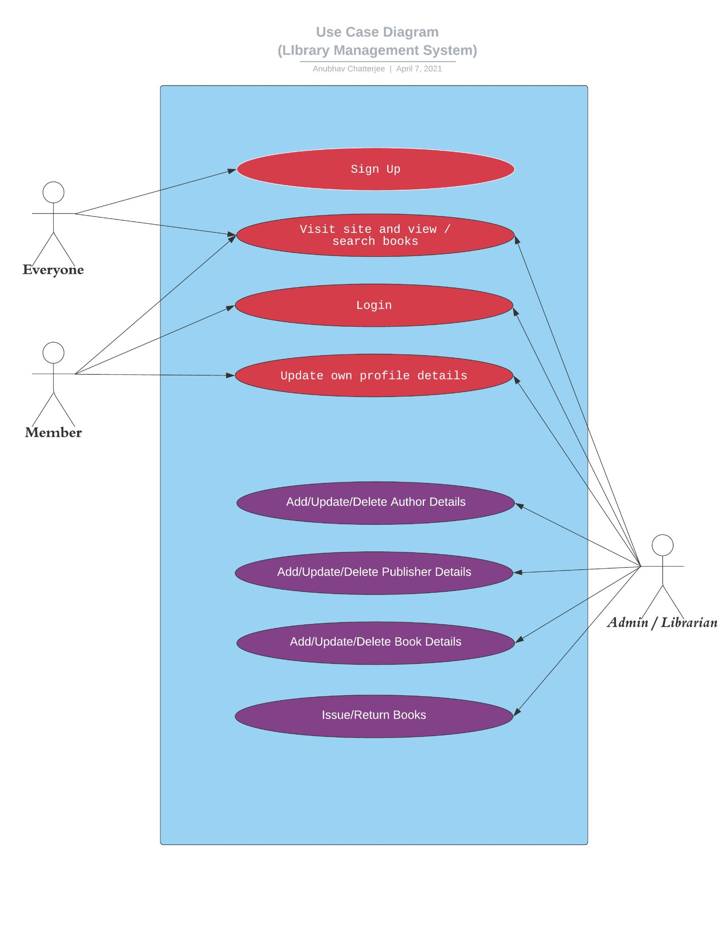

User Stories:

- As a Customer , I want to Search for a book.
- As a Customer, I want to Create a account.
- As a Customer, I want to Issue a book.
- As a Customer, I want to Return a book.
- As a Customer, I want to Delete my account when required.
- As a Customer, I can Communicate with the creators regarding issues.
- As a Customer, I want Security regarding my profile information.
- As an Admin, I can access the accounts of a member.
- As an Admin, I can Activate a customer’s account.
- As an Admin, I can Check the availability of the books.
- As an Admin, I can Add a new book.
- As an Admin, I can Update a book.
- As an Admin, I can Delete a book.
- As an Admin, I can Access author inventory.
- As an Admin, I can Send An Alert regarding late fine.

