Project Title:
Online Examination Scheduler

Description:
This project will develop a software which conducts/schedules exam. The exams are conducted at various cities at different centres on different dates at particular time. Only few members are allowed to write the exam at particular time on a date at any centre in a city.
The functions that we are thinking to apply are:
- Entering User id, Password in the login screen for the administrator and application developer.
- Registration process for the examinee.
- Fixing venue and date by the examinee for a exam.
- Entering Exam centres, dates by the administrator for different exams.
- Displaying the Examinee id, Examinee password and selected details for the examinee.

Modules:
Login: The Administrator and the Examinee has to login.
Adding Certification Exam, Date, City, Center by Administrator: The Administrator has the facility the add a city having different centers where the certification exam is going to be held on different/same date.
Registration process for Examinee: The Application developer has to login first and then he has to register for the certification exam giving his details along with Examinee Id and Examinee password of his selection.
Examinee Login: The already registered candidate has to login with his Examinee id and Examinee Password for fixing the venue and date.
Fixing the Examination venue and details by Examinee: The Examinee fixes the venue and date for writing the exam for which he has applied.
Viewing the details by Examinee: The Examinee is provided by the information that he has selected.

Use Case:
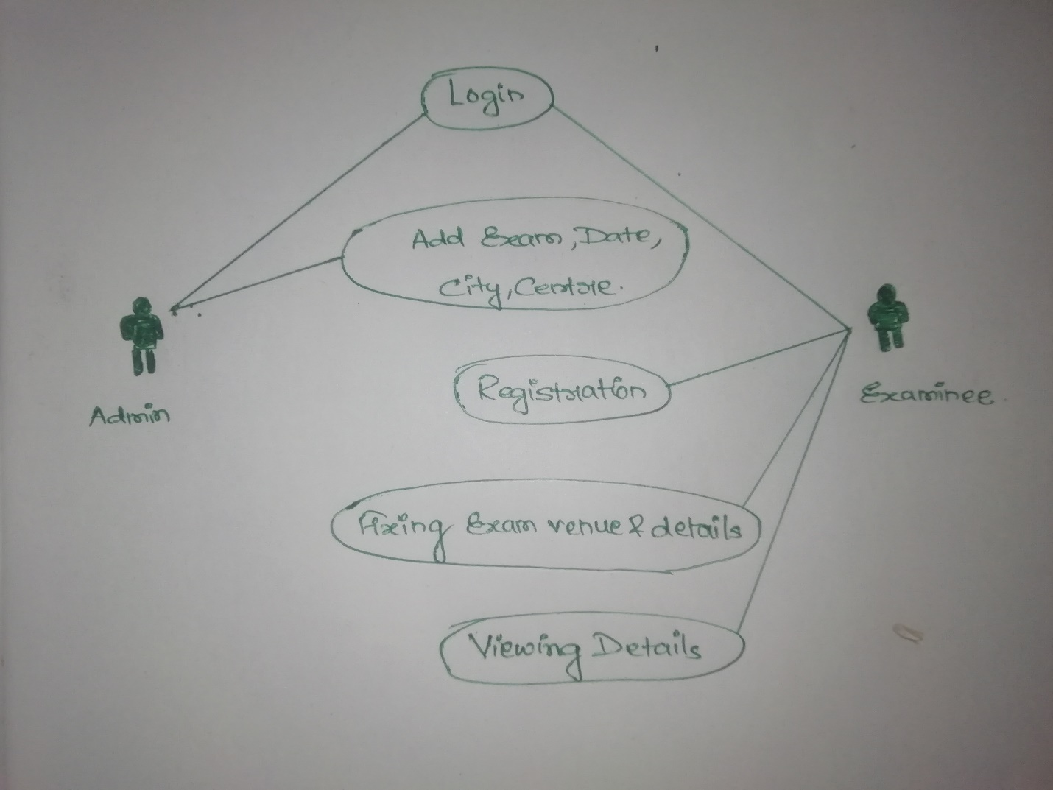

User Story:
- As an administrator, I want to login.
- As an administrator, I want to add exam, date, city and centre.
- As an examinee, I want to login in the website.
- As an examinee, I want to register for examination.
- As an examinee, I want to login in the course with ExamineeID and Password.
- As an examinee, I want to fix venue and date for exam.
- As an examinee, I want to view the final details.

