PoD No.2

Gullapali Lakshmi Swaraj
Gayathri KP
Harini B
Gunaseelan K
Sai Ashwin D

PROJECT TITLE:
Stock Management System

DESCRIPTION:
Stock Management System is a real time application used by the merchant to maintain, track and organize various products and the information regarding the products. This system enables the manager and the checkout clerk to manage the stock inwards and stock outwards with respect to the transactions made. The people associated with this system are:
- Manufacturers – The manufacturers are the producers of the items whose name, address and the type of items they produce are mentioned in the system.
- Shopkeeper/Manager – Prime source for selling the items in the market. He is the person who will use this system to maintain and track the stocks.
- Checkout clerk/Billing person – The person who maintains customer’s information, order history and the new orders
- Customers – The customers buy the products according to their needs.
The stock management system maintains the entire information involving the products, from the availability of the products with the manufacturer to the products ordered by the customer.

USER STORIES:
User here refers to the manager who maintains the stock management system.
Checkout clerk who makes final checkout in a shop and gives bill to the customer.
- As a User I need a login portal for secure personnel to handle the stock management system.
- As a user I need an overall PRODUCT LIST to view, So that, I can view and understand and maintain the stock availability.
- As a user I need access and functionality to add stocks to the available product list so that it is easy to maintain the stock system
- As a user I need access and functionality to delete stocks in the existing product list so that it is easy to maintain the stock system
- As a user I need access and functionality to update existing stocks in the existing product list so that it is easy to maintain the stock details like price, quantity, etc.
- As a user, I need to check stock availability based on product categories for easy maintenance of stocks.
- As a user, I need to check stock availability based on products from specific manufacturers currently available in the stock for maintaining stock details.
- As a user I need a separate column/functionality to order new stock from manufacturers, so that I can maintain my Stock availability .
- As a user I need to access order details for every manufacturer specifically so that it’ll be easier to maintain financial records with each manufacturer individually.
- As a user I need order details of stocks that I have ordered previously from all the manufacturers in a single list, so that it will be easier to maintain stock and finance.
- As a checkout clerk/billing persons I need to add products for every new orders in the system to proceed with the billing
- As a billing person, I need functionality to add customer details along with every order that I proceed with for future order related references.
- As a billing person, I need functionality to print each bill so that I can give that to the customers.
- As a billing person, I need functionality to get order details based on order id for maintaining the system and for reference.
- As a billing person, I need functionality to get order details based on customer id for maintaining the system and also for references.

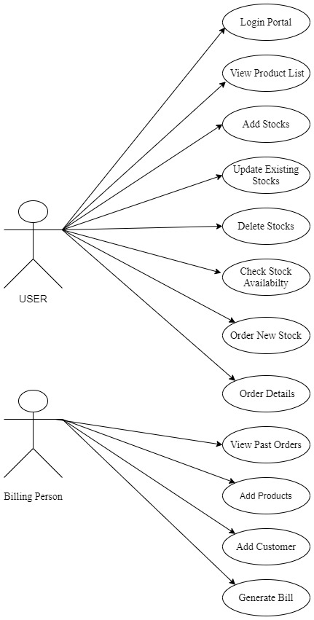
Fig 1 Use Case Diagrams

