CLINIC MANAGEMENT SYSTEM

I. TEAM MEMBERS:

- Kavyashree A – 916009(Pod Leader)
- Abitha P – 916504(Pod Member)
- Akash Raja S.R.J – 916013(Pod Member)
- Balaganesh S - 916014(Pod Member)
- Joel Paul A - 916023(Pod Member)

II. DESCRIPTION:

Clinics currently use a manual system for the management and maintenance of critical information. The current system requires numerous paper forms, with data stores spread throughout the clinic management infrastructure. Often information (on forms) is incomplete, or does not follow management standards. Forms are often lost in transit between departments requiring a comprehensive auditing process to ensure that no vital information is lost. Multiple copies of the same information exist in the clinic and may lead to inconsistencies in data in various data stores. A significant part of the operation of any clinic involves the acquisition, management and timely retrieval of great volumes of information. This information typically involves; patient personal information and medical history, staff information, room and ward scheduling, staff scheduling, operating theater scheduling and various facilities waiting lists. All of this information must be managed in an efficient and cost wise fashion so that a clinic Management System resources may be effectively utilized CMS will automate the management of the hospital making it more efficient and error free. It aims at standardizing data, consolidating data ensuring data integrity and reducing inconsistencies.
The proposed clinic management system comprises of the following modules:
- Reception
- Administration
- Pharmacy
- Laboratory
- Registration
- Discharge Summary

III. USE CASE DIAGRAM

The use case diagram for the clinic management system is depicted below:
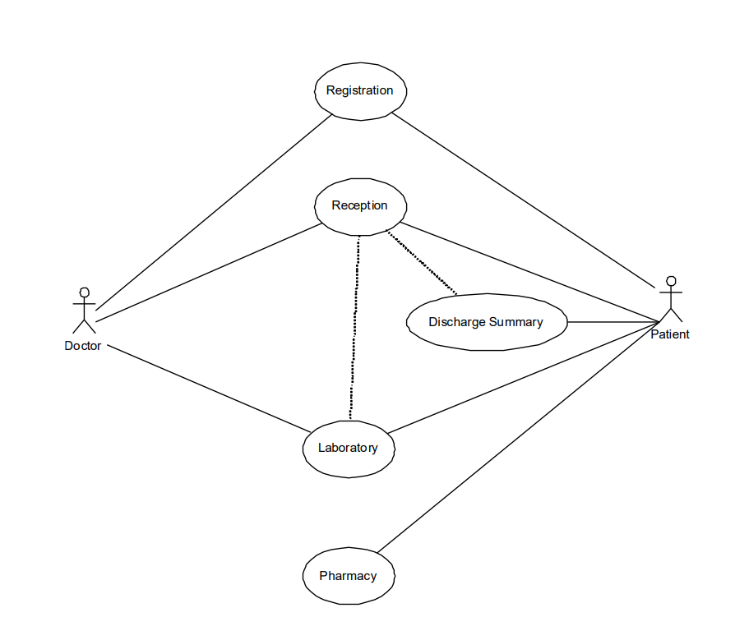
IV. USER STORIES:

- As a doctor, I want a full summary of the patient health so that I can make decision on discharge of patient.
- As a patient, I want a discharge summary so that I can use it for my next visit to hospital.
- As a pharmacist, I want to know the medication available so that I can restock the medical supply.
- As a Patient, I want to Register and get a unique ID so that I will have my records saved and retrieved easily from the database.
- As a patient, I want to book an appointment so I can visit the doctor as per my convenient time.
- As a receptionist, I want to register the patient’s information so that I could handle both IPD and OPD patient’s query.
- As a receptionist, I want to know doctor’s appointments so that Scheduling can be done.
- As a receptionist, I want to know history of patients so that I can inform the doctors.
- As a receptionist, I want to add or remove doctors so that unwanted discrepancies during the appointment schedule can be eliminated.
- As a laboratorist, I want to check the availability of blood banks so that emergency situations can be handled more efficiently.
- As a Pharmacist, I Want to handle the medical items master and patient medical prescription so that I can Generate retail bills.
- As a Pharmacist, I Want to handle the medical items master so that I can see the remaining stock, Handling of material return and Receipt of Drugs/consumables.

