PoD No.2 (THE RAVENS)

Member Details:

 | Name | Emp ID
Leader | Gullapalli Lakshmi Swaraj | 915655
Member | Gayatri KP | 915654
Member | Gunaseelan K | 915767
Member | Harini B | 915674
Member | Sai Ashwin D | 915768

USER STORIES:
User here refers to the manager who maintains the stock management system.
Checkout clerk who makes final checkout in a shop and gives bill to the customer.
- As a User I need a login portal for secure personnel to handle the stock management system.
- As a user I need an overall PRODUCT LIST to view, So that, I can view and understand and maintain the stock availability.
- As a user I need access and functionality to add stocks to the available product list so that it is easy to maintain the stock system
- As a user I need access and functionality to delete stocks in the existing product list so that it is easy to maintain the stock system
- As a user I need access and functionality to update existing stocks in the existing product list so that it is easy to maintain the stock details like price, quantity, etc.
- As a user, I need to check stock availability based on product categories for easy maintenance of stocks.
- As a user, I need to check stock availability based on products from specific manufacturers currently available in the stock for maintaining stock details.
- As a user I need a separate column/functionality to order new stock from manufacturers, so that I can maintain my Stock availability .
- As a user I need to access order details for every manufacturer specifically so that it’ll be easier to maintain financial records with each manufacturer individually.
- As a user I need order details of stocks that I have ordered previously from all the manufacturers in a single list, so that it will be easier to maintain stock and finance.
- As a checkout clerk/billing persons I need to add products for every new orders in the system to proceed with the billing
- As a billing person, I need functionality to add customer details along with every order that I proceed with for future order related references.
- As a billing person, I need functionality to print each bill so that I can give that to the customers.
- As a billing person, I need functionality to get order details based on order id for maintaining the system and for reference.
- As a billing person, I need functionality to get order details based on customer id for maintaining the system and also for references.

USECASE DIAGRAM:

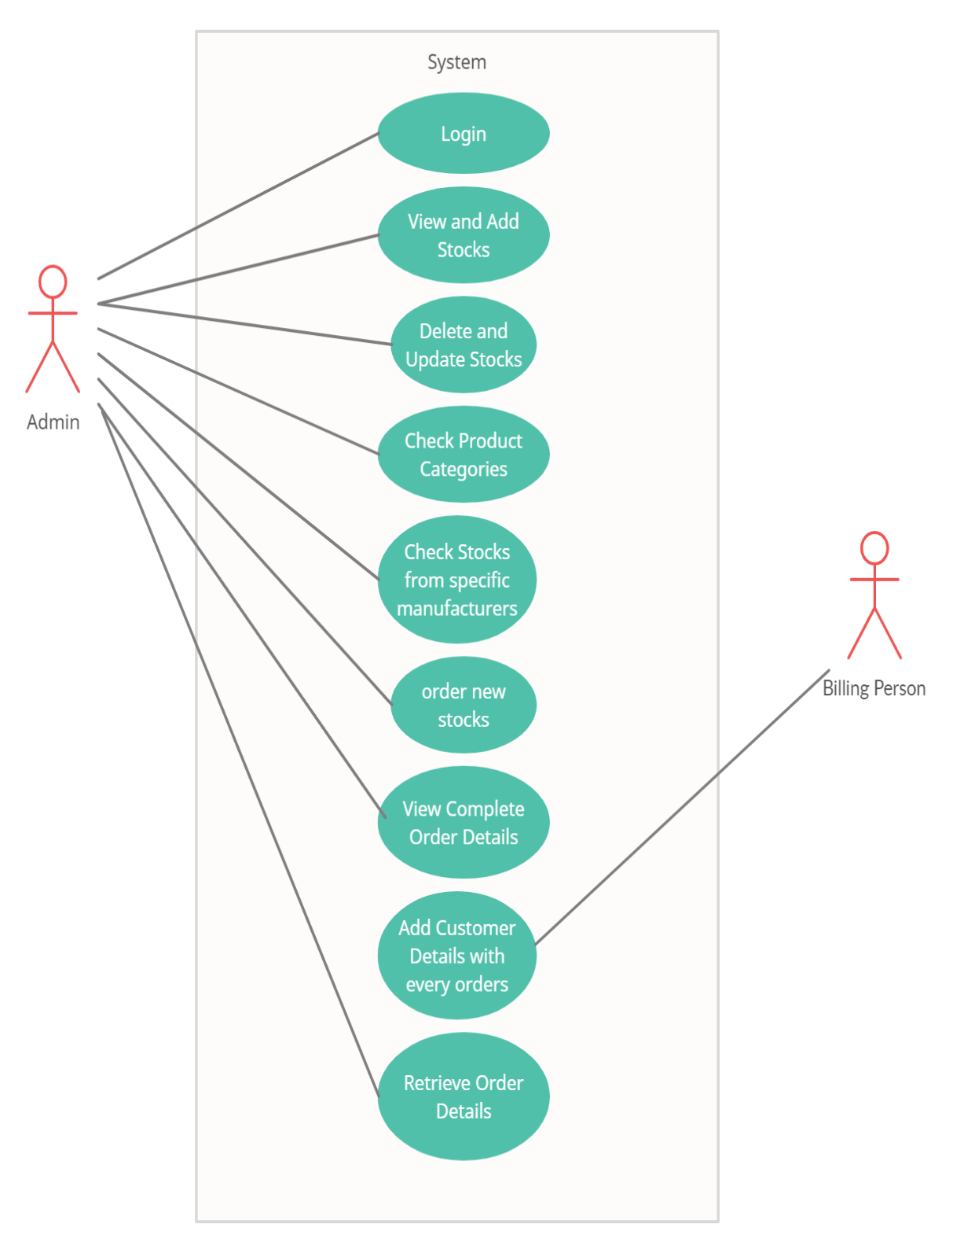

CLASS DIAGRAM:

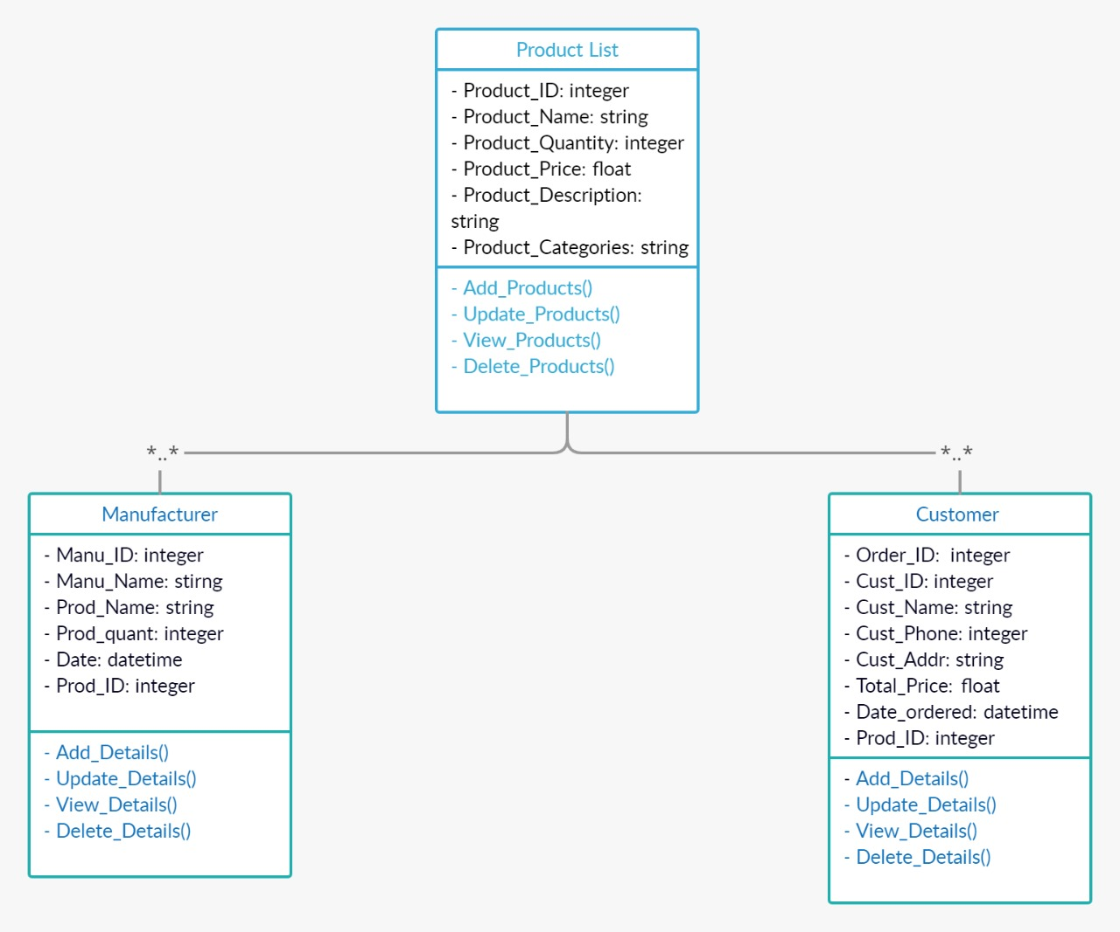

CONCEPTUAL MODEL:

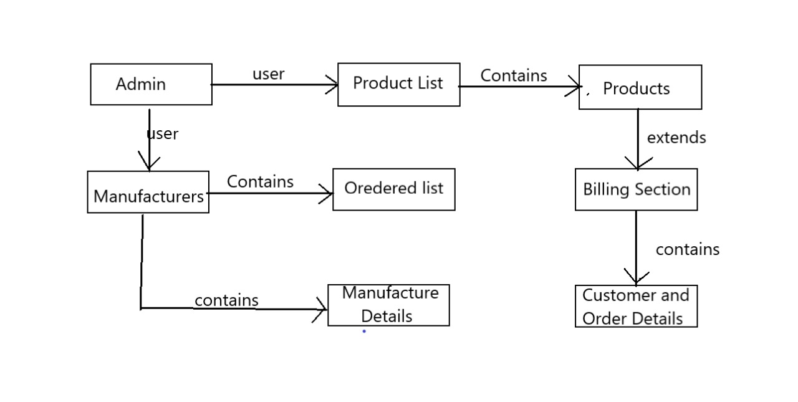

DB DIAGRAM:

