**Description:**  
**5V 0-1.2 MPa Pressure Transducer Sensor Oil Fuel Diesel Gas Water Air Sensor**

**Specifications:**

|  |  |
| --- | --- |
| Working Voltage | DC 5.0V |
| Output Voltage | DC 0.5-4.5 V |
| Sensor material | Carbon steel alloy |
| Working Current | ≤10 mA |
| Working Pressure Range | 0-1.2 MPa |
| The Biggest Pressure | 2.4 MPa |
| Cable length | 19cm |
| Destroy Pressure | 3.0 MPa |
| Working TEMP. Range | 0-85℃ |
| Storage Temperature Range | 0-100℃ |
| Measuring Error | ±1.5 %FSO |
| Temperature Range Error: | ±3.5 %FSO |
| Response Time | ≤2.0 ms |
| Cycle Life | 500,000 pcs |
| Application | non-corrosive gas liquid measurement |

**Features:**

Easy removal, carbon steel connection more firmly.

Stainless steel is durable, sealed waterproof line, imported chips.

Wiring: red +, black -, yellow output

**Package Included:**

1x Pressure Transducer Sensor  
  
**More Details:**

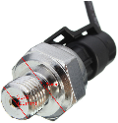 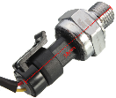 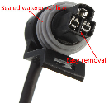 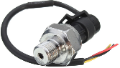

**Sensor Analogico 5v Presion Agua Aire 1.2mpa 174psi G1/4**

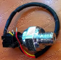

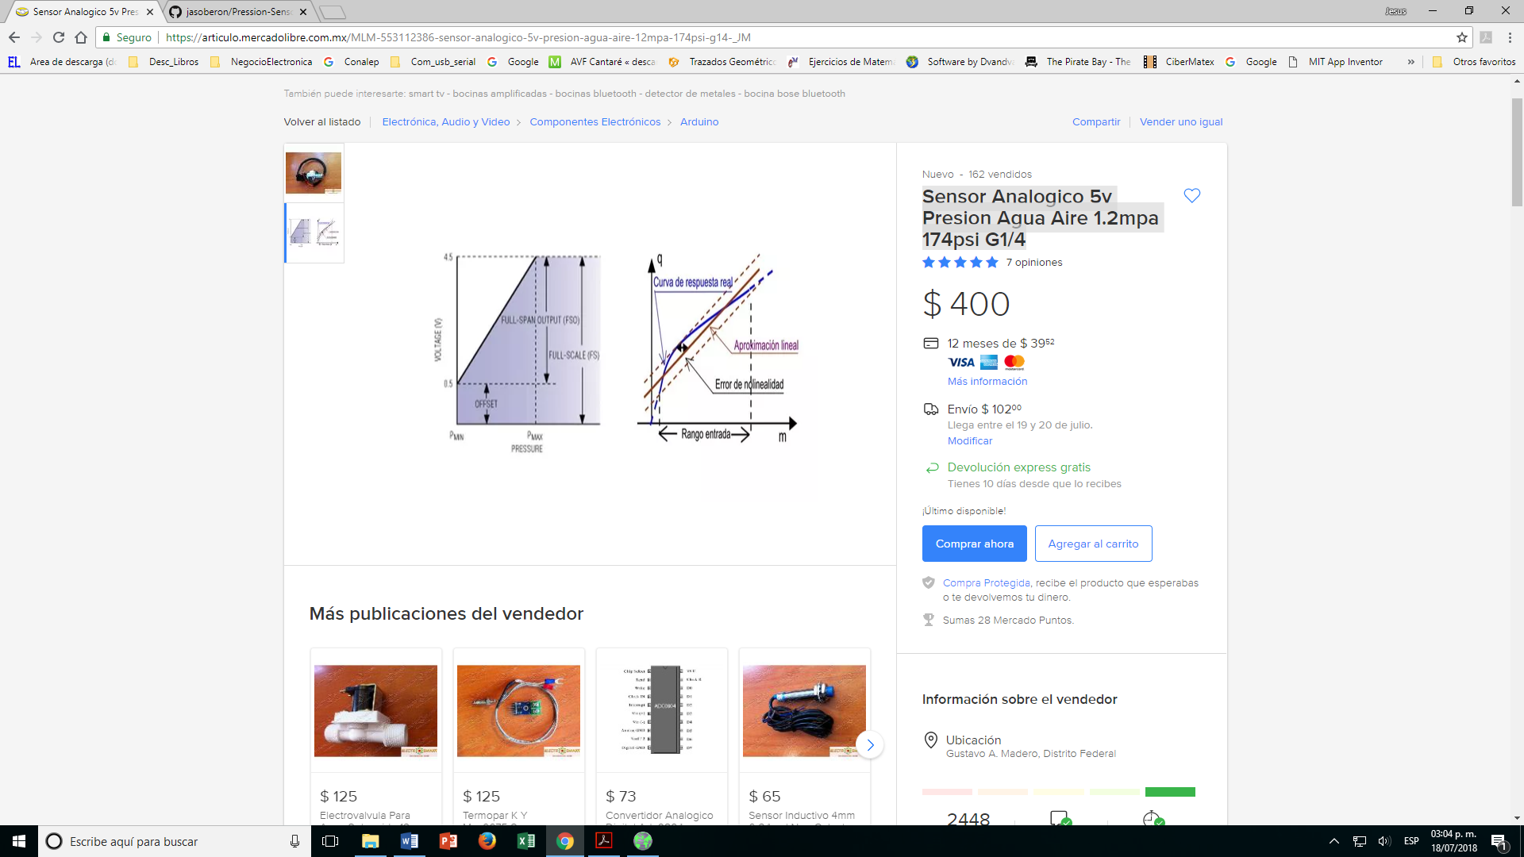

**Características**

Modelo: SENSOR PRESION 1.2MPA

Voltaje de funcionamiento: 5 V  
Entradas análogas: 0  
Pines digitales de entrada y salida: 0

**Descripción del vendedor:**  
SENSOR ANALOGICO DE PRESION  
VOLTAJE: 5V DC  
CORRIENTE:<50ma  
RANGO DE MEDIDA: 0 - 1.2MPa (174psi)  
**RESPUESTA A LA SALIDA : P(MPa) ={ (Vout / 3.75 ) - 0.1}**  
SALIDA: 0.5 - 4.5VDC   
PRESION DE RUPTURA: 2.4MPa  
FLUIDO:AIRE, AGUA, ACEITE (NO CORROSIVOS)  
TEMPERATURA MAXIMA DEL FLUIDO: 80°C (NO EXCEDER TEMPERATURA)  
ERROR : 1.5% FSO (15 - 50°C) ; 3.5% FSO, FUERA DEL RANGO ANTERIOR  
TIEMPO DE RESPUESTA: 2ms  
CABLEADO: ROJO(+), NEGRO(-), AMARILLO(SALIDA)  
CONEXION: ROSCA MACHO TIPO G 1/4 (13mm)  
MATERIAL: ACERO AL CARBON