DAILY ACCOMPLISHMENT REPORT
MEANS OF VERIFICATION (MOV)
Work-From-Home Arrangement — OJT Internship
Date: August 5, 2026
Time Started: 8:00 AM
Time Ended: 6:30 PM
Total Hours Rendered: 10 hours

1. Tasks Accomplished
- Task 1 - Reviewed the ECRATS repository, project rules, documentation, database migrations, policies, services, routes, views, and relevant tests.
- Task 2 - Analyzed the high-fidelity Reviewer design, official review forms, and reported issues across the Applicant, Reviewer, Adviser, and RES Lead viewports.
- Task 3 - Prepared a detailed VS Code AI Agent implementation prompt covering the required code, database, UI, security, testing, and documentation changes.

2. Details / Description of Work
Conducted a repository-wide requirements-to-code analysis for the ECRATS enhancement request. Reviewed the global project guidelines, current workflows, relevant source files, database structures, automated tests, high-fidelity Reviewer workspace, official Protocol Review Worksheet and Informed Consent Checklist, and the supplied issue screenshots. Consolidated the findings into a decision-complete implementation prompt that defines functional changes, migrations, secure reviewer reassignment, asynchronous commenting, official form generation, responsive behavior, documentation updates, and verification criteria.

3. Proof of Work (Screenshots / Attachments)
The screenshots below document the ECRATS source-code review, local-system inspection, and requirements analysis completed during the work session.

Workspace 1 - User-management and Reviewer-workflow source review
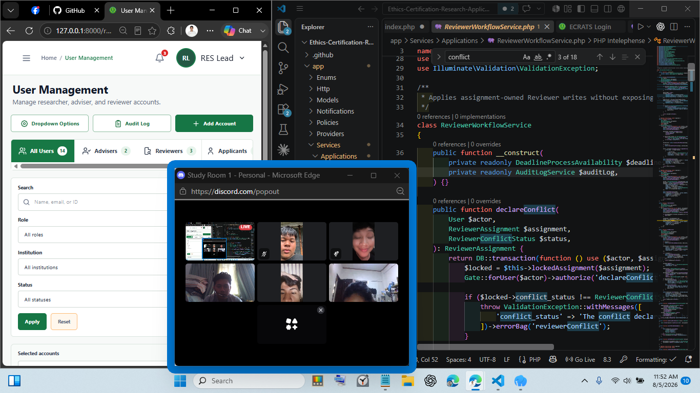

Workspace 2 - RES dashboard, notifications, and repository review
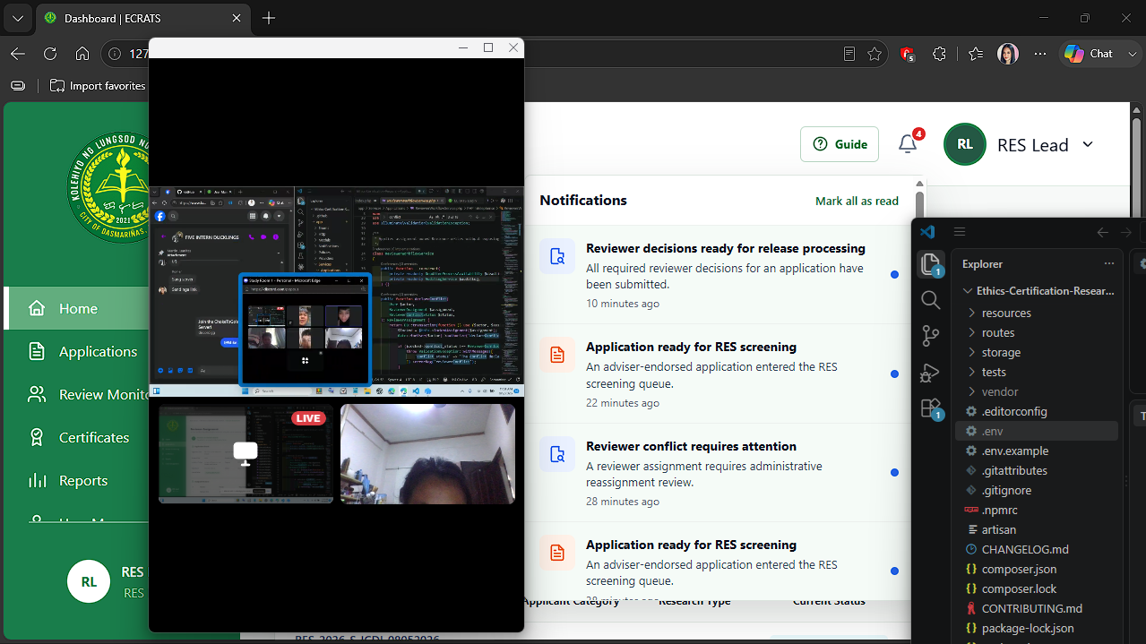

Workspace 3 - Reviewer dashboard issue verification
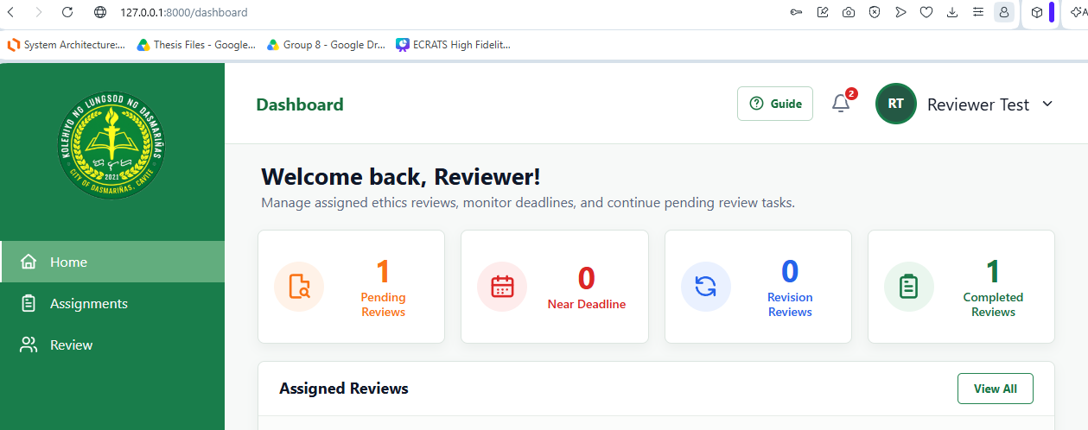

4. Remarks / Notes
Completed the repository analysis, requirements mapping, and implementation-ready VS Code AI Agent prompt. The next work phase is code implementation and full verification. The PHP ZipArchive extension must be checked before validating the Excel bulk-upload template workflow.

