DAILY ACCOMPLISHMENT REPORT
MEANS OF VERIFICATION (MOV)
Work-From-Home Arrangement — OJT Internship

System Project: Ethics Certification Review Application and Tracking System (ECRATS)
Date: August 5, 2026
Time Started: 8:00 AM
Time Ended: 6:30 PM
Total Hours Rendered: 10 hours

1. Tasks Accomplished
- Task 1 - Implemented shared interface and role-dashboard corrections, including the standard document-view icon, streamlined Adviser summary cards, and current-assignment dashboard scoping.
- Task 2 - Removed the Reviewer conflict-declaration workflow, simplified RES classification, and implemented non-destructive reviewer reassignment with preserved assignment history.
- Task 3 - Updated deadline availability controls, retired the unnecessary release deadline, corrected the profile-option collection error, and added safer Excel workbook runtime handling.

2. Details / Description of Work
Completed a major ECRATS workflow-correction batch across shared, Adviser, Reviewer, RES Lead, settings, and user-management modules. The document-view action now uses a standard unslashed eye icon, the Adviser dashboard retains only Pending, Endorsed, and Returned summaries, and Reviewer queries are restricted to current active assignments. Removed the assignment-level conflict declaration from active routes, requests, policies, services, models, and interface controls while preserving the official protocol question concerning study disclosure. Simplified RES screening to research classification and introduced auditable reviewer supersession so assignments can be replaced without deleting prior comments, forms, or decisions. Updated deadline configuration to use schedule-aware On/Off states, explicit manual overrides, Asia/Manila date handling, and retirement of the Release Decision and Certification deadline. Corrected the profile-option collection type that caused the user-management error and added safe workbook-runtime validation for bulk-account Excel processing. Updated the implementation plan, migrations, affected tests, code comments, and supporting documentation requirements with continued emphasis on authorization, private files, responsive behavior, reliability, and data preservation.

3. Proof of Work (Screenshots / Attachments)
The screenshots below show the affected ECRATS modules used during issue reproduction, implementation, and developer verification.

Workspace 1 - Excel workbook validation issue reproduced and safeguarded
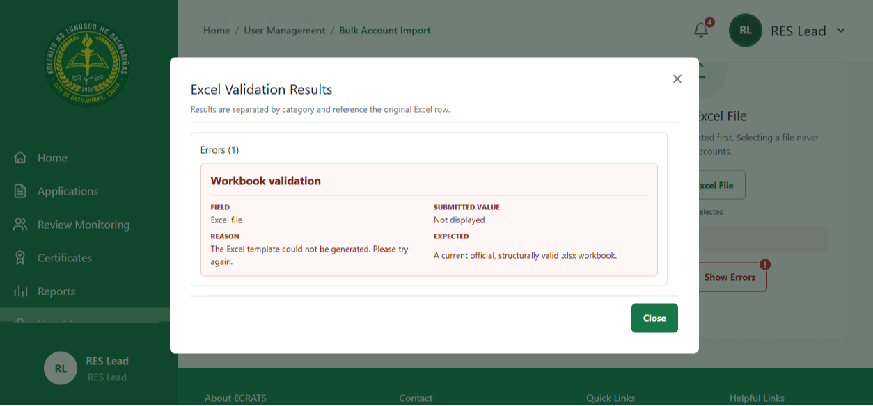

Workspace 2 - Deadline availability and schedule controls updated
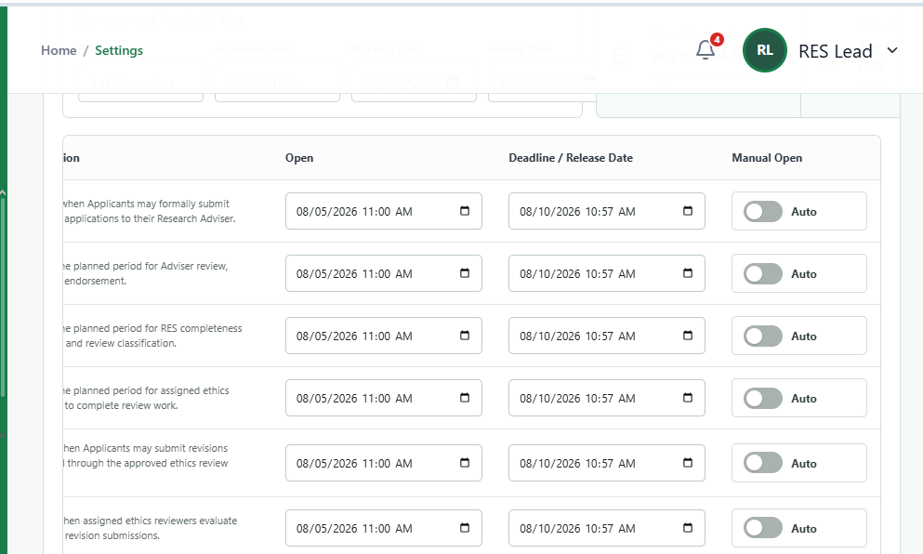

Workspace 3 - Adviser dashboard status-card workflow streamlined
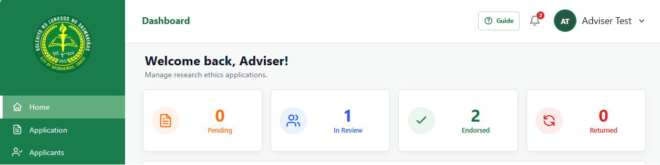

4. Remarks / Notes
Output: An updated ECRATS development build with streamlined role dashboards, simplified RES classification, replaceable reviewer assignments with preserved history, schedule-aware deadline controls, corrected user-management collection handling, and safer Excel workbook processing. Remaining work includes the full high-fidelity Reviewer workspace, official finalized-form artifact generation, Applicant timeline remapping, complete documentation synchronization, and final end-to-end regression and responsive testing.

