DAILY ACCOMPLISHMENT REPORT
MEANS OF VERIFICATION (MOV)
Work-From-Home Arrangement — OJT Internship

System Project: Ethics Certification Review Application and Tracking System (ECRATS)
Date: August 5, 2026
Time Started: 8:00 AM
Time Ended: 6:30 PM
Total Hours Rendered: 10 hours

1. Tasks Accomplished
- Task 1 - Implemented shared interface and role-dashboard corrections, including the standard document-view icon, streamlined Adviser summary cards, and current-assignment dashboard scoping.
- Task 2 - Removed the Reviewer conflict-declaration workflow, simplified RES classification, and implemented non-destructive reviewer reassignment with preserved assignment history.
- Task 3 - Updated deadline availability controls, retired the unnecessary release deadline, corrected the profile-option collection error, and added safer Excel workbook runtime handling.

2. Details / Description of Work
Completed a major ECRATS workflow-correction batch across shared, Adviser, Reviewer, RES Lead, settings, and user-management modules. Removed the assignment-level conflict declaration from active routes, requests, policies, services, models, and interface controls while preserving the official protocol question concerning study disclosure. Simplified RES screening to research classification and introduced auditable reviewer supersession so assignments can be replaced without deleting prior comments, forms, or decisions. Updated deadline configuration to use schedule-aware On/Off states, explicit manual overrides, Philippine Standard date handling, and retirement of the Release Decision and Certification deadline. Corrected the profile-option collection type that caused the user-management error and added safe workbook-runtime validation for bulk-account Excel processing. Updated the implementation plan, migrations, affected tests, code comments, and supporting documentation requirements with continued emphasis on authorization, private files, responsive behavior, reliability, and data preservation.

3. Proof of Work (Screenshots / Attachments)
The screenshots below show the affected ECRATS modules used during issue reproduction, implementation, and developer verification.

Workspace 1 - Excel workbook validation issue reproduced and safeguarded
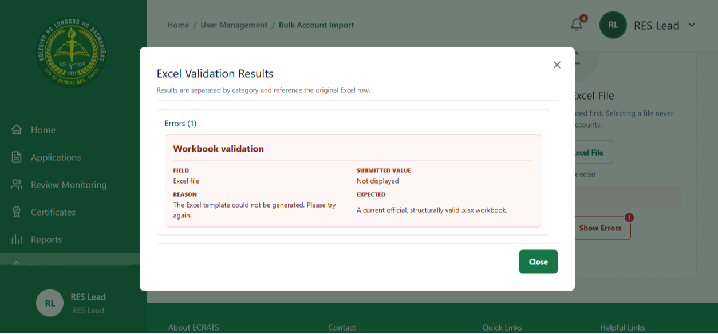

Workspace 2 - Deadline availability and schedule controls updated
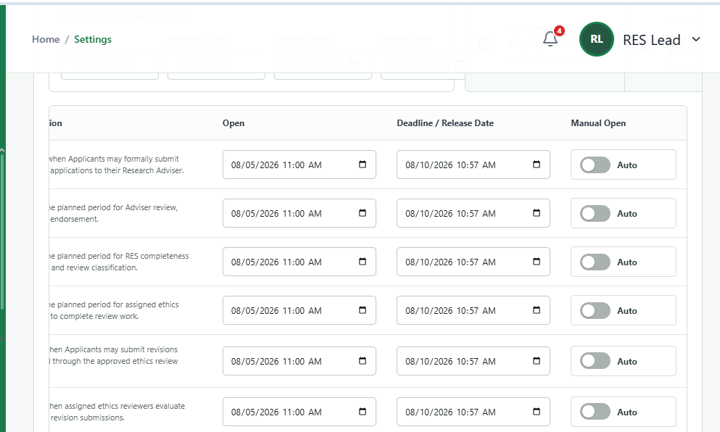

Workspace 3 - Adviser dashboard status-card workflow streamlined
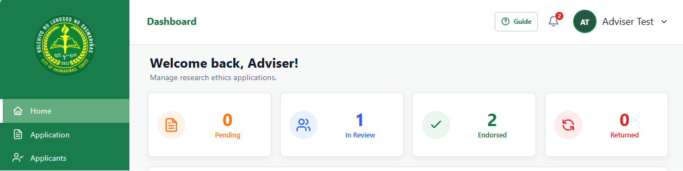

4. Online Meeting / Work Modality Verification
The screenshot to be inserted below will serve as proof of the work-from-home coordination meeting held with fellow interns. During the session, the team discussed assigned ECRATS tasks, shared development progress, reviewed identified issues and completed changes, coordinated responsibilities, and agreed on priorities for the succeeding Revision and Certification modules.

Online Coordination Meeting with Fellow Interns

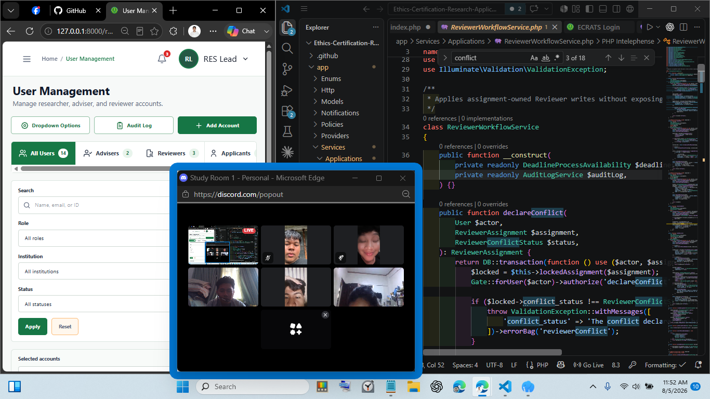

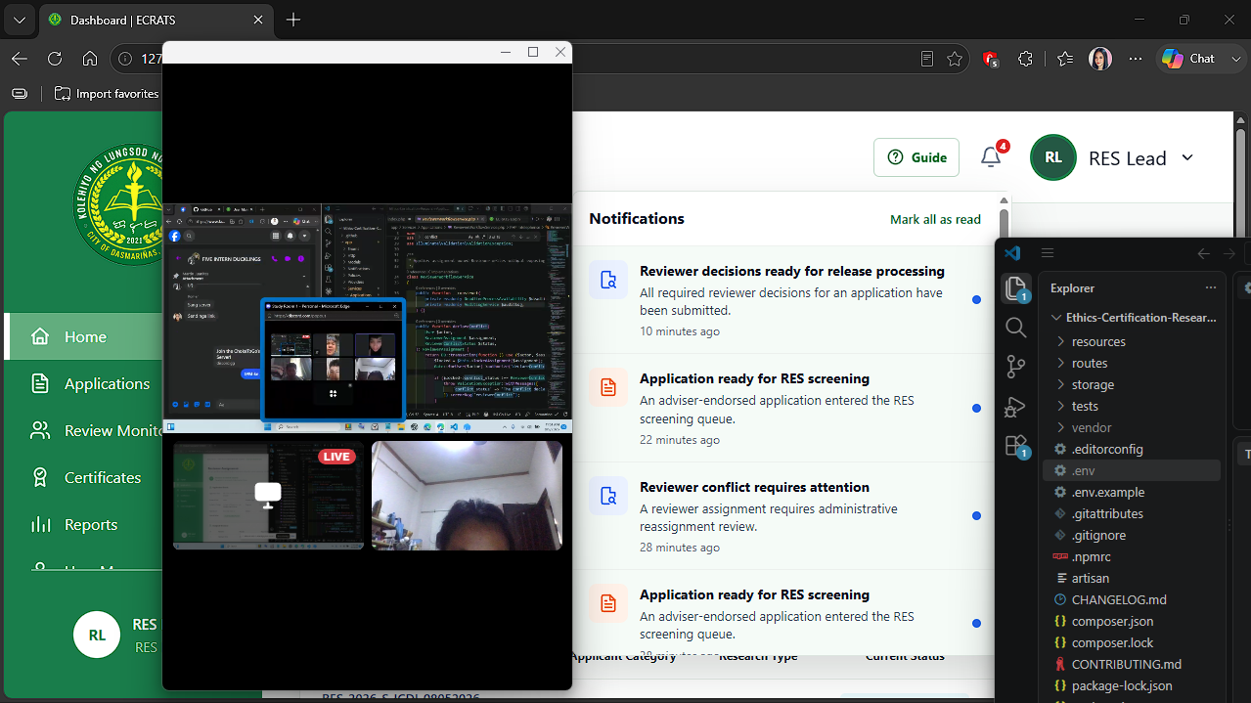

5. Remarks / Notes
Output: An updated ECRATS development build with streamlined role dashboards, simplified RES classification, replaceable reviewer assignments with preserved history, schedule-aware deadline controls, corrected user-management collection handling, and safer Excel workbook processing.

Next Development Modules (Final Step) – Revision Cycle and Certification: The succeeding development phase will introduce a direct revision workflow for student applicants and their assigned reviewers.

- Students will be able to upload revised versions of their applications in response to reviewer comments, after which the revised submission will return directly to the assigned reviewer for re-evaluation without repeating Adviser endorsement or RES classification.
- The module will preserve the original submission, each revised version, reviewer comments, response and resolution status, comparison history, and audit timestamps so reviewers can verify whether the requested corrections were satisfactorily addressed.
- The Certification module will manage the complete certification lifecycle after a favorable ethics-review decision. It will support generating the certificate from approved application data, authorized issuance, temporary holding when release conditions have not yet been satisfied, and controlled release to the eligible student. Certificate status, issuing authority, generated document record, hold or release reason, release date, recipient access, and audit history will be maintained to ensure secure, traceable, and accountable certificate handling.

