DAILY ACCOMPLISHMENT REPORT
MEANS OF VERIFICATION (MOV)
Work-From-Home Arrangement — OJT Internship

System Project: Ethics Certification Review Application and Tracking System (ECRATS)
Date: August 5, 2026
Time Started: 8:00 AM
Time Ended: 6:30 PM
Total Hours Rendered: 10 hours

1. Tasks Accomplished
- Task 1 - Reviewed the ECRATS repository, project rules, documentation, database migrations, policies, services, routes, views, and relevant tests.
- Task 2 - Analyzed the high-fidelity Reviewer design, official review forms, and reported issues across the Applicant, Reviewer, Adviser, and RES Lead viewports.
- Task 3 - Prepared a complete technical implementation specification and development plan covering the required code, database, interface, security, testing, and documentation changes.

2. Details / Description of Work
Performed a repository-wide requirements-to-code analysis for the ECRATS enhancement request. Reviewed the project guidelines, current workflows, relevant source files, database structures, automated tests, high-fidelity Reviewer workspace, official Protocol Review Worksheet and Informed Consent Checklist, and the supplied issue screenshots. Consolidated the findings into a development-ready technical specification defining the functional changes, database migrations, secure reviewer reassignment, asynchronous commenting, official form generation, responsive behavior, documentation updates, and verification criteria.

3. Proof of Work (Screenshots / Attachments)
The screenshots below document application testing, issue reproduction, and interface review completed during the development work session.

Workspace 1 - Reproduced the Excel bulk-upload workbook validation issue
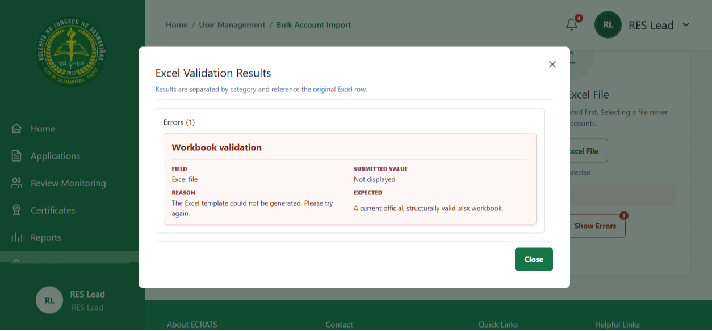

Workspace 2 - Reviewed deadline configuration behavior and controls
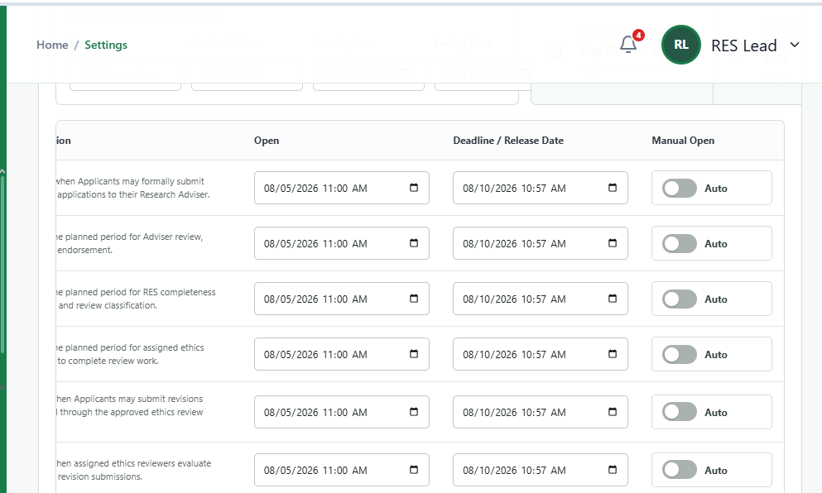

Workspace 3 - Reviewed the Adviser dashboard status-card layout
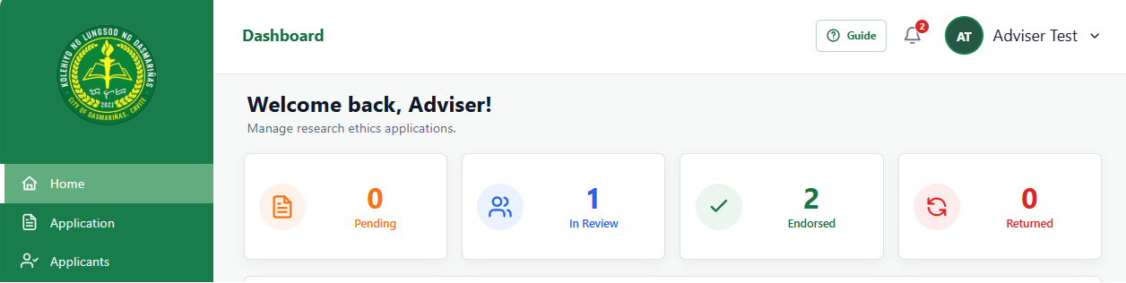
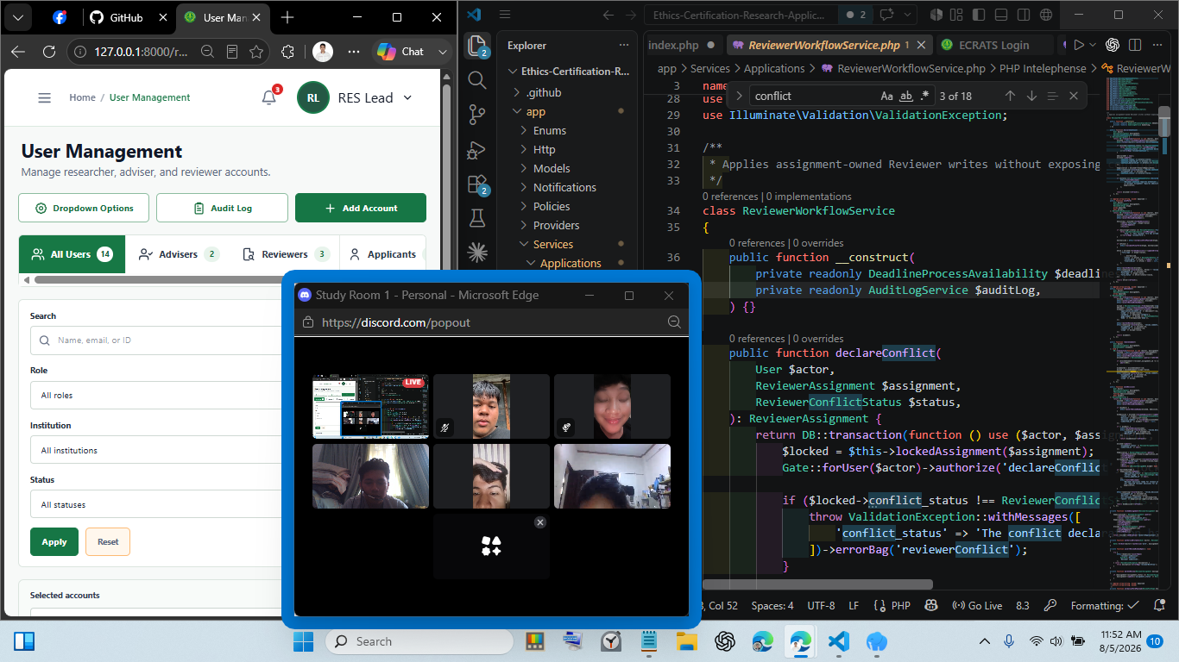

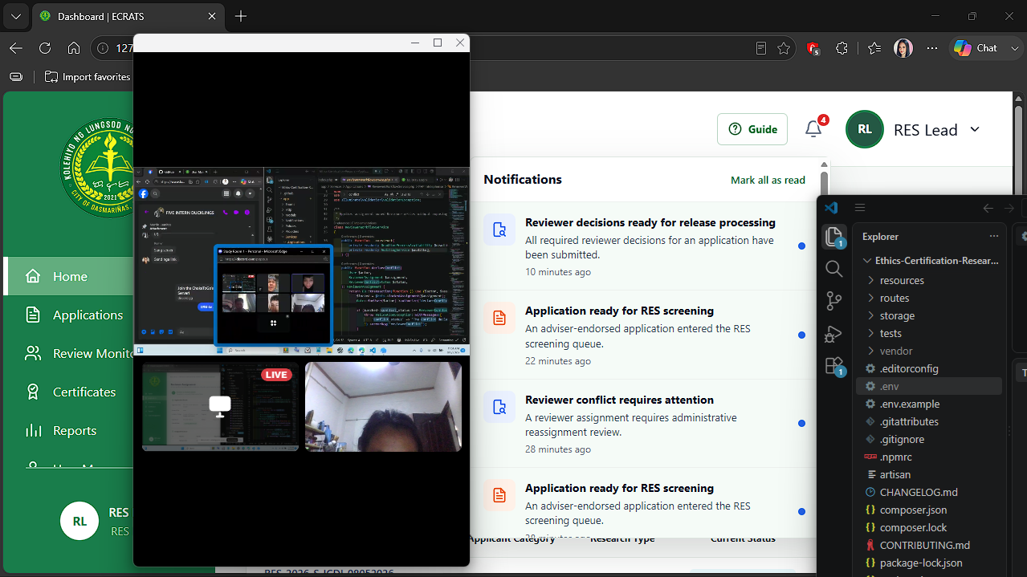

4. Remarks / Notes
Completed the codebase review, issue reproduction, requirements mapping, and technical implementation plan. The next work phase is implementation and full verification. The PHP ZipArchive extension must be checked before validating the Excel bulk-upload template workflow.

